Request for Proposal

I am writing on behalf of NHS Arden and Greater East Midlands Commissioning Support Unit (AGCSU) (hereby known as the Authority); seeking Procurement & Contract Management Resource via this Request for Proposal (RfP), the details of which are set out in Annex A to this letter.

If you are interested in quoting for this requirement, pleases complete:
- The organisation details form within Appendix A
- The questions contained within Appendix C utilising the written response template contained within Appendix D.

Your response should answer each question required and demonstrate how you meet the evaluation criteria contained within Appendix B. Your response must be in the format requested otherwise this may be rejected as being uncompliant.

We will be looking to appoint a provider to commence this work from 1st August 2019, so the ability to mobilise resource(s) quickly is essential.

Please return your response via email to agcsu.southprocurement@nhs.net by no later than 5pm Friday 26th July 2019.

Your proposal must be valid for acceptance for 30 days from the deadline for receipt. Your response constitutes an offer / bid and if the Authority accepts that offer then a legally binding contract will exist.

Respondents accept that the Authority is subject to the Freedom of Information Act and government transparency obligations which may require the Authority to disclose information received from you, to third parties.

This letter and your response do not give rise to any contractual obligation or liability, unless and until such time as, the Authority issues a letter referencing this Request for a Proposal accepting your proposal. The Authority does not make any commitment to purchase and shall have no liability for your costs in responding to this Request for Proposal.

If you have any queries about this letter or the requirement, please submit your questions via email to agcsu.southprocurement@nhs.net and a response shall be sent as soon as is possible.

Yours sincerely,

Andy Harvey
Associate Director of Procurement
For AGCSU

12th July 2019 – Published to Contracts Finder

Service Specification
for the
Provision of Commercial & Procurement support
to the
Medicines Value Programme

Background and Introduction
The NHS spends c£16 billion a year on medicines. Driving better value from medicines spend is central to ensuring financial sustainability.

To support these ambitions, NHS England has embarked on a Medicines Value Programme (MVP) to deliver better value from its investments in medicines. The program encompasses the full spectrum of NHS medicines spend including primary care, acute care and specialised commissioning.

The program seeks to develop and deploy innovative commercial approaches where justified and stronger market engagement, development and management; whilst also delivering a series of procurements or market interventions to reduce cost and/or add value.

The program also seeks to develop, document and embed best practice techniques and processes that can form the building blocks for future activity.

Specification
As part of this programme, NHS England has contracted NHS Arden & GEM CSU (AGCSU) which is now seeking support for the following two work streams of support under the MVP programme to help with the design and delivery the work streams detailed below:

- Contract Management Support for Hepatitis C Elimination Programme:
The Procurement for Hepatitis C Drugs was the largest NHS medicines procurement to date and resulted in significant savings as well as investment from industry and a collaborative approach/commitment to eliminating HCV in England ahead of the 2030 WHO target. The implementation of this procurement is now underway and additional resource is required to complete the contract mobilisation and to develop the contract monitoring and contract management of 3 supply and service contracts prior to handing over this responsibility to NHS England by the end of December 2019.

- Procurement & Contracting Support:
NHS England has completed an assessment of medicines spend and developed a Category Management strategy and prioritised work plan to maximise the benefit derived from the MVP.
Two highly specialised procurements within the work plan have been identified as high priority and we are seeking commercial / procurement resource to deliver these projects as well as to provide commercial / procurement expertise to the wider MVP:

- To develop, with industry and other stakeholders (e.g. DoH, NICE), a novel / innovative payment model to encourage the development/deployment of new antibiotics in compliance with the principles of antibiotic stewardship and to develop a procurement strategy within which to deploy the innovative payment model
- To develop and implement an innovative procurement strategy for Direct Acting Anticoagulants (DOACs).
- To provide Adhoc commercial/procurement advice and expertise as necessary to the MVP programme team.

Deliverables
(Specific Scope)
  - Contract Management Support for Hepatitis C
End-to-end development and implementation of a contract management structure, processes and reporting for Hepatitis C, reflecting the obligations set out in the supplier contracts, including:
    - Ensuring Supplier reporting obligations are satisfied;
    - Update the supplier reporting obligations, templates, etc in line with contract amendments / learning as the contract develops;
    - Ensuring NHS England reporting obligations are satisfied;
    - Overall contract performance monitoring and management of corrective actions;
    - Monitoring supplier compliance to the contractual requirements;
    - Managing contract variations (if / when required);
    - Monitoring the mix of patient treated and the treatments used in comparison the supplier’s awarded market shares and making adjustments to the prescribing recommendations provided to clinicians so as to ensure awarded market shares are achieved;
    - Monitoring supplier payments (via NHS England Finance) and ensuring these are in accordance with the contractual payment mechanism;
    - Managing adjustments (via NHS England Finance) to supplier payments;
    - Representing NHS England at monthly supplier contract review meetings;
    - Managing contract clarifications / issues;
    - Escalation of contractual issues, as necessary, both with Suppliers and within NHS England;
    - Production / presentation of internal contract / governance reports;
    - Preparation of a Hepatitis C contract management handover pack / process document; and
    - Structured and successful handover of the contract management activities to NHS England resources for onward management of the Hepatitis C suppliers.

  - Procurement & Contracting Support
- Innovative antimicrobial payment model
      - to design, in conjunction with industry and stakeholder feedback, an alternative payment model that jointly encourages development and long-term stewardship of new antimicrobials (antibiotics).
    - Develop and undertake supplier payment model engagement;
    - Develop and undertake stakeholder payment model engagement (e.g. DH, NHS England, NICE, etc);
    - Develop value-based payment model(s) for consideration / approval by NHS England that reflect the NICE value estimate of new antimicrobial to the UK health system whilst decoupling supplier remuneration from volume of supply and whilst also managing new antimicrobial risk / value uncertainty;
    - Model the payment model cost/benefits under various scenarios and undertake ‘what if’ / sensitivity analysis and risk assessment of the model(s);
    - Document the proposed payment model;
    - Facilitate supplier and stakeholder feedback to proposed payment model;
    - Document the preferred model for implementation (procurement or other process) stage;
    - Develop supplier and stakeholder briefing materials for the final payment model.

- Innovative Direct Acting Anticoagulants procurement strategy:
    - Develop and undertake supplier engagement;
    - Develop and undertake stakeholder engagement;
    - Develop and agree the key elements of a DOAC cost containment strategy
    - Develop and document payment model
    - Develop and document other cost containment activities / processes
    - Develop and document the procurement / negotiation process
    - Model cost/benefits under various scenarios and undertake ‘what if’ / sensitivity analysis and risk assessment;
    - Finalise and document the payment model and procurement process;
    - Facilitate supplier and stakeholder feedback to the proposed payment model and procurement process;
    - Seek internal governance approval of the proposed procurement process
    - To the ‘extent possible’ within the 5 month support period:
      - Implement the procurement process*
      - Support / undertake supplier negotiation*
      - Conclude initial contracts*

- Commercial / procurement expertise to the wider MVP – Utilise any spare / unused capacity during the support period to:*
    - Contribute to additional complex procurements requirements within the MVP work plan*
    - Assist with the development of a best practice ‘toolkit’ and processes*

NB: (* only if all the deliverables in a) & b) above have been achieved and the timeframe allows)
Timescales
The Contract Support Term is expected to be for a period not exceeding 5 months / 109 working days and to commence from 01 August 2019 to 31 December 2019.

Resource expectation
A suitably experienced and knowledgeable level of resource(s) is/are required for a total period of 109 working days (5 months) from 01 August 2019 to deliver the scope of above two work streams.

Location
There is a requirement to regularly attend NHS Offices at Fosse House, Leicester and Skipton House, London, where key members of the Medicines Value / Commercial Medicines Team reside. However, there is also an opportunity to work flexibly at any of AGCSU sites or from home/own offices, when the client is not requiring attendance at Fosse or Skipton House.

Expenses
Travel expenses incurred in attending client office locations are reimbursable at face value, by submission of copy receipts monthly in arrears.

Pricing
Please provide a price for each of the following phases:
- Contract Management for HepC
- Procurement Support
  - Antimicrobial payment model
  - Direct Acting Anticoagulants procurement strategy

It is expected that the successful Supplier will invoice based upon the total tendered cost divided into 5 equal monthly invoices, to be submitted monthly in arrears.

Anticipated Contract Value
It is anticipated that a day rate of between £500 - £600 (exclusive of VAT and any other charges for the provider) will be required to attract a suitably experienced and knowledgeable level of resource(s) to deliver the scope of work of above two work streams. Day rates of over £600 exclusive of VAT will be rejected.

Form of Contract
NHS terms and conditions for provision of services contract will apply to this RfP:
https://assets.publishing.service.gov.uk/government/uploads/system/uploads/attachment_data/file/681011/NHS_TERMS_AND_CONDITIONS_FOR_THE_PROVISION_OF_SERVICES__CONTRACT_VERSION_.docx

Appendix A – Organisation Details
Complete each section of the table below for your proposal to be considered
Company Information
Company Name
Registered Office Address
Telephone Number
Assignment Director/Partner
Email address for correspondence
Assignment lead (if different to assignment director)
Contact details for Assignment lead

Appendix B – Evaluation Methodology

Please Note:

- Organisation details (Appendix A)– Completion of accurate data and information will be evaluated as “Pass” and the proposal will be considered further. If this section contains anomalies or missing data your proposal may be evaluated as “Fail” and may not be considered further.

- Quality (Appendix C) – The quality questions will be evaluated using the “0-5 criteria” contained further within this Appendix B. A threshold score for each question has been contained and is detailed within Appendix C; Bidders must meet the threshold score for each and every question in order for their Proposal to be considered further.

- Price (Appendix C) – It is anticipated that a day rate of between £500 - £600 (exclusive of VAT and any other charges for the provider) will be required to attract a suitably experienced and knowledgeable level of resource(s) to deliver the scope of work of above two work streams. Day rates of over £600 exclusive of VAT will be rejected.

Price Evaluation Criteria

The below table details the scoring and weighting method for this RFP
Criteria | Weighting | Sub-criteria | Sub-Criteria Weighting
Quality | 80 | Scored | Quality will be assessed against the responses to the questions in Appendix C
Price | 20 | Scored | Linear Analysis – Using 30% as price weighting  Scores are awarded according to lowest cost and the ratio of the other bidders’ costs related to this baseline.  Worked Example (figures not representative, example only)  Bidder A submits a bid for £97,000  Bidder B submits a bid £120,000  Bidder C submits a bid £90,500
  Bidder | Cost | Calculation | Score (%)
  Bidder A | £97,000 | (90,500/97,000)x30% | 27.99%
  Bidder B | £120,000 | (90,500/120,000)x30% | 22.62%
  Bidder C | £90,500 | (90,500/90,500)x30% | 30%

Quality Evaluation Criteria

Proposals will be evaluated in line with the following evaluation criteria

Scored questions evaluation mechanism
Assessment | Score | Interpretation
Excellent | 5 | Exceeds the requirement. Exceptional demonstration by the Bidder of the relevant ability, understanding, experience, skills, resource & quality measures required to provide the supplies / services. Response identifies factors that will offer potential added value, with evidence to support the response, including evidence of innovative approaches.
Good | 4 | Satisfies the requirement with minor additional benefits. Some minor additional benefits by the Bidder of the relevant ability, understanding, experience, skills, resource & quality measures required to provide the supplies / services. Response identifies factors that will offer potential added value, with evidence to support the response.
Acceptable | 3 | Satisfies the requirement. Demonstration by the Bidder of the relevant ability, understanding, experience, skills, resource & quality measures required to provide the supplies / services, with evidence to support the response.
Minor Reservations | 2 | Minor reservations. Some minor reservations of the Bidder’s relevant ability, understanding, experience, skills, resource & quality measures required to provide the supplies / services, with limited evidence to support the response.
Major Reservations | 1 | Major reservations. Considerable reservations of the Bidder’s relevant ability, understanding, experience, skills, resource & quality measures required to provide the supplies / services, with little or no evidence to support the response.
Unacceptable | 0 | Does not meet the requirement. Does not comply and/or insufficient information provided to demonstrate that the Bidder has the ability, understanding, experience, skills, resource & quality measures required to provide the supplies / services, with little or no evidence to support the response.

Quality question response format

For the questions requiring a text response, a template (Appendix D) has been provided within the attachments area of the ITT.
This has been provided to allow Bidders to include diagrams, pictures, tables etc. to properly present responses.
Please note, the ENTIRE RESPONSE must be included in this page limit, including diagrams, tables etc. and any response outside of the stated page limit will not be evaluated, also embedded documents will not be evaluated.
This template must be used for all responses where the question details a number of pages are allowed for a response.
The page margins have been set and must not be moved; the font and size (Arial 11) has also been set and must not be changed; the paragraph settings (0pt) and line spacing options (single) have been set and must not be changed.
Bidders may add a title page to the template, and for the actual response to start on page 2, if this facilitates the Bidding process; Bidders should be aware that if they choose to do this, material on page 1 will not be evaluated. Bidders should not embed documents to this template as these will not be opened and will not be evaluated.

The page margins have been set as follows:
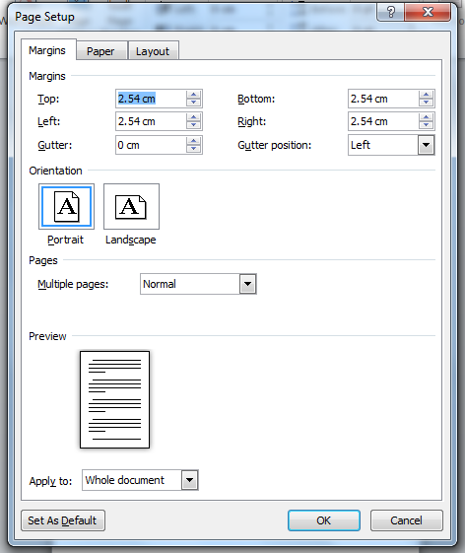

The paragraph settings have been set as follows:
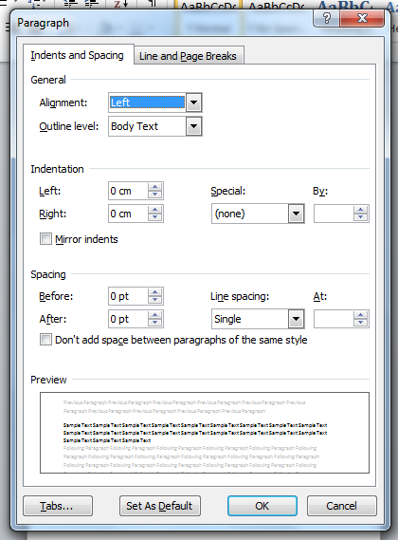

The font settings have been set as follows:
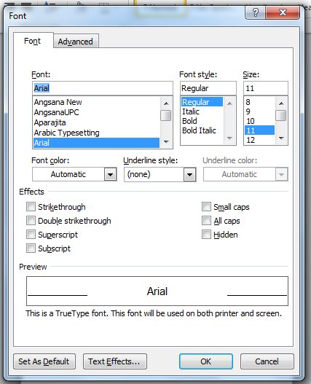

If a Bidder changes any of the settings on the template, these will be re-set to the published template, and the information evaluated will be that that is seen within the stipulations of that question; for example, if a question has a page limit of 4 pages, and the re-formatted response goes on to 5 pages, then the information contained within the first 4 pages will be evaluated, and the remainder of the information discarded.
For one question, additional attachments for CVs / resumes, have been requested and these should be attached to the response also. These additional documents must meet the requirements as stated in the question; however, Bidders do not need to use the provided template for these documents. Bidders should only attach the documents that have been requested; any other material will not be accepted and will not be evaluated. Bidders are able to attach multiple documents, where requested, by zipping several documents together. Bidders should ensure that when zipping documents that these aren’t then encrypted / password protected, as they will not be accessible by the evaluation panel.

Failure to return a completed Final Tender by the deadline may result in the disqualification of the Bidder from participating in this Procurement.

Appendix C

Please Note:

Maximum word limits will apply to each of the response questions below. Exceeding these limits will result in your submission being rejected. A template has been provided for your responses and is detailed in Appendix B.

Quality Questions:
Question Number | Question | Minimum Acceptable Score - Threshold | Maximum Available Score | Weighting 80% Quality total
1 | Please set out your understanding of the key deliverables of the specification and include a clear methodology on how your contribution and intended approach will drive better value.  Text response required - Format MS Word template provided.  Page limit 2 pages. | Bidders must score at least 3 – Acceptable | 5 - Excellent | 4.00%
2 | Please set out your understanding and ideas on potential approaches to developing new payment and alternative financing models for antimicrobial to help promote best value outcomes.  Text response required - Format MS Word template provided.  Page limit 4 pages. | Bidders must score at least 3 – Acceptable | 5 - Excellent | 8.00%
3 | Please evidence that the proposed resource has the skills, credibility, knowledge and the specialist market experience to deliver the programme of work specified. Please include the number of people you will assign to each stage and the number of consultancy days each member of the team will utilise.  Text response required - Format MS Word template provided.  Page limit 2 pages.  Please also include CV / resumes for the proposed staff as appendices (these are not counted in the above Page limit).  Bidders should note that evaluators will be checking the pricing schedule matrix to verify the response to this question | Bidders must score at least 3 – Acceptable | 5 - Excellent | 20.00%
4 | Please describe how you will pass on capability and learning to NHS England, including how this demonstrates commitment to knowledge transfer from you to NHS England to enable their long-term development.  Text response required - Format MS Word template provided.  Page limit 1 page. | Bidders must score at least 3 – Acceptable | 5 - Excellent | 8.00%
5 | Please include your full Project Plan for delivery including key risks and mitigations.  This may be in an Excel spreadsheet or PDF format. It MUST include milestones and accountable individuals. The Authority notes that some milestones may change throughout delivery of the project however the project start and end dates must be delivered a per the Bid and other dates changed must be agreed with the Authority.  Page limit not applicable. | Bidders must score at least 3 – Acceptable | 5 - Excellent | 12.00%
6 | Please set out your relevant experience and skills that demonstrates your solid understanding and approach to secondary care and tertiary care medicines and highlighting relevant experience and skills across large and complex health and social care economies. emphasising the successful outcomes achieved.  Text response required - Format MS Word template provided.  Page limit 2 pages. | Bidders must score at least 3 – Acceptable | 5 - Excellent | 16.00%
7 | Please set out your experience, knowledge and an in-depth understanding of tariff-excluded high cost drugs and the interface between NHS policies and the pharmaceutical industry.  Text response required - Format MS Word template provided.  Page limit 1 page. | Bidders must score at least 3 – Acceptable | 5 - Excellent | 12.00%

Cost question:
Question | Question | Maximum cost – day rate | Maximum Available Score | Weighting 20% cost total
Cost | Please provide a description of your costs and charges, providing assurance that you are able to provide your proposal within the day rate cost you quote.  No other expenses will be paid to the provider throughout the term of the contract, and the provider is anticipated to attend all meetings and engagements as seen fit by NHS England, without seeking additional expense or reimbursement.  Text response required - Format MS Word template provided.  Page limit 1 page. | £600 exclusive of VAT and all other expenses | 20% | 20%

