Climate Impacts Group: Flooding & Coastal Erosion

Local Context
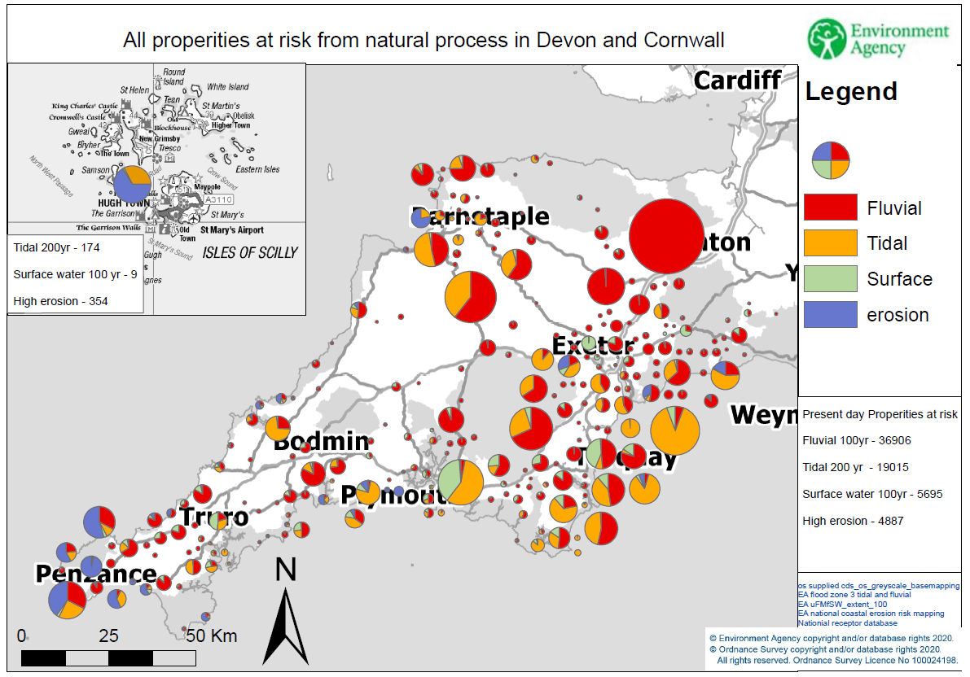
There are many forms of flood risk that Devon, Cornwall and the Isles of Scilly are susceptible to impacts from. Many communities are located in deep, steeply sided valleys, with properties clustered around the valley bottom. The steepness of these valleys results in a rapid onset of flooding after heavy rainfall. Many communities around the coastline are located on flat, low lying areas of reclaimed land, or are at the rear of exposed beaches, all of which are susceptible to flooding from the sea or coastal erosion. Both of these risks will increase in severity and frequency over time as storm frequency increases, rainfall patterns change and sea level rises occur.

The diagram above summarises the scale of the impacts from tidal, fluvial (river), surface water flooding and coastal erosion. These risks are spread around 300 disparate communities.

The headline figures for residential properties at risk are summarised in the following table for a flood event with a 0.1% chance of occurring every year single year (a significant proportion of these are at risk of much more frequent flooding):
Flood risk type | Number of properties at risk
Rivers | 65,000
Sea/tidal | 15,000
Surface water & minor watercourses | 50,000
Total | 130,000
Locally we have a long history of flash flooding (examples including Lynmouth 1952, Boscastle 2004, Coverack 2017). This is due to a high concentration of Rapid Response Catchments which are small and respond to very heavy and prolonged rainfall very quickly. The nature of the response in these catchments often poses issues with providing timely warnings of an impending flood, thereby limiting the amount of preparation that can take place.
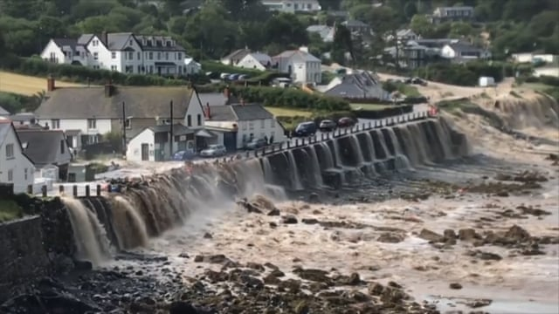
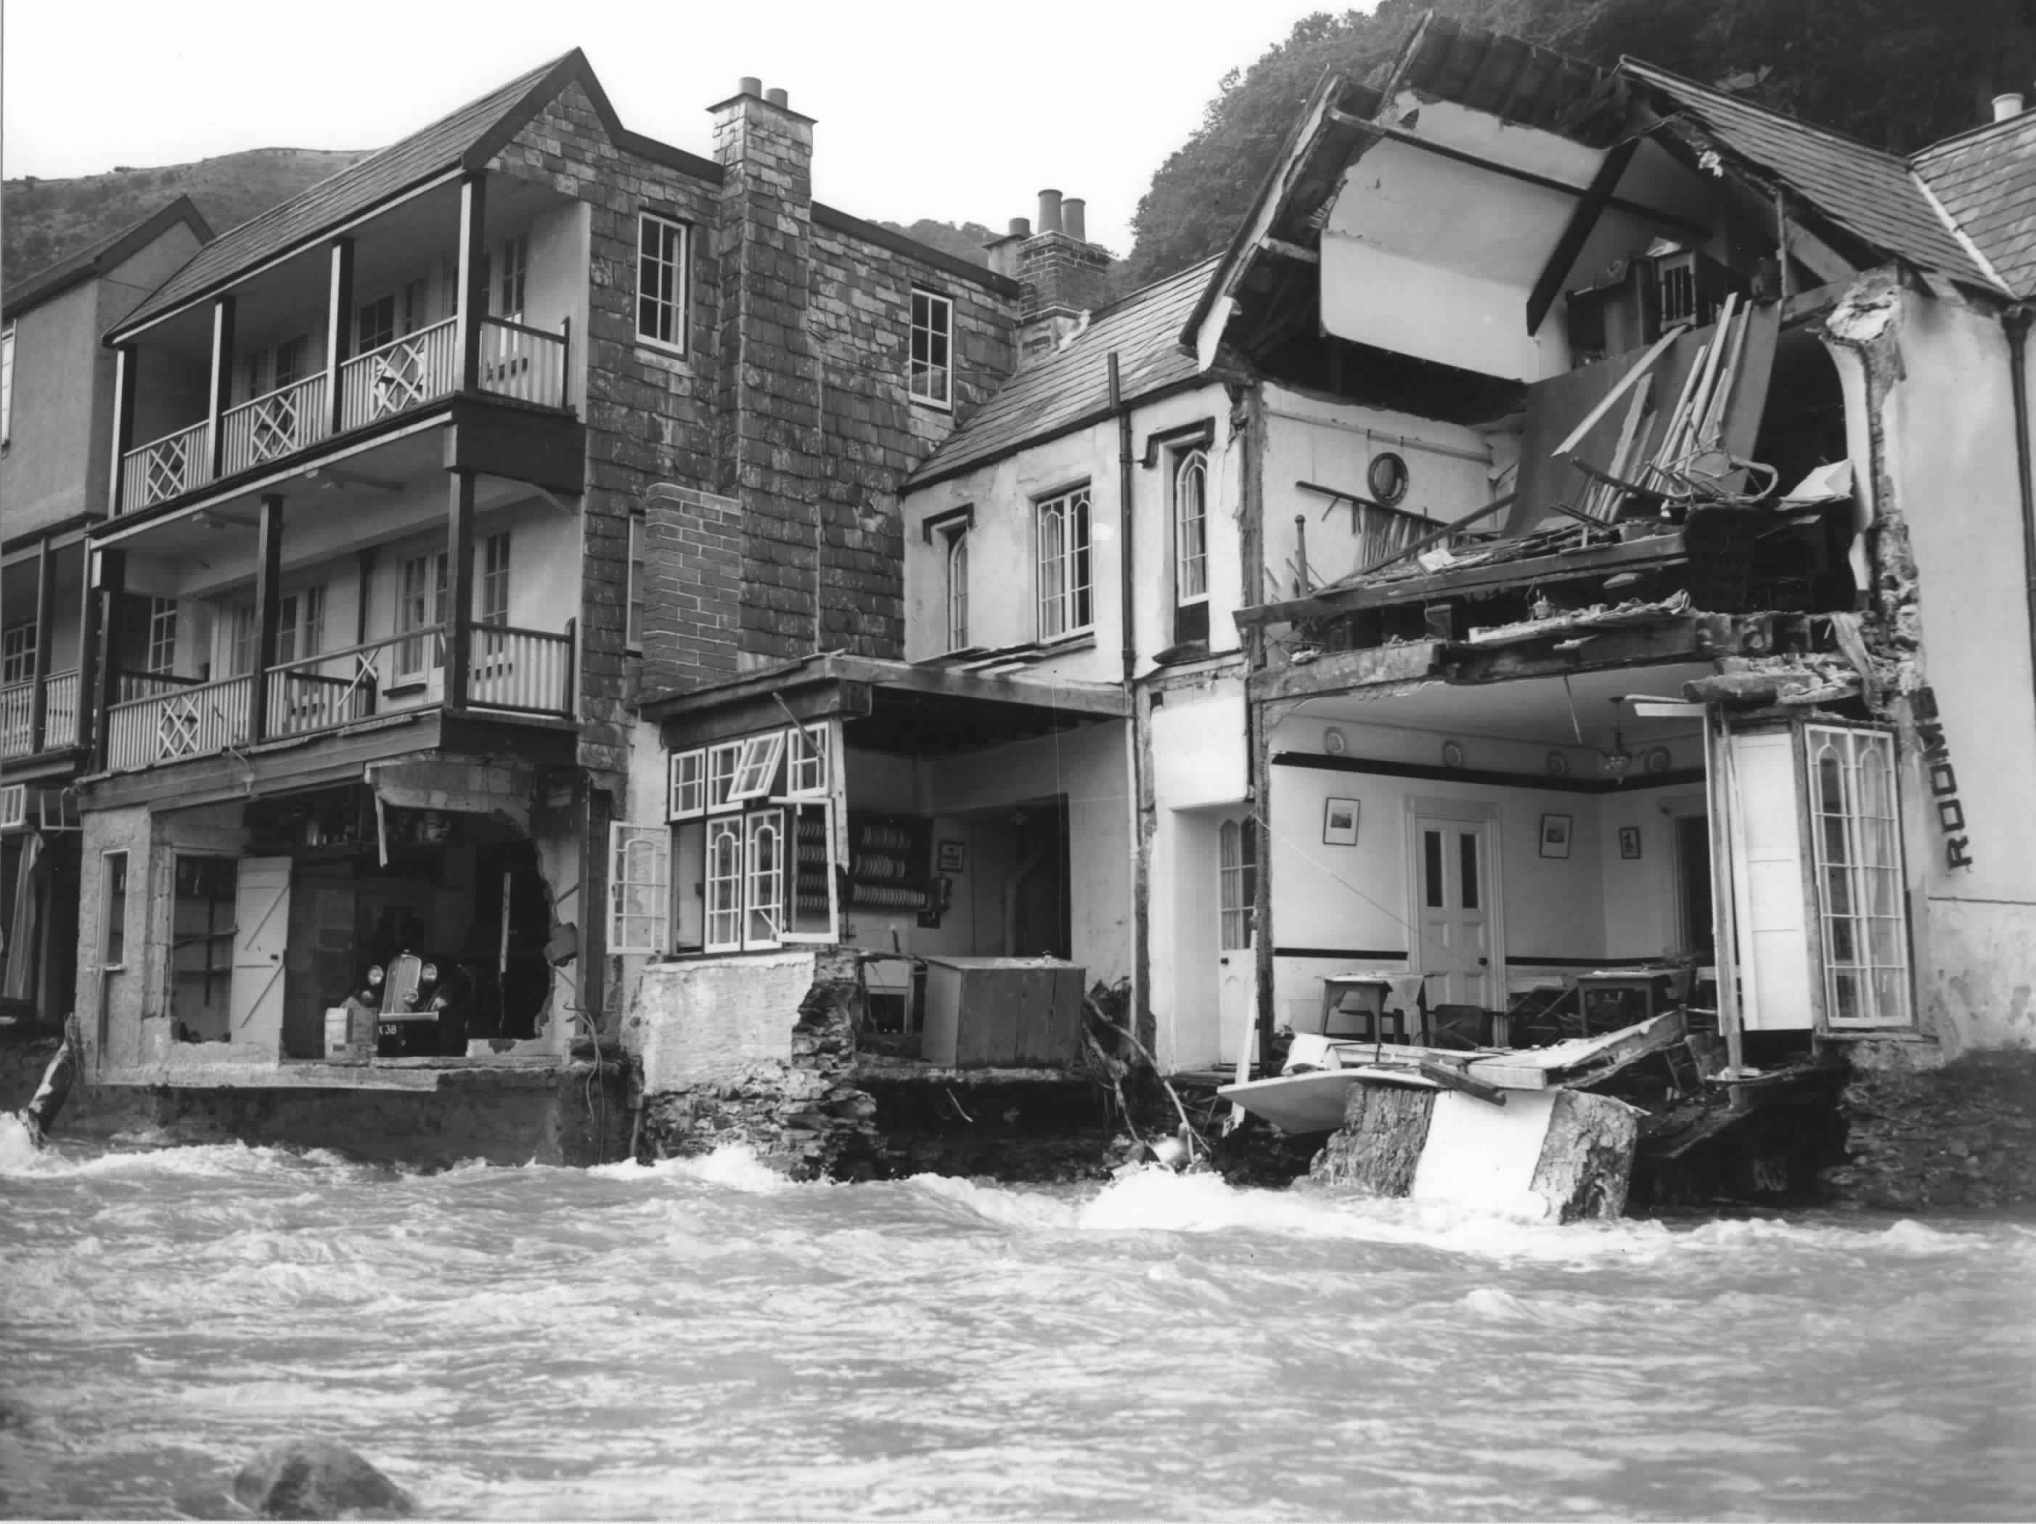

Lynmouth following 1952 flood. Flooding at Coverack in 2017.
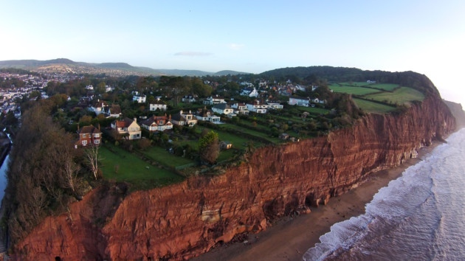
Present day coastal erosion risks are minimal, with a total of 67 properties identified at risk over the next 20 years. This rises to 122 properties in 20-50 years’ time, and 250 properties in 50-100 years’ time. These properties are clustered around a handful of locations in East and South Devon and small groups along the Cornish coast. Additionally there are some individual properties which will also be susceptible to erosion as the risk increases over time.

It should be noted that flooding and coastal erosion also present a very serious risk to public assets, critical infrastructure and transport across Devon, Cornwall and the Isles of Scilly. In February 2014 a failure of the seawall at Dawlish resulted in the closure of the main line railway to London for two months, the resultant repairs and other strategically planned improvements to increase rail resilience between Exeter and Newton Abbot will cost tens of millions of pounds to deliver. Similarly, the A379, which runs across Slapton Ley, has suffered significant damage due to coastal erosion events, resulting in closure of the road and significant detours for road users. The position has now been accepted that the stretch of road across the Ley will be permanently closed after the next failure. One further example is the failure of the sewer at Livermead in Torbay following damage to the seawall and highway in 2013. Many other instances of infrastructure and transport networks at risk exist across Devon, Cornwall and the Isles of Scilly.

The Isles of Scilly are probably the area of England with the greatest exposure to climate change. The total land area is just over 16km2 and over 30% is less than 5 metres above Mean Sea Level. Much of this low lying area includes Hugh Town which is the main settlement and district hub for administration and services. Climate change impacts on the Scillies driven by increases in storms and wave heights will result in a significant erosion and inundation threat to key infrastructure, economy and habitats. Increasing rainfall variation also threatens freshwater supplies which are already at extreme risk due to over abstraction and sea water inundation.

Roles & Responsibilities
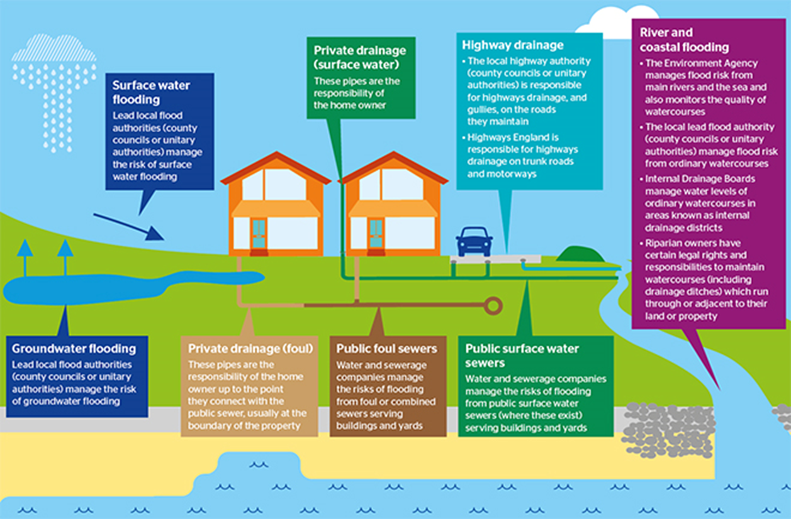
There are many organisations with a role in flood and coastal erosion risk management (FCERM), known as Risk Management Authorities. In addition to those indicated on the following diagram, the Environment Agency has a Strategic Overview role for all sources of risk, the Local Resilience Forum has a key role in coordinating multi-agency flood incident preparation and response activities, and many partners in the environmental sector are now getting involved in progressing more natural solutions to flood risk issues. The statutory roles of Risk Management Authorities and that of members of the public are summarised on the diagram above.
Source: Southern Water

There is a critical part that Local Authorities play in their Local Planning Authority role in preventing inappropriate development in the areas susceptible to flooding and coastal erosion, which will only exacerbate the impacts the climate emergency poses if it is allowed to proceed. Over time this role will become more vital in helping plan adaptation of communities away from increasingly unsustainable areas at risk of flooding and coastal erosion.

Impacts
Climate change statistics
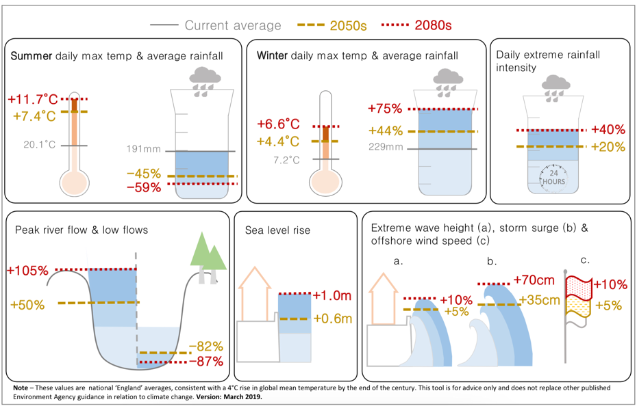
The most recent climate change projections confirm we will experience wetter winters and drier summers, with an increased likelihood of more intense rainfall causing a heightened flood risk. Sea level rise and storm intensity increases will lead to increased coastal flooding and erosion. These predictions are summarised at a national level on the diagram to the right which highlights the key changes from present day to the 2050s and 2080s.

The number of properties at risk of flooding from rivers is not expected to increase drastically due to the steeply sided nature of many valleys, however the increase to depths of flooding will be pronounced. The onset of floods may also become more rapid, and the seasonality of high river flows is likely to be less predictable. The timing of these impacts is very dependent on local variables such as the land use in the catchment, the size of urban area vs rural area, any constrictions to watercourses such as road bridges, culverts etc. Many communities in either low lying area of the coast, or those locations which are exposed to large waves are vulnerable to storms and coastal erosion. It is predicted that high astronomical tides (which occurs every 12 hours) will start to inconvenience some communities in our area by the 2040s as we see sea level rise increase the depth and extent of coastal flooding over time. Coastal erosion will see the coastline naturally retreat inland, causing conflict with areas that are currently occupied by part of the footprint of communities.

Many communities have developed around aged drainage and sewerage systems, which often are attempting to cope with both surface water and foul sewage flows. This combined flow leads to overloading of these urban systems, and can result in unpleasant forms of flooding from the sewer. Rectifying this is complex and requires understanding complex underground systems that are often the responsibility of a number of agencies. Solutions have often involved installing new pipework or systems to separate out these flows at key pinchpoints although dualling the network everywhere is unaffordable and unsustainable especially as it treats rainwater as a problem rather than a resource. This will inevitably become more important as rainfall intensity increases and urban areas expand with the consequential increase in hard areas and runoff. Working with communities and our partners, South West Water have been looking at innovative and sustainable ways to manage the amount of surface water that enters our sewer network. By managing rainwater naturally, we can avoid wasting energy and money pumping and treating clean rainwater in our sewage network.

Wider impacts of flooding
Flooding doesn't just impact areas within flood zones. It can often impact much wider than that. Much of the infrastructure that supports our region and communities is located in the floodplain, whether that is telecoms, water or power supply, or transport networks. This risk is currently poorly understood, as is the interdependency of the infrastructure systems on one another. There is little engagement of these infrastructure operators in flood risk management discussions, and little awareness of the risks it poses to their activities. An example of the impacts is shown on the image overleaf from the EU Circle project run by Torbay Council.
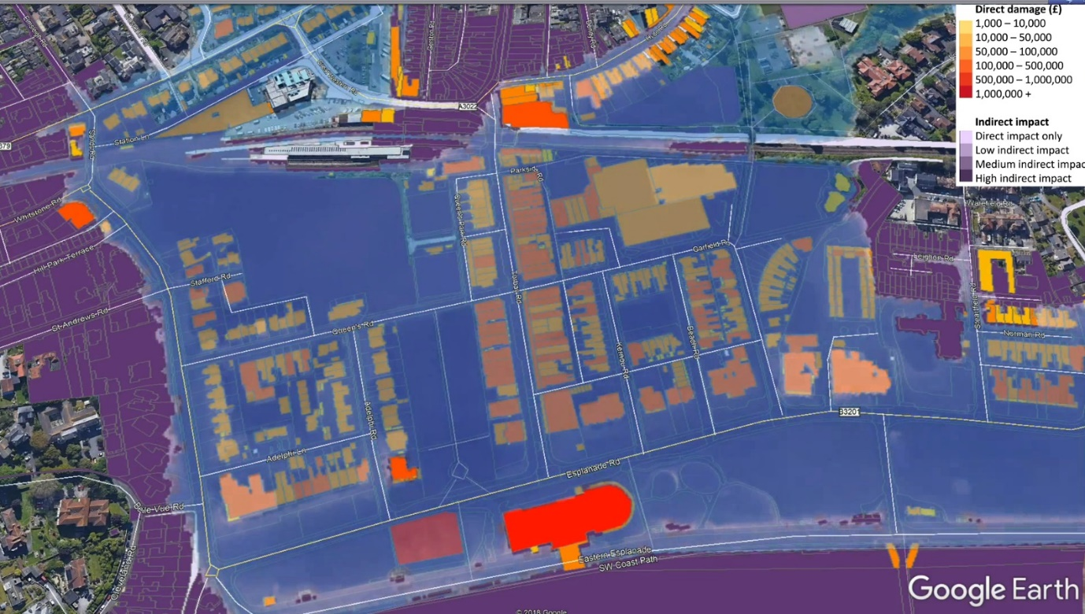
The areas of Paignton experiencing direct impacts from the inundation of flood water are highlighted in the yellow to red colour range, whilst those impacted indirectly by power outages or loss of other services are shown in purple. As can be seen the area of communities impacted by flooding can be much wider spread than simply the area which gets wet during a flood event.

For future FCERM schemes the indirect consequences of flooding or coastal erosion should be taken into account when considering the benefits and damages associated with flooding and coastal erosion.

Joint probability
Flood risk can be compounded by several sources of flooding being felt by a community at once (joint probability), such as a heavy rainfall event resulting in both increased river flows and surface water flooding at the same time. Coastally joint probability refers to the chance of spring tides, storm surges caused by low pressure weather systems and large waves coinciding.
The risks and scale of impacts can increase dramatically in these circumstances. It is likely that these incidences of multiple impacts will increase with storm frequency predicted to increase with climate change, making the likelihood of significant impacts higher.

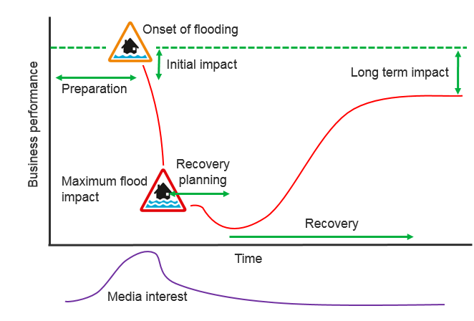
Economic impacts of flooding
Flooding and coastal erosion can significantly impact the local economy. The impacts of a flood can be felt both in immediate impacts caused by damage to property and infrastructure, but also longer term by the protracted recovery period where families are often out of their homes, or businesses not in their properties for 12 months or more.

An academic study was conducted which used data from some local flood events and produced the diagram to the right that describes the impact over time of a flood on the local economy. The dotted green line representing the state of the local economy had the flood not happened, and the red line showing the resulting impacts after a flood. Much of the economic impact comes from resources being directed to recovery efforts, leading to a long lag time in return to normality.

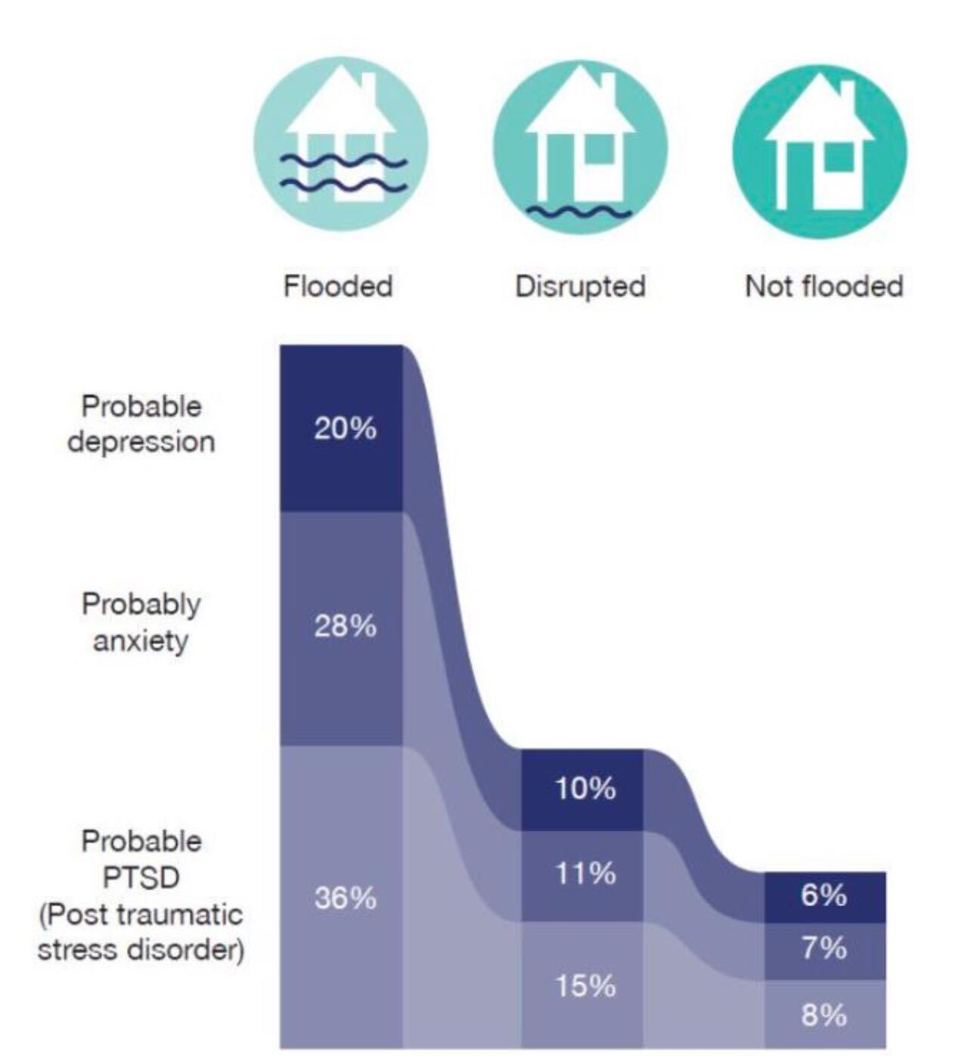
Health impacts of flooding
The protracted return to normality after a flood and the loss of, or damage to possessions has a marked impact on people's mental health. The diagram to the left shows the results of a study from flooded communities on the likelihood for increases in conditions such as Post Traumatic Stress Disorder (PTSD), anxiety and depression depending on the scale of impact experienced during and after a flood.

As the frequency and scale of flooding increases with climate change, these impacts are likely to become more commonplace, impacting more of the population more frequently. This will place an increased pressure on the local health services.

Agricultural impacts of flooding
During Storm Desmond (2015) a heavily studied farm in Devon noted a loss of approximately a third of the soil in some fields due to heavy rainfall and scour caused by runoff. As storms increase in severity and frequency this loss of soils, and therefore productive land, could have a profound impact on the rural economy of our region, on many hundreds of farm businesses and on the downstream infrastructure, watercourses and drainage systems which further exacerbates the scale of flooding.

2.2 million tonnes of topsoil is eroded nationally on an annual basis, much of which ends up in the river systems and, ultimately, the sea. Not only does this result in the issues highlighted above, but it has been shown to have negative impacts on the productivity of fisheries and coastal habitats.

Carbon impact of flood defence construction
The focus of protecting communities from flooding in the past has led to creation of defences such as flood walls and flood storage reservoirs. Often these structures are constructed using concrete, which has a significant amount of carbon emission associated with its use. Therefore the approach of constructing defences in this manner can, in itself, have a negative impact in the larger picture of climate change. We estimate that the national carbon footprint of the Environment Agency is 273,000 tonnes per year, 54% of which comes from the construction of new flood defences, and 6% from the pumping operations to alleviate flooding and drought risks. These figures are currently being developed to enable an area-level view of impact, meaning local figures should be available in March 2021.

Lower carbon concrete and other engineering based initiatives are being explored currently, as are more sustainable working methods on developing projects using the United Nations Sustainable Development Goals. Other key initiatives which will help reduce the impact or offset the carbon costs of constructing new defences include the increasing focus on natural solutions including tree planting and peatland restoration, both of which can store carbon in significant quantities.

Actions For Mitigation
The National Flood & Coastal Erosion Risk Management Strategy will change the approach that Risk Management Authorities take to flooding and coastal erosion from one that has prioritised new flood defences and reactive incident management activities, to a more rounded approach based on the full list of activities shown to the right which aim to enhance resilience to flooding, and adaptation away from those locations where the risks are too high or unresolvable.
The aim of the strategy is to create 'a nation ready for, and resilient to, flooding and coastal change - today, tomorrow and to the year 2100'. It expands on this aim to state that this challenge will be met by working towards the following ambitions:
Climate Resilient Places
Today's growth and infrastructure resilient in tomorrow's climate
A nation ready to respond and adapt to flooding and coastal change

Further information about the actions proposed to change the approach to flood and coastal risk management in the coming years can be found online in the strategy executive summary.

The following sections describe some local actions that comply with the objectives of the national strategy, but also tackle some locally specific issues.

Evidence & Engagement
Risk Management Authorities typically produce evidence of the sources of flood risk and coastal erosion they are responsible for independently from one another. Some of this evidence is coarse and produced at a national level to aid strategic planning, and is not fit for purpose for local decision making.

These datasets are often shared on separate platforms and not pulled together into a coherent single picture of the flood and coastal erosion risk issues and priorities. Nor do they include predictions of climate change impacts which are directly compatible with those that are used by Local Planning Authorities for spatial planning, and those required for investment decision making.
The present day flood risk is published and used to respond to enquiries from communities, individuals and professional partners. However the mapping of future risks and issues is not as readily available. This, coupled with the complex nature of describing flooding mechanisms, roles and impacts, makes it difficult to concisely convey the flooding issues to people with non-technical knowledge. This places increased importance on the engagement activities that take place with community groups, the establishment of flood groups, training of flood wardens and dissemination of key messages at public events.

Place Making
Establishing an intended management regime for flooding and coastal issues at a community level is vital to inform growth, redevelopment and regeneration proposals to enable them to become more sustainable. Over time this will increasingly involve potentially 'difficult conversations' with individuals or communities whereby longer term sustainability in light of climate change requires careful examination. This may result in longer term plans to safeguard against inappropriate development, promotion of relocating property from flood plains and the coast to areas of lower risk, or adaptation to lower risk forms of occupancy.

Flooding as part of spatial planning necessitates close partner working to align growth and regeneration with flood and coastal issues to deliver integrated solutions, and can often act as a catalyst to make changes to enhance a community.

At present we have two means of highlighting these sensitivities:
Critical Drainage Areas (CDAs): These are currently used to highlight where a higher standard for management of surface water risks are. However, they can be used for other means and we are exploring how we use them to highlight sensitive river catchments or particularly susceptible areas of communities, thereby encouraging Local Planning Authorities to apply greater scrutiny and safeguard against unsustainable development.

Coastal Change Management Areas (CCMAs): These zones are used to highlight areas of particularly vulnerable coastal communities. There are two present, one in Newquay and one in Torbay. Like CDAs they require greater scrutiny of any proposals for change within communities to consider flooding and coastal erosion issues to become more sustainable.

Environmental place making is also important. Work to link the landscape upstream of communities at risk of flooding to the area of risk is very important. A lot of initiatives to do this are currently underway locally across Risk Management Authorities and many environmental organisations locally. There are significant opportunities to link in mitigation of flooding to tackling the biodiversity crisis through Nature Recovery Networks, and through agricultural payments via the Rural Payments agency. Both of these activities will help ensure a more resilient landscape and lessen the impact of flooding on communities downstream.
There are many strategic plans which cover flood and coastal issues, therefore it can often be difficult to know where to look for the overview of all proposed actions for a community. All of the place making actions aspirations and projects are captured in the Shoreline Management Plans, Flood Risk Management Plan, and each County and Unitary Authorities' Local Flood Risk Management Strategy. Water Company Drainage and Wastewater Management Plans (DWMPs) are designed to complement rather than duplicate these ongoing activities. The DWMP process is a new way of making a long term plan for drainage and wastewater infrastructure which takes account of future pressures, working in partnership with others and providing lower costs and better value solutions which protect the environment for our customers in a more sustainable way.

Protection
Sustained and longer term increased investment in the promotion of new defences to reduce flood risk to communities is vital. The manner in how this is done, however, is likely to change over time.
Increased sea levels and river flows will require larger and larger engineered solutions which will, over time, become more challenging to fit into the character of our communities without being obtrusive as they increase in size. These solutions will remain necessary until adaptation of those areas of risk takes place, however the way they are implemented may change to become more stage-based to ensure they do not pose an inconvenience to communities in the short to medium term, but can be expanded and improved over time as impacts increase and predictions for climate change are better understood.

It is anticipated that projects will look at the landscapes that generate floods and attempt to balance a combination of natural approaches within that landscape and engineering within the area at risk. There are significant projects such as the South West Peat Partnership which can deliver benefits by restoring and enhancing habitats that will store more water in the uplands.

Other aspects that need careful consideration are the condition of the soils in the region, and how the improvement of soil condition links both to reducing runoff generation, and therefore the size and impact of some flood events. This also has a direct positive link to agricultural business models and could lead to a reduction in environmental pollution incidents. It is also expected that these new projects will also plan for what happens at a community level when larger floods than the defences are designed for occur, and any impacts from potential failure of defences.

Both at the coast and on the river network we must evaluate areas that have been defended historically which no longer require that level of protection now, and utilise these to 'make space for water' to help address the issue of flooding or coastal risks.
Owners of properties have been able to apply for grants to fund property level resilience measures, such as flood proof doors and air brick covers for some years now. Both Devon County and Cornwall Councils have been running schemes which promote these measures and encourage take up as well as carrying out installations. Whilst it has been very successful for residential properties, some concerns about 'coming forward' have been expressed with residents concerned that doing so may impact their insurance premiums, when in reality the converse is more likely. Commercial properties have also posed a real challenge to engage with these techniques, with 9,000 businesses being engaged and only 7 progressing solutions to increase their resilience.

Response
Organisations and communities must work closer together to prepare for a flood or coastal event, and plan how to respond to them as a team when they occur.

Warning and informing improvements are planned with an ambition to have 100% coverage for flood warnings by 2022. This needs coupling with residual risk management activities which look at the potential for failure of defences and the production of evacuation plans, this approach is known as 'building for exceedance'. Community and partner education and volunteering initiatives will be key to this aspect succeeding.

The South West Major Incident Plan is currently being reviewed. This sets out the framework for how a widespread flood or coastal event would be dealt with within the region, and aims to plan for aspects of this that can be predicted. It will set out a management regime, roles and responsibilities and means of tackling the incident both before, during and after.

Recovery
Enabling communities and the local economy to recover from flooding quicker will be vitally important as both the frequency and impact of these events increase over time. Timely reinstatement of systems such as water supply, wastewater treatment, electricity, transport networks etc. will help normality return faster after these events, but will require significant investment to improve resilience of these systems.

‘Building back better' after a flood event will be key to prevent recurrence of the same issues in the future. It is vital this concept is adopted by all involved in flood and coastal risk management, Local Planning Authorities and any local investment decision makers.

Local Opportunities
Evidence
At present change in flood and coastal erosion risk is analysed on an individual project basis, not amalgamated into an overall picture, or communicated openly to the public in a coherent manner at the local level. This is a key blocker which needs to be overcome to enable a coordinated approach to adapting communities, local investments and resources to climate change risks.

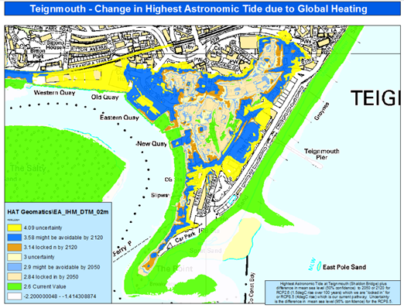
An example of the need for this is the scale of change to high tide in the next few decades. The map to the left shows the potential increase to high tide at Teignmouth, with the high tide outline for 2050 being shown in beige. By 2050 this level could be reached twice a day.

Several prestigious local academic institutions are researching lots of relevant issues. A more effective link between the data they collect and the work done on flood and coastal erosion projects should be made. This could enable the creation of a centre of excellence for monitoring the changes in the relevant climate, coastal and water trends to inform appropriate responses. This will also give those academic institutions clear line of sight for their research to impact 'industry', thereby being mutually beneficial.

The South West Property Resilience Pathfinder project is being led by Cornwall Council in partnership with many other local Risk Management Authorities. This initiative has analysed the surface water flooding risks, and how they are likely to change over time. It will engage with residential and commercial property owners to make them more aware and familiar with PFR products, their benefits and the different types available.

The Catchment Based Approach project is led by the Environment Agency and will identify priority areas where working with natural processes such as peatland restoration, enhancing soil condition and tree planting (amongst others) can be used to reduce flooding impacts. It will enable a view of the wider benefits of these initiatives to be taken to also tackle issues such as the biodiversity crisis and seek opportunities to offset carbon dioxide.

A portal to capture the key datasets that show future risks should be created to amalgamate all of the valuable data held by local organisations and institutions to make the scale of future risks more transparent and easily accessible to partners and the public. This would enable a more targeted way of reviewing where the greatest increases in flood risk are in the future and have a single version of the truth to work from

The Risk Management Authorities are actively engaged with the South West Regional Flood and Coastal Committee (SWRFCC) on the development of a special delivery vehicle - South West Integrated Framework Team (SWIFT) and are seeking joint funding across relevant organisations. The focus of delivery will be to collaborate on solution and option development through co-creation with co-funding opportunities being developed and implemented across the parties.

Planning
There are many plans which show the strategic direction for flood and coastal erosion risk management. Often it is difficult to know where to go for the right information. A simple solution to this could be to couple the evidence portal proposed above with a planning segment which illustrates the desired policy decision for a given community. This would entail creating community profiles and enabling them to be utilised to direct decision making and investment planning, as well as raising awareness of impacts with residents and local interest groups.

Adaptation plans should be developed to identify communities, assets and habitats at significant and unsustainable levels of risk. These plans should influence key decisions around investment in these locations in the future and enable a more sustainable position to be reached. In some instances this could result in very localised changes, and in others more significant changes from the present regime will be required to a more sustainable position.

The indirect impacts of flooding need to be better planned for. Particular scrutiny should be given to infrastructure impacts, and the interdependency of infrastructure that could be impacted by a flood. For example, if an electricity substation is flooded that may prevent supply of critical services and transport systems. A common understanding of these interdependencies should be developed locally with the key infrastructure organisations to map out the impact to society and plan for how to make these systems more resilient to climate change.
Investment
The annual investment programme for Flood and Coastal Erosion Risk Management Grant funding is on average £40 million for Devon, Cornwall and the Isles of Scilly. The Partnership Funding model that governs the cost benefit analysis used to distribute this funding nationally often results in a 40-60% requirement for each project to secure additional funding from other sources. At times this has resulted in the funding to progress schemes not being available, or solutions having to be designed to deliver smaller reductions in flood or coastal erosion risk than originally envisaged. The Partnership Funding policy is currently under review.

Inevitably the total funding required to keep pace with climate change, however, it does present a significant opportunity to link up a large investment programme which has important linkages to both the built and rural environments to initiatives such as building greener local economies, making local businesses and infrastructure more resilient and tackling the biodiversity crisis through initiatives such as delivery of biodiversity net gain and the Nature Recovery Networks. It can also often act as a catalyst for growth and regeneration of communities as has been seen at Royal William Yard in Plymouth.

An assessment of the investment in existing flood defences across organisations should be undertaken to identify whether this is fit for purpose, or whether pressures will be felt sooner due to a lack of revenue funding to maintain the assets, staff and resources that already exist. It should also be considered as to what assets currently in existence can be removed to allow more natural processes to occur and to prioritise funding to where it is needed, rather than simply where it has been traditionally spent.

With areas of growth and regeneration proposed in many of our larger communities, sustainability to flood and coastal issues should be inherently built into the thinking of these locations to enable a greener and sustainable economy to be built and to reduce overall community resilience issues over time. Equally infrastructure providers should collaborate with risk management authorities to help build the picture of the true scale of flood and coastal impacts on communities.

Where to go for more information
A guide for riparian ownership (ownership of a watercourse)
Environment Agency flood risk map portal
Sign up to receive Flood Warnings
South West Flood Risk Management Plan
Shoreline Management Plans
Devon County Council Flood Risk Management
Cornwall Council Flood Risk Management
Torbay Council Flood Risk Management
Plymouth City Council Food Risk Management
Isles of Scilly Flood Risk Management
South West Water Flood Risk Management
National Flood Forum

