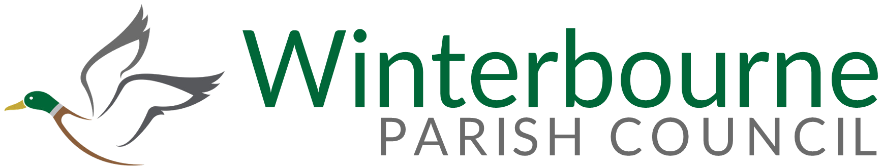

GRASS CUTTING CONTRACT 2025-2028

To whom it may concern

You are invited to tender a quote for the cutting of the highways and grass verges in Winterbourne Parish Council, and the cutting of Frenchay Common and part of Hambrook Common.

The contract will be for a period of 3 years from 1st April 2025. However, the Parish Council are willing to consider a 5 year contract.

Please can you itemise how much each individual cut would be as well as the total cost for the year.

- The first part of the contract is for the grass verges which would normally have 13 cuts per year.

- The second part is for the Common areas in Frenchay and Hambrook These areas are normally cut on a fortnightly basis between April and October depending on weather conditions.

Please can you return your quotes by 12th November 2024

I look forward to hearing from you.

Yours Sincerely

Sarah Lucy
Parish Clerk
Winterbourne Parish Council

The Greenfield Centre
Park Avenue
Bristol
BS36 1NJ
01454776922

