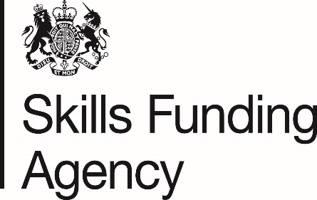

EXEMPTION FROM FINANCIAL HEALTH ASSESSMENT
For upload against [REG15-FHA-02a]:
I believe that [NAME OF ORG] is exempt from submission of financial statements for Financial Health Assessment on the basis that we are:
(Please tick one box)
A College (General Further Education corporation incorporated under the Further and Higher Education Act) currently receiving funding from the Skills Funding Agency (SFA).

OR

A central government department, an executive agency or a non-departmental
public body.

OR
A local authority including Local Education Authority (LEA) schools.

OR
An NHS trust, or a fire authority, or a university monitored and supported by HEFCE.

OR
An Academy, Free School or Sixth Form College.
OR
A major national charity or voluntary organisation with annual turnover in excess of £100M where SFA funding is less than 5% of the organisation’s annual turnover.

OR

A Public Limited Company (PLC) or other registered company with an annual turnover in excess of £100M where SFA funding is less than 5% of the organisation’s annual turnover.

