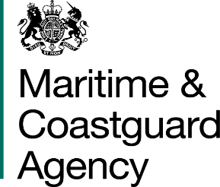 |  |  | Bay 3/21  Spring Place  105 Commercial Road  Southampton  SO15 1EG  United Kingdom
 | All Tenderers for the Provision of Emergency Towing Vessel Via Contracts Finder |  | Tel:  Fax:  E-mail: | +44 020381 72476  +44 (0)23 80329388  contracts@mcga.gov.uk
 |  |  | Your ref:  Our ref: |  | TCA 3-7-991
 |  |  | 21st September 2016
Dear Sirs

PROVISION OF AN EMERGENCY TOWING VESSEL (ETV) –EXTENTION TO THE DEADLINE FOR THE SUBMISSION OF TENDERS

We would like to inform you that the deadline for the receipt of tenders for the above contract has been extended to 11am on the 7th October 2016.

The information available on the Official Journal of the European Union, Contracts Finder and Public Contracts Scotland will be amended to reflect this change.

To ensure that all tenderers have access to the same information and allow tenderers sufficient time to digest any responses provided, please can all requests for information be submitted by no later than 5pm on 28th September 2016.

Regards,

Richard Skeats MCIPS
Contract Manager Business Partner
Maritime and Coastguard Agency

