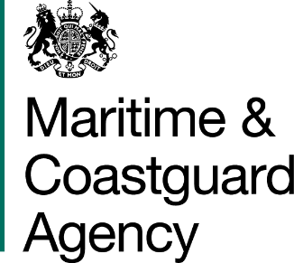 |  |  | Bay 3/20  Spring Place  105 Commercial Road  Southampton  SO15 1EG
 | To whom it may  Concern, |  | Tel:  E-mail: | +44 (0)20 381 72173  contracts@mcga.gov.uk
 |  |  | Our ref: |  | TCA 3/7/1118
 |  |  | 02 September 2019

INVITATION TO TENDER REPLACEMENT ROOF AND RENDER AT MCA LIVERPOOL, HALL ROAD WEST, CROSBY, L23 8SY

You are invited by the Secretary of State for Transport (from now on referred to as "the Authority") to submit a tender for the above contract.

One original and one copy (so marked) of your tender and proposals, including any covering letter, will be required. Your Tender Price should be entered onto the Price Schedule included within the documentation. Tenderers should be aware of the following dates.

- Site visits are available on 10.30am, 10 September by arrangement
- Deadline for final Questions and Answers will be 11 September 2019
- Deadline for request for site visit will be 09 September 2019
- Tenders must be delivered by 11.00 hours on 17 September 2019

Late tenders will not be accepted, and it is your responsibility to ensure that your tender is received on time.

As part of your tender you should supply the following:-

- The MCA’s Form of Tender signed and dated by an authorised representative of the tendering organisation;
- Their completed Pricing Schedule and Pricing Schedule Declaration form;
- Their completed Template Tender Return;
- Any other information requested at 2.0 of the Invitation to Tender.

SHOULD YOU BE SUCCESSFUL, THESE DOCUMENTS AND ANY SUBSEQUENT CORRESPONDENCE BETWEEN YOU AND THE DEPARTMENT WILL FORM A BINDING CONTRACT BETWEEN YOU AND THE AUTHORITY.

Please read all the documents listed in the Form of Tender. To ensure that all tenderers have access to the same information you can only obtain further information about contractual issues and Technical Information from me (The Contract Officer). All requests must be submitted in writing to me at the above e-mail address.

Yours sincerely,

Amanda Dunbar
MCA Procurement Team

