Service Specification

Dental Electronic Referral System

NHS England – Wessex and Thames Valley

August 2018

1 Introduction 4
1.1 Purpose 4
1.2 Background 44
1.3 Vision and Principles 5
1.4 Strategic Drivers 5
2 Population Needs and Context 7
2.1 Oral Surgery 10
2.2 Oral Medicine 10
2.3 Orthodontics 10
2.4 Other Specialties 10
3 Outcomes 11
3.1 NHS Outcomes Framework Domains and Indicators 11
3.2 Locally Defined Outcomes 11
4 SystemAims and Objectives 12
5 System Description 14
5.1 SystemAvailability 15
5.2 Accessibility and Acceptability 15
5.3 Population covered 16
5.4 Acceptance and Exclusion Criteria 16
5.5 Discharge Criteria 17
5.6 Interdependencies with other Services / Providers 17
6 Operational Model 18
6.1 Overview 18
6.2 Screening 19
6.3 Triage 19
6.4 Acceptance and Disposal 20
6.5 Advice and Guidance 20
6.6 Integration and Usability 20
6.7 Patient Information and Discharge 22
7 Response Time and Prioritisation 23
8 System Monitoring and Quality 24
9 Reporting 25
10 Electronic Communications/Functionality 26
11 Information Governance 27
12 Clinical Governance 28
13 Complaints, Incidents and Concerns 29
14 Record Keeping and Confidentiality 30
15 Applicable System Standards 31
16 Activity and Pricing 32
17 Implementation 34
18 Annex A: Reporting Requirements 36
19 Annex B: Key Performance Indicators 38
20 Annex C: Definitions 41

- Introduction
  - Purpose
Every patient journey to NHS specialist dental care should begin with a visit to his or her primary dental care practitioner from whom they receive regular care. This dentist may work in primary care or in a community dental service.
The dentist will complete a comprehensive examination to assess risk and need. The patient should receive information on their individual oral health status and risk of dental disease together with tailored preventative advice on what they can do to maintain and/or improve oral health. If a patient needs dental treatment, the primary care provider delivers comprehensive primary dental care. If a patient requires a complex procedure, has modifying factors that make routine dental care complex, or requires additional equipment or facilities to deliver care then a referral to a specialist service maybe required.
The referral will be triaged and directed to a level 2 or 3 care complexity provider as part of a referral management process.
The purpose of this document is to set out the requirements for a Dental Electronic Referral System (DERS) for NHS England – South (Wessex and Thames Valley – referred to as W&TV) for patients that may require level 2 and 3 services which cannot be provided by their dentist.

For Wessex the system will initially cover Oral Surgery and Orthodontics, the intention is that over time this will be expanded to include the full range of dental specialties. These may include:

- Restorative Dentistry including the mono specialties
- Special Care and Paediatric Dentistry
- Maxillo Facial Surgery or Oral Medicine for referrals made by a GDP
For Thames Valley the system will initially cover Oral Surgery, Intermediate Restorative Dentistry and Orthodontics, the intention is that over time this will be expanded to include the full range of dental specialties. These may include:

- Special Care and Paediatric Dentistry
- Secondary Care Restorative Dentistry
- Maxillo Facial Surgery or Oral Medicine for referrals made by a GDP

NHS England – South (W&TV) reserves the right to request expansion of this system in the future to include other dental specialities. NHS England – South (W&TV) accepts that any future expansion would be subject to negotiation. However, the DERS must be able to demonstrate that their systems and processes are capable of expansion, to manage referrals for additional specialties.

It is recommended thathe DERS software supplier shouldt provide open APIs (Application Programming Interface) to allow the hospital system to import data from DERS into the hospital system should it be necessary. It must also be easy for the dentist based systems (Kodak R4 and Software of Excellence - Exact and others) to export to.

System integration must include seamless ability to transfer patient data and clinical imaging securely, ability to accept referrals and the ability to send/receive secure messages between the referee and the service provider.

From 1/04/20 the system must using SNOMED CT coding.
  - Background

Since the introduction of the Health and Social Care Act 2012, NHS England, a national organisation, now has responsibilities for commissioning all dental services.

Across the NHS England – South (W&TV) area (see section 2), there are currently a range of referral management and referral administration systems. These are a mixture of legacy systems from Primary Care Trusts (PCTs) as well as provider managed processes.
Nationally there are multiple systems employed for DERS which currently vary in both how they are structured and the time periods over which they are contracted.

At present we know that waiting times vary across specialised services resulting in effects to both access and quality of services that are provided; the quality of referrals are also variable resulting in inconsistent acceptance of cases and therefore difference in access to services. Waiting times for treatment between secondary care, primary care and community based services differ, potentially resulting in inefficiency and inequality.

As laid out by the Five Year Forward View, there has been a move towards clinical commissioning as supported by Local Professional Networks (LPN). The current system poses operational commissioning challenges making it difficult to assess service need and define future commissioning intentions. It is also challenging in this environment to monitor the quality of services to compliment both clinical and patient requirements. There is a need to improve the quality of reporting information for specialist services. A more reliable and efficient referral system is needed to support implementation of agreed pathways to improve timely and appropriate access to services.

Historically, Choose and Book was a national system that combined electronic booking with a choice of place, date and time for first hospital or clinic appointments. It revolutionised archaic booking and referral systems, by allowing patients to choose their initial hospital or clinic appointment, and book an appointment themselves. This system had several issues associated with it and was not being used widely for the administration of dental referrals. A new NHS e-Referral System has succeeded the Choose and Book service. However this does not cover dental referrals, and there is a need for an equivalent system that specifically supports dentists: it has been identified on numerous occasions that the national systems implemented do not convey the complex information required as part of dental referral algorithms. Subsequently a growing number of dental commissioners have sourced independent DERS to better suit their requirements,

The intention is that a DERS will be commissioned and developed across NHS England – South (W&TV) that can be enhanced to work in conjunction with the NHS e-Referral Service.

  - Vision and Principles

- The new DERS is intended to facilitate timely access to appropriate NHS intermediate and specialist dental care across the NHS South (W&TV) area.
- The needs of patients and professionals will be foremost in designing the new system, which will include support for enhanced functionality and usability.
- The new system will support the drive to a future paperless NHS referral system.
- A flexible commissioning approach should be considered as part of ongoing national changes which will reflect requirements by the National Information Board, NHS England and NHS Digital.
- Empowering patients to allow access to a patient portal to manage their appointments and improve patient experience
  - Strategic Drivers

There are a number of recent policies and strategic drivers that contain statements relevant to the development of a new DERS.

- The NHS Constitution
- The NHS Mandate
- The New NHS Provider Licence
- Liberating the NHS – ‘No decision about me without me’
- The NHS Five Year Forward View
- Putting Patients First
- Dental Commissioning Guides
- GDPR
- FYFV Next Steps
- AOMRC Information and Digital Clinical Requirements 2020
- Personalised Health and care 2010
- NIS
- Wachter Review 2016
- Widening Digital Participation programme

The Commissioning Guides in particular recommend the use of these systems to both capture information about need within an area and also as a tool to aid the appropriate management of patients and allocation between services.
- Population Needs and Context
The NHS England South (Wessex) area covers the following CCG’s within Dorset, Hampshire and the Isle of Wight and NHS England South (Thames Valley) area covers the following CCG’s within Buckinghamshire, Oxfordshire and Berkshire (see maps below). This also gives an indication of the sites of the main acute hospitals/trusts.

Dorset

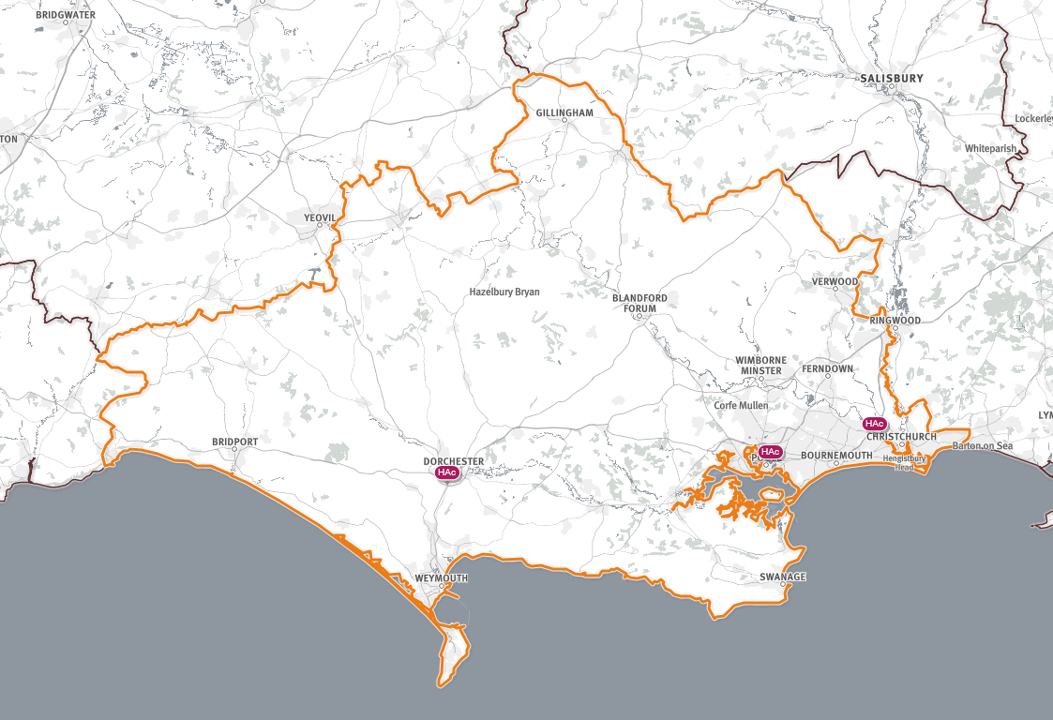

Hampshire and Isle of Wight

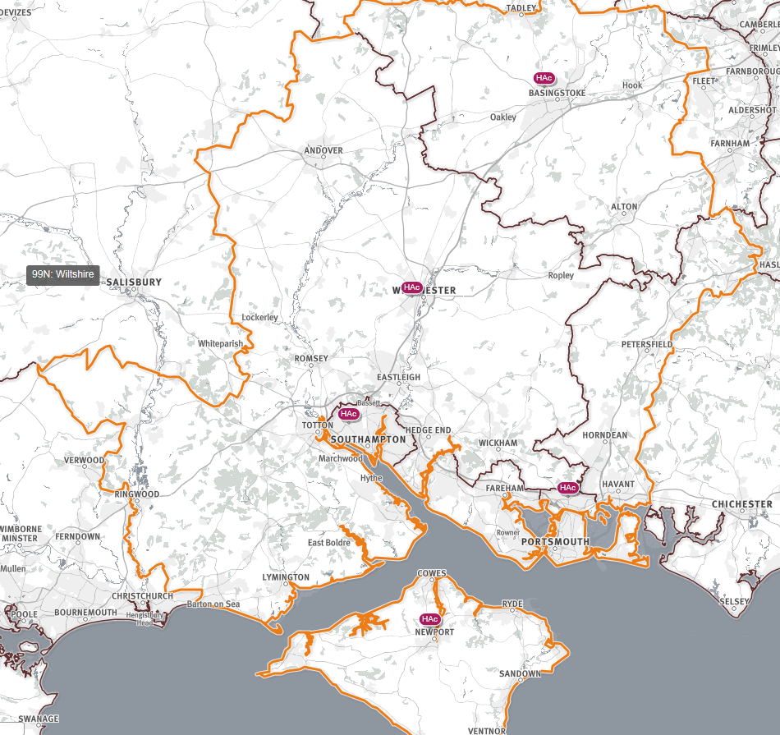

Thames Valley

Buckinghamshire, Oxfordshire and Berkshire East (BOB) STP area

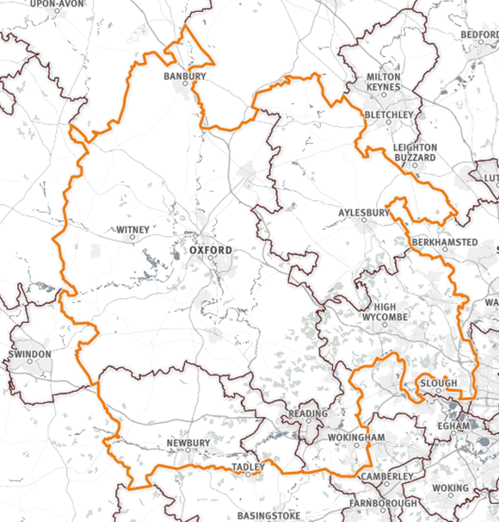

Berkshire East (part of Frimley STP area)

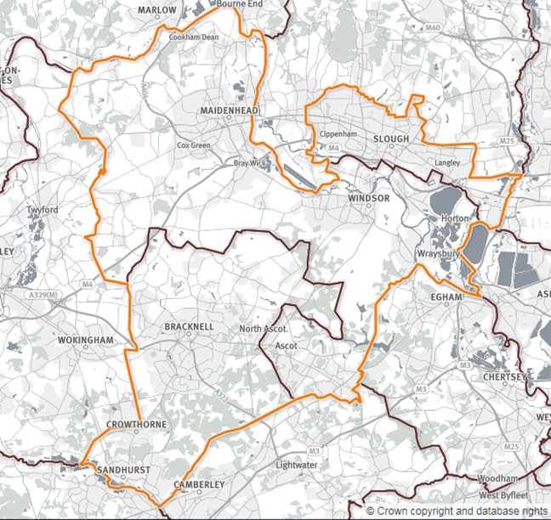
The area of Wessex covers 9 CCGs and total population of 2,742,482 – a list is given below along with population information and an indication of the number of contractors in each area:
 |  |  |  |  |  |  | BH23 2JX | General acute hospital
Population Number of Dental practices  Southampton City CCG 254,275 23  Portsmouth CCG 214,832 26  South Eastern Hampshire CCG 212,282 29  Fareham and Gosport CCG 200,786 29  West Hampshire CCG 588,297 55  North Hampshire CCG 221,875 26  North East Hampshire and Farnham CCG (excluding 5 GP practices in Farnham) * 210,545 17  Isle of Wight CCG 137,798 18  Dorset CCG 771,884 112  Total 2,812,574 435  Figures Taken from SHAPE Tool and are based on ONS estimated population from mid-2016. |  |  |  |  |  |  | DT1 2JY | General acute hospital
The area of Thames Valley covers 10 CCGs (8 local authorities) and total population of 2,096,262 (mid 2016 estimate) – a list is given below along with population information and an indication of the number of contractors in each area:  Population Number of Dental practices  Buckinghamshire 528,164 75  Oxfordshire 677,861 90  Bracknell Forest 119,031 16  Windsor and Maidenhead 147,622 31  Slough 145,653 17  West Berkshire 155,089 20  Reading 161,669 20  Wokingham 160,395 14  Acute Hospitals  Within the Wessex area all referrals to the Acute Hospitals must be made using this DERS system. Referrals for patients from Wessex may be made to Acute Hospital Trusts outside of the Wessex area. These will ideally be made using this DERS system but this depends on what system these Hospitals use. |  |  |  |  |  |  | BH15 2JB | General acute hospital
 |  |  |  |  |  |  | BH7 7DW | General acute hospital

Within the Thames Valley area all referrals to the Acute Hospitals must be made using this DERS system. Referrals for patients from Thames Valley may be made to Acute Hospital Trusts outside of the Thames Valley area. These will ideally be made using this DERS system but this depends on what system these Hospitals use.

  - Oral Surgery
Oral Surgery Services are provided by Secondary Care Providers (Acute Hospital Trusts) and by Primary Care Providers (Intermediate Oral Surgery Services providers). All 7 Acute Hospital Trusts within Wessex provide Secondary Care Oral Surgery Services as well as at other Acute Hospital Trusts outside of Wessex. There are also currently 9 Intermediate Oral Surgery Services providers in a primary care setting across Wessex. Referrals will be made to all of these providers for Oral Surgery. Estimates of the number of referrals are provided in section 16.
In the Thames Oral Surgery Services are provided by Secondary Care Providers (Acute Hospital Trusts) and by Primary Care Providers (‘Minor’ Oral Surgery Services providers). All 4 Acute Hospital Trusts within the Thames Valley provide Secondary Care Oral Surgery Services as well as at other Acute Hospital Trusts outside of the Thames Valley. There are also currently 6 ‘Minor’ Oral Surgery Services providers in a primary care setting across the Thames Valley. Referrals will be made to all of these providers for Oral Surgery. Estimates of the number of referrals are provided in section 16
  - Oral Medicine
Oral Medicine services are provided by Acute Hospital Trusts – the referrals to Oral Medicine will continue to be sent directly to Acute Hospital Trusts so will not be part of this service. This is currently under review.
  - Orthodontics
In Wessex Orthodontic Services are provided by Secondary Care Providers (Acute Hospital Trusts) and by Primary Care Providers (Primary Care Orthodontic providers). 7 Secondary Care Providers (Acute Hospital Trusts) across Wessex provide Secondary Care Orthodontics as well as at other Acute Hospital Trusts outside of Wessex. . There are also 38 primary care orthodontic providers across Wessex. Estimates of the number of referrals are provided in section 16.
In the Thames Valley, Orthodontic Services are provided by Secondary Care Providers (Acute Hospital Trusts) and by Primary Care Providers (Primary Orthodontic providers). 4 Secondary Care Providers (Acute Hospital Trusts) across the Thames Valley provide Secondary Care Orthodontics as well as at other Acute Hospital Trusts outside of the Thames Valley. There are also 25 primary care orthodontic providers across Wessex. Estimates of the number of referrals are provided in section 16.
  - Restorative

In Wessex, Restorative services are provided by Poole Hospital NHS Foundation Trust and Portsmouth Hospitals NHS Trust with a limited amount of Intermediate treatment provided via an IFR route. These services are currently being reviewed.

In the Thames Valley, Secondary Care Restorative services are provided by the Oxford University Hospitals NHS Foundation Trust with a small service also provided by Buckinghamshire Healthcare. The hospital services focus on treatment of cancer, cleft lip and palate and hypodontia patients. There is also a primary (intermediate) care pathway for more complex Endodontic, Periodontal and Prosthodontic referrals. There are currently 7 providers of these services under the Thames Valley. The Restorative pathway is currently under review with the aim of introducing new arrangements in 2019.

  - Other Specialties

There are a number of other Dental Specialties provided by Secondary Care and Primary Care Providers. Referral numbers are provided in Section 16.

- Outcomes
Patient outcomes and user experiences will be improved in the following ways:
  - NHS Outcomes Framework Domains and Indicators
- Domain 4 - Ensuring people have a positive experience of care
  - Locally Defined Outcomes
- Single point of entry into the local healthcare system for NHS orthodontic and oral surgery referrals and restorative (Thames Valley only), to specialist and secondary care or other agreed dispositions within the geography.
- Ensuring Patients are treated in the most clinically appropriate setting.
- Reduced number of referrals resulting in discharge without treatment i.e. those that are not necessary
- Reduced number of incomplete referrals received by receiving Providers
- Reduced Referral to Treatment times for patients accessing services due to more efficient use of available appointments.
- Complete and accurate data capture for commissioning intelligence
- Activity and outcomes information to support service evaluation and needs assessment
- Workforce intelligence for education and training planning
- Facility to support identification and diversion of activity to support undergraduate and postgraduate teaching and training provision
- Improved level of patient confidence and approval, based on the anonymous patient surveys mentioned in Annex A, levels of satisfaction agreed with the Service and identified through the ability for a patient to leave a survey response at the point of log in to track the referral.
- Increase the collection of Friends and Family returns and PROMS/PREMS through the DERS system
- System Aims and Objectives
NHS England – South (W&TV) requires a DERS that can manage all orthodontic, restorative (Thames Valley only) and oral surgery referrals for NHS dental services for patients across the Wessex and Thames Valley region (which includes Dorset, Hampshire, Isle of Wight, Oxfordshire, Buckinghamshire and Berkshire). The aim of this system is to improve the quality and appropriateness of referrals and help streamline the referral process using an electronic referral system.
4.1 The overall aims of the System

The overall aims of the system are to:

- Provide clinicians with a single efficient mechanism to refer patients that require NHS specialist led dental services that cannot be provided by the patients primary care or specialist dentist
- Ensure the efficient and effective use of specialist services in support of primary dental care provision

- Improve the quality of referrals in order to support effective triage, including the transfer of imaging or investigations relevant to clinical treatment
- Ensure the transfer of imaging or investigations relevant to clinical treatment
- Enable patients to access care that is most suited to their needs
- Provide accurate referral information to support clinical service evaluation and future service development
- Achieve long term improved value for money
- Limit potential areas that may compromise the patient journey and safety
  - Ensure patients can track their referral, taking into account any special requirements for communication.

4.2 Key Objectives

The key objectives are to:
- Reduce the number of inappropriate referrals currently resulting in assessment costs with no further treatment
- Reduce the number of referrals by increasing management in primary care through reassurance, advice or action by the patient’s primary care or specialist dentist
- Improve the quality of referrals so speed up the referral process
- Divert clinically appropriate referrals from acute care into primary care based services and in so doing reduce demand on hospital services and reduce waiting times
- Improve long term dental referral patterns through identifying and addressing areas of educational need and facilitating a feedback loop
- Improve data retrieval to inform reconciliation with activity data and development of patient care pathways
- Improve levels of patient confidence and satisfaction with the referral process

- System Description

The System shall consist of the provision and operation of an electronic system which will provide screening and triage of referrals for patients requiring dental services from within NHS England – South (W&TV).

The Services shall include the following elements to support the processing of referrals:

- Provision of a System to allow processing of dental referrals using bespoke referral templates with the facility to allow appeal against allocation and reactivation of referrals where necessary, ensuring that referral templates are mapped to the respective agreed referral guidelines so that a patient cannot access specialist care unless the referral is made within this guidance.
- Screening (administrative triage): Electronically administered criteria will be used to ensure completeness, comprehensiveness and accuracy of referral
- Triage: all referrals are assessed against local referral guidelines to determine the most appropriate service(s) suitable for the patient based on the information supplied on the referral form by the referring dentist or clinician.
- Patient choice: facilitation of choice by providing information (such as waiting times) to support discussion and guidance between patients and the referring dentist on their preferred choice of provider from those identified from the local Directory of Services (DOS) during the referral process, including appropriate options for “opt outs”
- Patient information and discharge: capability of administering discharge summaries to referrers is essential (utilising the most up to date messaging standards)
- A Reporting Function to provide NHS England – South (W&TV) with information on referral activity and support governance at a local and regional level.
- Support communication between primary, intermediate and secondary care providers.
Additional requirements identified as required by the Supplier are as follows:

- Facility for an incorrectly directed referral to be either forwarded to the correct provider or returned through DERS to the dentist for onward referral.
- The referring dentist should be able to see where the patient has been referred for treatment and should be able to track the referral and any changes that may occur.
- Referral Form - Most fields within the referral form must be mandatory e.g. name, DOB, address and contact details, reason for referral (including IOTN and SCAN for orthopaedic referrals), medical history/medication, referrers name and contact details (without this the referral will not be accepted), other fields will not be mandatory.
11. Discharge – E-discharge forms should be returned to referrer for their records, to include good quality x-ray where they have been taken by the provider in an appropriate format.

12. Ensure DERS is available for private practices if they wish to use the referral system for referring private patients to NHS specialist care.

13. Secure access to DERS needs to be available through remote devices, such as tablets.

14. Training for users (primary sector, secondary sector and commissioners) during the implementation period.

15. Training is required for clinicians, administrators and nurses. This is an enormous task and it is essential to the effective mobilisation of DERS to ensure new processes are understood and followed, and thereafter embedded in to business as usual.

As part of the training processes, the Commissioner requires:
- A training plan which sets out how the provider will ensure that the initial and ongoing training can be delivered within the agreed timescales
- Evidence that training has taken place and who has been trained and when
- a log detailing training for each practice which will act as a central source of tracking
- certificate / e-certificate should be provided for each Service User demonstrating that they are comfortable with their learning and ready to proceed to mobilisation
- on line options of remote training sessions / WebEx’s / User guides / helpdesk support etc. to enable full coverage for all users.
All training throughout the duration of the contract including the mobilisation phase and any additional training thereafter for new users to DERS and updates/refreshers for current users, should be included in the fixed contract fee and not incur additional charges.
  - System Availability
The System used by the Supplier shall be capable of taking receipt of referrals at all times apart from scheduled downtime. Scheduled downtime should be kept to a minimum. This capability must only be taken offline for scheduled maintenance with the prior agreement of NHS England and only at times when usage/access is likely to be low. The Supplier will be responsible for notifying service users when the system will not be available including the estimated down time and notification when the system is reinstated. The Supplier should organise the systems to meet the requirements set out in the Key Performance Indicators.
The Supplier shall offer a support function that is accessible to service users on all Business Days between 08:00 until 18:00 by phone and email (see also section 5.2) A helpline should be available during these hours for referrers, patients or providers to call for assistance.

It is essential that a Business Continuity Plan is in place ensuring disaster and recovery plans, which is in accordance with the NHS England Business Continuity Management Framework (Service Resilience) and the principles of PAS 2015 and ISO 22301)
  - Accessibility and Acceptability
The System shall accept referrals from all NHS England – South (W&TV) NHS dentists, and private dentists. This will include dentists located outside of the NHS England – South (W&TV) area referring to services within the W&TV area.

The System will take referrals from primary care dentists. If other referrers need to use this system this will be reviewed and costs agreed.

The System should have the capability such as the Patient Portal, for patients and referrers to track the status of their referral online and records will always be kept for a period in accordance of current legislation.

The System will provide facilities for patients and professionals to make contact by telephone, email and/or web-based contact form, and respond within 2 working days to those enquiries. The telephone number to be used by patients and or professionals must start with the digits 01, 02, 03 or 0800 or 0808.

Upon the Supplier being notified by NHS England of a new source or recipient of referrals, the Supplier shall ensure the Provider or Practice receives guidance and training to allow them to access the System within one week of notification.
  - Population covered

All referrals made to the appropriate providers within the W&TV area will be made via this system. Therefore all referrers that refer patients to these providers must have access and training to use this system. This will include NHS dentists within W&TV as well as some outside the area, and private dentists.

Dentists within W&TV who refer to Providers outside the W&TV area will ideally be able to use this system but it depends on the referral system at other Providers (so they may need to make some referrals by paper that are going outside the W&TV area)

  - Acceptance and Exclusion Criteria
The System shall reject any referrals that are not made in accordance with agreed referral pathways and protocols using an agreed standardised format for all urgent and routine referrals. The referral will not be accepted if mandatory information is not provided.

The System will not accept referrals for:
- Non Elective Care
- Where malignancy is suspected (Two Week Wait Referrals)
- Patients who are being referred for non-NHS care.
Two Week Wait Referrals or Non-Elective Care referrals (including urgent cancer referrals) will not be handled by the DERS but a failsafe system must be in place to fast track any such referrals that are misdirected to the system.

The pathways and protocols will be developed with local clinicians identified by NHS England – South (W&TV) which may include the Local Dental Network, Managed Clinical Networks and other clinical groups and advisors.

The System must adapt to accommodate changes in dental care pathways and include flexibility to modify and update pathways, protocols and referral forms when required by NHS England.

  - Discharge Criteria
The Patient will be considered to be discharged from the DERS when the point of treatment has been completed.
In the event that the patient is returned to the DERS, for example where the Provider determines that the patient’s treatment is outside their service specification, the System will re-open the episode of care using the same unique reference number (URN – probably the 10 digit NHS number and an episode number), and manage the referral accordingly.
  - Interdependencies with other Services / Providers
The System shall be provided in a manner that facilitates the efficient and effective delivery of NHS Dental services including without limitation, co-operation and effective liaison with all relevant providers across the continuum of the pathway from referrer to referral destination.

The Supplier shall ensure that a local DOS is developed that includes all relevant local dental services and ensure that this is kept up to date. Any changes notified by Providers will be actioned within 5 Business Days.

There will be a requirement to attend meetings and/or provide briefings to groups and stakeholder which will include but not be limited to:

- Local Dental Professional Network (LDN)
- Local Dental Committees (LDCs)
- Managed Clinical Networks (MCNs)
- Local GPs or Pharmacies as appropriate as additional specialties are added in the future
This System will need to link with other DERS systems in adjoining NHS England Offices.
- Operational Model
The operation of the System shall include management of screening and triage for all orthodontic and oral surgery referrals submitted, and other specialties as agreed with NHS England as the Systems are developed.
  - Overview

The System shall receive and manage referrals directly from local Referrers. Any referrals that are not submitted electronically on the agreed templates shall be returned to the Referrer except as explicitly agreed with NHS England.. For these agreed exceptions the Supplier will convert referrals to a form that can allow them to be processed and triaged. One exception may be referrals originating external to NHS England – South (W&TV) area who refer infrequently.

The System shall only accept referrals made using the templates agreed with NHS England. These templates will capture all necessary information to support the appropriate review of the referral, including (but not limited to):

- Patient demographics (including phone and email contact details)
- Reason for referral
- Type of treatment required including tooth level information
- Relevant medical history
- Relevant social history
- Treatment regimens previously carried out
- Available test and investigation results (including X rays)
- Patient preference for appointment booking times
- Information relating to orthodontic transfer patients
- NHS number to be used when known but not mandatory

Two Week Wait Referrals (suspected cancer diagnosis) or Non Elective Care referrals are excluded but a failsafe protocol agreed with NHS England must be in place to safely manage any inappropriately directed referrals. The Supplier must contact the referring practice or Provider by telephone within 1 Business Day of receipt to ensure a correct referral is being processed and confirm in addition by digital/postal return.
The System shall generate a URN for each new referral and NHS number, where available.
The Supplier shall make available a function for radiographs and diagnostic images to be uploaded to a referral on or after initial submission, where indicated by the referral pathway and agreed protocol. The system needs to allow images to be presented in an agreed useful format that ensures the receiving clinician is able to review and evaluate them as part of the diagnostic process without the need for unnecessary duplication.
A clear system needs to be identified for radiographs.

  - Screening

- System functionality will be used to manage the administrative screening and ensure that all required referral details and supporting information, including any attachments, are included on the referral and, where necessary, will electronically return the referral to the Referrer so that any missing information can be supplied.
- The System will generate a receipt to the referrer for all referrals received by the System.
  - Clinical Triage
The System will manage the triage of referrals in line with the agreed local pathways and protocols supplied or agreed by NHS England. These protocols will be developed collaboratively with clinicians through the LDN and MCNs for relevant specialties.
It is anticipated that the following specialties will require Clinical Triage.

Services | Digitised & Passed through | Clinical Triage
Oral surgery
Orthodontics
Restorative
(including mono specialties)
Paediatric
Maxillo-facial surgery incl Oral Medicine
Special Care Dentistry

Over time some specialities that require clinical triage may be able to move to change to Electronic Triage which Commissioners would expect to see reflected in the tariff when this change takes place.

The clinical triage process will ensure the following:
- An assessment of the referral based on clinical information made available by the Referrer at time of referral
- Obtain additional information from the Referrer if required
- The DERS should be able to track the re-direction and this functionality should be integral to the system. It should also make the dentist or other relevant providers aware as part of the process.
- Advise the Referrer if the outcome of the assessment is to suggest further workup of the Patient is required, or treatment can be managed within the Dental Practice. Where the Referrer refuses to accept the referral back the Supplier may refer the decision to NHS England.
- Where the referral is for a procedure or treatment not funded by NHS England, the System will contact and return the referral to the Referrer. The Referrer is responsible for discussing alternative treatment options with the Patient and/or Provider and/or contacting NHS England for advice.
- Where a referral is agreed, the choice preferences of the patient will be taken into account, where indicated, when transmitting to the receiving Provider.
- Where the Supplier carries out a review of a referral and this is undertaken by a clinician, that clinician must, as a minimum:
- have ten-year’s experience in general dental practice or in the Speciality being triaged and working in the United Kingdom within the NHS for a minimum of 5 years
- Maintain at least 10 hours a week clinical practice within a general dental setting or in their Speciality e.g. orthodontics, special needs, oral surgery.

  - Acceptance and Disposal
- The System will use a local DOS or, where agreed, access the NHS Digital DOS in order to correctly determine allocation of referral.
- The referral will be assigned to the appropriate treatment Provider taking into account the Patients preferred location. The allocation to Provider will, in line with the relevant protocol, take into account the current waiting times and capacity of treatment Providers, achievement of specified activity levels, training quotas and other factors set by NHS England.
- Inappropriate or duplicate referrals must be returned to the referring clinician with details for reasons for the rejection within four Business Days or forwarded to the correct provider for action.
- The DERS shall ensure that onward referral to allocated Providers is completed in line with relevant key performance indicators in order to minimise delay and duplication of any stage of the care pathway. This will involve escalating triage or acceptance delays to NHS England and include notification and updates to the Referrer.
- The System will include the functionality to be able to identify and allocate Level 1 activity, as defined in the relevant Dental Commissioning Guide, to selected Providers to support undergraduate and postgraduate training.
  - Advice and Guidance
Where requested by a Provider, the System shall support an Advice and Guidance functionality that will allow backwards and forwards dialogue between clinicians, with the ability to add attachments and other supporting information. It will be possible to convert the advice into a referral and retain the clinical conversation.
  - Integration and Usability
- The Supplier shall ensure that the System is fully accessible (subject to local network speeds) within the primary care setting during patient consultation.
- The Supplier will undertake to provide sufficient software licenses to ensure all current and future Service Users can access and use the System during the life of the contract.
- The core application will ideally be fully integrated, via multiple points of access, with existing appointment-booking and administration systems, along with clinical Electronic Patient Records in hospital and primary care settings. The System will ideally interface with the NHS e-Referral Service to provide a comprehensive end-to-end system. If the system is not fully integrated then Suppliers need to demonstrate how the different systems will interface.
- In most cases, integration will be seamless, allowing users to access functions of the system using software applications with which they are already familiar.
- The System shall ensure that enhanced security processes facilitate easy access to the system and for both Patients and professionals to safely and simply do business with the system (e.g. without the need for smartcard technology).
- Preference will be given to direct ‘system to system’ seamless interfacing (practice system to DERS) however where this is not possible, a web based system, in order to support those professionals or organisations that do not have access to integrated referral or booking systems.
- The System will support the seamless transfer of referral information from practice clinical systems into Provider systems, in a structured referral message format that complies with agreed NHS professional record standards.
- The System will have functionality that will allow Provider clinical systems to send back clinical outcome information (e.g. clinic letters, discharge summaries and diagnostics) using the same electronic route.
- The System shall enable communication to a secure nhs.net email address from the referral system.
- The system will enable the user to identify the current status of the referral and locate its position within the pathway.
- It is expected that the proposed dental electronic referral system should interface and integrate with most dental practice management software including Exact and R4
- The system will be capable of expansion as required
13. The system will allow the import of PDF or image files so any previous correspondence, paper medical history sheets, stored electronically on the practice software can be sent with the DERS referral.
14. The system will allow the export of a DERS referral to a PDF to be stored locally. This can then be imported to the GDS patient record, or it may be by secondary care to enable a traditional paper based clinical consultation. The PDF export needs to include all information contained in the referral.
The System will adhere to all relevant NHS Digital Interoperability standards such as:

- Health and Social Care Integration Domain Message Specification
- HL7 Clinical Document Architecture for clinical correspondence (NHS Digital Interoperability Correspondence)
- Clinical Dashboards – NHS Digital Interoperability Dashboards
- Admission Discharge and Transfer - ITK HL7 V2 Message Specification
- ITK Spine Mini Services
- Document Retrieval Domain Message Specification
- Notifications Domain Message Specification
- SNOMED CT coding should be used when rolled out
- SCCIO129 (DERS supplier)
- SCCIO160 (for acute trusts)
  - Patient Information and Discharge
- Patients will be able to log in to receive referral information and updates. The System will support electronic communication to patients.
- Modern technology will enable the use of mobile phone apps, e-mails, text reminders etc., to support different ways of communicating referral related information to Patients and system alerts to professional users.
- The System will have the functionality to support dissemination and collation of electronic patient experience surveys such as specialty specific Dental PROMs and PREMs on behalf of service providers. The Supplier shall be responsible for processing the questionnaire and responses as well as selecting a random sample of patients. The Supplier shall agree the surveys to be undertaken and the target samples with NHS England.

- Response Time and Prioritisation
The System shall ensure that there is minimal delay in the patient journey so that referrals to treatment targets are not adversely affected. The Supplier shall give assurance of this by providing automated monitoring reports to NHS England.

For Incomplete referrals that are rejected:

- 98% of referrals will be processed within two Business Days of receipt and returned to the referring clinician with details for reasons for the rejection
For fully complete referrals accepted by the System that do not require triage:

- 98% of referrals will be processed within One Business Day of receipt and transferred to the correct disposal point. This will include any 2WW referrals that have been inadvertently sent via DERS
For fully complete referrals accepted by the System that do require triage:

- 98% of referrals will be processed within four Business Days of receipt and will be transmitted to the identified disposal point
A full set of Key Performance Indicators for the Supplier can be found in Annex B
- System Monitoring and Quality
- The Supplier shall ensure that appropriate systems are in place for monitoring referrals, managing patient records and for reporting on key performance indicators.
- The Supplier shall undertake regular surveys to ensure that both the referring clinician and the service user’s experience is a positive one. A continual feedback mechanism must be in place to ensure on-going dialogue between the Supplier and referring and receiving dentists regarding referral handling and referral quality.
- Regular reporting will be required on a number of metrics as detailed in Annex A. This data will be collected to:
  - Evaluate the operation of the DERS
  - Monitor Service User and Patient satisfaction
  - Gather information for NHS England on referral data
- A system must be in place to allow regular audit of triage outcomes to ensure that the triage process is sensitive and specific. That is to say that all referrals that need onward transmission are appropriately allocated and that no referrals that are not eligible for onward transmission are transmitted.
- The Supplier shall provide assurance through annual audit that referrals returned to a dental practice are appropriately directed and that a reason for rejection is supplied.
.
- Reporting

- The DERS shall contain a reporting module that provides easy access to referral data, allowing it to be presented in meaningful formats to support different stakeholder groups. Anonymised data should be available via a secure online portal.
- The System will supply a simple reporting user interface that will allow intuitive queries to be run without the need for extensive data analysis skills and can be manipulated within Excel as required at a local level.
- Where requested by NHS England the Supplier will co-operate to facilitate uploads to national reporting systems in order to allow referral information to be combined with other patient outcome/activity data to provide meaningful trend analysis across systems and health communities.
- The System shall supply:
i) Standard reports that allow NHS England to analyse referral outcomes and to compare with activity derived from other sources (e.g. rates for patients who did not book, did not attend or had appointments repeatedly cancelled - either by themselves or by the Provider). This information will be available at different organisation levels such as by Performer, NHS England locality, Dental Practice, CCG or local authority.
ii) Additional reports as required for commissioning, contract management and clinical governance as well as to support the evaluation of local services.
iii) Provide ad hoc reports in an agreed format within 20 Business Days as requested by NHS England.

- Standard reports shall include, but not be limited to the following:
- KPI reports
- Referral volumes by referrer and provider
- Incomplete referrals (including reasons for rejection)
- Inappropriate referrals (including reasons for rejection) i.e. 2 week waits
- Repeated referrals of the same patient by different referrers (to support safeguarding)
- Information provided by the Supplier will be used by NHS England to support the on-going review of clinical practice and best practice guidance to support continued development of clinical pathways in liaison with Providers.
- The ability to link referrals to a clinical category to enable detailed analysis is desirable in order to identify opportunity for increasing knowledge and sharing experience and best practice.
- Electronic Communications/Functionality

- Where requested, the System shall process discharge summaries (including copies of diagnostics) supplied by Providers and will be responsible for ensuring they are sent to the sending Referrer. This should reflect treatment outcomes and include where the treatment was provided, what treatment was provided and if no treatment was provided what was the reason.
- Service Users should be able to use the system to set alerts (e.g. by text or email) to remind them when system events occur (e.g. responses to Advice and Guidance requests or when referrals are rejected or accepted)
- The System will support the use of special flags to allow messaging of additional needs for patients or an ability to raise concerns e.g. issues such as a need for Interpreters or limited mobility or for safeguarding
- Information Governance

- The Services shall be compliant with NHS Digital Guidance and be fully compliant with the requirements set out in the Information Governance Toolkit (IGT) at a minimum of Level 2.
- The Services shall have in place the following policies:
  - Confidentiality Policy compliant with Caldecott requirements
  - Compliance with GDPR 2018.
  - A Records Management Policy
  - IM&T Security Policy
These must be reviewed and updated on a regular basis and made available to all staff.
- The IM&T systems and premises used to service this contract must be suitably protected and governed to ensure that access to Patient Identifiable Data (PID) is strictly limited to staff who need access to it to perform their duties, and housed in appropriate and secure DDA (Disability and Discrimination Act) compliant premises that comply with the requirements set out in the IGT, at a minimum Level 2.
- All staff must undergo annual information governance training and obligations should be reflected in their contracts of employment.
- All decisions relating to all referrals whether by the System, by administrative or clinical staff are fully documented and recorded.
- The Supplier will ensure that an Information Security Management plan is in place in line with Schedule 3 Section 4 of the contract

- Clinical Governance
- The Services shall hold responsibility for the referral on behalf of the referring clinician from receipt of referral until the referral is accepted by the receiving service.
- Clear leadership and robust administrative arrangements must be in place to ensure that Service User referrals are tracked from referral to destination, which may be:
- Referral passed on to appropriate provider
- Referral returned to Referrer for further management
- Referral rejected due to image quality or incomplete information
- Patient no longer requires referral
- A regular quarterly Contract & Performance Meeting will be established between NHS England and the Supplier to oversee quality and performance.
- The commissioner has appointed a Clinical Safety Officer (CSO) who will approve the DERS system and review any future enhancements that may be required. Approval must be authorised through this role prior to any changes being implemented.
- The system provider must appoint a Clinical Safety Officer (CSO) who will approve the DERS system and review any future enhancements that may be required. Approval must be authorised through this role prior to any changes being implemented.

- Complaints, Incidents and Concerns
- The Supplier shall deal with complaints about the service in line with its complaints procedure and will remain responsible for investigation and management of any complaints, incidents or concerns and for acknowledging all compliments.
- The Supplier shall be responsible for tracking complaints, incidents, compliments and concerns and will notify NHS England of all complaints and incidents about the service through the regular quarterly report.
- The Supplier must notify and deal with all serious incidents related to the service in line with NHS England incident policy and co-operate fully in all investigations.
- An escalation process will be agreed and associated resolution timings outlined, to ensure close management of any raised issues or concerns through the contracted deliverables.

- Record Keeping and Confidentiality

- The Supplier shall maintain an electronic log of all patients referred to the service together with records of actions taken and any patient feedback.
- The Supplier shall maintain appropriate records to ensure effective ongoing service delivery and audit.
- The Supplier shall ensure that the service is operated within NHS England confidentiality policies.
- All records shall be confidential. Where relevant information needs to be shared with other healthcare professionals, data shall be transferred in accordance with General Data Protection Regulation (GDPR), Information Governance and Caldicott principles.
- Patient documentation shall be kept securely and destroyed in accordance with the NHS England policy for data management and storage.
- All data and records processed or handled by the Services remain the property of NHS England South (W&TV) as set out in clause 16.2.2 of the contract
- At the end of the terms of contract, the DERS Service will securely submit all data held by the Service, in a format which is helpful and easy to import for the next provider of such a service.

- Applicable Service Standards

Applicable local policies and protocols advised during mobilisation or implementation through the Project Board and Local Dental Network (LDN).

- Activity and Pricing

Indicative Referral numbers over the life of the contract.
Wessex

Implementation | Previous Year | Current ytd Apr 17 to  Jan 18 (pro rata to give full year) | Year 1 | Year 2 | Year 3 | Estimated Number of Referrals
 | Apr 16- Mar 17 | Apr 17- Mar 18 | Apr 18 - Mar 19 | Apr 19 - Mar 20 | Apr 20 –Mar 21 | TOTAL
Oral Surgery | 29,875 | 31,610 | 32,559 | 33,535 | 34,542 | 162,121
Orthodontics | 17,627 | 18,514 | 19,070 | 19,642 | 20,231 | 95,084
Restorative | 626 | 547 | 564 | 581 | 598 | 2,916
Community Dental Services (which included Paediatric and Special Care Services) | 4,137 | 5,324 | 5,484 | 5,648 | 5,818 | 26,411
Total Estimated Number of Referrals | 52,265 | 55,995 | 57,677 | 59,406 | 61,189 | 286,532

Thames Valley

Implementation | Average number of referrals per annum 2013-14 to 2017-18 | Year 1 | Year 2 | Year 3 | Estimated Number of Referrals April 2018 to March 2021
 |  | Apr 18 - Mar 19 | Apr 19 - Mar 20 | Apr 20 –Mar 21 | TOTAL
Oral Surgery | 25,574 | 26,341 | 27,131 | 27,945 | 81,417
Orthodontics | 14,151 | 14,575 | 15,013 | 15,463 | 45,051
Restorative | 4,400 | 4,532 | 4,668 | 4,808 | 14,008
Community Dental Services (which included Paediatric and Special Care Services) | 7,781 | 8,014 | 8,255 | 8,503 | 24,772
Total Estimated Number of Referrals | 51,906 | 53,462 | 55,067 | 56,719 | 165,248

Referral figures have been provided for 2016-17 and 2017-18. An estimated increase of 3% growth per year has been applied for future years.
There is no guarantee that the activity will remain at these levels in the future. They may increase or decrease accordingly, these are for illustrative purposes only and the Commissioners will not be held to them. The bidder must ensure they can meet the actual activity demands.
For info regarding Orthodontic Referral:- Population projections for the Wessex (Hampshire, Isle of Wight and Dorset) and Thames Valley (Buckinghamshire, Oxfordshire and Berkshire) 12 year-old population (according to ONS statistics) is as follows. These figures are based on the cohorts coming through the population and do not include changes due to migration and other factors:

Wessex Thames Valley
2018 is 29966 26,996
2022 is 32106 29,790
2027 is 29939 28,856
Orthodontic need is calculated taking one third of the population of 12 year-olds. This is because not all children will require treatment or if treatment is required, they may decide not to have treatment or to have private treatment. We are aware of new, large housing developments being created in pockets across Wessex which could influence the above population figures.

Basis of Contract | * | See Document 4 – Form of Contract (NHS Supply of Services)
Maximum Value of Contract | * | See ITT Document 1 Section 1.4
Cost per referral | * | See Financial Model Template Document 8

- Implementation
The Services shall be implemented in a staged approach. The following are provisional arrangements and may be subject to change – an Implementation Plan will be submitted as part of the tender evaluation and subsequently agreed with NHS England South (W&TV) prior to Contract Award. This agreed implementation plan will then be included within Schedule 5 of the contract. This will include a set of deadlines for achievement of key milestones. Below are some suggested Stages for the Implementation Plan but feel free to use a different format.

Stage 1: Sign up and training for all referral practices (including NHS and Private) and Specialist and Acute providers in the NHS England – South (W&TV) area (including high volume Providers outside of W&TV). The training will be provided as outlined in section 5.

Stage 2: The collation and partial validation of existing waiting lists for primary and secondary care orthodontic providers

Stage 3: Phased implementation of referral management across the first set of specialties and all geographical areas including but not limited to:
- Setting up Directory of Services
- Conducting an IT audit of dental practices and services
- Collating and loading pathway information and referral forms
- Setting up premises and IT systems
- Recruiting staff
- Establishing IT links with receiving services
- Communication with Providers
- Liaison with Providers to establish required patient flows for training
- Liaison with local clinicians including Consultants and Dentists including development of diagnostic imaging processes.

Stage 4: Full functionality for first set of specialities (Oral Surgery, and Orthodontics) to be achieved by end December 2018

Stage 5: To be confirmed on extension of contract – addition of extra specialties by negotiation.

The contracted Services shall operate for 2 Years from the implementation date (plus the implementation period). There will then be a further three optional extension periods of six months (so a potential 5 year contract in total plus implementation). Stage 4 will operate initially with the potential to expand to further specialties in Stage 5 subject to mutual agreement.

Requirements for Stage 2
As part of the implementation NHS England – South (W&TV) requires the Supplier to contact all Orthodontic service providers (as notified by NHS England) and collect and collate information on existing waiting lists so that this can be used to guide patient choice of provider when managing new referrals. Templates will be provided to assist in the collection of this information. The Services shall be asked to run basic validation checks to ensure that patients are not represented on more than one waiting list or that Patients who are over 18 years of age are still awaiting treatment and have not previously been treated.
NHS England will require a report by local authority area of the numbers of patients waiting assessment or treatment at each of the Orthodontic Providers and the maximum length of time on the waiting list and the numbers of any duplicates identified as part of the validation.
- Annex A: Reporting Requirements

Reporting Requirement | Data source / Method of Measurement | Purpose | Frequency
Clinical Referrals received (Screening Stage) | Split by referral pathway AND rejected or accepted by month | Contract management | Quarterly
Clinical Referrals rejected (screening stage) | Split by reason for rejection by provider | Contract management and Quality monitoring | Quarterly
Triage: Number of referrals reviewed | Split by triage disposition by month | Contract management | Quarterly
% of clinical referrals triaged within 1 and 2 business days of screening. | Split by referral type  by month | Quality monitoring | Quarterly
% of clinical referrals accepted by treatment provider within 2 business days | Split by referral type by provider by month | Quality monitoring | Quarterly
Number of clinical referrals pending triage for more than 2 business days Number of referrals awaiting dentist (sender) further action more than two business days | Exceptions report | Quality monitoring and contract management | Quarterly
Number of 2WW referrals received and forwarded | By Specialty | Quality Monitoring | Quarterly
Service User Experience Questionnaire | Specific to Senders  Specific to Receivers  Specific to Patients | Quality monitoring | Six monthly
Referral rejection rate by referral type | By provider and by performer | Quality monitoring and contract management | Quarterly
Electronic Referral: Proportion of referrals submitted by paper and reason why not electronically | By practice and by geographic location | Quality monitoring and contract management | Quarterly
Complaints, Incidents, Concerns and Compliments relating to DERS: Report to including outcome / status/ response | By referral type, service user (referring practice or receiving provider) and by geography | Quality monitoring | Six monthly
Clinical Audit | The RMS will provide a selection of cases (URN identifiable only) against prescribed commissioner criteria for review by the MCN Chair/ Dental Practice Advisor. | Quality Monitoring | 6 monthly look-back

- Annex B: Key Performance Indicators

Performance Indicator | Indicator | Threshold | Consequence of Breach | Method of Measurement | Frequency of Monitoring
Quality

Service User Experience | A patient experience survey is offered to patients who have direct contact with the DERS with a minimum response rate of 10% | 80% of the response is good or better | Action Plan to rectify | Report incorporated into overall service user experience produced on an annual basis | Six monthly
 | A user experience survey is offered quarterly to all routine users of the service – referrers and receiving clinicians. Minimum response rate of 10% | 80% of the response is good or better. | Action Plan to rectify | Report incorporated into overall service user experience produced on an annual basis | Six monthly
Experience Improvement Plan | Action plans developed to ensure improvements in top 3 areas of concern in patient’s and referrer’s surveys, comments, feedback and complaints. The frequency of measuring improvements and refreshing of the top 3 areas of concern should be conducted every 6 months | Action plans for top 3 areas of concern |  | The frequency of measuring improvements and refreshing of the top 3 areas of concern should be conducted every 6 months | Six monthly
Outcomes | All patient referrals accepted by the Service not requiring triage allocated and sent to appropriate provider within 1 Business Day of receipt of referral from referring clinician | 98% | Forfeit of payment for any referral not requiring triage where process time exceeds 3 Business Days. The total sum withheld under this KPI to be capped to a maximum of 2% of the monthly contract payment in any month.. | Monthly reporting and exception report for any waiting longer than 1 Business Day | Quarterly
 | All patient referrals requiring triage to be processed by no longer than 4 Business Days (as above) | 98% | Forfeit of payment for any referral requiring triage where process time exceeds 6 Business Days. The total sum withheld under this KPI to be capped to a maximum of 2% of the monthly contract payment in any month. | Monthly reporting and exception report for any waiting longer than 4 Business Days | Quarterly
 | All referrals rejected by the Service to be returned to the referring clinician within 2 Business Days with reason for rejection | 98% | Forfeit of payment for any rejected referral where process time exceeds 4 Business Days. The total sum withheld for this KPI to be capped to a maximum of 2% of the monthly contract payment in any month. | Monthly reporting and exception report for any waiting longer than 2 Business Days | Quarterly
Training | All staff will receive mandatory training for information governance | 100% | Dated action plan to achieve compliance where <100% | Report | Annually

- Annex C: Definitions

2WW | An urgent referral pathway for suspected cancer, requiring that patients should wait no more than two weeks to be seen is called a “Two Week Wait” referral
Advice and Guidance | A facility by which referrers can access support from a Provider regarding management of a patient based on an electronic exchange of information without the need for the patient to be seen by the provider
Business Continuity Plan | the Provider’s plan for continuity of all of the Services in adverse circumstances, which is in accordance with the NHS England Business Continuity Management Framework (Service Resilience) and the principles of PAS 2015 and ISO 22301)
Caldicott Guardian | the senior health professional responsible for safeguarding the confidentiality of patient information
Clinical Safety Officer (CSO) | The role of the CSO requires in-depth knowledge of the two clinical safety standards as mentioned in the Service Specification DCB0129 and DCB0160. The safety elements should be considered a shared responsibility between the commissioner and the system provider. Responsibilities cover the procurement, deployment and life of the solution.
Directory of Services | A directory of information that describes the services that organisations offer, provides a window through which providers can display their services and enables referring clinicians to search for appropriate services to which they can refer Patients
General Dental Practitioner (GDP) | A general dental practitioner registered on the Performers List held by the NHS England
General Medical Practitioner (GP) | A general medical practitioner registered on the Performers List held by the NHS England
Dental Practice/Dental Surgery | A premises acting as a location for provision of NHS Dental Services under the Regulations
IOSS | Intermediate Oral Surgery Services
Local Dental Network (LDN) | Dental Local Professional Network.
MCN | Managed Clinical Networks. Linked groups of health professionals and organisations from primary, secondary and tertiary care, working in a co-ordinated manner, unconstrained by existing professional and Health Board boundaries, to ensure equitable provision of high quality clinically effective service.
Non Elective Care | Care which is unplanned and which may include:  (ii) Emergency Care; and  (iii) Unscheduled Care, whether or not it is also Emergency Care
Patient/Patients | A person/persons receiving NHS Dental Services
PREMs | Patient Reported Experience Measures is a rolling programme of experience gathering which reports regularly to demonstrate experience trends and can be used to inform service development and improvement. This is usually completed through questionnaires.
PROMs | Patient Reported Outcome Measures are a quality of life measure, by measuring the quality of life before and after a treatment or intervention, then again a fixed amount of time after. This gives insight into the impact of a treatment or intervention to a patient’s life
Provider | Any NHS Provider of Dental Services including Primary Care, Community Care and Secondary Care
Referrer | (i) the authorised Healthcare Professional who is responsible for the referral of a Patient to the Provider;  (ii) any organisation, legal person or other entity which is permitted or appropriately authorised in accordance with the Law to refer the Patient for assessment and/or treatment by the Provider;
Referral to Treatment Time (RTT) | In England, under the NHS Constitution, patients ‘have the right to access certain services commissioned by NHS bodies within maximum waiting times, or for the NHS to take all reasonable steps to offer a range of suitable alternative providers if this is not possible’. The NHS Constitution sets out that patients should wait no longer than 18 weeks from GP/Dentistreferral to treatment.
Service User | Any Provider making use of the Dental Electronic Referral Management System
System | The Electronic Referral Management system through which referrals are received and allocated to Providers
Two Week Wait Referrals | Patients have the right to be seen by a cancer specialist within a maximum of two weeks from GP and Dentist referral for urgent referrals where cancer is suspected.

Document status
Document Status
Document Author | Sally Gifford
Customer | NHS England Wessex
Date Issued
Approved by | (sign) (date)

Version Control
Version | Date | Reviewer | Comment
0.1 | 12/3/18 | Sally Gifford | Initial draft
0.2 | 15/3/18 | Sally Gifford | Added Acutes, demographic/population data
0.3 | 19/3/18 | Sally Gifford | WebEx - edits agreed
0.4 | 26/03/18 | Tracy Blake | Updated for Wessex
0.5 | 1/05/18 | Sally Gifford | Comments TB/SG removed(other than referral data)
0.6 | 2/05/18 | Sally Gifford | Wessex referral data amended
0.7 | 3/05/18 | Sally Gifford | Reviewed & edited following Project Board meeting on 2/05/18
0.8 | 23/05/18 | Sally Gifford | Edited with requested changes
0.9 | 23/05/18 | Sally Gifford | Amendments to Index and GDP / Dentist
1.0 | 18/06/18 | Sally Gifford | Updates to referral data
1.1 | 19/06/18 | Sally Gifford | KPI/Reporting amendments
1.2 | 28/06/18 | Sally Gifford | KPI/Reporting amendments
1.3 | 12/07/18 | Sally Gifford | Updates including Thames Valley, VES, Evaluation Criteria, updated demographic maps
1.4 | 17/07/18 | Sally Gifford | Changes following meeting with NHS England (13/07/18)
1.5 | 23/07/18 | Sally Gifford | Changes from TV, Dentist table & Evaluation Criteria.
1.6 | 23/08/18 | Sally Gifford | Inclusion of TV maps and role of CSO

https://www.gov.uk/government/publications/the-nhs-constitution-for-england
https://www.gov.uk/government/publications/nhs-mandate-2017-to-2018
https://www.gov.uk/government/publications/the-nhs-provider-licence
https://www.gov.uk/government/publications/liberating-the-nhs-white-paper
https://www.england.nhs.uk/five-year-forward-view/
https://www.england.nhs.uk/wp-content/uploads/2013/04/ppf-1314-1516.pdf
https://www.england.nhs.uk/commissioning/primary-care.../dental/dental-specialities

