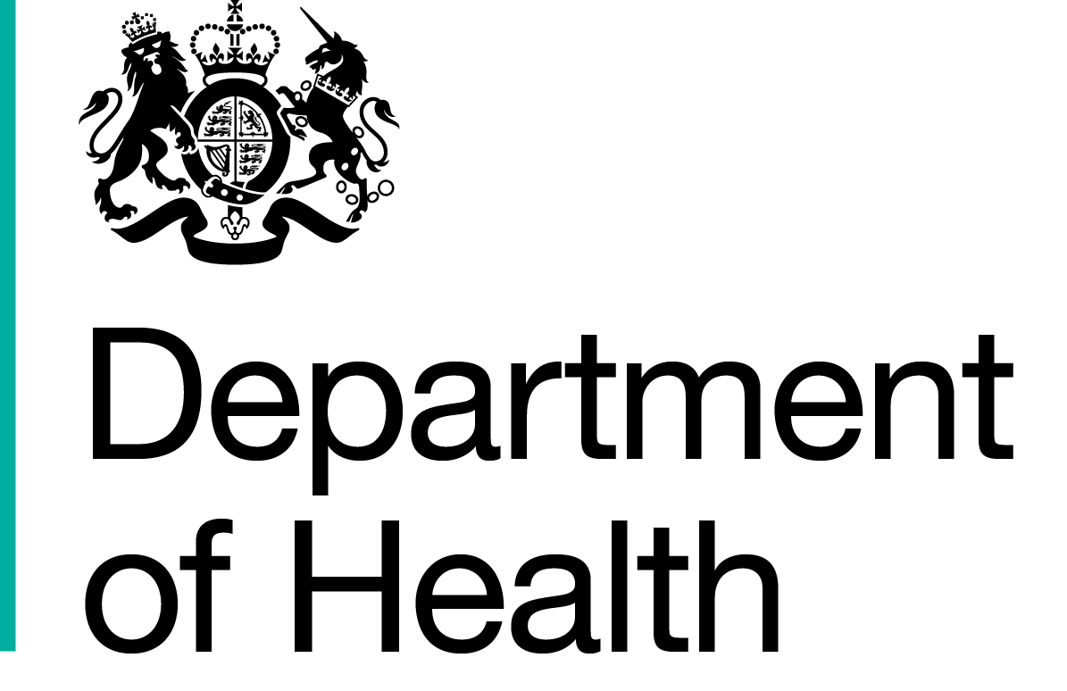
Commercial Medicines Unit (CMU)
Medicines, Pharmacy & Industry
2nd Floor
Rutland House
Runcorn
WA7 2ES

www.dh.gov.uk
All messages regarding the
Offer documentation should be sent via the Bravosolution Website

29 May 2016

Dear Supplier

Invitation to offer for NHS National Framework for Generic Pharmaceuticals - Sevoflurane and Vaporisers
Offer reference number: CM/PHG/14/5455
Period of framework agreement: 32 months with the possibility of an extension of up to a further 16 months
Potential periods of call-offs under the framework agreement: 1 August 2016 to 31 March 2019

The Secretary of State for Health acting as part of the Crown through the Commercial Medicines Unit (‘Authority’) invites offers for the above mentioned goods and/or services as defined in Document No.08 Specimen framework agreement. Offers shall be made subject to the terms of:

Document No.01 This covering letter
Document No.02 Terms of offer
Document No.03a NHS conditions of contract for the purchase of goods (supplementary) May 2015
Document No.03b Agreement for the Supply of on-loan Vaporisers January 2006
Document No.04 NHS supplementary conditions of contract for the purchase of pharmaceuticals October 2012
Document No.05a Contract technical specification
Document No.05b Supplementary Specification
Document No.06 Offer Schedule Document – Worksheets 6a to 6h
Document No.07 Form of offer
Document No.08 Specimen framework agreement (excluding mini competitions)
Document No.09a Quality control technical sheet
Document No.09b Guidance for performing a pharmaceutical quality assessment of licensed medicines for the NHS
Document No.10 Pharmacy Participating Authorities list
Document No.11 Commercially sensitive information schedule
Document No.12 Local award criteria

all of which constitute this Invitation to offer.

If any of the documents constituting the Invitation to offer is missing please contact the undersigned immediately via the Bravosolution messaging portal.

The Authority does not bind itself to accept the lowest offer or any offer at all and reserves the right to accept an offer either in whole or in part, each item being for this purpose treated as offered separately. The Authority reserves the right to conclude a framework agreement for the supply of the goods and/or services with more than one Offeror.

I would like to draw your attention to the following important points when completing and submitting your offer:

1. All offers must be written in English.

2. All offers must be submitted subject to and in accordance with the documentation comprising the Invitation to offer. Save where the Offerors are instructed to provide information, the documentation comprising the Invitation to offer must not be amended in any way.

3. All offers must be loaded onto the Commercial Medicines Unit’s eTendering portal https://cmu.bravosolution.co.uk/web/login.shtml

4. Offers must be open for 90 days.

5. Offers must be fully completed and available on the designated website no later than 1300 on Friday 3 June 2016.

I must also draw your attention to the enclosed Form of offer where all the requirements for completing and submitting an offer can be found. Failure to comply with these instructions may result in your offer being rejected.

I hope that the above instructions are clear but please contact the undersigned via the Bravosolution messaging portal if there is anything you wish to clarify.

Yours faithfully

Marie Thompson

Marie Thompson
Procurement Specialist

