
Concession Tender Pack and Application Form

West View Concession Huts, Esplanade, Seaford, BN25 1JP

Date opportunity posted | 2nd February 2026
Last date for queries | 11:59pm 22nd February 2026
Application return date | 11:59pm 4th March 2026
Application returned to | tenders@seafordtowncouncil.gov.uk
With the subject line | Application – West View Concession Huts
Contact in case of queries | projectsandfacilities@seafordtowncouncil.gov.uk

Introduction:
The Town Council invites applications for this opportunity in accordance with the terms and requirements of this tender pack.
Contents:
This concession tender pack sets out:
Section | Pages | Content
1 | 2 | Introduction to Seaford and Seaford Town Council
2 | 2 to 5 | Information about the concession opportunity, tendering process and timetable
3 | 5 to 6 | Evaluation process and criteria
4 | 6 to 7 | Application outcome, awarding of contract and concerns / complaints
5 | 7 | Terms and conditions
6 | 7 to 11 | Application form and declaration
7 | 12 | Checklist for submitting the form
Appendix 1 | 13 to 16 | Evaluation criteria and scoring guide

Section 1 – Introduction to Seaford & Seaford Town Council
Seaford Town
Seaford has a population of around 27,000 and a further 67,000 people reside within the Lewes District. Seaford is well known for its position on the South Downs with tranquil coastal paths and views. As a town by the sea, it boasts a world class golf course, free promenade parking, easy access to the single beach, local town, shops and eateries. Seaford is a favoured alternative for visitors seeking an uncomplicated seaside and coastal countryside destination.
Seaford Town Council’s Concessions Mission Statement
‘To create a diverse commercial offering for the residents and visitors of Seaford. Providing local sustainably operated businesses the chance to launch and explore viability in affordable, accessible, and influential town spaces.’
To help meet its mission, concession applications are assessed not just on price but also quality of offering, with a 50/50 split of score between the two criteria.
Concessions in Seaford
The Town Council offers a number of concession opportunities across the town, as well as considering and issuing consents for street trading.
Details of the current concessionaires the Town Council works with are available on the Town Council’s website.

Section 2 – Concession Information, Tendering Process and Timetable
Introduction
Join Seaford’s growing seafront concession community for a summer season in 2026. The West View Concession Huts are a great opportunity for fledgling and small local businesses to reach a wider audience and make a name for themselves.
Perfectly situated along the centre of the busy promenade, these huts welcome a wide variety of visitors including locals, tourists, beach-users, ramblers, families, anglers and sport enthusiasts. The huts are nearby Frankie’s Beach Café, which offers refreshments and outdoor seating.
With four huts available, these spaces are a commercial pop up in situ from April until September to create an offering during the peak busy summer period. The dimensions of the concession huts are 8ft deep, 12ft wide, 5ft double doors.
This is a non-refreshment concession opportunity; no tender applications will be considered for West View Concession Huts that include food and drink within its offering.

Concession Particulars
Electricity | No
Water | No
Parking | Yes | Free* parking along Seaford Seafront.  *This is subject to change and not a guarantee of the concession
Toilet Facilities | Yes | West View Concession Hut Toilet for concessions only
Licence Period | 6 months | 1st April to 30th September 2026
Core Trading Times | Weekends & Bank Holidays | Must be open every weekend and bank holidays. Weekdays optional. Opening minimum 5 hours per-day, between 8am-9pm.
Minimum Bid Price Expected | Yes | £1,000 (£200 per month)
VAT Applicable | No
TUPE Applicable | No
Location & Footprint
What3words: ///timing.bubble.observers
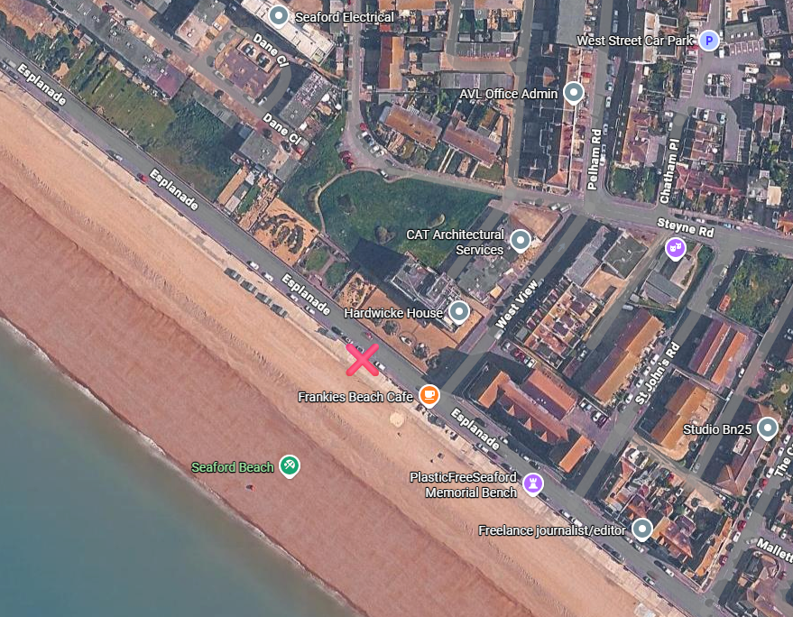
Pictures of West View Concession Huts below:
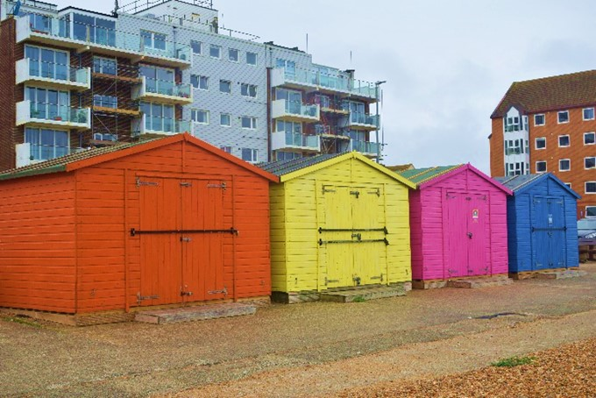

Tendering Process & Timetable
Tender documents available | 2nd February 2026
All tender documents are available from this date on the Town Council’s website, and the Contracts Finder and Find a Tender online platforms..
Deadline for asking questions | 11:59pm 22nd February 2026
Questions should be submitted in writing by email to projectsandfacilities@seafordtowncouncil.gov.uk
All questions asked by potential bidders and the answers provided will be shared here: https://www.seafordtowncouncil.gov.uk/contracts-and-tenders/
Please note that the Town Council must remain neutral in the process and can only advise on the details provided within this document and are not able to support potential bidders with their applications.
Deadline for returning applications | 11:59pm 4th March 2026
The completed application form and all supporting documents must be submitted by this deadline.
Submissions:
By email to tenders@seafordtowncouncil.gov.uk using ‘West View Concession Hut - Application’ in the Subject line
Postal / paper submissions will not be accepted
Awarding of contract | W/c 16th March 2026
All bidders will be advised of the outcome of their application in writing on this date, to the email address provided on the application form.
Bidders will be notified of the outcome, criteria scored against, their individual score and score (and name) of the winning bidder, and for unsuccessful bidders, qualitative feedback.
Contract start | 1st April 2026

Section 3 – Evaluation Process & Criteria
Applications will be evaluated by a Town Council evaluation panel consisting of officers and councillors who have not been involved in the earlier stages of the tendering process and overseen by a process moderator.
The evaluation will be a balance of quality and price (i.e. income to the Town Council) to determine best value and selection of an applicant who, based on their submission, will provide a balance of the most income for the Town Council and highest quality offer.
Panel members will individually score each application against the set criteria and then meet to agree a final score and select the preferred bidder. If required during this period, the process moderator may reach out to bidders with any clarification questions where panel members feel this is required in order to understand and score the application.
Appendix 1 to this form sets out:
- The evaluation criteria
- A scoring guide
- An example of how the scoring formula is applied
Bidders are strongly recommended to read through this information in full and then to have this open whilst you complete the application questions. This will help you to ensure that your application evidences how you meet the criteria as best you can and takes into account the guidelines as to what the Town Council is going to be scoring against i.e. what a good answer looks like.
Bids that vary from the terms and conditions set out within this pack can be considered but not with contract length – this is non-negotiable. If you are looking to include variations (such as with core opening times or concession footprint, for example) please include two quotes within your bid – one according to the specification within this pack and one taking into account any variations. This is important to ensure that all bidders can be scored fairly.
Submission of an application or offer does not constitute any commitment by the Town Council to grant a licence, lease or concession.
The Town Council reserves the right to accept or reject any or all submissions in whole or in part, to decline to make any award, and to discontinue the process at any stage, without incurring any liability to applicants.

Section 4 – Application Outcome, Awarding of Contract & Concerns/Complaints
As per the above timetable, all bidders will be advised of the outcome of their application in writing and will be informed of the criteria scored against, their individual score and score (and name) of the winning bidder, and for unsuccessful bidders, qualitative feedback.
Town Council officers will work with the successful bidder/s to finalise and execute the concession licence ahead of the contract start date. A press release will then be issued confirming the details of the successful bidder/s.
The Town Council is committed to providing qualitative feedback to bidders to enable an understanding of the outcome and where improvements could be made in future bids.
Unsuccessful bidders will not however have a right to appeal the outcome of a concessions tender process internally at the Town Council and there is no standstill period before the awarding of a concessions contract.
Concerns or complaints:
Concerns relating to any procurement process or outcome (including concession tendering) can be submitted and discussed with the process moderator, who will have maintained oversight of the entire process and is responsible for ensuring the process is compliant with Town Council policy and legislative requirements.
Those looking to escalate this to a formal complaint may do so in accordance with the Town Council’s Complaints Policy (available on the Town Council’s website).
Whilst the Town Council would rather deal directly with any complaints or concerns, from February 2026 complaints relating to any procurement process or outcome (including concession tendering) can also be reported externally to the Cabinet Office’s Procurement Review Unit using the Procurement Complaint Services.

Section 5 – Terms and Conditions
Appendix 2 sets out the example Licence to Occupy being tendered for. It is imperative that bidders read through these fully before applying.
Bidders are also advised to consider seeking legal or professional advice before entering into such an agreement. This would be at the bidders own discretion and cost – the Town Council will not reimburse legal fees.

Section 6 – Application Form
Key Points:
- Set out below are the application questions for bidders to complete in full
- Please refer to the evaluation criteria and scoring guide at Appendix 1 whilst completing the application form to understand how each section will be scored
- Please ensure that you are including the relevant documents with your submission (the checklist at section 7 below should assist with this)
- If you are unsure about any aspects of this application form, please reach out to the Town Council with your queries by email to projectsandfacilities@seafordtowncouncil.gov.uk

Application for the Right to Occupy under Licence
West View Concession Huts

Name of Applicant:
Position In Company:
Company Name:
Company Status:
e.g. Sole Trader, Limited Company
Include VAT registration number and Companies House number, if applicable
Telephone:
Email:
Website:

Price: SCORE 50
This is the section where we ask that you confirm your bid price i.e. the amount that you are offering to pay the Town Council for the concession site per year.
PLEASE NOTE:
- The minimum price expected for this concession site is £1,000 over the whole term of the contract. Bid offers below this value will be rejected. If there is only one bidder, the Town Council reserves the right to apply an exception and disapply the minimum bid value if there is justification for this.
- The bid must be for the concession as advertised and cannot be conditional i.e. subject to the Town Council agreeing to changes, additions etc
- The Town Council reserves the right to negotiate any provided figures following successful selection across the concessions matrix to ensure commercial viability of this site
- By submitting this form, you are making the following declaration:
I/we the undersigned hereby agree to pay the under mentioned sum(s) for a licence to occupy the site as described above and in the location shown on the plan.

Quality: TOTAL SCORE 50
This is the section where we ask that you to provide full details of what you plan to bring to the concession and community with your offering.
PLEASE NOTE:
- The quality score is made up of the following components:
  - Business proposal (score 45)
  - Other site ownership (score 5)
  - Previous agreements with the Town Council (score deduction to be confirmed depending on any previous breaches, maximum of 8 point deduction)
- All submissions should be in English

- Business Proposal: SCORE 45
Please provide a copy of your written business plan tailored for this concession site.
This document will be used by the evaluation panel to identify the quality score of your application.
We will be scoring your business plan against the criteria set out below.
To aid the evaluation panel with scoring, you may wish to think about clear headings that allow you to ensure you are covering the criteria below within your plan.
1a | Summary of the core offer and how this benefits the local community | SCORE 10
1b | Your aspirations for the concession over the contract term and the added value this will bring in terms of community benefit | SCORE 5
1c | The trading hours to be provided | SCORE 5
1d | Your financial forecast for the concession | SCORE 5
1e | Relevant experience and qualifications of you and your staff | SCORE 5
1f | Confirmation of your business’s Equal Opportunities Policy and Health & Safety Policy and how these will apply to the concession * | SCORE 5
1g | Confirmation of your business’s Sustainability Policy and how this will be enacted at the concession * | SCORE 5
1h | Your business’s use and support of local suppliers | SCORE 5
* Please note: copies of these policy documents should be included with your application but we will still require your business plan to explain how these policies will be applied at this concession (not having the relevant policies included with your application will result in a 0 score for that specific criteria)

- Other Site Ownership: SCORE 5
Please give details of any other sites or businesses you have within 25 miles and explain how you will be able to operate all of them without any detriment.

- Previous Agreements with the Town Council: SCORE DEDUCTION FOR PREVIOUS BREACHES UP TO 8 POINTS
If you have held a contract or licence with Seaford Town Council in the last six (6) years, the Town Council will assess any breaches that were recorded in this period. If so, points will be deducted from your quality score as follows:
3 point deduction if any minor breaches occurred
5 point deduction if any major breaches occurred
i.e. a maximum of an 8 point deduction may be made

- References: NO SCORE
Whilst this is not scored, the Town Council must undertake due diligence when entering into contracts with third parties.
Please provide two written professional references supporting your suitability to this concession. Ideally, these will be written on a company letterhead and from organisations that you have carried out services similar in nature to the concession type being applied for. Where a new business is applying, previous employment references will be accepted.
Please confirm the referees’ details below for completeness.
 | Reference 1 | Reference 2
Reference Type | Professional / Employment | Professional / Employment
Referee Name
Referee Contact Details (phone & email)
Capacity Known to You
For Professional References:
Contract Title
Start Date and Length of Contract
Type of Service Being Delivered
Contract Value over the Whole Term | £ | £
For Employment References:
Employer Name
Employment Dates
Position Held
Reason for Leaving

Declaration
I/we declare that:
- the information contained in the application form is true and correct
- I/we have not deliberately withheld any relevant information that could affect the Town Council’s decision to enter into a concession licence with me/us
I/we understand that:
- any false or misleading information or omissions, may disqualify my/our application or may render my/our licence, if awarded, liable to termination
- the Town Council is not bound to accept the highest, or any, offer
- prospective applicants are prohibited from contacting councillors or staff to encourage or support their application outside of the prescribed process. If found to have occurred, this may disqualify my/our application or may render my/our licence, if awarded, liable to termination
- all applications must be signed and dated by a company director or the named sole trader or partnership.
Name/s:
Position in organisation:
Company name:
Email address:
Date:
Signed:
Submitting this completed application form electronically signifies your acceptance of ALL of the above declaration.

Section 7 – Submission Checklist
Before submitting the form, please check that you have carried out all of the necessary steps, and included all of the necessary supporting documents, as per the table below:
Action | Done
Reviewed the tender pack in full, including the evaluation criteria and scoring guide (Appendix 1) and example concession licence (Appendix 2)
(At own discretion and cost) sought legal or professional advice on the proposed concessions licence
All questions completed within the application form and declaration signed
Fee Offer Submission (price) completed and checked for accuracy
Additional documents included as follows:
Business Plan (application question 1)
A copy of your Equal Opportunities Policy (application question 1f)
A copy of your Health & Safety Policy (application question 1f)
A copy of your Sustainability Policy (application question 1g)
Two written references (application question 4)
Conflict of Interest Declaration (found here)

Submissions: By email to tenders@seafordtowncouncil.gov.uk using West View Concession Huts - Application’ in the Subject line

Deadline for returning submissions: 11:59pm 4th March 2026

APPENDIX 1 –
Evaluation Criteria and Scoring Guide

Scoring will be applied as follows:
 | Score | How Assessed
Price Score Available | [50] | A formula is applied to the price offered to identify the score
Quality Score Available | [50] | Each application question is evaluated against set criteria and assigned a score
Total Score Available | 100 | Combined total of quality and price scores

Price Score
In order to apply a consistent score to the prices within the applications, a formula is applied as follows:
TOTAL AVAILABLE SCORE x PRICE OFFERED ÷ HIGHEST PRICE

Quality Score
Scoring will be applied by the Town Council’s evaluation panel with reference to the tables below:
Evaluation Criteria | Application Questions | Score Weighting
Business Proposal  With the following criteria to be met within the provided written business plan: | Q1 | [45]
Summary of the core offer and how this benefits the local community |  | 10
Your aspirations for the concession over the contract term and the added value this will bring in terms of community benefit |  | 5
The trading hours to be provided |  | 5
Your financial forecast for the concession |  | 5
Relevant experience and qualifications of you and your staff |  | 5
Confirmation of your business’s Equal Opportunities Policy and Health & Safety Policy and how these will apply to the concession * |  | 5
Confirmation of your business’s Sustainability Policy and how this will be enacted at the concession * |  | 5
Your business’s use and support of local suppliers |  | 5
Site Ownership / Trading - assessing the business commitments of the bidder, where any conflicts or risks may lie or any economies of scale | Q2 | 5
Previous Contracts – assessing the performance of bidders that have previously held agreements with the Town Council within the last six years, assigning a deduction from the bidders score for any previous breaches (5 for a major breach, 3 for a minor breach = total of 8 points can be deducted) | Q3 | To be confirmed

* Please note: copies of these policy documents should be included with your application but we will still require your business plan to explain how these policies will be applied at this concession (not having the relevant policies included with your application will result in a 0 score for that specific criteria)

Quality Scoring Guide:
Scores are assessed in line with the following definitions.
Where a score of 10 is achievable, the scores below are doubled i.e. excellent is a 10, good an 8, acceptable a 6 and so on.
Assessment | Score | Quality Scoring Guide
Excellent | 5 | Exceptional demonstration of the relevant ability, understanding, experience, skills, resources and quality measures required to provide the supplies/services. Response identifies factors that will offer potential added value, with evidence to support the response.
Good | 4 | Satisfies the requirement with some additional benefits. Above average demonstration of the relevant ability, understanding, experience, skills, resource and quality measures required to provide the supplies/services. Response identifies factors that will offer potential added value, with evidence to support the response.
Acceptable | 3 | Satisfies the requirement. Demonstration of the relevant ability, understanding, experience, skills, resources and quality measures required to provide the supplies/services, with evidence to support the response.
Minor Reservations | 2 | Satisfies the requirement with some minor reservations of the relevant ability, understanding, experience, skills, resource and quality measures required to provide the supplies/services, with little or no evidence to support the response.
Serious Reservations | 1 | Satisfies the requirement with major reservations of the relevant ability, understanding, experience, skills, resources and quality measures required to provide the supplies/services, with little or no evidence to support the response.
Unacceptable | 0 | Does not meet the requirement and/or insufficient information provided to demonstrate that there is the ability, understanding, experience, skills, resource and quality measures required to provide the supplies/services, with little or no evidence to support the response.

Example Scoring

PRICE | TOTAL Price (over XX Years) | Calculation (50) | Score
Applicant 1 | £12,000 | =50*12000/15000 | 40
Applicant 2 | £15,000 | =50*15000/15000 | 50
Applicant 3 | £11,000 | =50*11000/15000 | 37
QUALITY |  | Calculation (50) | Score
Applicant 1 |  | Sum of all scores | 45
Applicant 2 |  | Sum of all scores | 25
Applicant 3 |  | Sum of all scores | 40

Applicant | Calculation (100) | Score
Applicant 1 *awarded contract* | Price + Quality | 85
Applicant 2 | Price + Quality | 75
Applicant 3 | Price + Quality | 77

Minimum Score Thresholds
Minimum bid value:
- A minimum bid value of £1,000 for the whole contract term has been applied to this contract opportunity
- Any bids below this value will be automatically rejected
- If there is only one bidder, the Town Council reserves the right to apply an exception and disapply the minimum bid value if there is justification for this
Minimum quality score:
- There are no minimum score thresholds with this concession tender.
- Submission of an application or offer does not constitute any commitment by the Town Council to grant a licence, lease or concession.
- The Town Council reserves the right to accept or reject any or all submissions in whole or in part, to decline to make any award, and to discontinue the process at any stage, without incurring any liability to applicants.

