**Buckfast Play Area**

**Cradle swings and chain to be replaced, swing frame to be painted.**

**Wetpour under swing to be replaced.**

**Flat seats and chains to be replaced, swing frame to be painted**

**Wetpour under swing to be replaced.**

**Slide frame to be painted.**

**Multiplay to remain.**

**Spring car to remain.**

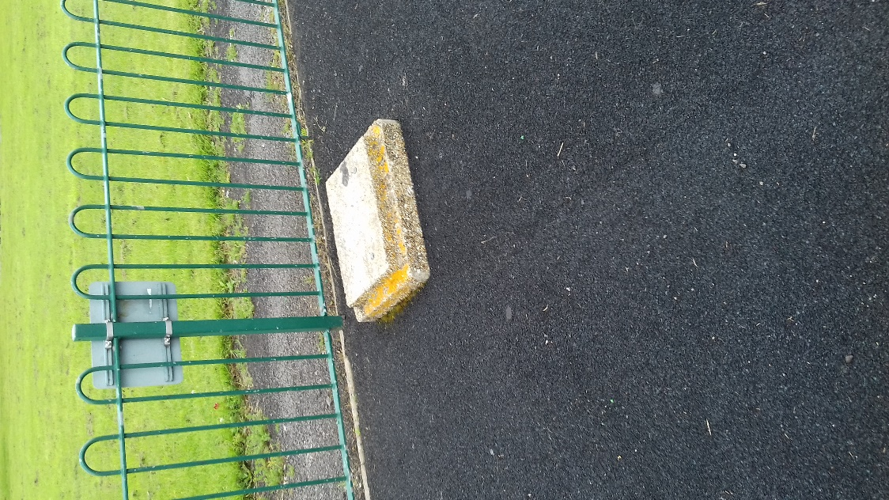

**Bin base to be removed and new bin installed.**