Request for Quotation

Design and build of a toolkit and supporting content. Environment Agency; Integrated water management approaches.

13 November 2023

Request for Quotation
Design and build of a toolkit and supporting content. Environment Agency; Integrated water management approaches.
You are invited to submit a quotation for the requirement described in the specification, Section 2.
Please confirm by email, receipt of these documents and whether you intend to submit a quote or not.
Your response should be returned to the following email address by:
Email: ceri.lewis@environment-agency.gov.uk and daniel.curtis@environment-agency.gov.uk
Date: 08/12/2023
Time: 17.00
Ensure you include the name of the quotation and ‘Final Submission’ in the subject field to make it clear that it is your response.

Contact Details and Timetable
Ceri Lewis will be your contact for any questions linked to the content of the quote or the process. Please submit any clarification questions via email and note that, unless commercially sensitive, both the question and the response will be circulated to all tenderers.

Action | Date
Date of issue of RFQ | 13/11/2023 at 10.00
Deadline for clarifications questions | 01/12/2023 at 10.00
Deadline for receipt of Quotation | 08/12/2023 at 17.00
Intended date of Contract Award | 29/12/2023
Intended Contract Start Date | 15/01/2024
Contract Duration | 15/01/2024 to 31/03/2025

Section 1: General Information
Glossary
Unless the context otherwise requires, the following words and expressions used within this Request for Quotation shall have the following meanings (to be interpreted in the singular or plural as the context requires):

“Authority” | Means the Environment agency who is the Contracting Authority.
“Contract” | means the contract to be entered into by the Authority and the successful supplier.
“Response” | means the information submitted by a supplier in response to the RFQ.
“RFQ” | means this Request for Quotation and all related documents published by the Authority and made available to suppliers.

Conditions applying to the RFQ
You should examine your Response and related documents ensuring it is complete and in accordance with the stated instructions prior to submission.
Your Response must contain sufficient information to enable the Authority to evaluate it fairly and effectively. You should ensure that you have prepared your Response fully and accurately and that prices quoted are arithmetically correct for the units stated.
By submitting a Response, you, the supplier, are deemed to accept the terms and conditions provided in the RFQ. Confirmation of this is required in Annex 2.
Failure to comply with the instructions set out in the RFQ may result in the supplier’s exclusion from this quotation process.
Acceptance of Quotations
By issuing this RFQ the Authority does not bind itself to accept any quotation and reserves the right not to award a contract to any supplier who submits a quotation.
Costs
The Authority will not reimburse you for any costs and expenses which you incur preparing and submitting your quotation, even if the Authority amends or terminates the procurement process.
Self-Declaration and Mandatory Requirements
The RFQ includes a self-declaration response (Annex 1) which covers basic information about the supplier, as well as any grounds for exclusion. If you do not comply with them, your quotation will not be evaluated.
Any mandatory requirements will be set out in Section 2, Specification of Requirements and, if you do not comply with them, your quotation will not be evaluated.
Clarifications
Any request for clarification regarding the RFQ and supporting documentation must be submitted via email no later than the deadline for clarifications set out in the Timetable. The Authority shall be under no obligation to respond to queries raised after the clarification deadline.
The Authority will respond to all reasonable clarifications as soon as possible but cannot guarantee a minimum response time. The Authority will publish all clarifications and its responses to all suppliers via email unless deemed commercially sensitive.
If a supplier believes that a request for clarification is commercially sensitive, it should clearly state this when submitting the clarification request. However, if the Authority considers either that:
● the clarification and response are not commercially sensitive; and
● all suppliers may benefit from its disclosure,

then the Authority will notify the supplier (via email), and the supplier will have an opportunity to withdraw the request for clarification by sending a further message requesting the withdrawal of the clarification request. If not withdrawn by the supplier within 2 working days of the Authority’s notification, the Authority may publish the clarification request and its response to all suppliers and the Authority shall not be liable to the supplier for any consequences of such publication.
The Authority reserves the right to seek clarification of any aspect of a quotation and/or provide additional information during the evaluation phase to carry out a fair evaluation. Where the Authority seeks clarification on any aspect of the quotation, the supplier must respond within the timeframe requested by the Authority.
Amendments
The Authority may amend the RFQ at any time prior to the deadline for receipt. If it amends the RFQ the Authority will notify you via email.
Suppliers may modify their quotation prior to the deadline for Responses. No Responses may be modified after the deadline for Responses.
Suppliers may withdraw their quotations at any time by submitting a notice via the email to the named contact.
Conditions of Contract
The Authority’s standard Goods and Services Terms and Conditions provided as part of the RFQ will be included in any contract awarded as a result of this quotation process. The Authority will not accept any changes to these terms and conditions proposed by a supplier.
Suppliers should note that the quotation provided by the successful bidder will form part of the Contract.
Prices
Prices must be submitted in £ sterling, exclusive of VAT.
Disclosure
All Central Government Departments, their Executive Agencies and Non Departmental Public Bodies are subject to control and reporting within Government. In particular, they report to the Cabinet Office and HM Treasury for all expenditure. Further the Cabinet Office has a cross-Government role delivering overall Government policy on public procurement, including ensuring value for money and related aspects of good procurement practice. For these purposes, the Authority may disclose within Government any details contained in your quotation. The information will not be disclosed outside Government during the procurement.
In addition, the Authority is subject to the Freedom of Information Act 2000 and the Environmental Information Regulations 2004, which provide a public right of access to information held by public bodies. In accordance with these two statutes, the Authority may be required to disclose information contained in your quotation to any person who submits a request for information pursuant to those statutes.
Further to the Government’s transparency agenda, all UK Government organisations must advertise on Contract Finder in accordance with the following publication thresholds:
● Central Contracting Authority’s: £12,000
● Sub Central Contracting Authority’s and NHS Trusts: £30,000
For the purpose of this RFQ the Authority is classified as a Sub Central Contracting Authority with a publication threshold of £30,000 inclusive of VAT.
If this opportunity is advertised via Contracts Finder, we are obliged to publish details of the awarded contract including who has won the contract, the contract value, and indicate whether the winning supplier is a small and medium-sized enterprise (“SMEs”) or voluntary organisation or charity. A copy of the contract must also be published with confidential information redacted.
By submitting a Response, you consent to these terms as part of the procurement.
Disclaimers
Whilst the information in this RFQ and any supporting information referred to herein or provided to you by the Authority have been prepared in good faith the Authority does not warrant that this information is comprehensive or that it has been independently verified.
The Authority does not:
● make any representation or warranty (express or implied) as to the accuracy, reasonableness or completeness of the RFQ;
● accept any liability for the information contained in the RFQ or for the fairness, accuracy or completeness of that information; or
● accept any liability for any loss or damage (other than in respect of fraudulent misrepresentation or any other liability which cannot lawfully be excluded) arising as a result of reliance on such information or any subsequent communication.
Any supplier considering entering into contractual relationships with the Authority following receipt of the RFQ should make its own investigations and independent assessment of the Authority and its requirements for the goods and/or services and should seek its own professional financial and legal advice.
Protection of Personal Data
In order to comply with the General Data Protection Regulations 2018 the supplier must agree to the following:
You must only process any personal data in strict accordance with instructions from the Authority.
● You must ensure that all the personal data that we disclose to you or you collect on our behalf under this agreement are kept confidential.
● You must take reasonable steps to ensure the reliability of employees who have access to personal data.
● Only employees who may be required to assist in meeting the obligations under this agreement may have access to the personal data.
● Any disclosure of personal data must be made in confidence and extend only so far as that which is specifically necessary for the purposes of this agreement.
● You must ensure that there are appropriate security measures in place to safeguard against any unauthorised access or unlawful processing or accidental loss, destruction or damage or disclosure of the personal data.
● On termination of this agreement, for whatever reason, the personal data must be returned to us promptly and safely, together with all copies in your possession or control.
General Data Protection Regulations 2018
For the purposes of the Regulations the Authority is the data processor.
The personal information that we have asked you provide on individuals (data subjects) that will be working for you on this contract will be used in compiling the tender list and in assessing your offer. If you are unsuccessful the information will be held and destroyed within two years of the award of contracts. If you are awarded a contract it will be retained for the duration of the contract and destroyed within seven years of the contract’s expiry.
We may monitor the performance of the individuals during the execution of the contract, and the results of our monitoring, together with the information that you have provided, will be used in determining what work is allocated under the contract, and in any renewal of the contract or in the award of future contracts of a similar nature. The information will not be disclosed to anyone outside the Authority without the consent of the data subject, unless the Authority is required by law to make such disclosures.
Equality, Diversity & Inclusion (EDI)
The Client is striving to create a diverse and inclusive working environment where every individual has equality of opportunity to progress and to apply their unique insights to making the UK a great place for living. The Service Provider is expected to respect this commitment in all dealings with the Environment Agency staff and service users.
Suppliers are expected to;
● support Defra group to achieve its Public Sector Equality Duty as defined by the Equality Act 2010, and to support delivery of Defra group’s Equality & Diversity Strategy.
● meet the standards set out in the Government’s Supplier Code of Conduct
● work with Defra group to ensure equality, diversity and inclusion impacts are addressed (positive and negative) in the goods, services and works we procure, barriers are removed and opportunities realised.
Sustainable Procurement
Addressing global sustainability impacts and realising additional community benefits within commercial activity is core to Defra group’s approach, working with its supply chain is key to achieving sustainable outcomes. In addition to supporting Defra group to meet its outcomes we look to understand and reduce negative sustainability impacts associated with our commercial activity and realise benefits.
The Client encourages its suppliers to share these values, work to address negative impacts and realise opportunities, measure performance and success.
Suppliers are expected to have an understanding of the Sustainable Development Goals, the interconnections between them and the relevance to the Goods, Services and works procured on the Client’s behalf
Conflicts of Interest
The concept of a conflict of interest includes but is not limited to any situation where an Involved Person or Relevant Body has directly or indirectly, a financial, economic or other personal interest which might be perceived to compromise their impartiality and independence in the context of the procurement procedure and/or affect the integrity of the contract award.
We expect suppliers to mitigate appropriately against any real or perceived conflict of interest through their work with government. A supplier with a position of influence gained through a contract should not use that position to unfairly disadvantage any other supplier or reduce the potential for future competition
Where the supplier is aware of any circumstances giving rise to a conflict of interest or has any indication that a conflict of interest exists or may arise you should inform the Authority of this as soon as possible (whether before or after they have submitted a quotation). Tenderers should remain alert to the possibility of conflicts of interest arising at all stages of the procurement and should update the Authority if any new circumstances or information arises, or there are any changes to information already provided to the Authority. Failure to do so, and/or to properly manage any conflicts of interest may result in a quotation being rejected.
Provided that it has been carried out in an open, fair and transparent manner, routine pre-market engagement carried out by the Authority should not represent a conflict of interest for the supplier.

Section 2: The Invitation
Specification of Requirements
Specification
Background to the Environment Agency
Who is the Environment Agency?
We are an Executive Non-departmental Public Body responsible to the Secretary of State for Environment, Food and Rural Affairs. Our principal aims are to protect and improve the environment, and to promote sustainable development.
Further information on our responsibilities, Corporate Plan and how we are structured can be found on our website:
https://www.gov.uk/government/organisations/environment-agency/about

What do we spend our money on?
We are a major procurer of goods and services within the UK, spending circa £600M per annum, our major spend areas are:
Flood and Coastal Risk Management (design, construction, and maintenance)
ICT and Telecommunications
Vehicles and Plant
Environmental Consultancy and Monitoring
Temporary Staff and Contractors
Facilities Management, Energy and Utilities
Flood Management and Water Related Services

What do we need from our suppliers?
Suppliers are vital in supporting the delivery of our corporate plan. We aim to support the economy and society whilst delivering more environmental outcomes for every pound we spend. In many areas we are leading the way on environmental and technical developments. It is our role to ensure that suppliers clearly understand our corporate aims and objectives and know that we are committed to delivering the best value most sustainable solutions, taking into account the whole life cost of our procurement decisions. We promote diversity and equality and treat all of our suppliers fairly.

Our procurement strategy may be of interest to you as a potential supplier. It sets out our priorities and key commitments in a range of areas such as delivering our corporate plan, Government policy, supplier management and sustainable procurement:
https://www.gov.uk/government/organisations/environment-agency/about/procurement#procurement-strategy

Government changes and collaboration
Since 1 April 2013, the Environment Agency is no longer responsible for delivering the environmental priorities of Wales. This is now the remit of Natural Resources Wales (NRW). Further information can be found here:
http://naturalresources.wales/splash?orig=/
By bidding for this requirement, you may also be approached by other members of the Defra network, NRW or other government departments that are specifically named in the tender document.

Further information
For further information and to see our commitments to Diversity and Equality, please visit our website:
https://www.gov.uk/government/organisations/environment-agency/about/procurement
https://www.gov.uk/government/organisations/environment-agency/about/equality-and-diversity
Also, are you up to date on environmental legislation? See links below for further information:
Waste and Environmental Impact - https://www.gov.uk/browse/business/waste-environment
Environmental Regulations -
https://www.gov.uk/browse/business/waste-environment/environmental-regulations

Contract Ref:
Contract Title: Design and build of a toolkit and supporting content. Environment Agency; Integrated water management approaches.

Background to the specific work area relevant to this purchase
The Integrated Water Management Framework (IWMF) programme is hosted by the Environment Agency’s Oxford to Cambridge team on behalf of the wider Defra Group, working closely with stakeholders across the sector and geography. Embedded in strategic placemaking partnerships, this 3-year programme offers the opportunity to shape, test and trial developing mechanisms and policy approaches to help deliver a step-change in the way water, including flood risk, is managed. The programme works with the Oxford to Cambridge Pan Regional Partnership governance framework, geography, and stakeholders, however it is designed and managed in a way that will provide learning and approaches that are applicable more widely.

The IWMF programme will explore how to draw together current and ongoing water, flood, natural capital, and land use planning work, to create a fully interconnected water and flood risk approach to planning and decision making. The end goal is to enable a more proactive, holistic approach to decision making and solution planning for water management infrastructure – focusing on the needs of the natural environment and ultimately avoiding reactive water management solutions that focus primarily on damage limitation.

The programme has delivered its first phase which focuses on evidence, exploration of issues and dependencies, and engagement. This relied on collaborative steering and technical groups that have co-designed outputs and are invested in defining change collectively. It brings together work across water, flood, natural capital, and land use planning to create an integrated water and flood risk evidence base. In its current phase, the programme will support the identification of options at scale which deliver multiple benefits for the environment and people, allowing a more proactive and holistic approach to decision making and solution planning across all water management infrastructure.
This phase has multiple concurrent projects, each one looking to integrate part of the water planning and interventions processes. To effectively use the outputs of these projects and studies to influence future ways of working we need to coherently present the learning, case study examples and recommendations from these projects to an extensive and varied stakeholder group in a user centric way.

Requirement
The Oxford to Cambridge Integrated Water Management Framework (IWMF) end goal is to enable a more proactive, holistic approach to decision making and solution planning for water management infrastructure.
We need to communicate the programme’s outputs coherently and effectively and, in a user, centric way. We have identified the need to create an interactive or self-selection toolkit/framework that can easily, and based on user needs, communicate the learning and guidance from across the whole suite of projects.
The majority of this commission will be design and functionality focused, with the client team providing the content. We would however expect the supplier to provide guidance on the appropriate style of content that could work best with the proposed design elements. The Supplier shall take a lead in providing clear requests of what is needed from the client to enable the supplier to deliver a strong and compelling product.
This commission's aim is to develop a strong, recognisable identity for integrated water management. This is to support the embedding of the approach externally, and to help stakeholders to navigate the tools, guidance and products that surround it.

Target Audience
Our target audience is internal Environment Agency/Defra group staff, external regulators, policy makers, land use and water planners.
The framework should ensure that they can access integrated water management material easily and based on their selections in the toolkit to engage effectively with taking an integrated approach. The toolkit should also support users to interact knowledgeably and effectively with other organisations taking an integrated water management approach.

Benefits
1. Capability and confidence of users in taking an integrated water management approach is raised.
2. Clarity and efficiency of access to integrated water management tools, approaches, guidance, and learning is increased.
3. Ability to share integrated water management learning is increased.
4. The internal and external profile of the development and application of integrated water management is significantly increased. With a focus on the Environment Agency’s work around this.

Objectives
Deliver the above requirements in developing and delivering an engaging, user centric, consistent, simple, and visually pleasing way, to optimise understanding and buy-in.
● Ensure all stakeholders are able to review our project findings to gain a basic understanding of how integrated water management fits in to the environmental planning and delivery cycle through a toolkit. This will be achieved through an effective use of design, graphics, and diagrams
● Route different stakeholders to access our project summaries and findings and to focus in on the material that is most relevant for their role, yet still allow interested stakeholders to see the full picture of our work, how it links into the work of the wider water sector and our ambitions for the water environment.
● Ensure simple access to integrated water management information and guidance through design and delivery of a framework tool to link to current and future integrated water management material
● Ensure users recognise key decisions points in the integrated water management planning cycle where the most effective opportunities for taking an integrated approach are and provide links to material and guidance that will support them doing so.

Products/ Elements
We anticipate the work to create the toolkit to be developed in three parts:
The detail of the three elements or products and timings can be seen in the workflow diagram below

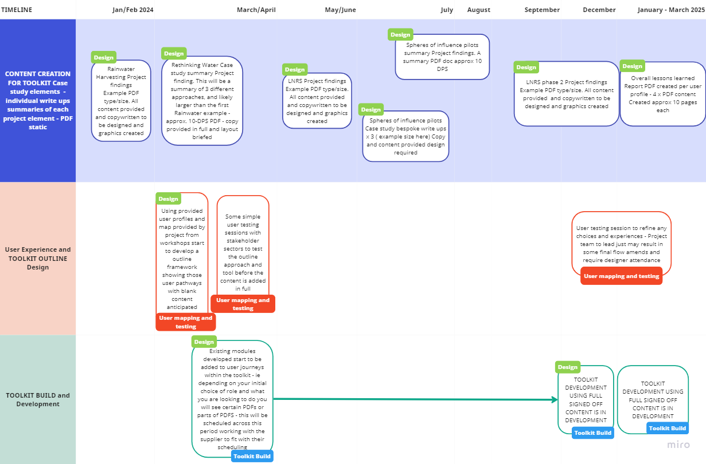

Element 1: Content creation
Development of case study summaries or the base content of the toolkit
We first need to create engaging summaries of the work we have. We have 4 pilot projects in progress, that will each require a summary case study to be developed. Within each of these there are a few case studies which may also warrant individual summaries.
The EA project team will provide all the base content, so the brief is around layout and presentation of that copy with supporting graphics and elements that help to communicate the key points and processes.
An example of the sort of size and detail is given here: Note the summary may need to link to pre-existing and pre hosted full reports through simple embedded links.
There is no hosting requirement within this brief nor any requirement to design full technical reports.
As the product timeline indicates we will have approx. 8-10 summary PDFs needing to be created. All will use the same colour palette and general approach, in order to create a 'package' feel. In terms of icons and graphics, there will be a requirement for individual "setting" of text and images for each PDF.

Element 2 – Toolkit/Framework Design
Develop a simple, visual, and interactive integrated water management toolkit/ framework to link the users with the relevant content and relevant context. A combination of static and interactive elements may help to bring the story to life.
The toolkit will provide a window to the learning and approaches that are applicable more widely than just the Oxford to Cambridge area. We hope that an integrated approach will focus on the needs of the natural environment, ultimately avoiding reactive water management solutions that focus primarily on damage limitation.
It should have an intuitive menu and journey for users. Bringing in messages, examples, stories and resources as appropriate. Functionality and design will allow spotlights on specific work programmes that direct users to alternative materials / web hosted content.
We would like this there to be stakeholder feedback loop built into the design process to refine the design.
We would like you to consider the use of 'user personas' (4-6 of them) to improve the look and feel for a range of different stakeholders and to direct people to relevant content. The Client would provide these personas if this option was deemed to be appropriate and taken forward.
The toolkit must adhere to all our branding and accessibility requirements. See link here.

Element 3 – Build of Toolkit
The final element is to build the toolkit.
The build would be based on the design for element 2 and the content developed through element 1. The client team will also signpost to external guidance and content to be signposted to in the toolkit ensuring wider work is considered.
You will need to plan the build using the most appropriate platform.
We would like you to undertake the build in stages to allow for review and sign off of functionality.

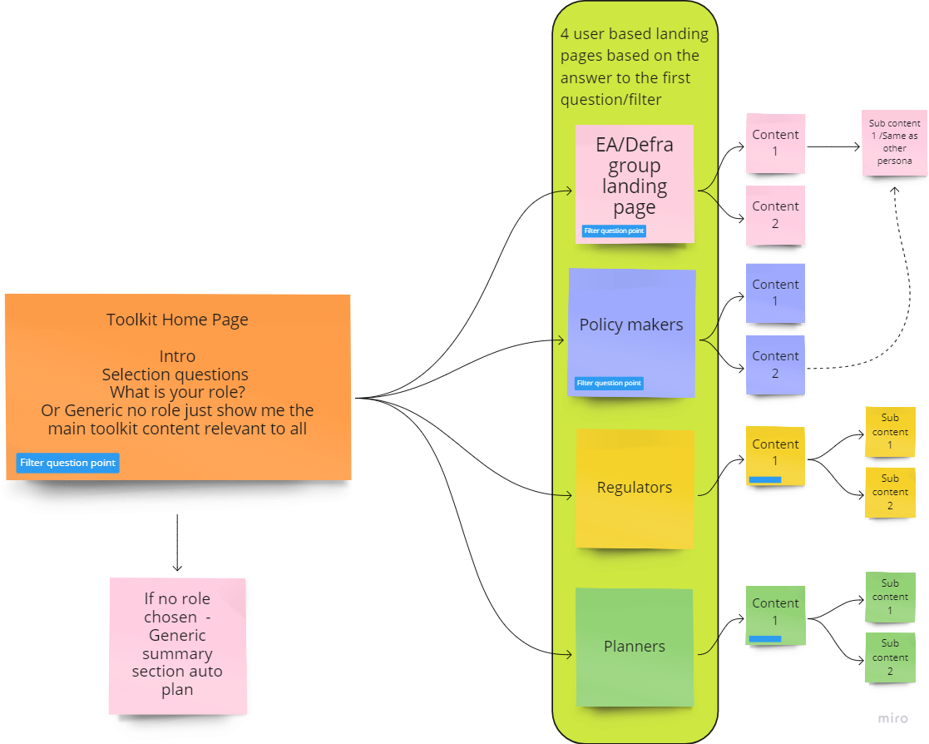

Usability
The end products must be accessible and interactive to the user’s needs.
All products may include signposts to tools hosted on websites external to the EA.
All products should be developed to enable EA to make updates to content and structure in the future and should include methods/guidance to enable this.
Additional information will be supplied following the award of contract.

Sustainability
The Environment Agency protects and improves the environment and is committed to reducing the sustainability impacts of its activities directly and through its supply chains. We expect the Contractor to share this commitment and adopt a sound, proactive sustainable approach in keeping with the 25 year environmental plan/our commitments compliant with all applicable legislation. This includes understanding and reducing direct and indirect sustainability impacts and realising opportunities, including but not restricted to; resilience to climate change, reducing greenhouse gas emissions, water use and quality, biosecurity, resource efficiency and waste, reducing the risk of pollution, biodiversity, modern slavery and equality, diversity & inclusion, negative community impacts.
As a delivery partner, the successful contractor is expected to pursue sustainability in their operations, thereby ensuring the Contracting Authority is not contracting with a supplier whose operational outputs run contrary to the Contracting Authority’s objectives. The successful contractor will need to approach the project with a focus on the entire life cycle of the project

Sustainability Considerations
We are committed to continually improving our sustainability performance. The Environment Agency has set itself tough objectives as a clear commitment and contribution to sustainable development throughout England. The Agency recognises that this can only be achieved through commitment from all sectors of society, and it is intent on raising awareness amongst industry and commerce.

Contractors must adopt a sound proactive environmental approach, designed to minimise harm to the environment.

Environmental criteria should be considered as part of your tender submission with credit given for innovation. Factors to be considered could include areas such as:
1. Paper use: All documents and reports prepared by consultants and contractors are produced wherever possible on recycled paper containing at least 100% post consumer waste and printed double sided.
2. Travel: use of public transport, reduce face to face meetings by using email and videoconferencing. Meetings to be held in locations to minimise travel and close to public transport links.
3. Packaging: should be kept to a minimum. Re-use and disposal issues must be considered.
4. Efficient Energy and Water Use.
5. Disposal of Waste: Whilst on site the contractor is responsible for the disposal of their own waste and can only use client facilities with express permission from the on site facilities officer.
6. Whilst on site, contractors should comply with the local environmental policy statement which will be made available to you in advance or on arrival.

Diversity and Equal Opportunities
We are committed to promoting equality and diversity in all we do and valuing the diversity of our workforce, customers, and communities. As a public body, we publish regular information about what our equality objectives are and how we’re meeting them.
https://www.gov.uk/government/organisations/environment-agency/about/equality-and-diversity

Health and Safety
Contractors will be responsible for making sure all required health and safety aspects including risk assessments are undertaken and required management measures are in place to protect worker exposure. This includes management of all partners, consortium members and subcontractors.

eMission2030 - our sustainability plan
We need to act urgently to tackle our own negative impact on the environment through the carbon produced by our use of raw materials, energy and transport and the impact on those working in the manufacturing processes of what we buy. Our new sustainability plan - eMission2030 – outlines our ambition for the future and use hard evidence to radically change our way of thinking to build sustainability into every decision we make.

We have adopted the United Nations Sustainable Development Goals (also known as The Global Goals) as a framework for eMission2030 – to tackle a broader range of social and economic development issues. But to achieve our commitments we'll need to do things with urgency, together and even more work in partnership with others. This will need to be delivered across the whole organisation to be successful.

We want you to feel empowered to take your own actions and try out innovative ideas to make both big and small changes and challenge unsustainable decisions and actions We'll be asking all parts of our organisation to create their own delivery plans which shows what they will do to achieve our commitments.

Outputs and Contract Management

● January 2024– Start up meeting between project officer/team and supplier.
● Monthly status check ins thereafter along with management of the provided Timeline and the milestones below
● Monthly Budget view of work done and budget remaining/spent

Key milestones are as per the provided timeline graphic:
● End of February 2024 – PDF 1 summary briefed and created
● End of April 24 – PDF 2,3,4 Summaries briefed and created
● End of May 24 - Outline initial user journey toolkit with "dummy" content created and tested with user reps
● User toolkit development starts - using existing content to start population
● End of June 24 -PDF 5 Summary briefed and created.
● End of August 24 PDF 6,7,8,9 Summary briefed and created.
● End of September PDF 10 Summary briefed and created.
● End of January 2025 - User toolkit final user testing and adjustments
● End of February 2025 - Toolkit finalised

This contract shall be project managed on behalf of the Environment Agency by Ceri Lewis, Oxford to Cambridge Programme Manager (ceri.lewis@environment-agency.gov.uk). With Daniel Curtis, Integrated Water Management Delivery Manager as the Project Executive (daniel.curtis@environment-agency.gov.uk).

Monthly project team meetings (virtual or face to face as appropriate) with additional check points should be used to ensure the project is keeping to time and scope. The regularity of these can be adjusted to reflect different periods of the project and needs. Regular conversations and emails between the project manager and contractor are expected throughout the project.

We will expect the supplier to invoice for work periodically (monthly or bi-monthly as appropriate). These invoices will be assessed and paid within a month, with the intention of this turn around being much shorter (1-2 weeks).
All invoices must quote the purchase order number in order to be processed. A file copy invoice must be provided to the contract manager, on request. The timescale for payment of invoices will be up to 30 days after we have received a valid invoice.

Payment
The Authority will raise purchase orders to cover the cost of the services and will issue to the awarded supplier following contract award.
The Authority’s preference is for all invoices to be sent electronically monthly, quoting a valid Purchase Order number
It is anticipated that this contract will be awarded for a period of 15 months to end no later than 31/03/2025. Prices will remain fixed for the duration of the contract award period. We may at our sole discretion extend this contract to include related or further work. Any extension shall be agreed in writing in advance of any work commencing and may be subject to further competition.

Evaluation Methodology
The evaluation is broken down into 2 elements, technical (quality) and commercial (price). A weighting is applied to each element.

Within the overall technical score there are a number of technical criteria, each needing to be individually answered and then scored.
We will award this contract in line with the most economically advantageous tender (MEAT) as set out in the following award criteria:
Technical – 60%
Commercial – 40%

Evaluation criteria
Evaluation weightings are 60% technical and 40% commercial, the winning tenderer will be the highest scoring combined score.
Award Criteria | Weighting (%) | Evaluation Topic & Weighting | Sub-Criteria | Weighted Question
Technical | 60% | Service / Product Proposal | 1. Methodology Creating content material.  (25% of technical score available) | Q1.1 Please can you demonstrate/explain how you would take copy written material and add value through the way you present it and add graphics. Examples of previous work would be beneficial
 |  |  | 2. Methodology  Design and build of Toolkit  (25% of technical score available | Q2.1 Please can you demonstrate/explain one or two ways in which could present the information and content that we have described as a toolkit
 |  |  | 3. Key personnel  (20% of technical score available) | 1 Question  Q4.1 Please tell us about your team and how their skills and experience will support our work. Please include an indication of the expected allocation of work within this section.
 |  |  | 4. Quality Assurance measures and project management  (20% of technical score available) | 2 Questions  Q5.1 Please explain what assurance and control measures you will put in place to ensure good quality outputs.  Q5.2 Please explain how the project and contract will be managed and how you will interact with the client team.
 |  |  | 5. Management of sustainability and social value  (5% of technical score available) | 1 Question  Q6.1 Please consider how through this project you could provide opportunities to social value and how you will consider sustainability
 |  |  | 6. Health & Safety  (5% of technical score available) | 1 Question  Q7.1. How will you manage your teams heath, safety and well being throughout the contract period.
Commercial | 40% | Whole life cost of the proposed Contract | Commercial Model  (100% of commercial score available)

Technical (60%)
Technical evaluations will be based on responses to specific questions covering key criteria which are outlined below. Scores for questions will be based on the following:

Description | Score | Definition
Very good | 100 | Addresses all the Authority’s requirements with all the relevant supporting information set out in the RFQ. There are no weaknesses and therefore the tender response gives the Authority complete confidence that all the requirements will be met to a high standard.
Good | 70 | Addresses all the Authority’s requirements with all the relevant supporting information set out in the RFQ. The response contains minor weaknesses and therefore the tender response gives the Authority confidence that all the requirements will be met to a good standard.
Moderate | 50 | Addresses most of the requirements with most of the relevant supporting information set out in the RFQ. The response contains moderate weaknesses and therefore the tender response gives the Authority confidence that most of the requirements will be met to a suitable standard.
Weak | 20 | Substantially addresses the requirements but not all and provides supporting information that is of limited or no relevance or a methodology containing significant weaknesses and therefore raises concerns for the Authority that the requirements may not all be met.
Unacceptable | 0 | No response or provides a response that gives the Authority no confidence that the requirement will be met.

Technical evaluation is assessed using the evaluation topics and sub-criteria stated in the Evaluation Criteria section above.
Separate submissions for each technical question should be provided and will be evaluated in isolation. Tenderers should provide answers that meet the criteria of each technical question.

Methodology Creating content material. | Detailed Evaluation Criteria
Q1.1 Please can you demonstrate/explain how you would take copy written material and add value through the way you present it and add graphics.  Max 3 sides A4, and use Arial font, size 11. | Your Response should:  Demonstrate your understanding of our needs.  Demonstrate your understanding of designing documents to engage the reader and tell a story.  Clearly show how you would approach the task and your expectations/needs from the client to allow you to deliver  Provide examples of previous work were available.

Methodology Design and build of Toolkit | Detailed Evaluation Criteria
Q2.1 Please can you demonstrate/explain one or two ways in which could present the information and content that we have described as a toolkit.  Max 3 sides A4, and use Arial font, size 11. | Your Response should:  Demonstrate your understanding of our needs.  Demonstrate your understanding of designing a toolkit to engage the reader and tell a story.  Clearly show how you would approach the task to determine the best design.  Provide examples of previous work were available  Demonstrate your understanding of how you will link together the user needs and content

Key personnel | Detailed Evaluation Criteria
Q4.1 Please tell us about your team and how their skills and experience will support our work.  Max 2 sides A4, and use Arial font, size 11. | Your Response should:  Demonstrate the skills and experience of the proposed project team  Provide an indication of the expected allocation of work within this section  Provide an indication of the resource demand forecasted against each of the tasks.

QAand Project Management | Detailed Evaluation Criteria
Q5.1 Please explain what assurance and control measures you will put in place to ensure good quality outputs.  Max half side A4, and use Arial font, size 11 | Your Response should:  Explain the assurance measures that you will put in place to ensure a high-quality project.  Explain how you will undertake quality control of the projects deliverables.
Q5.2 Please explain how the project and contract will be managed and how you will interact with the client team.  Max half side A4, and use Arial font, size 11 | Your Response should:  Demonstrate the project management processes that you will use to ensure smooth running of the project.  Explain how you would interact with the client team to ensure alignment of thought and collaboration.

Management of sustainability and social value | Detailed Evaluation Criteria
Q6.1 Please consider how through this project you could provide opportunities to social value and how you will consider sustainability  Max half side A4, and use Arial font, size 11 | Your Response should:  Demonstrate your organisations social value initiatives and how you will apply them through this project or how this project will help support them aims.  Demonstrate any considerations towards sustainability that you would take on this project

Health & Safety | Detailed Evaluation Criteria
Q4.1 How will you manage your teams health, safety and wellbeing throughout the contract period  Max half side A4, and use Arial font, size 11 | Your Response should:  Demonstrate your organisations HS&W process and how you will apply them on this project.

Commercial (40%)
The Contract is to be awarded as a 'fixed price' which will be paid according to the completion of the deliverables stated in the Specification of Requirements.
Suppliers are required to submit a total cost to provide the deliverables stated in the Specification of Requirements. In addition to this the Commercial Response template must be completed to provide a breakdown of the whole life costs against each 'element' used in the delivery of this requirement.
Calculation Method
The method for calculating the weighted scores is as follows:
● Commercial
Score = (Lowest Quotation Price / Supplier’s Quotation Price) x 40% (Maximum available marks)
● Technical
Score = (Bidder’s Total Technical Score / Highest Technical Score) x 60% (Maximum available marks)
The total score (weighted) (TWS) is then calculated by adding the total weighted commercial score (WC) to the total weighted technical score (WT): WC + WT = TWS.

Information to be returned.
Please note, the following information requested must be provided. Incomplete tender submissions may be discounted.
Please complete and return the following information:
● completed Commercial Response template
● separate response submission for each technical question (in accordance with the response instructions)
● completed Mandatory Requirements (Annex 1)
● completed Acceptance of Terms and Conditions (Annex 2)

Award
Once the evaluation of the Response(s) is complete all suppliers will be notified of the outcome via email.
The successful supplier will be issued the contract, incorporating their Response, for signature. The Authority will then counter sign'

Annex 1 Mandatory Requirements
Part 1 Potential Supplier Information
Please answer the following self-declaration questions in full and include this Annex in your quotation response.
Part 1.1 Potential Supplier Information:
Question no. | Question | Response
1.1(a) | Full name of the potential supplier submitting the information
1.1(b) | Registered office address (if applicable)
1.1(c) | Company registration number (if applicable)
1.1(d) | Charity registration number (if applicable)
1.1(e) | Head office DUNS number (if applicable)
1.1(f) | Registered VAT number
1.1(g) | Are you a Small, Medium or Micro Enterprise (SME)? | (Yes / No)

Note: See EU definition of SME https://ec.europa.eu/growth/smes/business-friendly-environment/sme-definition_en
Part 1.2 Contact details and declaration
By submitting a quotation to this RFQ I declare that to the best of my knowledge the answers submitted and information contained in this document are correct and accurate.
I declare that, upon request and without delay you will provide the certificates or documentary evidence referred to in this document.
I understand that the information will be used in the selection process to assess my organisation’s suitability to be invited to participate further in this procurement.
I understand that the authority may reject this submission in its entirety if there is a failure to answer all the relevant questions fully, or if false/misleading information or content is provided in any section.
I am aware of the consequences of serious misrepresentation.

Question no. | Question | Response
1.2(a) | Contact name
1.2(b) | Name of organisation
1.2(c) | Role in organisation
1.2(d) | Phone number
1.2(e) | E-mail address
1.2(f) | Postal address
1.2(g) | Signature (electronic is acceptable)
1.2(h) | Date

Part 2 Exclusion Grounds
Part 2.1 Grounds for mandatory exclusion
Question no. | Question | Response
2.1(a) | Please indicate if, within the past five years you, your organisation or any other person who has powers of representation, decision or control in the organisation been convicted anywhere in the world of any of the offences within the summary below.
 | Participation in a criminal organisation. | (Yes / No)  If yes please provide details at 2.1 (b)
 | Corruption. | ((Yes / No)  If yes please provide details at 2.1 (b)
 | Fraud. | (Yes / No)  If yes please provide details at 2.1 (b)
 | Terrorist offences or offences linked to terrorist activities | (Yes / No)  If yes please provide details at 2.1 (b)
 | Money laundering or terrorist financing | (Yes / No)  If yes please provide details at 2.1 (b)
 | Child labour and other forms of trafficking in human beings | (Yes / No)  If yes please provide details at 2.1 (b)
2.1(b) | If you have answered yes to question 2.1(a), please provide further details.  Date of conviction, specify which of the grounds listed the conviction was for, and the reasons for conviction.  Identity of who has been convicted  If the relevant documentation is available electronically please provide the web address, issuing authority, precise reference of the documents.
2.1 (c) | If you have answered Yes to any of the points above have measures been taken to demonstrate the reliability of the organisation despite the existence of a relevant ground for exclusion? (i.e. Self-Cleaning) | (Yes / No)
2.1(d) | Has it been established, for your organisation by a judicial or administrative decision having final and binding effect in accordance with the legal provisions of any part of the United Kingdom or the legal provisions of the country in which the organisation is established (if outside the UK), that the organisation is in breach of obligations related to the payment of tax or social security contributions? | (Yes / No)
2.1(e) | If you have answered yes to question 2.3(a), please provide further details. Please also confirm you have paid or have entered into a binding arrangement with a view to paying, the outstanding sum including where applicable any accrued interest and/or fines.

Part 2.2 Grounds for discretionary exclusion
Question no. | Question | Response
2.2(a) | The detailed grounds for discretionary exclusion of an organisation are set out on this webpage, which should be referred to before completing these questions.  Please indicate if, within the past three years, anywhere in the world any of the following situations have applied to you, your organisation or any other person who has powers of representation, decision or control in the organisation
2.2(b) | Breach of environmental obligations? | (Yes / No)  If yes please provide details at 2.2 (f)
2.2(c) | Breach of social obligations? | (Yes / No)  If yes please provide details at 2.2 (f)
2.2(d) | Breach of labour law obligations? | (Yes / No)  If yes please provide details at 2.2 (f)
2.2(e) | Shown significant or persistent deficiencies in the performance of a substantive requirement under a prior public contract, a prior contract with a contracting entity, or a prior concession contract, which led to early termination of that prior contract, damages or other comparable sanctions? | (Yes / No)  If yes please provide details at 2.2 (f)
2.2 (f) | If you have answered Yes to any of the above, explain what measures been taken to demonstrate the reliability of the organisation despite the existence of a relevant ground for exclusion? (Self Cleaning)

Annex 2 Acceptance of Terms and Conditions
I/We accept in full the terms and conditions appended to this Request for Quote document.
Company ____________________________________________________
Signature ____________________________________________________
Print Name ____________________________________________________
Position ____________________________________________________
Date ____________________________________________________

