Request for Quotation

Moss Side Farm

Stuarts Rewetting Works

6th November 2023

Request for Quotation
Moss Side Farm Stuarts Rewetting Works

You are invited to submit a quotation for the requirement described in the specification below.
Please confirm by email, receipt of these documents and whether you intend to submit a quote or not.
Your response should be returned to the following email address by:
Email: Chris Evans christopher.evans@naturalengland.org.uk
Date: 04/12/2023
Time: 12:00
Ensure you include the name of the quotation and ‘Final Submission’ in the subject field to make it clear that it is your response.

Contact Details and Timetable
Chris Evans 07979 873504 will be your contact for any questions linked to the content of the quote or the process. Please submit any clarification questions via email and note that, unless commercially sensitive, both the question and the response will be circulated to all tenderers.
Action | Date
Date of issue of RFQ | 06/11/23 at 12:00
Deadline for clarifications questions | 27/11/23 at 12:00
Deadline for receipt of Quotation | 04/12/23 at 12:00
Intended date of Contract Award | 11/12/23
Intended Contract Start Date | 02/01/24
Intended Delivery Date / Contract Duration | 02/01/24 to 01/03/24

Section 1: General Information
Glossary
Unless the context otherwise requires, the following words and expressions used within this Request for Quotation shall have the following meanings (to be interpreted in the singular or plural as the context requires):
“Authority” | means Natural England who is the Contracting Authority.
“Contract” | means the contract to be entered into by the Authority and the successful supplier.
“Response” | means the information submitted by a supplier in response to the RFQ.
“RFQ” | means this Request for Quotation and all related documents published by the Authority and made available to suppliers.

Conditions applying to the RFQ
You should examine your Response and related documents ensuring it is complete and in accordance with the stated instructions prior to submission.
Your Response must contain sufficient information to enable the Authority to evaluate it fairly and effectively. You should ensure that you have prepared your Response fully and accurately and that prices quoted are arithmetically correct for the units stated.
By submitting a Response, you, the supplier, are deemed to accept the terms and conditions provided in the RFQ. Confirmation of this is required in Annex 2.
Failure to comply with the instructions set out in the RFQ may result in the supplier’s exclusion from this quotation process.

Acceptance of Quotations
By issuing this RFQ the Authority does not bind itself to accept any quotation and reserves the right not to award a contract to any supplier who submits a quotation.

Costs
The Authority will not reimburse you for any costs and expenses which you incur preparing and submitting your quotation, even if the Authority amends or terminates the procurement process.

Self-Declaration and Mandatory Requirements
The RFQ includes a self-declaration response (Annex 1) which covers basic information about the supplier, as well as any grounds for exclusion. If you do not comply with them, your quotation will not be evaluated.
Any mandatory requirements will be set out in Section 2, Specification of Requirements and, if you do not comply with them, your quotation will not be evaluated.

Clarifications
Any request for clarification regarding the RFQ and supporting documentation must be submitted via email no later than the deadline for clarifications set out in the Timetable. The Authority shall be under no obligation to respond to queries raised after the clarification deadline.
The Authority will respond to all reasonable clarifications as soon as possible but cannot guarantee a minimum response time. The Authority will publish all clarifications and its responses to all suppliers via email unless deemed commercially sensitive.
If a supplier believes that a request for clarification is commercially sensitive, it should clearly state this when submitting the clarification request. However, if the Authority considers either that:
- the clarification and response are not commercially sensitive; and
- all suppliers may benefit from its disclosure,

then the Authority will notify the supplier (via email), and the supplier will have an opportunity to withdraw the request for clarification by sending a further message requesting the withdrawal of the clarification request. If not withdrawn by the supplier within 2 working days of the Authority’s notification, the Authority may publish the clarification request and its response to all suppliers and the Authority shall not be liable to the supplier for any consequences of such publication.
The Authority reserves the right to seek clarification of any aspect of a quotation and/or provide additional information during the evaluation phase to carry out a fair evaluation. Where the Authority seeks clarification on any aspect of the quotation, the supplier must respond within the timeframe requested by the Authority.

Amendments
The Authority may amend the RFQ at any time prior to the deadline for receipt. If it amends the RFQ the Authority will notify you via email.
Suppliers may modify their quotation prior to the deadline for Responses. No Responses may be modified after the deadline for Responses.
Suppliers may withdraw their quotations at any time by submitting a notice via the email to the named contact.

Conditions of Contract
The Authority’s Standard Good and Services Terms & Conditions can be located on the Natural England Website and will be applicable to any contract awarded as a result of this quotation process. The Authority will not accept any changes to these terms and conditions proposed by a supplier.
https://assets.publishing.service.gov.uk/government/uploads/system/uploads/attachment_data/file/1149567/standard-condensed-terms.odt
Suppliers should note that the quotation provided by the successful bidder will form part of the Contract.

Prices
Prices must be submitted in £ sterling, exclusive of VAT.

Disclosure
All Central Government Departments, their Executive Agencies and Non Departmental Public Bodies are subject to control and reporting within Government. In particular, they report to the Cabinet Office and HM Treasury for all expenditure. Further the Cabinet Office has a cross-Government role delivering overall Government policy on public procurement, including ensuring value for money and related aspects of good procurement practice. For these purposes, the Authority may disclose within Government any details contained in your quotation. The information will not be disclosed outside Government during the procurement.
In addition, the Authority is subject to the Freedom of Information Act 2000 and the Environmental Information Regulations 2004, which provide a public right of access to information held by public bodies. In accordance with these two statutes, the Authority may be required to disclose information contained in your quotation to any person who submits a request for information pursuant to those statutes.
Further to the Government’s transparency agenda, all UK Government organisations must advertise on Contract Finder in accordance with the following publication thresholds:
- Central Contracting Authority’s: £12,000
- Sub Central Contracting Authority’s and NHS Trusts: £30,000

For the purpose of this RFQ the Authority is classified as a Central Contracting Authority with a publication threshold of £12,000 inclusive of VAT.

If this opportunity is advertised via Contracts Finder, we are obliged to publish details of the awarded contract including who has won the contract, the contract value, and indicate whether the winning supplier is a small and medium-sized enterprise (“SMEs”) or voluntary organisation or charity. A copy of the contract must also be published with confidential information redacted.
By submitting a Response, you consent to these terms as part of the procurement.

Disclaimers
Whilst the information in this RFQ and any supporting information referred to herein or provided to you by the Authority have been prepared in good faith the Authority does not warrant that this information is comprehensive or that it has been independently verified.
The Authority does not:
- make any representation or warranty (express or implied) as to the accuracy, reasonableness or completeness of the RFQ;
- accept any liability for the information contained in the RFQ or for the fairness, accuracy or completeness of that information; or
- accept any liability for any loss or damage (other than in respect of fraudulent misrepresentation or any other liability which cannot lawfully be excluded) arising as a result of reliance on such information or any subsequent communication.

Any supplier considering entering into contractual relationships with the Authority following receipt of the RFQ should make its own investigations and independent assessment of the Authority and its requirements for the goods and/or services and should seek its own professional financial and legal advice.
- In order to comply with the General Data Protection Regulations 2018 the supplier must agree to the following:
- You must only process any personal data in strict accordance with instructions from the Authority.
- You must ensure that all the personal data that we disclose to you or you collect on our behalf under this agreement are kept confidential.
- You must take reasonable steps to ensure the reliability of employees who have access to personal data.
- Only employees who may be required to assist in meeting the obligations under this agreement may have access to the personal data.
- Any disclosure of personal data must be made in confidence and extend only so far as that which is specifically necessary for the purposes of this agreement.
- You must ensure that there are appropriate security measures in place to safeguard against any unauthorised access or unlawful processing or accidental loss, destruction or damage or disclosure of the personal data.
- On termination of this agreement, for whatever reason, the personal data must be returned to us promptly and safely, together with all copies in your possession or control.

General Data Protection Regulations 2018
For the purposes of the Regulations the Authority is the data processor.
The personal information that we have asked you provide on individuals (data subjects) that will be working for you on this contract will be used in compiling the tender list and in assessing your offer. If you are unsuccessful the information will be held and destroyed within two years of the award of contracts. If you are awarded a contract it will be retained for the duration of the contract and destroyed within seven years of the contract’s expiry.
We may monitor the performance of the individuals during the execution of the contract, and the results of our monitoring, together with the information that you have provided, will be used in determining what work is allocated under the contract, and in any renewal of the contract or in the award of future contracts of a similar nature. The information will not be disclosed to anyone outside the Authority without the consent of the data subject, unless the Authority is required by law to make such disclosures.

Equality, Diversity & Inclusion (EDI)
The Client is striving to create a diverse and inclusive working environment where every individual has equality of opportunity to progress and to apply their unique insights to making the UK a great place for living. The Service Provider is expected to respect this commitment in all dealings with Natural England staff and service users.
Suppliers are expected to;
- support Defra group to achieve its Public Sector Equality Duty as defined by the Equality Act 2010, and to support delivery of Defra group’s Equality & Diversity Strategy.
- meet the standards set out in the Government’s Supplier Code of Conduct
- work with Defra group to ensure equality, diversity and inclusion impacts are addressed (positive and negative) in the goods, services and works we procure, barriers are removed and opportunities realised.

Sustainable Procurement
Addressing global sustainability impacts and realising additional community benefits within commercial activity is core to Defra group’s approach, working with its supply chain is key to achieving sustainable outcomes. In addition to supporting Defra group to meet its outcomes we look to understand and reduce negative sustainability impacts associated with our commercial activity and realise benefits.
The Client encourages its suppliers to share these values, work to address negative impacts and realise opportunities, measure performance and success.
Suppliers are expected to have an understanding of the Sustainable Development Goals, the interconnections between them and the relevance to the Goods, Services and works procured on the Client’s behalf.

Conflicts of Interest
The concept of a conflict of interest includes but is not limited to any situation where an Involved Person or Relevant Body has directly or indirectly, a financial, economic or other personal interest which might be perceived to compromise their impartiality and independence in the context of the procurement procedure and/or affect the integrity of the contract award.
We expect suppliers to mitigate appropriately against any real or perceived conflict of interest through their work with government. A supplier with a position of influence gained through a contract should not use that position to unfairly disadvantage any other supplier or reduce the potential for future competition.
Where the supplier is aware of any circumstances giving rise to a conflict of interest or has any indication that a conflict of interest exists or may arise you should inform the Authority of this as soon as possible (whether before or after they have submitted a quotation). Tenderers should remain alert to the possibility of conflicts of interest arising at all stages of the procurement and should update the Authority if any new circumstances or information arises, or there are any changes to information already provided to the Authority. Failure to do so, and/or to properly manage any conflicts of interest may result in a quotation being rejected.
Provided that it has been carried out in an open, fair and transparent manner, routine pre-market engagement carried out by the Authority should not represent a conflict of interest for the supplier.

Section 2: The Invitation
Specification of Requirements

Aims
- Improve the sites hydrology and restore hydrological function of a raised ground water mound.
- Improvements in hydrological function to increase the sites resilience and help establish fenland habitat.

Objectives
- Creation of hydrological buffer zone to adjacent land to allow the rising of water levels within the Stuarts field.
- Construction of new ditches to protect adjacent land from raised water levels.
- Improve the sites hydrology through the blocking and backfilling of the existing field drains.
- Construction of earth/peat bunding to reduce hydrological gradient from the edges of the field to external drains.

Short Site Summary
Site name | Stuarts field
Region | North West England
County | Greater Manchester
District | Salford
Size | 9.2 ha
Condition | Former Farmland, now reverting to a poor fen with willow, juncus and reed.
Site Designation | Part of a proposed National Nature Reserve.
OS Grid Reference | SJ 71484 96057
Access | Access from north side of field, at intersection of Twelve Yards Road, Cutnook Lane, Higher Irlam, Irlam, Salford, Greater Manchester, England, M44 5NB,

Constraints
- We will create buffer zones to keep adjacent land dry. Landowner engagement would be advisable if out of nothing more than courtesy. Natural England will make the introductions. No works within the main drain (see Fig 1, drain to the east of the star) in order to have no impact on water levels across other fields or properties.

- The Historic Environment Assessment identified the site of a former farm within the area of the proposed works reference as Gazetteer entry 05 and 10 (see Fig 2). The proposed works have been planned to avoid any disturbance or excavation around this site or around Twelve Yards Road. From discussions on site with Greater Manchester archaeologist it has been agree that if we encounter any archaeological remains during excavations, we will stop work and consult with Greater Manchester Archaeology Service. We will make the service aware of the work taking place and they may send someone to observe. In this case they will provide a Risk Assessment and take direction from the contractor.

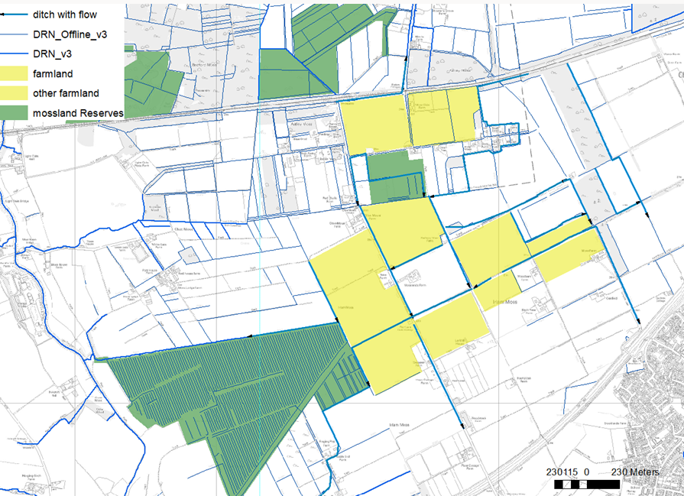
Fig 1. Chat Moss drainage plan.

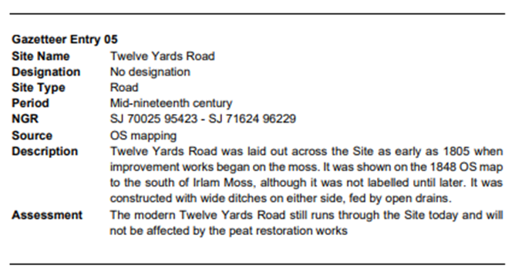
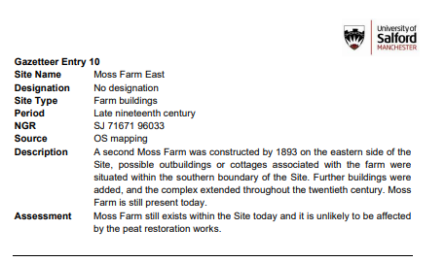
Fig 2. Gazetteer entry 05 and 10
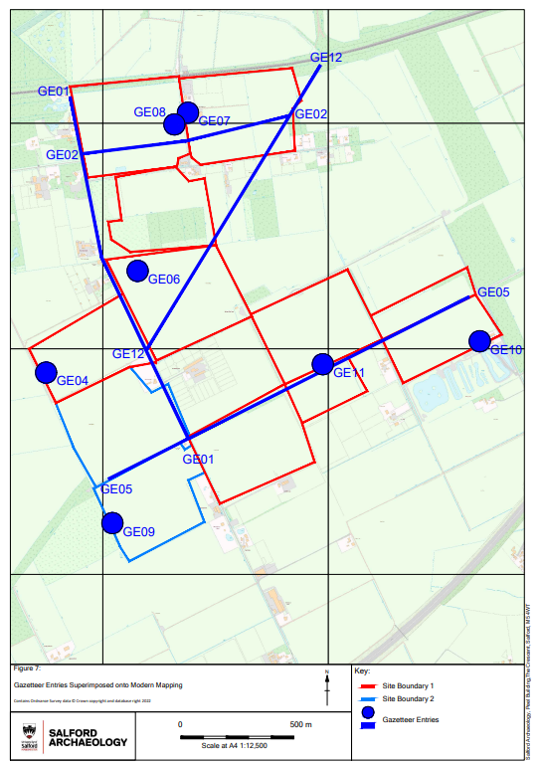

Fig 3. Historic Environment Assessment Map

Re-wetting and fen creation

Peat bunding
1717m of deep trench bunds (see Fig 4) will be installed to slow both the surface and subsurface water movement. The digging of the trenches will also break through any drainage pipes in the land, reversing previous land drainage. This work will significantly raise the water table level of the site.
The essential part of the bund instillation is the creation of a ‘peat wall’ below ground by digging to below the depth of drainage damage (approx. 2m), turning over the peat and compacting this in place. This compaction is essential to ‘seal’ the cracks and stop water leaking out by sub-surface flow. This technique allows for several inspection digs first to determine the depth of the underground trench. Once determined, the instillation must dig below the water loss depth and ensure good peat is compacted in the trench to seal the water loss. At the surface, the bunds need to be constructed to at least 0.2m in height and 1m in width. Note that trench bund F4 is off set from Twelve Yards Road to create a buffer zone, the field drain within this strip/buffer zone will be retained unblocked, so water levels next to the road are not raised.
Peat for the bunds will be won by creating small borrow pits within the fen zones. The borrow pits will be no more than 1m deep and 5-10m across and will be profiled into shallow sided bog pools.
Overflow V-notch pile weirs will be installed within the bunds at 4 locations selected using Lidar (see Fig 5). Weirs will be constructed using 1.5 lengths of plastic pile, with 5 piles used in each weir. The centre 3 pile will be set 15cm below the top of the bund, with the outer pipes at the level of the top of the bund. The centre gap in the piles will be fitted with a V-notched drop log to allow water levels to be managed. Contractors are required to supply these materials.
A new ditch will be constructed along the southern boundary of the field. This ditch will be 1m wide at bank top, 0.5m wide at invert level and be 1m deep. There are some lengths of open ditch along this boundary that can be incorporated into the new ditch. A 30m buffer zone will be maintained between the ditch and the deep trench bunding to allow future maintenance.

Item | Specification
Deep trench bunds | F1 197m  F2 311m  F3 557m  F4 652m  total 1717m
New ditch | 506 m
Overflow V-notch pile weirs | X4
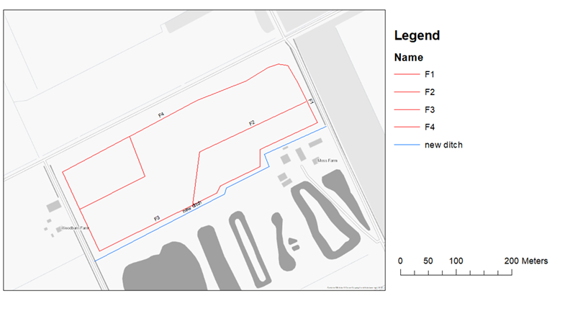
Fig 4. Indicative Plan of re-wetting works

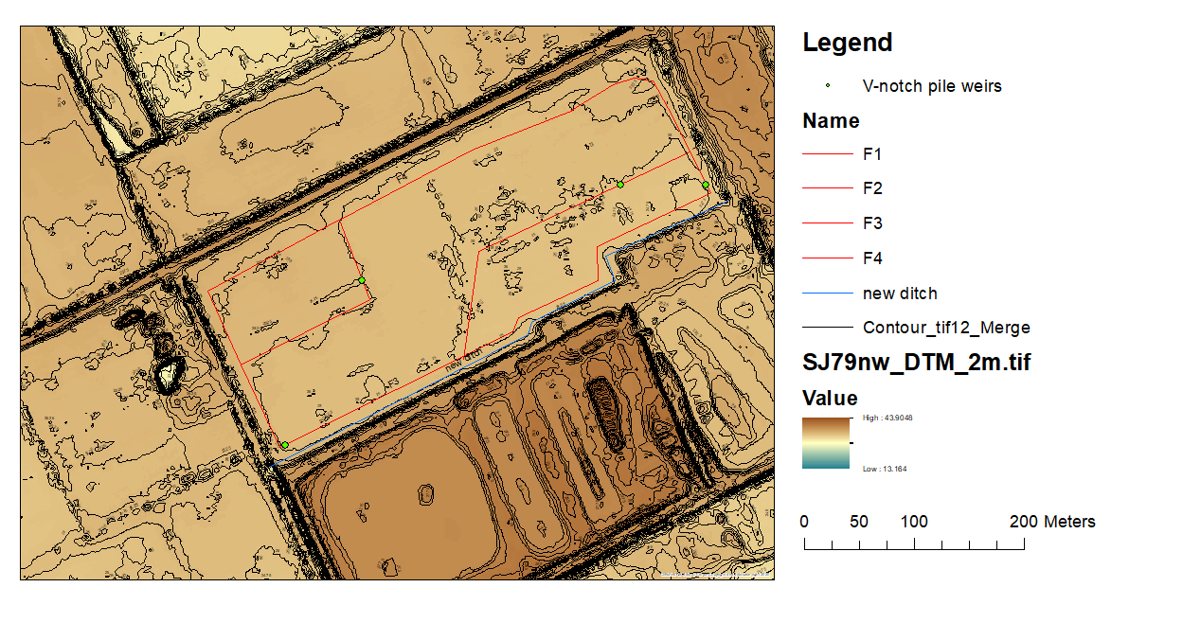
Fig 5. Lidar land levels and overflow locations

Payment
The Authority will raise purchase orders to cover the cost of the services and will issue to the awarded supplier following contract award.
The Authority’s preference is for all invoices to be sent electronically, quoting a valid Purchase Order number. Contractors can invoice as work is undertaken in agreement with the project officer.
It is anticipated that this contract will be awarded for a period of 9 weeks to end no later than 01/03/24. Prices will remain fixed for the duration of the contract award period. We may at our sole discretion extend this contract to include related or further work. Any extension shall be agreed in writing in advance of any work commencing and may be subject to further competition.

Evaluation Methodology
We will award this contract in line with the most economically advantageous tender (MEAT) as set out in the following award criteria:
Technical – 50%
Commercial – 50%
Evaluation criteria
Evaluation weightings are 50% technical and 50% commercial, the winning tenderer will be the highest scoring combined score.

Award Criteria | Weighting (%) | Evaluation Topic & Weighting | Sub-Criteria | Weighted Question
Technical | 50% | Service / Product Proposal | Methodology | 2 Questions  Q1.1 (25% of technical score available)  Q1.2 (25% of technical score available)
Technical | 50% | Service / Product Proposal | Key personnel | 1 Question  Q2 (25% of technical score available)
Technical | 50% | Service / Product Proposal | Health & Safety | 1 Question  Q3 (25% of technical score available)
Commercial | 50% | Whole life cost of the proposed Contract | Commercial Model | 1 Question  Q4 (100% of commercial score available)

Technical (50%)
Technical evaluations will be based on responses to specific questions covering key criteria which are outlined below. Scores for questions will be based on the following:
Description | Score | Definition
Very good | 100 | Addresses all the Authority’s requirements with all the relevant supporting information set out in the RFQ. There are no weaknesses and therefore the tender response gives the Authority complete confidence that all the requirements will be met to a high standard.
Good | 70 | Addresses all the Authority’s requirements with all the relevant supporting information set out in the RFQ. The response contains minor weaknesses and therefore the tender response gives the Authority confidence that all the requirements will be met to a good standard.
Moderate | 50 | Addresses most of the requirements with most of the relevant supporting information set out in the RFQ. The response contains moderate weaknesses and therefore the tender response gives the Authority confidence that most of the requirements will be met to a suitable standard.
Weak | 20 | Substantially addresses the requirements but not all and provides supporting information that is of limited or no relevance or a methodology containing significant weaknesses and therefore raises concerns for the Authority that the requirements may not all be met.
Unacceptable | 0 | No response or provides a response that gives the Authority no confidence that the requirement will be met.

Technical evaluation is assessed using the evaluation topics and sub-criteria stated in the Evaluation Criteria section above.
Separate submissions for each technical question should be provided and will be evaluated in isolation. Tenderers should provide answers that meet the criteria of each technical question.

Experience | Detailed Evaluation Criteria
Q1.1 Provide an example of previous similar works.  Q1.2 Provide an example of work focusing on biodiversity. | Your response should:  Provide evidence that you can provide the technical expertise required for this work.

Key personnel | Detailed Evaluation Criteria
Q2 Provide details on personnel likely to undertake this work. | Your response should:  Provide evidence that key staff have correct certificates and experience.

Health & Safety | Detailed Evaluation Criteria
Q3 Provide example of relevant RAMS | Your response should:  Provide evidence that you can provide this work safely.

Commercial (50%)
The Contract is to be awarded as a fixed price which will be paid according to the completion of the deliverables stated in the Specification of Requirements.

Suppliers are required to submit a total cost to provide the deliverables stated in the Specification of Requirements. In addition to this the Commercial Response template must be completed to provide a breakdown of the whole life costs against each deliverable used in the delivery of this requirement.

Calculation Method

The method for calculating the weighted scores is as follows:
- Commercial

Score = (Lowest Quotation Price / Supplier’s Quotation Price ) x 50% (Maximum available marks)
- Technical

Score = (Bidder’s Total Technical Score / Highest Technical Score) x 50% (Maximum available marks)
The total score (weighted) (TWS) is then calculated by adding the total weighted commercial score (WC) to the total weighted technical score (WT): WC + WT = TWS.

Information to be returned
Please note, the following information requested must be provided. Incomplete tender submissions may be discounted.
Please complete and return the following information:
- completed Commercial Response template
- separate response submission for each technical question (in accordance with the response instructions)
- completed Mandatory Requirements (Annex 1)
- completed Acceptance of Terms and Conditions (Annex 2)

Award
Once the evaluation of the Response(s) is complete all suppliers will be notified of the outcome via email.

The successful supplier will be issued the contract via a Purchase Order.

Annex 1 Mandatory Requirements
Part 1 Potential Supplier Information
Please answer the following self-declaration questions in full and include this Annex in your quotation response.
Part 1.1 Potential Supplier Information:
Question no. | Question | Response
1.1(a) | Full name of the potential supplier submitting the information
1.1(b) | Registered office address (if applicable)
1.1(c) | Company registration number (if applicable)
1.1(d) | Charity registration number (if applicable)
1.1(e) | Head office DUNS number (if applicable)
1.1(f) | Registered VAT number
1.1(g) | Are you a Small, Medium or Micro Enterprise (SME)? | (Yes / No)

Note: See EU definition of SME https://ec.europa.eu/growth/smes/business-friendly-environment/sme-definition_en

Part 1.2 Contact details and declaration
By submitting a quotation to this RFQ I declare that to the best of my knowledge the answers submitted and information contained in this document are correct and accurate.
I declare that, upon request and without delay you will provide the certificates or documentary evidence referred to in this document.
I understand that the information will be used in the selection process to assess my organisation’s suitability to be invited to participate further in this procurement.
I understand that the authority may reject this submission in its entirety if there is a failure to answer all the relevant questions fully, or if false/misleading information or content is provided in any section.
I am aware of the consequences of serious misrepresentation.

Question no. | Question | Response
1.2(a) | Contact name
1.2(b) | Name of organisation
1.2(c) | Role in organisation
1.2(d) | Phone number
1.2(e) | E-mail address
1.2(f) | Postal address
1.2(g) | Signature (electronic is acceptable)
1.2(h) | Date

Part 2 Exclusion Grounds
Part 2.1 Grounds for mandatory exclusion
Question no. | Question | Response
2.1(a) | Please indicate if, within the past five years you, your organisation or any other person who has powers of representation, decision or control in the organisation been convicted anywhere in the world of any of the offences within the summary below.
 | Participation in a criminal organisation. | (Yes / No)  If yes please provide details at 2.1 (b)
 | Corruption. | ((Yes / No)  If yes please provide details at 2.1 (b)
 | Fraud. | (Yes / No)  If yes please provide details at 2.1 (b)
 | Terrorist offences or offences linked to terrorist activities | (Yes / No)  If yes please provide details at 2.1 (b)
 | Money laundering or terrorist financing | (Yes / No)  If yes please provide details at 2.1 (b)
 | Child labour and other forms of trafficking in human beings | (Yes / No)  If yes please provide details at 2.1 (b)
2.1(b) | If you have answered yes to question 2.1(a), please provide further details.  Date of conviction, specify which of the grounds listed the conviction was for, and the reasons for conviction.  Identity of who has been convicted  If the relevant documentation is available electronically please provide the web address, issuing authority, precise reference of the documents.
2.1 (c) | If you have answered Yes to any of the points above have measures been taken to demonstrate the reliability of the organisation despite the existence of a relevant ground for exclusion? (i.e. Self-Cleaning) | (Yes / No)
2.1(d) | Has it been established, for your organisation by a judicial or administrative decision having final and binding effect in accordance with the legal provisions of any part of the United Kingdom or the legal provisions of the country in which the organisation is established (if outside the UK), that the organisation is in breach of obligations related to the payment of tax or social security contributions? | (Yes / No)
2.1(e) | If you have answered yes to question 2.3(a), please provide further details. Please also confirm you have paid or have entered into a binding arrangement with a view to paying, the outstanding sum including where applicable any accrued interest and/or fines.

Part 2.2 Grounds for discretionary exclusion
Question no. | Question | Response
2.2(a) | The detailed grounds for discretionary exclusion of an organisation are set out on this webpage, which should be referred to before completing these questions.  Please indicate if, within the past three years, anywhere in the world any of the following situations have applied to you, your organisation or any other person who has powers of representation, decision or control in the organisation
2.2(b) | Breach of environmental obligations? | (Yes / No)  If yes please provide details at 2.2 (f)
2.2(c) | Breach of social obligations? | (Yes / No)  If yes please provide details at 2.2 (f)
2.2(d) | Breach of labour law obligations? | (Yes / No)  If yes please provide details at 2.2 (f)
2.2(e) | Shown significant or persistent deficiencies in the performance of a substantive requirement under a prior public contract, a prior contract with a contracting entity, or a prior concession contract, which led to early termination of that prior contract, damages or other comparable sanctions? | (Yes / No)  If yes please provide details at 2.2 (f)
2.2 (f) | If you have answered Yes to any of the above, explain what measures been taken to demonstrate the reliability of the organisation despite the existence of a relevant ground for exclusion? (Self Cleaning)

Annex 2 Acceptance of Terms and Conditions
I/We accept in full the terms and conditions appended to this Request for Quote document.
Company ____________________________________________________
Signature ____________________________________________________
Print Name ____________________________________________________
Position ____________________________________________________

Date ____________________________________________________

