QB5

BETTER HEALTH - SMOKING CESSATION
CAMPAIGN BRIEF

Brief: Creation of a five-year smoking cessation marketing campaign strategy, including a more detailed creative approach and plan for the first year, to contribute to the ambition for England to be smoke free by 2030.

Budget: £3.5m
The budget for year one of this brief is £3,500,000 inclusive of agency fees (excluding VAT). It is anticipated that c. 70% of this budget should be allocated to paid media, however responses should include a recommendation and rationale on how the budget would be split between the various proposed elements of the campaign including paid media.
Timing: Five-year strategy and year-one plan to commence following Stoptober 2021.
Issue
Smoking is a major cause of preventable mortality and is responsible for more than 50,000 deaths a year. In addition, during 2019/20 there were estimated to be 506,100 hospital admissions attributable to smoking.
It is estimated that smoking costs the economy in excess of £11bn per year. Of this, £2.5bn falls to the NHS
Encouragingly, smoking prevalence in England have been continually falling and at 13.9%, rates now stand at an all time low, one of the lowest in Europe. Marketing has made a significant contribution to this decline through campaigns reinforcing the harms of smoking, the annual Stoptober campaign (now in its 10th year) urging people to make a quit attempt and signposting to evidenced based tools and support that increase the chances of individuals making a successful quit attempt.
However, despite this progress, smoking remains a major public health issue. Around 6 million people in England still smoke and rates remain high within certain groups such as those from a lower socio-economic background. Indeed, smoking makes a significant contribution to health inequalities across the country. Against some estimates smoking accounts for 50% of preventable health inequalities.
Audience
Traditionally we have focussed on older smoking audiences but increasingly there is an opportunity to address a younger cohort of smokers. The table below provides a snapshot of audience groups and full prevalence data is available at: https://fingertips.phe.org.uk/profile/tobacco-control
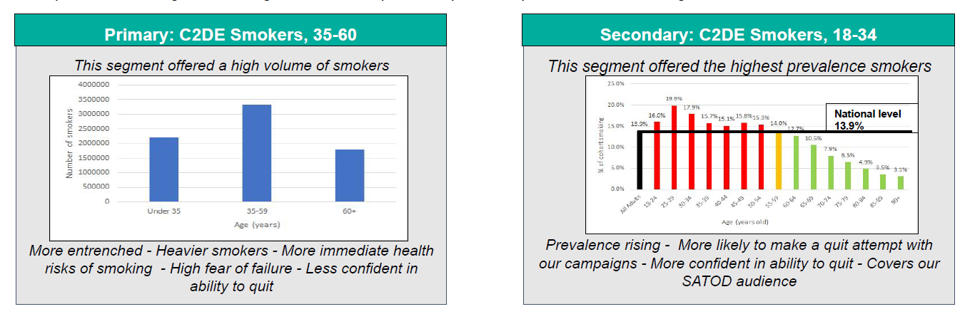
Insight
While the barriers to quitting vary between different groups, there are some fundamental core insights that affect all smokers:
- The majority of smokers want to quit – around 60%
- A lack of confidence in quitting based on multiple failed quit attempts
- Many smokers enjoy smoking and quitting is regarded as a negative process deemed as difficult and in some cases physically painful. It is associated with loss not gain
- Struggle to get started on a quit attempt even when they are highly motivated (since addiction competes with positive action). Smokers can suffer inertia; delay putting off quitting or feel overwhelmed by the challenge
- Justify their own behaviour and undermine/refute calls to change and especially quit
Insight on two broad audience categories is provided below.

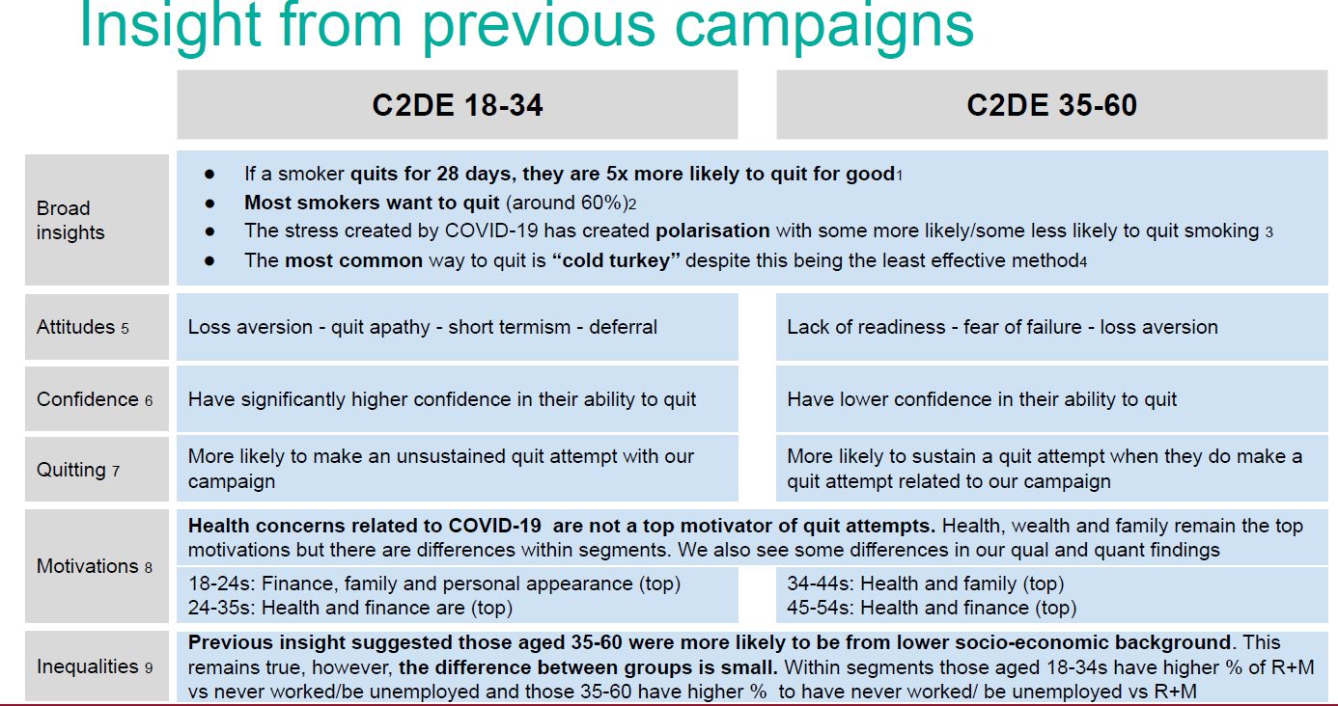

Campaign Overview: Smoking Endgame
In the (July 2019) Prevention Green Paper there is a clear, committed ambition for England to be a smoke free nation by 2030. (reducing smoking rates to under 5%). A new Tobacco Control plan for England is being drawn up to support this ambition.

As the smoking portfolio becomes integrated under the Better Health umbrella brand, we are looking ahead to see how marketing can contribute to the ‘endgame’ on smoking over the coming years. We seek to refresh our approach to build on our successful activity to date and would welcome bold ideas that address the diversity of audiences, innovation in targeting, inequalities and have creative impact to tackle this unique public health challenge.

Public Health England’s Better Health campaign was launched in July 2020 to help support people look after their mental and physical health. Whether they're looking to lose weight, eat better, get more active, look after their mental wellbeing or quit smoking, the campaign provides motivation, tools and resources to support people to take simple actions to make healthy changes. Further information can be found at https://www.nhs.uk/better-health/
This brief requires creation of the campaign strategy for the next five years over a changing landscape, including how targeting and messaging would evolve over time as the smoking population changes. Alongside the five-year strategy, responses should include a more detailed approach for the first year using the total budget of £3.5m (which includes all campaign elements including beyond this brief’s scope as detailed below). Responses should also include a view on how the campaign strategy may develop after year one, taking into consideration the changing context of the market.

Response to brief should include:
- Communications Strategy Development (30% of evaluation mark):
Development of a communications strategy in line with GCS OASIS framework, including audience analysis, insight generation, strategic planning of content/messaging. This does not include media planning.
- Concept Development and Creative Design (30% of evaluation mark):
Development of creative propositions, inclusive of relevant research; creative development across both art and copy; development of ideas, core messages and values.
- Campaign Delivery (20% of evaluation mark):
Campaign management and delivery of owned and earned channels, alongside account management across multi-channel campaigns; consideration of client specific comms. Dependent on the communications strategy campaign delivery may include (but is not limited to):
- Public Relations
- Direct Marketing
- Digital Marketing and Social Media
- Partnerships
- Experiential and events
- Evaluation and measurement (20% of evaluation mark):
Evaluation framework as part of the communications strategy; client reporting and management; campaign effectiveness measurement.

Considerations to inform responses

Within your response you may want to consider these specific challenges. You do not have to reference them all, however you may find them useful for informing responses.

- While there are varying degrees of smoking prevalence across the country, achieving the 2030 ambition will require a significant reduction in volume. How would you ensure appropriate targeting of smokers such that:
- activity cost effectively reaches the (shrinking) smoking audience
- inequalities are addressed
- a ‘halo’ effect is provided which supports the implementation of new legislation and wider work of those in the health care system
- Creative and messaging. Everybody knows smoking is bad for their health and an expensive habit. How do we elevate these notions so that they have enough personal resonance and drive motivation to overcome inertia and drive quit attempts? Within this, how is the messaging balanced between harm (to themselves, to their families) and encouragement (hope), that gives smokers the confidence and belief that they can quit.
- Post Covid-19. At present there is no clear evidence between Covid-19 and smoking. However, research suggests that the pandemic has seen people re-evaluate their health.
Data suggests the pandemic led to an increase in quit attempts but also a worrying increase in the number of young people smoking. How is this built into our future thinking?
- Support. Despite evidence that supported quit attempts are more successful, the majority of quits are ‘cold turkey’. The support environment has also been made more complex with the emergence of eCigarettes which are now the most popular form of quitting support and are widely available.
However, we also know that talking to people about support can be complicated and off-putting.
- Partnerships. Smoking is a key concern for Local Authorities. How is activity developed to enable them to participate in national programmes while addressing local concerns and recognising regional differences?
How can we activate other strategic partnerships from retailers to technology platforms? Are there any other innovations that can be incorporated to help achieve strategic objectives?

GOV Smoking and Tobacco Guidance
NHS Digital, Statistics on Smoking in England, published 2020
Towards a Smoke-free generation: tobacco control plan for England (March 2017). Adult smoking habits in the UK: 2019. ONS.
Adult smoking habits in the UK: 2019. ONS.
Advancing our health: prevention in the 20s

