

JNCC Report
No: 546

Guidance on Assigning Benthic Biotopes using EUNIS or the Marine Habitat Classification of Britain and Ireland

Megan E. V. Parry

March 2015

© JNCC, Peterborough 2015

ISSN 0963 8901

For further information please contact:

Joint Nature Conservation Committee
Monkstone House
City Road
Peterborough PE1 1JY
www.jncc.defra.gov.uk

This report should be cited as:

Parry, M.E.V. 2015. Guidance on Assigning Benthic Biotopes using EUNIS or the Marine Habitat Classification of Britain and Ireland JNCC report No. 546

Contents
1 Introduction 1
2 Data available for assigning a biotope 1
2.1 In situ intertidal habitat survey 1
2.2 In situ subtidal dive habitat survey 2
2.3 Remote subtidal habitat survey 2
2.4 Deep-sea habitat survey 3
2.5 Broad-scale maps 3
3 Statistical analysis for biotoping 4
3.1 Grab and core data 4
3.2 Video and stills data 5
4 Assigning a biotope to survey data 6
4.1 Summarise results 6
4.1.1 Select a zone for each sample 6
4.1.2 Select a substrate category for each sample 7
4.1.3 Select an energy / mobility category for each sample 8
4.1.4 Select an salinity category for each sample 8
4.1.5 Summarise the characterising species for each sample 8
4.2 Step-by-step guide to using the Marine Habitat Classification 9
4.2.1 Level 1 9
4.2.2 Level 2 9
4.2.3 Level 3 10
4.2.4 Level 4 11
4.2.5 Level 5 12
5 How to deal with common problems 13
5.1 No biotope matches the biological community 13
5.2 A matching a biotope is found in the wrong section of the classification 13
5.3 Biotope mosaics 14
5.4 Infauna/ epibiota 14
6 Summarise results 15
6.1 Record a biotope for each sample 15
6.2 Map biotopes 15
6.3 Biotope information to summarise in a report 16
6.3.1 Example biotope summary – Epibiota 18
6.3.2 Example biotope summary – Infauna 19
7 References 20
Appendix 1: Version tracker 21
Appendix 2: Example sample biotope summary table 22
Appendix 3: JNCC Guide Definitions for Substrate Types Used in EUNIS and the Marine Habitat Classification of Britain and Ireland 23
7.1 Method for identification of substrate type 23
7.2 Definition of substrate categories 24
7.2.1 Level 2 24
7.2.2 Level 3 26
7.2.3 Mosaic Substrates 28
7.2.4 Stony reef 29
7.3 Summary 30

Introduction
Various habitat classification schemes have been developed which provide a list of biotopes defined based on characterising species and associated physical characteristics, such as the substrata it occurs on, the depths at which it can be found, and the type of wave and tidal energy conditions it is associated with. Biotopes provide a simplified description of the variation in biological community across a region to make it easier to visualise patterns and see which areas are similar in character. In the UK there are two commonly used classification schemes; the Marine Habitat Classification for Britain and Ireland (Connor et al., 2004) and the Europe-wide scheme EUNIS which is strongly based on the UK system (Davies and Moss, 2004).

Biotopes are positioned at the lowest level (level 5) in the classification hierarchy. The user matches survey data to biotope descriptions. This guidance outlines a favoured JNCC approach for assigning a biotope which should ensure biotoped data are suitable for JNCC needs. It can be applied to either EUNIS (Davies and Moss, 2004) or the Marine Habitat Classification for Britain and Ireland (Connor et al., 2004). EUNIS covers pelagic and ice associated habitats as well as benthic habitats but these will not be discussed in this document. This guidance is aimed at any user of these classifications but, in particular, those who assign biotopes to survey data gathered for the Statutory Nature Conservation Bodies (SNCBs). It does not cover the acquisition of habitat data for biotoping, processing of samples or data interpretation; this information can be found in various standard operating procedures (e.g. Davies et al. 2001, Irving et al. 2012, Cefas SOPs, MESH ROGs, NMBAQC guidelines, Wyn et al. 2006). It is likely that this document will continue to be updated as new information becomes available.

Data available for assigning a biotope
Different data types will be available for use in biotoping depending on the survey undertaken. As a minimum, information is generally gathered on the species present (epibiota, infauna or both) and details of the substrate and depth.

In situ intertidal habitat survey
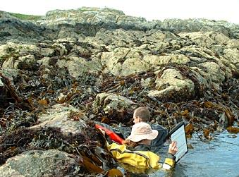
For intertidal habitat surveys biotopes are often identified in the field using information available. In some cases biotopes are assigned simply based on expert knowledge of the area and the typical species expected for certain biotopes. Information on the physical character of the site is recorded often using the site forms developed for the Marine Nature Conservation Review (MNCR) or modified versions thereof. These include information about zone, physiographic feature type (e.g. linear coast, estuary), salinity, wave exposure, tidal streams and geology, all of which are useful in assigning the correct biotope. A species list or representative quadrats are collected for each habitat surveyed. For rock habitats this will be epibiota only. For sediment habitats a hand core may be taken and processed for infauna on site or sometimes post survey. Key epibiota in the vicinity of infaunal samples would also be recorded. Specimens of key species important for assigning a biotope are taken if they cannot be identified on site. The biotope could then be altered later based on the species identification. Species and physical data are generally recorded in MNCR littoral habitat forms or similar.

In situ subtidal dive habitat survey
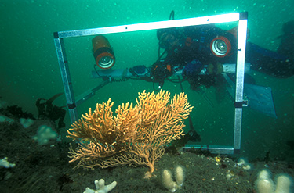
Biotopes are also identified in the field for dive surveys in shallower subtidal areas. For rock habitats a species list and associated physical information is recorded during the dive, often using the MNCR sublittoral habitat form or a similar form adapted from this. This includes information on depth, the % composition of substrate, substrate features and modifiers. Species data are generally recorded using the SACFOR scale. Video and photographs are sometimes taken to check identification at a later date. For sediment habitats notes are taken on depth, substrate and epibiota. A useful guidance document was produced for Seasearch (Irving and Wood, 2007) that provides a biotope key to assists divers with the identification of biotopes.

Hand cores may be taken for infauna and an additional sediment sample may be taken for Particle Size Analysis (PSA). These samples are processed subsequently and resulting data are available for statistical analysis.

Remote subtidal habitat survey
Deeper subtidal habitats are surveyed remotely using underwater video and grab sampling. Some field notes are taken on substrate and characteristic fauna identified from videos and grabs. MNCR sublittoral habitat forms6 or other similar log sheets are used. Video data and grabs are processed after the survey. The following outputs are produced from a typical offshore survey:
- A species matrix for infauna above a certain size recorded in grab samples;
- Particle size analysis results for grab samples;
- One species matrix for epibiota recorded in stills, and one for video tow divided by habitat;
- A log sheet showing associated information about zone and substrate, and;
- Metadata for each sample including its location, depth, and sometimes additional environmental information collected at that point such as seabed water temperature.
These analysed data can be reviewed to look for patterns in biological community and how this relates to associated physical variation. Sometimes only a subset of stills are analysed to get a full species list due to time or financial constraints. Images without species lists can still help to get an overall impression of the site, although they wouldn’t be included in any statistical analysis.
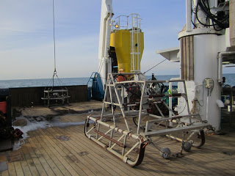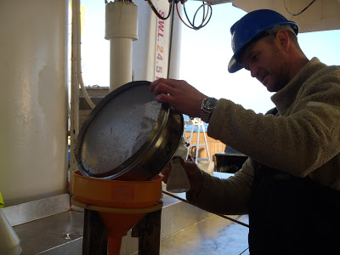

Deep-sea habitat survey
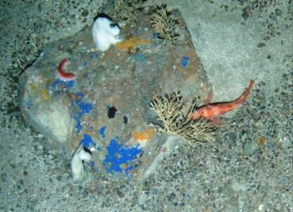
Deep-sea surveys generally acquire video data either using an ROV or towed system. These video data are processed in a similar way to shallower subtidal surveys; however, identification of species is a lot more challenging as the deep-sea is still poorly understood. Associated physical information such as water temperature and salinity are often recorded using a CTD which may or may not be mounted on the camera. Some surveys may also acquire grab samples but this is rare as it takes a long time for the equipment to reach the seabed.

Broad-scale maps
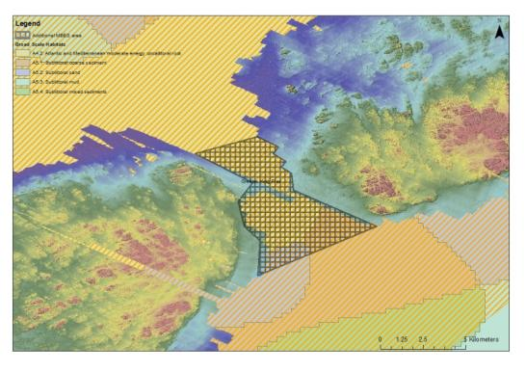
In addition to data collected in the field, broad modelled layers for environmental variables could be used to assist with biotoping. The EUNIS level 3 broad-scale habitat maps produced based on the EUSeaMap model, or similar models, can be useful to give a general impression of which part of the classification the correct biotope may fall in, although the resolution is not fine enough to show fine-scale spatial variation in habitats. More detailed modelled maps such as HABMAP may be available which were created using physical and biological data and classify habitats up to biotope level.

Site-specific habitat maps are often produced using remote data such as aerial photographs and LiDAR (nearshore), or multi-beam and side-scan sonar (subtidal) data gathered during survey. Maps are useful to get a general picture of how habitats are distributed across the site, and which stations may fall on the same feature; however, it is not always possible to distinguish between broad habitats from remotely sensed data, particularly if the quality is poor. The boundaries of specific biotopes are generally not evident from remotely sensed data alone.

Statistical analysis for biotoping
In addition to an initial review of data, statistical analysis can help with identifying patterns in biological community and how environmental variables influence these changes. Statistical analysis is generally only undertaken where data are analysed following the survey (subtidal remote survey and dive survey where hand cores are taken), not for surveys where a biotope is assigned in situ. Results can be used to select the biotope with the appropriate community and characterising environmental variables. In some cases, statistical analysis may not be appropriate for the data and expert judgement should be used. A statistical test should only be used if the data meet its assumptions.

Grab and core data
Infaunal data are generally provided as abundance per sample. A number of factors should be considered before applying a statistical analysis:

- Do all the samples have the same surface area/volume? If not abundance may need to be standardised to the same size units.
- Were replicates at the same location used? If so, abundance may need to be averaged across replicates.
- Was different gear used for different samples? If so, data acquired with different gear should be analysed separately.
- Faunal data need to be checked to ensure there are no discrepancies in identification, particularly if different taxonomists identified fauna in different samples. Specific taxa need to be identified to the same level across all samples and not be given different names. It may be necessary to aggregate some taxa up to a higher level if they are inconsistently identified. For example, a situation where two taxonomists identify two clearly different individuals which cannot be identified to species level as “Ophiuroidea A”. In this example, either the two individuals should be given unique codes (“Ophiuroidea A” and “Ophiuroidea B”) or both aggregated to genus level: “Ophiuroidea”. It is also possible old species names have been used for some individuals or some records have been misspelled, so this needs to be checked.
- It may be necessary to remove some inappropriate fauna prior to analysis, such as mobile species like fish, juveniles and species smaller than the required fraction size.
- Colonial species will be recorded as presence/absence or percentage cover rather than counts; these may need to be analysed separately or all data will need to be converted to a common measure.
A number of different statistical analyses are available for investigating patterns in biological community. The tests used mostly commonly to identify differences / similarities in biological communities are hierarchical agglomerative cluster analysis (e.g. Figure 3.1) and SIMPROV and MDS ordination available with PRIMER statistical software (see Clarke and Warwick 1994 for more detail on assumptions and limitations). Clusters identified in cluster analysis do not all necessarily represent truly different communities. Results of any analysis need to be interpreted by experts in order to identify whether patterns shown are real or the result of inconsistencies in the data. Some may need to be merged or disregarded. It can be useful to apply more than one statistical test and see if they both get similar results. SIMPER can be used in PRIMER to identify which species characterise each cluster of samples, and which distinguish clusters. Various types of cluster analysis and ordination are also available in ‘R’. Tests such as BIOENV and PERMANOVA (PRIMER), PCA, DCA and CCA can be used to investigate how environmental variables are influencing the variation in biological communities.

Figure 3.1: Example of a dendrogram output from PRIMER Cluster analysis

Video and stills data
One species matrix is generally provided for sections of video transect covering a single habitat type, and a separate matrix for stills. The video data give a broader picture of the habitat and the stills allow identification of smaller and less conspicuous taxa but over a smaller area. As these data capture different sections of the community they should be analysed separately. Generally for each species both abundance and SACFOR is provided per video section or per still, but sometimes only presence/absence is used. Most of the considerations taken for grab data also apply to video data. In addition, some further considerations need to be taken when deciding how to use stills data:

- Stills are unlikely to sample the same area as the camera frame moves up and down in the water column. Lasers can give an indication of field of view. One option for standardising sample area is to crop images to a standard field of view.
- Stills are often taken at regular intervals with additional stills in between to look at features of interest. Only the regular stills should be included in statistical analysis.
- If stills are taken very close together it may be necessary to select a subset of the stills at a larger regular distance to avoid the clustering of data as a result of spatial proximity. It may also be appropriate to ensure the subset adequately reflects the variety of habitat types encountered. Expert judgement is required to decide the best approach to take for different datasets.
- Each still taken on sparsely populated sediment habitats is likely to record few different taxa. In this case, statistical tests such as cluster analysis and ordination are unlikely to give usual results and the raw data should probably be used to assign a biotope. The same may apply for whole video tows if very few taxa are present.
- As stills show only a small area of the seabed, it is advisable to take into account the wider habitat recorded in the video tow when assigning a biotope.
There is currently no consensus amongst experts as to how appropriate it is to apply statistical techniques to video data. As with grab data, the most common approach is to use PRIMER software for cluster analysis with SIMPROV and MDS ordination (see grab section 3.1), and expert interpretation of results is required. These comments on video and stills data also apply to dive transect and quadrat data.

Assigning a biotope to survey data
Once analysed faunal and physical data are available, and any required statistical analysis has been undertaken, results can be used to match survey data to biotopes. It is important that the biotope name assigned to data accurately describes the physical environment as well as the biological community (see Section 5.2 for advice on dealing with a mismatch).

Summarise results
If biotopes are being assigned using survey results, rather than in the field, it is helpful to summarise the information known about each sample to inform the selection of a biotope. In order to match a sample to a biotope description, information is required on all the characterising variables used in the classification (biological zone, substrate, energy level/ sediment mobility, salinity and species composition). This information can be summarised in a table (see columns 1 – 10 in Appendix 2). The correct category for each variable should be selected based on all the available survey information. If it is not possible to select a category for a variable using the information available then state ‘unknown’. The following guidance discusses how the correct category can be selected for different variables.

Select a zone for each sample
- Check depth.
- Check other factors influencing zone (e.g. light, water temperature, presence of indicator species particularly algae).
- Note depth ranges given in habitat descriptions can be misleading as they are based on where records have been found to date, not the full potential range. Considering this, zone should be selected based on accepted definitions such as those provided in the classification introductory text and ranges used for EUSeaMap (Cameron and Askew, 2011), rather than simply depth ranges provided in the habitat descriptions.
- Overlaying sample points onto EUSeaMap modelled broad-scale habitat maps or, if available, EUNIS broad-scale habitat maps produced from remotely sensed survey data, can give an indication of which zone is likely. It should be noted that the spatial resolution of modelled maps can be limited.

Box 1: What is ‘offshore circalittoral’ or ‘deep-circalittoral’?
The definition of ‘circalittoral’ is currently not well defined. For rock habitats it currently refers to the whole circalittoral zone (from the lower limit of kelp down to 200 m as a rule of thumb) although only one circalittoral rock biotope has been described for the deeper part of the circalittoral at the moment. For sediment habitats circalittoral is divided into ‘circalittoral’ and ‘offshore circalittoral’ (Marine Habitat Classification for Britain and Ireland) or ‘deep-circalittoral’ (EUNIS). EUSeaMap defined ‘circalittoral’ as the shallower part of the circalittoral zone from infralittoral to the wave base and ‘deep-circalittoral’ was from the wave base down to 200 m. However, in the classifications ‘circalittoral’ and ‘deep-circalittoral’ are not mutually exclusive. The level 5 sediment biotopes defined within ‘circalittoral’ tend to occur across the whole circalittoral zone. Those defined within ‘deep-circalittoral’ tend to occur just towards the deeper end of the range but their distribution does overlap with circalittoral sediment biotopes. Further work is needed to establish whether the deep-circalittoral really warrants being classed as a different biological zone, or if most communities do in fact occur across the whole circalittoral. Meanwhile it is recommended that at level 5 circalittoral sediment biotopes are selected from within either level 4 ‘circalittoral’ or ‘deep circalittoral’ based on the biological community present regardless of whether the sample occurs in the shallower or deeper part of the circalittoral. If no level 5 biotope matches the community present, or no biological information is available, then a level 4 habitat would be assigned. For simplicity the EUSeaMap definitions could be used to decide if a level 4 sediment habitat occurs in ‘circalittoral’ or deep-‘circalittoral’.

Select a substrate category for each sample
Different levels of detail are required about substrate at different levels in the classification. At levels 2/3, substrate is classified into five broad substrate categories (rock, coarse sediment, mixed sediment, sand and muddy sand, and mud and sandy mud). The four sediment categories are based on the relative proportions of mud, sand and gravel, as defined in the Folk classification (See Appendix 3 for details).
At level 4 in the classification muddy and sandy sediment is divided further using terms for several sediment classification systems – muddy sand and sandy mud (Folk), fine sand (Wentworth) and fine mud (neither). In order to classify muddy and sandy habitats to level 4 on the basis of sediment type it is recommended to use the specific Folk category assigned to the sediment and treat “fine sand” as Folk “sand” and “fine mud” as Folk “mud”.
At level 5 it can be useful to know more details about the specific substrate type such as if it is peat or hard clay rather than rock, if it is bedrock or stony reef, if it is comprised of shell material or gravel.
Select a level 3 broad substrate category and also provide any other details on substrate, including the specific Folk category in the sample summary table (e.g. Appendix 2).
For physical samples:
- Check PSA results but consider that mud may have been washed out and larger rocky material not retained.
- Check grab photographs and deck logs to get more of a picture of the sediment retained in the whole grab, including any large stones.
- Cross check with any visual samples taken at the same station (including video taken using equipment attached to the grab) to get an impression of the substrate in the wider area.
- The functional traits of species present in the sample should also give an indication of what substrate type is.
For visual samples:
- Check notes in logs.
- Check raw data to ensure the logs are correct.
- Cross check with PSA results from physical samples taken at the same location as this can provide more detailed information about mud / sand / gravel content.
- The functional traits of species present in the sample should also give an indication of what the substrate type is.

Select an energy / mobility category for each sample
For rock samples:
- Energy regime is sometimes noted in field logs such as the MNCR site form.
- The classification introductory text (p43-44) gives guidance on how to identify energy regime.
- It is recognised that energy level is only obvious at the extreme ends of the spectrum so energy level assigned may be a best guest.
- The energy category selected should reflect the type of communities present. If energy regime is uncertain, check the level 3 habitat descriptions for each energy type and which broad communities are defined under each at level 4 then cross reference this with the communities found in the sample. Select the energy category which best fits the community present.
- If energy regime cannot be ascertained from field data then another option is to overlay sample points onto modelled data layers such as those used for EUSeaMap (Cameron and Askew, 2011), although it should be noted that the spatial resolution of these layers is limited.
For sediment samples:
- Mobility is sometimes noted in field logs such as the MNCR habitat forms.
- Video footage is useful to gauge mobility of sediment.
- Features such as sand ripples can indicate sediment is mobile.

Select an salinity category for each sample
Select a salinity category based on notes in the logs, geographic location or any salinity readings taken. Definitions for categories are provided in the Marine Habitat Classification of Britain and Ireland introductory text¹².

Summarise the characterising species for each sample
For each sample investigate the faunal community present and add a description in the summary table (e.g. Appendix 2).
- Check field logs to get an overall idea of the community present, but note that faunal identification undertaken in the field may not be completely accurate.
- Review raw species abundance data to get an overall impression of species composition, which species are most abundant, and how the community compares with other samples.
- Cross check visual samples with species lists from physical samples taken at the same location as this could give additional information; for example, a taxon seen in a video may have been identified to a higher level from a physical sample.
- Review results of any statistical analysis of species data undertaken (see Section 3). Statistical analysis such as cluster analysis can help to identify groups or ‘clusters’ which have similar biological communities. These may not directly reflect real differences in community. Expert judgement should be used to decide whether some clusters are simply artefacts of the data and should be merged or discounted. SIMPER analysis can be used to identify characterising species for each cluster of samples.
- Although physical samples and visual samples may occur within the same area they sample different components of the community so are unlikely to have the same characterising species. Physical samples will be associated with infaunal species only while visual samples will be associated with epibiotal species only.

Step-by-step guide to using the Marine Habitat Classification
To assign a biotope start at level 1 and progress step-wise through the classification from level 1 to level 5. The expandable hierarchy is displayed online for EUNIS and the Marine Habitat Classification for Britain and Ireland and description pages are provided for each habitat when the user clicks on a habitat type name. These descriptions should be cross-referenced with survey data to select a habitat type at each level. A key is available to help select a EUNIS habitat up to level 3. More detailed metadata about the core records used to define biotopes is available in biological and physical comparison tables on the JNCC website.
The steps outlined below provide guidance on how to select a habitat type at each level. The user should work through these steps in turn from Level 1 through to Level 5 to assign a biotope to each sample. Use information collated in the sample summary table (e.g. Appendix 2) to guide this process.

Level 1
Level 1 only has a single category ‘Marine’ selected to distinguish this section from terrestrial coastal habitats.

Level 2
At this level the user needs to select a habitat based on substrate type and biological zone.
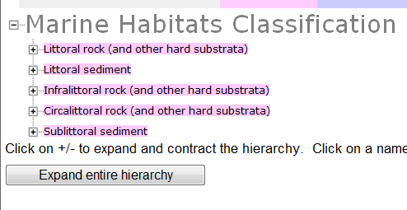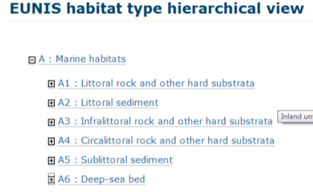
Figure 4.1: Level 2 Marine Habitat Classification for Britain and Ireland (left) and EUNIS (right)

- For each sample select rock (and other hard substrata) or sediment substrate. Rock is generally considered to comprise bedrock, soft rock, peat, artificial substrate, hard clay or any mixture of stable pebbles, cobbles and boulders. See Appendix 3 for details.
- For each sample select the appropriate biological zone. For rock habitats select littoral, infralittoral or circalittoral; for sediment habitats select littoral or sublittoral. Note, ‘sublittoral’ incorporates both infralittoral and circalittoral – these are not split for sediment at level 2 as sediment communities do not differ as significantly as rock communities do. EUNIS also has a ‘deep-sea bed’ category which does not specify substrate type. At the time of publication, UK classification does not yet cover the deep-sea but deep-sea zones will be added shortly in 2015.

Level 3
Select one of the ‘child’ level 3 habitat types listed under the ‘parent’ habitat type selected at level 2 (e.g. if ‘Littoral rock’ is selected at level 2, select one of ‘high energy’, ‘moderate energy’ ‘low energy’ or ‘features of’ littoral rock). At level 3 rock habitats are subdivided based on energy (a combination of the effects of wave exposure and tidal current) or if they are a ‘feature’. Sediment habitats are subdivided based on broad sediment type, with all macrophyte-dominated or biogenic reef covered sediments kept separate. EUNIS includes some littoral sediment features not found in the UK system, and subdivides macrophyte-dominated littoral sediments into saltmarsh and aquatic angiosperms.
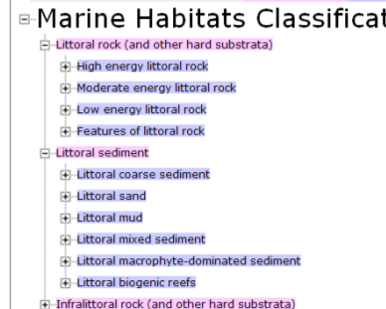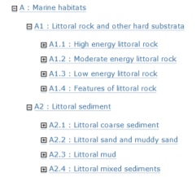
Figure 4.2: Examples from level 3 Marine Habitat Classification for Britain and Ireland (left) and EUNIS (right).

- Check if the rock/sediment habitat sampled would be classed as a ‘feature’ by looking at the categories listed under features at level 4. If so, ‘features of’ should be selected regardless of substrate type.
- For each sample on rock, check which energy regime is present.
- EUNIS also separates Atlantic and Mediterranean rock habitats from those in the Baltic at this level. Select the appropriate category based on which region the data are from.
- For each sample on sediment, select the broad sediment type present (coarse, mixed, mud or sand) – see Appendix 3 for further guidance.
- Check raw data and logs to see if sediment is covered by biogenic reef or macrophytes. If so, those categories should be selected instead of broad sediment categories. Note, these reef and macrophyte-dominated categories apply only to those occurring on sediment and not similar communities on rock.

Level 4
Select one of the ‘child’ level 4 habitat types listed under the ‘parent’ habitat type selected at level 3. At this level rock and littoral sediment habitats are defined by broad biological community and sometimes more specific environmental conditions as well, such as ‘on variable salinity’. Sublittoral sediment habitats are subdivided by salinity and more specific biological zone.

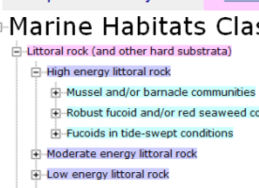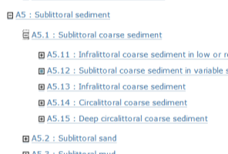
Figure 4.3: Examples from level 4 of Marine Habitat Classification for Britain and Ireland (left) and EUNIS (right).

For rock habitat samples:
- Select a broad community in the field using expert knowledge or by cross-referencing the characterising species observed with those listed in habitat description pages.
- If assigning a biotope using analysed data check the species matrices/lists for the presence of key species and review any visual data.
- Check the physical environment matches with the habitat type description.

For sediment habitat samples:
- Check if sample occurs in ‘low or reduced salinity’ or ‘variable salinity’. If so, select one of the first two habitat types.
- Otherwise, select a category based on the biological zone. Cross check species data with characterising species given in the level 4 habitat descriptions to establish which is the best match. If it is not possible to reliably match species data to a level 4 habitat, assign the appropriate zone using physical proxies such as depth (see Box 1 for further guidance).

Level 5
Select one of the ‘child’ level 5 biotopes listed under the ‘parent’ habitat type selected at level 4. At this level biotopes are defined based on their characterising species (Figure 4.5). Biotopes are described when similar communities are known to occur in multiple locations in similar environmental conditions. Each biotope should occupy its own unique niche.
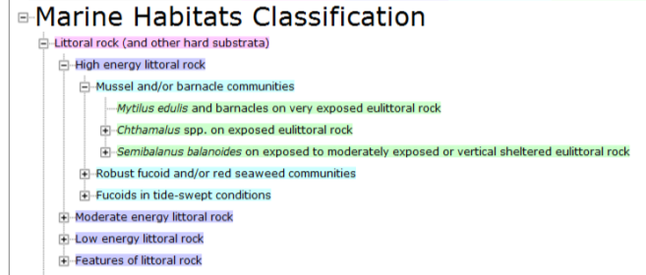
Figure 4.4: Example from level 5 of Marine Habitat Classification for Britain and Ireland.

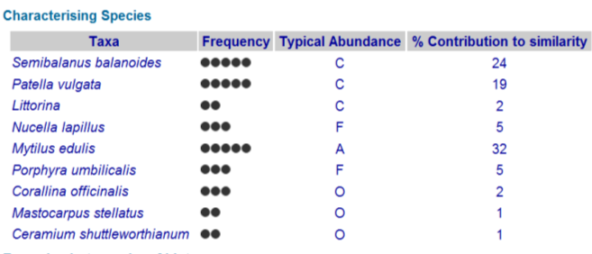
Figure 4.5: Example characterising species table from a biotope description page.

Use available data to assign a biotope to each sample:
- Cross-check the entire species list, as well as the characterising species identified in any multivariate analysis, with species mentioned in the biotope descriptions (Figure 4.5).
- Not all of the characterising species listed in a biotope description need to be present to assign the biotope – expert judgement should be used.
- It can be helpful to plot samples spatially to help decide which samples are likely to have the same community.
- It should be noted that still photographs sample only a very small area so the biotope assigned to a photograph could be based on the video footage of the wider area surrounding it as well as species data from that specific still.

How to deal with common problems

No biotope matches the biological community
It is recognised that there are gaps in the classification. In particular, deep-circalittoral habitats are poorly covered. Revisions planned for the classification in 2015/16 should help to address this. If no matching level 4 habitat or level 5 biotope is available in the appropriate section of the classification then check other sections of the classification with different physical parameters to see if matching communities are described elsewhere. If no match is found anywhere in the classification the following steps should be taken:
- The appropriate habitat at the next level up should be assigned to relevant samples.
- At level 5 the biotope code should be the ‘parent’ code with an ‘x’ on the end to indicate that level 5 is unknown.
- The report should describe the unmatched community present and where it was found.
- If more than one new community is found they should both be described separately (i.e. ‘unmatched biotope A’ and ‘unmatched biotope B’) not aggregated at a higher level.
- In describing an unmatched biotope the contractor is not suggesting that it should necessarily be added to the classification, but simply highlighting that data does not match existing descriptions.
- When a potential new biotope is identified, this should be reported to JNCC at MarineHabitatClassification@jncc.gov.uk. The email should state which survey the new biotope was found in, give contact details for the person who identified the new biotope, and provide a link to, or copy of, the report that gives details of the biotope. If associated survey data are not stored in Marine Recorder details of the data holder should be provided.
- Providing information on newly identified communities, or communities recorded outside the previously identified physical parameters, will help JNCC to make future revisions to the classification and to better interpret changes in community structure across a site.

A matching a biotope is found in the wrong section of the classification
Information on habitat distribution is often presented using the upper levels for conservation purposes; in particular, broad-scale habitats listed for the Marine Conservation Zones project are taken from level 3 of EUNIS. It is misleading if a level 5 biotope assigned to a sample specifies a physical characteristic that does not match an underlying level 3 broad-scale habitat map. In some cases, the level 5 biotope that best describes the biological community found during a survey may be located in a section of the classification where the physical description does not match survey data (e.g. if a matching biotope occurs within ‘high energy circalittoral rock’ but the field data are from an area of ‘moderate energy circalittoral rock’). It is important to record the biological community present, but some steps should be taken to make sure it is clear the physical environment differs from the description.

In this situation, the following steps should be taken:
- The biotope with a matching biological community should be assigned but flagged as ‘physical mismatch’.
- A matching EUNIS level 3 habitat should also be identified that best describes the physical characteristics of the habitat.
- The report should clearly explain why the physical characteristics in the biotope description do not match those observed.
- When the biological community associated with a biotope has been recorded outside the expected range outlined in its description page this should be reported to JNCC at MarineHabitatClassification@jncc.gov.uk.
- JNCC will use this information to consider if the description of a biotope needs altering.

Biotope mosaics
In some cases, it is necessary to assign more than one biotope with different ‘parent’ broad habitats to the same sample. Sometimes the seabed comprises a mosaic of more than one substrate type (e.g. rocks on mixed sediment, fine sand interspersed with coarse sediment). Mosaics could also be comprised of ‘biogenic reef’ along with rock, mixed sediment, coarse sediment, sand or mud. This only applies to visual samples which can record more than one substrate type.

As a working guide, biotope is considered to extend over an area at least 25 m². For minor habitats, such as rockpools and overhangs on the shore, this 'minimum size' can be split into several discrete patches at a site. Small features, such as crevices in rock or the biota on kelp stipes, are described as features of the main biotope rather than biotopes in their own right. Other areas with patches of biotopes of < 25 m² could be considered a biotope mosaic. At a broader scale most mapped areas will have a mixture of several biotopes and it is up to the user how to visualise this; this section refers only to the situation where a single sample records more than one biotope.

In this situation the following steps should be taken:
- First select the broad habitats in the mosaic based on physical data then select a ‘child’ biotope for each.
- Identifying biotopes in a mosaic using species matrices can be difficult as the species associated with different substrate types in the mosaic will not be divided. Consider which recorded species are likely to be associated with the different broad-scale habitats in the mosaic and assign each a ‘child’ level 5 biotope accordingly.
- For rock and sediment mosaics, the infauna species recorded from physical samples tend to represent the sediment component and the epibiota from visual methods tend to be mostly associated with the rock component.
- It would be useful additional information to note the relative percentage cover of each of the biotopes making up the mosaic.
- When describing a mosaic habitat, the predominant biotope should be written first (e.g. ‘A5.141 / A4121 mosaic’ where A5.141 covers more area).

Infauna/ epibiota
While some biotope descriptions mention both infauna and epibiota components of the associated community, many only describe one or the other due to the way original survey data were collected. For example, A5.143 (Protodorvillea kefersteini and other polychaetes in impoverished circalittoral mixed gravely sand) presumably was identified using physical sample data and only lists infaunal species, whereas A5.141 (Pomatoceros triqueter with barnacles and bryozoan crusts on unstable circalittoral cobbles and pebbles) presumably was identified using visual data and only lists epibiota species. In general, communities are either epibiota or infauna dominated. Rock generally cannot support infauna and sediment tends to have sparse epibiota. However, in some situations both infauna and epibiota are important components of the community; for example, sea-pens on mud with associated infauna, or encrusting communities on coarse sediment with associated infauna. In general, physical samples are assigned an ‘infaunal’ type biotope, while visual data are assigned a ‘epibiota’ type biotope. Those biotopes which mention both infauna and epibiota could be assigned to any sample type, but the community recorded would only match part of that mentioned in the biotope description. Within the same survey area, one infaunal type biotope could be assigned to sample data, and a different epibiotal type biotope may be assigned to visual data.

Summarise results

Record a biotope for each sample
The biotope assigned to each sample should be clearly recorded. Each sample will subsequently be tagged with a biotope in the Marine Recorder database. Providing a table is a clear way to summarise biotoping results. The biotope information can be added onto the table produced to summarise sample information (see Appendix 2). This summary should include information for all acquired sample types; for example, both video habitat sections and still photographs for an underwater camera survey. If a sample recorded a mosaic of two biotopes both should be recorded in the summary table. If the physical environment described in the biotope name differs from that noted for the sample then it can be identified as a ‘physical mismatch’ in the comments column. The EUNIS level 3 habitat that would be assigned to the sample should also be recorded in the summary table in case this does not match the level 5 biotope name.

Map biotopes
Various methods are available for mapping boundaries around biotopes and habitats but there will always be some uncertainty associated with these interpreted maps. It should be recognised that, although it is likely the same biotope or habitat occurs across all areas on a site with similar environmental conditions, the biotope or habitat is only really known where ground-truthing has occurred.

The most accurate boundaries are those that can be identified from full-coverage remotely sensed data sets, such as changes in substrate type. These mainly relate to physical changes and therefore the mapping of boundaries is most suitable for levels 2 to 4 (e.g. Figure 6.1). The habitat assigned to samples at level 3 based on the zones and substrate type will inform the production of the map.

Once level 5 biotopes have been assigned to samples it is useful to plot them spatially to look for patterns in the data. The spread of biotopes will show how heterogeneous the environment is. One option for displaying biotope information is to overlay point locations of biotoped samples onto a habitat map of the site. The samples could also be displayed with any other layers useful for interpretation, such as multi-beam bathymetry, backscatter, particle size information, or interpreted substrate layers. It is very helpful to label sample locations so maps can be cross-referenced with raw data and results from analysis.

As noted in Section 5.4, an area mapped as one habitat using physical data may be associated with both an ‘infauna type’ biotope assigned to the physical samples in that area, and an ‘epibiota type’ biotope assigned to the visual samples. Some users chose to display ‘infauna type’ biotopes from physical samples and ‘epibiota type’ biotopes from visual samples on separate maps, but it would aid interpretation if both were displayed on the same map or side by side.

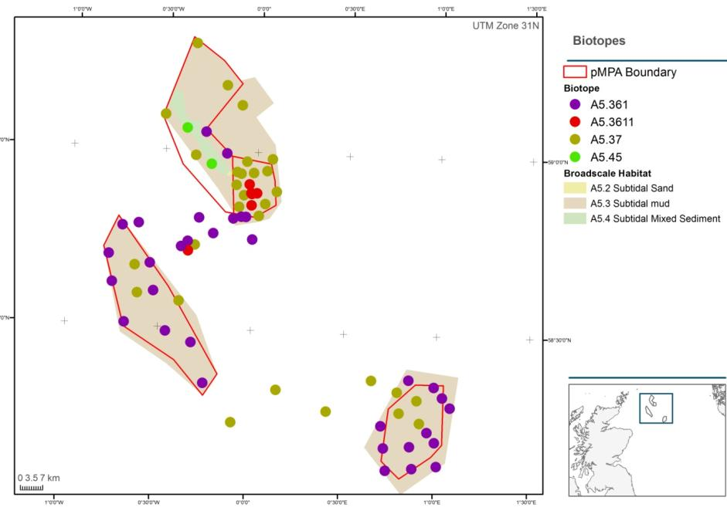
Figure 6.1: Example habitat map with point samples of recorded biotopes (from draft Fladen Ground survey report, copyright JNCC/Cefas).

Ideally maps should also display station codes and symbols to show sample type (grab, core, video section, still, dive transect etc.).

Biotope information to summarise in a report
The following template is provided as a guide to what should be included in a biotope report.
- Table of Contents
- Executive Summary
- Introduction
- Methods
  - Statistical methods used to undertake identification of epibiotal and infaunal communities
  - Methods/process undertaken to link biological communities observed with EUNIS/JNCC classification biotopes
  - Quality Assurance – Detail QA procedures in place for data analysis/interpretation. Results of any QA checks should be included.
- Results
  - Physical habitats
    - Overall summary of physical information
    - Contextual maps (e.g. multi-beam bathymetry, aerial photography)
    - Map of physical habitats (for sublittoral, use EUSeaMap if no map from is survey available) with sample locations and PSA results as points
    - Description and map(s) showing confidence in physical habitat map.
  - Epibiota
    - Patterns in epibiotal communities – discussion of analysis results, characterising species
    - Distribution maps of epibiotal clusters (overlay on habitat map)
    - Description of epibiotal biotopes present
  - Infauna
    - Patterns in infaunal communities – discussion of analysis results, characterising species
    - Distribution map of infaunal clusters (overlay on habitat map)
    - Description of infaunal biotopes present
- Discussion/Conclusions
  - Discussion of epibiotal and infaunal biotopes present
  - Distribution map with both infaunal and epibiotal biotopes as sample points (overlay on habitat map and other contextual maps)
  - Data limitations/issues
- References
- Appendices
  - Sample summary table (e.g. Appendix 2 in this report)
  - Results/outputs of analyses
It is useful for reports to provide a clear summary of each biotope identified (points 5.2.3 and 5.3.3 in the report structure above). This summary should specify which samples were assigned to each biotope so it is possible to link them to raw data and cross-reference with maps showing sampling locations. Biotope summaries should give a full picture of the associated biology and physical environment. A similar summary should be provided for potential new biotopes. Samples recording a mosaic of two biotopes should be listed under the summary for both. Example biotope summaries are provided below.

Example biotope summary – Epibiota

EUNIS: A5.141 Pomatoceros triqueter with barnacles and bryozoan crusts on unstable circalittoral cobbles and pebbles
MHCBI: SS.SCS.CCS.PomB
Stations: 1, 5
Video tow sections: T123_STN1_H1, T123_STN5_H2
Stills: T123_STN1_H1_001-005, T123_STN5_H2_001-007
Depth range: 40 – 55 m
Substrate: Poorly sorted fine – very coarse sand with gravel and pebbles. Folk gS and sG. EUNIS coarse sediment.
Epibiota community: Encrusting bryozoa, serpulid worms and barnacles attached to stony material present. Characterising taxa: Spirobranchus triqueter (previously Pomatoceros), Balanus, and Flustra foliacea
Epibiota multivariate clusters: B, C
Comments: Some samples tagged with this biotope were recorded on a sand rather than coarse sediment substrate.
Example seabed photographs:
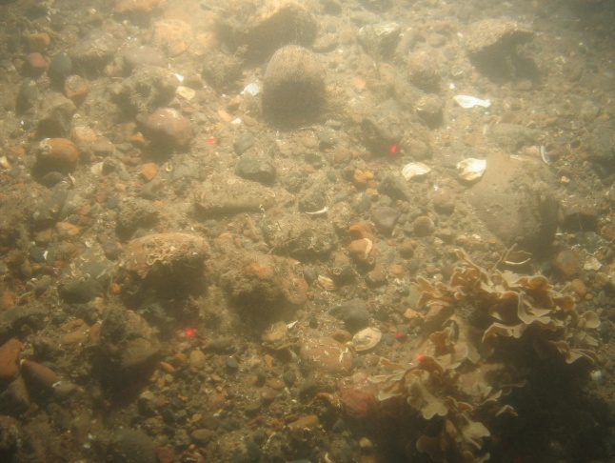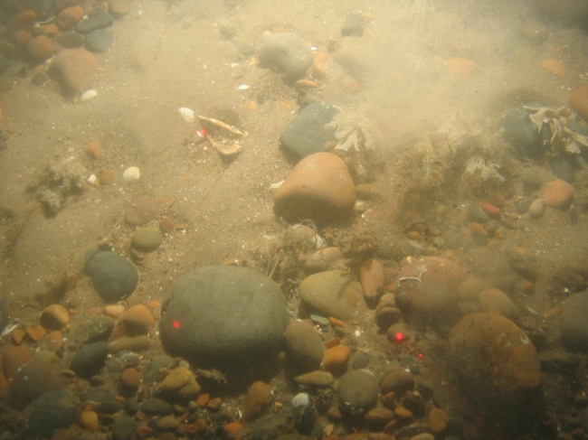

EUNIS: A5.26x Circalittoral muddy sand
MHCBI: SS.Ssa.CMSa
Stations: 2, 4
Video tow sections: T123_STN2_H1, T123_STN4_H1
Stills: T123_STN2_H1_001-010, T123_STN2_H4_001-04
Depth range: 42 – 65 m
Substrate: Poorly sorted muddy fine sand. Folk mS. EUNIS Sand and muddy sand.
Epibiota community: Sparse epibiota, occasional Paguridae
Epibiota multivariate clusters: D
Comments: Community was sparse and could not be matched to any existing biotopes so level 4 assigned based on physical data.
Example seabed photographs:
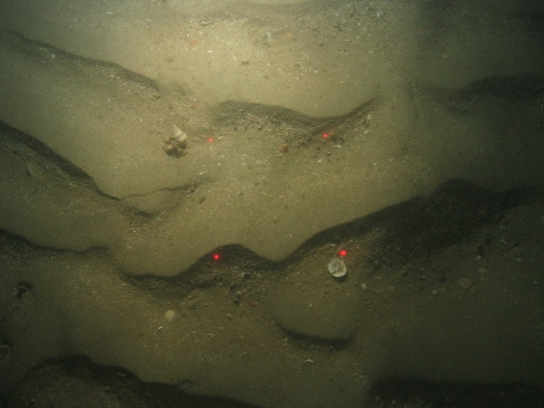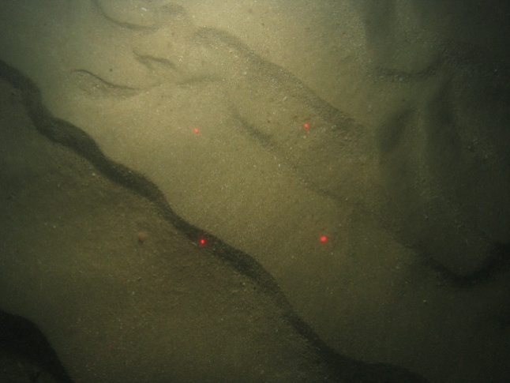

Example biotope summary – Infauna

EUNIS: A5.251 Echinocyamus pusillus, Ophelia borealis and Abra prismatica in circalittoral fine sand
MHCBI: SS.Ssa.CfiSa.EpusOborApri
Stations: 3, 6
Grabs: T123_STN3_HC1, T123_STN6_HC2
Depth range: 30 – 45 m
Substrate: Poorly sorted fine – very coarse sand. Folk (g)S. EUNIS sand and muddy sands.
Infaunal community: Diverse community dominated by polychaetes with bivalves, amphipods and occasional decapods. Characterising taxa: Echinocyamus pusillus, Glycera lapidum, Nemertea, Ophelia borealis and Spatangoida.
Infaunal multivariate clusters: A, B
Example physical sample photographs:

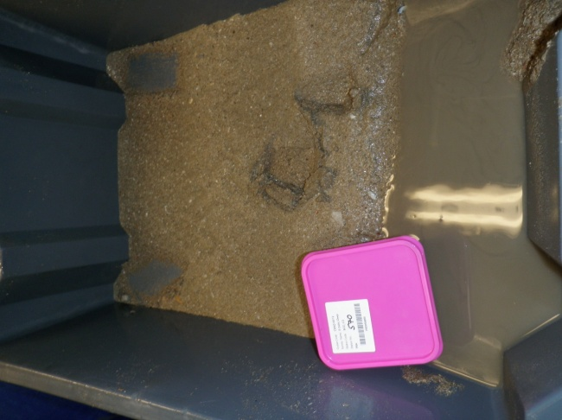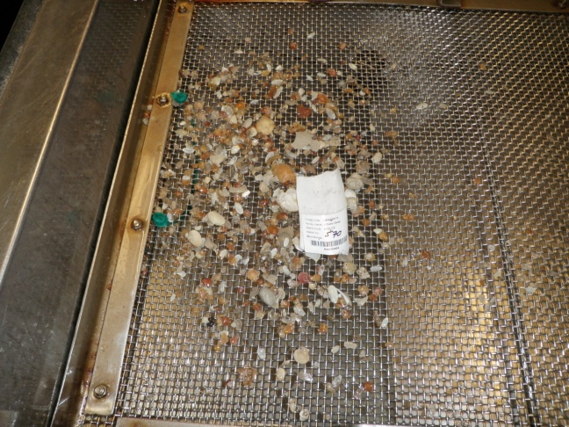

References
Cameron, A, N Askew. EUSeaMap – Preparatory Action for development and assessment of a European broad-scale seabed habitat map final report. EC Contract No MARE/2008/07, 1-241. 2011. EMODNet; JNCC; Ifremer; DHI; ISPRA; Danish Ministry of the Environment.
Clarke, K R and R M Warwick. 1994. Change in marine communities: An approach to statistical analysis and interpretation. Plymouth Marine Laboratory.
Connor, D, J H Allen, N Golding, K L Howell, L M Lieberknecht, K O Northen, J Reker. The Marine Habitat Classification for Britain and Ireland. Version 04.05. Littoral Rock Section. 2004. The Marine Habitat Classification for Britain and Ireland.
Connor, D. Rock-Sediment issues in marine habitat classification and mapping (draft). 2009. Internal JNCC document
Davies, CE, D Moss. EUNIS Habitat Classification Marine Habitat Types: Revised Classification and Criteria. C02492NEW. 2004. Centre for Ecology & Hydrology (CEH) Dorset.
Davies, J, J Baxter, M Bradley, D Connor, J Khan, E Murray, W G Sanderson, C G Turnbull, M Vincent. Marine Monitoring Handbook. Davies, J., Baxter, J., Bradley, M., Connor, D., Khan, J., Murray, E., Sanderson, W. G., Turnbull, C. G., and Vincent, M. 2001. JNCC. UK Marine SACs Project.
Folk, R.L., 1954. The distinction between grain size and mineral composition in sedimentary rock nomenclature. Journal of Geology 62 (4), 344-359.
Irving, R. JNCC 432 – The identification of the main characteristics of stony reef habitats under the Habitats Directive. 432, 1-42. 2009. JNCC.
James, J W C, B Pearce, R A Coggan, S H L Arnott, R Clark, J F Plim, J Pinnion, C R S Barrio Frojan, C Gardiner, A Morando et al. 2010. The South Coast Regional Environmental Characterisation. Marine Aggregate Levy Sustainability Fund (MALSF). British Geological Survey Open Report OR/09/51, 1-249. Marine Aggregate Levy Sustainability Fund (MALSF).
Long, D. 2006. BGS detailed explanation of seabed sediment modified folk classification. Available at http://www.searchmesh.net/PDF/GMHM3_Detailed_explanation_of_seabed_sediment_classification.pdf
McBreen, F., Askew, N. and Cameron, A. 2011. UKSeaMap 2010 Technical Report 3: Substrate data. June 2011.
Robinson, K A, K Ramsay, C Lindenbaum, N Frost, J Moore, D Petrey, and T Darbyshire. 2009. Habitat Mapping for Conservation and Management of the Southern Irish Sea (HABMAP). II: Modelling & Mapping. Studies in Marine Biodiversity and Systematics from the National Museum of Wales. BIOMÔR Reports 5(2): 210pp & DVD.
Wyn, G, P Brazier, K G Birch, A Bunker, A Cooke, M Jones, N Lough, A McMath, S Roberts. CCW Handbook for Marine Intertidal Phase 1 Biotope Mapping Survey. 2006. CCW.
Appendix 1: Version tracker
BUILD STATUS:
Version | Date | Author | Reason/Comments
1.0 | 15.07.13 | Megan Parry | First draft
1.1 | 19.08.13 | Megan Parry | For internal use only
1.2 | 14.10.13 | Megan Parry | Incorporate NE comments
1.3 | 19.11.13 | Megan Parry | Add details on statistical analysis for analysis contract
1.4 | 21.11.13 | Megan Parry | Incorporate comments from NRW and SNH
1.5 | 20.03.14 | Megan Parry | Adapt biotope report structure
1.5 | 20.03.14 | Megan Parry | Incorporate comments from HE (JNCC)
DISTRIBUTION:
Copy | Version | Issue Date | Issued To
Link | 1.0 | 19.07.13 | Circulated internally to NG, GJ, NA
Electronic | 1.1 | 20.08.13 | JE – Cefas
Link | 1.2 | 22.10.13 | Internal MN, GJ, NG, NA
Electronic | 1.2 | 23.10.13 | KD, GB, BG (NE); KR (NRW); LC (SNH)
Link | 1.3 | 21.11.13 | Internal NG, MN
Link | 1.4 | 09.01.14 | Internal BH
Link | 1.4 | 14.01.14 | Internal NG, GJ, NA
Electronic | 1.5 | 01.01.15 | Comms, HE
Electronic | 1.6 | 04.03.15 | Comms

Appendix 2: Example sample biotope summary table
Area | Stn code | Sample | Gear type | Zone | Broad Substrate | Detailed Substrate description | Energy/ sediment mobility | Salinity | Characterising sp. | Multi-variate cluster | EUNIS level 3 | MHCBI Biotope code | EUNIS biotope code | Comment
Fladden grounds | FTR01 | FTR01_01_H1 | CS - video | Circalittoral | Mud | Mud with a small sand fraction (M) | Unknown | Full | Virgularia mirabilis  Paguridae | A | A5.3 | SS.SMu.CfiMu.SpnMeg | A5.361
Fladden grounds | FTR01 | FTR01_01_H1_001 | CS - still | Circalittoral | Mud | Mud with a small sand fraction (M) | Unknown | Full | Virgularia mirabilis  Paguridae | A | A5.3 | SS.SMu.CfiMu.SpnMeg | A5.361
Fladden grounds | FTR01 | FTR01_01_H1_002 | CS - still | Circalittoral | Mud | Mud with a small sand fraction (M) | Unknown | Full | Virgularia mirabilis  Paguridae | A | A5.3 | SS.SMu.CfiMu.SpnMeg | A5.361
Fladden grounds | FTR01 | FTR01N_03 | HG | Circalittoral | Mud | Mud with a small sand fraction (M) | Unknown | Full | Pholoe sp.  Glycera sp.  Corbula gibba  Brissopsis lyrifera | A | A5.3 | SS.SMu.CfiMu.SpnMeg | A5.361
Fladden grounds | FTR02 | FTR02_01_H1 | CS - video | Circalittoral | Mud | Mud with a small sand fraction (M) | Unknown | Full | Virgularia mirabilis Amphiura filiformis  Pecten maximus | B | A5.3 | SS.SMu.CSaMu.VirOphPmax | A5.354
Fladden grounds | FTR02 | FTR02_01_H1_001 | CS - still | Circalittoral | Sand | Muddy sand (mS) | Unknown | Full | Virgularia mirabilis Amphiura filiformis  Pecten maximus | B | A5.2 | SS.SMu.CSaMu.VirOphPmax | A5.354 | Physical mismatch – substrate sand
Fladden grounds | FTR02 | FTR02_02 | HG | Circalittoral | Mud | Mud with a small sand fraction (M) | Unknown | Full | Amphiura filiformis  Mysella bidentata  Phaxas pellucidus  Nuculoma tenuis | B | A5.3 | SS.SMu.CSaMu.AfilNten | A5.353
Fladden grounds | FTR03 | FTR03_01_H1 | CS - video | Circalittoral | Mud | Sandy mud (sM) | Unknown | Full | Paguridae | C | A5.3 | SS.SMu.CfiMu | A5.36
Fladden grounds | FTR04 | FTR04_01_H1 | CS - video | Circalittoral | Mud / Rock | Mud (M) with pebbles and cobbles | High energy | Full | Virgularia mirabilis  Paguridae Phakellia sp.  Axinella sp. | C | A5.3 | SS.SMu.CfiMu.SpnMeg / CR.HCR.DpSp.PhaAxi | A5.361 / A4.121 | Approx 80% mud 20% rock
Fladden grounds | FTR04 | FTR04_01_H2 | HG | Circalittoral | Mud | Mud (M) | Unknown | Full | Galathowenia oculata  Lagis koreni  Spiophanes sp.  Abra alba  Nucula sulcata | D | A5.3 | SS.SMu.CfiMu.x | A5.36x | Possible new biotope

Appendix 3: JNCC Guide Definitions for Substrate Types Used in EUNIS and the Marine Habitat Classification of Britain and Ireland

In order to select the appropriate habitat types in the EUNIS Classification (Davies and Moss, 2004) and JNCC Marine Habitat Classification of Britain and Ireland (Connor et al., 2004) substrate is compulsory. It is, therefore, important that the correct substrate category is identified from survey data.

It should be noted that terminology in the JNCC classification refers to the substrate particle size categories used for the MNCR, which are also used when entering substrate information from visual interpretation into Marine Recorder (Table A 1). These categories differ slightly from those used in the Wentworth scale and Folk classification. PSA data entered into Marine Recorder (MR) is also aggregated to slightly different categories. These differences in terminology should be kept in mind when interpreting several types of data as the categories will not be directly comparable.

This document provides some general guidance on how to identify the correct substrate category in the EUNIS/JNCC classifications.

Table A 1: Sediment particle sizes and equivalent classification terms*
Mm | Phi | Wentworth | Folk | MNCR (video in MR) | PSA categories in MR
2048 | -11 | Boulder | Gravel | Very large boulders | NA
1024 | -10
512 | -9 | Boulder | Gravel | Large boulders | NA
256 | -8 | Boulder | Gravel | Small boulders | NA
128 | -7 | Cobble | Gravel | Cobbles | NA
64 | -6
32 | -5 | Pebble | Gravel | Pebbles | Medium pebbles
16 | -4
8 | -3 | Pebble | Gravel | Gravel | Medium pebbles
4 | -2 | Pebble | Gravel | Gravel | Small pebbles
2 | -1 | Granule | Gravel | Coarse sand | Granule
1 | 0 | Very coarse sand | Sand | Coarse sand | Very coarse sand
0.5 | 1 | Coarse sand | Sand | Medium sand | Coarse sand
0.25 | 2 | Medium sand | Sand | Medium sand | Medium sand
0.125 | 3 | Fine sand | Sand | Fine sand | Fine sand
0.063 | 4 | Very fine sand | Sand | Fine sand | Very fine sand
0.031 | 5 | Silt | Mud | Mud | Silt and clay
0.016 | 6
0.008 | 7
0.004 | 8
0.002 | 9 | Clay | Mud | Mud | Silt and clay
*Note: when classifying habitats using visual data, Wentworth stable pebbles/cobbles and boulders (or the equivalent in other sediment classifications) are considered to be ‘rock’ rather than sediment.

Method for identification of substrate type
When assigning a substrate type (and associated habitat code) to an area it is important to consider all available data collected within the habitat together, and not rely on data collected using a single method, for a number of reasons:
- It is not possible to grab rock
- Grabs may not retain certain fractions of the substrate
- Grabs/stills may sample a small patch of a heterogeneous seabed which is not representative of the wider area
- It is not possible to accurately identify mud fractions using video
- It is not easy to identify particle size using video

Considering these points it is recommended that, where possible, surveys undertaken to characterise habitats include both visual and grab sample data acquisition for ground-truthing. If only visual data is available, it may not be possible to reliably distinguish between level 3 broad substrate types, and where this is the case a level 2 ‘rock’ or ‘sediment’ habitat type will have to be assigned.

The following steps should be undertaken to identify habitats with the appropriate substrate:
- Interpret video data
  - Identify sections of video footage with the same habitat
  - Use stills with calibrated lasers displayed in the field of view to help estimate particle size of substrate
  - For each habitat assign a EUNIS/JNCC classification substrate type based on the proportion of different particle sizes
- Interpret grab data
  - Review PSA results
  - Verify PSA captures substrate variation using any HamCam footage of the surrounding seabed
  - Assign EUNIS/JNCC classification substrate type based on PSA and video
- Cross check concurrent video and grab data and summarise habitats present
  - Overlay grab and video sample location with acoustic data and identify those that potentially sample the same habitat
  - Using all available data assign a final EUNIS/JNCC classification substrate type (and an associated habitat code) to each habitat
  - Usually a report will list each habitat type with a description of substrate and biology, and state which samples (video or grab) were taken within that habitat

Definition of substrate categories
Habitats are assigned by making a stepwise progression through the hierarchy of a classification. Habitat types specify substrate categories which are increasingly more specific at each next level.

Level 2
At level 2 in the EUNIS/JNCC classification classifications habitat types are divided into two substrate categories – rock and sediment. Rock is considered to include both bedrock and stony material (stable pebbles/cobbles and boulders). It can be broadly be defined as substrate which supports erect epibiota although, in areas of high energy/scour, rock may support no epibiota, or only crusts/ shelled epibiota. Table A 2, produced for an internal JNCC reference document (Connor, 2009), provides a summary of which substrate types (using the Wentworth classification) would be classified as rock. This depends on both the particle size and stability/scour. Boulders and bedrock are always rock regardless of stability. Cobbles are considered rock if stable enough to support robust erect epibiota, while pebbles must be stable enough to support fragile epibiota. If an area of pebbles/cobbles is known to have high energy and mobile substrata, and there are few erect epibiota, it is likely to be sediment habitat.

Table A 2: Summary definition of rock and sediment substrata for the purpose of habitat assignment (adapted from Connor, 2009).

Rock Summary

Substrate types included:
- Bedrock
- Boulders, stable cobbles, stable pebbles (and mixtures of these)

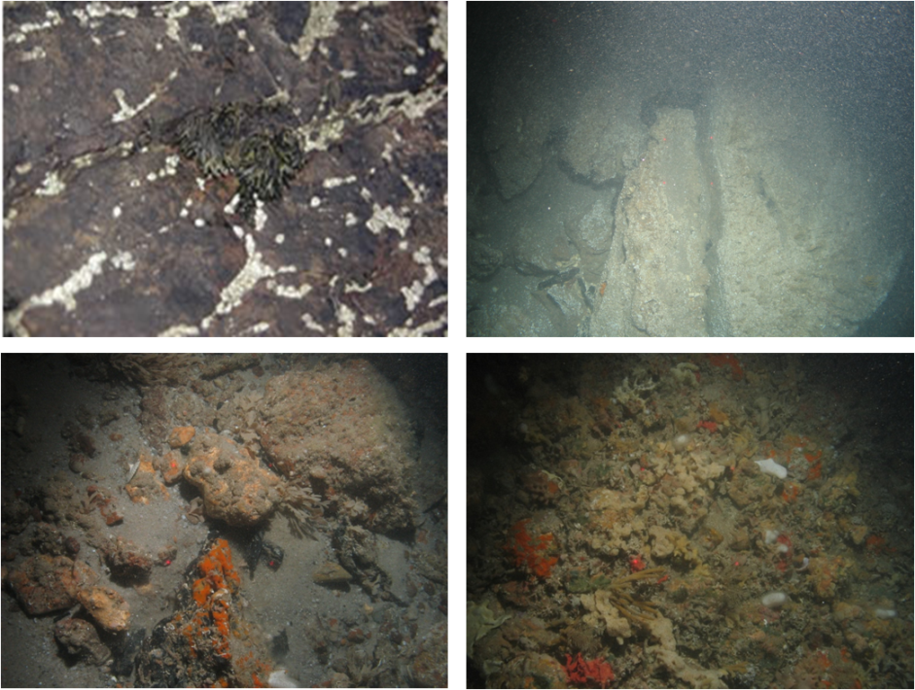
Figure A 1: Example photographs showing variation in rock substrate.

Sediment summary

Substrate types included:
- Unstable cobbles, unstable pebbles, gravel, sand or mud
- Mixtures of the above

Level 3

At level 3 in the EUNIS/JNCC classification, sediment is further divided into four categories – ‘coarse sediment’, ‘mixed sediment’, ‘mud and sandy mud’, and ‘sand and muddy sand’. It is recommended that these categories are defined based on the proportions of mud, sand and gravel as displayed in Figure A 2, which shows the classes superimposed onto the Folk ternary diagram which describes sediments based on the relative proportions of mud, sand and gravel as described by the Folk classification (Folk, 1954). The sediment type descriptions below are described using the Folk classification; however, it should be noted that, for habitat classification of visual data, ‘Gravel’ (G) should be considered to exclude stable pebbles, cobbles and boulders as these would be classified as rock. For practical purposes, all pebbles and cobbles found in grabs can be included under ‘Gravel’.

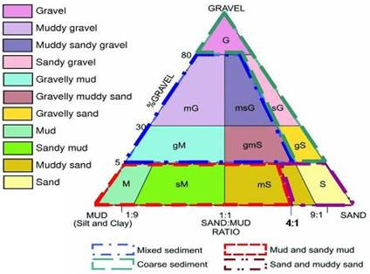
Figure A 2: Folk ternary diagram with suggested aggregations of Folk classes for defining level 3 sediment types

Mixed sediment summary

The key difference between ‘coarse sediment’ and ‘mixed sediment’ is the proportion of mud present. Mixed sediment has a higher proportion of mud as shown in Figure A 2. It can be difficult to identify the proportion of mud using video footage (Figure A 3). The presence of mud is indicated when fine material is suspended in the water column when the camera system hits the seabed. The results of PSA analysis from grab samples taken in the vicinity of video footage are useful in confirming the proportion of mud present. The term ‘mixed sediment’ should not be confused with ‘mixed substrate’ which refers to any mixture of sediment and rock. Mixed sediment specifically includes the following types of substrate:
- Mixture of mud and gravel2
- Mixture of mud, sand and gravel

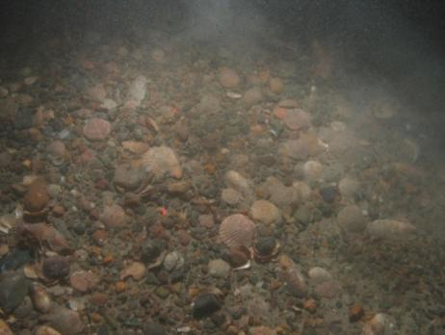
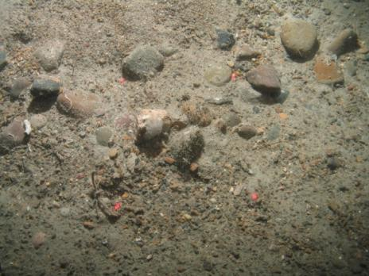
Figure A 3: Example photographs of mixed sediment.

Coarse sediment summary

Substrate types included:
- Gravel
- Mixture of sand and gravel (with minimal mud) - see Figure A 2

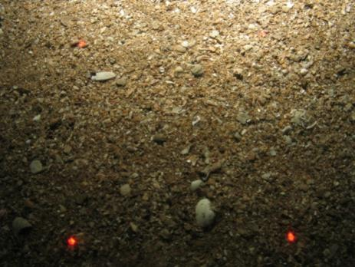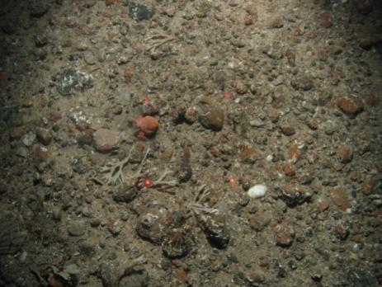
Figure A 4: Example photographs of coarse sediment

‘Mud and sand mud’ and ‘Sand and muddy sand’ summary

The key difference between ‘mud and sandy mud’ and ‘sand and muddy sand’, is the proportion of mud present, as shown in Figure A 2. The results of PSA analysis are useful in confirming the proportion of mud. ‘Mud and sandy mud’ and ‘sand and muddy sand’ may have only a very small proportion of ‘gravel’, as shown in Figure A 2.

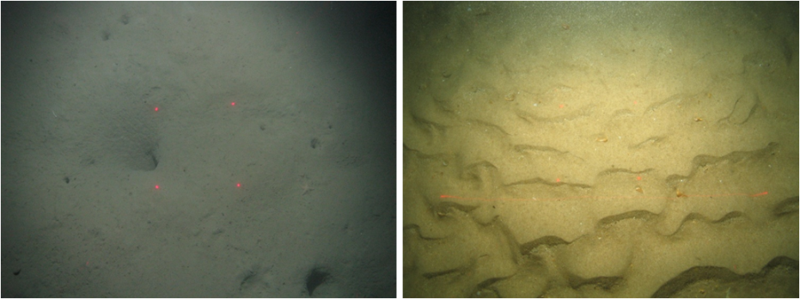
Figure A 5: Example photograph of ‘mud and sandy mud’ (left) and ‘sand and muddy sand’ (right).

Mosaic Substrates
Mosaic substrates are made up of more than one substrate type occurring together in a patchwork. Where this is the case, the habitat can be described as having a mosaic of substrate x and substrate y, and two biotopes would be assigned (one associated with substrate x and one with substrate y). Substrate that contains a mosaic of rock and sediment is termed ‘mixed substrata’. If rock and sediment are both present in significant proportions it would be valid to describe the habitat as having a mosaic substrate. As an example, if communities appear to comprise a combination of rock assemblages and mud assemblages the substrate could be classed as a mosaic of ‘rock’ and ‘mud and sandy mud’. In these areas both a rock and a mud biotope would be assigned. Mosaic substrates can also be a patchwork of more than one sediment type, such as ‘sand and muddy sand’ interspersed with ‘coarse sediment’, as commonly occurs in association with sand waves. It can be difficult to distinguish between rock/sediment mosaics and coarse or mixed sediment using multi-beam bathymetry and backscatter data only, so video and grab ground-truthing should be used to aid identification.

In the past it has not been common practice to assign mosaics of two substrate types to data. Instead, data have generally been assigned to the predominant substrate type. A common mosaic substrate is rock (stable pebbles, cobbles and boulders) with mixed sediment (mud, sand and gravel). In the past these substrate types have frequently been assigned to mixed sediment if the sediment proportion is greater than the rock proportion. This means it is then not possible to distinguish between mixed sediment with a rock component, and mixed sediment without. This can cause issues for trying to identify those areas which could be classed a ‘stony reef’. Considering this, it is now recommended that a rock/sediment mosaic is assigned to any substrates with significant proportions of both.

In the EUNIS/JNCC classification, some biotopes with ‘mixed substrata’ comprised predominantly of rock are located within the rock section. These mixed substrata biotopes typically describe only the epibiotal rock component of the community and could be considered as rock biotopes. It may be considered appropriate in the future to rename these biotopes as rock to avoid confusion.

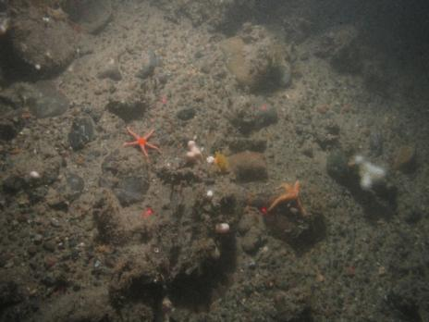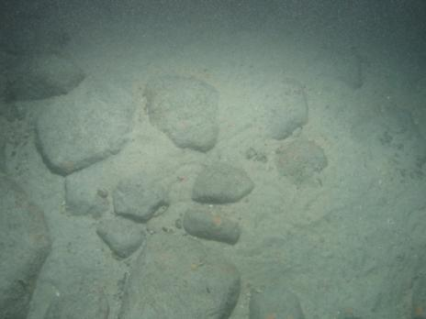
Figure A 6: Example photograph of ‘rock’ / ‘mixed sediment’ mosaic (left) and ‘rock’ / ‘mud’ mosaic (right).

Stony reef
In addition to identifying habitats using the EUNIS or JNCC classification, it is often necessary to identify those areas which meet the requirements to be one of several habitats listed for protection under Annex I of the Habitats Directive, e.g. Reef, which can be either biogenic or geogenic (rocky). Rocky reef can be either bedrock or a ‘stony reef’ comprising cobbles and boulders. Habitats with 100 % rock substrate will mostly qualify as reef, but stony reefs need to meet the criteria in Irving (2009). Mosaics of stony reef and sediment would also qualify if the percentage cover of cobbles and boulders is great enough. There are specific criteria which have to be met to be a stony reef (Table A 3) (Irving, 2009) so this assessment should be undertaken independently of defining areas of broad EUNIS substrate types. Resulting Annex I stony reef maps should be overlain onto interpreted habitats rather than existing maps being reclassified. An Annex I reef assessment may not necessarily have the same boundaries as EUNIS habitats; for example, only part of a mixed sediment/rock mosaic may be stony reef (Figure A 7). It is recognised that it may not be possible to distinguish areas of sparser pebble/cobble rocky reef from surrounding mixed or coarse sediments using acoustic data only. As noted in the previous section, in the past, habitats with a mosaic of rock and sediment have been frequently been assigned to mixed sediment or coarse sediment, and these habitats may or may not meet Annex I stony reef criteria.

Table A 3: Characteristics of stony reef (from Irving, 2009).
Characteristic | Not a ‘stony reef’ | ‘Resemblance’ to being a ‘stony reef’
Characteristic | Not a ‘stony reef’ | Low | Medium | High
Composition  (proportion of boulders/cobbles (>64 mm)) | <10 % | 10-40 % matrix-supported | 40-95 % | >95 % clast-supported
Elevation | Flat seabed | <64 mm | 64 mm-5 m | >5 m
Extent | <25 m² | >25 m²
Biota | Dominated by infaunal species |  |  | >80 % of species present composed of epibiotal species

Figure A 7: Example to illustrate how stony reef boundaries may not match habitat boundaries.

Summary
Table A 4 provides some general descriptions for each of the broad substrate types used in the EUNIS and JNCC classification, identifies which habitats explicitly have these substrate types, and whether or not they could potentially include areas of Annex I ‘stony reef’ (see Table A 3 for detailed stony reef criteria).

Table A 4: Descriptions of substrate categories
Substrate | Relevant EUNIS Codesª | Relevant JNCC classification Codesª | General description^{b} | Annex I reef?
Rock | A1, A3, A4 | LR, IR, CR | Rock (Bedrock or any mixture of stable pebbles/cobbles and boulders) | Bedrock – yes; stony reef – if meets criteria
Mixed sediment | A2.4, A5.4 | LS.LMx, SS.SMx | Mixtures of mud, sand and gravel, or mud and gravel | No^{c}
Coarse sediment | A2.1, A5.1 | LS.LCS, SS.SCS | Gravel, or mixtures of sand and gravel | No^{c}
Mud and sandy mud | A2.3, A5.3 | LS.LMu, SS.Smu | Mud and sandy mud | No
Sand and muddy sand | A2.2, A5.2 | LS.Lsa, SS.Ssa | Sand and muddy sand | No
Rock/ sediment mosaic | A1, A3, A4  with any other code | LR, IR, CR with any other code | A patchwork of rock with any type of sediment. | If rock >10% Stony reef must meet criteria
ª Includes ‘child’ types
^{b} For habitat classification purposes, Gravel excludes stable pebbles, cobbles and boulders which are classified as rock.
^{c} In the past, mixtures of rock and sediment have generally been assigned to mixed sediment or coarse sediment rather than being described as a mosaic of rock and sediment. Past data assigned to mixed sediment or coarse sediment may have a significant rock component and, therefore, meet criteria to be Annex I reef.

http://jncc.defra.gov.uk/marine/biotopes/hierarchy.aspx
.euhttp://www.emodnet-seabedhabitats/default.aspx?page=1939
http://www.nmbaqcs.org/reports.aspx
http://jncc.defra.gov.uk/page-2683
http://jncc.defra.gov.uk/pdf/lhabform.pdf
http://jncc.defra.gov.uk/pdf/shabform.pdf
http://www.seasearch.org.uk/downloads/SeasearchBiotopeKeyDec07web.pdf
Data layers available at http://jncc.defra.gov.uk/page-6266
http://www.ccgc.gov.uk/landscape--wildlife/habitats--species/habmap/downloads.aspx
http://jncc.defra.gov.uk/pdf/04_05_introduction.pdf
www.emodnet-seabedhabitats.eu/outputs
Available through EMODnet Seabed Habitats webGIS www.emodnet-seabedhabitats.eu/webgis
These groupings were created to cluster similar biotopes together – they are not intended as a sediment classification system, but to generally reflect the usual sediment type associate with the communities described in the biotopes.
http://jncc.defra.gov.uk/pdf/04_05_introduction.pdf
See the EMODnet Seabed Habitats webGIS: www.emodnet-seabedhabitats.eu/webgis
http://eunis.eea.europa.eu/habitats-code-browser.jsp
http://jncc.defra.gov.uk/marine/biotopes/hierarchy.aspx
http://www.emodnet-seabedhabitats.eu/pdf/GMHM1%20EUNIS_Habitat_Classification_Revised_2004.pdf
http://jncc.defra.gov.uk/page-1645
The recommended classification for broad sediment types is based on a by-eye interpretation of the distribution of communities on a ternary diagram (Long, 2006). Other site-specific studies (e.g. [Humber REC?]) have found that alternative classifications are more biologically relevant for certain areas, while McBreen et al, (2011) found no conclusive biologically-relevant categorisations for broad sediment types for the wider. Therefore for consistency the categorisation described in Long (2006) is recommended.
Note: For habitat classification of visual data, Gravel excludes stable pebbles, cobbles and boulders which are classified as rock.
Note: For habitat classification using visual data, ‘Gravel’ excludes stable pebbles/cobbles and boulders which are classified as rock.
Note: For habitat classification of visual data, ‘Gravel’ excludes stable pebbles/cobbles and boulders which are classified as rock.
http://jncc.defra.gov.uk/pdf/web_432.pdf
When determining whether an area of the seabed should be considered as Annex I stony reef, if a ‘low’ is scored in any of the four characteristics (composition, elevation, extent or biota), then a strong justification would be required for this area to be considered as contributing to the Marine Natura site network of qualifying reefs in terms of the EU Habitats Directive.

