# GENERAL GROUND MAINTENANCE SPECIFICATION Ref GMG/3

**Note**

This specification must be read in conjunction with the Contract Procedure Rules.

**General Conditions**

The requirements for each location vary and the details are shown below.

The plans shown for each location define the sites and areas where grounds maintenance operations are to be carried out. Any plans have been provided for identification and information only and should not be used for estimating purposes.

1. **Grass Cutting**
   1. The contractor shall maintain the grass between 50 mm and 75 mm throughout the Contract period leaving no uncut grass between passes and no tufts or bents shall be left standing above the general sward area on completion of cut.
   2. The Contractor should recognise that it may be necessary to employ more than one type of machinery on a site in order to achieve this standard.
   3. Grass shall not be cut when ground conditions are so wet that damage to the surface occurs.
   4. Certain areas may be planted with naturalising bulbs and corms and these areas shall be left uncut until the plant leaves have died back.
   5. Mowing shall be carried out as close to fixed structures as possible. Moveable obstructions shall be removed to facilitate cutting and be replaced afterwards.
   6. The Contractor shall be required to maintain the grass along boundaries and around fixed obstacles such as posts, furniture and rubbish bins to the same standard as the main grass areas. This shall be achieved by use of edging shears or strimmer. The Contractor shall ensure that adequate care and attention is paid so as to prevent damage to the fixed objects.
2. **Pruning**
3. Pruning should be of a nature to maintain the shape and size of the shrubs and to ensure that they do not encroach on any accessibility of the public to the areas.
4. **Leaf Clearance**
5. During the autumn leaf fall, the Contractor shall clear and dispose of all fallen leaves.

**Location 1: Memorial Green, Haslemere High Street**

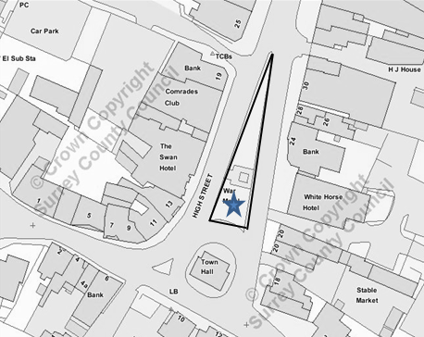

|  |  |
| --- | --- |
| **Task** | **No. of times per year** |
| Grass cutting | 30 |
| To supply and plant bedding (Spring & Autumn) | 2 |
| Edging and weeding of beds throughout the growing period | 30 |
| Weeding and treating of grassed area | As required |
| Trimming of Buxus hedge in circular bed and feed | 2 |
| Watering of bedding plants and eight tubs around the Town Hall May-September | 44 |

**Location 2: Flowerbeds in front of Half Moon House, High Street, Haslemere**

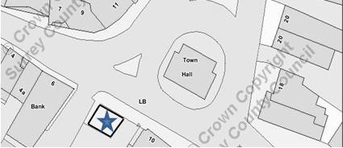

|  |  |
| --- | --- |
| **Task** | **No. of times per year** |
| To weed the bed in front of Half Moon House inclusive of pruning | 12 |
| To prune any perimeter shrubs as required | 2 |

**Location 3: Pocket Park at the bottom of Shepherds Hill, Haslemere**

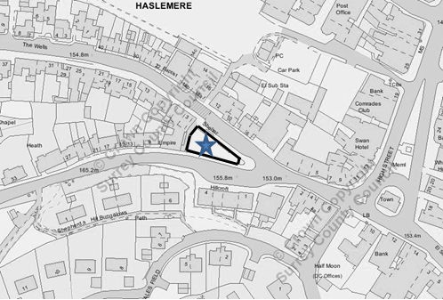

|  |  |
| --- | --- |
| **Task** | **No. of times per year** |
| Grass cutting | 25 |

**Location 4: Grass opposite Police Station, West Street, Haslemere**

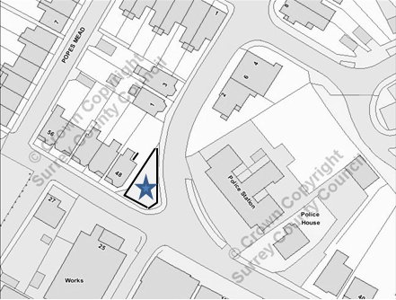

|  |  |
| --- | --- |
| **Task** | **No. of times per year** |
| Grass cutting | 20 |

**Location 5: Railway embankment, Lower Street, Haslemere**

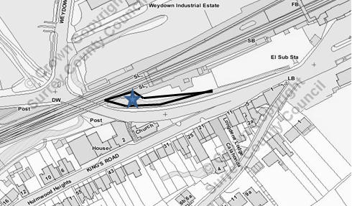

|  |  |
| --- | --- |
| **Task** | **No. of times per year** |
| To prune and weed the embankment bed. | 4 |

**Location 6: St Christopher’s Green (including the strip of land on the opposite side of Wey Hill, adjacent to Wey Hill car park)**

|  |  |
| --- | --- |
| **Task** | **No. of times per year** |
| Grass cutting | 20 |
| To remove epicormic growth and lift the crowns of the trees | 1 |
| Leaf clearance following autumn fall | As required |
| Grass cutting (strip of land adjacent to fairground car park) & removal of swarf on first cut | 15 |

**Location 7: Town Meadow, Tanners Lane, Haslemere**

|  |  |
| --- | --- |
| **Task** | **No. of times per year** |
| Grass cutting | 30 |
| To remove epicormic growth and lift the crowns of the trees | 1 |
| Leaf clearance following autumn fall | As required |
| To prune back hard hedges, shrubs and bushes around the perimeter of the paths and shape to the extent possible | 2 |
| To weedspray the paths around the park and going all the way through to the fire station as well as the play area | 4 |
| To cut hedge line along path from Town Meadow to the Fire Station to Town Meadow path | 2 |

**Location 8: Clement Corner, Wey Hill, Haslemere**

|  |  |
| --- | --- |
| **Task** | **No. of times per year** |
| Grass cutting | 20 |
| Hedge cutting | 2 |
| Prune shrubs | 2 |
| Weedspray bed | 10 |
| Remove epicormic growth and lift crowns of the trees | 1 |

**Location 9: Planting & Maintenance of Floral tubs in High Street, Haslemere**

## 

To supply and plant bedding plants to 31 flower tubs, twice a year (spring & autumn), add feed and water gel, exchange the compost twice per year and water them twice a week from May to September. The locations of the tubs are listed below.

|  |  |  |
| --- | --- | --- |
| **High Street** | **No. of Tubs** | **Location/Name of premises** |
| Town Hall | 4 | In front of the Town Hall |
| Town Hall | 3 | Behind the Town Hall |
| Half Moon House | 2 | Between the post box and benches |
| No. 10-12 | 1 | Headcase and old Lloyds Bank |
| No.20 | 1 | Raymond Reid Photos |
| No.23-25 | 3 | Brewers |
| No.26 | 1 | Keats Estate Agents |
| No.31-33 | 2 | Marley Flowers & Space NK |
| No.32 | 1 | Warren Powell Richardson |
| No.34 | 1 | Liphook Valet |
| No.35-35a | 1 | Seymours estate Agent |
| No.38 | 1 | Boots the Chemist |
| No.40 | 1 | Collingwood Batchelor |
| No.44 | 1 | Amazing Grace/Costa |
| No.46 | 1 | D&A Hair |
| **West Street** |  | |
| No.8-10 | 1 | Anya |
| No.14 | 1 | Have2haveit |
| No. 28 | 1 | Bakehouse |
| No.34-36 | 1 | Seabrights |
| **Petworth Road** |  | |
| No. 2-4 | 2 | Hasleworks by the bench |
| No.3-14 | 1 | Between Sports Locker & the Entertainer |
| No. 7 | 1 | Olive (our pot but they have put a plant in it and they are maintaining) |

**Location 10: The Woodcock Memorial Garden at the junction of the A287 & Beacon Hill Road, Beacon Hill.**

A287

|  |  |
| --- | --- |
| **Task** | **No. of times per year** |
| To mow and edge the grass | 20 |
| To weed the beds | 15 |
| Pruning of shrubs when appropriate in both locations marked with a blue star | 2 |

**Location 11: Grover’s Gardens, Wood Road, Hindhead**

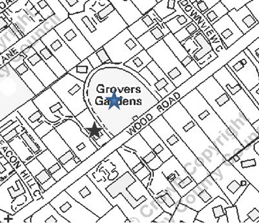

|  |  |
| --- | --- |
| **Task** | **No. of times per year** |
| To cut and edge the grass | 20 |
| Leaf clearance following autumn fall | 15 |
| To prune the hawthorn hedge adjacent to Wood Road | 2 |

**Location 12: Woodcock Green, Beacon Hill**

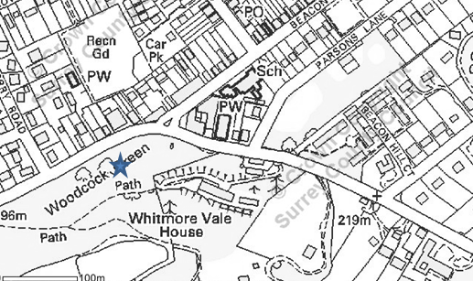

|  |  |
| --- | --- |
| **Task** | **No. of times per year** |
| To cut grass | 28 |
| Leaf clearance following autumn fall | 15 |

**Location 13: St Albans War Memorial, Hindhead**

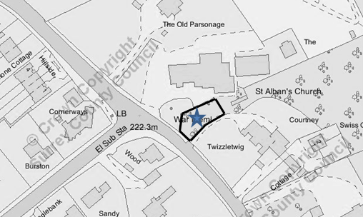

|  |  |
| --- | --- |
| **Task** | **No. of times per year** |
| Cutting and strimming of the lawn immediately around the memorial | 20 |
| Edging of the lawns surrounding the memorial. | 4 |
| Weed killing of the following hard standing areas, the base of front wall next to road, slabs around memorial and the base of the retaining wall of memorial area. | 5 |
| Removal of all leaves and debris during the winter. | As required |
| Triangle of grass at the side of the church opposite the community hall | 20 |
| Main lawn in front of church | 20 |

**Location 14: Golden Valley**

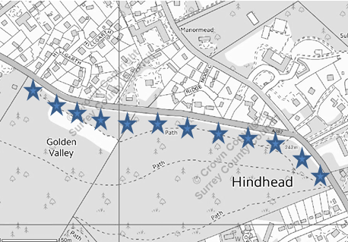

|  |  |
| --- | --- |
| **Task** | **No. of times per year** |
| Cut and strimmed | 14 |

**Location 15: Planting & Maintenance of Floral tubs in Beacon Hill area**

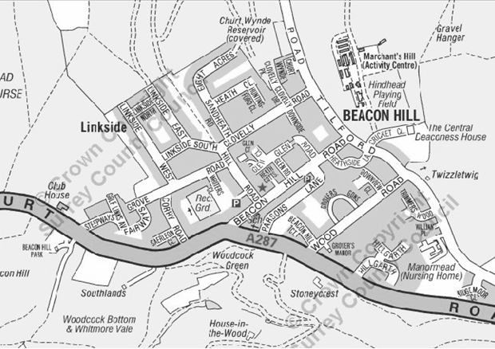

To supply and plant bedding plants to 17 flower tubs, twice a year (Spring & Autumn), add feed and water gel, and exchange the compost twice per year. The locations of the tubs are listed below:

|  |  |  |
| --- | --- | --- |
| **Churt Road** | **No. of Tubs** | **Location/Name of premises** |
| Churt Road (A287) | 1 | United Reformed Church*[1] |
| Churt Road (A287) | 2 | The Hub Coffee Bar * |
| Churt Road (A287) | 6 | Outside Lloyds Pharmacy * |
| Churt Road (A287) square wooden planters | 3 | Opposite junction to Beacon Hill Road* |
| **Beacon Hill Road** |  |  |
| 2 Beacon Hill Road | 2 | Headmasters |
| 1 Bank Side | 1 | Phyllis Tuckwell Hospice Charity Shop |
| Southdown House | 1 | Scoop |
| Devon House | 1 | Beacon Hill Boiler supplies |
| 3 Hampton Terrace | 1 | Carlo |
| 6 Hampton Terrace | 1 | Jamie Baker Fitness |
| No known number | 1 | Simply Fresh/Post Office |

**Location 16: Maintenance of areas at Clammer Hill allotment**

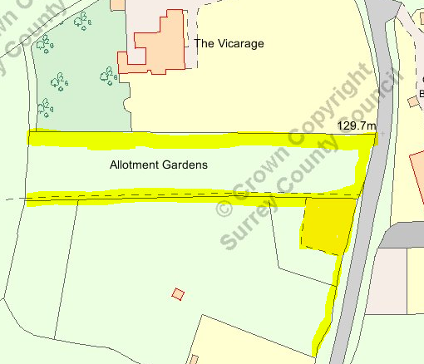

|  |  |
| --- | --- |
| **Task** | **No. of times per year** |
| Cut car park grass during growing season | 2 |
| Cut public footpath during growing season | 2 |
| Cut roadside hedge and remove waste | 2 |
| Cut top lefthand side hedge to 4 foot and remove waste | 1 |

1. Tubs marked with * are subject to damage by deer when thinking about planting