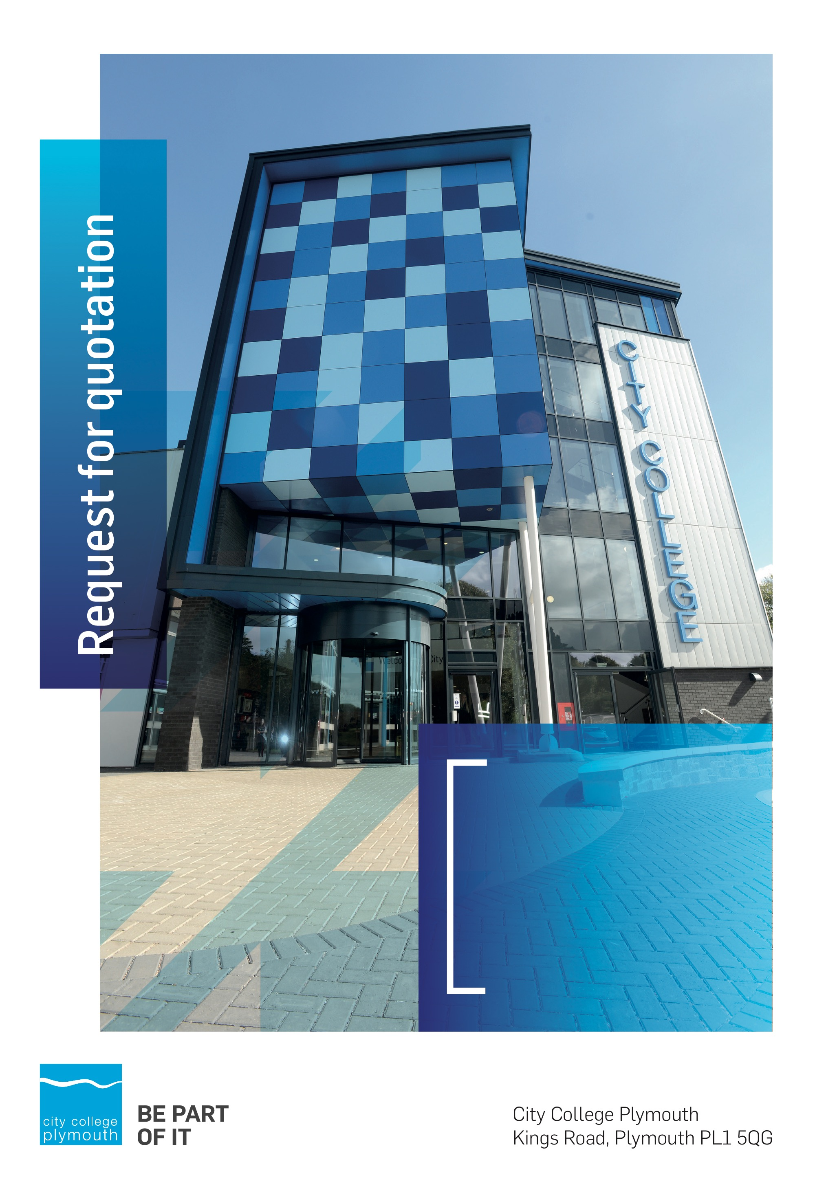

Request for Quotation
RFQ148
IOT Oceangate General Equipment
Issued 23rd July

Table of Contents
Table of Contents 2
Confidentiality Statement 3
Open Procedure 3
Submission Details 3
Submission Deadlines 3
Submission Questions and Clarifications 4
Electronic Submissions 4
Introduction and Executive Summary 5
Business Overview & Background 5
Our Vision … is where our future lies 5
Our Mission … is what we focus on each and every day 5
Background 5
Detailed Requirement 6
Terms and Conditions 7
Validity 7
Selection Criteria 7
Assessment of Quotations 7
Freedom of Information Act 2000 7
General Data Protection Regulation (GDPR) 2018 8
Agreement Conditions Acceptance and Declaration 8
Supporting Documentation 8

Confidentiality Statement
This document, and any attachments thereto, regardless of form or medium, is intended only for use by the addressee(s) and may contain legally privileged and/or confidential, copyrighted, trademarked, patented or otherwise restricted information viewable by the intended recipient only. If you are not the intended recipient of this document (or the person responsible for delivering this document to the intended recipient), you are hereby notified that any dissemination, distribution, printing or copying of this document, and any attachment thereto, is strictly prohibited and violation of this condition may infringe upon copyright, trademark, patent, or other laws protecting proprietary and, or, intellectual property. In no event shall this document be delivered to anyone other than the intended recipient or original sender and violation may be considered a breach of law fully punishable by various domestic and international courts. If you have received this document in error, please respond to the originator of this message or email him/her at the address below and permanently delete and/or shred the original and any copies and any electronic form this document, and any attachments thereto and do not disseminate further.
Thank you for your consideration, City College Plymouth.
Where no notice is given, all information contained herein is Copyright 2020 City College Plymouth.

Open Procedure
The College fully adheres to the requirements of the Public Contracts Regulations 2015, including for opportunities which are under threshold amounts.
Any Contractor who directly or indirectly canvasses any Member or Officer of the Institution, or advisor concerning the award of the contract for the provision of the services, or who directly or indirectly obtains or attempts to obtain information from any such member or Officer concerning any Tender or proposed Tender for the service will be disqualified from having his/her Tender considered.

Submission Details

Submission Deadlines
All submissions for responding to this Request for Quote must be submitted via email as stated below, no later than:
Friday 7th August 2020
12:00 Noon
Any submissions received after this date will not be considered.

Submission Questions and Clarifications
You may contact the following person if you have any questions or require clarification on any topics covered in this Request for Quotation by 3rd August 2020.
Adam Baker
Procurement Assistant
Phone: 01752 305313
Email: tenders@cityplym.ac.uk
All correspondence during the Tender should be channeled via the Procurement Officer using the above details only. Bidders found to have gained an unfair advantage shall be disqualified from the current opportunity and future opportunities with the College for a minimum of four (4) years.

Electronic Submissions
Electronic submissions in response to this Request for Quotation are required and must meet the following criteria:
Sent via email to: tenders@cityplym.ac.uk
Document standards:
- Text must be in Microsoft Word format;
- Price tables must be in Microsoft Excel format (using pricing schedule in Appendix A);
- Supportive evidence may additionally be submitted in PDF format;
- Images, Designs, and other supporting evidence may be in either JPEG or PDF format
- Signed Agreement Acceptance and Declaration.

Please note that the College is able to accept submissions sent in a compressed or “.zip” file format, so long as the files contained meet the standards described above.

WARRANTY:
By submitting your tender bid, you are warrantying to the College that you have not breached our canvassing or soliciting clause.

If any successful tenderer awarded a contract is found to have provided an inaccurate warranty, then the College reserves the right to terminate the awarded contract with immediate effect and re-tender the contract from which the successful tenderer will be excluded from re-bidding and shall be disqualified from any future opportunities for a period of four years.

Introduction and Executive Summary
The College is looking to purchase various specialist Engineering and IT equipment for delivery to commence in February 2021.
The anticipated value of the supply contract will exceed £25,000. Therefore, as per the Public contracts Regulations 2015 the opportunity will be advertised on the government portal ‘Contracts Finder’.

Business Overview & Background
The College operates on two sites within the city, serving 12,533 students and employing over 500 staff. The College operates year round, with opening times from 0800-2100 on some days.

Our Vision … is where our future lies
We are a College with a national reputation for promoting enterprise, employability and science, technology, engineering and mathematics (STEM).

Our Mission … is what we focus on each and every day
To be the South West’s leading provider of innovative, technical, professional education and training by supporting partnerships for growth, raising aspirations and fostering wealth creation

Background
City College Plymouth is one of the largest providers of innovative, technical and professional, education in the South West with a national reputation for promoting enterprise, employability and science, technology, engineering and mathematics (STEM). The College plays a central role in the educational, cultural and economic life of the region and works with strategic partners to facilitate growth, raise aspirations and foster wealth creation.
The College was awarded the Teaching Excellence Framework Gold award for its university-level provision and its most recent Ofsted inspection confirmed that the College continues to be ‘Good’ with outstanding features. The College was rated first in the South West and second nationally for student satisfaction in the latest FE Choices student satisfaction survey.
City College supports the region’s employers with their award-winning Apprenticeship provision, as well as providing a range of courses and bespoke training programmes which enable employees to upskill or retrain to better support their business’ requirements. Their successful partnership working with the local business community resulted in a 99.5% satisfaction rate in the Government’s national ‘FE Choices employer satisfaction survey 2016 to 2017’ - placing them first in the country for general further education colleges.
City College Plymouth offers a wide range of academic and vocational courses in a variety of subjects. The total number of students supported by the College is 12,533 –comprising of: 3,569 full-time students, including 765 higher education students and 179 non EU students; 8,964 part-time students; and 1,599 apprentices. The College also employs over 500 staff.

Detailed Requirement
City College Plymouth is looking to purchase a variety of general engineering equipment as per the spec listed in Appendix A. The equipment will be required for delivery commencing in February 2021, but the purchase of actual items will be prioritised and ordered over the next 3-6 months.
We would invite you to submit a price for the individual items as listed. Whilst the College would prefer to engage with a single supplier, we reserve the right to acquire individual items from the most cost effective supplier which may mean a pick and mix scenario could result. It is therefore essential that you clearly mark any items you cannot supply and also indicate any discounts you would apply for bulk purchase or exclusivity.
The College would expect to raise a purchase order for the goods as required. Please indicate if you are unable to accept purchase orders.
As curriculum delivery is due to commence in March 2021 it is essential you provide your lead in times for delivery for each of the items. This will help us to plan our timings for some modules if necessary. We also request you note any warranty periods where applicable, including any extended warranty periods available and the relevant costs.
Please note responding to this request and submitting prices does not give a commitment to buy. Our final purchases will depend on funding and student numbers. As this is a grant funded scheme separate approval for the purchase will need to be obtained from the Department of Education.
We estimate the total costs of the equipment to be in the region of £65,000.
Prices should be firm and valid at least until March 2021. The College does not expect any escalation in prices during this period but would expect to benefit from any price reductions should these apply.
We are willing to accept any further documentation you wish to submit to support your quotation.

Terms and Conditions
The College’s normal business terms are 1-2 months from the date of invoice. Payment will become due subject to the above upon the College’s full acceptance of the goods/services. This Request for Quotation and any resulting purchase order will be subject to the College’s General Terms and Conditions of Purchase of Goods/Services – see Appendix B.

Validity
Bidder’s offers should be open and valid for acceptance for a period of no less than four months [120] days from the date of submission.

Selection Criteria
The successful supplier will have provided the most cost effective tender to the College, which may mean the award of one or more items as outlined above. All bidders will be notified via email of the results of the outcome no later than 60 days from the date of submission.

Assessment of Quotations
Bidders must ensure that their quotation fully addresses all information requested within this RFQ document. Bidders must ensure that any quotation fully meets the specification required. The College reserves the right to discount any quotation which does not fully meet the specification.
The College reserves the right to seek clarification with bidders upon receipt of quotations.

Freedom of Information Act 2000
Under the Freedom of Information Act 2000 the College cannot guarantee that information provided by bidders during the course of this RFQ procedure or any resulting contract will be held a confidential. The College will not routinely release information to interested parties unless required to do so in order to meet our statutory obligations.

General Data Protection Regulation (GDPR) 2018
All bidders must comply with the General Data Protection Regulation (GDPR) 2018 in respect of using and processing personal information. Bidders must have in place technical and organisational safeguards to protect personal data from unauthorised use, disclosure or loss.
The College reserves the right to request a copy of your privacy statement if you are the successful bidder.

Agreement Conditions Acceptance and Declaration
Bidders are required to sign and return the attached Agreement Conditions Acceptance and Declaration, Appendix C.

Supporting Documentation
Appendix A: Pricing Schedule
Appendix B: City College Plymouth Standard Terms & Conditions
Appendix C: Agreement Conditions Acceptance and Declaration

