Request for Quotation

Subtidal *Sabellaria spinulosa* surveys in The Wash and North Norfolk Coast SAC & Inner Dowsing, Race Bank and North Ridge SAC

July 2023



**Contents**

Request for Quotation 3

Specification of Requirements 10

About Natural England 10

Project Background 10

Proposed Survey Area 12

Previous Surveys 15

Aims & Objectives 15

Methods 15

Outputs and Contract Management 18

Payment 20

Evaluation Methodology 20

Technical (60%) 21

Commercial (40%) 23

Annex 1 Mandatory Requirements 24

Part 1 Potential Supplier Information 24

Part 1.1 Potential Supplier Information: 24

Part 1. 2 Contact details and declaration 24

Part 2 Exclusion Grounds 25

Part 2.1 Grounds for mandatory exclusion 25

Part 2.2 Grounds for discretionary exclusion 27

Annex 2 Acceptance of Terms and Conditions 29

References 30

# Request for Quotation

**Subtidal *Sabellaria spinulosa* surveys in The Wash and North Norfolk Coast SAC & Inner Dowsing, Race Bank and North Ridge SAC**

You are invited to submit a quotation for the requirement described in the specification, Section 2.

Please confirm by email, receipt of these documents and whether you intend to submit a quote or not.

Your response should be returned to the following email address by:

Email: shannon.mccloskey@naturalengland.org.uk

Date: 04/08/2023

Time: 17:00

Ensure you include the name of the quotation and ‘Final Submission’ in the subject field to make it clear that it is your response.

Contact Details and Timetable

Shannon McCloskey (shannon.mccloskey@naturalengland.org.uk) will be your contact for any questions linked to the content of the quote or the process. Please submit any clarification questions via email and note that, unless commercially sensitive, both the question and the response will be circulated to all tenderers.

|  |  |
| --- | --- |
| Action | Date |
| Date of issue of RFQ | 13/07/2023 |
| Deadline for clarifications questions | 02/08/2023 |
| Deadline for receipt of quotation | 04/08/2023 |
| Intended date of contract award | 07/08/2023 |
| Intended contract start date | 09/08/2023 |
| Intended date for completion of surveys | 30/09/2023 |
| Intended date for delivery of final outputs | 01/03/2024 |

**Please note that this RFQ is for surveys to be completed by the end of September to ensure optimal conditions for visual surveys. However, if this timing is not feasible due to time constraints, please provide an alternative timeline. This can be done via direct submission of a quote, or via email to the above contact(s).**

**Section 1: General Information**

**Glossary**

Unless the context otherwise requires, the following words and expressions used within this Request for Quotation shall have the following meanings (to be interpreted in the singular or plural as the context requires):

|  |  |
| --- | --- |
|  |  |
| “Authority” | Means Natural England who is the Contracting Authority. |
| “Contract” | means the contract to be entered into by the Authority and the successful supplier. |
| “Response” | means the information submitted by a supplier in response to the RFQ. |
| “RFQ” | means this Request for Quotation and all related documents published by the Authority and made available to suppliers. |

**Conditions applying to the RFQ**

You should examine your Response and related documents ensuring it is complete and in accordance with the stated instructions prior to submission.

Your Response must contain sufficient information to enable the Authority to evaluate it fairly and effectively. You should ensure that you have prepared your Response fully and accurately and that prices quoted are arithmetically correct for the units stated.

By submitting a Response, you, the supplier, are deemed to accept the terms and conditions provided in the RFQ. Confirmation of this is required in Annex 2.

Failure to comply with the instructions set out in the RFQ may result in the supplier’s exclusion from this quotation process.

**Acceptance of Quotations**

By issuing this RFQ the Authority does not bind itself to accept any quotation and reserves the right not to award a contract to any supplier who submits a quotation.

**Costs**

The Authority will not reimburse you for any costs and expenses which you incur preparing and submitting your quotation, even if the Authority amends or terminates the procurement process.

**Self-Declaration and Mandatory Requirements**

The RFQ includes a self-declaration response (Annex 1) which covers basic information about the supplier, as well as any grounds for exclusion. If you do not comply with them, your quotation will not be evaluated.

Any mandatory requirements will be set out in Section 2, Specification of Requirements and, if you do not comply with them, your quotation will not be evaluated.

**Clarifications**

Any request for clarification regarding the RFQ and supporting documentation must be submitted via email no later than the deadline for clarifications set out in the Timetable. The Authority shall be under no obligation to respond to queries raised after the clarification deadline.

The Authority will respond to all reasonable clarifications as soon as possible but cannot guarantee a minimum response time. The Authority will publish all clarifications and its responses to all suppliers via email unless deemed commercially sensitive.

If a supplier believes that a request for clarification is commercially sensitive, it should clearly state this when submitting the clarification request. However, if the Authority considers either that:

* the clarification and response are not commercially sensitive; and
* all suppliers may benefit from its disclosure,

then the Authority will notify the supplier (via email), and the supplier will have an opportunity to withdraw the request for clarification by sending a further message requesting the withdrawal of the clarification request. If not withdrawn by the supplier within 2 working days of the Authority’s notification, the Authority may publish the clarification request and its response to all suppliers and the Authority shall not be liable to the supplier for any consequences of such publication.

The Authority reserves the right to seek clarification of any aspect of a quotation and/or provide additional information during the evaluation phase to carry out a fair evaluation. Where the Authority seeks clarification on any aspect of the quotation, the supplier must respond within the timeframe requested by the Authority.

**Amendments**

The Authority may amend the RFQ at any time prior to the deadline for receipt. If it amends the RFQ the Authority will notify you via email.

Suppliers may modify their quotation prior to the deadline for Responses. No Responses may be modified after the deadline for Responses.

Suppliers may withdraw their quotations at any time by submitting a notice via the email to the named contact.

**Conditions of Contract**

The Authority’s standard condensed terms and conditions provided alongside the RFQ will be included in any contract awarded as a result of this quotation process. The Authority will not accept any changes to these terms and conditions proposed by a supplier.

Suppliers should note that the quotation provided by the successful bidder will form part of the Contract.

**Prices**

Prices must be submitted in £ sterling, inclusive of VAT.

**Disclosure**

All Central Government Departments, their Executive Agencies and Non Departmental Public Bodies are subject to control and reporting within Government. In particular, they report to the Cabinet Office and HM Treasury for all expenditure. Further the Cabinet Office has a cross-Government role delivering overall Government policy on public procurement, including ensuring value for money and related aspects of good procurement practice. For these purposes, the Authority may disclose within Government any details contained in your quotation. The information will not be disclosed outside Government during the procurement.

In addition, the Authority is subject to the Freedom of Information Act 2000 and the Environmental Information Regulations 2004, which provide a public right of access to information held by public bodies. In accordance with these two statutes, the Authority may be required to disclose information contained in your quotation to any person who submits a request for information pursuant to those statutes.

Further to the Government’s transparency agenda, all UK Government organisations must advertise on Contract Finder in accordance with the following publication thresholds:

* Central Contracting Authority’s: £12,000
* Sub Central Contracting Authority’s and NHS Trusts: £30,000

For the purpose of this RFQ the Authority is classified as a Central Contracting Authority with a publication threshold of£12,000 inclusive of VAT.

If this opportunity is advertised via Contracts Finder, we are obliged to publish details of the awarded contract including who has won the contract, the contract value, and indicate whether the winning supplier is a small and medium-sized enterprise (“SMEs”) or voluntary organisation or charity. A copy of the contract must also be published with confidential information redacted.

By submitting a Response, you consent to these terms as part of the procurement.

**Disclaimers**

Whilst the information in this RFQ and any supporting information referred to herein or provided to you by the Authority have been prepared in good faith the Authority does not warrant that this information is comprehensive or that it has been independently verified.

The Authority does not:

* make any representation or warranty (express or implied) as to the accuracy, reasonableness or completeness of the RFQ;
* accept any liability for the information contained in the RFQ or for the fairness, accuracy or completeness of that information; or
* accept any liability for any loss or damage (other than in respect of fraudulent misrepresentation or any other liability which cannot lawfully be excluded) arising as a result of reliance on such information or any subsequent communication.

Any supplier considering entering into contractual relationships with the Authority following receipt of the RFQ should make its own investigations and independent assessment of the Authority and its requirements for the goods and/or services and should seek its own professional financial and legal advice.

**Protection of Personal Data**

In order to comply with the General Data Protection Regulations 2018 the supplier must agree to the following:

You must only process any personal data in strict accordance with instructions from the Authority.

* You must ensure that all the personal data that we disclose to you or you collect on our behalf under this agreement are kept confidential.
* You must take reasonable steps to ensure the reliability of employees who have access to personal data.
* Only employees who may be required to assist in meeting the obligations under this agreement may have access to the personal data.
* Any disclosure of personal data must be made in confidence and extend only so far as that which is specifically necessary for the purposes of this agreement.
* You must ensure that there are appropriate security measures in place to safeguard against any unauthorised access or unlawful processing or accidental loss, destruction or damage or disclosure of the personal data.
* On termination of this agreement, for whatever reason, the personal data must be returned to us promptly and safely, together with all copies in your possession or control.

**General Data Protection Regulations 2018**

For the purposes of the Regulations the Authority is the data processor.

The personal information that we have asked you provide on individuals (data subjects) that will be working for you on this contract will be used in compiling the tender list and in assessing your offer. If you are unsuccessful the information will be held and destroyed within two years of the award of contracts. If you are awarded a contract it will be retained for the duration of the contract and destroyed within seven years of the contract’s expiry.

We may monitor the performance of the individuals during the execution of the contract, and the results of our monitoring, together with the information that you have provided, will be used in determining what work is allocated under the contract, and in any renewal of the contract or in the award of future contracts of a similar nature. The information will not be disclosed to anyone outside the Authority without the consent of the data subject, unless the Authority is required by law to make such disclosures.

**Equality, Diversity & Inclusion (EDI)**

The Client is striving to create a diverse and inclusive working environment where every individual has equality of opportunity to progress and to apply their unique insights to making the UK a great place for living. The Service Provider is expected to respect this commitment in all dealings with Natural England staff and service users.

Suppliers are expected to;

* support Defra group to achieve its Public Sector Equality Duty as defined by the Equality Act 2010, and to support delivery of [Defra group’s Equality & Diversity Strategy](https://www.gov.uk/government/publications/defra-group-equality-diversity-and-inclusion-strategy-2020-to-2024/defra-group-equality-diversity-and-inclusion-strategy-2020-to-2024).
* meet the standards set out in the [Government’s Supplier Code of Conduct](https://www.gov.uk/government/publications/supplier-code-of-conduct)
* work with Defra group to ensure equality, diversity and inclusion impacts are addressed (positive and negative) in the goods, services and works we procure, barriers are removed and opportunities realised.

**Sustainable Procurement**

Addressing global sustainability impacts and realising additional community benefits within commercial activity is core to Defra group’s approach, working with its supply chain is key to achieving sustainable outcomes. In addition to supporting Defra group to meet its outcomes we look to understand and reduce negative sustainability impacts associated with our commercial activity and realise benefits.

The Client encourages its suppliers to share these values, work to address negative impacts and realise opportunities, measure performance and success.

Suppliers are expected to have an understanding of the Sustainable Development Goals, the interconnections between them and the relevance to the Goods, Services and works procured on the Client’s behalf

**Conflicts of Interest**

The concept of a conflict of interest includes but is not limited to any situation where an Involved Person or Relevant Body has directly or indirectly, a financial, economic or other personal interest which might be perceived to compromise their impartiality and independence in the context of the procurement procedure and/or affect the integrity of the contract award.

We expect suppliers to mitigate appropriately against any real or perceived conflict of interest through their work with government. A supplier with a position of influence gained through a contract should not use that position to unfairly disadvantage any other supplier or reduce the potential for future competition

Where the supplier is aware of any circumstances giving rise to a conflict of interest or has any indication that a conflict of interest exists or may arise you should inform the Authority of this as soon as possible (whether before or after they have submitted a quotation). Tenderers should remain alert to the possibility of conflicts of interest arising at all stages of the procurement and should update the Authority if any new circumstances or information arises, or there are any changes to information already provided to the Authority. Failure to do so, and/or to properly manage any conflicts of interest may result in a quotation being rejected.

Provided that it has been carried out in an open, fair and transparent manner, routine pre-market engagement carried out by the Authority should not represent a conflict of interest for the supplier.

**Section 2: The Invitation**

## Specification of Requirements

### About Natural England

Natural England (NE) is the government’s advisor on the natural environment. We provide practical advice, grounded in science, on how best to safeguard England’s natural wealth for the benefit of everyone. Our remit is to ensure sustainable stewardship of the land and sea so that people and nature can thrive. It is our responsibility to see that England’s rich natural environment can adapt and survive intact for future generations to enjoy.

### Project Background

The Ross Worm *Sabellaria spinulosa* is a sedentary, epifaunal polychaete worm which builds tubes by consolidating particles of sediment (Limpenny et al, 2010). *S. spinulosa* is abundant in UK waters, largely existing in solitary form or within small, low-lying aggregations (Hayward and Ryland, 1990). However, under the right environmental conditions they also can establish dense colonies and form biogenic reefs. These biogenic reefs are protected as an Annex I habitat under the EU Habitats Directive (EEC, 1992), and Special Areas of Conservation (SACs) are designated for their protection.

*S. spinulosa* reefs are an important habitat in The Wash and North Norfolk Coast SAC, where extensive areas of subtidal mixed sediments in the tide-swept approaches provide the right conditions for reefs to form. Where the density of *S. spinulosa* is high, there is a greater variety of other marine fauna and a greater number of individuals compared to the surrounding soft sediments (Fletcher et al., 2012). Important areas of consistently occurring reef have been found across The Wash, particularly in deeper waters (Roberts et al. 2016).

With the aim of improving our understanding of the extent, distribution, and nature of *S. spinulosa* reef across The Wash and its approaches, Natural England plan to commission a series of monitoring surveys to be conducted over several years (Figure 1). This RFQ outlines the first contract available for this work, to be conducted in the Lynn Knock West area which crosses both The Wash and North Norfolk Coast SAC and the Inner Dowsing, Race Bank and North Ridge SAC (Figure 1.2). Future contracts may be available for the remaining locations.

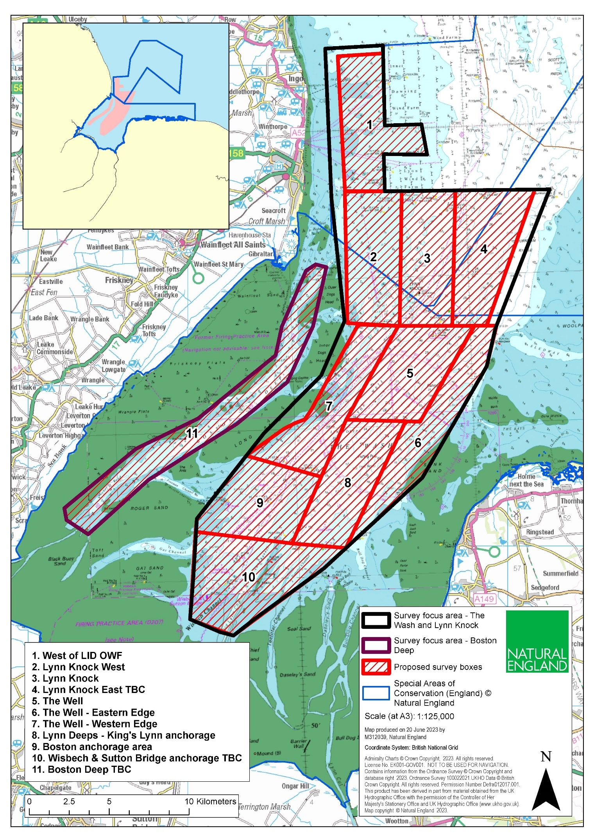**Figure 1.** Provisional map of areas to be surveyed within Natural England’s multi-year monitoring plan for *S. spinulosa* reef.

### Proposed Survey Area

The proposed survey area (Figure 2) is known as Lynn Knock West and crosses the boundaries of two adjacent Special Areas of Conservation – The Wash and North Norfolk Coast SAC and Inner Dowsing, Race Bank and North Ridge SAC.

**The Wash and North Norfolk Coast (WNNC) SAC**

The Wash and North Norfolk Coast SAC is situated on the East Coast of England and encompasses the largest embayment in the UK. It was designated as a SAC in 2005, and hosts the following qualifying features:

* Large shallow inlets and bays
* Mudflats and sandflats not covered by seawater at low tide
* Sandbanks which are slightly covered by sea water all the time
* Atlantic salt meadows
* Mediterranean and thermo-Atlantic halophilous scrubs
* Salicornia and other annuals colonising mud and sand
* Coastal lagoons
* Harbour seal (*Phoca vitulina*)
* Otter (*Lutra lutra*)
* Reefs (including *Sabellaria spinulosa* biogenic reef)

**Inner Dowsing, Race Bank and North Ridge (IDRBNR) SAC**

Inner Dowsing, Race Bank and North Ridge SAC is located off the South Lincolnshire Coast, occurring in the approaches to the Wash. It crosses the 12 nautical mile boundary and therefore lies across both territorial and offshore waters. The site was designated as a Special Area of Conservation in 2017 for the following features:

* Sandbanks which are slightly covered by sea water all the time
* Reefs (including *Sabellaria spinulosa* biogenic reef)

Full site details are available on the Natural England designated sites webpage, including information on feature condition: [Site Search (naturalengland.org.uk)](https://designatedsites.naturalengland.org.uk/SiteSearch.aspx).

The Lynn Knock West proposed survey area, as mapped in Figure 2, has a total estimated area of 28km2. Approximate coordinates are provided in the table below. While it is Natural England’s aim to survey the entirety of this area under this contract, we would welcome alternative proposals to survey a larger or smaller area as permitted by financial and/or time constraints.

|  |  |  |
| --- | --- | --- |
| Boundary point ID | Easting | Northing |
| 1 | 559914 | 362054 |
| 2 | 563374 | 362139 |
| 3 | 559981 | 353908 |
| 4 | 563238 | 353723 |

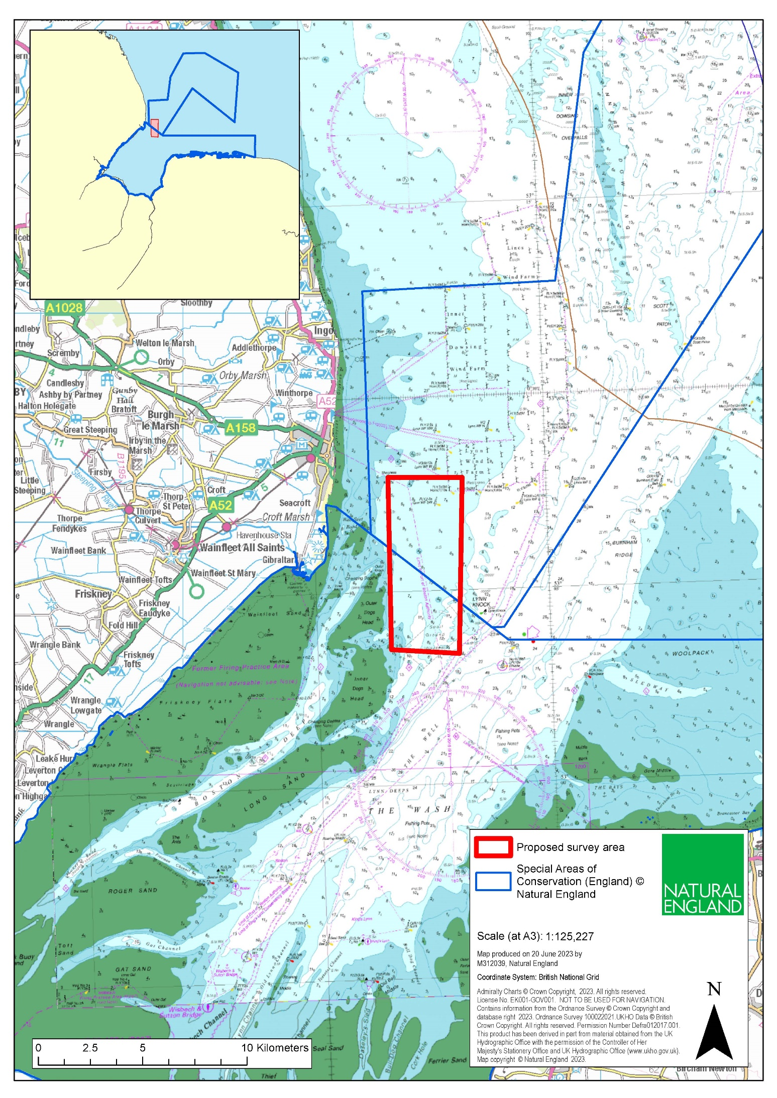

**Figure 2**. Map of proposed survey area Lynn Knock West, crossing the boundaries of The Wash and North Norfolk Coast SAC and Inner Dowsing, Race Bank and North Ridge SAC.

### Previous Surveys

Previous surveys undertaken for *S.spinulosa* biogenic reef in this area include:

* Curtis et al, 2014. Baseline Monitoring Survey of Lynn Knock Reefs within the Inner Dowsing, Race Bank and North Ridge cSAC. Centre for Environment, Fisheries & Aquaculture Science (Cefas).
* Eggleton et al, 2016. North Norfolk Sandbanks and Saturn Reef SAC, Haisborough, Hammond and Winterton SAC, and Inner Dowsing, Race Bank and North Ridge SAC Monitoring Report 2016. JNCC/Cefas Partnership Report No. 38.

A GI package from the Marine Evidence database can also be provided upon request to the successful contractor.

### Aims & Objectives

The overall aim of this project is to identify and report on the extent, distribution, and quality of *S. spinulosa* biogenic reefs within Lynn Knock West. The results of this work will contribute to Natural England’s overarching monitoring plan for *S. spinulosa* biogenic reef in WNNC and IDRBNR SACs, inform statutory advice on marine protected areas (MPAs), and assist in the assessment of site condition.

Working in collaboration with Natural England, the specific objectives of this contract are to undertake:

* A comprehensive acoustic survey of the area via side scan sonar (SSS), followed by analysis to identify suitable ground-truthing stations for further analysis.
* Ground-truthing surveys via drop-down video (DDV) and/or the collection of grab samples.
* Analysis of ground-truthing data to complete an assessment of reefiness.
* Processing of acoustic data to determine reef extent and distribution.
* Comprehensive reporting and provision of outputs.

### Methods

Acoustic Surveys and Ground-truthing Surveys

Suppliers are invited to propose an appropriate survey design to meet the objectives described above. Each component should be costed separately.

Natural England request that acoustic surveys are conducted via side scan sonar with a minimum coverage of 100%. We also request that contractors provide a separate quote for additional multibeam bathymetry data and associated backscatter to inform other work areas.

Ground-truthing surveys are required within this contract to validate the acoustic soundings. If proposed surveys are conducted visually (e.g., via drop-down video), please provide detail on how methods can be adapted to contend with poor visibility.

Natural England welcomes proposals based on the expertise of potential contractors and in consideration of any limitations. Final methods will be determined during pre-survey discussions between both parties.

Reef Delineation

Using the results of acoustic and ground-truthing surveys, an assessment of reefiness should be completed in keeping with the criteria outlined in Gubbay et al, (2007), to include measures of extent, elevation and patchiness.

Anthropogenic Impacts

The results of this survey may be used to inform future management of relevant marine protected areas. As such, Natural England requests that the contractor records any instances of anthropogenic impacts observed during ground-truthing surveys and subsequent analysis.

Invasive Non-native Species

Invasive Non-Native Species (INNS) are considered to be one of the top five pressures directly driving biodiversity loss globally. Prevention is the key focus, particularly in marine environments. The contractor shall be aware of and work in accordance with standard good practice biosecurity measures to avoid spread of INNS:

* Equipment, clothes, and boots should be clean before carrying out any work on site
* When on or near water it is important that equipment is drained after use and as far as possible dried
* Boats to be used in survey work should have their hulls cleaned on a regular basis. Best practice guidelines should be followed as outlined by [The Green Blue](http://www.thegreenblue.org.uk/boat_users/antifoul_and_invasive_species/boaters_best_practice_invasive.aspx).

INNS species previously recorded in this region and to particularly look out for during this survey include the Slipper Limpet *Crepidula fornicata.*

The contractor must report any records of INNS observed on site on Marine Recorder and to the Natural England project officer as part of the survey report. Any species currently listed as ‘alert’ species should be flagged immediately to the GB Non-Native Species Secretariat <http://www.nonnativespecies.org/alerts/index.cfm>. More information and guidance including ID guides can be found at [www.nonnativespecies.org](https://defra.sharepoint.com/teams/Team2434/Shared%20Documents/Monitoring/WNNC%20SAC%20-%20subtidal%20sab%20reef/Contract%20Documents/www.nonnativespecies.org) and the [Marine Aliens Project](https://www.marlin.ac.uk/marine_aliens/).

Health & Safety Requirements

All risk assessments must be seen and signed off by the Nominated Officer (ideally when presented with then project plan), as part of the contract management process. Risk assessments must be provided by the contractor.

Weather Downtime & Contingency

Survey windows should be allocated in accordance with the best available tides. Contractors will be expected to check weather regularly (daily) prior to agreed survey windows. If contractors have 48 hours' notice of impending poor weather, they will be expected to make alternative arrangements for the duration of the poor weather and reschedule survey work to be completed at a later date. If contractors have not yet mobilised, Natural England does not expect to be charged for any weather downtime. It is the responsibility of the contractor to contact Natural England in the event that impending poor weather is putting the survey at risk.

In the event of unforeseeable weather events, a maximum of 1 day of downtime or contingency may be paid. In the event of uncertainty or other unforeseen events that impact upon the ability of the contractor to undertake the survey, the Natural England Nominated Officer should be contacted immediately.

Site Access

Where contractors intend to use either a vessel or hovercraft to access sites this requirement should be made clear in the tender submission and any use of these vehicles will be subject to SSSI consent and Habitats Regulations Assessment (HRA). Obtaining relevant permissions for work is the responsibility of the successful contractor - this should be discussed from the outset with the Nominated Officer and site leads.

Sustainability

Natural England protects and improves the environment and is committed to reducing the sustainability impacts of its activities directly and through its supply chains. We expect the Contractor to share this commitment and adopt a sound, proactive sustainable approach in keeping with the 25 yr environmental plan/our commitments compliant with all applicable legislation. This includes understanding and reducing direct and indirect sustainability impacts and realising opportunities, including but not restricted to; resilience to climate change, reducing greenhouse gas emissions, water use and quality, biosecurity, resource efficiency and waste, reducing the risk of pollution, biodiversity, modern slavery and equality, diversity & inclusion, negative community impacts.

As a delivery partner, the successful contractor is expected to pursue sustainability in their operations, thereby ensuring the Contracting Authority is not contracting with a supplier whose operational outputs run contrary to the Contracting Authority’s objectives. The successful contractor will need to approach the project with a focus on the entire life cycle of the project.

### Outputs and Contract Management

This project shall be managed on behalf of Natural England by Shannon McCloskey. Project deliverables will follow the objectives set out in this tender and refer to available guidance for writing Natural England Technical publications.

Project Report

Draft reports should be provided in electronic MS Office Word *.DOCX format for comment. A template and guidance exist for writing Natural England commissioned reports and will be sent to the contractor upon award of the tender. All reports should retain a clear suggested citation stating that it is a ‘Report to Natural England’. Data must be interpreted, analysed and presented in light of the overarching hypotheses stated above.

Natural England are to be provided with two electronic copies of the final report in MS Word and Adobe PDF formats.

**Natural England will publish this report in accordance with our Technical Publication Guidance**. Please refer to available guidance for writing Natural England Technical publications (<http://publications.naturalengland.org.uk/publication/5790636781600768>).

The intellectual property rights and copyright for all outputs will lie with Natural England. All data will be made available by Natural England under the [Open Government Licence](http://www.nationalarchives.gov.uk/doc/open-government-licence/) at the end of the project via the MEDIN Data Archiving Centres.

GIS Shapefiles and Metadata

All interpreted products following data analysis should accompany the draft report; these will include:

* All GIS datasets need to be provided in ESRI ArcGIS format compatible with ArcGIS 10.2 and have attached metadata.
* The GUI provided by Natural England for each survey will be used, and as much information as possible (e.g., survey name, originally assigned feature/habitat name etc.) from the original dataset, as well as any documentation provided (where available) should be included in the resulting datasets to maintain a useful audit trail. As specified in the MESH DEF, data files must be provided as ESRI Shapefiles or as a feature class data within a geodatabase using the WGS1984 geographic coordinate system and (lat/long coordinates. If not included in the GIS data layers listed above all sampling locations, vessels tracks, and links to data obtained should also be included as a single GI layer.
* Copies of the original data spreadsheets or databases are to be provided in the appropriate Microsoft Office format.
* Still photographs (if taken) to be provided in their raw format on CD/DVD or USB compliant external hard drives.

All sample data (e.g., grab sample analyses, video/still photography analyses, PSA analysis and biotope lists, biological taxon data), if taken, must be entered into Marine Recorder NBN data and an exported snapshot file of the data should be provided for QA. Natural England will provide licence keys for Marine Recorder. Natural England will supply a ‘Marine Recorder guidance for contractors’ document to successful contractors.

The contractor must report any records of Invasive and Non-Native Species observed on site on Marine Recorder and to the Natural England project officer as part of the survey report. Any species currently listed as ‘alert’ species should be flagged immediately to the GB Non-Native Species Secretariat Species alerts. More information and guidance including ID guides can be found at [GB non-native species secretariat](https://www.nonnativespecies.org/alerts/index.cfm).

Copies of the original data spreadsheets or databases are to be provided in the appropriate Microsoft Office format. All data products and electronic files must be appropriately named so they sufficiently describe the contents and are not purely a numerical value. All products should be named appropriately so that they can be clearly linked to the report/project. Video and still camera filenames must include the recording start date and time. Position data must be included within the overlay information.

Any species lists submitted will be compliant with current taxonomic names and synonyms (e.g., Marine Species of the British Isles and Adjacent Seas (MSBIAS), World Register of Marine Species (WoRMS)).

Presentation

A virtual presentation to Natural England staff upon completion of the project to include full methods and results. Please note the presentation will be recorded.

Project Timeline

|  |  |
| --- | --- |
| Event | Date |
| Intended contract start date | 08/08/2023 |
| Intended survey completion date | 30/09/2023 |
| Draft report and associated products | 01/02/2024 |
| Final report, GI products, and all other outputs | 01/03/2024 |
| Contract Completion Date | 01/03/2024 |

Please note that this RFQ is for surveys to be completed by the end of September to ensure optimal conditions for visual surveys. However, if this timing is not feasible due to time constraints, please provide an alternative timeline.

It is requested that the Tenderer provide an indicative timescale for delivery of all deliverables within their Tender proposal, including whether it meets the Project Timeline outlined above.

It is anticipated that this contract will be awarded for a period of eight months to end no later than **1st March 2024**. Prices will remain fixed for the duration of the contract award period. We may at our sole discretion extend this contract to include related or further work. Any extension shall be agreed in advance of any work commencing and may be subject to further competition.

## Payment

The Authority will raise purchase orders to cover the cost of the services and will issue to the awarded supplier following contract award.

The Authority’s preference is for all invoices to be sent electronically, quoting a valid Purchase Order number. Invoices are typically paid as a lump sum after work has concluded and final reports have been submitted to Natural England.

It is anticipated that this contract will be awarded for a period of six to end no later than 01/03/2023. Prices will remain fixed for the duration of the contract award period. We may at our sole discretion extend this contract to include related or further work. Any extension shall be agreed in writing in advance of any work commencing and may be subject to further competition.

## Evaluation Methodology

We will award this contract in line with the most economically advantageous tender (MEAT) as set out in the following award criteria:

Technical – 60%

Commercial – 40%

The winning tenderer will be the highest scoring combined score.

|  |  |  |  |
| --- | --- | --- | --- |
| Award Criteria | Weighting (%) | Sub-Criteria | Weighted Question (s) |
| Technical | 60% | Availability | PASS/FAIL |
| Methodology | 40% |
| Key personnel | 20% |
| Commercial | 40% | Cost | 40% |

### Technical (60%)

Technical evaluations will be based on responses to specific questions covering key criteria which are outlined below. Scores for questions will be based on the following:

| Description | Score | Sub-Criteria |
| --- | --- | --- |
| Very good | 100 | Addresses all the Authority’s requirements with all the relevant supporting information set out in the RFQ. There are no weaknesses and therefore the tender response gives the Authority complete confidence that all the requirements will be met to a high standard. |
| Good | 70 | Addresses all the Authority’s requirements with all the relevant supporting information set out in the RFQ. The response contains minor weaknesses and therefore the tender response gives the Authority confidence that all the requirements will be met to a good standard. |
| Moderate | 50 | Addresses most of the requirements with most of the relevant supporting information set out in the RFQ. The response contains moderate weaknesses and therefore the tender response gives the Authority confidence that most of the requirements will be met to a suitable standard. |
| Weak | 20 | Substantially addresses the requirements but not all and provides supporting information that is of limited or no relevance or a methodology containing significant weaknesses and therefore raises concerns for the Authority that the requirements may not all be met. |
| Unacceptable | 0 | No response or provides a response that gives the Authority no confidence that the requirement will be met. |

Technical evaluation is assessed using the evaluation topics and sub-criteria stated in the Evaluation Criteria section above.

Separate submissions for each technical question should be provided and will be evaluated in isolation. Tenderers should provide answers that meet the criteria of each technical question.

|  |  |
| --- | --- |
| Award Sub-criteria | Technical Question |
| Availability  (PASS/FAIL) | Q1: Please provide a statement on your availability & capacity to mobilise a survey vessel/team. |
| Q2: Supply a proposed schedule of work, stating the timescales you will be able to execute and deliver the product specified. |
| Methodology  (40%) | Q1: Provide an explanation of the methodology to be used and demonstrate an understanding of the specific challenges associated with surveying subtidal *Sabellaria spinulosa*.  Q2: Detail proposed contingency plan(s) for poor visibility.  Q3: Detail how you will manage health and safety risks. |
| Key Personnel  (20%) | Q1: Provide CVs for the survey team. CVs should demonstrate appropriate skills for subtidal survey work and detail any occasions where staff have previously worked on contracts for Natural England. |

### Commercial (40%)

The Contract is to be awarded as afixed price which will be paid according to the completion of the deliverables stated in the Specification of Requirements.

Suppliers are required to submit a total cost to provide the deliverables stated in the Specification of Requirements. In addition to this the Commercial Response template must be completed to provide a breakdown of the whole life costs against each objective.

Calculation Method

The method for calculating the weighted scores is as follows:

* Commercial

Score = (Lowest Quotation Price / Supplier’s Quotation Price ) x 40% (Maximum available marks)

* Technical

Score = (Bidder’s Total Technical Score / Highest Technical Score) x 60% (Maximum available marks)

The total score (weighted) (TWS) is then calculated by adding the total weighted commercial score (WC) to the total weighted technical score (WT): WC + WT = TWS.

Award

Once the evaluation of the Response(s) is complete all suppliers will be notified of the outcome via email.

The successful supplier will be issued the contract, incorporating their Response, for signature. The Authority will then counter sign.

# Annex 1 Mandatory Requirements

## Part 1 Potential Supplier Information

Please answer the following self-declaration questions in full and include this Annex in your quotation response.

### **Part 1.1 Potential Supplier Information:**

|  |  |  |
| --- | --- | --- |
| Question no. | Question | Response |
| 1.1(a) | Full name of the potential supplier submitting the information |  |
| 1.1(b) | Registered office address (if applicable) |  |
| 1.1(c) | Company registration number (if applicable) |  |
| 1.1(d) | Charity registration number (if applicable) |  |
| 1.1(e) | Head office DUNS number (if applicable) |  |
| 1.1(f) | Registered VAT number |  |
| 1.1(g) | Are you a Small, Medium or Micro Enterprise (SME)? | (Yes / No) |

Note: See EU definition of SME <https://ec.europa.eu/growth/smes/business-friendly-environment/sme-definition_en>

### **Part 1.** **2 Contact details and declaration**

By submitting a quotation to this RFQ I declare that to the best of my knowledge the answers submitted and information contained in this document are correct and accurate.

I declare that, upon request and without delay you will provide the certificates or documentary evidence referred to in this document.

I understand that the information will be used in the selection process to assess my organisation’s suitability to be invited to participate further in this procurement.

I understand that the authority may reject this submission in its entirety if there is a failure to answer all the relevant questions fully, or if false/misleading information or content is provided in any section.

I am aware of the consequences of serious misrepresentation.

|  |  |  |
| --- | --- | --- |
| Question no. | Question | Response |
| 1.2(a) | Contact name |  |
| 1.2(b) | Name of organisation |  |
| 1.2(c) | Role in organisation |  |
| 1.2(d) | Phone number |  |
| 1.2(e) | E-mail address |  |
| 1.2(f) | Postal address |  |
| 1.2(g) | Signature (electronic is acceptable) |  |
| 1.2(h) | Date |  |

## Part 2 Exclusion Grounds

### **Part 2.1 Grounds for mandatory exclusion**

| Question no. | Question | Response |
| --- | --- | --- |
| 2.1(a) | Please indicate if, within the past five years you, your organisation or any other person who has powers of representation, decision or control in the organisation been convicted anywhere in the world of any of the offences within the summary below. | |
| Participation in a criminal organisation. | (Yes / No) If yes please provide details at 2.1 (b) |
| Corruption. | (Yes / No) If yes please provide details at 2.1 (b) |
| Fraud. | (Yes / No) If yes please provide details at 2.1 (b) |
| Terrorist offences or offences linked to terrorist activities | (Yes / No) If yes please provide details at 2.1 (b) |
| Money laundering or terrorist financing | (Yes / No) If yes please provide details at 2.1 (b) |
| Child labour and other forms of trafficking in human beings | (Yes / No) If yes please provide details at 2.1 (b) |
| 2.1(b) | If you have answered yes to question 2.1(a), please provide further details.  Date of conviction, specify which of the grounds listed the conviction was for, and the reasons for conviction.  Identity of who has been convicted. If the relevant documentation is available electronically please provide the web address, issuing authority, precise reference of the documents. |  |
| 2.1 (c) | If you have answered Yes to any of the points above have measures been taken to demonstrate the reliability of the organisation despite the existence of a relevant ground for exclusion? (i.e. Self-Cleaning) | (Yes / No) |
| 2.1(d) | Has it been established, for your organisation by a judicial or administrative decision having final and binding effect in accordance with the legal provisions of any part of the United Kingdom or the legal provisions of the country in which the organisation is established (if outside the UK), that the organisation is in breach of obligations related to the payment of tax or social security contributions? | (Yes / No) |
| 2.1(e) | If you have answered yes to question 2.3(a), please provide further details. Please also confirm you have paid or have entered into a binding arrangement with a view to paying, the outstanding sum including where applicable any accrued interest and/or fines. |  |

### **Part 2.2 Grounds for discretionary exclusion**

| Question no. | Question | Response |
| --- | --- | --- |
| 2.2(a) | The detailed grounds for discretionary exclusion of an organisation are set out on this [webpage](https://www.gov.uk/government/uploads/system/uploads/attachment_data/file/551130/List_of_Mandatory_and_Discretionary_Exclusions.pdf), which should be referred to before completing these questions.  Please indicate if, within the past three years, anywhere in the world any of the following situations have applied to you, your organisation or any other person who has powers of representation, decision or control in the organisation. | |
| 2.2(b) | Breach of environmental obligations? | (Yes / No) If yes please provide details at 2.2 (f) |
| 2.2(c) | Breach of social obligations? | (Yes / No) If yes please provide details at 2.2 (f) |
| 2.2(d) | Breach of labour law obligations? | (Yes / No) If yes please provide details at 2.2 (f) |
| 2.2(e) | Shown significant or persistent deficiencies in the performance of a substantive requirement under a prior public contract, a prior contract with a contracting entity, or a prior concession contract, which led to early termination of that prior contract, damages or other comparable sanctions? | (Yes / No) If yes please provide details at 2.2 (f) |
| 2.2 (f) | If you have answered Yes to any of the above, explain what measures been taken to demonstrate the reliability of the organisation despite the existence of a relevant ground for exclusion? (Self Cleaning) |  |

# Annex 2 Acceptance of Terms and Conditions

I/We accept in full the terms and conditions appended to this Request for Quote document.

Company ____________________________________________________

Signature ____________________________________________________

Print Name ____________________________________________________

Position ____________________________________________________

Date ____________________________________________________

# References

Curtis, M., Rance, J., and Froján, C. B. (2014). Baseline Monitoring Survey of Lynn Knock Reefs within the Inner Dowsing, Race Bank and North Ridge cSAC. Centre for Environment, Fisheries & Aquaculture Science (Cefas).

Eggleton, J., Bolam, S., Benson, L., Archer-Rand, S., Mason, C., Noble-James, T., Jones, L., McBreen, F. & Roberts, G. (2020). North Norfolk Sandbanks and Saturn Reef SAC, Haisborough, Hammond and Winterton SAC, and Inner Dowsing, Race Bank and North Ridge SAC Monitoring Report 2016. JNCC/Cefas Partnership Report No. 38. JNCC, Peterborough, ISSN 2051-6711, Crown Copyright.

Fletcher, S., Saunders, J., Herbert, R., Roberts, C. and Dawson, K. 2012. Descriptions of the ecosystem services provided by broadscale habitats and features of conservation importance that are likely to be protected by Marine Protected Areas in the Marine Conservation Zone Project area Sheffield: Natural England.

Gubbay, S. 2007. Defining and managing Sabellaria spinulosa reefs: Report of an inter-agency workshop 1-2 May, 2007, JNCC Report No. 405, JNCC, Peterborough, ISSN 0963-8091.

Hayward, P.J. and Ryland, J.S., 1990. The Marine Fauna of the British Isles and Western Europe. Oxford University Press, New York, 2 vols., 996 pp.

Limpenny, D.S., Foster-Smith, R.L., Edwards, T.M., Hendrick, V.J., Diesing, M., Eggleton, J.D., Meadows, W.J., Crutchfield, Z., Pfeifer, S., and Reach, I.S. (2010). Best methods for identifying and evaluating Sabellaria spinulosa and cobble reef. Aggregate Levy Sustainability Fund Project MAL0008. Joint Nature Conservation Committee, Peterborough, 134 pp., ISBN - 978 0 907545 33 0.

Roberts, G., Edwards, N., Neachtain, A., Richardson, H. & Watt, C. 2016. Core reef approach to Sabellaria spinulosa reef management in The Wash and North Norfolk Coast SAC and The Wash approaches. Natural England Research Reports, Number 065.

Please see link below to access the NE research reports.

[Natural England Access to Evidence](http://publications.naturalengland.org.uk/search?q=Cromer+Shoal+Chalk+Beds+MCZ&num=100)