Bid Pack For Open Market Competition
This procurement event will be conducted in accordance with the Public Contract Regulations 2015, specifically Chapter 8, Below Threshold Procurements.
Attachment 2 – How To Bid Including Evaluation Criteria
The Provision of Design Development and Delivery of a Diversity Leadership Course for the National Leadership Centre (NLC)
Contract Reference: CCHR20A06
Contents

1. How To Make Your Bid 1
2. How The Questionnaires Are Structured 3
3. Award Criteria 12
4. Marking Scheme 14
5. Technical Evaluation 15
6. Commercial Evaluation 16
7. Final Decision to Award 18
8. Further Information 18

How To Make Your Bid

Your bid must be made by the organisation that will be responsible for providing the deliverables if your bid is successful.

Remember to:

Accept or Decline this Bid Pack. If you Decline please provide a reason for doing so.

Enter your bid into the e-Sourcing Suite. We can only accept bids that we receive through the e-Sourcing Suite.

Make sure you answer every question.

Each question must be answered in its own right. You must not answer any of the questions by cross referencing other questions or other materials e.g. reports located on your website.

Submit your bid in good time and before the bid submission deadline.

Upload ONLY those attachments we have asked for in line with the requirements specified – any other supporting evidence, certificates for example, will be requested separately by us.

If we do not require attachments and have specified this please only use the Text Boxes provided for your answer.

Check for messages in the e-Sourcing Suite throughout the competition.

Press the Submit all Draft Bids button when your bid is ready, otherwise we will not be able to see it.

If you are unsure, ask questions before the Clarification Questions Deadline.

How The Questionnaires Are Structured:

A summary of all the questions in the quality questionnaire, along with the marking scheme, and weightings for each question is set out below:

QUESTIONNAIRE 1 – QUALIFICATION - KEY PARTICIPATION REQUIREMENTS

QUESTIONNAIRE 2 – QUALIFICATION - CONFLICTS OF INTEREST

QUESTIONNAIRE 3 – QUALIFICATION - INFORMATION ONLY

QUESTIONNAIRE 4 - TECHNICAL - PROJECT SPECIFIC EXPERIENCE

QUESTIONNAIRE 5 - TECHNICAL - UNDERSTANDING THE REQUIREMENT

QUESTIONNAIRE 6 – TECHNICAL - ACCOUNT MANAGEMENT & DELIVERY

QUESTIONNAIRE 7 - COMMERCIAL EVALUATION
QUESTIONNAIRE 1 – QUALIFICATION - KEY PARTICIPATION REQUIREMENTS

Response Guidance

The following questions are ‘Pass/Fail’ questions. If Potential Bidders are unwilling or unable to answer “Yes”, their submission will be deemed non-compliant and shall be rejected. Potential Bidders should confirm their answer by selecting the appropriate option from the drop down menu.

Question Number | Question |  | Your Response
1.1 | Do you accept the competition rules as described in Attachment 1 – About the Procurement? | Yes/No
1.2 | Have you read, understood and accepted the Bid Pack and all associated attachments, specifically Attachment 3 - Statement of Requirements? | Yes/No
1.3 | Do you agree, without caveats or limitations, that in the event that you are successful Attachment 5 - Terms and Conditions will govern the provision of this contract? | Yes/No
1.4 | Do you confirm your Organisation’s e-Sourcing suite profile is complete and accurate at the time the bid closed and that any amendments made following acceptance of this event will be notified to the buyer in writing? | Yes/No
1.5 | Please confirm that you understand that CCS reserve the right to use a credit reference agency to obtain a financial risk score for you and any members of your consortium or any nominated guarantor(s)? | Yes/No
1.6 | Do you agree without caveat or limitations that you will provide upon request any relevant Insurance or Accreditation certificates? | Yes/No

QUESTIONNAIRE 2 – QUALIFICATION - CONFLICTS OF INTEREST

Response Guidance

Question 2.1 is a ‘Yes/No’ question and will dictate whether or not question 2.2 needs to be answered.

Question 2.2 is a Pass / Fail question. Potential Bidders are required to provide details of how the identified conflict will be mitigated. The Contracting Authority will review the mitigation in line with the perceived conflict of interest, to determine what level of risk this poses to them.

Therefore, if Potential Bidders cannot or are unwilling to suitably demonstrate that they have suitable safeguards to mitigate any risk then their Bid will be deemed non-compliant and will be rejected.
Question Number | Question | Your Response
2.1 | Please confirm whether you have any potential, actual or perceived conflicts of interest that may be relevant to this requirement. |  | Yes/No
2.2 | We require that any potential, actual or perceived conflicts of interest in respect of this Bid Pack are identified in writing and that companies outline what safeguards would be put in place to mitigate the risk of actual or perceived conflicts arising during the delivery of these services. |  | Text Box

QUESTIONNAIRE 3 – QUALIFICATION - INFORMATION ONLY

Response Guidance

The following questions are for information only and do not form part of the evaluation. Information provided in response to these questions may be used in preparation of any Contract Award and any omissions may delay completion of this procurement exercise.
Question Number | Question | Your Response
3.1 | What are your details:  - Name (registered name if registered)  - Office address (registered address if registered)  - Website address (if applicable)  - Date of registration (if applicable) or date of formation  - Registration number (company, partnership, charity etc.) if applicable  - DUNS number (of head office, if applicable)  - VAT number | Text Box
3.2 | What is your trading status:  - Public limited company  - Limited company  - Limited liability partnership  - Other partnership  - Sole trader  - Third sector  Other | Text Box
3.3 | Are you a Small, Medium or Micro Enterprise (SME)?  See the definition of SME | Text Box
3.4 | Please provide details of where the Award Outcome should be directed. Your response must include their;  - Full Name  - Role/Title  - Registered Address  - Email Address | Text Box
3.5 | Please provide details of any sub-contractors you propose to use in order to meet your obligations should you be awarded a Contract. Your response must include their;  - Trading Name(s)  - Registered Address(es) and contact details  - Goods/Services to be provided | Text Box
3.6 | Please provide details of the Data Protection Officer for your organisation. Your response must include their;  - Full Name  - Role/Title  - Registered Address  - Email Address | Text Box

TECHNICAL ENVELOPE OVERALL WEIGHTING 80%
Response Guidance
Potential Bidders MUST answer ALL the following questions. The method of response, page limit on attachments and evaluation criteria is set per question.

Attachments may be submitted in Microsoft Word, Excel. PDF format and must be in Arial font size 11. Page limits include the use of headers footers and diagrams. Upload ONLY those attachments we have asked for – any other supporting evidence, certificates for example, will be requested separately by us
No costings should be included in responses to this Questionnaire.
QUESTIONNAIRE 4 - TECHNICAL – PROJECT SPECIFIC EXPERIENCE WEIGHTING 35%
Question Number | Question | Your Response | Minimum Acceptable Score | Maximum Available Score | Weighting
4.1 | Please provide examples (up to a maximum of four) of your organisation’s experience of delivering similar projects. Your response should include but not be limited to the following:  - Delivering diversity programmes for senior public sector leaders  - Running and hosting events for this audience  - Arranging speakers, interactive workshops, panel discussions, coaching, mentoring and informative visits  - Finding and securing speakers, facilitators, mentors and coaches to deliver interactive workshops, panel discussions, coaching and mentoring | Attachment  This attachment should not exceed 2 sides of A4. | 66 | 100 | 50
4.2 | Please outline your proposed project team that will be used to deliver the requirement detailed in Attachment 3 (Statement of Requirements). The key detail required for each individual is:  - Name.  - Role.  - Summary of relevant qualifications/experience/ expertise/knowledge.  - Demonstrable experience of working with senior staff in the public or private sector to deliver high quality training on leadership and diversity.  - Organogram with Team structure  As part of your response, please provide details of how these individuals add benefit to this project. It is important to the Customer that your team is diverse. Please show within your response how your team is diverse in every sense. | Attachment  This attachment should not exceed 3 sides of A4. | 66 | 100 | 50

QUESTIONNAIRE 5 - TECHNICAL – UNDERSTANDING THE REQUIREMENT WEIGHTING 45%
Question Number | Question | Your Response | Minimum Acceptable Score | Maximum Available Score | Weighting
5.1 | Please outline your proposal for the design and delivery of the Diversity Programme, clearly demonstrating how you will address all of the objectives and requirements outlined in the Statement of Requirements (Attachment 3), including:  - How you intend to convene this audience detailed in the statement of requirements.  - Proposed plans for what content could be covered during the programme, including potential speakers and learning outcomes.  - Proposed plans for evaluating the design and delivery of the programme.  - A detailed timetable of how and when you intend to fulfil all elements of the statement of requirements. | Attachment  This attachment should not exceed 4 sides of A4. | 66 | 100 | 100

QUESTIONNAIRE 6 - TECHNICAL – ACCOUNT MANAGEMENT & DELIVERY WEIGHTING 20%
Question Number | Question | Your Response | Minimum Acceptable Score | Maximum Available Score | Weighting
6.1 | Please provide a sample risk register. Please outline as part of your response any risks specific to this project and the steps you would take to mitigate them. | Attachment  This attachment should not exceed 2 sides of A4. | 66 | 100 | 40
6.2 | Please explain how your organisation will manage the governance around this project, including ensuring effective delivery of the requirement and objectives outlined in the Attachment 3 – Statement of Requirements.  Also include:  - An outline of how you will ensure your product is delivered to time, on budget and high quality.  - How you will manage the different elements to minimise the number of people the Client needs to brief. | Attachment  This attachment should not exceed 2 sides of A4. | 66 | 100 | 60

QUESTIONNAIRE 7 – COMMERCIAL WEIGHTING 20%
Response Guidance

Potential Bidders must enter costs by uploading the relevant Attachment 4 - Price Schedule at the question level on the e-Sourcing event.
Prices should be submitted in pounds Sterling inclusive of any expenses but exclusive of VAT.
Potential Bidders will be scored in accordance with the marking scheme at Section 2.
Question Number | Question | Your Response | Maximum Available Score | Weighting x%
7.1 | Please attach a completed Price Schedule in the response to this question. In so doing, you are also confirming that prices offered are inclusive of any expenses, exclusive of VAT and firm for the period following the Deadline for Submission as stated in the Attachment 1 - Bid Pack. | Attachment | 100 | 100%

Award Criteria

The award stage consists of a technical evaluation and a commercial evaluation.

The award of the resultant contract will be on the basis of the ‘Most Economically Advantageous Tender’ (MEAT).

The weighting for the technical evaluation is 80%; and, the commercial evaluation is 20%.

Award process - What you need to do

Answer the questions in section 2 above in the e-Sourcing suite.

Complete the Attachment 4 – Price Schedule.

You must upload your completed Price Schedule into the e-Sourcing suite at questionnaire 7.

What we will do
Compliance Check
First, we will complete a mandatory evaluation to make sure that you have answered all questions and have completed the Attachment 4 - Price Schedule in line with our instructions. All bids passing the mandatory evaluation will be progressed to the technical Evaluation.
Technical Evaluation
We will give your responses to the TECHNICAL questionnaires to the Contracting Authority’s evaluation panel. Each evaluator will independently assess your responses to the technical questions using the response guidance and the evaluation criteria.
They will give a score and a reason for their score for each question they are assessing. The evaluators will enter the scores and reasons into the e-Sourcing suite.
If the evaluation panel wishes to clarify any areas of your bid, bid clarification questions will be issued via the e-Sourcing suite on an individual basis.
Consensus
Once the evaluators have independently assessed your answers to the questions we will arrange for the evaluators to meet. We will facilitate the discussion.
At this meeting, the evaluators will discuss the technical responses and review their scores and reasons for that score. The discussion will continue until they reach a consensus regarding the score, and reason for that score, for each question.
These final scores will be used to calculate your technical score.
If the evaluation panel wishes to clarify any areas of your bid, bid clarification questions will be issued via the e-sourcing suite on an individual basis.
Technical Threshold
If you have not met the minimum acceptable score for each question, you will be excluded from the competition. We will tell you that you have been excluded from the procurement and why at award stage.
Evaluate Commercial
We will then evaluate your price and calculate your price score using the evaluation criteria specified.
If we wish clarify any areas of your bid, bid clarification questions will be issued via the e-Sourcing suite on an individual basis.
Final Score
Your technical score will be added to your commercial score, to create your final score.
Award
Award will be made to the successful bidder, subject to contract.
We will notify successful and unsuccessful bidders providing feedback.

Marking Scheme

The evaluation criteria set out below will be used during the Technical Evaluation:

Marking Scheme | Description
100 - Good | The response fully meets all requirements with detail provided minimising risks to delivery.  The response is comprehensive and unambiguous, demonstrating a thorough understanding of the requirements and provides details of how the requirement will be met in full without additional support from the Contracting Authority, other than that outlined within the Statement of Requirements.
66 – Acceptable – Minor Concerns | The response is acceptable and meets all the basic requirements. However, the response, is not sufficiently detailed to minimise risk and/or the proposed approach may require additional support (in addition to that outlined in the Statement of Requirements) from the Contracting Authority to meet its deliverables.
33 – Non Acceptable - Major Concerns | The response has met some, but not all elements of the requirement, which poses risk that the proposal will not meet the deliverables required.  The response does not demonstrate a full understanding of the requirement posing major concerns.
0 - Unsuitable | The response does not meet any of the requirements or no response has been provided. An unacceptable and/or non-compliant response with serious reservations, demonstrating no understanding of the requirement.

Technical Evaluation

Questionnaires Q1 and Q2 are mandatory question(s) and will be evaluated PASS / FAIL. If you fail any of these questions, you will be excluded from the competition. We will tell you that your bid has been excluded.

When the consensus meeting has taken place and the final score for each question has been agreed by the evaluators, your final score for each question will be multiplied by that question’s weighting to calculate your weighted score for that question.

Each weighted score for each question will then be added together to calculate your technical score.

Please see table A below for an example of how your technical score will be calculated.
Table A – EXAMPLE ONLY
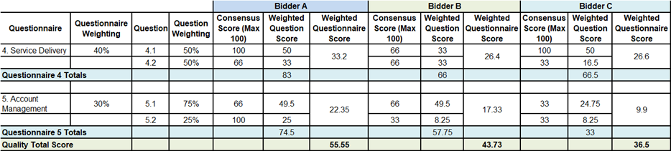

Commercial Evaluation

This section contains information on how to complete Attachment 4 - Price Schedule and the commercial evaluation process.

How to complete your Attachment 4 – Price Schedule

Read and understand the instructions in the Attachment 4 - Price Schedule, and in this section before submitting your prices.

Your prices should compare with the technical of your offer.

Your prices must be sustainable and inclusive of all costs for example your operating costs and profit.

Your prices are to exclude VAT.

Pricing is to be inclusive of expenses.

The currency is British pounds sterling, up to two decimal places.

The percentages submitted shall be up to two decimal places.

Pricing will be based on:

Eight (8) hour Working Day; and

Rounded to the nearest £10.

Zero bids will not be allowed.

We will investigate where we consider your bid to be abnormally low.

The prices submitted shall not exceed the overarching commercial agreement rates.

You must download and complete the Attachment 4 – Price Schedule you are submitting a bid for. Further detail may be provided within the Attachment 4 – Price Schedule.

When you have completed your Attachment 4 - Price Schedule, you must upload this into the e-Sourcing Suite at question Q7. If you do not upload your Attachment 4 – Price Schedule your bid may be rejected from this competition.

Do not alter, amend or change the format or layout of the Attachment 4 – Price Schedule.

Commercial Evaluation Process

This is how we will evaluate your pricing:

We will check you have completed the Attachment 4 – Price Schedule as instructed.

Failure to complete the Attachment 4 - Price Schedule as instructed may result in your bid being deemed non-compliant and it may be rejected from this competition.

The commercial evaluation will be undertaken separately to the technical evaluation process.

The Potential Bidder with the lowest total price per element will be awarded the maximum score available for that element

All other Potential Bidders will get a price score relative to the lowest total price.

The calculation we will use to evaluate your total price per element, you are bidding for, is as follows:
Price Score = Lowest total price * maximum score available Potential Bidder’s total price

Please see table B below for an example of how your Price score will be calculated.
Table B – EXAMPLE ONLY
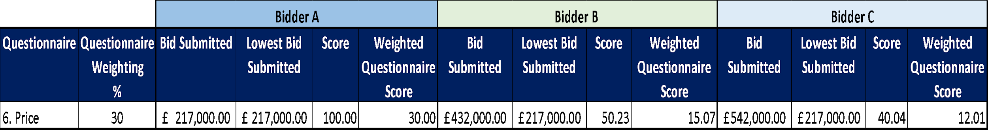

Where we consider any of the total price(s) you have submitted to be abnormally low will ask you to explain the price(s) you have submitted (as required in regulation 69 of the Public Contract Regulations 2015).

Final Decision to Award

We will add your quality score to your price score to calculate your final score.

Please see table C below for an example of how your Quality score and Price score will be added together to identify your final score.
Table C – EXAMPLE ONLY:

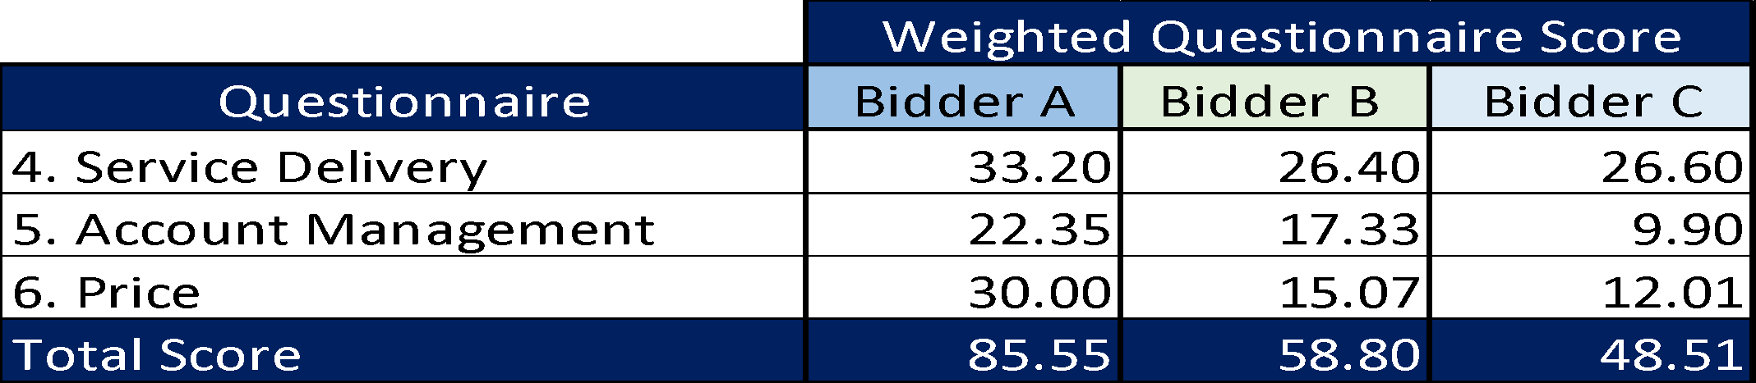

Further Information
  - We will tell you if you have been successful or unsuccessful via the e-Sourcing Suite.

