HDC202107 - Clarifications update 211022 (Update 5)

The council acknowledges that the responses to some clarifications have proved more complex, taking longer than we would have liked and in turn has prompted some further clarification. As a result, we have agreed to allow bidders additional time to factor in these updates and will extend the deadline for submissions to 4pm Monday 1 November. All other project deadlines should remain as planned.

For additional clarity, the price for the supply of sheet piling is not to be included in bidders pricing outlined in 6.1 of the ITT for this opportunity.
The pricing for supply is covered in the separate opportunity HDC202109: RfQ for sheet piles to retain 440 metre long footpath which ended 12 noon 22 October 2021.
Only the cost of installation of sheet piling should be covered in 6.1 of the ITT.

Similarly, the price for supply of the proposed footbridge referenced in 6.1 of the ITT should not be included in the bidders pricing, only the installation.
The footbridge solution is still being reviewed before finalisation, and so material costing is not being sought at this stage. An indicative price for the installation, based on the supplied information, is still required to support the evaluation of bids.

Remaining follow up clarifications:

- Prefabricated wood & steel bridge provided by the client
  - Is this going to be delivered to site?
  - Can we have the dimensions, construction details & weight please?
  - Are there any works required to the abutments to accommodate the new bridge?

1.1. The bridge will be delivered to site by the council appointed fabricator
1.2. Specification for the bridge is Appendix A below
1.3. This item is held to be agreed post award, as it requires input from the bridge fabricator

- PCC Culvert details

  - Can we use a series of large diameter pipes placed side by side with the same CSA in lieu of the 500mm height PCC culvert units?

2.1. Hart District Council needs to maintain a free flow of water at the outflow. Alternatives to the design at the culvert will be considered and will need to be confirmed by the councils Reservoir Supervising Engineer to agree any alternative, post award.

- Muck away

  - There is a conflict of information in the Fleet Pond Scope (Specification) in items WI 2003.22 & 23 WI 201.25 2c ‘It is proposed that all Pond arisings will be backfilled over the new structure. As the material is not to be relocated, it is proposed that no testing is undertaken on the Pond material unless visual or olfactory evidence suggests the material may be contaminated.’ Would you confirm that the vegetation and silt excavated from the pond can be left on site?
  - The existing footpath surface material is designated as acceptable – Can this be re-used in the new footpath construction?

3.1. Reuse of existing material in footpath construction is acceptable but will need to be regraded, so long as within current best practice and to clause 803 of the SHW.

3.2 Vegetation and silt excavated from the pond can be left on site.

- Please can you advise if tenderers should allow for removal of all the vegetation, including the trees, as part of their quotation?

4. Hart District Council have appointed tree works contractors to undertake clearance of vegetation: 1m clearance including stump grinding from 01/11/2021 for two weeks; lifting of any vegetation that overhangs the footpath to take it to 4 metre clearance to allow high vehicle access; and soft vegetation reduced to 10cm within 1 metre. However, tenderers should make some allowance to undertake limited vegetation clearance, as needed during the course of the contract.

- Please can you confirm that all parts of the worksite can be closed to pedestrians whilst the works are being undertaken?

5. The footpath is to be closed to pedestrians during the works

To assist bidders with finalisation of their submissions, no further follow up to clarifications will be provided. Any queries still outstanding for bidders should be highlighted in their submissions, with qualifications to the offer if necessary.

Appendix A:

Hart District Council bridge design

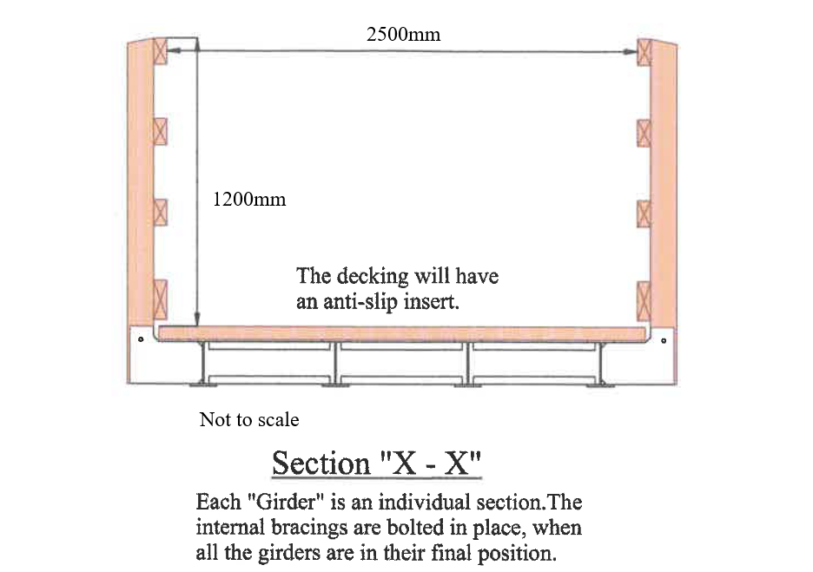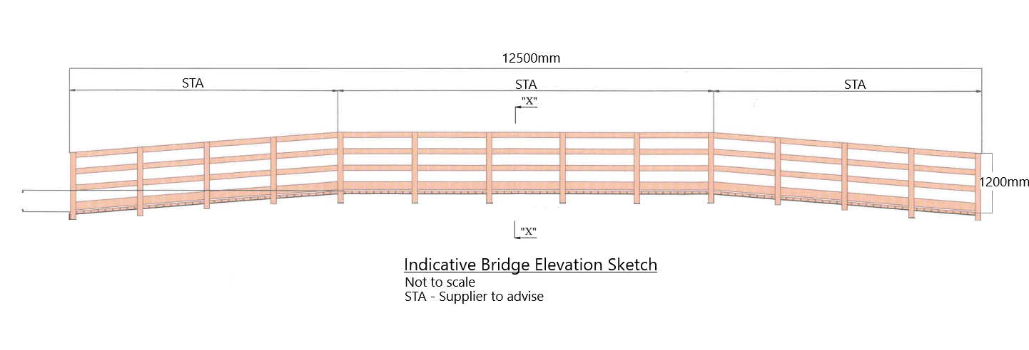
Bridge Specification

Bridge is to be steel and wood, designed to Hart District Council design shown above and to the following specification:

- Bridge designed to carry loading of 5kN/m2 and to current British Standards

- Dimensions: 12.5 metres long and 2.5 metres wide

- Main beams to Hart District Council unique “A” design

- All steel work to be hot dip galvanised, and all fixing bolts galvanised or stainless steel to current British Standards

- All wood to be Grade 1/A Douglas Fir FSC certified and treated to current British Standards

- Decking boards with anti-slip inserts, to current British Standards

- Parapets as per item [e]

- Handrail timber as per item [e] and to be planned with rounded edges [47x97mm] and 4 rails

- Wooden posts to be 1.2 metres in height when measured from the deck of the bridge

- Bridge soffit will be 68.250m AoD. Existing level of footpath ranges from 68.161mAod [eastern side] to 68.05mAoD [western side].

