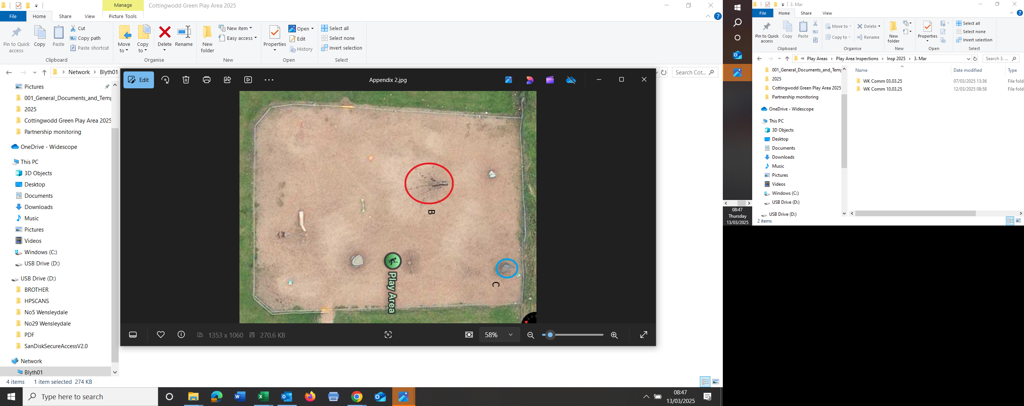

B = Space Net
C = Swing Set

