

Invitation for Tender

Planting and Maintenance of the Town’s 14 Gateways, 4 Roundabouts, Manor House Garden and Town Centre Summer Floral Displays – Littlehampton Town Council

You are invited to bid for the 3-year contract to provide floral displays in Littlehampton, West Sussex.
Littlehampton Town Council are looking for a contractor who will deliver displays of both high impact and quality. The displays will become a talking point for the Town and give the gateways a “wow” factor. In addition to spectacular colours, height and depth are also required. Planting choices must be hardy and able to survive in a marine and highway environment.

Littlehampton is a medium sized coastal town with a population of approximately 29,000 people. Littlehampton is popular day trip seaside destination drawing in 1,000’s of visitors from across the south-east each year.
The town’s main retail area is concentrated around the pedestrianised High Street where the majority of the additional summer planting scheme is situated.
The Town council and residents take great pride in its floral displays for both the local community and visitors alike.

Contact for all information in relation to this tender is listed below. To note we are working remotely, we will respond to enquiries as soon as reasonably practicable. The phone lines are not manned however messages will be pick up and we will call back to answer any queries.
Please send all enquiries to both contacts listed below.

Michael Grier
Community Resources Officer
Littlehampton Town Council
Tel: 07834700958
Email: mgrier@littlehampton-tc.gov.uk

Juliet Harris
Assistant Town Clerk
Tel: 01903 732063
Email: jharris@littlehampton-tc.gov.uk

Specification
- To supply spring and summer bedding of a high standard for 14 gateway planters – approximately 87m² of bedding area per season.
To plant and maintain the spring and summer bedding to a high standard within the 14 gateway planters.
- To supply, install and maintain a total of 14 hanging baskets across 6 sites at key gateways in Littlehampton for both spring and summer.
- To plant and maintain the spring and summer bedding to a high standard on the 4 Town Council managed roundabouts – approximately 50m² of bedding in total.
- To plant and maintain the spring and summer bedding schemes at the front of the Grade II Listed Manor House, Church Street, Littlehampton – the home of Littlehampton Town Council and the Littlehampton Museum.
- To supply and install a total of 20 hanging baskets, 22 barrier baskets and 4 half-unit lamp column floral wraps in Littlehampton Town Centre for the summer season only.

All transport, labour, materials and water are to be included within the contract price.

The contractor will replace plants lost due to failure and will be required to carry out maintenance, including adequate watering at their own cost.

During the first two years of the contract it is anticipated town centre improvements will be undertaken and this will require adaptability and flexibility in the delivery of any floral scheme. It is foreseen some planting may not be deliverable due to construction works at different stages and pricing will need to reflect any work not undertaken.

In the quality section of the tender, flexibility in delivery and charging will form part of the scoring matrix.

- Gateway Planters

A contractor is required to supply, plant and maintain (water & weed) both spring and summer bedding for Littlehampton Town Council’s 14 existing gateway planters – see Appendix 1.

Several of the planters are planted up with a combination of seasonal bedding displays and permanent shrubs (already in situ). Any established shrubs should be maintained as part of the contract.
The contractor shall be responsible for the supply, transport, planting and maintenance of the seasonal bedding displays totalling 87m².

Spring Requirements – the contractor will undertake planting in the month of October.
Summer Requirements – the contractor will undertake the planting between the third week of May and the third week of June.
Preparation:
- All planters are to be stripped of all existing bedding plant material which will be disposed of by the contractor.
- Any bulbs must be carefully lifted to avoid interference with subsequent displays.
- Slow release fertiliser should be added to the planting beds.

Maintenance:
- All plants should be dead headed/pruned as required to ensure a high standard of display at all times.
- All planters shall be irrigated by the contractor as necessary to maintain healthy plants at all times including the winter.
- In any event all planters should be watered twice per week from May – September inclusive).
- The contractor shall supply and apply additional fertiliser, as necessary, to ensure a high standard of display at all times.
- Any existing shrubs to be maintained.
- Any green waste arising from maintenance shall be removed from site by the contractor.

Health & Safety:
- The contractor will provide an adequate risk assessment and method statement relating to the above tasks to the Town Council.
- The contractor will hold sufficient (£10 million pounds) Public Liability and Employers Liability Insurance policies.
- The contractor to hold the correct qualifications to work on the Highway.

- Hanging Baskets at Gateway locations
The contractor will be responsible for the 14 hanging baskets as detailed in Appendix 1.

Spring Requirements – the contractor will ensure that all hanging baskets are in situ by the 2nd week of October.
Summer Requirements – the contractor will ensure that all hanging baskets are in situ by the third week of May.

Preparation:
- All baskets are to be stripped of all existing capillary matting and soil which will be disposed of by the contractor.
- Slow release fertiliser should be added to the new soil.
- All plants should be healthy and true to type.

Maintenance:
- All plants should be dead headed/pruned as required to ensure a high standard of continuous display at all times.
- All baskets shall be irrigated by the contractor as necessary to maintain healthy plants at all times including the winter.
- In any event all baskets should be watered twice per week from May – September inclusive).
- The contractor shall supply and apply additional fertiliser, as necessary, to ensure a high standard of display at all times.
- Any green waste arising from maintenance shall be removed from site by the contractor.

Health & Safety:
- The contractor will provide an adequate risk assessment and method statement relating to the above tasks to the Town Council.
- The contractor will hold sufficient (£10 million pounds) Public Liability and Employers Liability Insurance policies.
- The contractor to hold the correct qualifications to work on the Highway.

- Roundabouts
Littlehampton Town Council, via a licence from West Sussex County Council, manages the horticultural maintenance of 4 roundabouts within the Parish of Littlehampton – see Appendix 1 location map. The total area of planting across all four sites is approximately 50m².
The Beach Road roundabout currently has two small pleasure boats in situ which are used as planters. The floral scheme on this particular roundabout should reflect and compliment the planting at the adjacent War Memorial (this is managed by the District Council).
The grass cutting of the roundabouts would be undertaken by the Town Council’s Amenity Team and is excluded from this contract.

Spring Requirements – the contractor will undertake planting in the month of October.
Summer Requirements – the contractor will undertake the planting between the third week of May and the third week of June.

Preparation:
- All flower beds on roundabouts are to be stripped of all existing bedding plant material which will be disposed of by the contractor.
- Any bulbs must be carefully lifted to avoid interference with subsequent displays.
- Slow release fertiliser should be added to the planting beds.

Maintenance:
- All plants should be dead headed/pruned as required to ensure a high standard of display at all times.
- All beds shall be irrigated by the contractor as necessary to maintain healthy plants at all times including the winter.
- In any event all roundabouts should be watered twice per week from May – September inclusive).
- The contractor shall supply and apply additional fertiliser, as necessary, to ensure a high standard of display at all times.
- Any existing shrubs to be maintained.
- Any green waste arising from maintenance shall be removed from site by the contractor.

Health & Safety:
- The contractor will provide an adequate risk assessment and method statements relating to the above tasks to the Town Council.
- The contractor will hold sufficient (£10 million pounds) Public Liability and Employers Liability Insurance policies.
- The contractor to hold the correct qualifications to work on the Highway.

4. The Manor House, Church Street, Littlehampton
The Manor House is a Grade II Listed Building in the heart of Littlehampton. It is the administrative base for Littlehampton Town Council and also the home of the Littlehampton Museum. Appendices 2 & 3 – location map and exterior photographs.
The Manor House also accommodates several rooms for hire including the impressive Millennium Chamber which is licenced for weddings and civil ceremonies. The ornamental garden to the front of the building is to be included as an option within this contract. The garden is used as the main location for wedding photography and is largely laid to lawn with approximately 42m² of seasonal beds. In addition, there are several trees and memorial plaques.
The grass cutting of the lawn and any tree works are excluded from this contract.

Spring Requirements – the contractor will undertake planting in the month of October.
Summer Requirements – the contractor will undertake the planting between the third week of May and the third week of June.

Preparation:
- All flower beds on roundabouts are to be stripped of all existing bedding plant material which will be disposed of by the contractor.
- Any bulbs must be carefully lifted to avoid interference with subsequent displays.
- Slow release fertiliser should be added to the planting beds.

Maintenance:
- All plants should be dead headed/pruned as required to ensure a high standard of display at all times.
- All beds shall be irrigated by the contractor as necessary to maintain healthy plants at all times including the winter.
- In any event all roundabouts should be watered twice per week from May – September inclusive).
- The contractor shall supply and apply additional fertiliser, as necessary, to ensure a high standard of display at all times.
- Any existing shrubs to be maintained.
- Any green waste arising from maintenance shall be removed from site by the contractor.

Health & Safety:
- The contractor will provide an adequate risk assessment and method statements relating to the above tasks to the Town Council.
- The contractor will hold sufficient (£10 million pounds) Public Liability and Employers Liability Insurance policies.
- The contractor to hold the correct qualifications to work on the Highway.

5. Town Centre above ground Floral displays – Summer only
Home to superb sandy award-winning beaches, a bustling marina and harbour and stunning contemporary architecture, Littlehampton is a highly popular visitor destination. As part of the Town Council’s commitment to enhancing the visitor experience additional floral displays are added to the street scene throughout the summer months. Appendix 4 – location map. Appendix 5 – Summer display photos.

Specification:
To plant up, install, maintain, take down, disposal and storage of above ground displays.

14 x full barrier baskets 1250 mm length – Franciscan Way
8 x full barrier baskets 1250 mm length – Surrey Street
4 x half units (lamp post baskets) 800 mm reservoir – Surrey Street
20 x hanging baskets – Cup and saucer 410 mm chain hung reservoir basket. To be hung using existing hanging brackets on basket columns situated along the eastern end of the High Street. 2 baskets per column.

Summer Requirements – the contractor will ensure that all hanging, lamp and railing baskets are in situ by the third week of May.

Preparation:
- All baskets are to be stripped of all existing capillary matting and soil which will be disposed of by the contractor.
- Slow release fertiliser should be added to the new soil.
- All plants should be healthy and true to type.

Maintenance:
- All plants should be dead headed/pruned as required to ensure a high standard of continuous display at all times.
- All baskets, hanging, lamp and railing, shall be irrigated by the contractor as necessary to maintain healthy plants at all times including the winter.
- In any event all baskets should be watered twice per week from May – September inclusive).
- The contractor shall supply and apply additional fertiliser, as necessary, to ensure a high standard of display at all times.
- Any green waste arising from maintenance shall be removed from site by the contractor.

Health & Safety:
- The contractor will provide an adequate risk assessment and method statements relating to the above tasks to the Town Council.
- The contractor will hold sufficient (£10 million pounds) Public Liability and Employers Liability Insurance policies.
- The contractor to hold the correct qualifications to work on the Highway.

Standard & Quality required for all aspects of the schemes included within this tender:
- The displays must have the “wow” factor.
- The standard should be at least able to match that of neighbouring Rustington which is thought to be excellent.
- Spectacular colours, height and depth.
- Hardy.

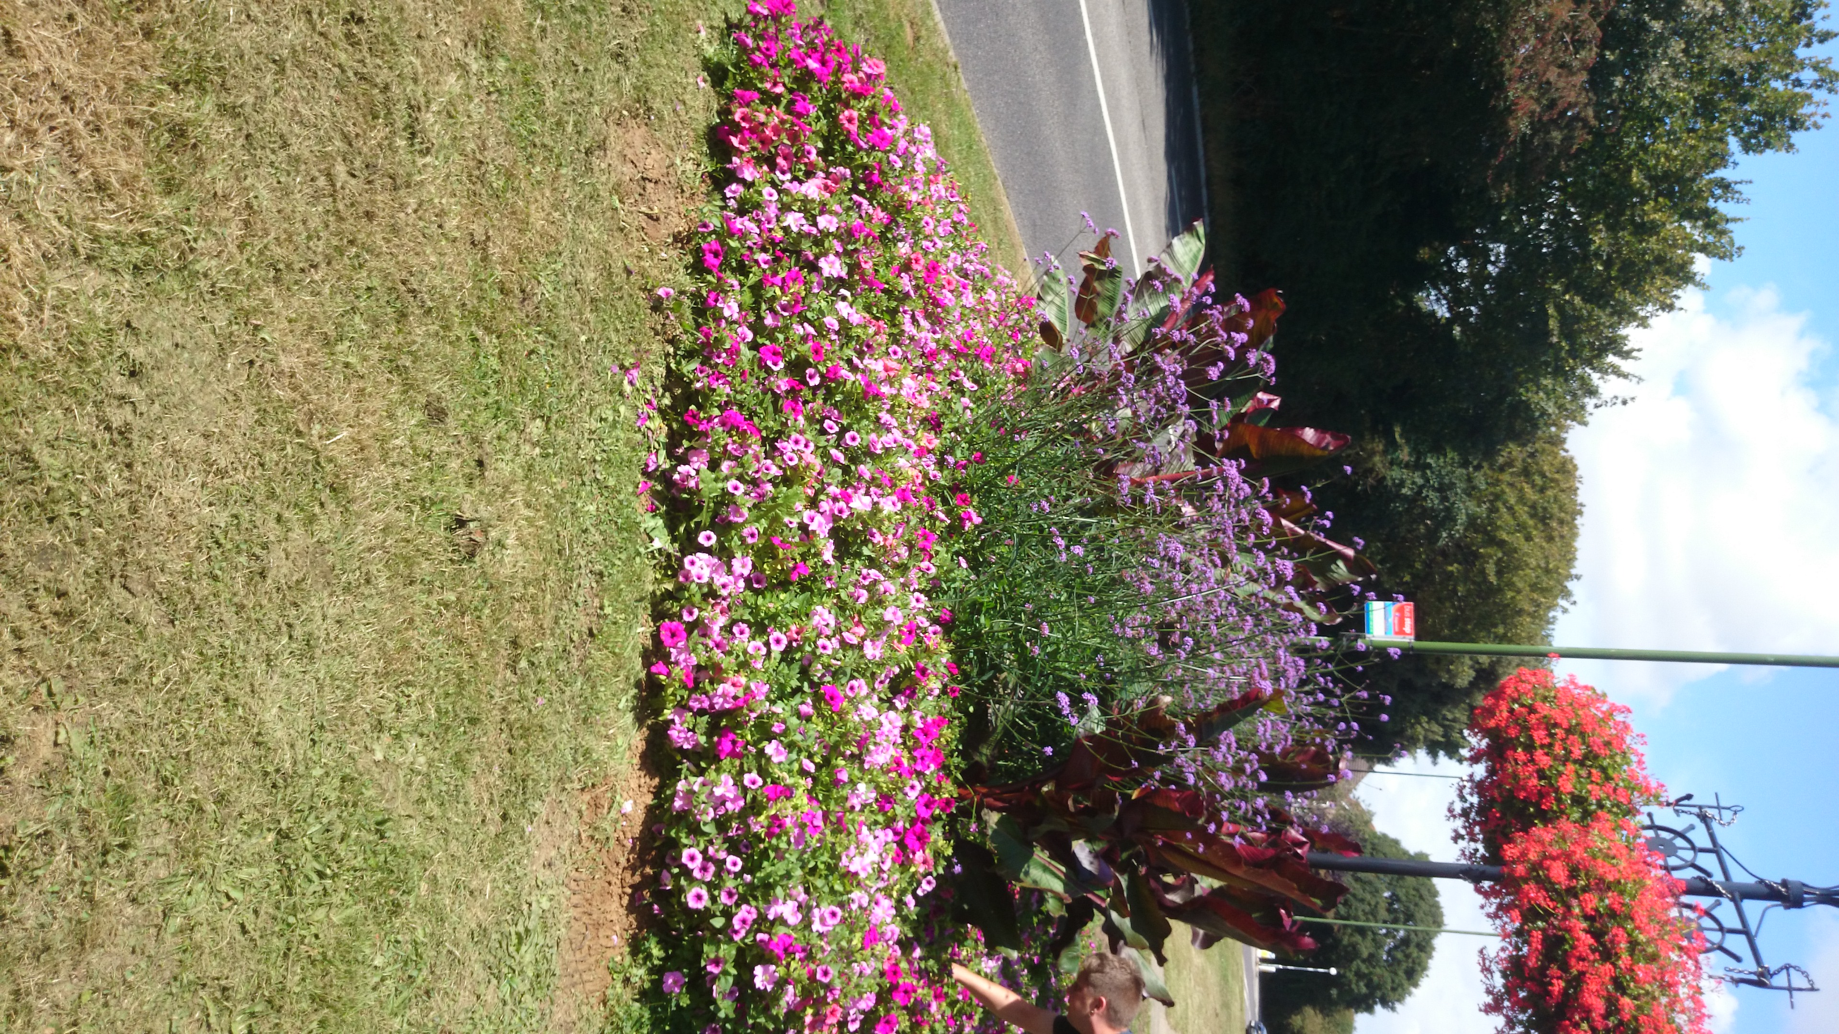
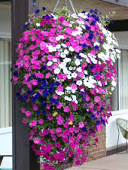

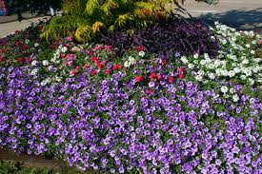

Contract

Any contract will be between the designated contractor and Littlehampton Town Council.

The tender should be based on the contract lasting three years (Spring 2022 – October 2024). Littlehampton Town Council budget for this scheme is set at a maximum budget of £25,000 per annum.

Assessment of tenders

Tenders will be assessed on the following criteria:-
40% Cost
60% Quality

Please ensure with the tender pack verification of required insurance and three references is provided.

Tender submissions

Please note no tenders will be accepted electronically.

Please return your submission by Friday 5th March at 16:00.
You are requested to submit separate prices for the five areas of work detailed above - please use the form Appendix 6. Any pictorial representations of proposed floral displays, example photographs of floral displays in situ or additional information that might help Littlehampton Town Council to reach a decision are welcomed as part of the bid.

All submissions are to be sent by post attached with sealed tender form Appendix 9. All tender submissions should be sent in a plain sealed envelope which should bear the word “Tender” followed by the subject to which it relates, but shall not bear any name or mark indicating the sender. The envelopes will remain the custody of the Town Clerk until the appointed time of opening on Tuesday 9th March 2021. Please ensure a signed copy of Appendix 10 Declarations as to conduct of tender is submitted with any application.

The successful company will be required to enter into a contract with Littlehampton Town Council and this will require the production of all relevant certification including Risk Assessment of the work to be carried out and copies of Public and Employee Liability Insurance. You may wish to submit these documents with your tender.
Please provide the contact details of three organisations for whom you have carried out similar work.

Persons or organisations submitting a tender are advised that the canvassing of Councillors or the members of a committee or sub-committee either directly or indirectly shall disqualify them from the tendering process.

Tender submission address:

Littlehampton Town Council
The Manor House
Church Street
Littlehampton
West Sussex
BN17 5EW

