**Appendix B6: Description and Specification**

LOT 6

1. **Site identification**

|  |  |  |  |
| --- | --- | --- | --- |
| Site name | Fuller Close and Yapp Road | | |
| Site reference | I4 | Site Postcode | SP4 7ZL |
| What3Words location | ///carefully.blockage.ember | | |

Site photograph/s:

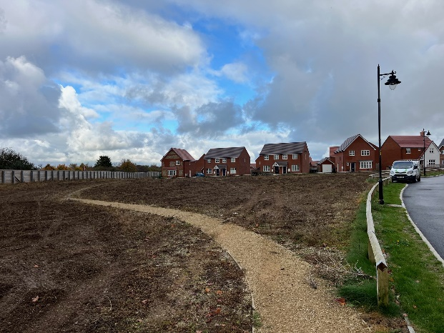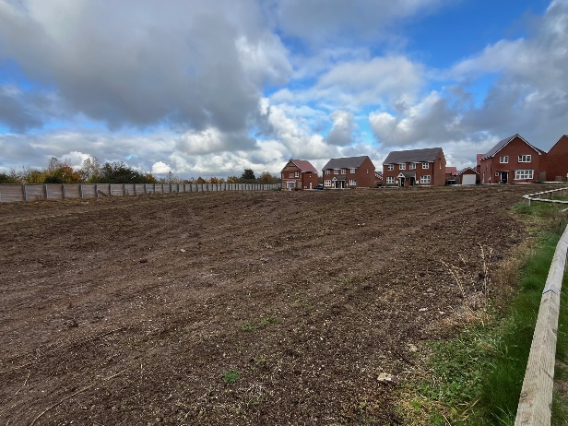

Site set-up:

Welfare (drinking water and a portable toilet) must be provided for the duration of the Works.

Heras Fencing must be established around the entire site for the duration of the Works, with sufficient CDM signage and double clipped.

Compound and Access Route: details on the tender submission should include any vehicle access route and contractor parking, proposed compound, and processes to mitigate any impact on the community such as vehicle movement, noise, or any other factors.

1. **Lot budget**

This Lot has an allocated maximum budget of £250,000.00

The full budget should be used but not exceeded.

All features included within the design must be included within the budget and quotation, there must be no ‘suggested’ additional works shown in the design outside the tendered price.

1. **Lot requirements & objectives**

This Lot is required to broadly meet the Fields In Trust definition for a NEAP.

Key considerations are the appropriate provision of play equipment for the 7-14 age group.

The buffer zones set out in the definitions of a NEAP should be applied and noted on the design plans.

The design should consider creating a play space that is unique to this location and distinctive from other play areas within the Kings Gate development. This could be achieved with the style, design and general theme of the play area. The design will also include a Multi-Use Games Area (MUGA) that will form part of the entire design and budget.

1. **Specification** 
   1. Play equipment

Play equipment construction should be predominately **steel**. Additional materials are acceptable for non-structural parts.

Fixings should be anti-tamper style (Torx Screws), and any bolts covered with protective caps.

Chains should be stainless steel.

Basket swing seats should be moulded plastic composite with drainage holes.

Rope should have a steel core.

Timber equipment is not acceptable at this location.

Maximum Height: 4.0 metres

Swings: Swings should have Anti-Wrap connectors where possible.

Suggested inclusions: 25-30 Metre Zip Wire x 2. High embankment slide on mound using spoil from MUGA. 4.0 metre high Pyramid Net or similar. Dynamic items to attract and retain the attention of older children.

* 1. Safety Surfacing

Surfacing should be primarily grass mats unless deemed necessary to use wetpour.

Grass mats shall be fire retardant, cable tied, trench cut on the perimeter and have turf provided under where grass is not established. Also requires the installation of *Grass Mat Underlay Mesh.*

* 1. Landforms, mounds & landscaping

Soil excavations may remain on site and be formed into an interesting and playful landscape that enhances the play environment. Mounds, slopes and undulations should be finished with turf, watered until established and gradients designed to be maintained with a mechanical mower.

* 1. Pathways

Connecting pathways should be included in the design to link play zones to the existing footpaths serving the site and to provide a high level of accessibility for all throughout the year and in all weather conditions. Main connecting paths to gates and with wider recreation space must be a minimum 1.2 metres wide. Footpath widths should be clearly noted on your design plan.

Pathways should be constructed from a rubber/stone/ resin mix (such as ‘Conipave’/ ‘Enviro-Pave’ or similar). Pathway edging shall be pre-cast concrete (PCC).

* 1. Fencing & Gates

Fencing is not required at this site other than for the Multi Use Games Area (MUGA).

Vehicle access must be provided for locations with grass inside the fenced area. This may be a dedicated vehicle access gate or a combination gate and must be located in an appropriate position for access by mowing vehicles.

* 1. Furniture

Seating should be: Glasdon ‘Pheonix’ seats with armrests and Glasdon ‘Clifton’ picnic tables with wheelchair access. Quantity at the discretion of the tenderer.

All seating should be on hardstanding and preferably connected to any new pathways.

Litter bins (x2) should be: Broxap ‘Derby’ Steel, 120 Litres in Black.

Cycle hoops (x6) should be: Broxap ‘Sheffield’ Stainless Steel.

* 1. Multi Use Games Area (MUGA)

Playing Area: 28 x 18 metres.

Primary Sports: Football and Basketball (include permanent line markings for these sports)

Fencing Height: 4.0 metres on the western side (A345), 3.0 metres on the other three sides.

Must be certified to **BS EN 15312** including robust welded mesh panels, with rounded corners and rubber inserts to reduce any rebound noise.

Entrance via a 3.0 metre high Chicane that is accessible for all users including wheelchairs.

Goal Recess and Basketball Board and Hoop at each end with escape routes. Goals to be coloured White, fencing colour to be advised (please provide standard colour chart).

All specifications should conform to the guidance set out by SAPCA Code of Practice for the Construction of Outdoor Multi Use Games Area (September 2021).

Surface to be Porous Tarmacadam (open textured 40-50 mm thick) with PCC edging (BS EN 1340) around the perimeter, not encroaching into the playing area to reduce any potential injury.

Sub-base to be MOT Type 3 dressed with MOT Type 1, with a minimum of 250mm aggregate and membrane. Consider any additional drainage system based on the site, soil and ground conditions which should also determine the sub-base depth (reference guidance from SAPCA Code of Practice).

MUGA Sign (A1 Size) to be affixed to the fencing (Artwork to be advised).

Pathway (1.2 metre wide) should connect to the main pedestrian entrance and surround the MUGA along with some seating for any spectators or carers to use.

* 1. Other

A post installation inspection by an independent RPii qualified inspector (i.e. Play Inspection Company, RoSPA or other similar provider) is required to sign off the completed installation. The contractor should allow for this cost within their tender price.

Signage (minimum A2 size) on steel posts should be provided to indicate: The site name, age the play area is intended for use by, telephone number to report any incident or damage, number to call in an emergency, Town Council logo.

Include graphics that demonstrate:

* dogs are excluded
* smoking is prohibited
* litter should be disposed of

Example sign (replace Wiltshire Council with Amesbury Town Council):

