Date: 26/02/2024  Ref No: LTMN/Woodwalton Fen/Vegetation Survey/Contract/2024 | 

Contract lead: Sarah Grinsted
Natural England
LTMN@naturalengland.org.uk

Project Specification

Long Term Monitoring Network: Woodwalton Fen NNR - Vegetation Survey - 2024

- Background to Natural England.
Natural England is the government’s advisor on the natural environment. We provide practical advice, grounded in science, on how best to safeguard England’s natural wealth for the benefit of everyone.
Our remit is to ensure sustainable stewardship of the land and sea so that people and nature can thrive. It is our responsibility to see that England’s rich natural environment can adapt and survive intact for future generations to enjoy.

- Long Term Monitoring Network
The Long Term Monitoring Network (LTMN) is building on the work of the Environmental Change Network (ECN) and the Environmental Change Biodiversity Network (ECBN) to develop, with our partners, a cost-effective, long-term and integrated approach to meeting long term evidence needs. ECBN sites form the core of our Long Term Monitoring Network.

There are 37 LTMN sites in England where a number of physical, chemical and biological variables are measured in a standardised way in order to allow comparability between sites. This includes re-surveying the vegetation at each site on a 4 -5 year cycle.

The protocol for the vegetation monitoring is included in Appendix 1 – contractors should familiarise themselves with this.

- REQUIREMENT
This specification covers a number of activities that are required on the LTMN site: Woodwalton Fen. The baseline survey was undertaken in 2015 and a subsequent survey in 2020. This contract aims to repeat the survey again i.e. 50 plots, carrying out both the standard and additional woodland methodology on 5 of the plots. The target habitats for the site are Lowland Fens, Reedbeds, Purple Moor Grass & Rush Pastures, Lowland Mixed Deciduous Woodland, Wet Woodland and 13 plots on ex-arable, reverting land. The tasks are described in detail below, and summarised here:

Survey preparation
- Provide Natural England with a site-specific risk assessment before the survey - YOU MUST SEND THIS TO THE LTMN MAILBOX AND THE NNR MANAGER PRIOR TO THE SURVEY.
- Locate feno markers already in place at the permanent plots and flag these with a temporary cane.
- You will need a metal detector (equivalent to X Terra 705) to help find the feno markers.
- Precise recording of marker position using High Accuracy GPS, to within 10 cm. High Accuracy GPS is ideal but not always necessary. Last time, at this site: High Accuracy GPS was used to accurately record all of the plots. Sixteen of the feno markers could not be re-located and were replaced, due to the tall vegetation; and it is recommended that feno-finding is carried out as a separate exercise early in the season. However, please also note that some areas may have restricted access due to bird nesting, which the site manager will advise on. Please provide two quotes, one with High Accuracy GPS and one without. Please note that in woodland, HA GPS is unlikely to work and in areas of low mobile signal you may need a base station to improve triangulation. Please provide detail on the make, model and accuracy of any HA GPS to be used, and the method for transferring data from and to GIS - both in your quotation and in the required short report at the end. Please ensure that you use both latitude & longitude, and British National Grid co-ordinates in your final results.
- If a plot/feno marker cannot be found, you will need to install a replacement feno marker using the same accurate co-ordinates. You must order the feno markers from M&P Survey Equipment and bill Natural England for the amount purchased.

Please complete the LTMN site plot tracker with updated GPS co-ordinates, for latitude & longitude, and British National Grid, and any changes to plot numbers/names (see Appendix 3), and return at the end.

For more detail on the methodology, see Appendix 3.

Vegetation survey
Use the vegetation survey – standard methodology, plus the additional woodland methodology on 5 of the plots – see Appendix 1.

Order and timing
From experience, finding markers can take longer than perceived as they are often obscured by vegetation and soil over time. If feno markers cannot be found they will need to be re-marked in the same location. Please do not underestimate the length of time required to survey the plots. We need all the species that are rooted in the cell to be identified. It will take at least 2 -3 hours to complete a plot and often longer in species-rich habitats.

This contract is a re-survey, where surveyors must re-find markers and take high accuracy GPS readings. Fifty 2m x 2m vegetation plots are to be found and re-surveyed, including the additional woodland methodology on 5 of the plots. All this work must be completed by the end of the survey period stated. Contractors must bid for the full contract.

Preferred dates for the vegetation survey to be completed: the last two surveys have been from mid-August to September, and the next needs to repeat this as closely as possible.

Tasks
- Provide Natural England with a site-specific risk assessment.

- Re-find existing permanent markers – Appendices 1, 2, 3.

- High accuracy GPS – Appendix 3. The precise location of each marker should be confirmed using high accuracy GPS. Please ensure that you provide both latitude & longitude and British National Grid co-ordinates, if possible to 1m or even 10cm accuracy.

- If a plot cannot be relocated you as the contractor must install a new feno marker using the existing map co-ordinates and update the LTMN site plot tracker spreadsheet.

- Vegetation survey - standard methodology, plus the additional woodland methodology on all 5 of the plots – see Appendix 1. This includes taking a photo from the south side of each 2m² plot, showing the quadrat and feno marker, and labelled with plot number and map co-ordinates.

- Quality assure the data, using the QA methodology that will be provided as a separate document. This includes writing data entry comments and using QA codes, where relevant, in the LTMN vegetation data input spreadsheet provided.

- Whilst in the field, make a judgement on the National Vegetation Classification type and subsequently use the MAVIS tool or similar to analyse the plant species data for each plot (single plot analysis only), to provide NVC types and % matches. Include this information in the LTMN vegetation data input spreadsheet.

- Provide a short report (one side A4) about the survey noting any issues that were encountered during the survey e.g. the make, model and accuracy version of any HA GPS used, any advice to help smooth the process next time and how you QA’d the data.

Available data
- Map co-ordinates of permanent plots (including HA GPS if previously carried out), from previous surveys.
- For some sites, we can supply sketch maps and previous plot photos.
- Baseline and subsequent vegetation survey data for the site – also found on Natural England’s Access to Evidence Catalogue LTMN pages.
- LTMN vegetation data input template that can be used on a tablet – or printed.
- LTMN vegetation survey collation and QA guidance – updated January 2023.

Mobile phone signal
Please make sure you consider mobile reception when creating your risk assessment. We cannot guarantee mobile reception so make sure that you have considered alternative means of communicating and discuss this with the NNR reserve manager.

Access
For access, please contact: Katy Smith, Senior Reserve Manager, Woodwalton Fen NNR Base, m.07920 072006; e-mail Katy.Smith@naturalengland.org.uk

As already mentioned above, it is recommended that feno-finding is carried out as a separate exercise early in the season. However, please note that some areas may have restricted access due to bird nesting, which the site manager will advise you on.

Please also note that some ‘sensitive species’ are re-establishing themselves on the reserve and that any records made for these must not be publicised, or passed on informally, by the contractor. Such records will ultimately be removed from the LTMN dataset before publishing as normal under Open Government License. Please confirm that you will take this approach in your submission.

Please make arrangements directly with the Reserve Manager.

Terrain, distances and conditions
Where: Woodwalton Fen, in Cambridgeshire, was once a raised bog associated with the former Whittlesey Mere. It was dug for peat in the late 19th-century when most of the acidic peat was removed, exposing the underlying fen peat. The vegetation of the area today largely reflects this historical use of the site.

Main habitats: The target habitats for the site are Lowland Fens, Reedbeds, Purple Moor Grass & Rush Pastures, Lowland Mixed Deciduous Woodland, Wet Woodland and 13 plots on ex-arable, reverting land. Woodwalton Fen holds a range of wetland plant communities once characteristic of large areas of the East Anglian Fens, but that are now restricted to a small number of isolated examples in Cambridgeshire, Suffolk and Norfolk. The open fen and swamp communities represented are of several types. A relict area of acid peat holds stands of Purple moor-grass (Molinia caerulea) with Heath (Calluna vulgaris), Bog myrtle (Myrica gale), Tormentil (Potentilla erecta) and Great fen-sedge (Cladium mariscus). A further swamp community is dominated by Wood small-reed (Calamagrostis epigejos). Mixed fen covers a significant part of the site. This vegetation community is floristically rich and contains species such as Common meadow-rue (Thalictrum flavum), Yellow iris (Iris pseudacorus), Swamp meadow-grass (Poa palustris) and Water dock (Rumex hydrolapathum).

Important species: Rare fen plants such as the Fen wood-rush (Luzula pallescens) and Fen violet (Viola persicifolia) occur. Of particular note is the network of ditches on the site and these hold many water plants which are now relatively uncommon in Britain including Greater bladderwort (Utricularia vulgaris) and Water violet (Hottonia palustris).

- SUSTAINABILITY
Natural England protects and improves the environment and is committed to reducing the sustainability impacts of its activities directly and through its supply chains. We expect the Contractor to share this commitment and adopt a sound, proactive sustainable approach in keeping with the 25 yr environmental plan/our commitments compliant with all applicable legislation. This includes understanding and reducing direct and indirect sustainability impacts and realising opportunities, including but not restricted to; resilience to climate change, reducing greenhouse gas emissions, water use and quality, biosecurity, resource efficiency and waste, reducing the risk of pollution, biodiversity, modern slavery and equality, diversity & inclusion, negative community impacts.

As a delivery partner, the successful contractor is expected to pursue sustainability in their operations, thereby ensuring the Contracting Authority is not contracting with a supplier whose operational outputs run contrary to the Contracting Authority’s objectives. The successful contractor will need to approach the project with a focus on the entire life cycle of the project. Please indicate how you will minimise the impact of travel as part of this contract (e.g. minimise number of trips, use of cleaner fuels etc.).

- RISK MANAGEMENT
Though this contract is considered relatively low risk, it does involve fieldwork on Woodwalton Fen NNR and the contractor must provide a risk assessment for the project. The responsibility for Health & Safety lies solely with the contractor, and the contractor is expected to provide suitable personal protective equipment for the work.

The nature of the contract requires staff with a high level of botanical identification expertise - please confirm that sufficient qualified staff will be available to undertake the work. Please also detail how you will mitigate against any potential time delay within the project.

- REQUIRED OUTPUTS
- Site-specific risk assessment.
- Fully completed LTMN site plot tracker (including full information on any new plots, as per Appendix 4).
- Fully completed LTMN vegetation data spreadsheet including NVC classifications.
- Labelled plot photos (method described in appendix).
- Sketch maps if required (method provided in appendix).
- A short report (side of A4), including a description of how you quality assured the data.

- TIMESCALES
All finding markers and survey work to be completed by timescales outlined in the table below, with the vegetation survey data input spreadsheet and other outputs submitted to Natural England by Friday 15th November 2024.

Site name: Woodwalton Fen | Timing
Contact site manager to make access arrangements. | Well in advance of the survey
Provide site manager and LTMN project officer with site-specific risk assessment. | Prior to commencing fieldwork
Refind and flag markers, instal new ones if needed. | For some sites it is helpful to do this before the vegetation grows, as a separate exercise.
High accuracy gps. | At the same time as marker finding and/or vegetation survey.
Vegetation survey. | mid-August to September
Provide contract outputs to LTMN project officer and submit invoice. | By Friday 15th November 2024

- CONTACT
Sarah Grinsted, Sarah.Grinsted@naturalengland.org.uk, m.07827 232754 will be your contact for this project. If you have any questions linked to the content of the quote pack or the process, please submit them by email and note that, unless commercially sensitive, both the question and response will be circulated to all tenderers.

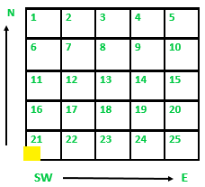
Appendix 1
LTMN Vegetation Survey – standard methodology

The methods have been developed under the ECBN coarse-grain protocol.

The permanent marker indicates the SW corner of the 2m x 2m plot. Each plot is divided into 25 cells, measuring 40 cm x 40 cm. Cells within the 2m x 2m plots should be labelled from 1 to 25 with 1 being the north-west cell, 2 being the next cell to the east, and 25 being the SE cell. These correspond to the 25 numbered columns on the vegetation survey data input spreadsheet. Table 1 lists the variables recorded in each cell. Table 2 lists the variables recorded at plot level.

Please also take a photo of the plot from the south side of the quadrat, showing the quadrat and feno marker, and labelled with plot number and map co-ordinates.

Please take the following measurements listed in the tables below:

Table 1 Variables recorded in each cell

Variable | Method/comments
Presence of vascular plants, bryophytes and lichens | The presence of all vascular plants rooted in the cell is recorded, with the exception of those growing on rock or wood. Non-vascular plants are recorded in the same way and for Sphagna, other bryophytes and lichens, the main species in these groups are recorded to species level whenever possible. Record any algal mats as ‘Algae’.
Sward height | A 200g drop disc and ‘sward stick’ is used to measure height in each cell location. Height is read at the centre of the cell on a graduated dowel passing through the centre of the disc.
Litter | Litter is assessed by recording presence by a visual assessment through the vegetation from above during botanical recording.
Bare ground | Bare ground is assessed by recording presence by a visual assessment through the vegetation from above during botanical recording.
Bare rock | As above.
Dead wood | As above.
Open water | As above. This is only to be recorded for permanent/semi-permanent water such as bog pools and edges of water bodies.

Table 2 Variables recorded for each plot

Variable | Method/comments
Photo | Take two photos of the plot, from the south side, one from above and one showing the landscape / horizon.
Cover of vascular plants, bryophytes and lichens | The total percentage cover of each species present is estimated for the whole 2m x 2m plot.
Cover of litter, bare ground, bare rock, dead wood and open water | The total percentage cover for each attribute present is estimated for the whole 2m x 2m plot.
Altitude | Measured at the centre of the plot using a GPS.
Aspect | Measured at each plot using a hand-held compass (from the highest point facing down to the lowest point).
Slope | Measured at each plot using a clinometer (from the lowest point facing up to the highest point).
Slope form | Use the codes given
Land use | Use the codes given
Broad and Priority habitats | Use the standard names given
Grazing levels | Presence of dung (and origin – rabbit, deer, sheep, cattle) is recorded along with other obvious signs of grazing impact (e.g. presence of pulled vegetation).
Disturbance/anthropogenic problematical features | Vehicle tracks, fires, dumping of farm or garden waste, and any other disturbance should be recorded. This is assessed qualitatively in the field and can also be assessed from aerial photographs.

Note: if a formerly grassland plot has turned to impenetrable scrub, and the feno marker is presumably somewhere within but not possible to reach, it is acceptable to assume the approximate outline of the plot and record the plot attributes and plant species as best one can. It is better to record this change in vegetation than to ‘lose’ such a plot and create another one.

LTMN Vegetation Survey – woodland methodology
A larger 10m x 10m grid is marked around the permanent vegetation plot of 2m x 2m (see diagram below). 1. Tree and shrub species rooted in the 10m x 10m plot will be listed and their crown classes (dominance categories) recorded. A species may be represented in more than one of these crown class/dominance categories. For each tree and shrub species, and crown class/dominance category, record percentage cover (this is new from 2023). 2. Ten subcells of 40cm x 40cm are randomly selected /repeated from last time within the 10m x 10m grid, and the species and number of seedlings in each recorded. 3. Ten sample trees (of >5cm DBH), which may be within or just outside the 10m x 10m plot, are selected, marked and measured, as described below. Previously, the distance and bearing of these was measured from the ten 40cm x 40cm subcells, but since 2021 is measured from the 2m x 2m feno marker – please confirm in your results comments that you have used this revised method. If a sample tree has died, record that is the case; then find a new sample tree, give it a new number e.g. 11 (>10 to indicate it is an additional tree to the original 10 trees), and mark and measure as below.

For the ten sample trees record:

Tree species | Record the tree species – must be >5cm DBH, within or close to the 10m plot.
Diameter at breast height (DBH) of nearest tree | Record the DBH, measured to the nearest 0.1cm at a height 1.3m above the ground - use a tape measure for the girth initially. If the plant is multiple-stemmed, the DBH of the tallest live stem is measured and the number of stems are counted and recorded.
Height | Record tree height to the nearest 0.5m. Using a tape measure and a clinometer measure your distance from the base of the tree, the angle to the top of the tree and your height (see quick guide to calculating height). If multiple-stemmed, the height of the tallest live stem is measured. Or a range finder can be used to measure tree height.
Distance and direction of the tree from permanent feno marker | The distance and direction between the 2m x 2m permanent feno marker and approximate centre of the chosen stem will be recorded. The measured stems should be marked with paint or a metal tree tag, for re-measuring on subsequent occasions. If a stem dies or disappears between surveys this must be recorded - and a replacement stem selected and new number applied. Need to distinguish between dead or disappeared, dying (keep recording) and number dropped off (re-tag the tree).

Tree crown classes
1. Dominant (DOM_CODE = C)
Trees with crowns extending above the general level of the crown cover and receiving full light from above and partly from the side. Usually larger than the average trees in the stand and with crowns well developed
2. Subdominant (DOM_CODE = S)
Trees with crowns forming the general level of the crown cover and receiving full light from above but comparatively little from the sides
3. Intermediate (DOM_CODE = I)
Trees shorter than those in the two preceding classes but with crowns extending into the crown cover formed by dominant and sub-dominant trees; receiving a little direct light from above
4. Suppressed (DOM_CODE = U)
Trees with crowns entirely below the general level of the crown cover
5. Tree (definition)
A woody perennial plant with a diameter at breast height (DBH, 1.3m above the ground) >5cm, typically with a single, well-defined stem carrying a more or less definite crown.
6. Sapling (DOM_CODE = A)
A young tree; no longer a seedling and growing vigorously; DBH between 0.5cm and 5cm.
7. Seedling (DOM_CODE = E)
A young tree or shrub grown from seed; from its germination up to the sapling stage, i.e. with a DBH <0.5cm.
8. Shrub (definition)
A woody perennial plant with persistent and woody stem(s). It differs from a tree or sapling, as defined
here, in its lower stature and the general absence of a well-defined main stem.

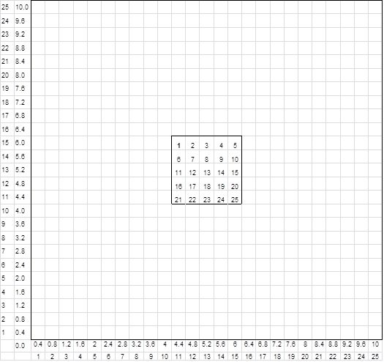
4m south
4m west

↑ North

The 10m x 10m woodland recording plot is located with the permanent 2m x 2m vegetation plot at its centre. Find the point 4m south and 4m west of the permanent feno marker, and lay out two 10m axes with measuring tapes. Use a compass and a further tape to find the ten 40cm x 40cm subcells, which were selected at random and then should be repeated each survey.

Appendix 2
Background information: selection of sample plots

Fifty (50) (unless otherwise specified) 2m x 2m plot locations are distributed across the site (usually stratified according to the main vegetation types present). Natural England has identified the locations of these plots using GIS software and a random point generator.

The coordinates identify the south-west corner of the 2m x 2m quadrat and this is where the feno marker was installed. All quadrats are marked with feno markers, except in exceptional circumstances. Different feno marker heads may have been installed depending on the habitat and site.

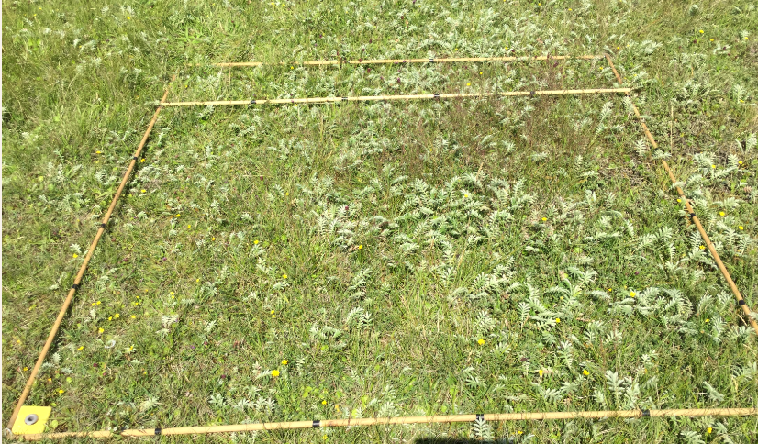

Figure 3: Example 2m x 2m plot, photo taken from south side.

Appendix 3
What to do if a plot/feno marker cannot be re-located

If you are unable to re-locate a plot then we require you to install a new feno marker with the same grid reference. Prior to doing this please consult with the LTMN team and NNR manager; and complete the site plot tracker spreadsheet.

Plot locations should be confirmed using a handheld GPS unit or a high accuracy GPS unit with a roving receiver as required in the specification. Handheld GPS devices have been used in the past, however if you have access to and experience of using high accuracy GPS equipment, please could you state what impact using such equipment would have on the cost and delivery timescale of this work.

Please use the following plot numbering/naming system:

For any plots needing a new feno marker, they must have a new name e.g. plot 2 becomes plot 2a on the site plot tracker. If the map grid ref. changes because of using HAGPS but it’s the original feno marker, a new name is not needed. When using HA GPS, record using latitude and longitude, and convert to British National Grid co-ordinates – please provide both sets of co-ordinates. Also record the HA GPS accuracy at each plot, as this will vary according to the mobile data signal and correction service, tree cover etc.

For any completely new plots (shouldn’t often be needed), upon reaching the designated location, the contractor should take a decision as to whether the location is appropriate for the intended survey. If the proposed location of a plot falls in a slightly unsuitable place, but a more representative area can be identified within close proximity (<20 metres away) then the plot should be re-positioned as such. If the proposed location is considered unsuitable and cannot be rectified with a small adjustment to the location, then the plot should be rejected and the first of the reserve plots should be used instead. Reserve plots should be used in this manner, in order according to their numerical ID, not geographic proximity to the rejected plot. Please note the sampling methodology is based on a random sample within a habitat and we do not want the plots to be placed in locations biased towards ‘good’ examples of a given habitat. The plots should be broadly representative of the habitat on that site as a whole.

Installing the permanent marker
The marker should be installed according to the instructions provided. The feno marker should be positioned so that the grooves in the top of the polyroc head are orientated at a north-south bearing.

In addition to installing the permanent marker, a temporary visual marker should also be installed next to the permanent marker to facilitate quick re-location during survey over the coming weeks. This temporary marker should be easy to spot and state the ID of the plot (e.g. 1.5m tall bamboo cane or similar, with a piece of gaffer tape stuck on it with the plot ID written on). The temporary marker should be installed to the western side of the permanent marker head so that it doesn’t fall within the 2m x 2m area to be surveyed.
The installation of feno markers requires the use of three accessories: the driving tool (reusable), fixing tool (reusable) and a mallet or hammer.
- Position the polyroc head and clip the white plastic spacer onto the spike. Drive in the spike using the driving tool and a hammer.
- Stop driving when the handle of the tool is 1cm from the polyroc head, with the white plastic spacer in position in the polyroc head.
- Replace the driving tool with the fixing tool.
- Hit the fixing tool with the hammer, which has the following effect:
  - it drives the anchorage fully home
  - it applies high pressure, ensuring a perfect seating for the marker in the ground
  - if causes the extension of the three high-strength prongs which will firmly anchor and lock the marker
- Stop driving when the fixing tool handle is a few centimetres from the polyroc head.
- Withdraw the fixing tool (reusable).

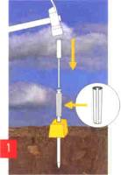
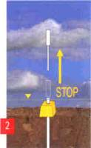
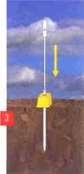
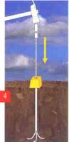

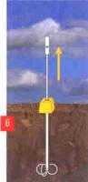
Appendix 4
Information required if a completely new plot is needed.
In order to assist future re-location of plots, sketch maps and photographs of the marker locations should be provided – just if it’s a new location.

Variable | Method/comments
Location of permanent marker | Taken from GPS to at least 10-figure (1m) accuracy or higher accuracy if available. Grid reference or the equivalent x, y coordinates should be given.
Description of location | Should contain description of location with respect to local landmarks e.g. plot is located in NW corner of ‘Smith’s Field’, approx 20m east of small oak tree.
Description of habitat/ features | For example, tall mixed grass/sedge sward, bare/trampled area close by.
Sketch map of marker location | Sketch map of location of markers in the context of any local landmarks with distance and bearings given. Example map given below. As an alternative, an Ordnance Survey map may be marked up with plot locations and local landmarks referred to in location descriptions. The aim is to assist surveyors in locating the feno markers rapidly at each four yearly re-survey with vegetation growth up around the markers.
Photographs | Four photos to be taken per plot of the surrounding area facing N, S, E & W from the permanent marker, with the marker in view in the photograph.
Plot ID of marked plots, grid references and plot descriptions should be recorded in the plot tracker. Sketch maps (if drawn by hand) should be scanned and provided in jpeg format. Photos should also be provided as jpegs with the plot ID and direction of view included in the filename in a consistent format.
Example sketch map: Chippenham Fen, Plot 2
The plot is located at TL 65195 –69410, close to a small oak tree (see Figure 2)
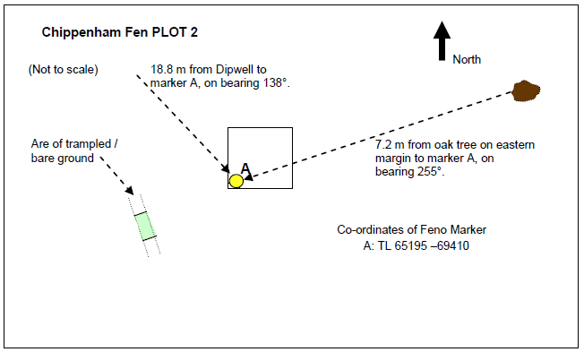
Figure 2: Chippenham Fen, view from Dipwell 8, looking south-east towards Plot 2, June 2011.
Oak tree on left, Plot 2 is towards the right hand side of the shot.

Appendix 5
Quality Assurance methodology
- Check all data has been captured and is complete.
- Spend time on the first day on site familiarising yourselves with species commonly present on the site and then practicing the methodology to ensure all survey team members are fully keyed into the botany of the site and the methodology particularly for the woodland method. Depending on the size of the team it would be good to all carry out the first plot together.
- After data collation using the LTMN vegetation data spreadsheet template identify a different person from your team to carry out a second check of the following:
  - Species names against latest Stace edition and commonality for the site and habitat type. Check against the LTMN baseline and repeat surveys data. For any rare or unusual species, if possible, check with BSBI records and county records for the site.
  - Apply the LTMN data issues and quality assurance codes, found in the vegetation data survey template. For any queries around data entry, see ‘LTMN vegetation survey collation and QA guidance – updated Jan 2023’ which will be provided.
  - Produce NVC types using analytical software (MAVIS - Modular Analysis of Vegetation Information System - or similar) providing the first three classes, and provide a final NVC classification using your considered opinion and the NVC publications as to which community the plot is most closely aligned to. Populate the LTMN vegetation survey data template.
  - Optional: a Twinspan analysis (Two-way indicator species analysis) is undertaken to try and reduce bias in grouping samples. When this is undertaken where quadrats are assigned based upon the surveyors judgement i.e. where the quadrats are located within the plant community and potentially not an ecotone, this generally produces a dendrogram which matches what the surveyor recorded in the field.
  - Ensure sign-off of finalised data from your lead botanist.

Appendix 6
Natural England’s Medical Support Card

