- Introduction

NHS Guildford and Waverley CCG (the “CCG”) will shortly be issuing a formal notification for the procurement of Children Community Services (the “Services”) across Surrey. Prior to formal notification the CCG are seeking professional advice from providers to ensure the effective planning and conduct of the procurement through undertaking market engagement. The CCG assures all participants the advice received from undertaking this engagement will not affect nor distort the competition, through abiding by principles of non-discrimination and transparency.
In order to capture the view of the market we will issue a questionnaire (this document), arrange meetings (where possible), and hold a bidder/market event.
This document contains the market questionnaire, it is not a scored questionnaire and responding to it will not impact upon any related procurement, it is to enable us to create a set of services and ultimately a contract that improves outcomes for patients.
Please submit your completed questionnaires to mark.algar2@nhs.net no later than the 11th March 2016 at 5pm
- Surrey Context
  - This procurement programme is set against a geography of 6 Clinical Commissioning Groups with 137 GP Practices,(below) 5 Acute Hospital Trusts and 1 Mental Health Trust. A two tier local authority with a County Council that works with 11 district and boroughs. There are 52 children centres, 509 schools (including state funded and Independent) and 31 community youth based settings.

  - The Surrey Clinical Commissioning Groups, Surrey County Council and NHS Commissioning Board (“NHS England”) commission a range of health and social care services for Children and Young People across Surrey. Collectively, this Commissioning Partnership is able to strategically commission across the county whilst focussing on specific CCG local localities health care systems.

NHS East Surrey CCG (18 GP Practices serving a population of approx. 170,000 people)

NHS Guildford and Waverley CCG (25 GP Practices serving approx. 207,000 people)

NHS North East Hants and Farnham CCG (24 GP Practices serving a population of approx.
220,000 people)

NHS North West Surrey CCG (42 GP Practices serving a population of approx. 360,000 people)

NHS Surrey Downs CCG (33 GP Practices serving a population of approx. 300,000 people)

NHS Surrey Heath CCG (10 GP Practices serving a population of approx. 90,000 people)

NHS England - Surrey and Sussex regional team covers the following geographical area: (N.B: For this procurement, NHSE services include the Surrey area only.)

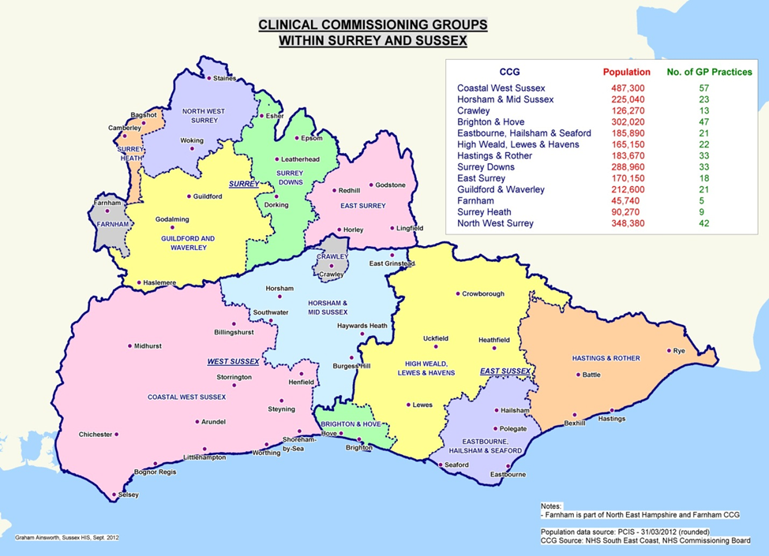

  - Children and Young People make up about 30% (approximately 279,800) of the population. While the predicted number of births and total fertility rate, in Surrey, is relatively stable In terms of numbers, those aged 5 to 14 years show the greatest increase in population over the years from 2012 to 2022.

  - By 2017 it is estimated that there will be a 14% increase in children aged 5-9 years, so approximately an extra 10,000 children in this age-group. The projected rise for 10-14 year olds occurs later, with a 19% increase in this population by the year 2022 (an extra 13,000 children.

  - For most children and young people Surrey is a good place to grow up – the economy is doing well and many households benefit from higher than average socio-economic circumstances. Most children and young people are safe, well educated, experience good health and have good leisure and employment opportunities.

  - Deprivation exists in Surrey and there are groups of children and young people who experience poorer outcomes. Around 10% of children and young people live in poverty with pockets of poverty often close to the most affluent areas. Surrey’s population of children and young people is growing, with increasing demands being put on public services. For example, 16,000 additional school places will be required in Surrey by 2018.

  - Surrey’s Joint Strategic Needs Assessment highlighted:

- Young parents: There are around 300 conceptions to girls under 18 in Surrey each year. About half of these result in a termination.
- Gypsy Roma Traveller families: Surrey has one of the highest numbers of resident Travellers in England.
- Domestic abuse: It is estimated that 7% of women in Surrey have experienced Domestic Abuse in the past year.
- Economic status: Nearly 10% of 0 to 19 year olds live in poverty in Surrey.
- 8% of children qualify for Free School Meals
- Parental qualifications: 7.8% of the Surrey working age population have no qualifications.
- Young Carers: at the last Census around 6,000 children and young people identified themselves as carers.
- Education and employment: Academic achievement for children eligible for Free School Meals is considerably lower than for other children.
- There are currently just over 1,000 young people classed as Not in Education, Employment or Training.
- Housing: the number of households in temporary accommodation has doubled since 2010.

  - In addition Surrey has a high prevalence of community, voluntary and faith sector organisations.

  - The CCGs have a legal duty to have regard to specific population groups; characteristics such as disability and religion are protected under the Equality Act (2010). This means the Commissioning Partnership must ensure that people with these characteristics are not discriminated against when accessing and using services.

- Scope of Children’s Community Health Services Procurement

The following sections provide an outline of the current services and how they are commissioned.

  - List of Services of ‘In Scope’:

CCG Commissioned:
- Community Paediatric Medical Services (Developmental Paediatricians)
- Physiotherapy
- Speech and Language therapy
- Occupational Therapy
- Community Children's Nursing team
- Children's Continuing healthcare Team
- Audiology
- Safeguarding children team
- Looked after children health team
- Tongue tie (over 10 days)
- Specialist school nursing
- Medical Advisor for SEND

Surrey County Council Commissioned:
Public Health
  - 0-19 including Family Nurse Partnership

Children Services
  - Parent and Infant Mental Health
  - Children and Adolescent Mental Health Services - School nursing
Education
  - Occupational therapy

NHS England Commissioned:
- Children’s Community and School based Immunisation Service
- Child Health Information Service

  - The contract will be managed by a lead CCG on behalf of the other CCGs, NHS England and Surrey County Council (Public Health) will be associate commissioners.

  - All commissioning partners wish to continue such a relationship as this provides opportunities for greater integration across health and social care and those services commissioned by these individual organisations

- Current Service Provision

  - Children’s Community Health Services are currently provided to the residents and patients of Surrey through a block contract with Virgin Care Services Ltd (VCSL) and two further contracts with First Community Health Services (FCH) and Central Surrey Health (CSH).

  - The VCSL contract serves NHS East Surrey CCG, NHS Guildford and Waverley CCG, NHS North East Hampshire and Farnham CCG, NHS Surrey Downs CCG, NHS Surrey Heath CCG, Surrey County Council and NHS England. The current contract spans both Adults and Children’s Community Health Services. It is due to expire on 31st March 2017.

  - The FCH contract serves NHS East Surrey and spans both Adults and Children’s Community Health Services. The children’s elements of this contract are the Public Health Commissioned Services (see page 6), NHS England commissioned children’s immunisation services and CCG specialist Safeguarding and LAC service. The children’s elements of this contract will be included in this procurement with a delayed implementation date, starting 1st April 2017.

  - The CSH contract serves NHS Surrey Downs CCG and spans both Adults and Children’s Community Health Services. The children’s elements of this contract are the Public Health commissioned services (see page 6) all the NHS England commissioned services (see page 6) and CCG specialist Safeguarding and LAC service; specialist Nursing, Safeguarding, Occupational therapy and Speech and language. The children’s elements of this contract will be included in this procurement with a delayed implementation date, starting 1st April 2018.

  - This procurement covers only Children’s Community Health Services, not the entire range of current service provision.

- The Requirement

  - Central to the Awarding Authority’s vision is to procure a provider who will be system leader for healthcare; leading change through innovation, continuous focus on evidence based best practice and user satisfaction; and integrating care across organisational divides to ensure we meet the needs of our population effectively.

  - Our vision for health and care delivery is articulated below:

A ‘No wrong door’ approach must be adopted – no child or young person will be turned away from advice and direction to support will be given;
Children and young people must receive quality, timely and age appropriate interventions;
Services must deliver positive outcomes for children, young people and their families;
Services should promote prevention, early identification and early intervention; to avoid costly packages of care across the health, education and social care economies;
Services should ensure equity of access to children’s community health services and quality of service delivery via:
- timely and equitable access, based on an agreed set of service criteria and key performance indicators, for parents, children and young people;
- universal services that are planned and delivered based on population level health and wellbeing needs;
- clear pathways of care and protocols;
- timely communication across community health services and with primary care, acute care, social care and education
- integrated care plans with a clear description of how and where to access services for children with complex needs, including clear protocols and healthcare plans that facilitate/support access to hospital care when necessary;
- maintaining appropriate skill mix and staffing levels that reflect national and local best practice and current and projected future needs should be established and maintained to deliver the service effectively;
- Service delivery including clinics in accessible locations and a range of home and community based services;
- Use of audit and service reviews to inform service transformation requirements or assurance of quality.
Maintaining effective partnership working with other health services (including CAMHS), early years or education services to support shared outcomes for children, young people and their families
  - The transformation of Children and Young People’s Community Services will be delivered through the is implementation of the model of care outlined below:

Single Point of Entry (SPE): The provider will develop a Single Point of Entry (SPE) for targeted and specialist children’s community health services in Surrey; taking referrals from health, education and social care professionals as well as from parents and young people themselves.

Dynamic Pathways that will:
- Be developed in line with national pathways and guidance
- Recognise that individual needs change over time
- Provide care that:
    - Focuses on prevention, recognition, assessment, and intervention,
    - Supports de-escalation; self-efficacy, and effective discharge
    - Flexes and is appropriate to the need, individual and setting
  - It is through the delivery of these requirements and this overall vision for a new way of working in health and social care that will enable us to provide the highest standard of service to the Children, Young People and their families within Surrey. These may take the form of agreed joint pathways and protocols.

  - Child and Adolescent Mental health services and education, and social care professionals will form a fundamental part of the integrated approach encompassing joint working arrangements with children and young people’s services in Surrey including but not exclusive to the following:

SEND including Education, Health and Care Planning
Children’s continuing health care
Communication including developing integrated single points of contact
Early Help
Multi-Agency Safeguarding Hubs (MASH)
Single Assessment Framework
Strategic planning and system leadership
Mental health and learning disabilities

  - The Department of Health’s good practice guide Transition moving on well (2008) outlines the characteristics of good transition. Every young person with complex physical and mental health needs, from age 14 should have support from health care providers.

  - Adult Community Health Services are excluded from this procurement and will be secured via a separate competitive exercise.

- Hours of Operation

  - The provider is expected to deliver a comprehensive, integrated community service response to meet clinical need on a 24 hours a day, 7 days a week, 365 days a year basis as described within the service level specifications.
- Patient Access

  - All patients registered with a GP in Surrey or resident within the boundaries of Surrey County Council will have access to services delivered subject to this procurement. The provider will be expected to ensure that services are made accessible to all members of the population on an equitable basis, including recognised “hard to reach groups”.

  - Using mobile, internet and telephone facilities to make services accessible for younger people, parents, carers and professionals
Ensuring the workforce is responsive to innovation and new technologies to continuously improve service access and delivery. Examples of innovative services delivery aimed at making service accessible to might include (but are not limited to):

- Mobile apps
- Secure Live chat facilities
- Social media
- SMS / text e.g. appointment reminders and test results
- Online appointments booking
- Online interactive information
- Online pre-filled forms
- Online access to records
- Translation/ interpretation services
- service user feedback
- Proactive and real-time service data

Additional Information
  - Additional sources of information that may be of use to potential providers are signposted below, this list is not exhaustive and providers are encouraged to undertake their own research:
- Patient and Market Engagement Event feedback and information Improving community services in Surrey
- Joint Strategic Needs Assessment Resources - Surrey-i
- Resident Population Data - Release Edition Reference Tables - ONS
- GP Practice Registered Population by age and sex - GP Practice Registered Population by Age and Sex Resource - Surrey

- Organisations are asked to responds to the following questions
The purpose of this is document set out how we wish to engage with potential providers (and sub-contractors) to enable GW CCG to make decisions to ensure the procurement and subsequent contract is effective.
As part of this questionnaire we would like to explore how the CCG should approach its re-procurement of children’s community services.
The CCGs have been prioritising its requirements for the contract and services and they are:
1. Integration.
The CCGs require multi-disciplinary teams to work at a local level to deliver a single care plan for the patient. Health and social care professionals must work together as one service, where there are no gaps or barriers between different services or specialisms.
2. Innovation:
The CCGs would like to see service improvement and innovation across the contract in order to change/shape the way that care is delivered. In this regard a transformation approach is critical to help us deliver the best and most appropriate services for Surrey.
3. Technology:
All staff involved in the delivery of the services will have easy access to patient records and will be unencumbered by poor technology/systems applications. Particularly important is the requirement for the provider to have in place a Children Health Information System with robust consideration of associated IG and data sharing arrangements. Consideration of National Information Board Digital road maps are also required.
4. Contract Reward.
The CCGs believe that being rewarded for good performance and for innovation will be key to a successful contract and we anticipate incentives to ensure that these are achieved.

Questionnaire
Considering these priorities Commissioners are seeking professional advice from providers to ensure the effective planning and procurement of Children’s Community services. We would therefore be very interested in responses to the questions below that would help us to achieve these aspirations.
In responding please create a separate sheet for each question and label it, for example:
Smith PLC – Question 1
All responses should be submitted via email to mark.algar2@nhs.net no later than 5pm on the 11th March 2016.
Any questions or comments with regards to this market engagement should be directed to mark.algar2@nhs.net

Specification / Information Document.
- Drawing on previous experience and best practice please suggest what we would need to consider to deliver a comprehensive children community service. Please illustrate your response with:
  - An indicative care pathway illustrating how services (listed above) will work between the Patient, GP, Nursing Staff and Paediatric Consultant.
  - An indication as to how the service will interact/work with other community service teams, GPs and other providers to deliver a seamless, multi-disciplinary, patient centred service.
  - An indication on how the services will have effective clinical supervision and leadership at all times
  - A summary of the key changes that your business would propose to make to allow the services to become more effective.

Market Entry / Participation
- What would you envisage are the current barriers to participation in the Children Community Services procurement and what you propose we could do to help you overcome these?

- If you were to bid for these services, would you be interested in bidding as part of a consortium, alliance, lead provider, or sub-contractor? What would you approach be if you were to bid as a lead provider and how would you ensure you engaged and appointed competent sub-contractors to meet service delivery. What do you foresee the benefits / disadvantages to these bidding approaches?

Pricing
- From your experience of delivering these or similar services how would you approach the pricing of these services that would reduce the potential financial risk?

  - What would you consider a fair profit margin to be in delivering these services?
  - Do you believe the contract should reward improved performance and if so what mechanisms would you suggest were put in place?

Mobilisation & transformation
- Please outline the length of time you envisage it will take to mobilise these services.

Please outline if you would propose to transform services during the Contract, the scale of ambition, and any risks associated with such a plan.
END

