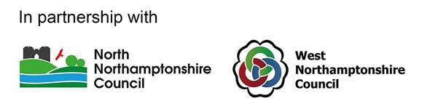

The Northamptonshire Suicide Prevention Steering Group have highlighted the importance of providing effective bereavement support to those affected by suicide within the Northamptonshire Suicide Prevention Strategy 2022-2025.

This engagement aims to inform the market of a potential opportunity and gather feedback regarding the requirement stated below:

West Northamptonshire Council working collectively with North Northamptonshire Council, are seeking to appoint an organisation to pilot bereavement support for primary care staff for a 1-year period. An estimated value of £42,000.00 has been identified. Please note this is an estimate and may change.

It is suggested that the funding provides a 0.5 WTE Senior Clinical Psychologist (including oncosts) or equivalent with evidence of appropriate registration and/or accreditation with a clinical professional body, and evidence of a clinical supervision qualification.   
  
The role would be expected to:

* Develop and provide a postvention support offer to all General Practices in the county (West and North Northamptonshire).
* Enable postvention support to be offered in a range of forms, i.e. clinical supervision, debriefing, after death reviews, advice and guidance, and support on basis of 1-2-1 and group/team support, for any member of the team who needs it and for clinicians assessing and managing suicidal patients.
* Develop and deliver training for GPs on postvention support and skills, delivered in ‘hot huddles’ to bring Primary Care teams together in difficult events such as a patient death by suicide.
* Collect Primary Care views and learning on postvention needs to support with development of this area of work.
* Support views from primary care clinicians to inform future suicide prevention by collating views and supporting these views getting to right person.

The role would need to have knowledge and experience in local services and support, evidence based postvention support and bereavement support, working with primary care staff and the context of primary care in the current landscape, and appropriate language for suicide awareness and prevention.  
  
The Council is seeking to engage interested organisations in answering the following questions:  
  
1. What is the likelihood that the parameters currently set for the proposal are viable given the estimated annual value on a scale of 1-5:  
  
5. Highly likely  
4. Likely  
3. Neither likely not unlikely  
2. Unlikely  
1. Highly unlikely  
  
2. Given the estimated annual value, would the current proposal interest your organisation?  
  
Yes or No  
  
3. Are there any other factors you would wish to highlight to the Council as it enters this process?  
  
Please submit your response, limited to one side of A4, outlining your organisations responses. Email your response to [linda.oconnell@westnorthants.gov.uk](mailto:linda.oconnell@westnorthants.gov.uk) or andile.chigbo@northnorthants.gov.uk quoting "postvention primary care support" no later than the close of business on 24/01/2025