8. PRE CONSTRUCTION INFORMATION



**Ward Williams Associates**  
Compass House

Truro Business Park

Threemilestone

Truro

Cornwall

TR4 9LD

Tel: (01872) 272906

Fax:(01872) 222042

Idless Nursery – Supply and Installation of GlassHouses

**HORTICULTURAL**

**NURSERY,**

**IDLESS,**

**TRURO**

Truro City Council

**CONTENTS**

1.0 INTRODUCTION 2

1.1 Pre Construction Information 2

1.2 Construction Phase Plan 2

1.3 HSE Notification 2

2.0 DESCRIPTION OF PROJECT 3

2.1 Location 3

2.2 Project Description 3

2.3 Programme 3

2.4 Parties 4

2.5 Workplace (Health, Safety& Welfare) Regulations 1992 5

2.6 Existing Records & Plans 5

3.0 CLIENT’S CONSIDERATIONS & MANAGEMENT REQUIREMENTS 6

3.1 Planning & Managing Construction Work 6

3.2 Communication & Liaison 6

3.3 Coordination of Ongoing Design 6

3.4 Site Hoarding, Compound & Signage 6

3.5 Site Security & Safety 7

3.6 Welfare Provision 7

3.7 Fire Precautions & Emergency Procedures 7

3.8 No-go Areas 8

3.9 Site Rules & Permits to Work 8

3.10 Personal Protective Equipment (PPE) 8

4.0 ENVIRONMENTAL RESTRICTIONS AND EXISTING ON-SITE RISKS 10

4.1 Traffic Management 10

4.2 Existing Hazardous Materials 10

4.3 Existing Services 10

5.0 SIGNIFICANT DESIGN AND CONSTRUCTION HAZARDS 11

5.1 Design Assumptions 11

5.2 Significant & Principal Risks 11

5.3 Materials Requiring Precautions 11

6.0 HEALTH AND SAFETY FILE 12

|  |  |  |  |  |  |
| --- | --- | --- | --- | --- | --- |
| ***Author*** | Thomas Rees  Senior Project Manager | *Signed*  *……………………..* |  | ***Job No.*** |  |
|  | ***Date*** |  |
| ***Approved*** | Richard Budge  **Client** | *Signed*  *……………………..* |  | ***Issue No.*** | 1 |
|  | ***Revision*** | . |

# INTRODUCTION

## Pre Construction Information

This document is intended to collate information provided into a useful document that can be taken forward and used to plan the project in terms of general cooperation and consideration as well as detailing known health and safety issues.

This document does not attempt to list the responsibilities of the Principal Contractor, of which he should already be fully aware. Further details of such can be viewed in the Approved Code of Practice for the CDM Regulations 2015. This document does however give a guide as to the issues that have been identified already and inform of any site peculiarities or Client restrictions.

This document should not be used in isolation for planning health and safety matters as reference should always be made to other information detailed as well as tender information. Site inspections should always be carried out by the Principal Contractor prior to works commencing to ensure all relevant issues have been identified as far as reasonably possible.

## Construction Phase Plan

It is a requirement under the CDM Regulations 2015 that the Principal Contractor produces a comprehensive Construction Phase Plan (herein referred to as the Plan). This document must be provided and deemed to be suitably developed prior to any works starting on site.

The information provided here can be used as a guide as to the contents for the Plan and particular issues that will need to be dealt with. Reference should also be made to the checklist at the rear of this document to ensure that all relevant information has been provided.

The Plan must not be a generic health & safety policy style document but must detail actual information that will be implemented. Irrelevant and out of date information (including reference to previous Regulations) must be removed or amended.

## HSE Notification

Due to the type and duration or work involved, the project will not require notification to the HSE and as such an F10 notification Document will not be required. Should any change to the project become apparent that would lead to the requirement for Notification an F10 will be provide as soon as possible.

# DESCRIPTION OF PROJECT

## Location

The site is located in Idless Woods off Higher Trehaverne, Idless, Truro, as detailed in the below map.

The site is currently secure with gated access and perimeter fence and occupies 2 No timber structured buildings and multiple poly tunnels. A small stream runs along the south boundary into the River Allen which runs along the east boundary of the site. The site is surrounded by agricultural fields and is within close proximity to a residential housing estate which occupies a local school.

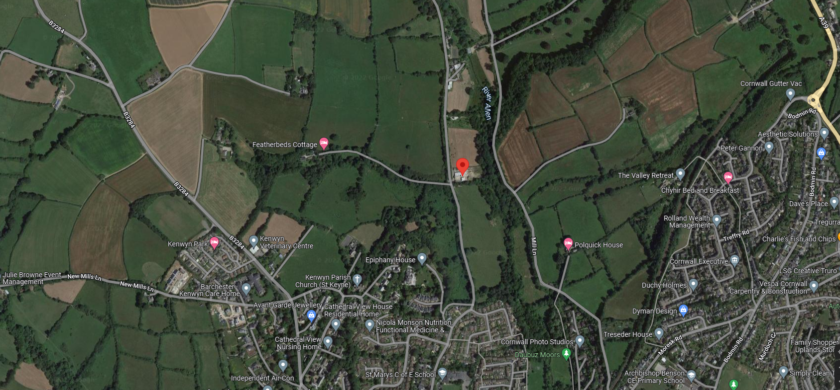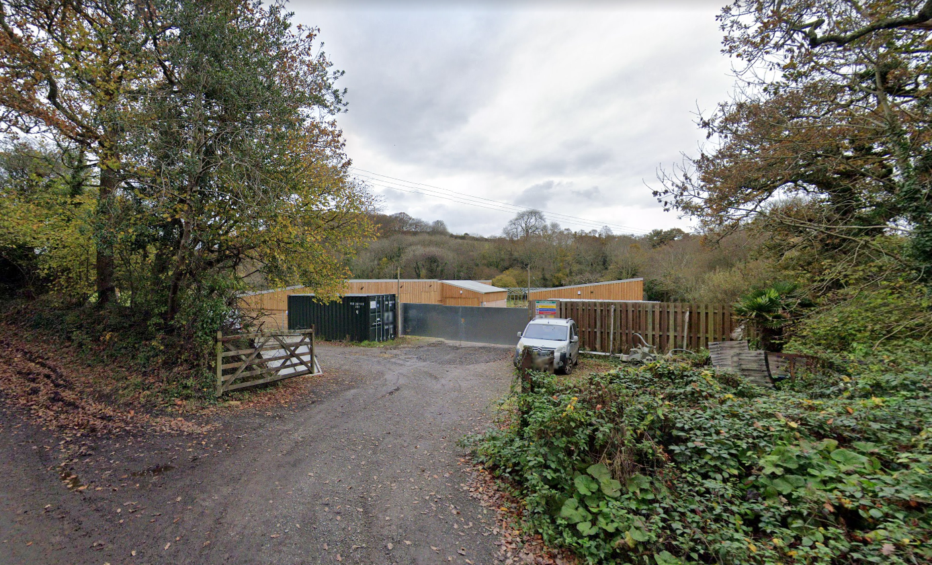

## 

## Project Description

Supply and installation of 3 No. commercial nursey quality glass houses, measurements detailed as follows:

* 1 No. 5m wide by 9m long
* 1 No. 8m wide by 21m long

Proposed works are to assist in the relocation of a commercial horticultural nursery facility to Idless Woods. Works will include the supply and installation of suitable frame and glazing, providing the necessary passive ventilation. With option to incorporate automatic opening. Appropriate base is to be specified by the successful contractor and provided to Truro City Council to be undertaken by others. Construction of the base will not form part of the works under this project.

## Programme

Planned commencement: 1st February 2022

Contract period: 8 weeks

Mobilisation period (minimum): Two weeks (after instruction of Principal Contractor before commencement of works on site)

The Principal Contactor is required to provide a detailed programme of the works which will be used and updated on a regular basis. Any significant changes to the programme should be notified to the Client in good time.

## Parties

|  |  |
| --- | --- |
| Client: | Truro City Council |
| Principal Designer | Responsibility to be adopted by Principal contractor |
| Principal Contractor: | To Be confirmed |

## Workplace (Health, Safety& Welfare) Regulations 1992

The above regulations will need to be upheld for the workforce on site as well as all provisions under the CDM Regulations 2015. Details of such will therefore need to be included within the Plan to ensure full compliance with all relevant health and safety legislation on the construction site.

## Existing Records & Plans

Site plan showing proposed glasshouses locations.

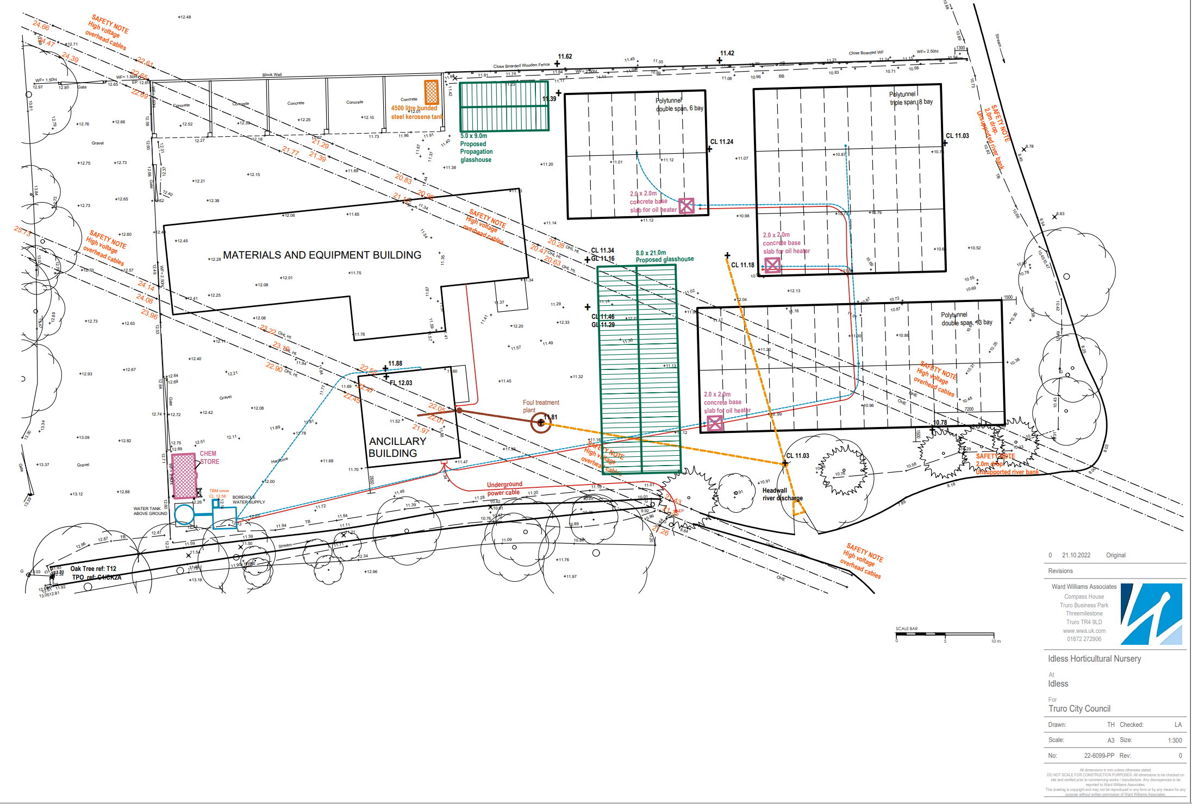

# CLIENT’S CONSIDERATIONS & MANAGEMENT REQUIREMENTS

## Planning & Managing Construction Work

The Client attaches particular importance to the promotion of a positive Health & Safety Culture on all its construction sites, and its target is zero reportable and classified accidents or injuries.

In pursuit of the goal of zero accidents the Client may employ a consultant health and safety advisor in addition to a directly employed health and safety officer, who may visit the site from time to time to inspect and advise on safety issues. This by no means absolves the Principal Contractor of his primary responsibility for health and safety, but is intended to provide support and encouragement.

The Principal Contractor will need to identify in the Plan exactly how the project will be planned and managed detailing, but not limited to, the sections provided in this document. This will include the need for a full and detailed programme of works.

## Communication & Liaison

It should be ensured that the lines of communication throughout the project are maintained to a high degree. Therefore any significant information produced or received should be passed to the relevant people in good time.

The Principal Contractor is to identify how and when communication and liaison will take place in the form of schedules of meetings etc. The method for passing information to all parties should also be detailed.

## Coordination of Ongoing Design

Any ongoing design changes are to be distributed to all relevant parties in good time in order to improve coordination and to ensure that all relevant health, safety and other issues have been identified. The Principal Contractor is to detail how such changes will be managed and who will retain responsibility for distributing and following up on such changes.

## Site Hoarding, Compound & Signage

The Principal Contractor will be required to provide hoarding / fencing and signage to the site to maintain security and safety for all persons. Details in relation to how this will be achieved should be noted in the Plan.

A formal compound area will also need to be provided with items such as site offices, welfare, storage (materials and waste) etc. The layout and position of such will need to be formally agreed with the Client and CDM Coordinator and marked up on a suitable site plan.

Adequate signage will need to be provided from day one to indicate that the site is a construction site and note any health and safety measures in place. Signage should also be provided to ensure that visitors can access the site offices safely. Further signage will be required in order to direct construction traffic by the most suitable route from main access roads to the site to cause the minimum amount of disturbance to local residents.

## Site Security & Safety

The details in relation to maintaining security of the site will need to be noted in the Plan. Please note that the Principal Contractor will still have a duty of care to trespassers, therefore security must always be maintained to a high degree.

An action plan in relation to maintaining safety on site will also need to be provided. This should detail items such as the provision of risk assessments and method statements along with how a safe site will be maintained by general housekeeping and good practice measures.

The Principal Contractor will be required to hold regular Tool Box Talks with all site personnel to detail activities taking place, safety issues, site rules, updates etc and any other relevant information. Details of these talks, including attendees are to be logged on a register in the site office.

## Welfare Provision

Adequate provision will need to be made by the Principal Contractor within the compound for all required welfare facilities. These are to include, but not limited to the following:

* Drinking water
* Means for heating water for drinks
* Means for heating food
* Area for seating for breaks
* Area for changing and locker facilities
* WCs (and showers if required)
* Office accommodation

The above items will need to be identified on the site plan in order to demonstrate how all facilities will be provided along with a description to support this information.

## Fire Precautions & Emergency Procedures

There are no specific fire precautions other than those that would normally be connected with working on such a site. Any specific fire risks brought about by the construction works will need to be raised in the Plan and detailed as required to reduce risks wherever possible.

The details relating to emergency procedures will need to be detailed in the Plan to include items such as those detailed in the list below.

* Means of warning and escape
* Firefighting provisions
* First aiders and location of first aid kits
* Location of all emergency contact information
* Procedures for reporting accidents and incidents

## No-go Areas

Works, delivery and storage are to be confined to the site boundary. No access will be provides to operational buildings on the site other than those directed by the client.

## Site Rules & Permits to Work

The Plan is to detail all site rules used by the Principal Contractor and the method of relating these to the workforce, such as in the site induction procedure. Inductions will also be required for all visitors where the site rules will be related. The rules are to be displayed on site in an accessible location and individual points reinforced as required.

The Client will set out all of the required permits to work in the pre start meeting. The Principal Contractor will also detail in the pre start meeting works which they will operate permits on and the management method for this.

## Personal Protective Equipment (PPE)

Strict details will need to be provided in relation to PPE to ensure the safety of all construction staff, project team members and visitors. The Principal Contractor will need to detail what PPE requirements are the minimum standard and provide suitable PPE for workers and visitors. In order to achieve exemplar levels of safety, the Principal Contractor should give consideration to implementing a PPE regime including the following items:

* Head protection
* Hi-Viz jackets / waistcoats
* Foot protection
* Gloves
* Eye protection

# ENVIRONMENTAL RESTRICTIONS AND EXISTING ON-SITE RISKS

## Traffic Management

A detailed traffic management plan will need to be produced by the Principal Contractor to show information in relation to, but not limited to, all items noted below:

* Access routes and one way systems
* Delivery / working times
* Parking (contractors & visitors)
* Construction vehicle storage & refuelling (bunded area)
* Delivery drop off
* Banksman
* Materials storage
* Waste storage
* Waste collection
* Wheel wash / road cleaning / inspection
* Pedestrian & vehicles routes

A clean area for deliveries / waste removal will be agreed with the client to ensure that no mud or debris will be transferred onto the road. Arrangements are also to be detailed in the event that any cleaning is required.

## Existing Hazardous Materials

The existing site is currently in operation and as such provides the client with storage for plant and chemicals in relation to their day to day activities within he existing buildings. No access to these buildings will be available to the principal contractor without prior authorisation from the client. As suck it is not anticipated that hazardous materials will affect the areas of work.

## Existing Services

Existing service are provided to the site in the form of water (both drinking and non drinking, electric and drainage it is anticipated that the proposed works will not be affected by existing services, however the Principal contract should undertake a full assessment and identify any risk relating to existing service within their Construction Phase Health & Safety Plan.

# SIGNIFICANT DESIGN AND CONSTRUCTION HAZARDS

## Design Assumptions

* Suitable groundworks and reinforced concrete raft slab base will be provided to facilitate the construction of the structures.
* Heating systems are to be provided by others
* Staging and shelving is not required
* Shading systems will not be required
* Electrical systems will not be required
* Irrigation systems will not be required
* Design should account for exposure to severe weather.

The Principal Designer/principal contractor are to identify and clarify any further design assumptions made.

## Significant & Principal Risks

Methods statements are to be provided for particularly high risks tasks. The following general and specific risks will particularly need to be borne in mind as relevant to the proposed construction works:

* Erection of framed structures
* Working at height
* Works involving noise / dust / vibration
* Traffic / personnel movements generally
* Waste storage and collection
* Protection of adjacent land uses (including public footpath)
* Use of lifting equipment

The sanction of the suitability of the Construction Phase Plan in compliance with regulations 23(1)(a); and 23(2) and 22(1)(c) is dependent on the inclusion of satisfactory method statements in respect the items noted above.

## Materials Requiring Precautions

The Principal Designer/Principal contractor are to identify all materials requiring precautions. This information is to be documented within the Construction Phase Health and Safety Plan and risks identified and mitigations strategies supplied within the Principal contractor Risk assessments and Methos Statements.

HEALTH AND SAFETY FILE

It is a requirement of the Regulations that the Principal Contractor implements an effective management system by which the requisite information is provided for inclusion in the Health and Safety File which should include:

* Brief description on the work carried out
* Residual hazards and how they have been dealt with (for example surveys or other information concerning contaminated land, water bearing strata, buried services etc)
* Key structural principles incorporated in the design of the structure (e.g. bracing, sources of substantially stored energy including pre or post tensioned members) and safe working loads for floors and roofs, particularly where these may preclude placing scaffolding or heavy machinery there
* Any hazards associated with the materials used (for example hazardous substances, lead paint, special coatings which should not be burned off)
* Health and safety information about equipment provided for cleaning or maintaining the structures
* The nature, location and markings of significant services, including firefighting services
* As-built drawings of the structure, its plant and equipment
* Operation and Maintenance information in relation to all building aspects including services and plant installed.
* Any other information relevant to the construction and future of the building, including demolition which should be passed to future users of the building.