Introduction

The Xantive.SupplierSelect.com portal is web based system for managing questionnaires or surveys. The questionnaire is issued as a series of web forms which are filled in online. Registration and basic use of the portal is intuitive. However, additional information is always useful for the new users.

Registration

Click the link https://xantive.supplierselect.com/

Click the link ‘Create a new organization account’

Provide a valid email address to which further instructions will be sent.

Note – As described in section 4 you will be able to add additional users after registering

Basic Steps

Login at https://xantive.supplierselect.com/ using the user id and password you created during Registration.

The first page you will see after logging in is the invitations list:
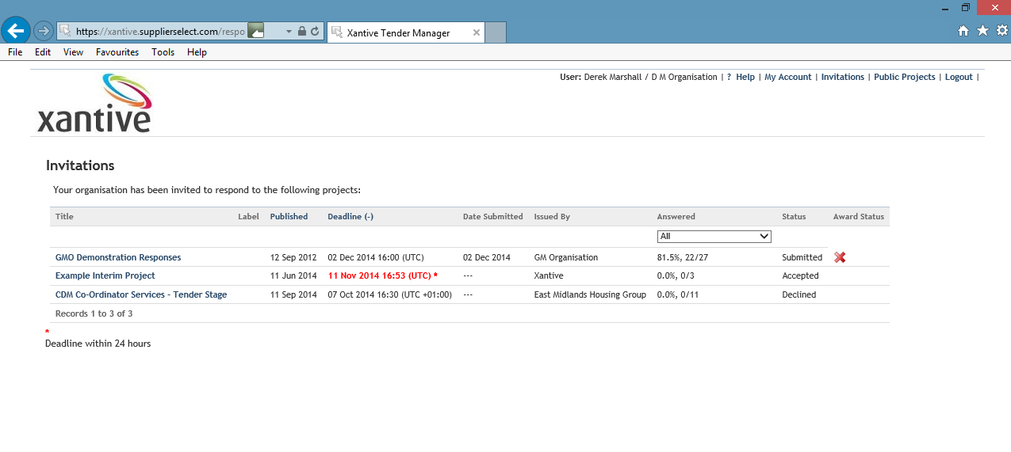
Click on the Public Projects link at the top right of the invitations page and you will see the following page.
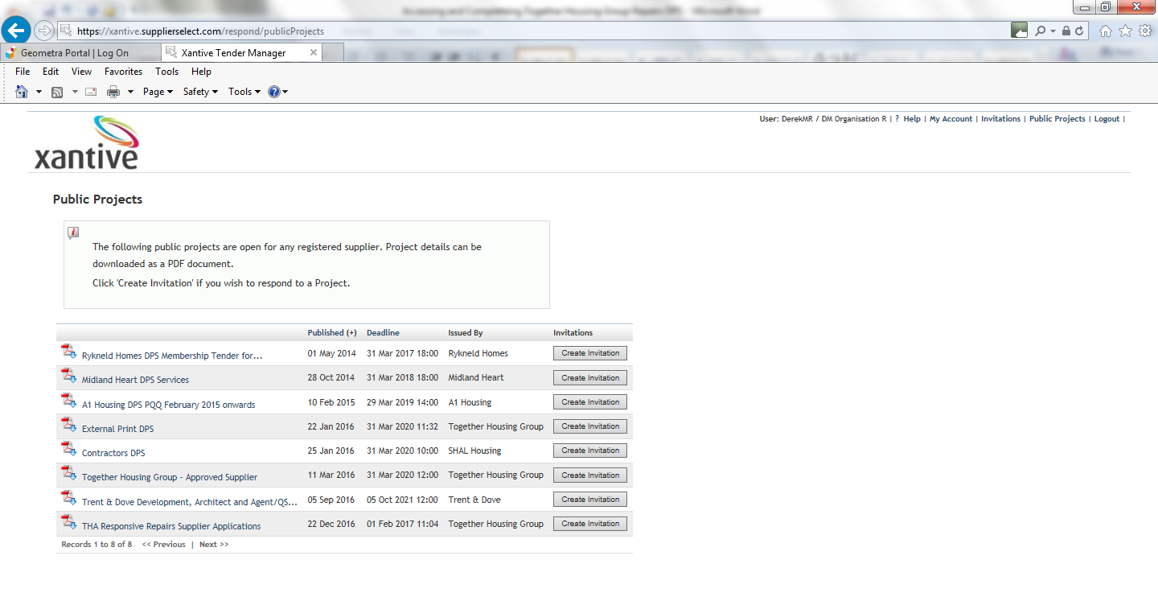
Find the ‘THA Responsive Repairs Supplier Applications’ questionnaire in this list and click the ‘Create Invitation’ button, and from then on the Invitation will appear in your Invitations list.

Accepting the Invitation

To enable the completion of the questionnaire accept the invitation via the Status page changing the status from ‘Opportunity’ to ‘Accepted’.
Prior to a change in status to ‘Accepted’ every time you click on the title from the Invitations list you will see the following reminder screen.

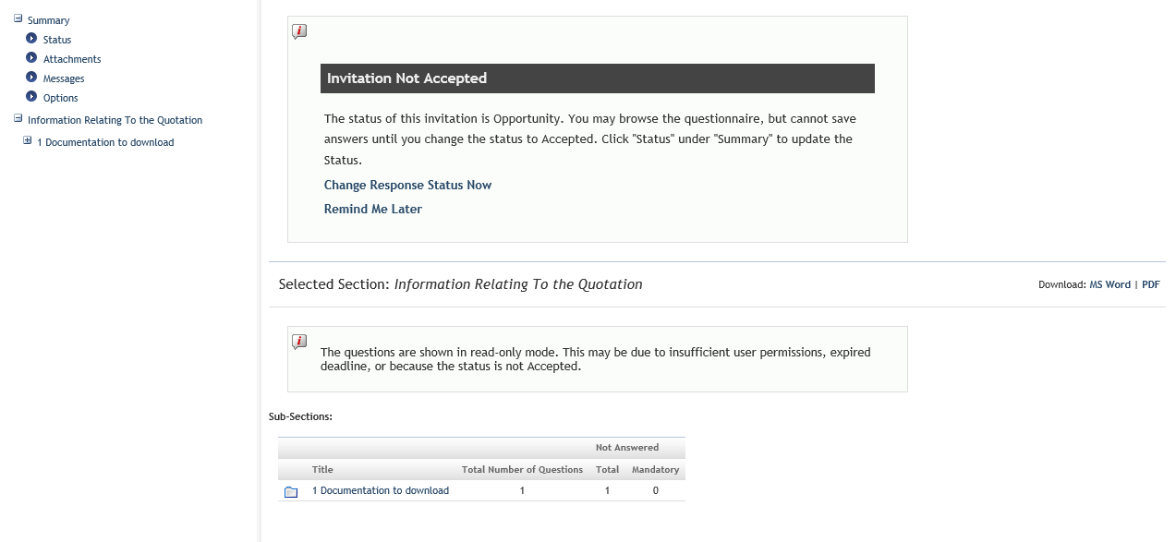

Responding to the Invitation

The tree menu on the left-hand side of the screen gives access to each question in the questionnaire. It is possible to view section summaries or individual questions. Questions are answered individually, and the section summaries will always show up-to-date statistics for the number of questions answered.

Mandatory responses
Some questions have mandatory answers. These are marked with an asterisk (*), and mandatory questions that are not answered are highlighted on section summaries. It is not possible to submit a response until these are all answered.

Question types
Questions can request information in a variety of ways. These should all be self-explanatory. Some questions may require a file to be uploaded. Use the button on the form to start a search for the required file on your hard disk, and upload it. Note that the uploaded file has a size limit.

Response Attachments
Sometimes there will be a requirement for a file to be uploaded but without reference to a question. This is done by using the ‘Attachments’ link. Use the ‘Upload New Attachments’ link and the browse button on the form to start a search for the required file on your hard disk, and upload it. Note that the uploaded file has a size limit.

Submit your response.

Once the response is finished, submit the invitation via the Status page changing the status from ‘Accepted’ to ‘Submitted’.
You must have loaded all of your response attachments and completed all of the Mandatory questions prior to this change of status.
If you have not completed all of the Mandatory questions you will see the following reminder screen.
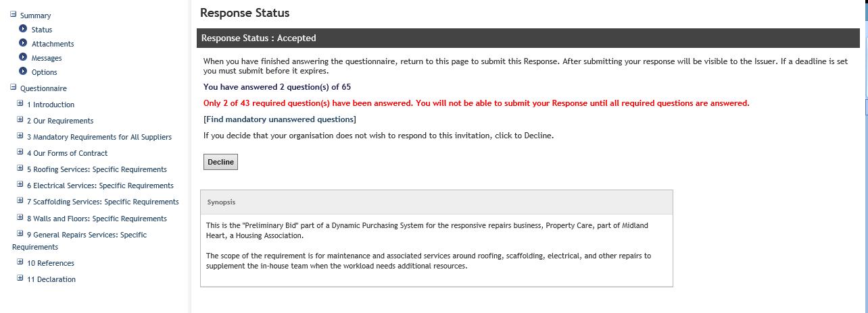

My Account

The My Account link shows the details of your account. The user who originally registered your organisation will be able to add and edit user details for all users in your organisation. Depending on your permissions, you will also be able to add and edit user details for all users in your organisation.

