HMP Channings Wood

HMMPS Prisoners, Family and Significant Other Services
Specification for Services

Governor

June 2020

Version Control:

Version | Date | Amendment | Made By

Foreword by the Governor:

HMP Exeter’s Drug Strategy is part of a wider strategic approach to tacking violence, self-harm, bullying and debt.

It is recognised that;

Substance misuse is linked to the offending behaviour of one third of adult offenders in custody. Effective treatment for offenders with problematic use has a substantial impact in terms of reducing re-offending, violence reduction, bullying and self-harm.

This document should not be considered in isolation, but as a key part of a holistic or whole system approach to creating and embedding a safe, decent and enabling environment, whilst creating rehabilitative culture with the individual at the centre of all we do.

This strategy will set out the key principles of how we intend to tackle substance misuse and support the individual within HMP Exeter, working in partnership to achieve positive outcomes across the establishment as a whole; with specific, timely actions that target crime reduction, community safety, harm minimisation and assisting substance misusers to move away from dependency and its related issues (inclusive of improving security around controlled healthcare and detoxification medication).

The strategy will be an evolving live document, revised and updated in line with legislation, advice from commissioners, partners, any identified best practices’ and establishment needs analysis.

At HMP Exeter we are committed to restricting the supply routes for drugs into our establishment, reducing the demand for them, and, most importantly, to put recovery at the heart of our efforts. We are determined to protect the public from the harms that drugs can cause to individuals, their families and society as a whole.

We now have a dedicated Drug Strategy Lead in order to support and revise this document strategy as previously outlined. This will be supported by monthly meetings led by the Drug Strategy CM and in consultation with the Drug Strategy Peer Mentor. It does not outline every process that is used within the establishment but should be used to identify and inspire new and current techniques to target the issues relating to drug supply, use and recovery.

Contents:

Contacts Page

Introduction, Approach & Issues Page

Values & Principles Page

Restricting Supply Page

Reducing Demand Page

Building Recovery Page

Longer Term Opportunities Page

Equalities Impact Assessment Page

Terms of Reference Page

HM Government 2017 Drug Strategy Page

HMPPS Prison Drugs Strategy 2019 Page

Points of Contact:

Devon & North Dorset Group Drug Strategy Lead | ian.king2@justice.gov.uk
Head of Reducing Reoffending HMP Exeter | bryan.dorward@justice.gov.uk
Local Mandatory Drug Testing (MDT) Co-ord, Head of Security, Intelligence and Operations | paul.cowell@justice.gov.uk
MDT Functional Mailbox | MandatoryDrugsTesting.Exeter@justice.gov.uk
Integrated Substance Misuse Service Exeter | Care UK: jamie.holmes@careuk.com  EDP: david.bentley@justice.gov.uk

Introduction & Approach:

The misuse of drugs in prison is one of the biggest challenges facing our criminal justice system today. Drug misuse is prevalent and contributes to violence, crime and vulnerability within prisons, which threatens safety and the ability of our hard-working staff to deliver effective regimes. We will not be able to improve safety, prevent reoffending and tackle both serious and organised crime without reducing the misuse of drugs in prisons.

This is a complex, multi-faceted problem with no simple answer, it requires
a coordinated effort to limit the supply of drugs both inside and outside prisons, encourage people away from drug misuse towards positive and productive activities, and finally to support those requiring treatment.

It is therefore crucial that our approach to tackling the problem considers the whole system, working across government and with our partners at a national, regional and local level.

The scale of the problem is significant and has become more challenging in recent years. The emergence of Psychoactive Substances (PS) such as synthetic cannabinoids has exacerbated the problem, and these are often used in conjunction with other drugs, while we remain aware of problems with the diversion and misuse of prescription medication.

The prevalence and patterns of drug misuse in prisons is shaped by patterns in the community, and the challenges faced by prisons can be exacerbated when those entering prison have an existing drug misuse issue or when drug misuse has been normalised in the community.

The National Drug Strategy and supporting guidance documents have 3 overarching aims:

- Restrict the supply of drugs within prisons.

- Reduce the demand for drugs amongst prisoners.

- Build recovery and improve through-care links with the community.

All of the activities that contribute to these aims reinforce each other to reduce substance misuse in our prison.

We will focus on restricting the supply of drugs by improving security, building intelligence, and targeting the criminal networks which aim to bring drugs into prison.

We will also reduce the demand for drugs in prison by developing more meaningful regimes, providing more constructive ways for prisoners to spend their time and ensuring the balance of incentives encourages prisoners to make the right choices.

We will work closely with our health and justice partners to build recovery for prisoners who want to overcome their substance misuse, providing prisoners who are serious about living substance free with the environment to do so successfully.

It is crucial that we deliver all three strands of this strategy in unison to make a meaningful, positive difference to both prisoners and staff.

A successful approach will rely heavily on close partnerships working alongside the prisons Security, Residence, Safer Custody and ISMS functions.

It must be noted that these roles are not limited and all departments are strongly encouraged to utilise all 3 strands in order to deliver this strategy.

Our Approach:

To tackle the problem of drug misuse in prisons, we need to prevent drugs being available in prisons (restrict supply), support prisoners to reduce and avoid drug misuse (reduce demand), and provide the help and treatment they need to maintain their recovery (building recovery).

To achieve these objectives, we are focusing on five areas that impact the levels of drug misuse in prisons:

People - That prisons have the right staff, with appropriate skills and support.

Procedural - That prison processes are clear, fair and effective.

Physical - That prison conditions are safe, clean, decent and promote well-being and
Recovery.

Population - That prisoners have positive relationships and engage in constructive activities.

Partnership - That all the organisations contributing to achieving our aims work together effectively.

For each of the three objectives, we have identified key activities in each of these five areas as well as aims against which we can measure our progress.

HMP Exeter Specific Issues:

All issues can be viewed alongside Future/Ongoing initiatives found at the Action Plan HERE

Restricting Supply:

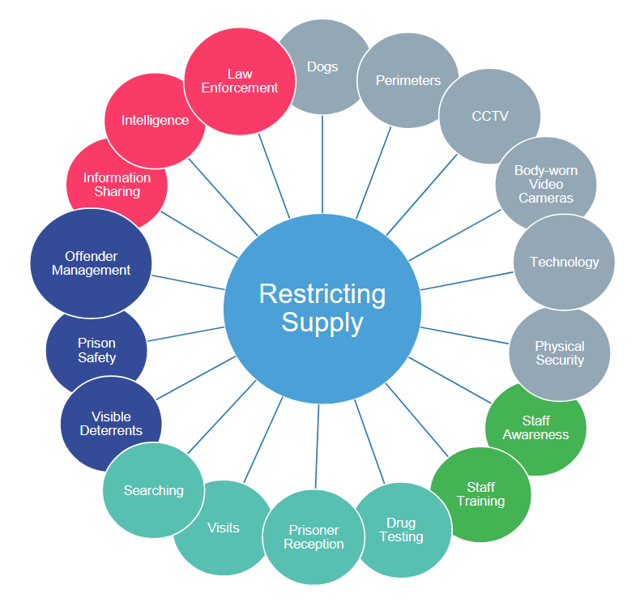

Drugs enter prison in a variety of ways, these can include visitors, contractors and staff entering the establishment, packages being thrown over the perimeter boundary, post, and more recently, deliveries by drone. Many instances are arranged using mobile phones, particularly as phones have become smaller and harder to detect using traditional scanning tools.

It must also be considered that those smuggling drugs into prisons have a range of motivations and capabilities, typically playing a part in a complex illicit economy driven in part by sophisticated, serious and organised criminal groups.

We continue to invest in new technology to increase the barriers in order to restrict the supply of drugs into HMP Exeter.

Aims:

- Minimise the supply of drug into prisons through guidance, processes and technology.

- Find drugs that do enter prisons using effective searching, intelligence and drug testing.

- Disrupt the trade of drugs within prisons, working with law enforcement, sharing information and tackling corruption.

People – Staff Awareness & Training.

Current Measures:

- HMP Exeter utilises several training packages to support staff including Security Awareness, Jailcraft, SASH, Debt Management, Security & Safer Custody Roadshows, SMS Awareness, FMI Keyworker packages and learning events. These are conducted on induction and also throughout the year as ongoing personal training.

- Current information is communicated via Drug Strategy, ISMS, Healthcare, Security and Tasking meetings, Complex Offender, EAT and Safer Communities meetings. Further learning/understanding is disseminated through a joint prisoner/staff Drug Strategy Newsletter which is produced monthly.

- Specific staff training in AFC, Use of Force, Searching, ACCT, CSIP and PPSIP is delivered on training days and full staff briefings.

- Actively updating Drug Strategy notice boards in all areas to reflect relevant issues and to signpost support, interventions and training for both prisoners and staff alike.

- Staff were given refresher training in order to search more confidently & effectively.

Future/Ongoing:

- To increase training opportunities and learning in more specific topics such as addiction, corruption, new substances etc.

- Continue to collect regular data and share within appropriate areas in order to consider the ‘bigger picture’ and understand concerns in order to become more proactive in restricting supply.

- Use the Drug Strategy meeting to update the Strategy through the Action Plan

Procedural – Searching, Visits, Prisoner Reception and Drug Testing.

Current Measures:

- Searching policy has been implemented in line with the HMP Exeter LSS. This is discussed regularly with the SWRDT (South West Regional Dog Team) to ensure best practice.

- Local task meetings take place weekly in order to include stakeholders in intelligence led operations.

- Random searching of staff continues to highlight to staff awareness around corruption and consequences. Searching is carried out regularly on staff and men through intelligence led and dynamic processes.

- Target searches are supported more regularly with the National Dog Team. Visitors are searched on entry and staff are regularly trained in new techniques and potential areas to conceal illicit items.

- Families are given regular information on the severe implications of supplying drugs and are invited to support supply reduction and to promote a drug free recovery.

- Property is searched using technology such as x-ray machine, high intensity pole, wands, and atomiser to detect illicit items. Paper correspondence (less Rule 39) is now photocopied in an effort to avoid PS enhanced paper entering the establishment.

- MDT’s are completed on a random selection process, staffing levels and hours dedicated to this process enable the establishment to reach its target figures each month. The monthly MDT process will be used to randomly test the population to provide an indication of drug misuse within the prison. At the present time it does not contribute to the measure of use of PS. MDT testing remains unpredictable in order to prevent any natural windows for drug misuse, which may mask the actual picture of supply and use within the prison.

- Suspicion testing is determined by local intelligence sources. Further testing is carried out through the ISMS referral process in order to support recovery. Failed MDT’s are referred to ISMS and Healthcare. They are then dealt with through adjudication and if necessary using the IEP process.

- As well as assisting to displace supply, healthcare medication (such as methadone maintenance and pain relief) also offers an opportunity of supply to other offenders. ISMS and Healthcare regularly monitor this and it is discussed at the Complex Offenders meeting where risk of bullying is also determined.

Future/Ongoing:

- Continual training & use of CCTV and Body Worn Cameras (BWC) to ensure supply routes are monitored and evidence collated to support consequential measures from police and prison.

- Rule 39 guidance to be reissued.

- To regularly train reception staff to embed the Reception search processes in order to maintain a high standard and ensure men are safe.

- Continue to involve families and external partners in reducing supply and understanding the implications of collusion.

- Consider procedural justice when determining consequences of failed MDT in order to challenge and support more effectively.

- Act more quickly on intelligence & remind staff to complete an IR no matter how trivial it may seem.

- Improved searching of property in order to detect property soaked in PS and other articles.

- To continue to use current data to target search using the dedicated search team.

- Encourage better use of the ‘e-mail a prisoner’ scheme.

Physical - Dogs, Securing Perimeters, CCTV, BWC, Technology & Physical Security.

Current Measures:

- Regular assistance from the SWRDT and the Dedicated Search Team for all intelligence based searching.

- Perimeters are regularly monitored by staff & police who have shared intelligence to support the reduction of throw overs.

- CCTV and Body worn cameras are regularly used where available to corroborate intelligence. All footage is checked and cross referenced with any use of force and intelligence reporting.

- Regular police presence in the car park at visiting times.

- Heightened use of data by security and safety analysts to establish the links between IR’s to gain a deeper understanding of intelligence within both the establishment and group. This also has the benefit of supporting internal moves and transfers to avoid familiar relationships and illicit economy.

Future/Ongoing:

- Consider other methods of detection of phones other than portable blockers and intelligence alone to support the reduction of illicit economy and organised crime.

- Ensure all staff collect cameras and are regularly trained in order to have evidence to support effective consequences.

- Further work on the PIDS system to ensure protection to vulnerable areas.

- Consult with Security and Healthcare to potentially change method of issue for all medication to avoid anything being passed and possibility of vulnerable men being bullied to supply prescribed medication.

Population - OMU, Prison Safety, Visible Deterrents.

Current Measures:

- Information is regularly shared through meetings, training and media. This has been supported by external agencies in an effort to involve family, police and local media to educate and inform. OMU, ISMS, Security and Safer Custody regularly use family as a medium to support processes such as sentence planning, ACCT, CSIP and PPSIP in an attempt to encourage more pro-social behaviours and elevate concerns.

- The Learner Journey Plan is a multi-agency document that is supported by OMU and used to identify and individual’s risks and needs, taking into account security, sentence history, health, substance misuse, capability and circumstance. This data takes into account current details and helps the Intelligence hub to determine links with other members of the population to discourage supply links when placing in relevant accommodation and programmes.

- Prison Safety Strategy, updated every 3 months.

- There is a variety of visual aids including posters and leaflets informing residents and family of the consequences of supplying drugs. These are visible in areas such as Reception, Visit Hall, Healthcare and Visitor’s Centre.

- Recently a Safer Custody hotline number has been added to the phone as a free phone number to support vulnerable men and to encourage intelligence sharing from men.

- A debt management programme is currently being embedded. This will help reduce vulnerability to the pressures of supply.

Future/Ongoing:

- Continue to build relationships with agencies and areas that can support and inform on the benefits of moving from drug related offending.

- Invite roadshows into Prisons in order to show the positive effect of a drug free recovery.

Partnerships - Information, Law Enforcement, Information Sharing.

Current Measures:

- Continual work with both internal and external partners as part of an all prison approach to tackle the many problems linked into Drug Strategy. All parties are invited to share information at the monthly drug strategy meeting as well as appropriate information sharing through the weekly task meeting where local enforcement operations are discussed.

- Drug Strategy Lead, in consultation with HORR and a Drug Strategy CM will work closely with the Drug Strategy Peer Support group to hold wing based groups and forums. This enables men and staff to share current information identify areas for support and improvement, all of which can be used to evolve this strategy.

- Needs Analysis is conducted bi-annually within the Drug Strategy Peer Support in order to maintain, and if required, change our approach to restricting the supply of drugs.

- More intelligence is shared between external agencies such as police and linked establishments regarding Organised Crime Individuals and Gangs. This has enabled regional and local disruption to supply.

- Drug Strategy is on the SMT agenda and the Risk Register.

Future/Ongoing:

- Continue to work as a multi-agency team and communicate appropriate information effectively in order for the wider population to feel they are part of the initiative.

- To analyse data such as intelligence reports more efficiently.

- To continue to use the adjudication process consistently and ensure evidence is collated effectively to ensure consequences are delivered.

Reducing Demand:

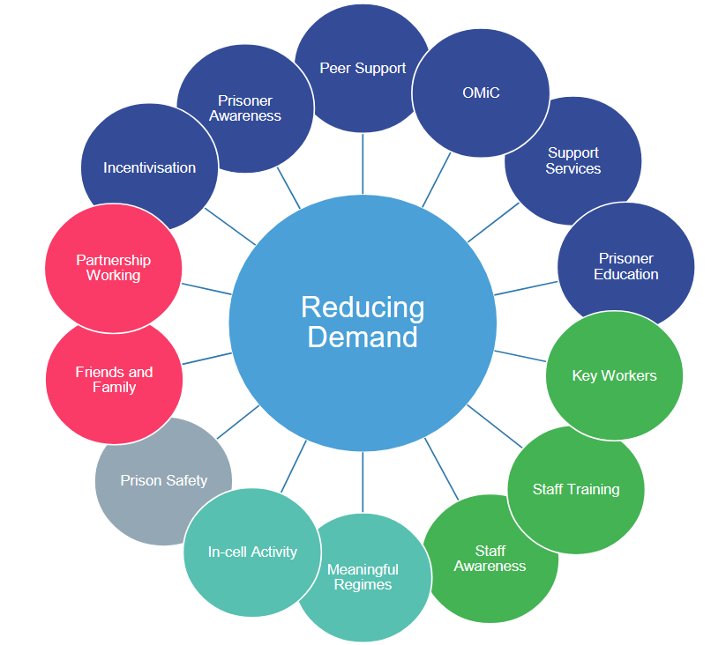

We aim to provide a safe, decent and secure environment where those in our custody have the opportunity to learn and practice the skills and behavior needed to live a law abiding and purposeful life on release.
We will promote a rehabilitative culture where drug misuse is unacceptable, but with awareness & understanding that people do misuse drugs for a variety of reasons.

We will provide a range of actions to enable prisoners to resist taking drugs, these interventions will raise awareness of the facts and associated risks of drug misuse. This will emphasize the benefits of a healthy lifestyle and help to develop the skills needed to make informed decisions aimed at resisting drug misuse.

As part of this strategy, HMP Exeter, in conjunction with ISMS, healthcare and education, will communicate this strategy to everyone in order to raise awareness about the risks of drug misuse and how support can be accessed. This will include communicating via the KIOSK system.

Meaningful regimes will provide prisoners with purposeful activity. Activity will help to give structure and stability to lives helping to reduce demand for drugs. The Reducing Reoffending Strategy sets out an ambitious activities improvement plan.

The Integrated Substance Misuse Service will provide specialist advice and has an integral part to play in the management of drug treatment and in securing access to treatment on release. The prisons activities team will ensure that prisoners attending interventions are paid and thus not financially disadvantaged.

Aims:

- Ensure there are the correct incentives in our prison to encourage and support prisoners to make informed decisions.

- Provide productive opportunities and constructive relationships with staff to steer prisoners away from drugs.

- Engage with families, friends and peers to help prisoners develop networks that will support them to avoid drug misuse.

People - Key Workers, Staff Training, Staff Awareness.

Current Measures:

- Highly visible information on Reception to all visitors informing them of the dangers of illicit drug misuse.

- Directory of Services available at Induction signposting ISMS/Chapel/ Healthcare/OMU and Activities to reduce stress and boredom services.

- Key worker training included presentations from healthcare, ISMS, Security and Safer Custody.

- Regular informative leaflets to men and staff in their activity places detailing topical issues.

- ISMS and Drug Strategy mentors at Induction to signpost and support.

- Keyworkers are regularly invited to multi-disciplinary reviews such as ACT, PPSIP, CSIP, Programmes and recovery events.

- Material is promoted in Visits area to the benefits of being healthy and drug free.

- Families are invited to support men through ISMS Recovery days, celebration events.

- Fully functioning Gym and ISMS led “Tackling Drugs through Sport” programme - a Health and Wellbeing 6 week course to promote the benefits of living drug free.

- Training days continue to support staff learning in morning meetings for CSIP, ACCT and welfare logs.

Future/Ongoing:

- The Safer Custody Roadshow to be viewed in Reception on the TV.

- Keyworkers to engage with the Learner Journey Plan and Reviews.

- Increased learning and advertisement to Staff in order to highlight alternative activities and support.

- A laminated page of all the supports available on pin phones to be attached to every cell door.

Procedural - Meaningful Regimes, In-Cell Activity.

Current Measures:

- The Core Day allows for a variety of activities that include specific recovery based programmes and work/hobby based activities that encourage the potential to earn money, educate or alleviate stress and boredom.

- Self-isolator paid timetable. This is to encourage men out of cell and to earn money to support payment of debt and a return to regular regime.

- The Drug Strategy Peer Mentors delivers drug strategy awareness to self-isolators. He also supports men in filling out referrals and signposting to support.

- Men are enabled access to confidential services such as AA and CA.

- Increased creative activities such as music and art has allowed alternative ways of expression.

- The Gym have a wider variety of activities to include Health, Wellbeing and the benefits of refraining from drug misuse. There are more team games available at weekends such as football championships, circuits etc which enable men to reduce boredom at riskier times such as weekends and evening.

- The Library service have activity packs available for in cell completion.

- Safer Custody offer distraction packs for in cell education.

- FUTC (Facing up to Conflict) is a distance learning programme that includes substance related violence and is available on request from Activities.

Future/Ongoing:

- Introduction of more wing based activities.

- Keyworkers to engage in activities out of office where possible.

- More peer delivered activities to be introduced.

Physical - Prison Safety.

Current Measures:

- Welfare logs are being used as a supportive process in order to monitor at risk men.

- PPSIP continues to embed with further training completed and the Drug Strategy CM recently appointed to ensure assurance.

- Better analysis of data has encouraged multi-agency information sharing to inform Drug Strategy and support the reduction in violence and self-harm related to substance misuse.

- Advertised information, substance and weapons amnesties to support men to distance themselves from criminal activity.

Future/Ongoing:

- More safety roadshows are planned to deliver current information and awareness.

- Continued staff support & training of the use of all safety documents such as ACCT, CSIP, PPSIP, welfare logs and bully logs.

- Further advertising of the location of ISMS and additional services to make them more accessible.

- Potential for introduction of a drug free wing/zone.

Population - IEP, Prisoner Awareness, Peer Support, OMiC, Support Services & Prisoner Education

Current Measures:

- IEP is being reviewed in line with Procedural Justice. Men were invited to forums to consider ideas and review impact of the current system.

- Celebration events take place to reward all achievements including Education and Family Recovery Days.

- Drug Strategy Research group is made up of staff from all areas and various peer supports. They enabled the assisted questionnaire that produced the data for the needs analysis.

- The Drug Strategy CM with the DS peer support deliver monthly DS forums with the men.

- Prison Education and External Providers have been part of initiatives such as Library awareness - Men’s health event and Wellbeing days.

Future/Ongoing:

- Increased peer led activities where possible.

- More ‘out of hours’ activities that reduce demand through boredom.

Partnerships - Partnership Working, Friends and Family.

Current Measures:

- Bi-annual Drug Strategy Needs Analysis.

- Drug Strategy Forums are multi agency and include external partnerships where possible.

- Families and significant others are encouraged to participate in supporting recovery through special visits.

- Families and significant others are encouraged to support the ACCT process and PPSIP/CSIP processes.

- Families and significant others are invited to attend reviews and celebrations.

- Families are encouraged at visits information events to understand the consequences of supply and demand of drugs and urged to support recovery.

- Partnerships such as the Growth Project and Volunteer project have supported Drug Strategy with wellbeing and community events.

- There is safer custody helpline for families and significant others.

Future/Ongoing:

- More family involvement with projects that encourage a move away from drug misuse.

- A more accessible Drug service. This would mean a move of location to the wider estate but would improve visibility.

- Introduction of a drop in service rather than formal appointments.

- Wider variety of additional supports such as local companies rather than national.

Building Recovery:

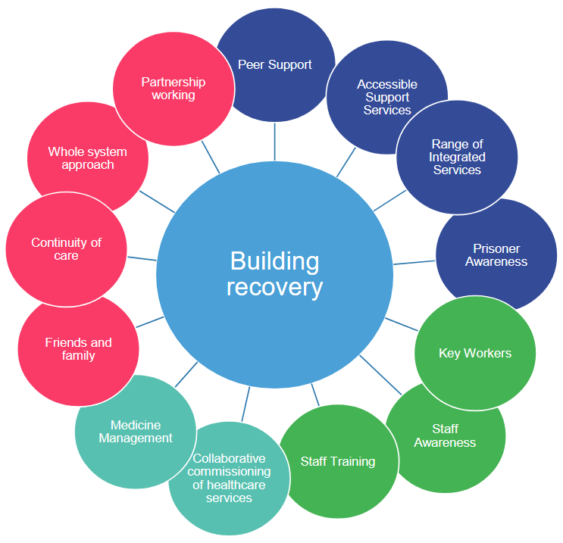

One of the purposes of prison is rehabilitation. Overcoming addiction is not easy and we need to change the culture of our prisons to recognise this and seek to address the root causes of dependency in order to support long lasting rehabilitation.

Many prisoners have complex needs and rates of substance misuse, mental health problems and complications with physical health are higher among prisoners than among the general population. Comorbidity rates are also high, with many offenders who misuse substances also suffering from mental health issues.

An MoJ study of adult offenders sentenced to prison in 2005 and 2006 found that nearly half (49%) of prisoners were assessed as being at risk of suffering from anxiety and/or depression, compared to approximately 16% of people the community.

Being in prison can often exacerbate poor mental health and wellbeing and prisoners can turn to drugs (illicit drugs and/or medication not prescribed to them) in an attempt to tackle these problems.

HMP Exeter is committed to supporting and building recovery. We will ensure the recovery journey is centred on the individual; taking into account the needs of the family and wider community.

We will adopt a zero tolerance approach towards the conveyance of illicit drugs into the establishment and a supportive approach to individuals who engage in drug misuse with an aim to maintain a safe, decent and secure environment.

Aims:

- Collaborate with health partners to ensure successful commissioning and delivery of substance misuse.

- Share successful initiatives from the Drug Recovery Prison pilot to build a whole prison, recovery focus.

- Work with community partners to ensure that prisoners receive continuity of care when released from prison.

People - Keyworkers, Staff Awareness, Staff Training.

Current Measures:

- Health and ISMS providers regularly share information through meetings and forums. There is a structured approach to using this information to inform Safer Custody, Security and Drug Strategy. This is further highlighted through the Complex meeting and multi-agency approach in dealing with complex men.

- ISMS have had successful information and awareness days. They also work closely with Security to ensure safety during Amnesty days.

- ISMS service hold weekly meeting in order to discuss men on their caseload. Drug Strategy and Safer Custody are invited to these meetings.

- There have been several training and learning sessions in morning meetings to ensure staff understanding of the service provision and what is available.

- ISMS have given wing staff training on the use of the PPSIP documents in order to support its use.

- ISMS and Healthcare information is available for the Learner Journey Plans.

Future/Ongoing:

- Further utilise the Offender Management in Custody (OMiC) model, ensuring Prison Officer Key Workers alongside Prison Offender Managers (if allocated) build respectful and purposeful relationships with prisoners enabling honest conversations around drugs and alcohol. This would then allow for referral to a range of activities and interventions. Additionally, if highlighted on the OASYS sentence plan, a prisoner would be prioritised for transfer to meet their needs, if such needs are not able to be met locally.

Current Procedural – Medicine Management, Collaborative Commissioning of Healthcare.

Current Measures:

- The prison is invited to external meetings in order to review Healthcare and ISMS provision.

- The Healthcare and Substance misuse services both regularly submit information to the Drug Strategy Meeting and Newsletter and co-ordinate relevant topics to ensure awareness.

- The Health provider has been supportive with care maps, action plans and welfare logs to aid monitoring of men under the influence and train staff in responding.

- Healthcare trained Custodial Managers in COILS which has supported staff to respond more effectively to Code Blue alarms.

- All men due for release are offered Naloxone training, which if completed, means they are provided with a Naloxone kit upon release.

- Every patient prescribed Opiate Substitution Therapy is jointly reviewed by the prescriber and the recovery worker every thirteen weeks.

Future/Ongoing:

- ISMS contract arrangements have changed and future delivery will be a seven day service. This will provide a more accessible service and additional support at risky times.

Population - Peer Support, Accessible Support Services, Range of integrated Services

Current Measures:

- New receptions are seen by an ISMS duty worker with 72 hours and given harm reduction advice. They have the opportunity to engage with the service and develop a recovery care plan.

- Following any report of illicit drug use, a recovery worker will meet with the man to offer support and harm reduction advice.

- SMART Recovery Mutual Aid meetings are held three times weekly for peer support.

- A structured programme is facilitated every month for a two week duration focusing on specific recovery modules. Examples of these are the Alcohol Awareness Programme, Peninsular Alcohol and Violence Programme and Inside Out.

- ISMS currently employ four Peer Mentors who are able to provide peer support to the harder to reach clients with in-cell workbooks and provide support in group programmes.

- Safer Custody, Drug Strategy, Violence Reduction, Equalities Reps and mentors are available from first reception. Also available listeners, Insiders and access to Samaritans.

- Recovery groups are signposted from Induction to AA and CA in the Chapel.

Future/Ongoing:

- A seven day working pattern will enable new receptions and illicit users to be seen more promptly.

Partnerships - Partnership Working, Whole System Approach, Continuity of Care, Friends & Family.

Current Measures:

- The Chapel facilitates the confidential support groups and offers a wider range of care practices. This is linked to all aspects of Safer Communities and Drug Strategy enabling men to have an opportunity to reflect in the Chapel, or take comfort in a calming environment.

- ISMS currently co-facilitate Anxiety and Emotional Wellbeing programmes with the MHT for dual diagnosis clients.

- Community links are made prior to clinical clients being released and appointments arranged for continuity of prescribing needs and psychosocial support.

- ISMS and Catch 22 work in partnership with regards to release planning so as to avoid setting up unrealistic timings for appointments on the day of release

Future/Ongoing:

- There will be a Community Link worker in post who will improve the links with community services and signpost appropriately for release planning.

- The Debt Management programme will work in conjunction with families to support drug related debt.

Longer Term Opportunities:
HMP Exeter understands that the drug culture changes rapidly and without reason. New drugs coupled with methods of misuse alongside trafficking and means of supply evolve constantly. As such we will remain committed to expanding our knowledge, intelligence and tactics and learning or devising methods to counter these threats.
We will undertake a review of prisoner activities to provide more purposeful activity spaces and development of individuals, with a view to increasing opportunities for employment upon release as part of our Reducing Reoffending strategy.
We will also ascertain if there is an appetite for compact based drug testing and incentivised substance free living.
The HMP Exeter Drug Strategy uses evidence based practice to inform and construct. Drug Strategy Forums, meetings and information days identified current needs, risks and trends.

A multi-agency approach will continue to be used to consider and tackle all current actions through the monthly Drug Strategy meeting. The minutes from these meetings will also be sent (alongside the other Group Establishments) to the National Drug Task Force in order for them to compare shared information and potentially link local trends that may impact regionally.

This Strategy will be reviewed every three months by the Governor, and updated where applicable with completed actions and or new objectives.

Equalities Impact Assessment:

U:\Documents\Drug Strategy\Equalities Asses_EXETER_DS_V1_IK.docx

Terms of Reference:

U:\Documents\Drug Strategy\TOR_EXETER_V1_IK.doc

HM Government 2017 Drug Strategy:

U:\Documents\Drug Strategy\2017 National Drug Strategy.pdf

HMPPS Prison Drugs Strategy 2019:

U:\Documents\Drug Strategy\Prison Drug Strategy.pdf

Governor
Huw Sullivan

08/12/21

Specification

HMP Channings Wood Domestic Visits Provision

Domestic Visits run Wednesday PM, Friday PM, Saturday PM and Sunday PM start time 14:00 finish 16:00 for each session.
Video visits as above. (currently running evenings sessions as part of COIVD regime recovery plan 2022 which have not been included in this specification).

For note - HMP Channings Wood Expansion project projected for 2024 population increase of 368 prisoners.

Conduct Visits:

- Visit Room Refreshments

HMP Channings Wood Requirements for Refreshments
- The Provider is expected to provide a selection of tea, coffee, juices and healthy snacks and hot food for visitors during all visits.
- Visiting days are Wednesday, Friday, Saturday and Sunday as specified.
- The Provider is responsible for the cleaning, upkeep and regular stocking of refreshments located in the Visitor’s Centre and Visit Hall.
- Family and Significant Others should be able to pre-order drinks and snacks prior to visits commencing (in order to maximise the length of time the visitor spends with the prisoner).

Visits Play

HMP Channings Wood Requirements for Visits Play
- The Provider should maintain a well-stocked play area providing a range of age-appropriate toys and activities for children in the Visit Hall keeping these toys clean, hygienic and safe to play with.
- A play worker should be present for each visits session to supervise the play area- the specification is 30 mins pre and 30 mins post to enable set up and close down.
- The play worker is able to support the discharge of the prison’s responsibility to safeguarding children.

Services for Visitors:

- Visit Meet and Greet

HMP Channings Wood Requirements for Visit Meet and Greet
- Visits run Wednesday PM, Friday PM, Saturday PM and Sunday PM start time 14:00 – 16:00 for each session.
- Visitors should be greeted on arrival to the prison and asked if they require any specific advice or guidance.
- Meet and greet (reception) should be available up to for at least 1 hour before visiting hours commence and 30 mins post visits.
- Providing reception services to visitors.
- Provider to be responsible for ensuring centre facilities including toilets, seating, baby changing facilities which and wider fixtures and fittings remain decent and fit for purpose (monitoring and reporting only).
- As agreed by Security, administer and ID checks all social visits in line with Local Security Strategy and National Security Framework.
- Maintain an area within the Visit Centre to enable visitors to securely store personal property and any unauthorised articles prior to coming into the prison.
- Amnesty bins for the safe and secure disposal of unauthorised articles must be maintained and clearly signposted in discreet areas of the Visitor’s Centre.
- To provide a range of information on support services to families including other prison services and services provided by external agencies with specific focus paid to information both verbal and written concerning the Help with Prison Visits Unit.
- Provider designs and regularly reviews (on a quarterly basis or significant change) a visitor information booklet that will be reproduced for publication to all new or returning visitors.
- The provider is required to work with any charities and Organisations which work within the establishment.
- Visitors receive understandable information in multi lingual and user friendly format on support services for families and signposting to specialist services.
- Accurate information about the Help with Prison Visits Scheme and establishment visiting arrangements is accessible to visitors.
- Put in place a complaints policy to enable visitors to feed into monitoring of service delivery so visitors are able to comment on or complain about the visits experience and receive a response and comments are used to improve the service. Conduct customer satisfaction surveys, ‘You said we did’.
- A range of information must be provided on support services such as, but not limited to, debt advice, employment and skills, children’s services, drug / alcohol support, women’s services, housing, health and wellbeing. This should be in the form of literature, posters and IT sources where possible and should be linked to the main stream providers.
- Information must be available, and a range of support services must be offered which reflects the needs of ethnically diverse visitors, women, children, carers, non-English speaking visitors.
- Literature is appropriate to the needs of those with low literacy skills
- Information is available from a variety of sources - written, electronic and visual for visitors / families and friends of offenders to find out about the visits procedures, booking system, financial assistance, transport provision and security matters related to their visits.

- Visits Enrichment Activity

HMP Channings Wood Requirements for Visits Enrichment Activity
The provider is required to provide a Programme of delivery, for example:
- Homework Clubs. Days and times to be agreed with the establishment.
- Special visits (well equipped with resources and play facilities for children from 0-16), for prisoner fathers/step/grandfathers to spend quality, focused time with their children (with one accompanying adult) in child-friendly family environment. The provider is required to provide Planning and support for these special visits.
- Themed visits according to needs – i.e.: baby visits; school work visits and free play visits.
- Celebrating success, the provider will support the establishment with family engagement for celebrating prisoner success.
- To support with issues arising with foreign nationals/deportations away from families and significant others.

- Extended Family Visit Days

HMP Channings Wood for Family Visit Days requirements

- Whole-day events for families and children to spend time together through extended time to do appropriate activities to support building relationships.
- The provider is to plan the visits and themes for each visit.
- The visits should take place quarterly throughout the year.
- One x Gypsy Traveller Roma Family Day per year.
- One x Black History Month Family Day per year.
- Celebrating prisoner success events as directed by the establishment.

- Services for Prisoners without Contact with Family and Significant Others

HMP Channings Wood Requirements for Prisoners without Contact for Family and Significant Others
- The provider should support the prison in helping prisoners to re-establish contact with family and friends.
- The provider will support and advise the prisoner to make initial contact with family and friends.
- The provider will support and advise the family or friend’s once initial contact has been made by the prisoner.
- The provider will support and advise prisoners for those who do not have family and friends.

- Family Engagement and Advice

HMP Channings Wood Requirements for Family Engagement and Advice

- The Family Worker is to be a position that seeks to ascertain the needs of the population and remain responsive to those needs through a variety of means including focus groups, surveys or consultations.
- Through collaborative working they will ensure all appropriate family services across the establishment are engaged by those with need.
- Where identified gaps in services are found, through innovative working these gaps are to be addressed.
- Provide telephone and face to face support for families.
- Refer prisoner families (with their consent) to other services that work with families in the community if appropriate, such as local authority Family Information Services and CAB’s

- Support for Secure Video Calls- Purple Visits

Requirements for Secure Video Calls
- To provide pre-call support to families, being particularly mindful of those who are new to the system or have difficulties using digital technology.
- To provide post-call support to families.
- To provide pre- and post-call support for prisoners.

8. Optional Services

- Deliver parenting courses in line with establishments needs analysis.

