# TOR: WWF-UK Request for Proposals for ‘Food Footprint report’

**Commissioned by:** WWF-UK, Living Planet Centre, Brewery Road, Woking, GU21 4LL

**Project manager:** Carmel Edwards: CEdwards@wwf.org.uk

## Summary

WWF-UK is calling for research consultant proposals to deliver technical and summary reports answering the research questions:

1. What is the ‘food footprint’ of the UK (and England, Wales and Scotland) – i.e. the contribution of the UK/nations’ food system to the UK’s global footprint (the environmental pressures and impact of UK production and consumption)?
2. What should the UK (and England, Wales and Scotland) food footprint reduction targets be for 2030 and 2050 to align with the targets of a) reducing the UK’s Global Footprint by three-quarters by 2030, b) achieving UK net-zero by 2050 and c) halting and reversing the loss of UK biodiversity by 2030?
3. What are the relative impacts of stakeholder actions (inc. consumers, farmers/fishers, businesses, governments) to reduce the UK’s food footprint?
4. What are the economic, social, health and environmental cost-benefits of these actions and the jeopardy of stakeholders not taking them?
5. What is the relative potential impact of each stakeholder group to reduce the UK’s food footprint?

## Background

We will not Bend the Curve on global biodiversity loss without addressing drivers. Reflecting this, WWF-UK’s strategy includes a goal to halve the global footprint of production and consumption globally by 2030. A science-based framework (launched in Oct 2020) has been developed in the context of the Convention on Biological Diversity (CBD) to define what this means and an indication of targets that are needed to achieve overall “halving” at the global level.

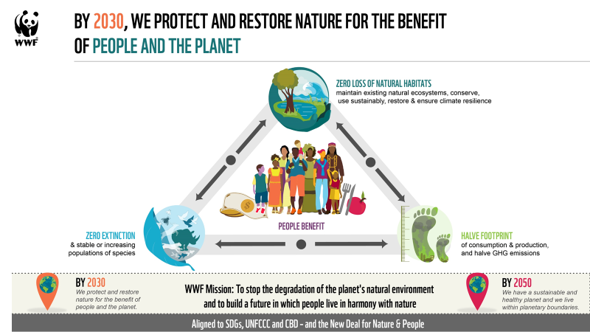

Last year WWF-UK published a [UK Global Footprint report](https://www.wwf.org.uk/what-we-do/uk-global-footprint) that calculated the extent to which the UK needs to reduce the environmental impact of UK production and consumption by 2030 in order to remain within planetary limits. WWF-UK is now looking to commission a follow up report to calculate the UK food sector’s contribution to the UK’s global footprint and identify those stakeholder actions (e.g. consumer, farmer/fisher, business, government) that can best achieve the necessary reductions in this to achieve WWF-UK’s 2030 and 2050 goals (which are aligned with the SDGs, UNFCCC and CBD). The stakeholder actions will build on WWF’s recently published [Land of Plenty report](https://www.wwf.org.uk/sites/default/files/2022-02/WWF_land_of_plenty.pdf) and [UK Basket report](https://www.wwf.org.uk/sites/default/files/2021-11/WWF-Basket-Outcomes-%26-Measures_2.pdf) and help align this work.

## Main purpose and scope

### Purpose

We are looking for a consultant to calculate and present in report and presentation form the following: (defining the targets and actions should broadly follow the methodology in the [UK Global Footprint report](https://www.wwf.org.uk/what-we-do/uk-global-footprint)).

* **Food footprint reduction 2030 and 2050 targets for England, Scotland, Wales, and the UK as a whole.**
  + This should include a breakdown of domestic and overseas footprint
  + The Food Footprint UK and England target will need to include a target for the food sector’s contribution to the materials footprint and carbon footprint.
* **Which actions will make the biggest contributions to reducing the food footprint, building on recommendations from WWF-UK’s analyses, including the** [**UK Global Footprint**](https://www.wwf.org.uk/what-we-do/uk-global-footprint)**,** [**Land of Plenty**](https://www.wwf.org.uk/sites/default/files/2022-02/WWF_land_of_plenty.pdf)**,** [**UK Basket**](https://www.wwf.org.uk/sites/default/files/2021-11/WWF-Basket-Outcomes-%26-Measures_2.pdf)**, Livewell and** [**Eating for Net Zero**](https://www.contractsfinder.service.gov.uk/notice/a94aaaf2-d4a5-4d85-961b-4587632677b1?origin=SearchResults&p=1)**,** [**Riskier Business**](https://www.wwf.org.uk/riskybusiness) **and** [**Wales and Global Responsibility**](https://www.wwf.org.uk/WalesAndGlobalResponsibility) **reports.**
* This should include narrative and ideally statistics around the **value (economic, social, health, and environmental cost-benefit) of these actions and the jeopardy of stakeholders not taking them**, (e.g. the added value of governments taking an integrated approach to food policy in addition to the food policies themselves, and the potential jeopardy of governments not taking this approach).
* **Illustrate the relative impact of stakeholder action** (government, business, farmer/fisher, and consumer) on a bending the nature curve graph (as shown on the illustrative graph below by the red, orange, blue, and green words/lines on the left). This graph would be illustrative only, not an accurately representation of the results and the curve would need to be updated from the one below to reflect the given pathway timeline and UK context.

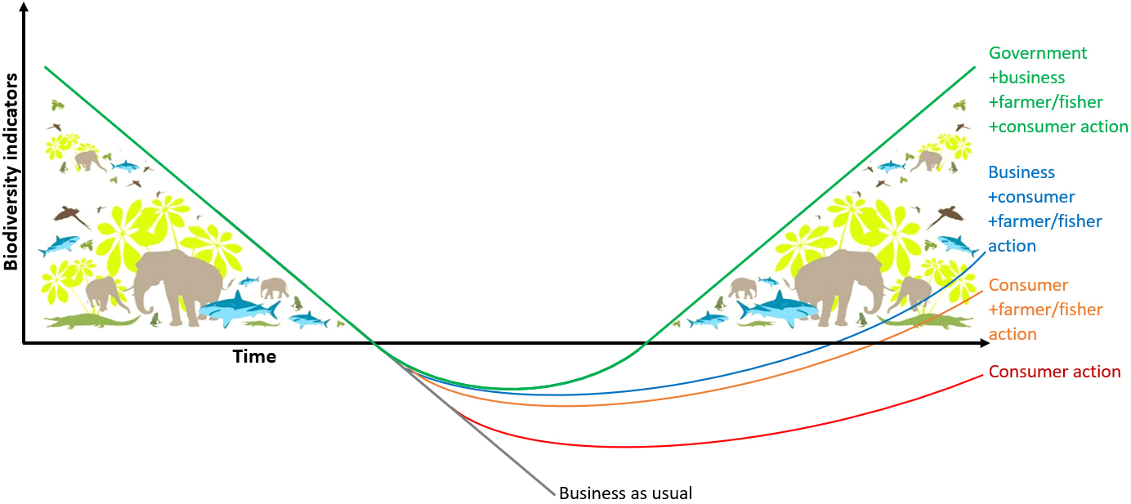

### Scope

The UK’s ‘food sector’ (or ‘food system’) refers to all parts of the process that delivers food and drink to the UK public:

* The direct supply chains – agriculture and fisheries, through processing, manufacture, and retail, to consumption.
* The support services that enable the food supply chain, including agricultural inputs, packaging, transportation, and waste management.

The same 10 impact areas used in the overall UK’s global footprint will be assessed, (greenhouse gasses, material footprint, biomass footprint, marine resource use, degradation and land use change, nutrient use, chemical pollution, water pollution, water availability and air pollution) and production and consumption (including imports) will be considered, as well as overseas and domestic impacts.

### Deliverables

1. A ~10Pg technical report fully describing the research methods and results for WWF-UK internal communication.
2. A ~100Pg comms designed public report outlining the full research results, particularly highlighting the food footprint targets and most impactful policy solutions to achieve these. This should include relevant graphical representations of the results. This report will go through several rounds of feedback with WWF-UK topic experts and comms, media, and content teams.
3. A ~10Pg policy makers summary report.
4. A ~10 slide ppt presentation summary of the main findings.

## Budget

The budget (£20-35k, inclusive of VAT) and should allow for all aspects of the process below.

## Process

* Desk based research on the food footprint metrics and the relative impact of stakeholder action, including government policy solutions.
* Fortnightly meetings with the Project Manager (to include members of Advisory Group as needed)
* 3 meetings/ workshops with Advisory Group (WWF-UK colleagues and external advisors): scope, mid project, draft report.

## Timeline

We would expect the work to be completed in around 27 days over 10weeks and in time for publication in June 2022, e.g., started w/b 11th April and completed w/e 11th June.

The work is separated into **three phases**:

* Phase 1 (~2weeks): Estimation of the UK food system’s footprint reduction required by 2030 and 2050, apportionment of the target across the UK nations, and short technical report.
* Phase 2 (~5weeks): Refinement of action targets seeking policy alignment.
* Phase 3 (~2 weeks): Development of a public technical and summary report and presentation.

## Proposal requirements and next steps

Proposals should be maximum 5 pages in length and include:

* Your approach and proposed method to address the Project Objectives and Outputs.
* Consideration of available data and collection methods.
* A project plan detailing proposed scope and timeframes.
* Details of relevant experience.
* A fee proposal including total days and day rates for each member of staff who will work on the project, and any non-staff/travel/ancillary costs. If possible, please specify the costs of deliverable 3 (presentation) and the content design of deliverables 2 and 3 (full and summary public reports) so these can be compared to in-house costs.
* Names and CVs of all staff who will work on the project, and proposed roles (can be beyond the 5 pages).

In your response, you must be able to demonstrate and evidence:

1. Understanding of the brief and propose options for the approach. *Please outline possible time frames and requirements of us in a high-level project plan*
2. Depth and breadth of expertise in this field in the charity /not for profit / NGO and commercial / private sectors. *Please include names of recent clients for who you have delivered similar work*
3. A strong team that can provide responsive service – i.e., not key person dependent – continuous service available. *Please provide short biographies for all those who would be involved on the project*
4. A strong alignment with WWF-UK’s vision and mission with values that respect diversity, equality and inclusivity and evidence of partnership working. *Please provide a short statement on this and how you evidence your values in your work*
5. Value for money; competitive pricing for expertise. We need fees to be clear and structured in a flexible way. *Please state day / hourly rates and price per project element, ideally with capped fees*
6. Confidentiality and Data protection. *Please provide your confidentiality statement and GDPR principles*
7. Diversity, Equality and Inclusivity (DE&I). *Please share your approach to DE&I and how you would approach the project in this respect*
8. References. *Please provide two referee clients.* (We would not approach without your permission)
9. It is our preference that an appointed external partner adopts our standards terms and conditions for engaging with us. These are attached. *Please can you state whether or not you would be comfortable with this and whether or not there are any terms which might create difficulty for you*

### The selection process

In line with our procurement process, we are now openly advertising this contract opportunity. A panel comprising members of the WWF-UK Science and Conservation department and the WWF-UK, WWF-Scotland and WWF-Cymru Wales Advocacy and Campaigns departments will consider the responses and make a decision based on the following criteria, with approximate weightings shown:

* 1. 25%: The organisation’s proposed approach to the 9 points above
  2. 20%: Depth and breadth of expertise as evidenced by recent client work
  3. 20%: Values, partnership, inclusivity – alignment with WWF-UK
  4. 35%: Price – value for money

### Timelines and next steps

* This RFQ was issued during w/c **14 March**
* Any potential providers can speak to **Carmel Edwards** CEdwards@wwf.org.uk with any queries
* We request that all responses are returned to us by **1 April**
* A decision will be made as soon as possible with a view to the project starting in April and to be delivered by early June 2022

--------------------------------------

Thank you for expressing an interest in working with and supporting WWF-UK-UK with this important piece of work. We look forward to receiving your response.