

www.gov.uk/naturalengland

Request for Quotation

## Request for Quotation

**Protected Species Monitoring and Survey – Survey of Bechstein’s, Grey Long-Eared and Barbastelle bat colonies around Creech Grange, Purbeck, Dorset to inform SSSI designation.**

You are invited, to submit a quotation for the requirement described in the specification below.

Please confirm, by email, receipt of these documents and whether you intend to submit a quote.

Your quote should be returned to the following email address by:

**Email:** [**sue.moore@naturalengland.org.uk**](mailto:sue.moore@naturalengland.org.uk)

**Date: 19th May 2023**

**Time: 17:00**

Ensure you state ‘Creech Grange Bechstein’s etc bat survey’ and ‘Final Submission’ in the subject field to make it clear that it is your response.

**Contact Details and Timeline**

Melanie Heath [melanie.heath@naturalengland.org.uk](mailto:melanie.heath@naturalengland.org.uk) and Sue Moore [sue.moore@naturalengland.org.uk](mailto:sue.moore@naturalengland.org.uk) will be your contacts for any questions linked to the content of the quote pack or the process. Please submit any questions by email and note that, unless commercially sensitive, both the question and the response will be circulated to all tenderers.

|  |  |
| --- | --- |
| Action | Date |
| Date of issue of RFQ | 5th May 2023 |
| Deadline for clarifications questions | 12th May 2023 at 17:00 |
| Deadline for receipt of Quotation | 19th May 2023 at 17:00 |
| Intended date of Contract Award | 2nd June 2023 |
| Intended Contract Start Date | 5th June 2023 |
| Intended Delivery Date / Contract Duration | 5th June 2023 to 22nd December 2023 |

### Glossary

Unless the context otherwise requires the following words and expressions used within this Request for Quotation shall have the following meanings (to be interpreted in the singular or plural as the context requires):

|  |  |
| --- | --- |
| “Authority” | Means the Department for Environment, Food and Rural Affairs acting as part of Natural England |
| “RFQ” | Means this Request for Quotation and all related documents published by the Authority and made available to suppliers |
| “Contract” | Means the contract to be entered into by the Authority and the successful supplier. |

### 

### Conditions applying to the RFQ

You should examine your response to the RFQ and related documents ensuring it is complete prior to submitting your completed quotation.

Your quotation must contain sufficient information to enable the Authority to evaluate it fairly and effectively. You should ensure that you have prepared your quotation fully and accurately and that prices quoted are arithmetically correct for the units stated.

The supplier by submitting a quotation is deemed to accept the terms and conditions in the RFQ. Failure to comply with the instructions set out in the RTQ may result in the supplier’s exclusion from this procurement.

**Acceptance of Quotations**

By issuing this RFQ the Authority does not bind itself to accept any quotation and reserves the right not to award a contract to any supplier who submits a quotation.

#### Costs

The Authority will not reimburse you for any costs and expenses which you incur preparing and submitting your quotation, even if the Authority amends or terminates the procurement process.

#### Mandatory Requirements

The RFQ includes mandatory requirements and, if you do not comply with them, your quotation will not be evaluated.

#### Clarifications

The Authority reserves the right to discuss, confidentially, any aspect of your quotation with you prior to any award of Contract to clarify matters.

#### Amendments

The Authority may amend the RFQ at any time prior to the deadline for receipt. If it amends the RFQ the Authority will notify you in writing and may extend the deadline for receipt in order to give you a reasonable time in which to take the amendment into account.

#### Conditions of Contract

The terms and conditions - [Condensed Terms and Conditions](https://assets.publishing.service.gov.uk/government/uploads/system/uploads/attachment_data/file/419955/standard-condensed-terms.doc) (Annexe 1) will be included in any contract awarded as a result of this RFQ process. The Authority will not accept any material changes to these terms and conditions proposed by a supplier.

#### Specification

The Authority is Natural England. The Authority’s priorities are to secure a healthy natural environment; a sustainable, low-carbon economy; a thriving farming sector and a sustainable, healthy and secure food supply. Further information about the Authority can be found at: [Natural England](http://www.naturalengland.org.uk/)

## Introduction

**Background to Natural England**

Natural England is the government’s adviser for the natural environment in England. We protect England’s nature and landscapes for people to enjoy and for the services they provide. Within England, we are responsible for:

* promoting nature conservation and protecting biodiversity;
* conserving and enhancing the landscape;
* securing the provision and improvement of facilities for the study, understanding and enjoyment of the natural environment;
* promoting access to the countryside and open spaces; and
* contributing to social and economic well-being through the sustainable management of the natural environment.

[Conservation 21](https://www.gov.uk/government/publications/conservation-21-natural-englands-conservation-strategy-for-the-21st-century) outlines out how we will work to protect England’s nature and landscapes for people to enjoy and for the services they provide, in support of Defra’s ambitions for the environment.

**Background to the specific Natural England work area relevant to this purchase**

Creech Grange Stables is designated as a SSSI as a greater horseshoe bat (*Rhinolophus ferrumequinum*) roost which is currently considered to be in declining condition. Prior to 1953 the site was a large maternity roost, however after treatment of the timbers with lindane (a highly toxic chemical to bats) the majority of the colony was poisoned. Current survey information indicates that it is used year round by up to 62 individuals (but more typically between 2 and 25) with highest counts in the autumn, when it is used as a mating and transitional roost. The SSSI citation (1986) quotes ‘seven other species of bats, including the grey long-eared bat (*Plecotus austriacus*), are also known to use the roof spaces of the outhouses and the main buildings’.

Creech Grange SSSI is located in a diverse lowland landscape and is unusual in Southern England for the quality, extent and connectivity of semi-natural habitats including ancient woodland, wood pasture, grassland, heathland and open water. Wood decay in the several hundred veteran and mature trees is a prime feature across the whole landscape from Lulworth Park SSSI in the west to Corfe Castle in the east demonstrating the continuity of tree and woodland cover in this landscape. This diverse landscape provides good quality foraging for bats and ample roost opportunities. A small roost of Greater Horseshoe bats has been located close by to the west of Creech Grange SSSI but its status is unknown at present. NE are undertaking biological and geological surveys across the landscape around Creech Grange SSSI to provide evidence to support a possible SSSI designation.

Currently only the stable building is designated as a summer roost for Greater Horseshoe bats. The updated SSSI designation criteria for mammals (Walsh *et al*. 2019[1]) confirms that designating roosts alone only offers partial protection for bat species as they are reliant on feeding areas and commuting routes within their territories, the current designation for Creech Grange Stables is not therefore considered fit for purpose.

Monitoring of the roost at Creech stables has taken place over the past few years and have indicated that the building remains in use all year round by Greater Horseshoe bats, particularly as an autumn mating site and a spring/autumn staging/transition post between the Purbeck hibernation sites and the mid-Dorset breeding sites.

The objective of the surveys undertaken so far was to find out more about the use of the roost and what surrounding habitat may be important to the bats roosting at Creech Stables. However, due to the highly variable number of bats at the roost due to the suspected roost type, traditional methods such as radiotracking did not yield wholly successful results. As such, different approaches using acoustic detectors placed across the landscape (both targeted and random) to gain an understanding of habitat use across the area was trialled (see additional information). Results of all surveys undertaken will be given to the successful contractor.

The habitats surrounding Creech Grange are considered optimal habitat for bats, especially Bechstein’s, Grey Long-eared and Barbastelle alongside Greater Horseshoe. Given the opportunity to amend the designation, Natural England is seeking more information about the colonies of these other species in the vicinity of Creech Grange with a view to revising the designation boundary and subsequent protection of the bat colonies present. There will also be a separate contract awarded to further investigate the status of Greater Horseshoe bats around Creech Grange.

More information on knowledge gathered so far and survey requirements for each species is given below:

**Bechstein’s Bat**

The habitat surrounding Creech Grange is considered optimal for Bechstein’s bats with many veteran trees in surrounding deciduous woodland and parkland habitat. They are known to be present at swarming sites close to the coast near Swanage. However, limited information is known about the presence and status of this species around Creech Grange. Therefore, the purpose of the survey work for Bechstein’s is to establish whether they are present, and if so, establish the status of the colony and key habitat they are using for roosting, foraging and commuting.

**Barbastelle Bat**

The habitats surrounding Creech Grange are also considered to be optimal habitat for barbastelle bats and they are also known to be present at swarming sites close to the coast near Swanage Acoustic records have been detected across the wider landscape surrounding Creech Grange. The purpose of the survey work for barbastelle is to establish whether there is a maternity colony present in the area, and if so establish the locations of the key roosts, colony numbers and key habitat the colony is using for foraging and commuting.

**Grey Long-eared bat**

The habitats surrounding Creech Grange are also considered to be optimal habitat for Grey Long-Eared bats and individual male Grey Long-Eared bats have been previously trapped at Creech Grange. The purpose of the survey work for Grey Long-Eared is to establish the status of this species in the area, such as whether there is a maternity colony present, and if so establish the locations of the key roosts, colony numbers and key habitat the colony is using for foraging and commuting.

The purpose of this contract therefore is to clarify the status of these different species and features in the landscape that are important for supporting the different populations to provide evidence for designation if appropriate.

Should other bat species of particular interest be found then they should also be investigated.

## Requirement

**Objectives**

A survey of Bechstein’s, Grey Long-Eared and Barbastelle bat colonies is required to inform revision of the designation and needs to address three key objectives:-

1. To identify whether there are maternity roosts for Barbastelle, Grey Long-Eared and Bechstein’s bat in the vicinity of Creech Grange
2. If maternity roosts are found, to undertake roost counts to establish the size of the colony(ies) and identify the key roosts, feeding areas and commuting routes used over the summer active period.
3. To synthesise the evidence to inform the designation as appropriate.

It is appreciated that surveys will need to be flexible depending on the results found. To enable fair assessment of tenders a scenario-based pricing and rate card approach will be used.

The following scenario should be costed:

* An inception meeting with Natural England to agree/confirm methodology and access protocol.
* Trapping of Barbastelle, Grey Long-Eared and Bechstein’s bats around Creech Grange and surrounding habitats. Weighing, sexing and attachment of radio transmitters to suitable individuals.
* Radiotracking a minimum of 5 (preferably female) Barbastelle and Bechstein’s bats and 3 (preferably female) Grey long-eared bats for a minimum of 7 nights
* Three emergence counts at three identified roosts for each species
* Two days additional survey time as needed to cover any additional roosts/surveys as required.

The contractor will need to source and provide their own equipment for the survey and provide evidence that they have the relevant experience to apply for an appropriate licence to carry out the works. The survey needs to be undertaken during the 2023 bat active season.

The quote will need to include (also see sections 5 and 6)

1. An outline survey design specification detailing what methods and equipment would be used and how the methods outlined would achieve the objectives detailed above. It is appreciated the survey methods and timings may need to adjust depending on weather and results gathered and an explanation should be given on how this would be approached. It is anticipated that as a minimum radiotracking and subsequent roost inspections and counts will be required to fulfil the objectives outlines above. Information on how impacts to bats will be minimised alongside Covid working practices will need to be included.
2. Provision for phase 1 habitat mapping to underpin survey data
3. Provision for analysis of raw data
4. Provision for synthesis of results and report writing
5. Experience of personnel involved and evidence of experience of carrying out similar work. CVs of all individuals to be employed during the contract period will need to be provided.

## Methods

### Field work

The contractor where possible should carry out survey work from public roads and rights of way. The contractor will also need to ensure that a site-specific health & safety risk assessment is carried out and biosecurity procedures are followed, including the undertaking of a risk assessment.

**Land Access**

Natural England will seek permissions for access using Land Registry searches. Land ownership contact details will be supplied at the start of contract by Natural England and held in confidence by the successful contractor and destroyed at the end of the contract. Landowner details are to be stored on a desktop GIS only and not on a cloud-based system such as ARC Online. The contractor must give at least 24 hours notice to the landowner prior to survey unless granted otherwise, with any refusals or other issues notified to the Natural England project officer within 1 working day.

A minimum of 72 hours' notice requesting access is required by the MoD, this duration to be confirmed by MoD and access may not granted depending on military activity (see below)

There are several activities in the area which may restrict access e.g. deer stalking, active quarrying, livestock farming and military ranges. It is the contractor’s responsibility to ensure that access is sought in a responsible and timely manner and NE informed of any restrictions etc.

There are specific H&S requirements the following areas of land:

Lulworth Military Ranges

The contractor and any employees will need to arrange for a H&S Induction at Lulworth Camp and pass security checks which will allow access for 1 year. Access to the military ranges is highly restricted i.e.weekends and Friday afternoons. Lone working isn’t advisable, the contractor will need to include specific details in their Risk Assessment following the MoD Induction. Firing dates are published here: [Lulworth firing times - GOV.UK (www.gov.uk)](https://www.gov.uk/government/publications/lulworth-firing-notice)

Imerys Minerals Ltd

The contractor and any employees will need to be registered with Imerys Minerals Ltd and pass an online H&S Induction before accessing land. All personal are required to sign in and out at their offices near Wareham, open 24hrs.

## Outputs

**General**

The products of this work will be:

* a comprehensive written report in MS Word on the appropriate Natural England template (to be provided) that covers objectives 1 to 3 above and provides recommendations on the designation boundary bearing in mind the guidance published in the [SSSI selection guidelines for mammals](https://data.jncc.gov.uk/data/dc370754-e136-4fc3-82f1-1435ea1892a0/sssi-guidelines-16-mammals-2022-v1-1.pdf)
* the data from the commissioned survey, following the Natural England data standards included at Annex 2

The supplier must comply with [Natural England publishing standards for commissioned reports (NECR000)](http://nepubprod.appspot.com/publication/5790636781600768) and use the report template provided on the page, following the guidance within it.

The supplier must not make any changes to the templates, including to heading styles and font sizes. The supplier must include a clear section on any third-party data replicated or used to derive the output from, and how, within the report.

The report will need to cover:

* An introduction to include previous surveys and knowledge of the bat species in the area
* Detailed methodology for survey of the different bat species to identify key roosts, foraging areas and important commuting routes,
* Analysis of survey results to include:
  + Phase 1 habitat data to underpin area studied
  + Interpretation of roost types found including negative results
  + Colony counts
* Any links between key roost sites found for each species
* Key flight lines and associated features such as woodlands, hedgerows etc connecting roosts with foraging habitat and other roosts across the landscape for each colony/species.
* Key foraging habitat for each colony/species
* The condition (observations on the structural condition of roosts) and threats to key roosts, flight paths, and foraging habitat and recommendations for future management.
* Discussion including assessment of the key roosts, flight paths, features and foraging habitat in relation to whether they meet the SSSI qualifying criteria.

Raw survey data will need to include the following:

* Maps, photographs and GPS coordinates showing the location of the key roosts, flight paths, feeding areas and any other key features including GIS shape files.
* Grid references for radiotracking fix data and cleaned raw data from bat detectors as applicable.
* MCP, 95% and 50% kernel density isopleths detailing ranges of tagged bats.

Natural England requires the opportunity to comment on the draft Final Report. A draft report in MS Word will be expected at least four weeks before the deadline for comments to be incorporated. Tenderers should be aware that Natural England and Defra will aim to publish reports. Reports must comply with Natural England’s publication style guidance (this will be supplied in advance of the report).

Natural England is also happy to encourage widespread publication, and welcomes the use of appropriate trade press, peer-reviewed journals and sector-specific journals. The appointed Contractor will be responsible for ensuring both the quality of the work as well as the presentation of the material (e.g. proof reading, ensuring clear English). The appointed Contractor is also to be aware that Natural England requests acknowledgement in the publication (including oral presentations) of its funded research, and that the project manager is notified at least two weeks prior to publication.

**Intellectual property**

The Intellectual Property Rights resulting from the work shall belong to Natural England. The cover of all reports or drawings will include a statement © Natural England and the date of creation.

Any data reproduced in all or in part, in the works the supplier submits, or used to derive the work must be owned by or licensed to Natural England. The supplier can request to use data held by Natural England and complete some of our contractor licences at <https://www.gov.uk/guidance/how-to-access-natural-englands-maps-and-data#request-data> .

Data not held by Natural England must have a license permitting the required rights. If it isn’t a standard licence (eg OGL, NCGL, CC suite) you must obtain a licence in Natural England’s name (as well as your own) which you must send to data.services@naturalengland.org.uk for Natural England to review and sign. If you’re contacting the data owner to request access to their data and/or a licence, you can adapt Natural England’s standard wording [Natural England staff - download and attach].

The Supplier shall indemnify and keep indemnified Natural England against all actions, claims, demands, losses, damages, costs and expenses and other liabilities Natural England may suffer or incur arising from any infringement or alleged infringement of any third-party Intellectual Property Rights except to the extent that they have been caused by or contributed to by Natural England’s acts or omissions.

The supplier must provide Natural England with details of any third-party data consulted or incorporated, and the processes used either within the report, or in the Lineage section of the metadata (see Outputs).

Contact [data.services@naturalengland.org.uk](mailto:data.services@naturalengland.org.uk) if you need advice.

## Timescales

W/C 5th June 2023 – Inception meeting between project officers and supplier by Microsoft teams.

Fortnightly during field work, thereafter monthly, emailed summary of progress to be sent to project officer, and follow up phone discussion

W/C 15th November 2023 – Draft reports due to project officer in digital format via e-mail

W/C 27th November 2023 - draft reports to be returned to contractor with Natural England’s comments

W/C 4th December 2023 – call to discuss report recommendations

W/C 18th December 2023 – Final reports, in digital format via e-mail, due to project officer

It is anticipated that this contract will be awarded to end no later than 22nd December 2023. Prices will remain fixed for the duration of the contract award period. We may at our sole discretion extend this contract to include related or further work. Any extension shall be agreed in advance of any work commencing and may be subject to further competition.

We will raise purchase orders to cover the cost of the services and will issue to the awarded supplier following contract award.

Suppliers will be required to invoice after the final reports have been received and signed off by Natural England. Invoices must be submitted to NE via SSCL by 15th January 2024.

## Prices

Prices must be submitted in £ sterling, excluding VAT.

Please state whether you are VAT registered.

Please provide a breakdown of the costs in the attached rate card excel spreadsheet, bearing in mind the scenario to be costed as described in section 3. Then return this spreadsheet along with the Supplier Undertaking.

The contract will be set up as a call off contract up to a maximum value. The pricing is put into the contract for baselining purposes (scenario) and calculation of the services to be provided (Rate Card).

**Quotation Submission**

The submission will be assessed against the criteria detailed in the table below. Please include a detail explanation of the methodology you intend to use for the surveys, to be no longer than four A4 pages, not including annexes.

In addition, include information relating to your quality assurance and project management procedures, to be no longer than two A4 pages long.

You will also be required to submit a curriculum vitae for each person that will be carrying out survey work in relation to this contract. This must include their qualifications relating to bat surveys as well as their experience of carrying bat surveys. To be no longer than one A4 page per person.

As outlined above, we require a detailed risk assessment covering;

* A risk assessment, which includes detailed requirements about how you will take covid-19 risks to both humans and bats into account - YOU MUST SEND THIS AS PART OF THE BID APPLICATION.

**Evaluation Criteria**

The contract will be awarded to the tender which best fits the profile of requirements. This will be assessed by the Project Officer in consultation with relevant colleagues using the evaluation criteria detailed below.

We will award this contract in line with the most economically advantageous tender (MEAT) as set out in the following award criteria:

Price – 30%

Quality – 70%

The tenders will be assessed by a tender evaluation panel comprising representatives from Natural England’s Area and Scientists Directorates team.

|  |  |  |  |
| --- | --- | --- | --- |
| **Criteria** | Weighting % |  | **To include:** |
| Proposed methodology | 50 |  | Please submit an outline method of how you propose to deliver the project, including:  • Survey specification, methods and analysis  • Health & Safety (including survey risk assessment and lone working policy)  • A Covid-specific risk assessment  • Biosecurity procedures |
| Key personnel who will be directly involved with this contract | 30 |  | Please submit CVs separately, including relevant bat licences previously held. |
| Quality Assurance measures | 10 |  | Please describe how you will assure quality of the protocol |
| Recent experience of carrying out similar contracts | 10 |  | Please detail previous relevant work you have undertaken |

|  |  |
| --- | --- |
| **Score** | **Justification** |
| For a score of hundred (100): | Excellent - Response is completely relevant and excellent overall.  The response is comprehensive, unambiguous and demonstrates a thorough understanding of the requirement and provides details of how the requirement will be met in full. |
| For a score of seventy (70): | Good - Response is relevant and good.  The response demonstrates a good understanding and provides details on how the requirements will be fulfilled. |
| For a score of fifty (50): | Acceptable - Response is relevant and acceptable.  The response provides sufficient evidence to fulfil basic requirements. |
| For a score of twenty (20): | Poor - Response is partially relevant and/or poor.  The response addresses some elements of the requirements but contains insufficient / limited detail or explanation to demonstrate how the requirement will be fulfilled. |
| For a score of zero (0): | Unacceptable - Nil or inadequate response.  Fails to demonstrate an ability to meet the requirement. |

**Contract Management**

This contract shall be managed on behalf of the Authority by Melanie Heath

Tel: 0[7974705699](tel:+447974705699) (working days Tuesday to Thursday)

Our alternative contact is Sue Moore

Tel: 0[7887823017](tel:+447887823017) (working days Monday to Friday)

Project group email: **[sue.moore@naturalengland.org.uk](mailto:sue.moore@naturalengland.org.uk)** (nb. This will be changed to a Project email once contract is awarded)

### Disclosure

All Central Government Departments, their Executive Agencies and Non Departmental Public Bodies are subject to control and reporting within Government. In particular, they report to the Cabinet Office and HM Treasury for all expenditure. Further the Cabinet Office has a cross-Government role delivering overall Government policy on public procurement, including ensuring value for money and related aspects of good procurement practice.

For these purposes, the Authority may disclose within Government any details contained in your quotation. The information will not be disclosed outside Government during the procurement.

In addition, the Authority is subject to the Freedom of Information Act 2000 and the Environmental Information Regulations 2004, which provide a public right of access to information held by public bodies. In accordance with these two statutes, the Authority may be required to disclose information contained in your quotation to any person who submits a request for information pursuant to those statutes.

By submitting a quotation you consent to these terms as part of the procurement.

### Disclaimers

Whilst the information in this RFQ and any supporting information referred to herein or provided to you by the Authority have been prepared in good faith the Authority does not warrant that this information is comprehensive or that it has been independently verified.

The Authority does not:

* make any representation or warranty (express or implied) as to the accuracy, reasonableness or completeness of the RFQ;
* accept any liability for the information contained in the RFQ or for the fairness, accuracy or completeness of that information; or
* accept any liability for any loss or damage (other than in respect of fraudulent misrepresentation or any other liability which cannot lawfully be excluded) arising as a result of reliance on such information or any subsequent communication.

Any supplier considering entering into contractual relationships with the Authority following receipt of the RFQ should make its own investigations and independent assessment of the Authority and its requirements for the goods and/or services and should seek its own professional financial and legal advice.

**Protection of Personal Data**

In order to comply with the General Data Protection Regulations 2018 the contractor must agree to the following:

* You must only process any personal data in strict accordance with instructions from the Authority
* You must ensure that all the personal data that we disclose to you or you collect on our behalf under this agreement are kept confidential.
* You must take reasonable steps to ensure the reliability of employees who have access to personal data.
* Only employees who may be required to assist in meeting the obligations under this agreement may have access to the personal data.
* Any disclosure of personal data must be made in confidence and extend only so far as that which is specifically necessary for the purposes of this agreement.
* You must ensure that there are appropriate security measures in place to safeguard against any unauthorised access or unlawful processing or accidental loss, destruction or damage or disclosure of the personal data.
* On termination of this agreement, for whatever reason, the personal data must be returned to us promptly and safely, together with all copies in your possession or control.

**General Data Protection Regulations 2018**

For the purposes of the Regulations the Authority is the data processor.

The personal information that we have asked you provide on individuals (data subjects) that will be working for you on this contract will be used in compiling the tender list and in assessing your offer. If you are unsuccessful the information will be **held and destroyed within two years** of the award of contracts. If you are awarded a contract it will be retained for the duration of the contract and destroyed within **seven years** of the contract’s expiry.

We may monitor the performance of the individuals during the execution of the contract, and the results of our monitoring, together with the information that you have provided, will be used in determining what work is allocated under the contract, and in any renewal of the contract or in the award of future contracts of a similar nature. The information will not be disclosed to anyone outside the Authority without the consent of the data subject, unless the Authority is required by law to make such disclosures.

**Annex 1: Additional Information**

Figure 1: Acoustic results for Barbastelle around Creech Grange as identified using BTO acoustic pipeline. The diamond relates to the Greater Horseshoe Summer roost at Creech Grange. The size of the circles relates to the number of one-minute blocks in which a bat was

recorded.

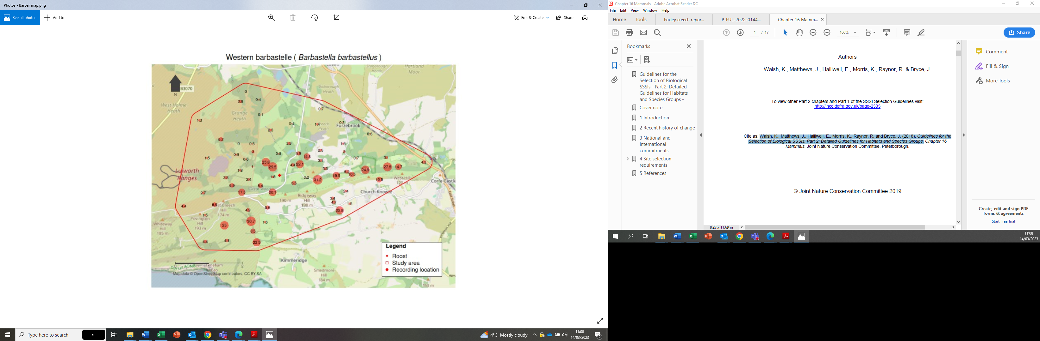

Figure 2: Acoustic results for Bechstein’s around Creech Grange as identified using BTO acoustic pipeline. The diamond relates to the Greater Horseshoe Summer roost at Creech Grange. The size of the circles relates to the number of one-minute blocks in which a bat was

recorded.

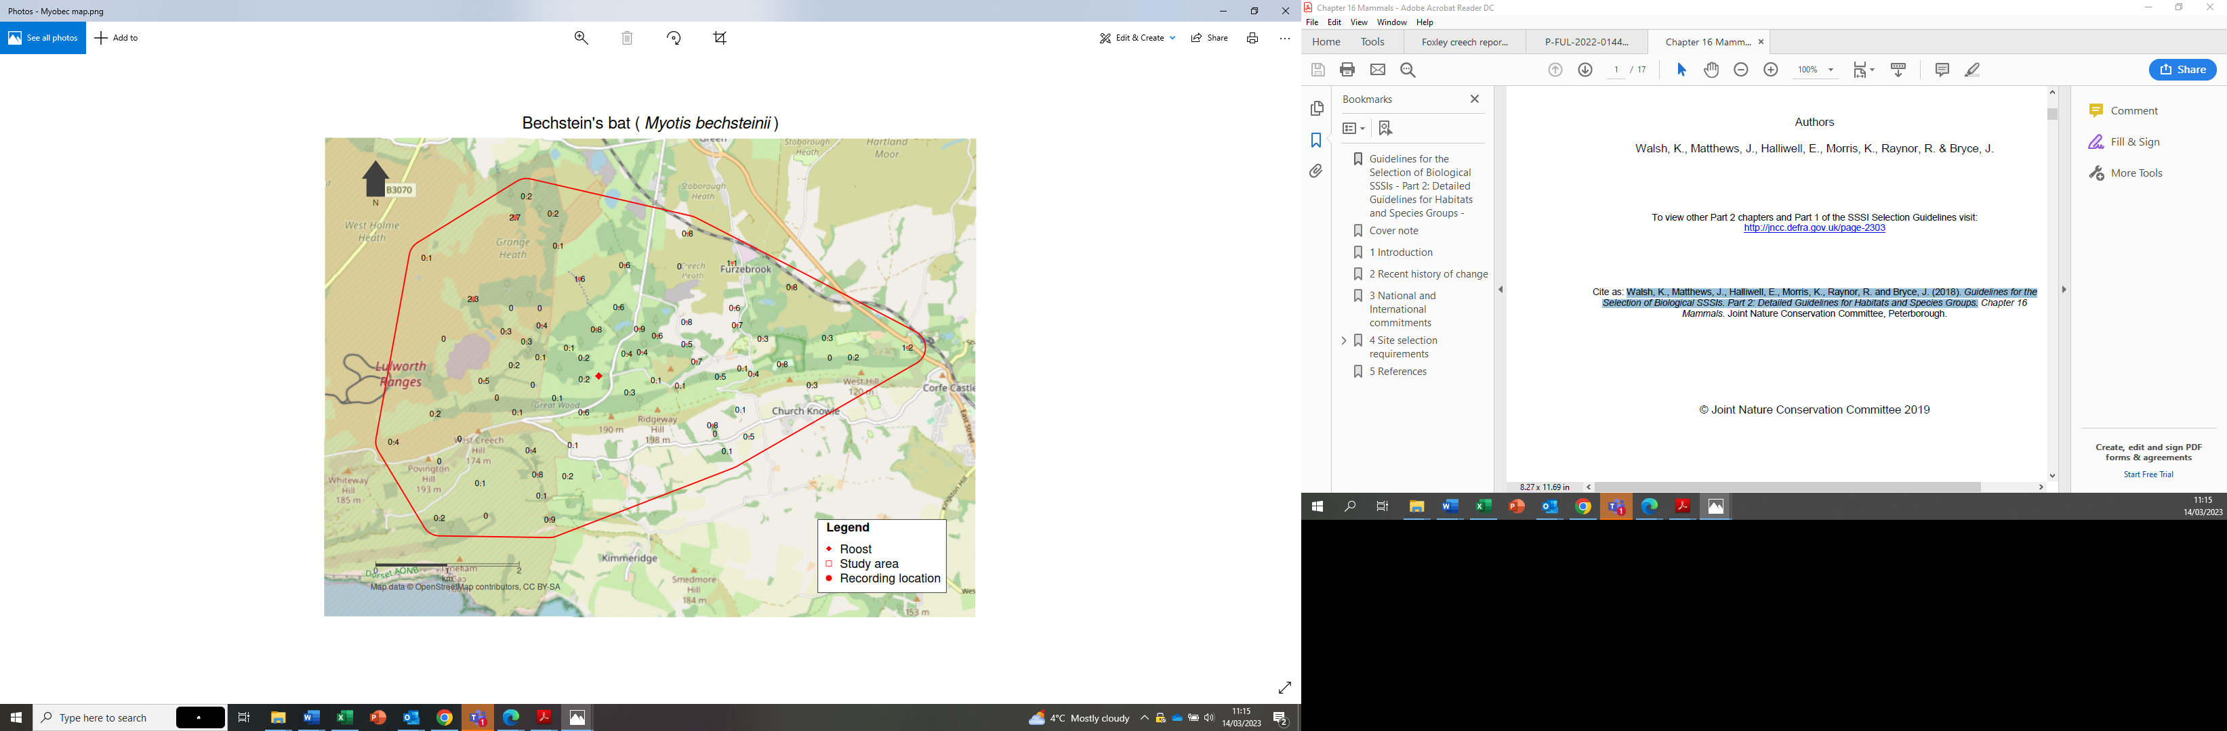

Figure 3: Acoustic results for Grey Long-eared bat around Creech Grange as identified using BTO acoustic pipeline. The diamond relates to the Greater Horseshoe Summer roost at Creech Grange. The size of the circles relates to the number of one-minute blocks in which a bat was

recorded.

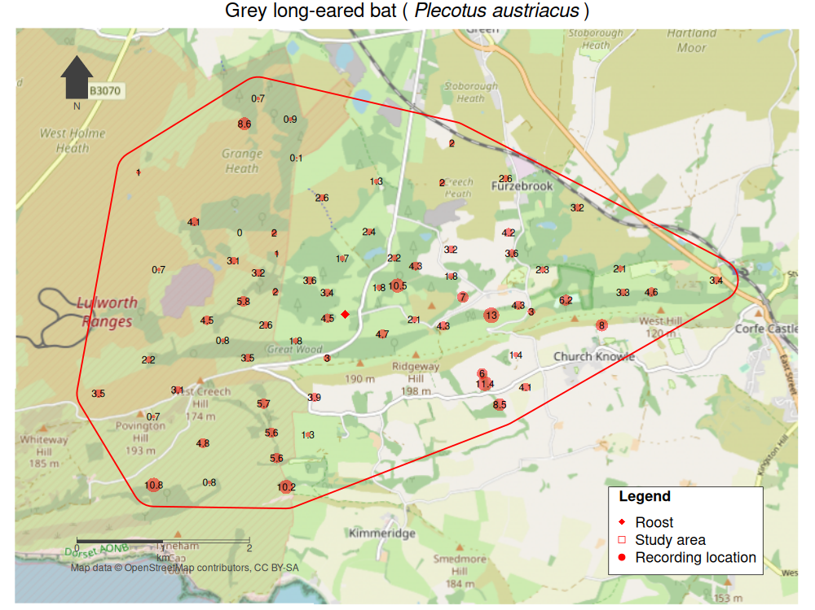

Figure 4 Acoustic results for Brown Long eared bat around Creech Grange as identified using BTO acoustic pipeline. The diamond relates to the Greater Horseshoe Summer roost at Creech Grange. The size of the circles relates to the number of one-minute blocks in which a bat was

recorded.

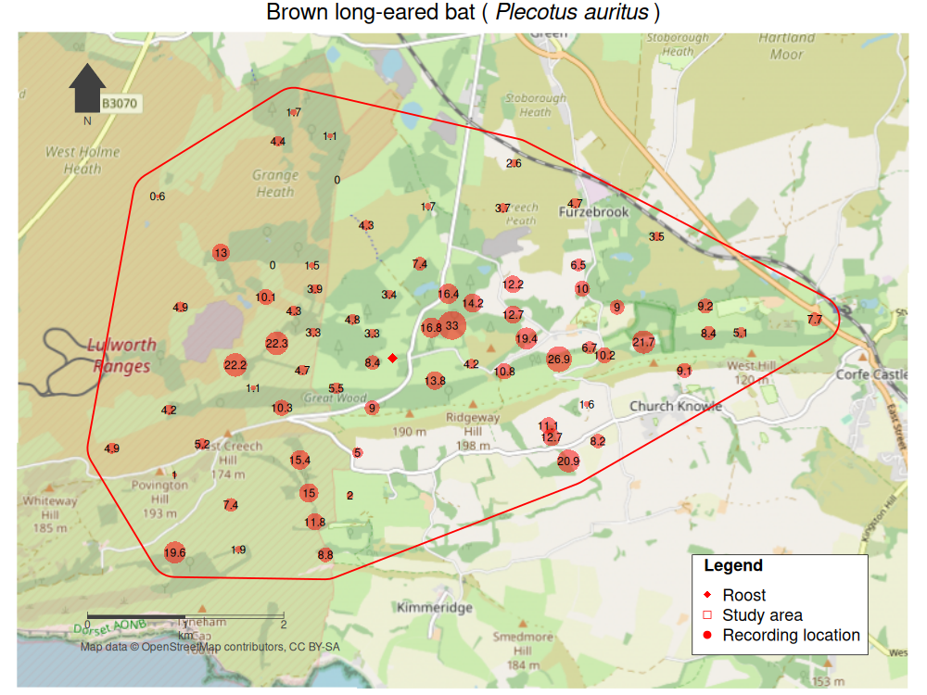

**Annex 2: Natural England data standards**

This Annex provides high level guidance for contractors regarding Metadata and Geographic Information System deliverables. Final details of requirements for this project, with reference to section 5 of the Specification, will be agreed with the Nominated Officer.

Natural England reserve the right to check the quality of all digital data and reserve the right to return any data that does not meet these compliance requirements. If any part of this guidance is unclear please make early contact with the Natural England Nominated Officer who will be able to provide clarification in consultation with data management colleagues.

A metadata record should be completed for the project outputs as a whole and for each GIS layer generated. This is so that so we can easily understand the lineage (what information products have been used in the output) and ensure the correct licensing and copyright attributions are applied.

Metadata derived as part of this project must be submitted to Natural England in an XML file which Natural England will archive through Data Archive Centres (DACs). Natural England can supply a basic metadata template for this on request. If you use your own template you should ensure it is complaint with [National Biodiversity Network Trust community standards](https://docs.nbnatlas.org/share-species-occurrence-records-with-the-nbn-atlas/).

It is essential that the final GI datasets are accompanied by a detailed ‘readme.doc’ describing the file structure within submitted outputs, and clearly outlining file associations (e.g. layer files for colours/ fill patterns).

Spatial data must be in ESRI Shapefile or Geodatabase (v10.2.2 with a .lyr file) format and must have been through the [Esri Check Geometry](https://desktop.arcgis.com/en/arcmap/10.7/tools/data-management-toolbox/check-geometry.htm) tool. Annex 2 provides more detail about data standards for spatial data. Documentsthat give more detailed information on the creation of the dataset or how to use the data should be in Word format.

All data, media of any nature containing information and data or other material belonging to Natural England or relating to the Services shall be delivered promptly. Spatial data and accompanying documents , along with Word documentsthat give more detailed information on the creation of the dataset or how to use the data should be sent to [data.services@naturalengland.org.uk](mailto:data.services@naturalengland.org.uk) .

|  |  |
| --- | --- |
| File format | ESRI shp or gdb  If MapInfo software is used then data must be converted to ESRI using either: the file conversion tools within that software; FME software; or download freely available conversion software such as QGIS |
| Geographic projection/spatial reference | If data is on or near land then use British National Grid co-ordinate systems. If data is marine-based then use WGS84. |
| Units | Coordinate units: metres  Distance units: metres  Area units: hectares |
| Digitising | Using Ordnance Survey MasterMap (as supplied) |
| Boundaries | Where a boundary follows an OS MasterMap feature the OS MasterMap feature should be copied so that the digitised boundary and OS MasterMap feature share the same geometry.  Where a boundary follows part of an OS MasterMap feature the digital boundary should be snapped along the OS MasterMap feature so that the digitised boundary and MasterMap feature both share the same geometry where appropriate.  Where a boundary does not follow an OS MasterMap feature the digitised boundary should be captured with sufficient nodes that the digitised feature takes on the shape of the feature on the source material at a scale of 1:2500.  Where a boundary is shared between two (or more) polygons the boundaries should all share the same geometry. Thus, there should be no slithers or gaps between polygons with contiguous boundaries.  Where a boundary follows a feature on an aerial photograph, scanned and geo-rectified map (maybe field or historical) or other raster image that is not shown on the OS MasterMap Data, the digitised boundary should be captured with sufficient nodes that the digitised feature takes on the shape of the feature on the raster material at a scale of 1:2500.  Holes in polygons should be appropriately "punched". Where there is a hole in a polygon this should be digitised as a hole as shown below.  goodhole |
| Errors | Features should not be "stream" digitised. Stream digitising is the process of manual digitising, of lines or regions, where nodes are automatically placed at pre-set intervals based upon distance or time.  Polygons should not contain inappropriate "spikes". In the figure below the digitised field has an inappropriate spike.  spike  Polygons must not contain "bowties". Polygons must not intersect or cross themselves. In the figure below the digitised field has a bowtie caused by a polygon crossing itself.  bowtie |
| Point data | Point data must be accurate to 10 metres.  Point data should be collected in the field using GPS wherever possible.  Grid references collected in the field should be to at least 8 figures, e.g. SE832413. |

1. Walsh, K., Matthews, J., Halliwell, E., Morris, K., Raynor, R. and Bryce, J. (2018). Guidelines for the Selection of Biological SSSIs. Part 2: Detailed Guidelines for Habitats and Species Groups.