
INVITATION TO TENDER LETTER
Date: 3rd August 2021

Dear ,
Invitation to Tender
Cemetery Chapel Roof including new installation of New Steel Tie Bars and Wall Plate improvements
1 Your organisation along with others are invited to tender for installation of structural tie bars and a new roof at Diss Cemetery Chapel, to the specification outlined in the following documents.
Document 1 Instructions and information on the tendering procedures.
Document 2 Specification of the Requirement for completion of roof.
Document 3 Drawing of Cemetery Chapel and pictures of the site.
Document 4 Cemetery roof pictures.
Document 5 Structural Engineer Drawings and specifications for Steel Tie Bars and improvements to wall plates.
Document 6 Structural engineer calculations
2 Please read the instructions on the tendering procedures carefully. Failure to comply with them may invalidate your tender which must be returned by the date and time given below.
3 Your tender must be received by Robert Ludkin via post and email on Robert.Ludkin@diss.gov.uk no later than 5 pm on the 6th September 2021. Late tenders will not be considered.
4 If having read the enclosed specification you decide not to submit a tender, I would be grateful if you could send your reasons (though you are under no obligation to do so) to Robert.Ludkin@Diss.gov.uk, at the above address marked 'No Tender'.

I look forward to your response.
Yours sincerely
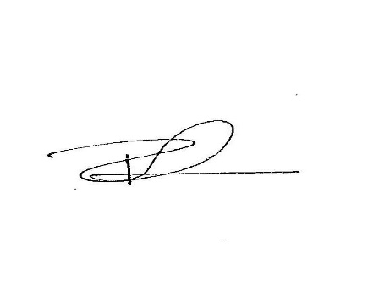

Robert Ludkin
Maintenance Manager
Robert.Ludkin@diss.gov.uk

