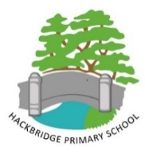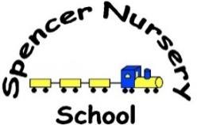

**APPENDIX E**

**Federation of Hackbridge Primary School and Spencer Nursery School**

**Ambitions and Expectations of Catering contract**

The Federation of Hackbridge Primary School and Spencer Nursery School consists of a Primary School (ages Nursery to Year 6) situated over two (2) sites, each with a separate modern kitchen. Together with a Nursery which on on a further separate site again with its own kitchen facility.

The Catering at both Hackbridge Primary School sites is a canteen service with Catering staff serving pupils from a serving hatch or from hot trollies. Spencer Nursery has a family service. Staff sit with the children to eat and they serve the food whilst the children are sitting at the table. Packed lunches are not allowed at Spencer Nursery. All children eat the meal served.

Our ambition is to have every child across the federation wanting to and having a meal provided by the school. We would at the very least hope that all children receiving Pupil Premium have this hot meal.

We would like the food to be appealing and tasty, reflecting the palette of our wide diversity of pupils.

The Federation would expect the Service Provider to proactively reduce the impact on the environment and support the federation in improving our environmental impact to):

* + Helping reduce the amount of avoidable food waste thrown away by 20%.
  + Supporting the Federation in eradicating single use plastics from school meals.
  + Working with schools to introduce cost effective food waste recycling.
  + Promoting a balanced and sustainable diet.

Service providers are required to have an up to date, UK Government approved (or European equivalent) accredited environmental management system registered to ISO 14001 or EMAS. Alternatively the Contractor is required to develop and implement an environmental improvement programme which is approved by the Federation and monitored annually.

It is expected that the Service Provider is compliant with all relevant environmental legislation.

Compliance with the London Brough of Sutton’s Environmental policies will be a contractual requirement with reports on how this has been met expected annually. These reports should demonstrate how the Service Provider has delivered to allow these achievements to be promoted and celebrated.