SCHEDULE 2 – THE SERVICES

- Service Specifications

Mandatory headings 1 – 4. Mandatory but detail for local determination and agreement
Optional headings 5-7. Optional to use, detail for local determination and agreement.

All subheadings for local determination and agreement

Service Specification No. | n/a
Service | Leicester City Open Mind Improving Access to Psychological Therapies (IAPT) Service
Commissioner Lead | Leicester City Clinical Commissioning Group
Period | 1st April 2016- 31st March 2021 ( with potential 2 year extension)
Date of Review | n/a
1. Population Needs
Open Mind Improving Access to Psychological Therapies (IAPT) Service for Leicester meets both national and local priorities.
  - NATIONAL CONTEXT

An estimated 17.7% of adults aged 18 and older meet the diagnostic criteria for at least one common mental health disorder. Reducing the prevalence of such disorders is a major public health concern. The HSE Labour Force Survey 2010/11 found that 10.8 million working days were lost due to stress, anxiety or depression. Figures from the Centre for Mental Health show that most people with stress continue to work, often struggling with concentration. It is estimated that this ‘presenteeism’ costs UK businesses £15.1 billion per year in reduced productivity.
National policy also stipulates that Primary Care IAPT Services for adults should be based on a local Joint Strategic Needs Assessment, informed by national epidemiological research, and which considers the needs of the whole community for primary care psychological therapies. In addition background and guidance relating service levels to meet the needs of people with common mental health disorders is available from the NICE commissioning guidance
Figure 1: Risk Factors for Common Mental Health Disorders
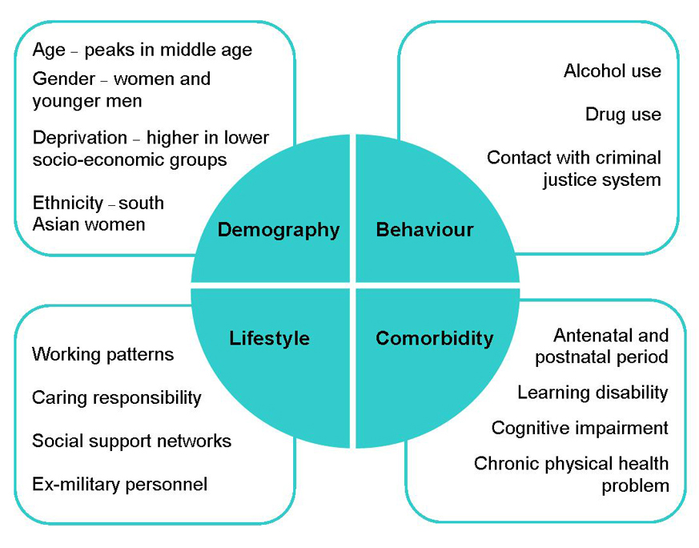
Data from the Adult Psychiatric Morbidity Survey 2007 show the prevalence of the various types of disorder (see figure 2).

Figure 2
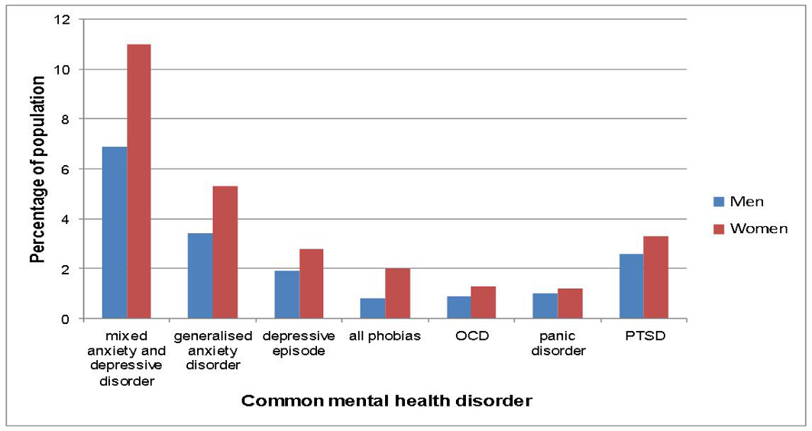

There is strong evidence that appropriate and inclusive services and pathways for people with common mental health problems, specifically depression and anxiety, reduce an individual’s usage of NHS services whilst contributing to overall mental well-being and economic productivity

LOCAL CONTEXT

Locally Leicester has high levels of risk factors for mental health, these can be found in the needs assessment at http://www.leicester.gov.uk/media/178811/mental-health-jspna.pdf. Key findings include:
Population | In 2010 Leicester had an estimated population of 306,600 people, with more younger and fewer older people compare with England. Projections suggest that the population will increase to 346,000 people by 2020.
Deprivation | Leicester has high levels of deprivation and is ranked 25th worse out of 326 local authority areas in England on the national Index of Deprivation 2010. Deprivation is wide cast; 41% of the Leicester population lives in the most deprived areas of England. There is wide variation of deprivation among different areas of the city.
Diversity | Leicester has a diverse population compared with England. 36% of Leicester residents are from black and minority ethnic (BME) backgrounds, compared with 13% for England as a whole. The age profile of people from BME ethnic backgrounds is younger than that of people from White/White British ethnic backgrounds.
Wider determinants of health | Leicester is significantly worse than the England values in: rate of working age adults who are unemployed per 1,000 percentage of 16-18 year olds not in education, employment or training, rate of episodes of violent crime per 1,000
Risk factors for mental illness | Leicester is significantly worse than the England values in : percentage of population with a limiting long term illness first time entrants into the youth justice system of 10 - 17 year olds percentage of adults participating in recommended levels of physical activity
Mental health in Leicester | - 3-5% of newly delivered mothers experience moderate to severe depressive illness equating to 150-250 women in Leicester each year  - 16-18% of working age adults experiences a common mental health problem at any time, equivalent to 34,358 to 38,652 people. The number registered with their GP as having depression is 30,831 suggesting that not all people with depression have health care support  - The number of new cases of adult depression in Leicester is estimated to be 11,000 per year  - It is estimated that there are 3,400 people in Leicester with a serious and enduring mental health condition such as schizophrenia, bipolar affective disorder and other psychoses  - An estimated 3,000 people aged over 65 years have depression and a further 1,500 have severe depression  - In Leicester each year approximately 32 people will take their own life

Table 1: Community prevalence of mental health need in Leicester
Population (2001 census) | Working-age adult population (18-64 years) | National Adult Psychiatric Morbidity Survey 2000
 | 214,736 | 36,009
Gender
Women | 107,935 | 18,113
Men | 106,801 | 17,896
Ethnicity
White (British) | 95,195 | 15,963
White (Irish) | 1,441 | 242
White (Other) | 11,637 | 1,951
Dual heritage (est.) | 5,638 | 945
Asian (Indian) | 62,886 | 10,545
Asian (Pakistani) | 5,048 | 846
Asian (Bangladeshi) | 2,095 | 351
Asian (Other) (est.)² | 8,605 | 1,443
Black (Caribbean) | 7,702 | 1,292
Black (African) (est.) | 3,143 | 527
Black (Other) (est.) | 1,510 | 253
Chinese | 3,844 | 645
Other Ethnic Group (est.) | 5,992 | 1,005

Older people estimated prevalence is :
Ethnic group | Males 65+ | Females 65+ | Persons 65+ | Estimated number at a rate of 16.8%
White | 11,231 | 14,804 | 26,035 | 4,366
Asian/Asian British | 4,239 | 5,318 | 9,557 | 1,603
Black/Black British | 500 | 615 | 1,115 | 187
Mixed | 100 | 124 | 224 | 38
Other Ethnic group | 143 | 142 | 285 | 48
Total | 16,213 | 21,003 | 37,216 | 6,241

Leicester City CCG Health Need Neighbourhoods
We are building a new environment for the provision of primary care in Leicester City. This is through the development of Health Need Neighbourhoods (HNNs), which are planned to be based on four geographical areas of Leicester City, based on:
- ward boundaries
- disease prevalence
- deprivation
- health need
- access
- patient experience
- population profile

 | Group | HNN 1: North and West | HNN 2: South | HNN 3: Central | HNN 4: North and East
Population characteristics | Registered Population | 105,020 | 84,784 | 121,968 | 65,017
Population characteristics | Ave Registered Population per practice June 14 | 6,564 | 6,056 | 6,419 | 5,001
Population characteristics | 75+ Registered Population | 5,954 | 3,130 | 5,790 | 5,032
Population characteristics | % 75+ Registered Population | 5.6% | 4.5% | 4.5% | 7.5%
Practices’ infrastructure | Total GPs | 52.4 | 44.3 | 74.5 | 37.0
Practices’ infrastructure | Ave List Size per GP | 2,052 | 1,888 | 1,816 | 1,961
Practices’ infrastructure | Number of Practices (including Branches) | 19 | 14 | 24 | 16

The HNNs form logical footprints on which to organise the delivery of services, with their main health challenges being:
- HNN 1: North and West
  - high infant mortality rates
  - high smoking prevalence and COPD

- HNN 2: South
  - high cancer rates
  - high levels of adult obesity
  - high number of patients registered with asthma

- HNN 3: Central
  - high cardiovascular disease prevalence
  - high diabetes prevalence
  - high perinatal mortality rates, the lowest birth weights
  - high number of patients with limiting long term problem or disabilities

- HNN 4: North and East
  - high cancer rates
  - high cardiovascular disease prevalence
  - highest registered population with dementia

In relation to estimated prevalence of common mental health disorders:
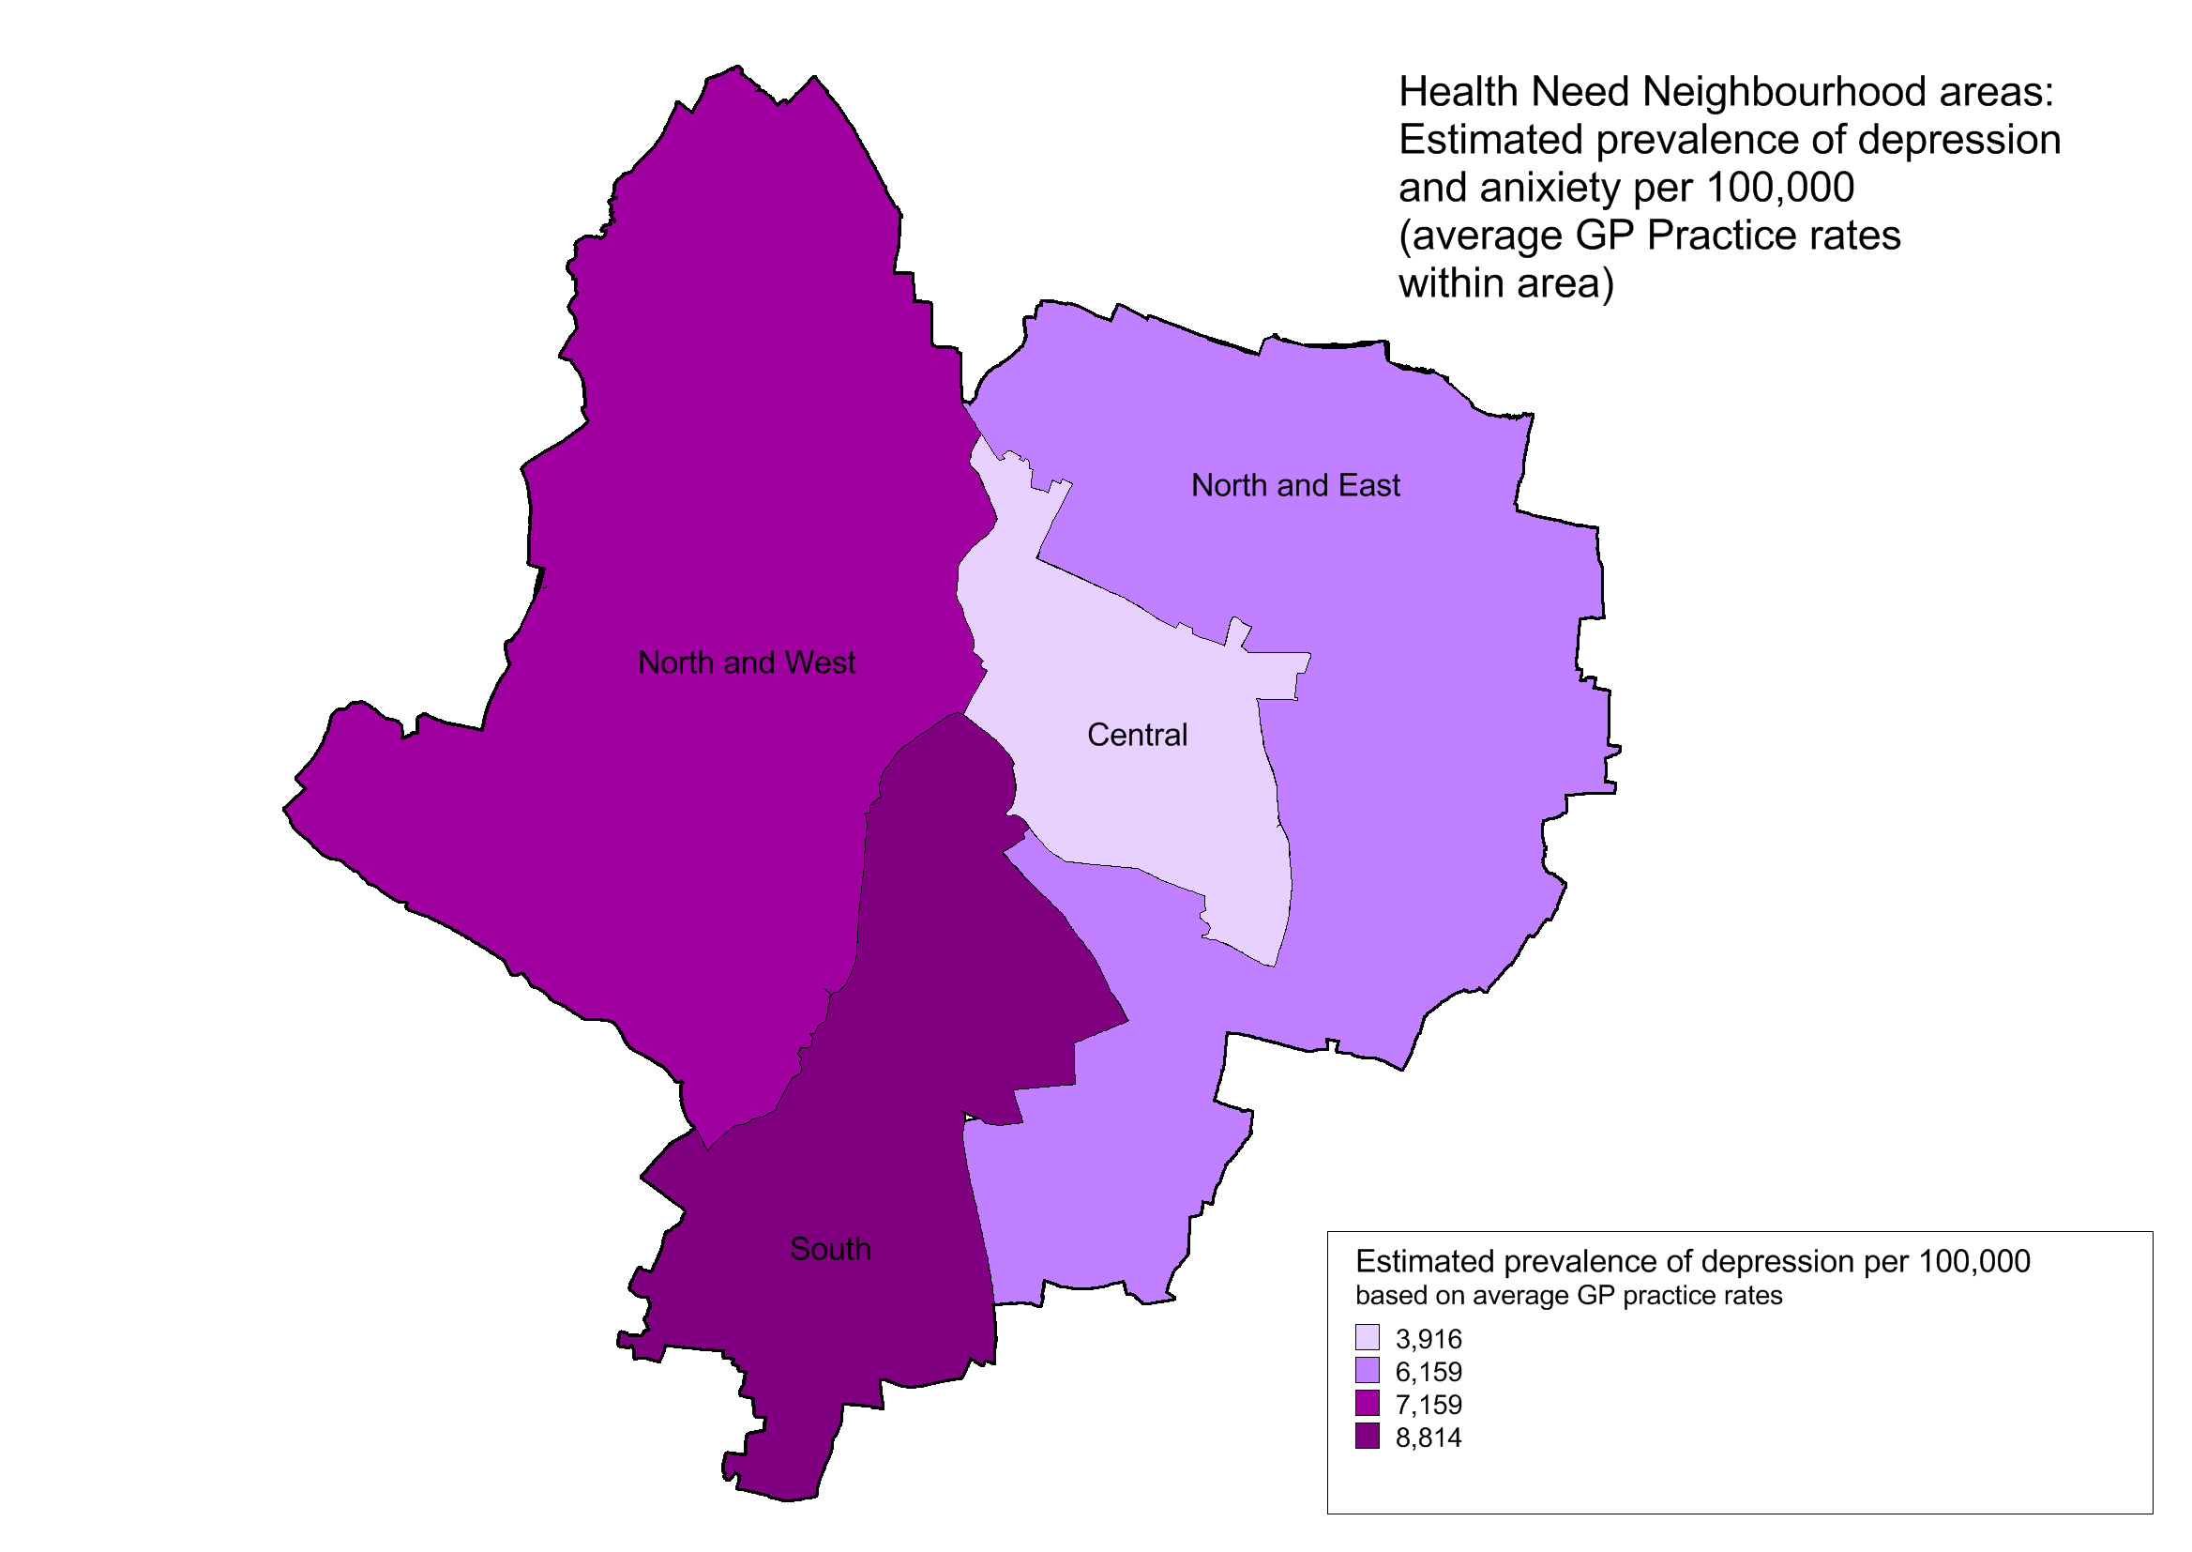
We expect the provider to establish equitable provision across the city but to tailor services within Health Needs Neighborhoods based on population needs.
2. Outcomes
2.1 NHS OUTCOMES FRAMEWORK DOMAINS & INDICATORS
Domain 1 | Preventing people from dying prematurely
Domain 2 | Enhancing quality of life for people with long-term conditions | X
Domain 3 | Helping people to recover from episodes of ill-health or following injury | X
Domain 4 | Ensuring people have a positive experience of care | X
Domain 5 | Treating and caring for people in safe environment and protecting them from avoidable harm

2.2 LOCAL DEFINED OUTCOMES
Locally defined outcomes will measure outcomes, progress, recovery and relapse; all of which are vital to ensure that people's treatment is reviewed and appropriate action taken in line with the stepped-care model (shown on page 9 and explained in NICE clinical guideline 123). They will take into account the NHS and Adult Social Care Outcomes Frameworks 2014/15 which include quality of life and outcome measures for mental health services.
The Key Service Outcomes for the Leicester City IAPT service are as follows:
- Reduce the stigma and discrimination associated with a diagnosis of, or treatment for, common mental health disorders.
- Increased proportion of people with common mental health disorders who are identified, assessed and receive treatment in accordance with appropriate NICE guidance
- Improve access and support in order to maintain people in work, help them to return to work, help them into education or training and where appropriate help people to find meaningful activity
- Improve emotional wellbeing, quality of life and functional ability in people with common mental health disorders
- Improve individual’s well-being and functionality, this will include people with physical health problems
- Increase social participation and community integration of service users
- Improving service-user experience of mental health services
- Improved access to screening for depression and anxiety of patients with a long-term condition, Older people and people from BME communities

3. Scope

3.1 AIMS AND OBJECTIVES OF SERVICE
Overall:
The Improving Access to Psychological Therapies (IAPT) is an NHS programme of talking therapy treatments recommended by the National Institute for Health and Clinical Excellence (NICE) which support frontline mental health services in treating depression and anxiety disorders. (see http://www.iapt.nhs.uk/).
It was created to offer people a realistic and routine first-line treatment, combined where appropriate with medication, which traditionally had been the only treatment available.
Achieving aims and objectives:
In relation to achieving the aims and objectives of the national programme we have identified a good IAPT service should provide:
- Equitable access to talking therapies
- Timely access
- Choice of NICE compliant treatments and access to alternative pathways
- Flexible number of sessions fitting clients’ needs
- Provide a choice treatment locations
- Good clinical outcomes with improved health and well-being (including employment)
Further this is supported by:

Excellent leadership, with a real focus on recovery | The overarching requirement for good leadership is not only at senior level but at team level, and includes: feedback of individual therapist performance, individually tailored Continuing Professional Development (CPD) for staff; benchmarking and active decision making by the whole team; individual accountability; and a culture of enquiry.
Optimised performance management systems | Including clinical supervision with a focus on data and recovery performance; accessible, reliable and complete data; tracking outcomes at an individual therapist level, and including this as part of performance management activity; good clinical productivity.
Workforce stability and experience | The best performing providers have good retention rates and experienced workforces.
Assessment and access: | Providers put an emphasis on correct assessment and getting the patients to the right therapists within waiting time targets – this includes an accurate judgement of their presenting problems (including provisional diagnosis using ICD10 codes).
Choice of NICE compliant treatments and access to alternative pathways | discussing treatment choices with patients and identifying step-up or step-down options when appropriate
Flexible number of sessions fitting clients’ needs | Well performing providers generally had an open-ended approach to the overall number of sessions that could be offered. However, therapists and clients discussed sessions in terms of relatively short ‘blocks’ in order to help focus therapist and client on making progress (egg six sessions followed by a review and further such blocks as appropriate).
Data informed, service level reflective practice: | Evidence indicates sustained increases in recovery rates have been achieved by systematically reviewing all non-recovered cases and taking specific actions on the themes identified as reasons for non-recovery.
Data informed, service level reflective practice: | Evidence indicates sustained increases in recovery rates have been achieved by systematically reviewing all non-recovered cases and taking specific actions on the themes identified as reasons for non-recovery.
Work collaborative with the local Third sector | To support access for hard to reach groups.

Equality Act 2010 and the Public Sector Equality Duty (PSED):
The Equality Act 2010 pulled together existing equalities legislation covering disability, gender, race, religion/belief and sexual orientation. It introduced an age equality duty on the public sector and a duty to consider reducing socio-economic inequalities. A core requirement of equalities legislation is to give due regard to eliminate discrimination and promote equality.

To avoid perpetuating inequality it is important for Open Mind IAPT to ensure care does not impact disproportionately on any one group, and that they protect the interests of minority and social excluded groups and individuals.

The service will be expected to support out public sector equality duty by:

- Providing a “whole person” approach to the delivery of the IAPT Open Mind Service which takes account of the person’s socio demographic characteristics, health comorbidities and lifestyle

- Working collaboratively and innovatively with local statutory and third sector organisations to increase access to vulnerable and minority groups.

- Promoting access to services from all sectors of the community including traditionally underserved/socially excluded groups.

- Provide Language and communication support and Where necessary home-based interventions

- To promote recovery and minimise the disabling effects of mental ill health supporting people in employment, education and meaningful activity.

The following groups have been recognised as being particularly vulnerable and therefore could benefit from specific care pathways and expertise:
- Lesbian, Gay, Bisexual and transgender people
- People with mild learning disabilities
- Older People
- People from BME communities
- New entrants and asylum seekers
- Women in the perinatal period
- People who have experienced sexual abuse or violence
- People with substance misuse problems
- Offenders
- Gipsy and Traveler communities

In 2014 Leicester City CCG undertook a equality deep dive into current IAPT provision a summary of which is in the following document:

A resultant of analysis a first year CQUIN will be related to increasing recovery rates in BME communities (see Section 4.2).

3.2 SERVICE DESCRIPTION/ CARE PATHWAY
SERVICE DESCRIPTION
Leicester City Open Mind will be a community based service firmly based on the Improving Access to Psychological Therapies (IAPT) is an NHS programme of talking therapy treatments recommended by the National Institute for Health and Clinical Excellence (NICE) which support frontline mental health services in treating depression and anxiety disorders. (see http://www.iapt.nhs.uk/).
The service is based on a stepped care mode and concentrates on provision at Steps 2 and 3:

Figure 3 Stepped Care Model: Focus and Nature of Interventions
'Talking therapies: a four year plan of action' estimates that two-thirds of people with common mental health disorders have mild mental health disorders and so need low-intensity treatment at step 2. One-third have moderate or severe mental health disorders and so need higher intensity treatment at step 3 and allocation of provider resources should reflect this.
The stepped care mode should ensure that local care pathways:
- provide the least intrusive, most effective intervention first
- have clear and explicit criteria for the thresholds determining access to and movement between the different levels of the pathway
- do not use single criteria (such as symptom severity) to determine movement between steps
- monitor progress and outcomes to ensure the most effective interventions are delivered and the person moves to a higher step if needed
- promote a range of evidence-based interventions at each step in the pathway
- support people in their choice of interventions

The IAPT Open Mind service will be part of an integrated care pathway for people with common mental health disorders and should build on existing multi-agency partnerships with a variety of statutory, voluntary and private providers working collaboratively.
Service Promotion and Information
The service will establish a clear strategy designed to promote appropriate use of the primary /community psychological therapies service which actively helps to secure the savings in other parts of the local NHS expenditure.
Service promotion has two distinct target audiences:-
- Health, employment and social care professionals who may refer their patients or clients to the psychological therapies service and be keen to see the treatment reduce demand on other aspects of NHS and other services

- Local residents and workers, who need accessible information about how the service may be able to help them recover their sense of wellbeing

Useful materials for promoting the service can be downloaded and adapted for local use from http://www.iapt.nhs.uk/services/providers/

CARE PATHWAY
- REFERRAL SOURCES

The service will be expected to receive referral from:

- GP’s
- Other healthcare professionals
- Other statutory and third sector organisations
- Self-referral

- REFERRAL ROUTE

The service will be expected to be able to have a central publicised point for the receipt and logging of all referrals.

The service will be expected to be able to receive referrals from both professionals and a patients through:
- Online portals
- Telephone
- Post
- Fax

The service provider will make full use of online referral systems and will be expected to work with Leicester City CCG to establish a GP web portal which is compatible with General Practice Clinical recording systems.

In all instances, the service will ensure that the relevant GP practice has been informed about the patient referral.

- SERVICE ELIGIBILITY CRITERIA

The service will be expected to primarily with mental health care clusters 1-3:
Care Cluster 1: Common Mental Health Problems (Low Severity) - This group has definite but minor problems of depressed mood, anxiety or other disorder, but they do not present with any psychotic symptoms
Care Cluster 2: Common Mental Health Problems (Low Severity with Greater Need) - This group definite but minor problems of depressed mood, anxiety or other disorder, but not with any psychotic symptoms. They may have already received care associated with Care Cluster 1 and require more specific intervention, or previously been successfully treated at a higher level but are re-presenting with low level symptoms
Care Cluster 3: Non-Psychotic (Moderate Severity) - This group has moderate problems involving depressed mood, anxiety or other disorder (not including psychosis)
Eligibility criteria include people presenting with at least one of the following conditions, either as a sole or co-morbid diagnosis, where a psychological therapy intervention would be appropriate:
Depression (including that relating to antenatal and postnatal mental health):
Mild Depression (4 ICD-10 symptoms and/or PHQ-9 score of 5-9)
Moderate Depression (5-6 ICD-10 symptoms and/or PHQ-9 score of 10-14)
Moderate – Severe Depression (7 ICD-10 symptoms and/or PHQ-9 score of 15-19)

Anxiety including:
Generalised anxiety disorder (GAD)
Panic Disorders
Phobias – Agoraphobia, Social phobia, Simple phobia
Post-Traumatic Stress Disorder
Obsessive Compulsive Disorder

Other Disorders
Bereavement or other life events resulting in any of the above
Relationship issues
Anger
The above list is not exhaustive and it recognises that there may be cases that fall outside the above definitions, however, these patients may still benefit from psychological interventions.
In the eventuality of a “disputed referral”, every effort should be made by the Service Provider, GP practice and partner organization/s to find a flexible solution. As a last resort, the issue should be escalated to the Commissioner.

People assessed as requiring Step 4 intervention should be referred on to the appropriate specialist/secondary care service and a referral protocol will be established with the secondary care provider to support this.

- OPT-IN PROCESS

Opt-in processes are not a mandatory requirement and the service should ensure that access by people with common mental health problems is unhindered by complex patient opt-in or confirmation systems. Services should make strenuous efforts to assertively contact both new referrals and those patients for whom the service has lost contact during a treatment episode.

- ASSESSMENT /SCREENING

The service will be expected to make contact with the patient with 2 days of opt in confirmation in order arrange an assessment in order support patient engagement and minimise waiting times

An assessment can be undertaken either face to face, telephone or video conferencing facilities.

The assessment/screening will focus on the presenting problem, a basic risk assessment and referral on to other agencies, if appropriate. This will include the following elements:

- Prior to the start of treatment all patients should receive a comprehensive ‘patient centred’ assessment that clearly identifies the full range and impact of their mental health problems and any linked employment, social and physical health issues.

- Risk (suicide, harm to others, etc.) should be assessed at initial contact and at each contact thereafter.

- All patients must have their clinical, work and social outcomes assessed using standardised measures that are appropriate to the conditions being treated. Key measures should be given at each treatment session so that a clinical end point is available even if patients finish treatment early.

People identified to be at high risk (e.g. suicidal ideation, severe self- injurious behaviour, psychotic symptomatology) should be urgently referred to the appropriate mental health service crisis support services. The access standard for referral is the same day.
Where an assessment is undertaken the assessor will discuss the range of options/therapies available (that are appropriate for the clinical presentation) taking into consideration gender, ethnicity and other diversity issues and offer choice wherever possible.

- TREATMENT

Following initial assessment, eligible patients must be offered an evidence-based treatment appropriate to their condition, as indicated in current NICE Guidelines. Where several evidence-based treatments are recommended by NICE, patients should be offered a choice.

The evidence-based treatment should be given at the minimum dose that is necessary to achieve full and sustained recovery.

In this respect it is expected that the number of interventions per individual being treated within step two of the stepped care model should not exceed 6 treatment sessions, if there is a requirement for the individual to receive treatment in excess of this, this should be discussed with their GP prior to receiving additional treatment, or alternative treatment.

Those patients being seen within step 3 of the stepped care model should be seen no more than 15 times, if there is a requirement for the individual to receive treatment in excess of this, this should be discussed with their GP prior to receiving additional treatment, or alternative treatment.

In addition to being offered evidence based psychological treatment, patients may be offered an experimental treatment if the treatment is in the process of being evaluated and there are reasonable grounds to assume that it is likely to be effective. Patients should be informed in writing that the treatment is experimental.

Commissioners expect the service provider to:
- Increased use of technology to deliver face to face treatments (e.g. video conferencing)
- Increase access to service provision for working age adults through offering evening and weekend clinics

Commissioners are also keen to see the establishment of online/ social media NICE compliant therapy support options at both Steps 2 and 3 as currently these are not in place within the Open Mind service.
Responsibility for prescribing medication normally resides with the patient’s GP. However, the psychological therapy service should have expertise in how medication can be used in conjunction with psychological therapies. In this way, mental health workers within the service will be able to assist patients to make decisions about their use of medication in a shared and informed manner and will be able to liaise with GPs over any possible medication changes.

High risk patients (i.e. suicidal ideations, severe self injurious behaviour, psychotic symptomology) identified through clinical judgement and/or objective risk outcome tools should be urgently referred to the appropriate crisis support or CMHT services without delay

Focus of interventions in stepped care
The Service Provider will complete an appropriate screening process, which will guide the patients’ pathway (GAD7 & PHQ9). This should include risk assessment of individuals who may be vulnerable and/or present a risk of harm to self or others.
Interventions will be determined by the level of need and individuals directed to the appropriate Step/service, for example, Step 2 or Step 3 intervention. The nature of the intervention will help determine how it is delivered (i.e. face to face, telephone, group classes, online etc.).
The focus of interventions at various levels of stepped care is highlighted below
Step 1
Focus of the intervention | Nature of the intervention
Presentation with known or suspected common mental health disorders | - Identification  - Assessment  - Psychoeducation  - Active monitoring  - Referral for further assessment and interventions.
Improved identification and awareness of common mental health problems and pathways to care by general practitioners and other health, education, welfare and criminal justice professionals is a crucial aspect of Step 1.
Low Intensity psychological therapy interventions at Step 2
Disorder | Psychological Intervention
Depression  Generalised Anxiety Disorder  Obsessive compulsive disorder  Panic Disorder | - Guided Self Help  - Problem Solving  - Brief person Centred/integrative counselling  - Bibliotherapy  - Exercise schemes  - Self - help groups  - self –help individual facilitated ( including online option)  - Self-help individual non-facilitated (including online option)  - CCBT  - CBT  - Behavioural Activation  - Psychoeducation 1:1/group  - Therapist assisted Exposure and Self-directed exposure  - Medication advice and support for people on anti-depressants  - Signposting to alternative support/services
Obsessive Compulsive Disorder | - Cognitive behavioural therapy (individual) including exposure and response prevention  - Cognitive behavioural therapy (group) including  - exposure and response prevention  - Problem Solving  - Signposting to alternative support/services
Post-Traumatic Stress Disorder | - Cognitive behavioural therapy (trauma-focused)  - Eye movement desensitising and reprocessing (EMDR)  - Counselling  - Signposting to alternative support/services
Depression with a LTC | - Guided Self-help  - Sleep Hygiene  - Group-based peer support (self-help) programmes  - Bibliotherapy  - Signposting to alternative support/services
Depression Antenatal and postnatal | - Non-directive counselling delivered at home  - Signposting to alternative support/services

High Intensity Psychological Interventions at Step 3
Disorder | Psychological Intervention
Depression | - Medication advice and support for people on anti-depressants  - Behavioural Activation  - Behavioural Couples Therapy  - Cognitive behavioural therapy (CBT)  - Counselling  - Interpersonal Psychotherapy  - Brief Dynamic Interpersonal Therapy
Generalised Anxiety Disorder  Panic Disorder | - Applied Relaxation  - Psychoeducational Groups  - CBT  - Self-Help Groups  - Bibliotherapy based on CBT principles  - Brief Psychodynamic Therapy
Obsessive Compulsive Disorder | - Cognitive behavioural therapy (individual) including exposure and response prevention  - Cognitive behavioural therapy (group) including exposure and response prevention  - Problem Solving  - Self help
Post-Traumatic Stress Disorder | - Cognitive behavioural therapy (trauma-focused)  - Eye movement desensitising and reprocessing a  - Counselling  - Signposting to alternative support/services
Depression with a LTC | - CBT  - Counselling  - Case Management  - Medication management  - Sleep Hygiene  - Bibliotherapy  - Signposting to alternative support/services
Depression Antenatal and postnatal | - Non-directive counselling delivered at home  - Signposting to alternative support/services

The following evidence based therapies and clinical interventions will also be made available to include but not exclusively:
- CBT
- DIT
- Interpersonal Therapy
- Counselling
- Brief Psychodynamic Therapy
- Solution Focused Therapy
- Family Therapy
- Psycho Sexual Therapy
- Personal Support
- Personal Development opportunities

Service Users will be signposted/ referred to the following range of additional support services. It is expected that the Open Mind Service will develop close working links/partnerships with the services that deliver the additional support:
- Education and employment support services – steps 2-3
- Support Groups – steps 2-3
- Befriending support – step 3
- Rehabilitation programmes – step 3
- Criminal justice services – step 2-3
- Substance misuse services – step 3

Treatment Waiting Times
In line with nationally mandated mental health waiting time targets:
In 2015/16 the following nationally mandated IAPT waiting times will be introduced:

- 75% of people referred to the Improving Access to Psychological Therapies programme will be treated within 6 weeks of referral, and 95% will be treated within 18 weeks of referral.

KPI Specifics.

- The proportion of people that wait 6 weeks or less from referral to entering a course of IAPT treatment against the number of people who finish a course of treatment in the reporting period.

- The proportion of people that wait 18 weeks or less from referral to entering a course of IAPT treatment against the number of people who finish a course of treatment in the reporting period.

Supporting KPI’s

- The proportion of people that wait 18 weeks or less from referral to their first IAPT treatment appointment against the number of people who enter treatment in the reporting period

- The proportion of people that wait 6 weeks or less from referral to their first IAPT treatment appointment against the number of people who enter treatment in the reporting period

For further information: http://www.england.nhs.uk/wp-content/uploads/2015/02/mh-access-wait-time-guid.pdf

- DISCHARGE CRITERIA

We expect the Provider(s) to have/develop a robust & clear discharge protocol.

Discharge protocols should also be shared with patients, GPs and other relevant stakeholders. We expect as a minimum the discharge protocol to include:

- patients who have achieved recovery as assessed by the definition of non-caseness
- patients who have achieved recovery as assessed by GAD-7 and PHQ-9 scores
- patients who are onwardly referred into other more appropriate services
- patients who have 2 successive DNAs for face to face appointments
- patients who drop out of, or decline treatment, or who the service cannot contact following adequate attempts

Discharge Procedure (Care Transfer)

When a patient has completed treatment and/or is discharged from the service:

- a copy of the treatment report is always offered to the patient and is sent to the patient’s GP within 10 working days
- a patient experience questionnaire is given to the patient (as per the CQUIN requirement.)
- Referrals into Specialist Mental Health services (not provided by this service) require a letter to be sent to the patient’s GP, if the source of referral, within 24 hours of the referral being sent
.
People with Long-term conditions

Providers will be expected to implement and further develop the existing pathways for people experiencing depression and anxiety who also have a physical long-term condition such as COPD, Diabetes etc. It is expected that the provider will work with GP’s and Long term conditions nurses to effectively screen and promote referral to IAPT for treatment.

3.3 POPULATION COVERED

Those people aged 16 and over suitable for the Open Mind IAPT service will Include the following:
- Residents in the City who are registered with a City GP
- Residents in the City who are not registered with a GP this does not cover City Residents who are registered with a County GP

For patients without a GP registration who self refer, the Responsible Commissioner
guidance applies.
3.4 ANY ACCEPTANCE AND EXCLUSION CRITERIA
This service will meet the needs of people aged 16 and over, and will not discriminate on the basis of age, gender, race, religion/belief, sexual orientation or disability.
The primary care psychological therapies service is not targeted towards those who pose a high risk to themselves, risk to others or who are at significant risk of self neglect. This may include “hard-to-engage” people who have consistently rejected various treatment options offered.

People suffering from acute psychosis or who are actively suicidal and those who have a pre-existing diagnosis of unstable severe mental illness are not suitable for the Open Mind IAPT Service. Such individual’s needs are best met via specialist or secondary community mental health teams and associated services.
Similarly those individuals who have a significant impairment of cognitive function (e.g. dementia); or significant impairment due to autistic spectrum problems or learning difficulties are best served by specialist services. This also includes patients who need to be primarily referred for forensic or neuropsychological assessment.
Individuals for whom drug and alcohol misuse present as their primary problems are best referred to substance misuse services. However, when their substance misuse problems have stabilised they may benefit from psychological therapies.

3.5 INTERDEPENDENCIES WITH OTHER SERVICES
The Vision for the Open Mind IAPT service is for the service to take an integrated approach that considers a person’s wider quality of life needs. This requires the service to work closely with a range of other organisations/services.
Services need to have a particularly close relationship with Primary Care with much treatment occurring in GP practices. Close relationships with Job Centre Plus, Occupational Health services, Specialist Mental Health Services and the third sector are also required and other social support advisers as appropriate.

Promotion of recovery and positive mental health provides an opportunity for collaboration and partnership with other community services and interventions as part of local service delivery (e.g. employment, social care, housing, environmental services, education, criminal justice agencies, substance misuse services, physical activity and leisure services, black and minority ethnic focused services etc.). This will help to build community resilience and opportunities for primary prevention of mental ill health and promotion of recovery.
In addition, collaboration with secondary care professionals in specialist mental health and general health services (particularly health professionals involved in treating long term musculoskeletal, respiratory, dermatology, diabetes, heart disease, chronic pain services, neurology and cancer) is vital to ensure that psychological treatment needs are met across the pathway in an integrated, timely and responsive manner

The service is expected to develop and demonstrate clear care pathways in order to move people through and out of service provision. Clear mechanisms to resolve and manage disputes at various stages of the care pathways will be demonstrated.

4. Applicable quality requirements and CQUIN goals

  - Applicable quality requirements (See Schedule 4 Parts A-D)

  - Applicable CQUIN goals (See Schedule 4 Part E)
5. Location of Provider Premises

The Leicester Open Mind IAPT service will be delivered from a range of community venues
The face to face element of the Open Mind IAPT service must be delivered in an environment which conducive to the needs of the individual, offering anonymity if required.
- Delivered close to patient’s homes wherever possible (and in patient’s own homes where they are housebound or have prohibitive mobility issues).
- Provided in a range of community settings (GP practices, libraries, resource centres and employment settings).
- Closely aligned with GP practices to ensure good integration with primary care.
- Integrated within local healthcare systems.
- In locations well-served by public transport
- Services would need to be provided in easily accessible locations which reflect local health needs.
- service provision must be integrated with existing local service providers and GP practices
- Space for individual and where appropriate group interventions would need to be identified and built into the cost of the service.
- Office space for administration, supervision and other non-clinical activity would need to be identified and the cost built in.

