www.gov.uk/naturalengland
Request for Quotation

Request for Quotation: Breeding bird survey on 2 SSSIs in West Midlands
You are invited, to submit a quotation for the requirement described in the specification below.

Please confirm, by email, receipt of these documents and whether you intend to submit a quote.

Your response should be returned to the following email address by:

Email: protectedsites.contracts@naturalengland.org.uk
Date: 09/02/2023

Ensure you state the reference number and ‘Final Submission’ in the subject field to make it clear that it is your response.

Contact Details and Timeline

Emma Bacchus will be your contact for any questions linked to the content of the quote pack or the process. Please submit any questions by email and note that, unless commercially sensitive, both the question and the response will be circulated to all tenderers.

Action | Date
Date of issue of RFQ | 26/01/2023
Deadline for clarifications questions | 08/02/2023
Deadline for receipt of Quotation | 09/02/2023
Intended date of Contract Award | 12/02/2023
Intended Contract Start Date | 13/02/2023
Inception Meeting | TBD
Draft report to submitted to Project Officer | 09/10/2023
Intended Delivery Date / Contract Duration | 01/11/2023

Glossary

Unless the context otherwise requires the following words and expressions used within this Request for Quotation shall have the following meanings (to be interpreted in the singular or plural as the context requires):

“Authority” | Means the Department for Environment, Food and Rural Affairs acting as part of Natural England
“RFQ” | Means this Request for Quotation and all related documents published by the Authority and made available to suppliers
“Contract” | Means the contract to be entered into by the Authority and the successful supplier.

Conditions applying to the RFQ

You should examine your response to the RFQ and related documents ensuring it is complete prior to submitting your completed quotation.

Your quotation must contain sufficient information to enable the Authority to evaluate it fairly and effectively. You should ensure that you have prepared your quotation fully and accurately and that prices quoted are arithmetically correct for the units stated.

The supplier by submitting a quotation is deemed to accept the terms and conditions in the RFQ. Failure to comply with the instructions set out in the RTQ may result in the supplier’s exclusion from this procurement.

Acceptance of Quotations

By issuing this RFQ the Authority does not bind itself to accept any quotation and reserves the right not to award a contract to any supplier who submits a quotation.

Costs

The Authority will not reimburse you for any costs and expenses which you incur preparing and submitting your quotation, even if the Authority amends or terminates the procurement process.

Mandatory Requirements

The RFQ includes mandatory requirements and, if you do not comply with them, your quotation will not be evaluated.

Clarifications

The Authority reserves the right to discuss, confidentially, any aspect of your quotation with you prior to any award of Contract to clarify matters.

Amendments

The Authority may amend the RFQ at any time prior to the deadline for receipt. If it amends the RFQ the Authority will notify you in writing and may extend the deadline for receipt in order to give you a reasonable time in which to take the amendment into account.

Conditions of Contract

Natural England’s general Terms and Condition can be found here.

Specification

The Authority is Natural England. The Authority’s priorities are to secure a healthy natural environment; a sustainable, low-carbon economy; a thriving farming sector and a sustainable, healthy and secure food supply. Further information about the Authority can be found at: Natural England

- Background

1.1 Tiddesley Wood SSSI

Tiddesley Wood SSSI is an 81.3 ha wood near Pershore, Worcestershire. The site occupies a ridge of Lias Limestone and clays between the Bow Brook and the river Avon. Most of the site consists of broadleaved woodland, with a strip of tall fen and marsh vegetation along the western edge of the wood. The wood supports a diverse breeding bird assemblage, most notably a population of breeding nightingales Luscinia megarhynchos.

1.2 Haugh Wood SSSI

Haugh Wood SSSI is a large block of woodland situated on the top of the Woolhope Dome to the south-east of Hereford. The site is primarily designated due to its exceptionally rich invertebrate fauna. The site is also of considerable ornithological interest and supports an assemblage of breeding bird species associated with the Woodland and mixed scrub habitats. The site is approximately 342.5 ha in area.

- Aim

The aim of this contract is to undertake a breeding bird survey across the whole SSSI with the objectives as:
- To undertake a breeding bird survey on the SSSIs to determine the breeding status of all bird species within the relevant habitats for which the SSSIs are listed
- Determine the approximate locations of confirmed and probable breeding scoring assemblage species
- Determine population estimates and number of territories for all probable and confirmed assemblage species
- Provide a habitat description and its condition, suggesting where current management is working for the breeding bird assemblage species and where it is not, why might that be
- Calculate the score for the breeding assemblage currently on site, using the scoring system in place at time of notification.
- Compare current breeding bird assemblage score to that at notification
- Compare current habitat extent to that of time of notification
- Produce a phase 1 habitat map of each SSSI
- Assess current and future climate change impacts

The results will allow Natural England to undertake a Common Standards Monitoring (CSM) (JNCC, 2004) assessment of the condition of the woodland and scrub breeding bird assemblage at each site, and also help with advising on future management.

- Methodology

A CSM assessment of the status of the breeding bird assemblage features require evidence of possible/probable/confirmed breeding for each species that score towards the assemblage using standard BTO Bird Breeding Status Codes (Annex 1). The list with scoring species is provided in Annex 2. The list was taken from the 1983 guidance as that is the guidance closest to the year of the SSSI designation. Each species in that list will score towards the woodland and scrub habitats, the score is given by the rank number.

The condition assessment is calculated by comparing the score with the score at the time of notification and the threshold for favourable condition. These figures will be provided in the inception meeting following the contract award.

Targets:
Tiddesly Wood
Assemblage of breeding birds – Mixed woodland and scrub: Assemblage score at designation of 45
Habitat: Extent of all habitats* used by the feature should be maintained – losses of 5% or more of any relevant habitat type is unacceptable. *(broadleaved, mixed and yew woodland)

Haugh Wood
Assemblage of breeding birds – Mixed habitat: Woodland and Scrub: Assemblage score at designation of 50
Habitat: Extent of all habitats* used by the feature should be maintained – losses of 5% or more of any relevant habitat type is unacceptable. *(broadleaved, mixed and yew woodland)

  - Field Work
Using the methodology below the identity and activity of all target birds should be mapped using BTO species codes and behaviour codes respectively on a separate map for each visit.
Assemblages only require evidence of probable or confirmed breeding of each species however an estimation of population and total numbers of breeding territories is required for all probable and confirmed scoring species.
Indicative survey locations
If the area is not well known to the contractor, a pre-survey reconnaissance of the indicative survey locations should be carried out to determine the general nature and extent of the woodlands/terrain and to confirm suitable locations for survey transects. During this visit, any additional risks should be added into the risk assessment and sent to the Project Officer. It is estimated that a preliminary walk-over assessment of all the proposed survey locations would take a maximum of four full days. Following the initial reconnaissance proposed transects will need to be sent to the Project Officer for review.
Please use the list provided (Annex 2)
  - Bird surveys

Detailed methodology for Assemblage survey

- Four diurnal visits in good weather should be undertaken to each SSSI transect.
- Two Dusk/nocturnal surveys should be included where relevant species are likely to be present (for example, woodcock-Scolopax rusticola, owls, nightingale-Luscinia megarhynchos).
- Surveys are to be carried out from March to early July. Individual visits should be undertaken at least 10 days apart. Timings should be chosen to cover the time of year likely species are most detectable, and to cover the full breeding season.
- A transect should be identified which allows good coverage of all relevant habitats. This should be sufficient to include the full range of habitat conditions present on the site. The intensity of coverage should be as even as possible although more time should be allowed for areas with higher bird density.
- The direction and, if possible, the starting point of the route should be varied between visits and a single visit should be completed in one morning.
- Survey visits for diurnal species should start 30 minutes before sunrise and finish by 10.00-11.00.
- Record as much information as possible including sex of adults and location of recently fledged juveniles.
- Record the date, start and finish times, observer name and weather conditions for each survey visit.
- No visits in windy conditions (Beaufort scale greater than 5), poor visibility or if the site is subject to unusually high levels of disturbance.
- Lesser Spotted Woodpeckers have been recorded on site at Haugh Wood SSSI. Please consider how this may change the surveying schedule for these sites

3.3 Phase 1
A Phase 1 habitat survey map should be completed following standard methodology Handbook for Phase 1 habitat survey (jncc.gov.uk)
If previous Phase 1 maps are available these will be provided after the contract has been awarded.
This contract does not require a full Phase 1 report.
A general description of the habitats should be included, with clear and concise recommendations for management to benefit individual species or groups of birds. Along with any negative impacts of current management or environment are having on the assessed species.
3.4. Climate Change Impacts
Please provide a description of the current and future impacts of climate change on the sites bird features and associated relevant habitat(s). Using professional judgement please infer how climate-based future alterations, such as potential range shifts of both current scoring species and other nationally and internationally scarce species, may influence the site and its bird feature(s). Suggesting any potential management mitigations or changes in designation that may be appropriate based on projections.
3.5 Access to Land

Natural England will initially obtain landowner/manager permission in advance of the surveys providing approximate timings of site visits.

If Land managers request to be contracted prior to visits, contact details will be securely supplied to the contractor at the start of contract by Natural England. The contractor will then liaise directly with landowners and occupiers to arrange specific dates and times for access. Permissions must be obtained at least 48 hours prior to monitoring, with any refusals or other issues notified to the Natural England project officer within 3 working days.

- Health & Safety / Known hazards & risks

Risks associated with field-based work need to be considered. The Health and Safety at Work Act 1974 is to be fully complied with at all times.
Please provide a clear and structured proposal to demonstrate your intended approach to health and safety on this project and how you ensure the requirements of legislation are met. You do not need to submit a site-specific risk assessment with your tender response, if successful you will be expected to do so before commencing any work.
If any incidents occur on site, these should be reported to the Project Officer within 3 working days.
Your quotation for the work should be accompanied by the following Health and Safety documentation required by Natural England:
- Risk assessment: this must take the hazards identified above into account.
- Valid certificates (if appropriate) to be made available on request:
- Employers Liability Compulsory Insurance
- Public Liability Insurance – provide description of level taken out
- Professional Indemnity Insurance – provide description of level taken out

Work shall not commence without Natural England being in possession of appropriate documentation and an agreed safe method of working.

- Reporting, analysis and presentation of data

The outputs, unless agreed otherwise in writing by the Project Officer, will be as detailed in this section.

  - Analysis and Reporting

- A report will be produced to include introduction, methods, limitations, results and discussion, together with maps showing the locations of transect routes.
- The results section will include the calculation of the breeding bird assemblage on the SSSI. This is calculated using the score at the time of notification and then compared to the threshold for favourable condition.
- The results section will also describe the habitat (see Phase 1 section above) and compare the current habitat extent to that at the time of notification (information will be provided).
- As described in the data format section above, an Excel spreadsheet should be included showing the six-figure x: y co-ordinates of the start and end points of the transect routes and the locations of registrations of confirmed/probable breeding bird species from the assemblage.
- A section describing the bird interest across the SSSI should be included, including a tabulated list of possible, probable and confirmed breeding birds for the SSSI, defined according to the Bird Breeding Status Codes. Estimates should be made of the number of territories of the probable and confirmed breeding species.
- Additional descriptive sections in the report relating to any bird species of conservation interest and concern that are additional to the assemblage scoring species (e.g. if any newly colonising species were recorded)
- A general description of the habitat should be included, with clear and concise recommendations for management to benefit individual species or groups of birds.
A separate report is required for each site

An electronic copy of the draft report, in Word format, should be submitted to Natural England for consideration and comments. All reports should be submitted according to the timescale below. All reports should be sent to the Project Officer.
The submission for the draft report 03/10/2023
The Final report must be returned by 01/11/2023

  - Maps

    - GPS data formats

It is important to be able to geo-locate the survey effort so that geospatial cross-referencing with other data sources can take place.
The location of the start and end points of all transect routes should be provided in six figure x:y co-ordinates format, entered in an Excel spreadsheet.
In addition, the location of registrations of the confirmed/probable breeding species from the woodland and scrub breeding bird assemblage should be provided using the same six figure x:y co-ordinates format, entered in an Excel spreadsheet.
At the discretion of the contractor, the locations of any additional ‘target notes’ of interest (e.g., registrations of ‘possible’ breeding species) can also be provided.
Once agreed with Natural England, a map showing the transect routes should be provided as part of the contract outputs (see below). Indicative mapped routes can be provided as part of the tender process at the discretion of the contractor.
5.2.2 Map Outputs

Provide maps showing the location of each recorded probable or confirmed breeding record for each target species and provide separate x:y grid references and species codes in an excel spreadsheet. Precise locations of rare and sensitive species should not be included if the report is for wider circulation – such information should be provided separately, ideally in a confidential, password-protected annex.
Provide maps showing the location of any transects, point counts and survey routes in the report or in a GIS file compatible with ArcMap.
The following maps should be provided:
Maps showing areas surveyed and transect routes
Maps showing location of confirmed / probable breeding species
Phase 1 map showing the habitats on the SSSI.
A copy of maps should be provided in jpg or pdf format and as GIS layers, in or compatible with ESRI ArcGIS format. Information and guidance on requesting baseline digital geographical data from Natural England can be found on our website at Geographical Information for contractors and partners.
- Sustainability
Please provide details of your company’s sustainability policy/procedures. Companies who are located closer to the survey sites will score higher (see Evaluation Criteria below).

Prices

- Prices must be submitted in £ sterling, inclusive of VAT.
- Please price against the work described in this specification and annexes and complete the pricing template in Annex 6.
- The tenderer should demonstrate how they will cover the survey area and how the visits will be organised in terms of personnel and timescales.
- Day rates and numbers of days for key staff should be provided. Costs should be broken down to show the time allocated to each part of the project. Please itemise other costs including material / equipment costs. Please detail any assumptions made when pricing for any aspects of this tender.
It is anticipated that this contract will be awarded for a period of 9 months to end no later than 01/11/2023. Prices will remain fixed for the duration of the contract award period. We may at our sole discretion extend this contract to include related or further work. Any extension shall be agreed in advance of any work commencing and may be subject to further competition.

Suppliers should email invoices to APinvoices-NEG-U@gov.sscl.com or post them to:
Shared Services Connected Limited
Natural England
PO Box 793
Newport
NP10 8FZ
Please ensure that the Purchase Order number is included on the invoice and copy in protectedsites.contracts@naturalengland.org.uk

Quotation Submission

Your tender should include the following information

- Pricing Template (Annex 5)
- Your proposal outlining how you will meet Natural England’s Requirements.
- Methodology including a proposed outline schedule or timetable of works, including a rationale for the estimate of the number of days required for field survey work, how you will cover the survey area, and how the visits will be organised in terms of personnel and timescales. Please use your professional judgement to estimate how long a single visit will take, taking into account the terrain of the site/s. Please use Annex 1 as an indication of which species may be present.
- Insurance certificates.
- Health and Safety Policy and approach to risk
- Acceptance of terms and conditions

Evaluation Criteria

The contract will be awarded to the tender which best fits the profile of requirements. This will be assessed by the Project Officer in consultation with relevant colleagues using the evaluation criteria detailed below.
As part of the evaluation process a quality threshold will be placed on each scoring criterion identified below. If your tender falls below the threshold then your bid will not be considered.
Your tender should include the following information and supporting evidence.
Evaluation Criteria | Weighting  (%) | Threshold score out of 10 | Tender Information
Technical expertise and experience –  Please provide details of your experience in undertaking:  - Breeding bird surveys using the methods detailed in this specification.  Please provide details of your experience in:  - Breeding bird surveys generally.  - Analysis, presentation and reporting of data generated from surveys.  - Phase 1 Habitat Surveys | 20 | 8 | Previous contracts for undertaking breeding bird surveys for site evaluations and Site Condition Monitoring on SSSI sites.  Qualifications, technical merit and experience of key staff engaged on the contract e.g. CVs, previous breeding bird survey / contracts, technical qualifications. Particular reference should be made to experience of breeding bird surveying of the habitats present.
Fit with Specification and methodology –  Availability:  Please provide full details as requested under Tender Information.  Capability for full delivery of expectation:  Please provide full details as requested under Tender Information. | 15 | 7 | Include details of availability given the timescales page 1/2 and a proposed outline schedule or timetable of works.  Include details of capability for field survey work with a clear rationale for the estimated number of days for field work. Please include details of how the survey area will be covered and how the visits will be organised in terms of personnel and timescales.
Project and risk management, and resources allocated –  Please provide full details as requested under Tender Information | 15 | 7 | Details of personnel, support systems, organisational and management skills to deliver all aspects of the requirement in full. This must include an assessment of the risks to project delivery and mitigation (including contingency in the event of delays), evidence of quality control measures and project management procedures.
Sustainability | 5 | 7 | Company sustainability policy/procedures.  Distance from the SSSIs, local suppliers will score more highly.
Financial (value for money) | 45 | No threshold | Include all costs and VAT clearly itemised.

The scoring quality criteria are listed in Annex 5

Contract Management

This contract shall be managed on behalf of the Authority by:

Emma Bacchus
Senior Adviser: SSSI Monitoring and Evaluation Team

Please send all correspondence to protectedsites.contracts@naturalengland.org.uk.

Natural England will raise purchase orders to cover the cost of the services and will issue to the awarded supplier following contract award.

Suppliers will be required to invoice after each contract milestone. An invoice schedule will be agreed after the contract is awarded.

Fortnightly updates during the first month then monthly updates thereafter, an e-mail summary of work progress should be sent to the project officer monthly.

Disclosure

All Central Government Departments, their Executive Agencies and Non-Departmental Public Bodies are subject to control and reporting within Government. In particular, they report to the Cabinet Office and HM Treasury for all expenditure. Further the Cabinet Office has a cross-Government role delivering overall Government policy on public procurement, including ensuring value for money and related aspects of good procurement practice.

For these purposes, the Authority may disclose within Government any details contained in your quotation. The information will not be disclosed outside Government during the procurement.

In addition, the Authority is subject to the Freedom of Information Act 2000 and the Environmental Information Regulations 2004, which provide a public right of access to information held by public bodies. In accordance with these two statutes, the Authority may be required to disclose information contained in your quotation to any person who submits a request for information pursuant to those statutes.

By submitting a quotation, you consent to these terms as part of the procurement.

Disclaimers

Whilst the information in this RFQ and any supporting information referred to herein or provided to you by the Authority have been prepared in good faith the Authority does not warrant that this information is comprehensive or that it has been independently verified.

The Authority does not:

- make any representation or warranty (express or implied) as to the accuracy, reasonableness or completeness of the RFQ;

- accept any liability for the information contained in the RFQ or for the fairness, accuracy or completeness of that information; or

- accept any liability for any loss or damage (other than in respect of fraudulent misrepresentation or any other liability which cannot lawfully be excluded) arising as a result of reliance on such information or any subsequent communication.

Any supplier considering entering into contractual relationships with the Authority following receipt of the RFQ should make its own investigations and independent assessment of the Authority and its requirements for the goods and/or services and should seek its own professional financial and legal advice.

Protection of Personal Data

In order to comply with the General Data Protection Regulations 2018 the contractor must agree to the following:

- You must only process any personal data in strict accordance with instructions from the Authority
- You must ensure that all the personal data that we disclose to you or you collect on our behalf under this agreement are kept confidential.
- You must take reasonable steps to ensure the reliability of employees who have access to personal data.
- Only employees who may be required to assist in meeting the obligations under this agreement may have access to the personal data.
- Any disclosure of personal data must be made in confidence and extend only so far as that which is specifically necessary for the purposes of this agreement.
- You must ensure that there are appropriate security measures in place to safeguard against any unauthorised access or unlawful processing or accidental loss, destruction or damage or disclosure of the personal data.
- On termination of this agreement, for whatever reason, the personal data must be returned to us promptly and safely, together with all copies in your possession or control.

General Data Protection Regulations 2018
For the purposes of the Regulations the Authority is the data processor.

The personal information that we have asked you provide on individuals (data subjects) that will be working for you on this contract will be used in compiling the tender list and in assessing your offer. If you are unsuccessful the information will be held and destroyed within two years of the award of contracts. If you are awarded a contract it will be retained for the duration of the contract and destroyed within seven years of the contract’s expiry.

We may monitor the performance of the individuals during the execution of the contract, and the results of our monitoring, together with the information that you have provided, will be used in determining what work is allocated under the contract, and in any renewal of the contract or in the award of future contracts of a similar nature. The information will not be disclosed to anyone outside the Authority without the consent of the data subject, unless the Authority is required by law to make such disclosures.

Annexes

Annex 1: Bird Breeding Status Codes
Annex 2: Bird Rank Scores
Annex 3: Map showing survey area
Annex 4: Scoring Criteria
Annex 5: Pricing Template

Annex 1: Bird Breeding Status Codes

Annex 2: Bird species Rank scores
Species | 1983 ranking | Relevant pre-89 guidance habitat categories for species with scores
Mute swan | 2 | Lowland grassland
Greylag goose | 0 | Upland grassland/Heaths/Peatlands
Shelduck | 2 | Lowland grassland
Wigeon | 4 | Upland grassland/Heaths/Peatlands
Gadwall | 4 | Lowland grassland
Teal | 3 | Upland grassland/Heaths/Peatlands
Mallard | 1 | Lowland grassland
Pintail | 5 | Lowland grassland
Garganey | 5 | Lowland grassland
Shoveler | 3 | Lowland grassland
Pochard | 4 | Lowland grassland
Tufted duck | 3
Eider | 2
Goldeneye | 5 | Upland grassland/Heaths/Peatlands
Red-breasted merganser | 3 | Upland grassland/Heaths/Peatlands
Goosander | 3 | Upland grassland/Heaths/Peatlands, Woodland
Red grouse | 1 | Upland grassland/Heaths/Peatlands
Black grouse | 2 | Upland grassland/Heaths/Peatlands, Woodland
Pheasant | 0
Grey partridge | 1
Quail | 1
Fulmar | 5
Manx shearwater | 1
Storm petrel | 1
Gannet | 1
Cormorant | 3
Shag | 2
Bittern | 5 | Lowland fen
Little egret | 0
Grey heron | 3 | Lowland grassland, Lowland fen, Woodland
Spoonbill | 0
Little grebe | 2 | Lowland fen
Great crested grebe | 3
Black-necked grebe | 5
Honey buzzard | 5 | Woodland
Red kite | 5 | Woodland
Marsh harrier | 5 | Lowland grassland, Lowland fen
Hen harrier | 4
Montagu’s harrier | 6 | Upland grassland/Heaths/Peatlands
Goshawk | 5 | Woodland
Sparrowhawk | 2 | Woodland
Buzzard | 2 | Montane and Upland grassland/Heaths/Peatlands, Woodland
Golden eagle | 4 | Upland grassland/Heaths/Peatlands
Osprey | 5 | Upland grassland/Heaths/Peatlands, Woodland
Kestrel | 2 | Lowland heath
Merlin | 4 | Upland grassland/Heaths/Peatlands
Hobby | 4 | Lowland heath, Woodland
Peregrine | 4 | Montane and Upland grassland/Heaths/Peatlands
Water rail | 3 | Lowland fen
Spotted crake | 6 | Lowland fen
Corncrake | 4 | Lowland grassland
Moorhen | 1 | Lowland grassland, Lowland fen
Coot | 2 | Lowland grassland, Lowland fen
Crane | 0 | Lowland grassland, Lowland fen
Oystercatcher | 2 | Upland grassland/Heaths/Peatlands
Avocet | 4 | Lowland grassland
Stone curlew | 4 | Lowland heath, Lowland grassland
Little ringed plover | 4
Ringed plover | 3 | Upland grassland/Heaths/Peatlands
Dotterel | 5 | Montane grassland/Heaths
Golden plover | 2 | Montane and Upland grassland/Heaths/Peatlands
Lapwing | 1 | Lowland grassland, Upland grassland/Heaths/Peatlands
Dunlin | 3 | Montane and Upland grassland/Heaths/Peatlands
Ruff | 5 | Lowland grassland
Snipe | 2 | Upland grassland/Heath/Peatland, Lowland grassland, Lowland fen, Lowland heath
Woodcock | 2 | Woodland
Black-tailed godwit | 5 | Lowland grassland
Curlew | 2 | Upland grassland/Heath/Peatland, Lowland grassland, Lowland heath
Common sandpiper | 2 | Upland grassland/Heath/Peatland
Redshank | 2 | Lowland grassland, Upland grassland/Heath/Peatland, Lowland heath
Kittiwake | 1
Black-headed gull | 1
Common gull | 2 | Upland grassland/Heath/Peatland
Lesser black-backed gull | 2 | Upland grassland/Heath/Peatland
Herring gull | 1 | Upland grassland/Heath/Peatland
Great black-backed gull | 2
Little tern | 3
Sandwich tern | 2
Common tern | 2
Roseate tern | 4
Arctic tern | 2
Guillemot | 1
Razorbill | 1
Black guillemot | 2
Puffin | 1
Rock dove/feral pigeon | 0
Stock dove | 1 | Woodland
Woodpigeon | 0
Collared dove | 2
Turtle dove | 1
Cuckoo | 2 | Upland grassland/Heaths/Peatlands, Lowland grassland, Lowland fen, Lowland heath, Woodland
Barn owl | 3
Tawny owl | 2 | Woodland
Long-eared owl | 3 | Lowland heath, Woodland
Short-eared owl | 3 | Upland grassland/Heaths/Peatlands
Little owl | 3
Nightjar | 3 | Lowland heath
Swift | 0
Kingfisher | 3 | Lowland fen
Green woodpecker | 2 | Woodland
Great spotted woodpecker | 2 | Woodland
Lesser spotted woodpecker | 2 | Woodland
Golden oriole | 5 | Woodland
Red-backed shrike | 5
Chough | 4
Magpie | 1 | Woodland
Jay | 1 | Woodland
Jackdaw | 1 | Woodland
Rook | 1 | Woodland
Carrion crow | 1 | Woodland
Hooded crow | 0
Raven | 3 | Montane and Upland grassland/Heaths/Peatlands, Woodland
Goldcrest | 0 | Woodland
Firecrest | 4
Blue tit | 0
Great tit | 0
Coal tit | 0
Willow tit | 2 | Woodland
Marsh tit | 1 | Woodland
Bearded tit | 4 | Lowland fen
Woodlark | 4 | Lowland heath
Skylark | 0
Sand martin | 1
Swallow | 1
House martin | 1
Cetti’s warbler | 4 | Lowland fen
Long-tailed tit | 1 | Woodland
Wood warbler | 2 | Woodland
Chiffchaff | 1 | Woodland
Willow warbler | 0
Blackcap | 1 | Woodland
Garden warbler | 2 | Woodland
Lesser whitethroat | 2
Whitethroat | 1 | Lowland heath
Dartford warbler | 4 | Lowland heath
Grasshopper warbler | 2 | Lowland grassland, Lowland fen, Lowland heath
Savi’s warbler | 5 | Lowland fen
Sedge warbler | 1 | Lowland grassland, Lowland fen
Marsh warbler | 5 | Lowland fen
Reed warbler | 2 | Lowland fen
Nuthatch | 2 | Woodland
Treecreeper | 1 | Woodland
Wren | 0
Starling | 0
Dipper | 2 | Upland grassland/Heaths/Peatlands
Ring ouzel | 2 | Montane and Upland grassland/Heaths/Peatlands
Blackbird | 0
Song thrush | 0
Mistle thrush | 1 | Woodland
Spotted flycatcher | 1 | Woodland
Robin | 0
Nightingale | 3 | Woodland
Black redstart | 5
Redstart | 2 | Woodland
Whinchat | 2 | Upland grassland/Heaths/Peatlands
Stonechat | 2 | Upland grassland/Heaths/Peatlands, Lowland heath
Wheatear | 2 | Upland grassland/Heaths/Peatlands, Lowland heath
Pied wagtail | 1
Dunnock | 0
House sparrow | 0
Tree sparrow | 1
Yellow wagtail | 2 | Lowland grassland
Grey wagtail | 2 | Upland grassland/Heaths/Peatlands
Pied flycatcher | 0
Tree pipit | 2 | Lowland heath, Woodland
Meadow pipit | 0
Rock pipit | 2
Chaffinch | 0
Brambling | 0
Serin | 6 | Woodland
Greenfinch | 0
Goldfinch | 1
Siskin | 2 | Woodland
Linnet | 0 | Lowland heath
Twite | 2 | Upland grassland/Heaths/Peatlands
(Lesser) redpoll | 1 | Woodland
Common Crossbill | 3 | Woodland
Parrot crossbill | 0
Bullfinch | 1 | Woodland
Hawfinch | 3 | Woodland
Yellowhammer | 1 | Lowland heath
Cirl bunting | 4
Reed bunting | 1 | Lowland grassland, Lowland fen
Corn bunting | 2

Annex 3: Maps showing approximate location and extent of survey areas
For more detailed information on site location please see Magic.gov.uk
Tiddesley
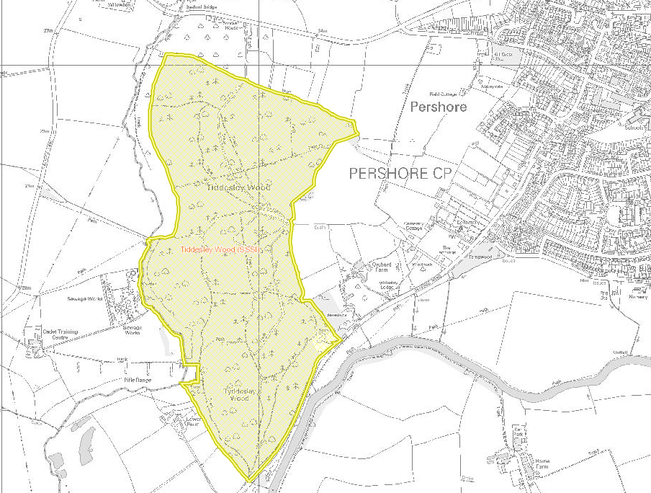
Haugh Wood Magic.gov.uk
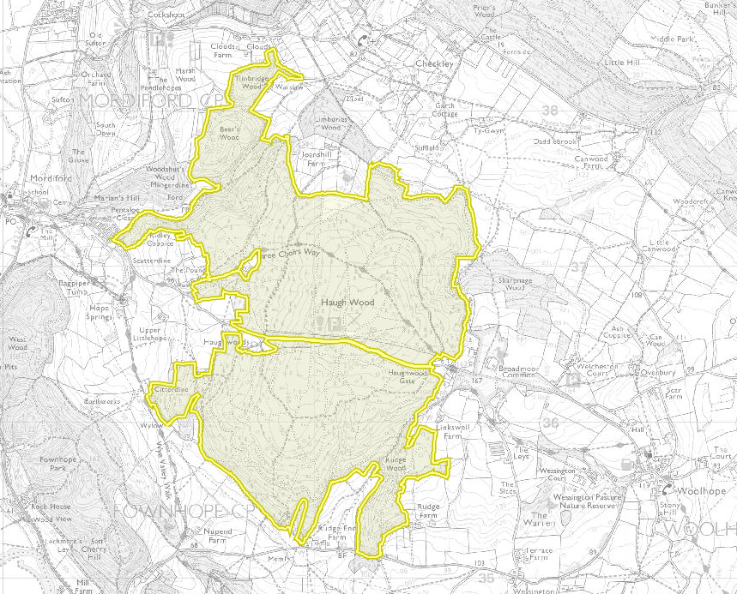

Annex 4: Scoring Criteria
Scoring - Quality Criteria
Rating of Response | Score
Very Good or Fully Compliant Submission:  meeting all requirements and is fully explained in comprehensive detail. | 9 - 10
Good or Fully Compliant Submission:  meeting all the requirements and is explained in reasonable detail. | 7 - 8
Satisfactory or Compliant Submission:  meeting the essential requirements and is explained in adequate detail. | 5 - 6
Weak or Partially Compliant (Minor issues) Submission:  falls short of requirements in some areas and is poorly explained. | 3 - 4
Unacceptable or Non-Compliant (Major issues) Submission:  fails to meet requirements and is not explained. | 1 - 2

Annex 5: Pricing specification
Item of work/task | Grade of Staff | Day Rate | Number of days | Total Cost
Project management meetings
Pre-survey reconnaissance
Bird Surveys
Phase 1 Survey
Collation and analysis of results
Reporting
Other costs including materials / equipment
T&S
Total excl. VAT

