Clarification to Bidders Questions
Cladding and Insulation of Premises Longdowns, Penryn, Cornwall
Project Reference: BUS001 BG 069_1

Date of request 08/05/2024:
We were asked to provide photographs of the Project Site. Please see photos below:

Photo 1 | Photo 2
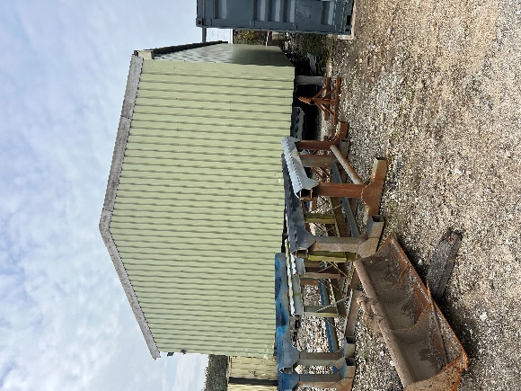 | 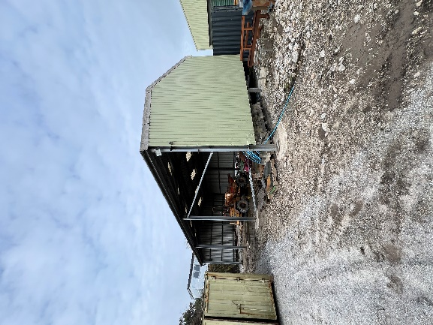
Photo 3 | Photo 4
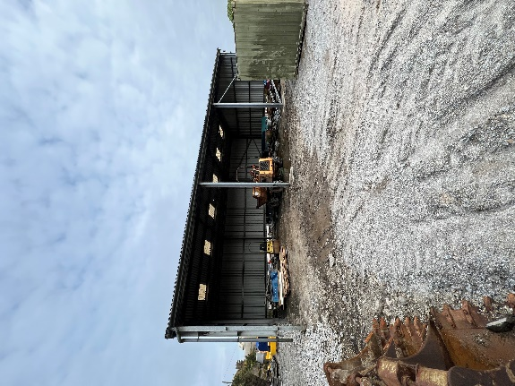 | 