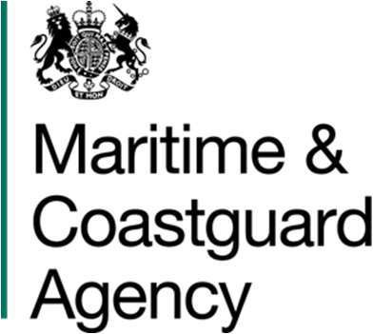Corporate Procurement Maritime and Coastguard Agency

Bay 3/19, Spring Place 105 Commercial Road, Southampton

SO15 1EG

[Contracts@mcga.gov.uk](mailto:Contracts@mcga.gov.uk)

[www.gov.uk/mca](http://www.gov.uk/mca) Ref: TCA 3/7/1365

04 February 2025

[REDACTED]

I.C.S. Electronics Limited Unit V, Rudford Industrial Est. Ford

West Sussex BN18 0BF

Dear [REDACTED],

NAVIGATIONAL TELEX (NAVTEX) AND DIGITAL SELECTIVE CALLING (DSC) SERVICES TERMINATION ASSISTANCE NOTICE

On behalf of the Secretary of State for Transport, acting through the Maritime and Coastguard Agency (MCA), I am writing to formally accept your quotation dated 1st August 2024 (Quote no. 10365), for an extension of the above-mentioned contract for a 12-month period until 31 March 2026. The Firm Price for this extension period is £187,260 excluding Value Added Tax.

This letter instructs Special Term 3 of the existing Contract, for the provision of Termination Assistance while the MCA continues to implement the new NAVTEX and DSC solutions.

This letter and your Quotation together constitute a legally binding variation to the Contract.

All other terms and Conditions of the Contract shall remain in force except as amended by this Variation**.**

I would like to take this opportunity to thank you for your continued co-operation with regards to the exit provisions.

Please acknowledge receipt of this instruction by signing below via Docusign.

Yours sincerely

[REDACTED]

Senior Procurement and Contracts Business Partner by authority of the Secretary of State for Transport

Accepted and agreed for and on behalf of I.C.S. Electronics Limited. Signed……SEE DOCUSIGN…………..

Name: …… SEE DOCUSIGN …………. Date:……… SEE DOCUSIGN ………….