 | Commercial Directorate  10 South Colonnade  Canary Wharf  London E14 4PU |  | T +44 (0)20 7123 2314  www.gov.uk/ukhsa
All messages regarding the
Offer documentation should
be sent via Atamis

06/09/2024

Dear Sir/Madam

Invitation to submit a Selection Questionnaire for the supply of pralidoxime chloride 2024
Non-disclosure Agreement of Confidential Information in respect of procurement exercise for the supply of pralidoxime chloride (the ‘Agreement’)
Offer reference number: CM/EMP/24/C305016

The Secretary of State for Health and Social Care acting as part of the Crown acting through the UK Health Security Agency (‘Authority’) intends to conduct a procurement exercise using the restricted procedure to put in place a contract for the supply of pralidoxime chloride. On 6
September 2024 the Authority published a call for competition in the Find a Tender service (FTS) in respect of this procurement exercise.

The Authority requires confidentiality as to the details of this procurement exercise therefore if you wish to participate in this procurement exercise, please return to the Authority a signed copy of this
Agreement by uploading a copy of the document to your Selection Questionnaire response on
Atamis.

- Subject to paragraph 5, in this Agreement, “Confidential Information” means, irrespective of whether it is marked as being confidential or not:

- all information supplied or made accessible to you by or on behalf of the Authority and any other health organisation in connection with this procurement for the supply of pralidoxime chloride (whether before or after the date of this Agreement);

- other information that ought reasonably to be considered confidential that comes (or has come) to your attention or into your possession in connection with this procurement exercise;

- discussions, negotiations and correspondence between you and/or any of your directors, officers, employees, consultants or professional advisers and the Authority and/or any of its directors, officers, employees, consultants or professional advisers in connection with this procurement exercise; and

- the existence of this Agreement.

- In consideration of you being invited to participate in this procurement exercise, you shall treat all Confidential Information as secret and confidential and have in place and maintain proper security measures which shall be at least as stringent as the measures and procedures you apply to your own confidential information to protect the confidentiality of the Confidential Information, including any reasonable measures that the Authority may propose from time to time.

- Subject to paragraphs 4 and 5, you shall not disclose or permit the disclosure of, nor otherwise make available, any of the Confidential Information to any individual including without limitation and save as permitted by paragraph 4 below, any of your officers, employees, agents or sub-contractors. You shall immediately notify the Authority in writing if you suspect or become aware of any unauthorised access, use or disclosure of Confidential Information. You shall not use the Confidential Information or any part of it for any purpose other than in responding to the invitation to offer.

- You may disclose the Confidential Information to those of your directors, officers, employees, agents, sub-contractors, company affiliates and professional advisors as are strictly necessary for the purpose of responding to the invitation to participate in this procurement exercise. You shall ensure that each party is aware of the confidential nature of the Confidential Information and is bound by confidentiality obligations no less protective of the Confidential Information than those set out in this Agreement. You shall be liable for the acts and omissions of each such party in respect of the Confidential Information as if they were your own.

- You shall be entitled to disclose Confidential Information only to the minimum extent that you are required to do so by applicable law or by order of a court or as required by the rules and regulations of any regulatory body or any enquiry or investigation by any governmental, parliamentary, or official body which has the power to compel disclosure.

- Confidential Information does not include any information:

- which, at the time of disclosure by or on behalf of the Authority is in the public
domain or subsequently becomes part of the public domain other than as a result of any action or inaction by you;

- which you can demonstrate by documentary evidence was in your possession prior to the time of disclosure by or on behalf of the Authority without restriction as to its disclosure; or

- All documents containing Confidential Information shall be and remain the property of the Authority. You shall not reproduce such documents except as reasonably necessary for the purpose of responding to the invitation to participate in this procurement exercise. On request by the Authority, you shall return to the Authority or destroy all such documents (including all copies) in your possession or control.

- You shall not issue any press release or other announcement or publicity relating to the
invitation to participate in this procurement exercise or the Authority’s procurement exercise relating to the purchase of antidotes and antibiotics without the prior written consent of the Authority.

- You will be responsible for any costs that you incur or that are incurred on your behalf in
connection with this Agreement.

- The provisions of this Agreement are not exclusive of any rights, powers or remedies
provided by law for either party. If any provision of this Agreement (or part of any provision) is or becomes illegal, invalid or unenforceable, the legality, validity and enforceability of any other provision of this Agreement shall not be affected.

- The obligations of confidentiality set out in this Agreement will continue to apply as long as the Confidential Information remains confidential.

- This Agreement and any issues, disputes or claims (whether contractual or non-contractual) arising out of or in connection with it or its subject matter or formation shall be governed by and construed in accordance with the laws of England and Wales. Both you and the Authority irrevocably submit to the exclusive jurisdiction of the courts of England and Wales to settle any dispute or claim (whether contractual or non-contractual) arising out of or in connection with this Agreement or its subject matter or formation.
Please sign below the acknowledgement of this Agreement to indicate your acceptance of these terms.
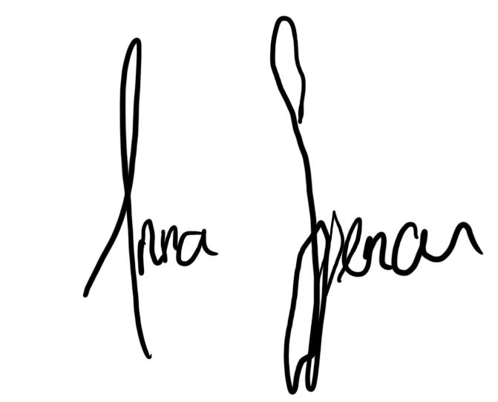
Your faithfully

A Spencer
Commercial Manager
E anna.spencer@ukhsa.gov.uk

Signed by .............................................................................................. for and on behalf of
Company: ……………………………………………………………………
Name: ……………………………………………………………………
Position: ……………………………………………………………………

