Our Ref: BSI Testing

Date: 26/05/22

Dear Supplier,

Contract Title: Temporary Barriers – BSI Testing

You are invited to quote for the above in accordance with the enclosed documents.

Instructions on what information we require you to provide is in Section 4 of the following Request for Quotation document.

Your response should be returned to the following email address by 5PM 10th June 2022 to
david.collins@environment-agency.gov.uk

Please confirm, by email, receipt of these documents and whether you intend to submit a quote.

If you have any queries, please do not hesitate to contact me.

Yours sincerely

David Collins
Senior Advisor – Temporary Barrier Review

E-mail: david.collins@environment-agency.gov.uk
Telephone: 07770 846269

The Environment Agency, Clyst Honiton Depot, Westcott Road, Exeter, Devon. EX5 2LL

Request for Quotation
Title: Temporary Barriers – BSI Testing

Section 1

Who is the Environment Agency?
We are an Executive Non-departmental Public Body responsible to the Secretary of State for Environment, Food and Rural Affairs. Our principal aims are to protect and improve the environment, and to promote sustainable development.

Further information on our responsibilities, Corporate Plan and how we are structured can be found on our Website.

https://www.gov.uk/government/organisations/environment-agency/about

What do we spend our money on?
We are a major procurer of goods and services within the UK, spending circa £600M per annum, our major spend areas are:

- Flood and Coastal Risk Management (design, construction and maintenance)
- ICT and Telecommunications
- Vehicles and Plant
- Environmental Consultancy and Monitoring
- Temporary Staff and Contractors
- Facilities Management, Energy and Utilities
- Flood Management and Water Related Services

What do we need from our suppliers?
Suppliers are vital in supporting the delivery of our corporate plan. We aim to support the economy and society whilst delivering more environmental outcomes for every pound we spend. In many areas we are leading the way on environmental and technical developments. It is our role to ensure that suppliers clearly understand our corporate aims and objectives and know that we are committed to delivering the best value most sustainable solutions, taking into account the whole life cost of our procurement decisions. We promote diversity and equality and treat all of our suppliers fairly.

Our procurement strategy may be of interest to you as a potential supplier. It sets out our priorities and key commitments in a range of areas such as delivering our corporate plan, Government policy, supplier management and sustainable procurement:

https://www.gov.uk/government/organisations/environment-agency/about/procurement#procurement-strategy

Government changes and collaboration
Since 1 April 2013, the Environment Agency is no longer responsible for delivering the environmental priorities of Wales. This is now the remit of Natural Resources Wales (NRW).Further information can be found here:

http://naturalresources.wales/splash?orig=/

By bidding for this requirement, you may also be approached by other members of the Defra network, NRW or other government departments that are specifically named in the tender document.

Further information
For further information and to see our commitments to Diversity and Equality, please visit our website.

https://www.gov.uk/government/organisations/environment-agency/about/procurement
https://www.gov.uk/government/organisations/environment-agency/about/equality-and-diversity

Also, are you up to date on environmental legislation? See links below for further information.

Waste and Environmental Impact - https://www.gov.uk/browse/business/waste-environment
Environmental Regulations - https://www.gov.uk/browse/business/waste-environment/environmental-regulations’

Section 2

The Customer

Summary

The Environment Agency Asset Operations and Improvements Team are responsible for the maintenance and deployment of a national strategic stock of temporary flood barriers. The deployment of these barriers is currently under review and part of the review requires that the organisation assures itself that any deployment of temporary barriers is safe and complaint with all relevant legislation.

Contract Length

It is anticipated that this contract will be awarded to one supplier for a period of 3 months to end no later than 01/10/22. Prices will remain fixed for the duration of the contract award period. We may at our sole discretion extend this contract to include related or further work. Any extension shall be agreed in advance of any work commencing and may be subject to further competition. Any amendment to contract prices for the extensions are to be by negotiation.

The Environment Agency Conditions of Contract for Research (Appendix C) shall apply to this contract.

This contract shall be managed on behalf of the Agency by David Collins

Contact Details and Timeline

David Collins will be your contact for any questions linked to the content of the quote pack or the process. Please submit any questions by email and note that both the question and the response will be circulated to all tenderers.

david.collins@environment-agency.gov.uk 07770846269

Key elements of the process have been reviewed. Anticipated dates for planned activities are below:

Activity | Due Date
Supplier responses for Request for Quote | 10/06/22
Evaluation of Request for Quote submissions | 17/06/22
Award of contract | 29/06/22
Project/Contract end date | 01/10/22

It should be noted that these timescales and activities may be subject to change.

Section 3

Evaluation Criteria

We will award this contract in line with the most economically advantageous tender (MEAT) as set out in the following award criteria:

- Price – 60%

- Quality – 40%

The following quality criteria are weighted in accordance with the importance and relevance attached to each one.

- Your proposed methodology
- Programme
- Personnel

The criteria listed above will be assessed on a 0 to 10 basis and will reflect the following judgements:

Rating of Response  The tenderer provides a response which in the opinion of the evaluators is: | Score
Excellent: Addresses all of the requirements and provides a response with relevant supporting information which does not contain any weaknesses, giving the Agency complete confidence that the requirements will be met. | 10
Very Good: Addresses all of the requirements and provides a response with relevant supporting information, which contains very minor weaknesses, giving the Agency high confidence that the requirements will be met. | 8
Good: Addresses all of the requirements and provides a response with relevant supporting information, which contains minor weaknesses, giving the Agency reasonable confidence that the requirements will be met. | 6
Satisfactory: Substantially addresses the requirements and provides a response with relevant supporting information which may contain moderate weaknesses, but gives the Agency some confidence that the requirements will be met. | 4
Weak: Partially addresses the requirements, or provides supporting information that is of limited relevance or contains significant weaknesses, and therefore gives the Agency low confidence that the requirements will be met. | 2
Nil: No response or provides a response that gives the Agency no confidence that the requirements will be met. | 0

Section 4

Information to be returned

Please note, the following information requested must be provided. Incomplete tender submissions may be discounted.

Please complete and return the following information:
- completed Pricing Schedule (Appendix A);
- completed Prior Rights Schedule (Appendix B);
- confirmation that terms and conditions are accepted (Appendix C. Please note that the terms cannot be amended later).

- Details of proposed methodology (to include but not be limited to; details and capability of facility, details of impact testing, details of leakage measurement)
- A timeline indicating key milestones
- Details of the personnel you are proposing to carry out the service (brief CVs for key staff detailing any relevant experience).
- Details of how you propose to maintain continuity of personnel.

Section 5

Specification for British Standard Testing

Background
The Environment Agency require a series of tests to be carried on samples of their stock of temporary defence barriers out in accordance with BS851188. These tests build upon the results of a previous set of tests carried out in November 2021 and have the desired outcome of better understanding the compliance of the organisations new temporary defence deployment methodology with BS851188. The results of the testing will inform the future method of temporary defence deployment adopted by the organisation.

Requirements

Deployment Methodology
Testing is to take place on two types of barriers (Geodesign EUR 101 [fig 1] and Inero H100 [fig 2]). A minimum specimen of 10m of barrier (as defined in BS851188).
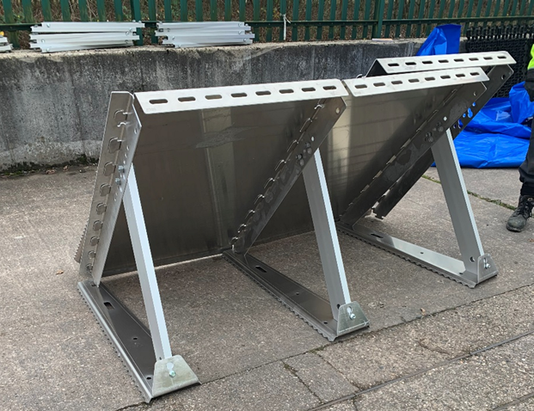
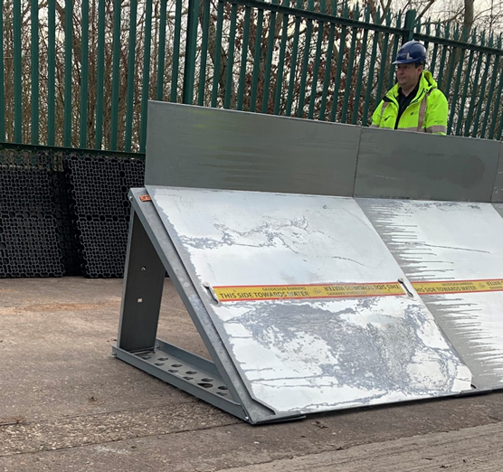
Fig 1 – Geodesign EUR101 Fig 2 – Inero H100
The barrier is to be braced against roadforms which in turn are to be braced against concrete kentledge blocks as is shown in figures 3 and 4.
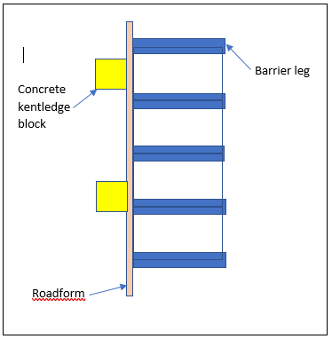
Fig 3 - Plan view of deployment methodology (not depicting membrane)
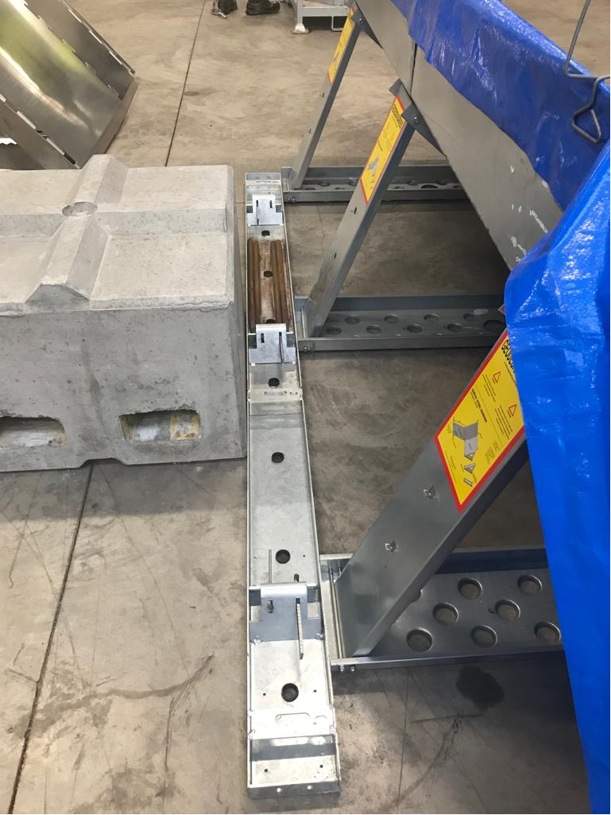
Fig 4 – View of barriers braced against kentledge block
The mass of the kentledge blocks and the intervals at which they are to be placed will be confirmed by the Environment Agency prior to testing. Membrane to be used is generic “builders” damp proof membrane, must have a minimum thickness of 0.30mm and be inspected for defects before use. Any membrane containing an excessive number of defects should be discarded.
The apron of membrane must have a width of 2 m and be weighted by the manufacturers chain (unfixed) supplied by the Environment Agency placed at 200mm from the edge of the membrane. The membrane is to be clipped to the top of the barrier using the manufacturers proprietary clips supplied by the Environment Agency.
Where a length of membrane is insufficient, and a join is required there must be a 3m overlap between lengths. The entire length of both seams of any overlap must be weighted by means of continuous rows of sandbags placed 200mm inside of the seam and parallel with the seam.
Roadforms, kentledge blocks, temporary barrier specimens and membrane are to be supplied by the Environment Agency. Temporary supply of additional pumps and power generation by the Environment Agency can be arranged if required.

Testing
The above deployment methodology for both Geodesign and Inero barriers is to be tested to the standards and against the full suite of tests described in Annex A of BS851188. We require that leakage is measured using a method that does not involve the accumulation of water on the “dry” side of the barrier. We also require that the impact testing rig does not compromise the integrity of the membrane.

Timescales

We require that the testing is completed with 12 weeks of an order being placed and before 01/10/22.

Section 6

Contract Management

This contract shall be managed on behalf of the Agency by David Collins david.collins@environment-agency.gov.uk 07770846269

The contract will be managed via a series of meetings and progress reports. Including:
- Pre-Start Meeting (Virtual or at the supplier’s premises)
- Observation visit (at the supplier’s premises)
- Progress reports (ad hoc, via email)
- Project closure (formal confirmation by the project manager that the project has been successfully completed, via email)

We will raise purchase orders to cover the cost of the services and will issue to the awarded supplier following contract award.

The successful supplier must invoice once after completion of the contract.

Before the invoice is issued, a fee note must be emailed in advance to the contract manager for approval. All invoices must quote the purchase order number in order to be processed. A file copy invoice must be provided to the contract manager, on request. The timescale for payment of invoices will be up to 30 days after we have received a valid invoice.

Section 7

Sustainability Considerations
We are committed to continually improving our sustainability performance. The Environment Agency has set itself tough objectives as a clear commitment and contribution to sustainable development throughout England. The Agency recognises that this can only be achieved through commitment from all sectors of society and it is intent on raising awareness amongst industry and commerce.

Contractors must adopt a sound proactive environmental approach, designed to minimise harm to the environment.

Environmental criteria should be considered as part of your tender submission with credit given for innovation. Factors to be considered could include areas such as:
    - Paper use: All documents and reports prepared by consultants and contractors are produced wherever possible on recycled paper containing at least 100% post consumer waste and printed double sided.
    - Travel: use of public transport, reduce face to face meetings by using email and videoconferencing. Meetings to be held in locations to minimise travel and close to public transport links.
    - Packaging: should be kept to a minimum. Re-use and disposal issues must be considered.
    - Efficient Energy and Water Use.
    - Disposal of Waste: Whilst on site the contractor is responsible for the disposal of their own waste and can only use client facilities with express permission from the on site facilities officer.
    - Whilst on site, contractors should comply with the local environmental policy statement which will be made available to you in advance or on arrival.

Diversity and Equal Opportunities
We are committed to promoting equality and diversity in all we do and valuing the diversity of our workforce, customers and communities. As a public body, we publish regular information about what our equality objectives are and how we’re meeting them.
https://www.gov.uk/government/organisations/environment-agency/about/equality-and-diversity

Health and Safety
Contractors will be responsible for making sure all required health and safety aspects including risk assessments are undertaken and required management measures are in place to protect worker exposure. This includes management of all partners, consortium members and subcontractors.

IEM2020:

Sustainability Objectives

As the Environment Agency, our overarching aim is to protect and improve the environment for people and wildlife. Over the last 10 years we have achieved significant reductions in our environmental impacts that occur through our everyday operations. This included a 40% reduction in our carbon emissions and a 37% reduction in the number of miles we travel. This year we have launched our new Internal Environmental Management strategy to take us through to 2020, building on these successes and widening our ambition.

Supply chain

Our 2020 approach will have a very strong emphasis on the indirect impacts of our supply chain.

Our supply chain accounts for over 70% of our total environmental impacts.

Working with our supply chain we want to be world class in the area of environmental management. The environmental impacts of our work and that delivered by and through our supply chain must be reduced; environmental risks must be effectively managed and opportunities for enhancements investigated.
As an organisation, our environmental management system (EMS) is accredited to ISO14001 and EMAS standards. Our procurement activities form part of this system; driving environmental performance improvements across the value chain.

Section 8

Additional Information

Copyright and confidentiality

Unless otherwise indicated, the copyright in all of the documentation belongs to the Environment Agency, and the documentation is to be returned to us with your tender. The contents of the documentation must be held in confidence by you and not disclosed to any third party other than is strictly necessary for the purposes of submitting your quote. You must also ensure that a similar obligation of confidentiality is placed upon any third party to whom you may need to disclose any of the documentation for the purposes of the tender.

Accuracy of documentation

You should check all documentation; should any part be found to be missing or unclear you should immediately contact us at the address given in the covering letter. No liability will be accepted by the Environment Agency for any omission or errors in the documentation which could have been identified by you.

Amendments to documentation

Prior to the date for return of tenders, we may clarify, amend or add to the documentation. A copy of each instruction will be issued to every Tenderer and shall form part of the documentation. No amendment shall be made to the documentation unless it is the subject of an instruction. The Tenderer shall promptly acknowledge receipt of such instructions.

Alternative Offers

Alternative offers may be considered if they constitute a fully priced alternative and are submitted in addition to a quotation complying with the requirements of the Invitation to Quote Documents. If, for any reason you wish to submit an alternative offer without a fully compliant tender please contact us in accordance with the details in the covering letter.

Continuity of personnel

The Contractor shall employ sufficient staff to ensure that the Services are provided at all times and in all respects to the Project Standard. It shall be the duty of the Contractor to ensure that a sufficient reserve of staff is available to ensure project delivery in the event of staff holidays, sickness or voluntary absence

The Environment Agency will be notified immediately of any changes to personnel associated with the project. The Contractor will ensure that every effort is made to replace outgoing staff with personnel of equal calibre and expertise. All new members of staff undertaking work for the Project will need to be agreed by the Environment Agency prior to commencement.

At all times, the Contractor shall only employ in the execution and superintendence of the Contract persons who are suitable and appropriately skilled and experienced.

Intellectual property rights

All results, including material and tools produced, developed or paid for under this contract shall be the property of the Environment Agency.

References

The Environment Agency may request recent and relevant references prior to the award of the project.

Contract award

This Request for Quote is issued in good faith but we reserve the right not to award any or all of this work.

DATA PROTECTION ACT ADDENDUM TO SPECIFICATION

Protection of personal data

In order to comply with the Data Protection Act 1998 the Contractor must agree to the following:

- You must only process the personal data in strict accordance with instructions from the Environment Agency.

- You must ensure that all the personal data that we disclose to you or you collect on our behalf under this agreement are kept confidential.

- You must take reasonable steps to ensure the reliability of employees who have access to personal data.

- Only employees who may be required to assist in meeting the obligations under this agreement may have access to the personal data.

- Any disclosure of personal data must be made in confidence and extend only so far as that which is specifically necessary for the purposes of this agreement.

- You must ensure that there are appropriate security measures in place to safeguard against any unauthorised access or unlawful processing or accidental loss, destruction or damage or disclosure of the personal data.

- On termination of this agreement, for whatever reason, the personal data must be returned to us promptly and safely, together with all copies in your possession or control.

APPENDIX A - PRICING SCHEDULE

ALL COSTS QUOTED MUST BE EXCLUSIVE OF VAT
All costs must be quoted on this schedule. Any costs not detailed will not be paid.

Other costs
Please state any other costs that will need to be taken into consideration.

DESCRIPTION | COST £
1. Completion of testing defined in Annex A of BS851188 on Inero and Geodesign barriers and completion of comprehensive report

2. Minus cost of any previous equipment rental by the EA to the supplier if relevant

TOTAL

APPENDIX B - PRIOR RIGHTS SCHEDULE

Details of Prior Rights held by the Parties (To be updated as Rights are introduced during the period of the Contract)
Prior Rights owned or lawfully used by a Party, whether under licence or otherwise, which it introduces to the Project for the purposes of fulfilling its obligations under the Contract

Held by the Environment Agency

Name and description of Prior Rights | Extent of proposed use in the Project | Proprietary owner of the Prior Rights
None | None | None

Held by the Contractor

Name and description of Prior Rights | Extent of proposed use in the Project | Proprietary owner of the Prior Rights

Explanation of Contractor's Prior Rights
All Intellectual Property Rights owned by or lawfully used by the Contractor, whether under licence or otherwise before the date of this Contract. It can also mean any invention and know how or other intellectual property (whether or not patentable) owned by one of the parties prior to the commencement of the Project, or devised or discovered by one of them only in the course of other projects during the Project period and not arising directly from the Project.

APPENDIX C – ACCEPTANCE OF TERMS AND CONDITIONS

I/We accept in full the terms and conditions named in Section 2 and appended to this Request for Quote document.

Company ____________________________________________________
Name

Signature ____________________________________________________

Print Name ____________________________________________________

Position ____________________________________________________

Date ____________________________________________________

