
Add NE Logo

Standard Contract for Goods and/or Services - Order Form

- Purchase Order Number | To be confirmed when contract is awarded
- Customer | Natural England
- Contractor(s) | Contractor’s name, registered address (if registered), and registration number (if registered)
- Defra Group Members | The following Defra Group members will receive the benefit of the Deliverables:  Natural England
- The Agreement | This Order is part of the Agreement and is subject to the terms and conditions referenced at Appendix 1 and shall come into effect on the Start Date.  Unless the context otherwise requires, capitalised expressions used in this Order have the same meanings as in the terms and conditions.  The following documents are incorporated into the Agreement. If there is any conflict, the following order of precedence applies (in descending order):  - this Order;  - the terms and conditions at Appendix 1; and  - the remaining Appendices (if any) in equal order of precedence.
- Deliverables | Applicable Deliverables | Goods Only: ☐  Services Only: ☒  Good and Services: ☐
 | Goods | None
 | Services | Description: Natural England is seeking a Risk Assessment and the installation of Lightning Protection, as well as surge protection for the entire Castle Eden Dene Natural England building, which is mainly single storey and with a two-storey office, and workshop.  To be performed at: Natural England, National Nature Reserve, Stanhope Chase, Peterlee SR8 1NJ.  Date(s) of Delivery: 10/03/2025 to 31/03/2025
- Start Date | 10/03/2025
- Expiry Date | 31/03/2025
- Charges | The Charges for the Goods and/or Services shall be as set out in Appendix 3 – Charges. The Charges are fixed for the duration of the Agreement.
- Payment | Payments will be made in pounds by BACS transfer using the details provided by the supplier on submission of a compliant invoice.
- Contractor’s Liability Cap (Clause 13.2.1) | A sum equal to £5,000,000.
- Customer’s Authorised Representative(s) | For general liaison your contact will continue to be  Helen Woolley  Natural England  Worcestershire County Hall  Worcester  WR5 2NP  Helen.woolley@naturalengland.org.uk  020 802 60871  or, in their absence,  Joe Davies  Senior Reserve Manager  Castle Eden Dene, Teesmouth, Thrislington & Cassop National Nature Reserves  Tel: 0191 5860004  Mob: 07803 228414
- Contractor’s Authorised Representative | For general liaison your contact will continue to be  [Insert contract manager name and contact details]  or, in their absence,  [Insert secondary name and contact details].
- Optional Intellectual Property Rights (“IPR”) Clauses | The Customer has chosen Option B(Default Option) in respect of intellectual property rights provisions for the Agreement as set out in the terms and conditions.  Default Option- Option B: Customer ownership of all New IPR with limited Contractor rights to all New IPR in order to deliver the Agreement.
- Progress Meetings and Progress Reports | - The Contractor shall attend progress meetings with the Customer at:  - Contract inception  - Additionally, as required by project officer.
- Address for notices | Customer: Contractor:  Natural England Mail Hub Natural England Foss House Kings Pool 1-2 Peasholme Green YORK YO1 7PX Attention: Valerie Brown Email: val.brown@naturalengland.org.uk [insert name and address of Contractor] Attention: [insert title] Email: [insert email address]
- Key Personnel of the Contractor | Key Personnel Role: Key Personnel Name: Contact Details:
- Procedures and Policies | For the purposes of the Agreement:  All relevant policies and procedures have been outlined in the Guided Buying Request for Quotation document.
- Special Terms | N/A
- Additional Insurance | N/A
- Further Data Protection Provisions | The further data protection provisions contained within Annex 4 of the terms and conditions are applicable to this Agreement where indicated below:  Yes: ☐  No: ☒

[Guidance note: Please note that typically the Contractor should sign first and return the copy to the Customer to sign]

Signed for and on behalf of the Customer | Signed for and on behalf of the Contractor
Name:  [Insert name]  [Insert job title] | Name:  [Insert name]  [Insert job title]
Date: | Date:
Signature: | Signature:

Appendix 1: Terms and Conditions

The Customer’s Standard Good & Services Terms and Conditions which can be located on the Natural England Website and which are called ‘Standard Goods & Services Terms and Conditions’

Appendix 2: Specification/Description

Specification of Requirements
Generally
The works: A Risk Assessment for the installation of Lightning Protection, as well as surge protection.
As Existing:
There is no lighting protection on site, and we are looking to cover the entire building, which is mainly single storey and with a two-storey office. Coverage should be for all buildings and distribution boards.
Office /House Single Phase: The incoming supply is on NW Elevation, outside of the courtyard. There is a dist board for the main office.
Workshop and Canteen: The incoming supply is within the Workshop, with a distribution board, and then a secondary one within the corridor.
Existing system details and photos:
Photo 1: Entrance to the Courtyard
Photo 2: SW elevation, before PVs installed.
Photo 3: SW Elevation
Photo 4: SE Elevation, two storey building
Photo 5: SE Elevation but outside of the courtyard area
Photo 6: NW Elevation outside
Photo 7: Workshop incoming supply
Photo 8: Office / House, incoming supply
- Scope of the works: Is to price and provide clarification / confirmation of all of the following within a quotation for the works:

  - The contractor is to provide a Risk Assessment: With the quotation, clearing stating the Lightning Protection calculated level of risk and the type of lighting protection system recommended.
  - Surge Protection: To clearly state the number of surge protection devices to be installed, with a narrative of their intended locations see suggested items to be covered.
- Main Switchboard 1No. 3 Phase Type I, 2 & 3 SPD – C/W Enclosure
- Sub-Distribution Board Feeding External Plant: 1No. 3 Phase Type I, 2 & 3 SPD – C/W Enclosure
- Fire Alarm Panel/Disabled Refuge: 2 No. Type 2 & 3 SPD
- Solar PV Inverter: 3 No. Solar PV Panel SPD up to 1000v – C/W Enclosure
- Telephone System: 1No. 10 pair Telecom line SPD for use with LSA framed terminal unit.
- Aerial/Satellite/DAB/CCTV: 5No. Coaxial SPD
  - Upon Contract Award: The contractor is to confirm within their quotation that they will attend site to verify intended locations of lighting protection pits.
  - Lightning Protection Design: To provide a schematic of the intended LP pits and with system layouts. Include for bonding to the PV panel rail supports.
  - As Built Layout: Provide a schedule of installation systems and a layout of ‘As installed equipment’.
  - Access Plant: Allow for all access plant for the full installation, and to clarify within the quotation the intended method of access.
  - Testing and Certificate of installation: Information / data for the installation of LP and surge protection devices.
  - Builders Works: Allow for all works that are non-electrical, associated with the installation. Ensure all pits installed include for the making good of areas around them.
  - Testing and Certification: Check and test all systems are working and provide an electrical certificate upon completion of the works.
2.0 Accreditation and Insurances: The contractor shall provide confirmation of registration of the NICEIC and any lightning protection accreditation or bodies registered with.
3.0 Welfare: The site will provide access to toilets and a kitchen.
4.0 Access, Location and Parking: The site is open from 8am until 4.30pm and is controlled via a CCTV system with card access. Parking is available adjacent to the building. All visits to be agreed with the Operational Manager, Joe Davies.
- The site is located: - Natural England, National Nature Reserve, Stanhope Chase, Peterlee SR8 1NJ.

5.0 Health and Safety: The contractor is expected to provide a set of RAMS prior to works commencing on site, and proof of qualifications for any installer, on the day. All ground works must utilise as a minimum a CAT scanner. Note all PV panels have an isolation switch which should be engaged and then returned to working order, should there be an electrical requirement to isolate the power supply.
6.0 Standards, Equipment and materials: All works should be carried out to British Standard for Lightning Protection BS EN 62305 and the IEE Regulations 18th Edition.
7.0 Site Inspection: The contractor has the opportunity to visit site or utilise the information provided, in order to provide a fixed priced for the supply and installation of the Scope of Works.
8.0 Tender Return: The contractor is to provide the following documents with the tender return, on the due date, as set out within ‘Contract Finder’.
- Priced Scope of Works items 1.1 to 1.9 + 2.0 inclusive.
- Quotation with Specification / Material list

9.0 Procurement: Natural England will set up the successful contractor on their supplier list, and then raise an order for the works, with payment upon completion. Payment is usually within 14 days.

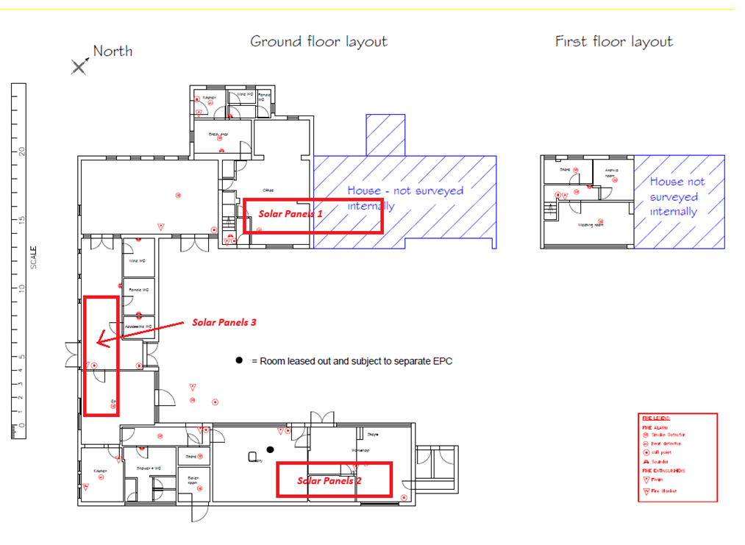
Site Layout Plan: Showing Office to the NW, the house to the NE and the Workshop to the SE corner.
In red are the new solar panel locations.
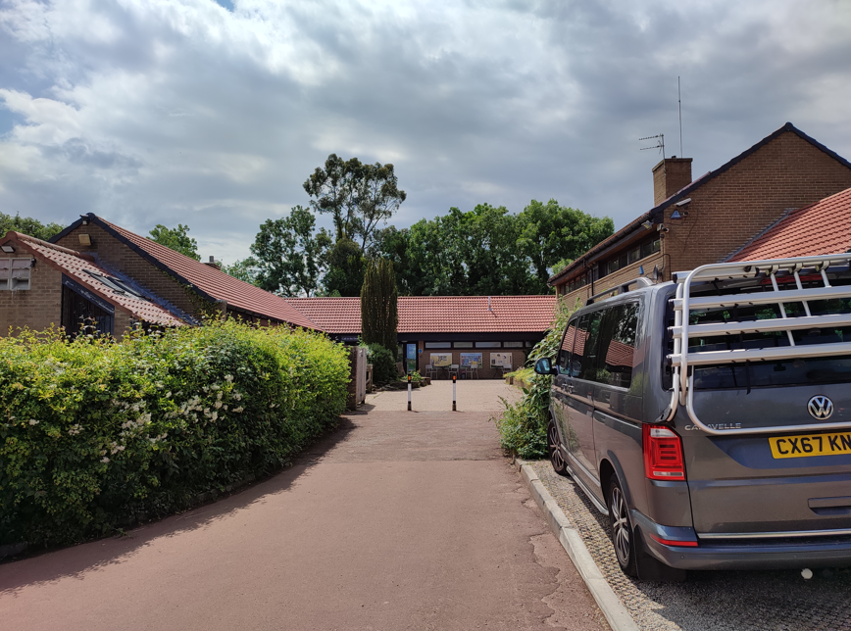
Photo 1: Entrance to the Courtyard
The entire building, with the two storeys to the right and the Workshop to the left

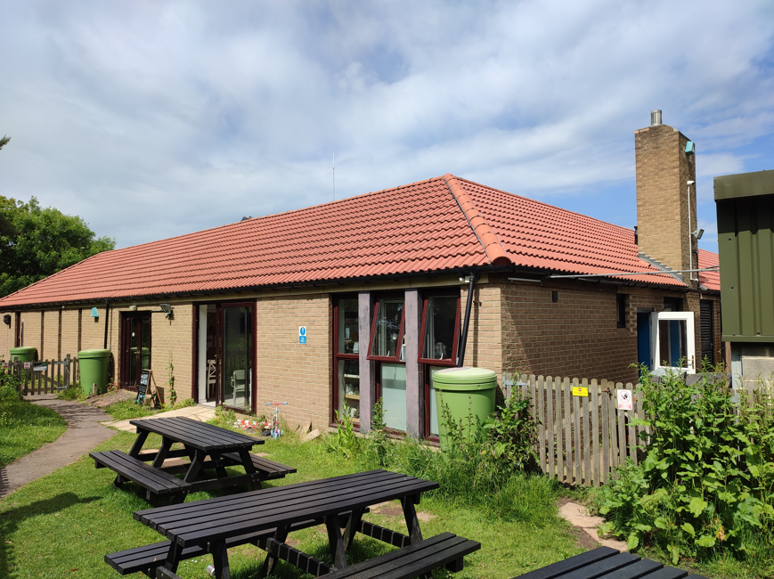
Photo 2: SW elevation, before the PV panels were installed, showing the chimney on the Workshop roof.
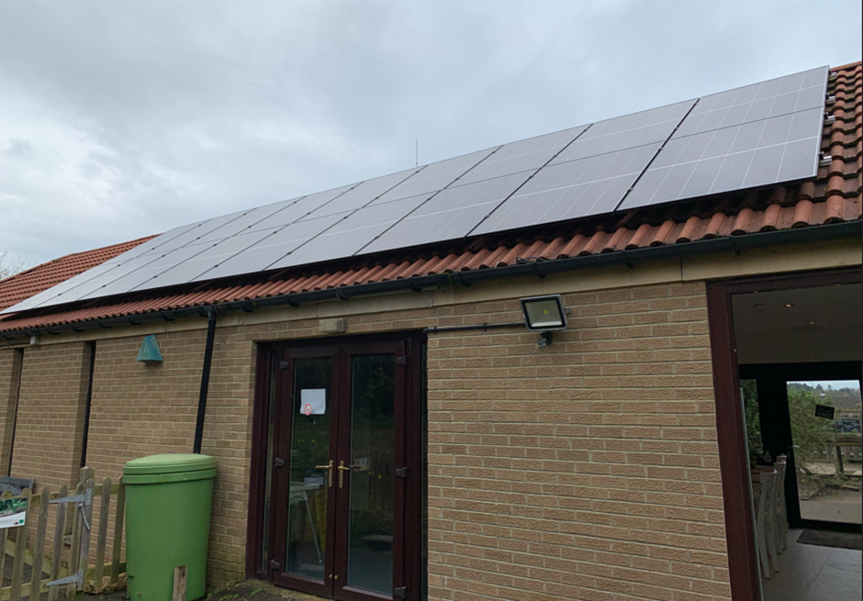
Photo 3: SW Elevation after PV panels fitted.

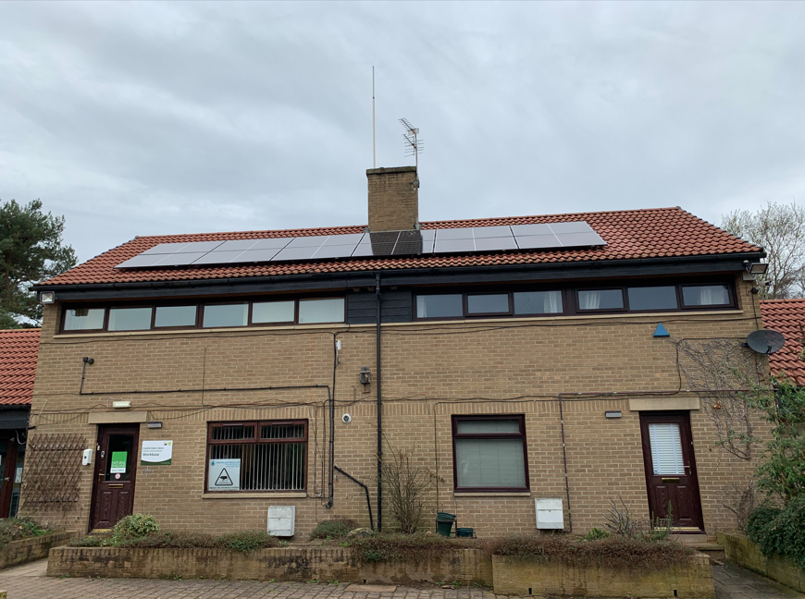
Photo 4: SE Elevation, two storey building within the courtyard. To the right is the house.

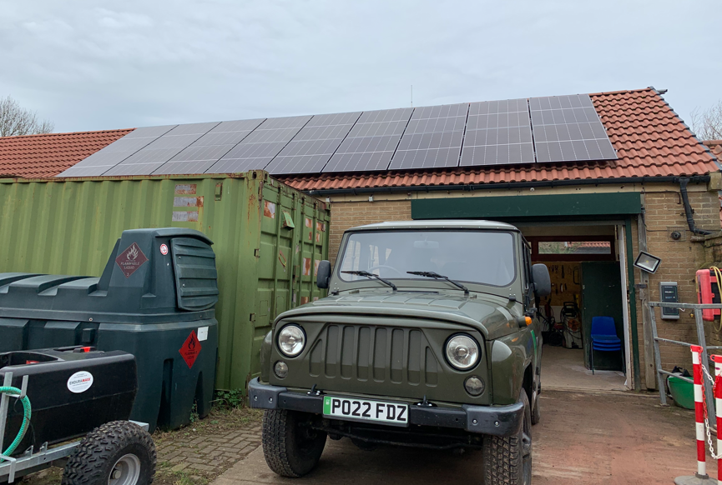
Photo 5: SE Elevation but outside of the courtyard area, with PV on roof
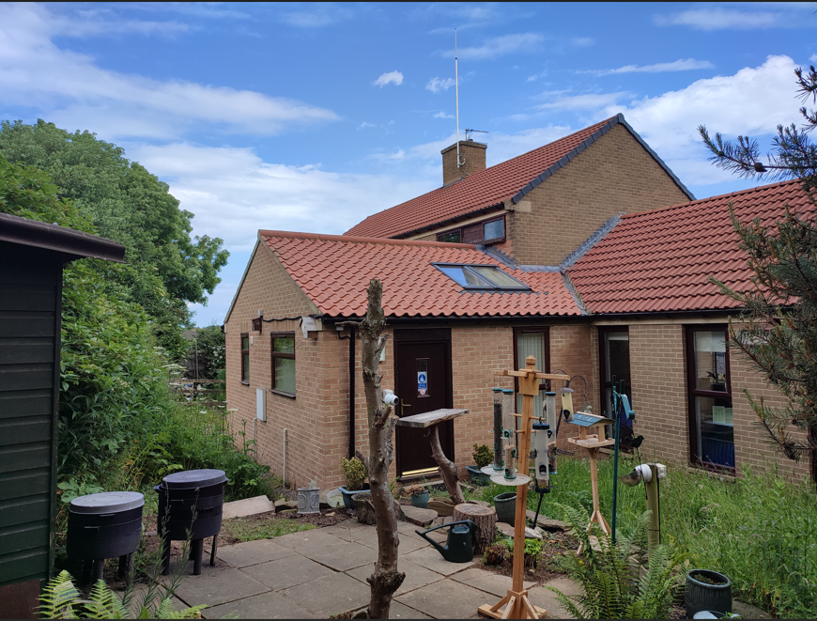
Photo 6: NW Elevation outside of the courtyard
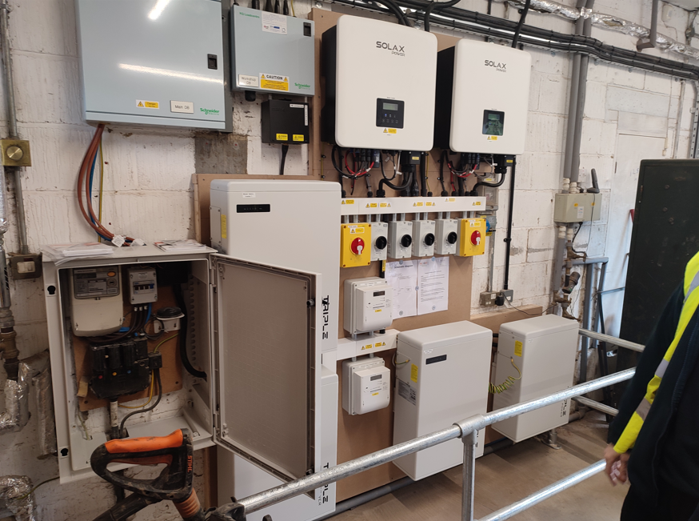
Photo 7: Workshop incoming supply and dist board at high level
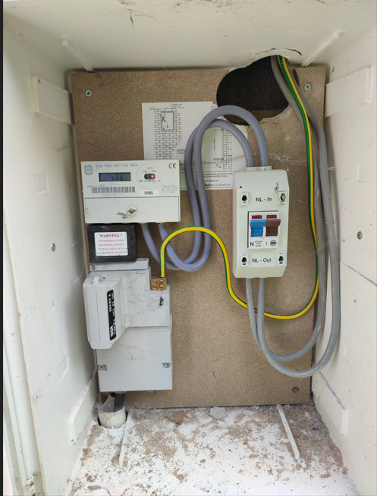
Photo 8: Office / House, incoming supply
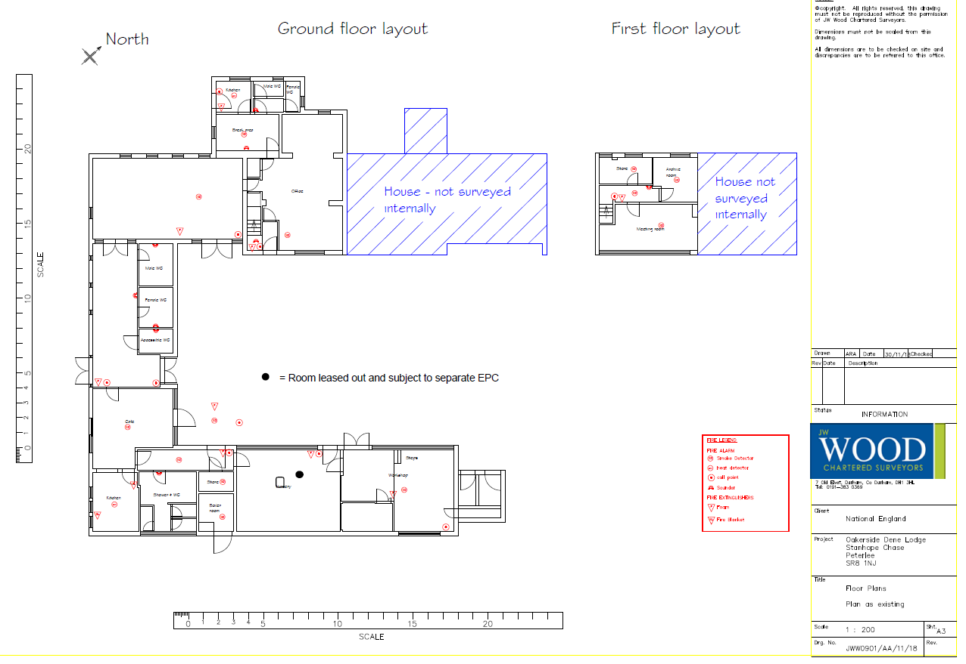
Existing Building Layout

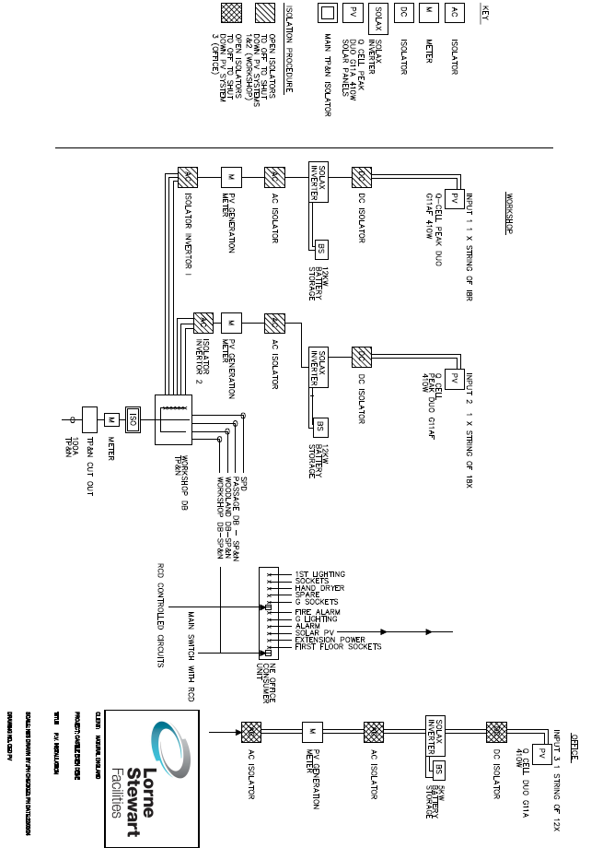
Electrical

Appendix 3: Charges
Will be inserted when contract has been awarded.

Appendix 4: Processing Personal Data

 | [XXXX]
Contract:
Date: | [XXXX]
Description of authorised processing | Details
Identity of Controller and Processor for each category of Personal Data
Subject matter of the processing
Duration of the processing
Nature and purposes of the processing
Type of Personal Data
Categories of Data Subject
Plan for return and destruction of the data once the processing is complete UNLESS requirement under law to preserve that type of data
Locations at which the Contractor and/or its subcontractors process Personal Data under this Agreement

Protective Measures that the Contractor and, where applicable, its subcontractors have implemented to protect Personal Data processed under this Agreement against a breach of security (insofar as that breach of security relates to data) or a Personal Data Breach

