
Kingstown Works Limited

Document Reference
8 - Specifications

Supply of Manufactured Joinery
01 April 2019 – 31 March 2021 with an option to extend a further year

CLOSING DATE AND TIME FOR RETURN OF THE TENDER:
12 Noon, On Friday 15th February 2019

Procurement Contact
Wendy Rhind
Kingstown Works Ltd
Connaught Road
Kingswood
Hull
HU7 3AP

tendering@kingstownworks.co.uk

DOCUMENT 8 – SPECIFICATIONS

KWL CODE: DOR01
BATTEN DOOR ONLY, PRIMED, SOFTWOOD, GRADE 5TH
Door size UP TO 2200mm Height x 950mm Width
(ANY SIZES OVER AND ABOVE THIS WOULD BE PRICED INDIVIDUALLY)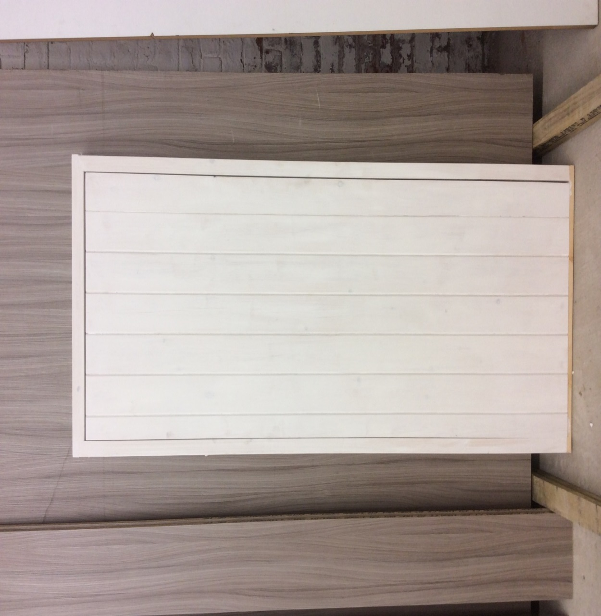
Door
22mm T&G Match Boarding
22mm x 120mm Rails & Braces
Glue and screw both sides
Use Knotting Solution were required
Fill & sand screw holes
I coat white primer

KWL CODE: DOR02
BATTEN DOOR & FRAME, PRIMED, SOFTWOOD, GRADE 5TH
Door size UPTO 2500mm Height X 1000mm Width
(ANY SIZES OVER AND ABOVE THIS WOULD BE PRICED INDIVIDUALLY)
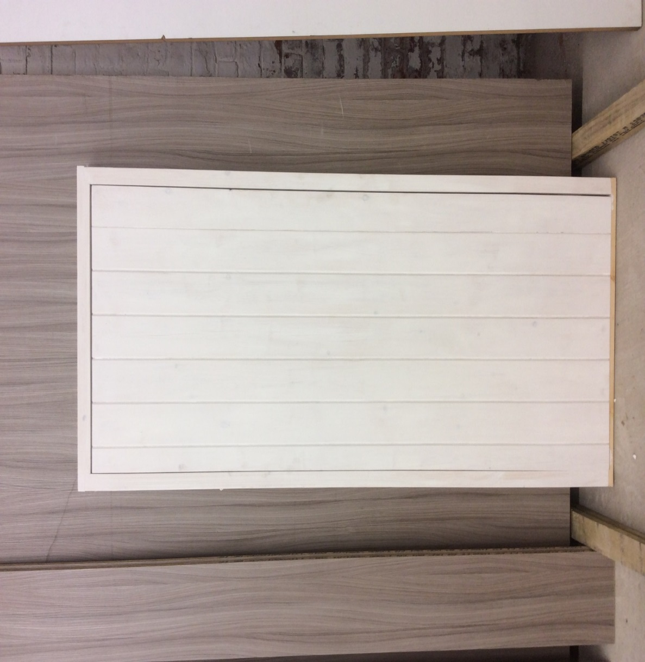
Frame
Mortice & Tenoned 45mm x 95mm PSE softwood timber with loose stop lath 22mm x 45mm, finished with water based primer

Door
22mm T&G Match Boarding
22mm x 120mm Rails & Braces
Glue and screw both sides
Use Knotting Solution were required
Fill & sand screw holes
I coat white primer

KWL CODE: DOR03
INTERNAL FLUSH PLYWOOD HOLLOW CORE DOOR, 35MM THICK, PRIMED, SOFTWOOD, GRADE 5TH
Door size UP TO 2040mm Height x 836mm Width
(ANY SIZES OVER AND ABOVE THIS WOULD BE PRICED INDIVIDAULLY)

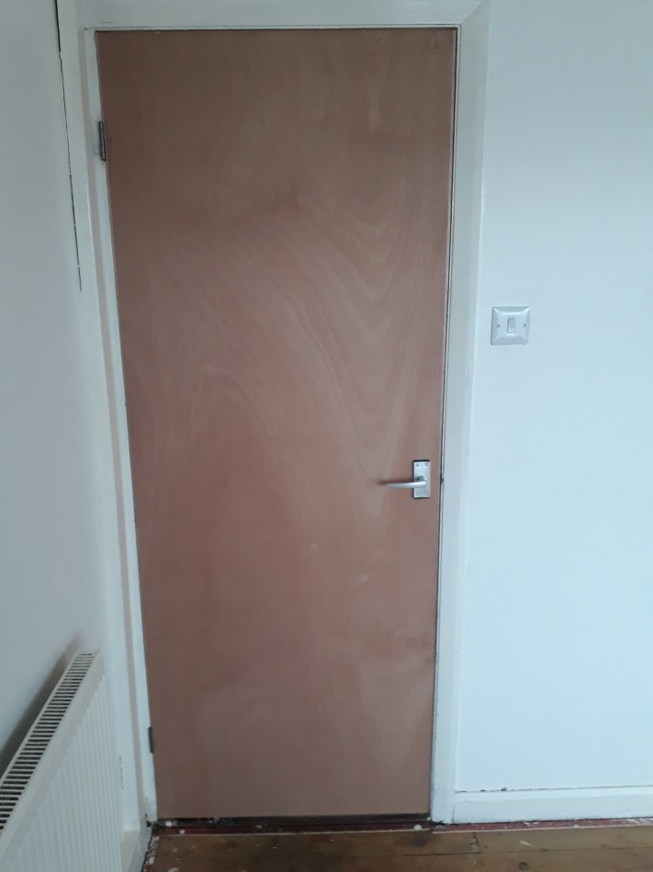

Door
Standard door cut down and lath replaced to fit unusual size casing
All laths to be glued filled and sanded
1 coat white primer

KWL CODE: DOR04
INTERNAL PSE DOOR CASING, PRIMED, SOFTWOOD, GRADE 5TH
Rebated as required
Size UP TO 2500mm Height x 1000mm Width
(ANY SIZES OVER AND ABOVE WOULD BE PRICED INDIVIDUALLY)

Casing dimensions up to maximum size 45mm x 125mm (Common Size 45mm x 100mm)
Glued and Screwed
Knotting Solution were required
1 coat white primer

KWL CODE: DOR05
EXTERNAL SOLID CORE DOOR ONLY, PRIMED, SOFTWOOD, GRADE 5TH
(Excluding Letterbox, handle & lock)
Cut from a 7ft x 3ft door blank

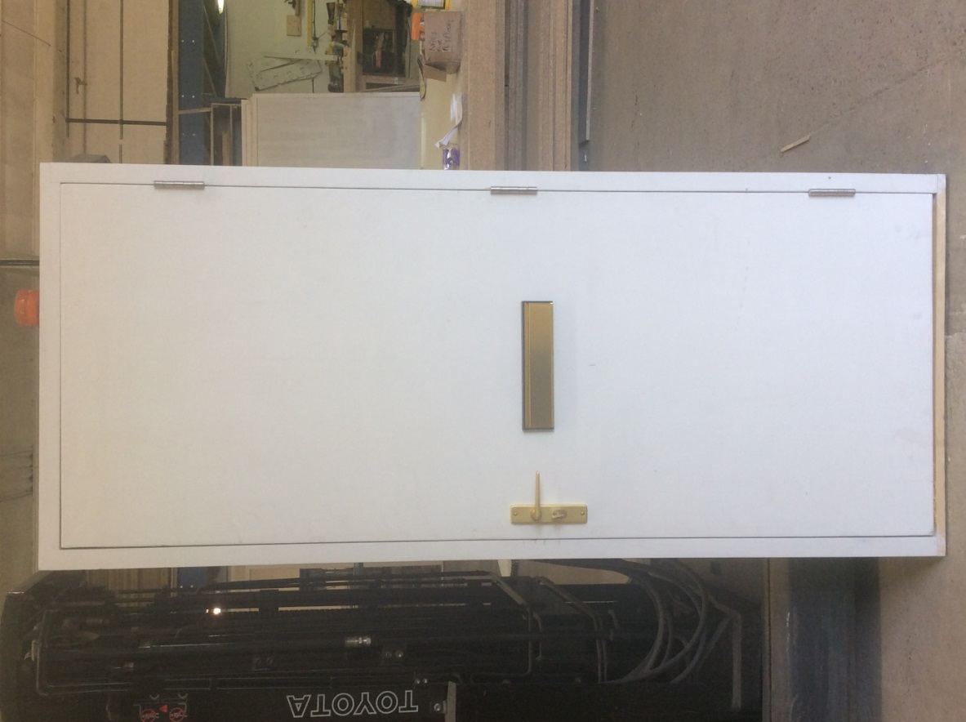

Door
45mm External solid core door cut to size
All laths to be glued filled and sanded
1 coat white primer

KWL CODE: DOR06
EXTERNAL SOLID CORE DOOR & FRAME WITH OR WITHOUT SILL, PRIMED, SOFTWOOD, GRADE 5TH
(Excluding Letterbox, handle & lock)
Door size UPTO 2070mm Height x 838mm Width

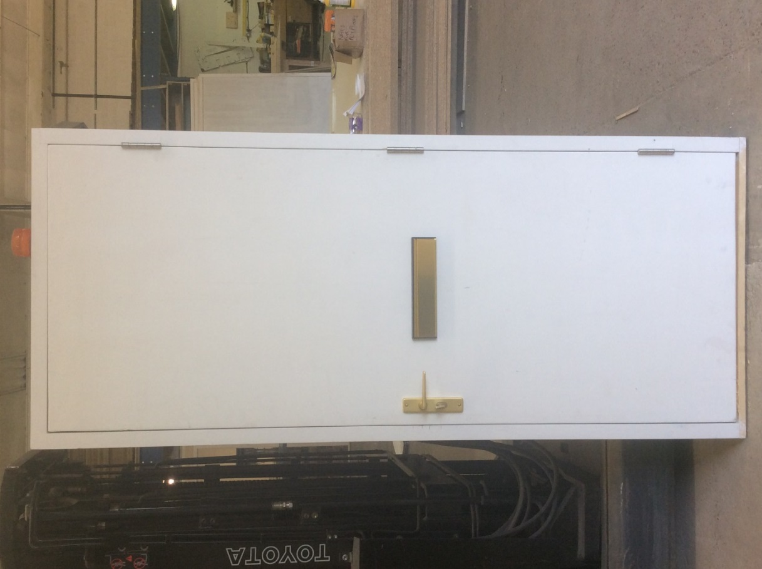

Door
1 External PREMDOR FD30 Fire Door, 44mm
Frame to be rebated for 10mm/15mm smoke seals
Frame to be morticed and tenoned
Glue screw and sand
Use knotting solution were required
1 coat white primer

KWL CODE: DOR07
INTERNAL FD30 SOLID CORE DOOR ONLY, PRIMED, SOFTWOOD, GRADE 5TH
(Excluding Letterbox, handle & lock)
Door size UPTO 2070mmH x 838mmW

Door
35mm FD30 Premdor Flush Ply
All laths to be glued screwed and sanded
1 coat white primer
Use knotting solution were required

KWL CODE: DOR08
10mm or 15mm REBATES ALL SIDES OF DOOR FOR INTRUMSCENT STRIP ANY SIZE DOOR

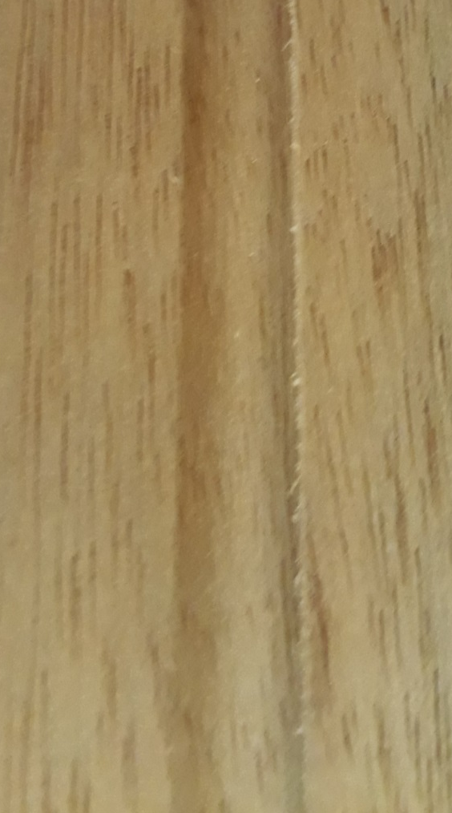

KWL CODE: DOR09
CUT OUT LETTER BOX OR VENT FOR ANY DOOR

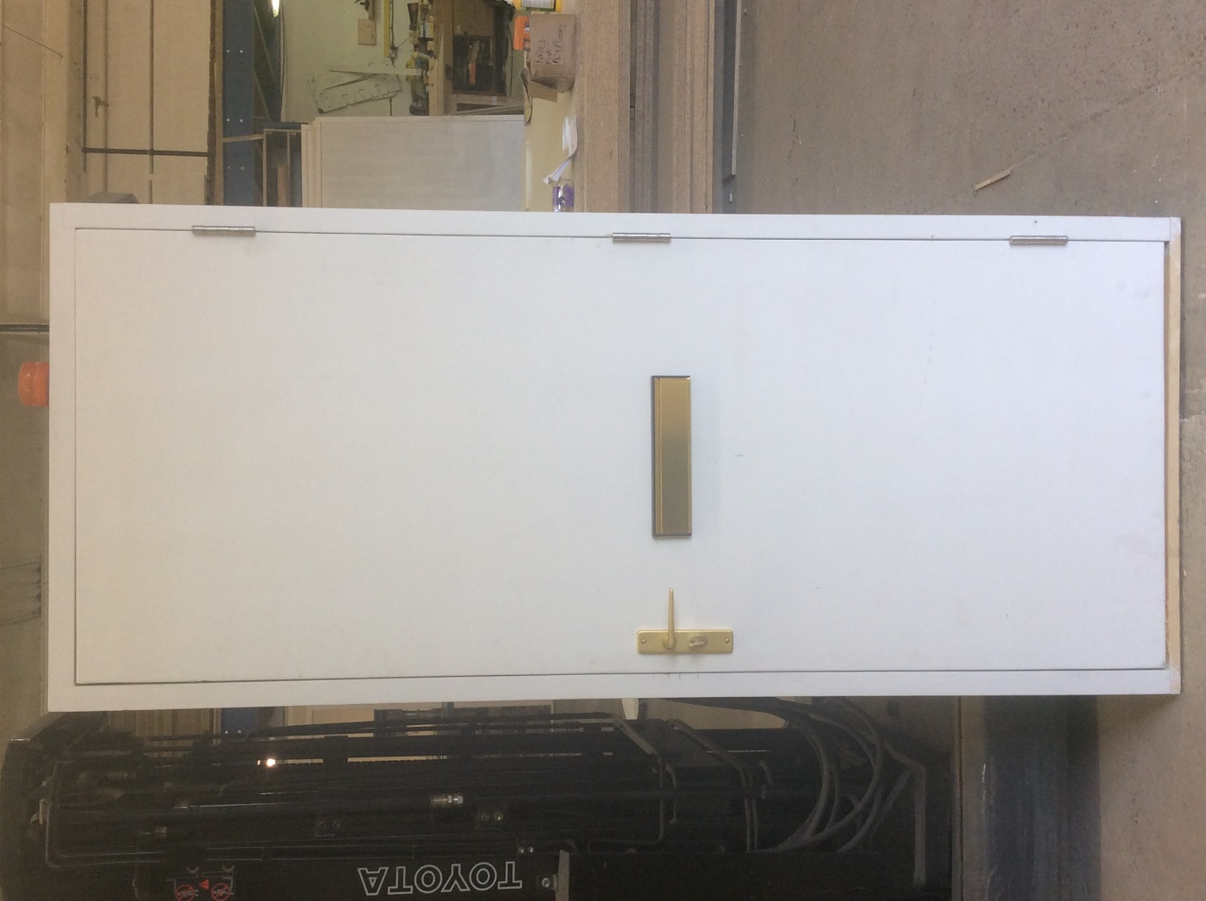

KWL CODE: DOR10
STORM DOOR & FRAME WITH FANLIGHT, PLYWOOD OR GLAZED FANLIGHT, PRIMED, SOFTWOOD, GRADE 5TH
Frame size up to 3000mm Height x 1200mm Width

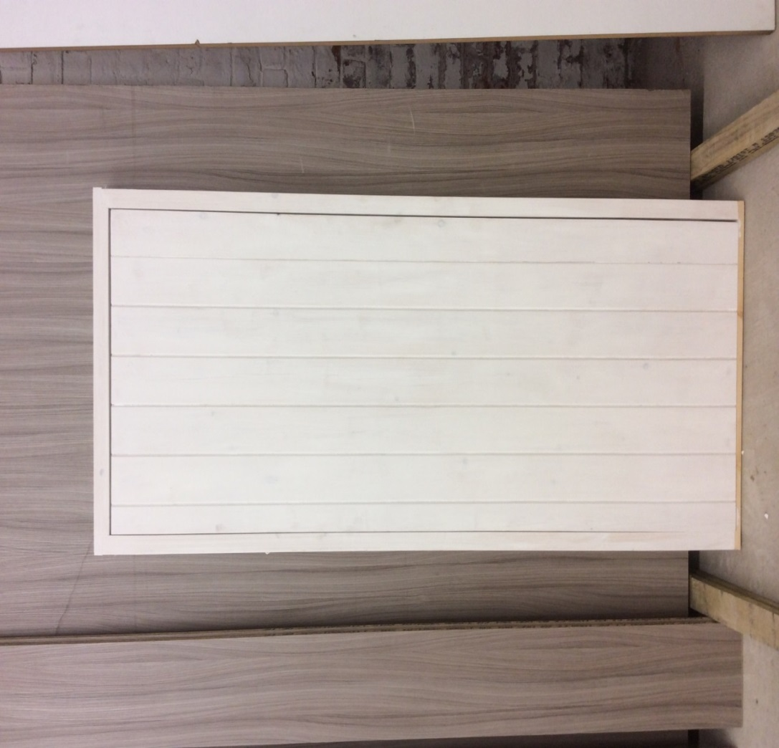
Frame
Mortice & Tenoned 45mm x 95mm PSE softwood timber with loose stop lath 22mm x 45mm, finished with water based primer

Door
22mm T&G Match Boarding
22mm x 120mm Rails & Braces
Glue and screw both sides
Use Knotting Solution were required
Fill & sand screw holes
I coat white primer

KWL CODE: DOR11
FRAMED, LEDGED & BRACED DOOR, SOFTWOOD, GRADE 5TH
PRIMED & ASSEMBLED
ANYSIZE

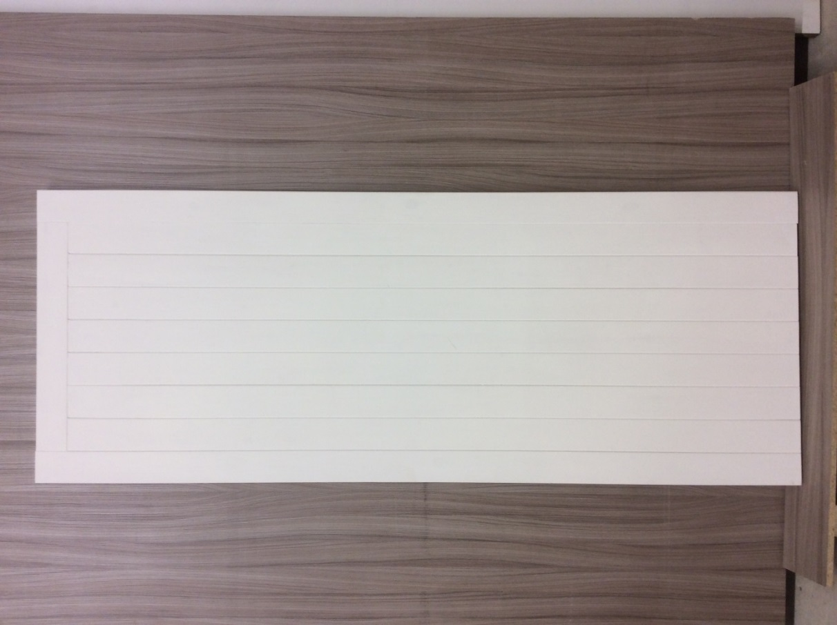

45mm x 95mm stiles and top rail
22mm x 95mm Rails and braces
22mm T&G match boarding
Rails morticed and tenoned in to stiles
Use knotting solution were required
1 coat white primer

KWL CODE: DOR12
FRAMED, LEDGED & BRACED DOOR & FRAME, SOFTWOOD, GRADE 5TH
TOPLIGHT WITH PLYWOOD INFIL
PRIMED AND ASSEMBLED
Size up to 3000mm Height x 1000mm Width

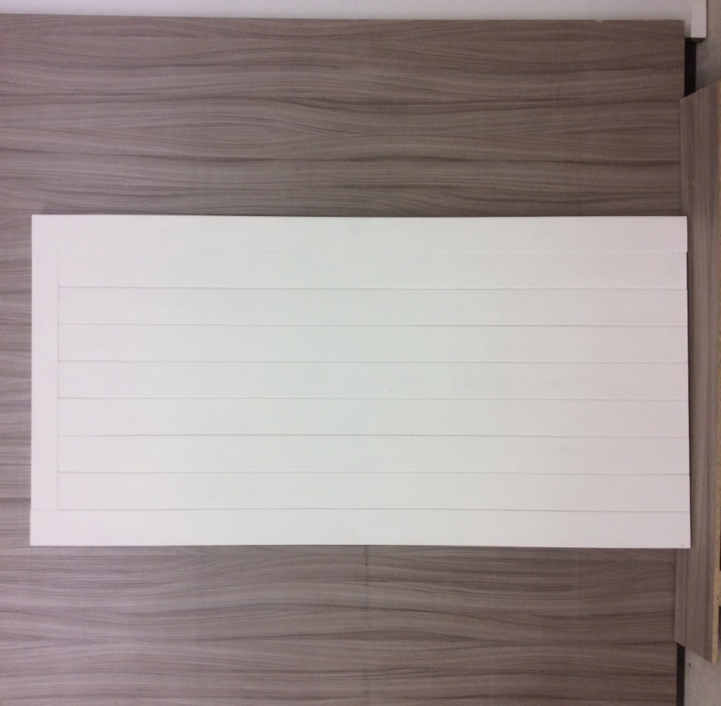

Frame
Mortice & Tenoned 45mm x 95mm PSE softwood timber with loose stop lath 22mm x 45mm, finished with water based primer

Door
45mm x 95mm stiles and top rail
22mm x 95mm Rails and braces
22mm T&G match boarding
Rails morticed and tenoned in to stiles
Use knotting solution were required
1 coat white primer

KWL CODE: DOR13
INTERNAL PLYWOOD CUPBOARD DOOR, 25MM THICK, PRIMED,
SOFTWOOD, GRADE 5TH
Door size UP TO 2040mm Height x 900mm Width
(ANY SIZES OVER AND ABOVE THIS WOULD BE PRICED INDIVIDUALLY)

DOOR MANUFACTURED FROM
1”x4” PSE frame
Covered with 6mm paint grade ply
12mm timber laths
Glued screwed filled and sanded
1 coat white primer

KWL CODE: DOR14
PAIR OF SOLID CORE DOORS 35MM WITH REBATES, PRIMED, SOFTWOOD, GRADE 5TH
SIZE OF APERTURE NO MORE THAN 2200MM Height x 1800MM Width

Door
1Pr External Grade FD30 Flush Fire Door, 35mm
Rebated
1 coat white primer

KWL CODE: DOR15
PAIR OF GARAGE DOORS, APPROXIMATELY 2180 WIDE X 2165 HIGH,
ALL PRIMED, SOFTWOOD, GRADE 5TH

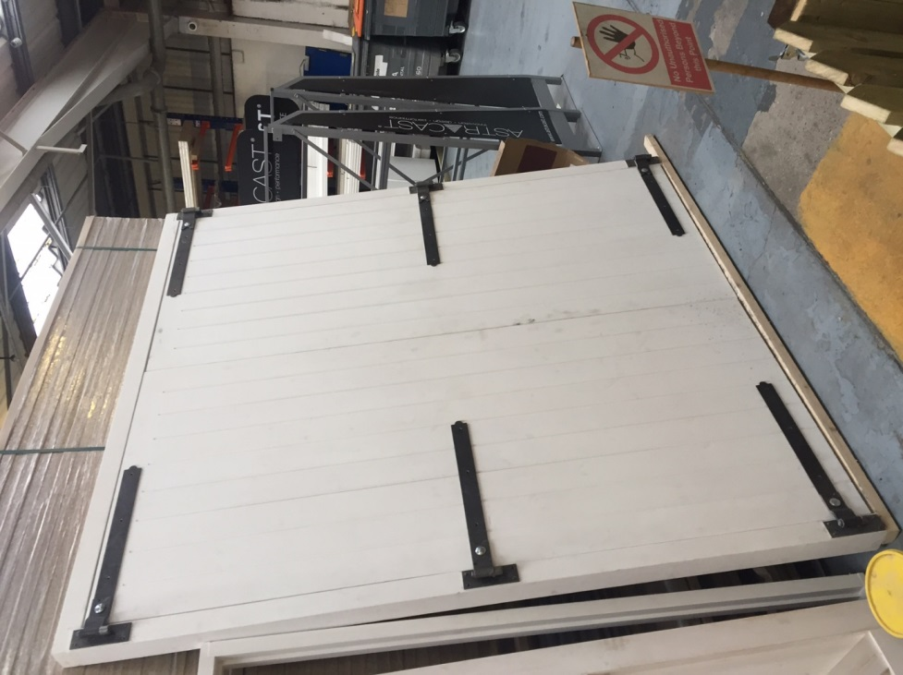

45mm x 145mm stiles and top rail
22mm x 145mm Rails and braces
22mm T&G match boarding
Rails morticed and tenoned in to stiles
Use knotting solution were required
1 coat white primer

KWL CODE: DOR16
PAIR OF GARAGE DOORS AND FRAME 2180 WIDE 2165 HIGH OVERALL SIZE ALL PRIMED

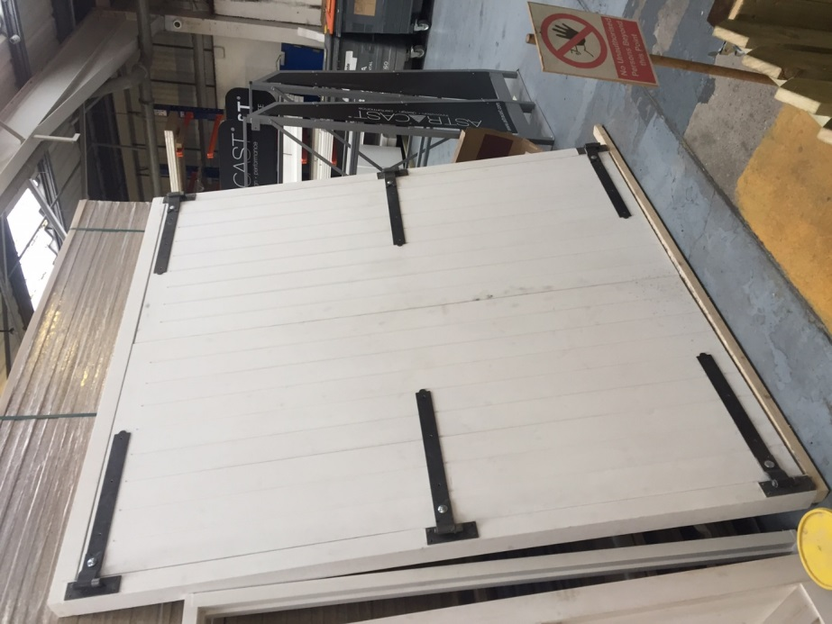

Frame
Mortice and Tenoned 3”x4” PSE Timber
1”x2” PSE Timber stop laths

Doors
45mm x 145mm stiles and top rail
22mm x 145mm Rails and braces
22mm T&G match boarding
Rails morticed and tenoned in to stiles
Use knotting solution were required
1 coat white primer

KWL CODE: DOR17
GARAGE DOOR FRAME, 3X4 PSE AND PRIMED, APPROXIMATELY 2.2 METERS WIDE X 2.1 METER HIGH, SOFTWOOD, GRADE 5TH

All supplied dry to assemble on site due to size of frame

Frame
Morticed and Tenoned 3”x4” PSE Timber
1”x2” PSE Timber Stop Laths
Use knotting solution were required
1 coat of white primer

KWL CODE: DOR18
BIN AND METER CUPBOARD DOOR AND FRAME, ANY SIZE, ASSEMBLED AND PRIMED, SOFTWOOD, GRADE 5TH

Frame
Morticed and tenoned
45mm x 95mm Square or bevelled timber
45mm x 12mm Rebates

Doors
44mm Solid Flush doors cut from standard blank and edged in PSE timber
Use knotting solution were required
1 coat white primer

Meter door approx. 900mm high x 600mm wide
Dustbin door approx. 1100mm high x 600mm wide

KWL CODE: DOR19
BIN OR METER CUPBOARD DOOR ONLY, PRIMED, 44MM THICK UPTO 1300MM HIGH AND 620MM WIDE, SOFTWOOD, GRADE 5TH

44mm Solid Flush Door

44mm Solid flush door cut from solid blank
12mm Timber laths to all sides
Use knotting solution were required
1 coat white primer

KWL CODE: DOR20
DOOR FRAME WITH FANLIGHT, ANY SIZE, EXTERNAL USE, UPTO 1 METER WIDE WITH TOP LIGHT AND PLYWOOD INFILL 2X4 PSE AND PRIMED, SOFTWOOD, GRADE 5TH

PLY INFILL

Morticed and tenoned
Hardwood sill if required
Door frame to be square or bevelled as required
Normal section size 45mm x 95mm PSE
Use knotting solution were required
1 coat of white primer

KWL CODE: DOR21
DOOR FRAME, ANY SIZE, EXTERNAL USE, UPTO 1 METER WIDE 2X4 PSE AND PRIMED, SOFTWOOD, GRADE 5TH

Morticed and tenoned
Rebated timber
Hardwood Sill if required
Door frame to be square or bevelled as required
Normal section size 45mm x 95mm PSE
Use knotting solution were required
1 coat of white primer

KWL CODE: DOR22
EXTERNAL PREMDOR, FD30 DOOR & FRAME, WITH OR WITHOUT SILL, PRIMED, SOFTWOOD, GRADE 5TH
Frame to be altered to fit standard door. INTUMESCENT STRIPS REBATED IN TO FRAME, FIRE RETARDANT BOARD FOR INFIL TO FANLIGHT.
Door to be fitted on 3no CE fire approved 100mm hinges in frame.
(Excluding Letterbox, handle & lock)
Door size UPTO 2400mm Height x 850mm Width

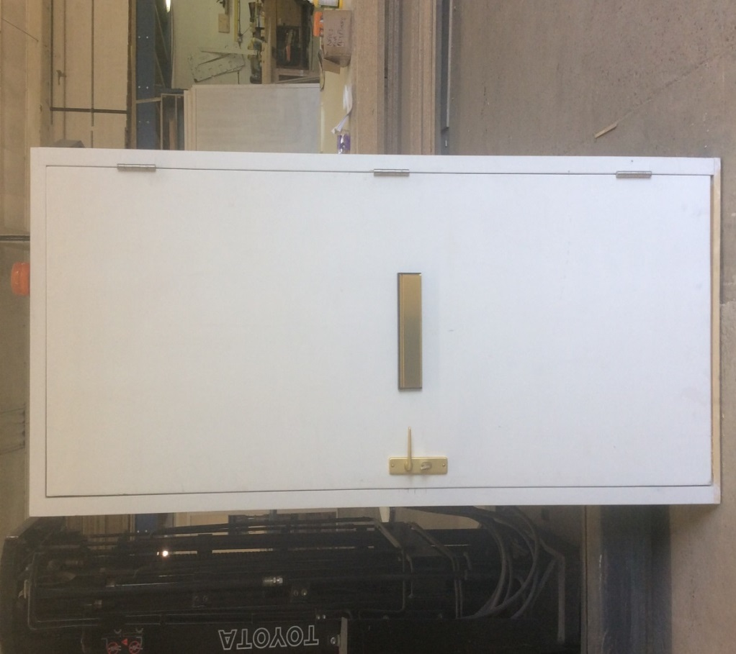

Frame
Morticed and tenoned
Hardwood sill if required
Door frame to be square or bevelled as required
Normal section size 45mm x 95mm PSE but up to 125mm
Use knotting solution were required
1 coat of white primer

Door
1 External PREMDOR FD30 Fire Door, 44mm
Frame to be rebated for 10mm/15mm smoke seals
Frame to be morticed and tenoned
Glue screw and sand
Use knotting solution were required
1 coat white primer

KWL CODE: GATE01
TREATED LARGE GATE WITH MORTICE TENON JOINTS, SOFTWOOD, GRADE 5TH, SIZE AROUND 1000mm WIDE AND 2000mm HIGH

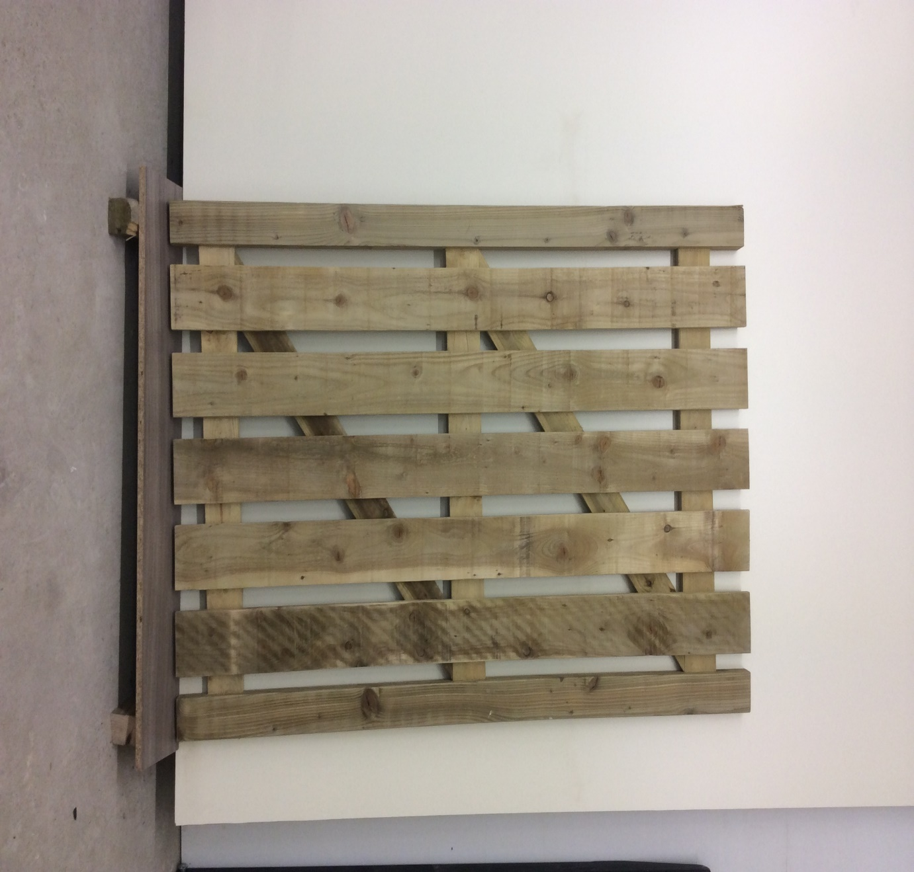

50mm x 100mm stiles tannalised timber
25mm x 150mm rails, braces pales
Glued and screwed

KWL CODE: GATE02
TREATED SMALL GATE AS PER ORIGINAL SPEC AGREED, 750MM WIDE X 710 HIGH, SOFTWOOD, GRADE 5TH

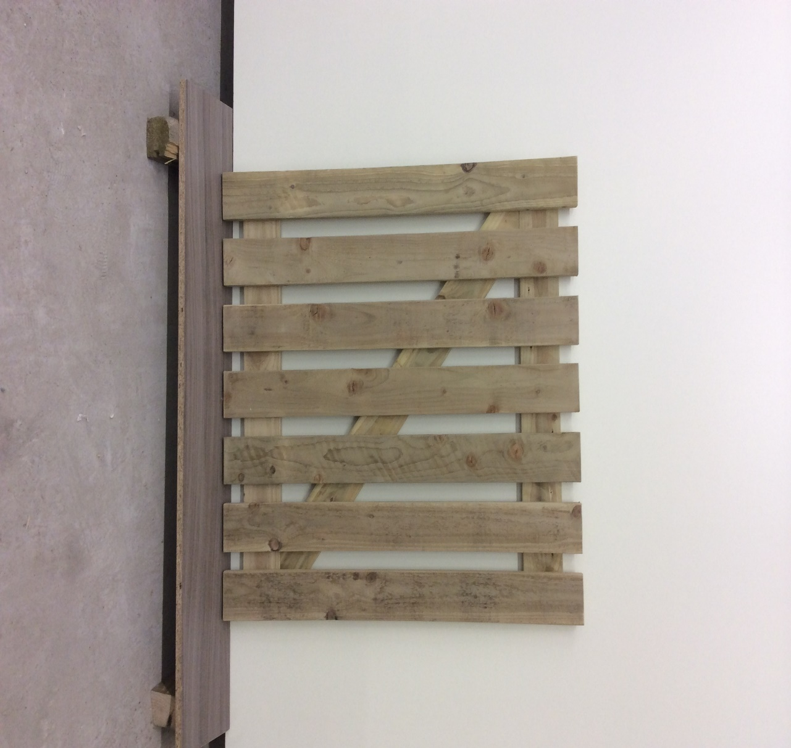

50mm x 100mm stiles tannalised timber
25mm x 100mm rails, braces pales
Glued and screwed

KWL CODE: STAIR03
6 TREAD STAIR CASE, SOFTWOOD, GRADE 5TH

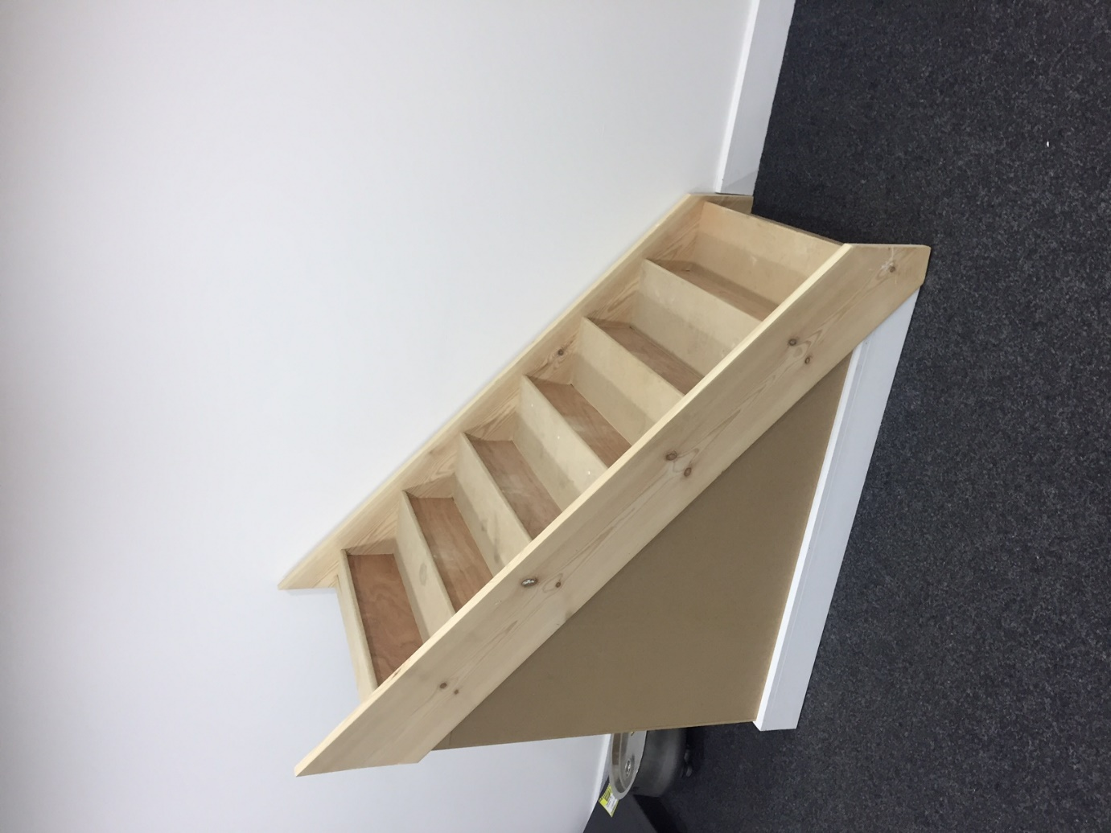

SITE VISIT REQUIRED TO MEASURE ORIGINAL STAIRS
String approx. size 220mm x 32mm PSE
Treads 22mm MDF
Glue, screw, fill and sand
Use knotting solution were required

KWL CODE: STAIR04
UPTO 3 TREAD STAIRCASE BOX, SOFTWOOD, GRADE 5TH

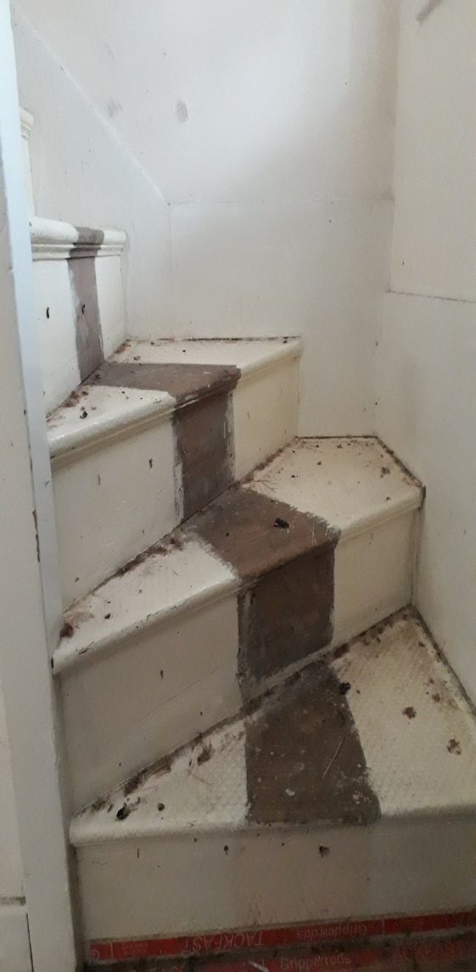

SITE VISIT REQUIRED TO MEASURE ORIGINAL STAIRS
Left or Right handed
String approx. size 220mm x 32mm PSE
Treads 22mm MDF
Glue, screw, fill and sand
Use knotting solution were required

