**REQUEST FOR INFORMATION**

**SUBMARINE DELIVERY AGENCY**

**Supply of Post Fire Monitors** 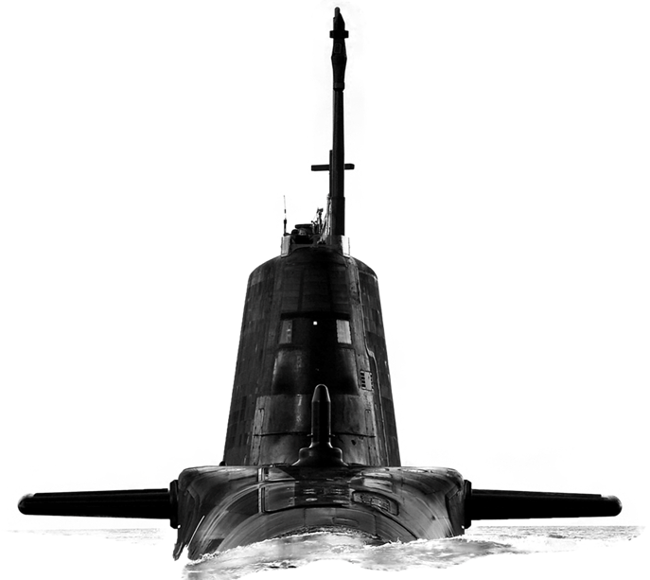

Version: 1.0

30th August 2023

**CONTENTS**

Confidentiality..............................................................................................................3

Introduction..................................................................................................................3

Background…………...................................................................................................3

Purpose of the Request for Information (RFI).............................................................3

RFI Procedure............................................................................................................ 4

How to Delivery Responses to this RFI………............................................................4

Contacts......................................................................................................................4

Timeframe...................................................................................................................5

Annex A - Request for Information Questionnaire……….........................................A-1

**Confidentiality**

1. All information included in this Request for Information (RFI) is confidential and only for the named addressee. No information included in your response, or in discussions connected to it, will be disclosed to any other party.

**Introduction**

1. The Submarine Delivery Agency (SDA) has never sourced Post Fire Monitors (PFM) for Royal Navy (RN) and Royal Fleet Auxiliary (RFA) ships. This RFI seeks to understand current opportunities and pricing in the market as well as lead times for the supply of Post Fire Monitors.
2. The supply of PFM for RN and RFA ships is critical to ensuring safety through mitigating the risk of exposing onboard personnel to toxic and non-life supporting gases following a fire. The SDA is seeking information to inform potential future procurements, and we would like to invite your company to answer a few questions to explore ways in which this can be achieved.
3. This RFI is not a bidding opportunity but a means by which industry can provide information. Any resulting procurement activity will be conducted competitively.

**Scope**

1. It is important to note that the PFM the SDA require must comply with the following:

Technical Details

* Capable of quickly detecting Carbon Dioxide, Carbon Monoxide, Nitrogen Dioxide, Hydrogen Cyanide, Sulphur Dioxide and Hydrogen Sulphide, Oxygen, Propane, Butane and Methane within the atmosphere following a fire.
* Have a mechanism which audibly alerts ships staff to gas level breaches
* All operating, calibrating, maintenance, and support functions can be completed by ships staff
* Preferably a COTS item with no requirement to develop or produce a new solution
* Can operate effectively and safely within the environment onboard RN and RFA ships and is compliant with relevant safety and environmental regulations

**Purpose of the RFI**

1. This RFI aims to achieve two outcomes:
2. To gather information about the current market for the provision of PFM for RN and RFA ships.
3. Develop a Procurement Strategy that will deliver best value for money for Defence.

**RFI Procedure**

1. This Request for Information will be advertised on the Defence Sourcing Portal (DSP) and Contracts Finder and issued to all who request an RFI together with other companies whom the MOD believes may be able to provide useful intelligence on this requirement.
2. Responses to this RFI will be reviewed by subject matter experts from different functional areas within the SDA. Following receipt of responses to this RFI the Authority may initiate follow on engagement with either individual potential suppliers, groups of potential suppliers or all potential suppliers. This may be undertaken in writing or through virtual meetings.
3. Any details provided in response to this RFI or during subsequent engagement will be used for information purposes only and will not be used to determine the potential suppliers who will be invited to bid, should the Authority proceed to tender.
4. The results and analysis of this RFI shall not constitute any form of pre-qualification exercise. Any formal procurement process will be undertaken in accordance with EU Procurement Law.
5. Nothing in this RFI, or any other engagements with Industry prior to a formal procurement process, shall be construed as a representation as to the Authority’s ultimate decision in relation to the future requirement.

**How to deliver responses to this RFI**

1. To respond to this RFI please complete the form at Annex A and return electronically to [Harry.Partridge101@mod.gov.uk](mailto:Harry.Partridge101@mod.gov.uk) no later than 13:00 13th September 2023. Responses will be acknowledged by email.

**Contacts**

1. Please raise questions relating to this RFI by email to [Harry.Partridge101@mod.gov.uk](mailto:Harry.Partridge101@mod.gov.uk)

**Timeframe**

1. This is the timeframe for the RFI and follow-on activity:

30th August 2023 – RFI Published on Defence Sourcing Portal.

13.00 13th September 2023 – Last date for submission of answers to RFI.

**Post Fire Monitors Request for Information**

|  |  |
| --- | --- |
| **Question** | **Answer** |
| Company Name |  |
| Company Address |  |
|  |  |
| Name of Company representative completing the RFI |  |
| Contact details (e-mail and telephone number) |  |
| Company web site address |  |
|  |  |
| Main products/services/line of business |  |
| Main market sector/customers |  |
| Number of years in this market sector |  |
|  |  |
| Pricing |  |
| 1. What is the price range, per unit, for PFM you provide which are available to procure on the market today? |  |
| Order Quantity/Contract Duration |  |
| 1. To what extent can discounts be offered on volume orders and at what level might these be available? |  |
| 1. What would be the estimated lead time for the supply and shipping of 200 PFM at the above specification? Shipping will be to the UK. |  |
| Technical |  |
| 1. Is there a portable, single PFM within the market to procure now, which can detect:  * Carbon Dioxide * Carbon Monoxide * Nitrogen Dioxide * Hydrogen Cyanide * Sulphur Dioxide * Hydrogen Sulphide * Oxygen * Methane * Propane * Butane   If a single monitor does not have the capability to detect these gases, can this be achieved using 2 monitors? |  |
| 1. What is the rate of detection for the PFM? |  |
| 1. To what level and accuracy can the PFM detect the required gases within the atmosphere? |  |
| 1. What is the user and maintainer training requirement for the PFM? |  |
| 1. Describe the PFM user interface? Are you able to provide a photographic example? |  |
| 1. What size and weight are the PFM? |  |
| 1. Are the PFM attachable to clothing to enable operators to use without impeding any activity? If yes, how are they attached? |  |
| 1. How do the PFM alert users to gas breaches within the atmosphere or when the atmosphere is no longer hazardous due to gases following a fire i.e., visual, audible, vibration or other |  |
| 1. What is the life of the batteries used in the PFM? |  |
| 1. Is there a difference in the battery life between PFM in use and in ‘stand by’ mode? |  |
| 1. Are the batteries chargeable? |  |
| 1. Is any additional testing i.e., bump testing required or is any ancillary equipment required to maintain, calibrate, operate, and support the PFM onboard a platform? |  |
| 1. What is the required process and frequency to calibrate and test the PFM onboard? |  |
| 1. What is the recommended support strategy for the PFM through life? |  |
| 1. What certifications do these PFM contain i.e., type testing, environmental standards, environmental operating limits, EMC, shock, vibration, heat, protection and any other that may apply? |  |