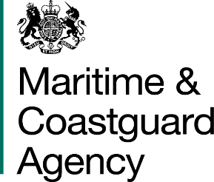 |  |  | Bay 3/21  Spring Place  105 Commercial Road  Southampton  SO15 1EG  United Kingdom
 | All Tenderers for the Provision of Emergency Towing Vessel Via Contracts Finder |  | Tel:  Fax:  E-mail: | +44 0238172476  +44 (0)23 80329388  contracts@mcga.gov.uk
 |  |  | Your ref:  Our ref: |  | TCA 3-7-991
 |  |  | 29th September 2016
Dear Sirs

PROVISION OF PROVISION OF AN EMERGENCY TOWING VESSEL (ETV)

Further to my previous questions and answers correspondence and the closing deadline date of 5pm on the 28th September 2016 to obtain further information. Please find attached final response to a question received and additional clarification information.

Question 1: Will owners that are unable to provide a substitute vessel during a planned dry dock and/or extensive maintenance still be considered?

Answer: Tenders must provide a substitute vessel during planned dry dock/ maintenance to be considered for this requirement.

Vessel Inspection Clarification:

The successfully tendered vessel will have its Port State Control history scrutinised by the MCA Survey and Inspection Branch. Should any additional inspection be required, then it will be the responsibility of the vessel owner to arrange for the appropriate inspection, as designated by the MCA. The cost of any inspection(s) will be at the vessel owners cost.

The deadline for the receipt of tenders for the above contract is 11am on the 7th October 2016.

Regards,

Richard Skeats MCIPS
Contract Manager Business Partner
Maritime and Coastguard Agency

