PART B – QUOTE RETURN

|  |
| --- |
| **Weed Control 2024-25**  **Reference number: RFQ-002-24** |

|  |
| --- |
| **Name of Applicant:**  **Date:** |

Section 4 - Quote Completion Documentation

4.1 Selection Criteria

**Explanatory Notes**

Applicants are required to complete all questions in this section which have space for answers. Some sections refer to criteria which are not applicable to this RFQ. This will be clearly marked with “Not Applicable to this RFQ”, and you are not required to answer these sections.

All responses provided must be clearly referenced to the questions to which they relate. Copies of certificates or policies will need to be provided by the successful supplier before any contract or purchase order is placed with them.

All applicable sections of the following Selection Criteria must be completed. Failure to do so may result in your submission being excluded from further evaluation. Where the answer is a statement of fact, it must be accurate and supported by documentary evidence as appropriate. It is the Applicant’s responsibility to ensure that the Council is not misled.

It is the responsibility of the Applicant to inform the Council of any matter that may affect the Applicant’s continued qualification.

4.2 Financial Matters

The Council will carry out a financial check on the Applicant. This will take the form of a review of the Applicant’s accounts available from Companies House. If company accounts are not available, then the Council will carry out a financial check on the information available as identified in Section 3.1. The Council may also need to undertake an Experian Credit Check as part of its financial assessment. The Applicant will be awarded an overall pass or fail mark based on the Council’s professional judgement. This professional judgement will be provided from the Council’s Responsible Finance Officer.

Any additional information provided should be clearly referenced to the question number in your submission.

4.3 Selection Questionnaire

|  |  |  |  |  |  |  |  |  |  |  |  |
| --- | --- | --- | --- | --- | --- | --- | --- | --- | --- | --- | --- |
| NOTE TO APPLICANT: Part 1 must be completed but will not be scored | | | | | | | | | | | |
| **Section 1.1** | | **Potential supplier information** | | | |  | | | | | |
| **Question number** | | **Question** | | | | **Response** | | | | | |
| 1.1(a) | | Full name of the potential supplier  submitting the information | | | |  | | | | | |
| 1.1(b) – (i) | | Registered office address (if applicable) | | | |  | | | | | |
| 1.1(b) – (ii) | | Registered website address (if applicable) | | | |  | | | | | |
| 1.1© | | Please mark ‘X’ in the relevant box to indicate your trading status | | | | 1. a public limited company | | | |  | |
| 1. a limited company | | | |  | |
| 1. a limited liability partnership | | | |  | |
| 1. other partnership | | | |  | |
| 1. sole trader | | | |  | |
| 1. other (please specify) | | | |  | |
| 1.1(d) | | Date of registration in country of origin | | | |  | | | | | |
| 1.1© | | Company registration number (if applicable) | | | |  | | | | | |
| 1.1(f) | | Charity registration number (if applicable) | | | |  | | | | | |
| 1.1(h) | | Registered VAT number | | | |  | | | | | |
| 1.1(k) | | Trading name(s) that will be used if successful in this procurement | | | |  | | | | | |
| 1.1(l) | | Please mark ‘X’ in the relevant box to indicate whether any of the following classifications apply to you | | | | 1. Voluntary, Community and Social Enterprise (VCSE) | | | |  | |
| 1. Small or Medium Enterprise (SME) | | | |  | |
| 1. Sheltered workshop | | | |  | |
| 1. Public service mutual | | | |  | |
| **Section 1.2** | | **Bidding model** | | | |  | | | | | |
| **Question number** | | **Question** | | | | **Response** | | | | | |
| 1.2(a) – (i) | | Are you bidding as the lead contact for a group of economic operators?  If yes, please provide details listed in questions below. | | | | **Please indicate your answer by marking ‘X’ in the relevant box.** | | | | | |
| **Yes** | | | | **No** | |
|  | | | |  | |
| 1.2(a) – (ii) | | Name of group of economic operators (if applicable) | | | |  | | | | | |
| 1.2(a) – (iii) | | Proposed legal structure if the group of economic operators intends to form a named single legal entity prior to signing a contract, if awarded. If you do not propose to form a single legal entity, please explain the legal structure. | | | |  | | | | | |
| 1.2(b) – (i) | | Are you or, if applicable, the group of economic operators proposing to use sub-contractors?  If yes, please provide details listed in questions below. | | | | **Yes** | | | | **No** | |
|  | | | |  | |
| Name of sub-contractors (if applicable) | | | |  | | | | | |
| The role each sub-contractor will take in providing the works and /or supplies e.g. key deliverables: | | | |  | | | | | |
| The approximate % of contractual obligations assigned to each sub-contractor: | | | |  | | | | | |
| Contact details and declaration | | | | | | | | | | | |
| I declare that to the best of my knowledge the answers submitted and information contained in this document are correct and accurate.  I declare that, upon request and without delay I will provide the certificates or documentary evidence referred to in this document.  I understand that the information will be used in the selection process to assess my organisation’s suitability to be invited to participate further in this procurement.  I understand that the authority may reject this submission in its entirety if there is a failure to answer all the relevant questions fully, or if false/misleading information or content is provided in any section.  I am aware of the consequences of serious misrepresentation. | | | | | | | | | | | |
| **Section 1.3** | | **Contact details and declaration** | | | |  | | | | | |
| **Question number** | | **Question** | | | | **Response** | | | | | |
| 1.3(a) | | Contact name | | | |  | | | | | |
| 1.3(b) | | Name of organisation | | | |  | | | | | |
| 1.3(c) | | Role in organisation | | | |  | | | | | |
| 1.3(d) | | Phone number | | | |  | | | | | |
| 1.3(e) | | E-mail address | | | |  | | | | | |
| 1.3(f) | | Postal address | | | |  | | | | | |
| 1.3(g) | | Signature (electronic is acceptable) | | | |  | | | | | |
| 1.3(h) | | Date | | | |  | | | | | |
| **Part 2: Exclusion grounds**  NOTE TO APPLICANT: this section must be completed and will be evaluated as a whole on a Pass or Fail basis. The section will be marked as a ‘Fail’ if “Yes” is answered to question 2.1(a) and 2.2(a) and satisfactory evidence of self-cleaning is not detailed in your response to question 2.1(b) and 2.2(b). | | | | | | | | | | | |
| **Section 2.1** | | **Grounds for mandatory exclusion** | | | |  | | | | | |
| **Question number** | | **Question** | | | | **Response** | | | | | |
| 2.1(a) | | **Regulations 57(1) and (2)**  The detailed grounds for mandatory exclusion of an organisation are set out on this [web page](https://www.gov.uk/government/uploads/system/uploads/attachment_data/file/551130/List_of_Mandatory_and_Discretionary_Exclusions.pdf), which should be referred to before completing these questions.  Please indicate if, within the past five years you, your organisation or any other person who has powers of representation, decision or control in the organisation been convicted anywhere in the world of any of the offences within the summary below and listed on the [webpage](https://www.gov.uk/government/uploads/system/uploads/attachment_data/file/551130/List_of_Mandatory_and_Discretionary_Exclusions.pdf). | | | | | | | | | |
|  | | | | **Please indicate your answer by marking ‘X’ in the relevant box.** | | | | | |
| **Yes** | | | | **No** | |
| Participation in a criminal organisation | | | |  | | | |  | |
| Corruption | | | |  | | | |  | |
| Fraud | | | |  | | | |  | |
| Terrorist offences or offences linked to terrorist activities | | | |  | | | |  | |
| Money laundering or terrorist financing | | | |  | | | |  | |
| Child labour and other forms of trafficking in human beings | | | |  | | | |  | |
| 2.1(b) | | If you have answered yes to question 2.1(a), please provide further details.  Date of conviction, specify which of the grounds listed the conviction was for, and the reasons for conviction,  Identity of who has been convicted  If the relevant documentation is available electronically please provide the web address, issuing authority, precise reference of the documents. | | | |  | | | | | |
| **Part 3: Selection questions** | | | | | | | | | | | |
| **Section 3.1** | | **Economic and financial standing** | | | |  | | | | | |
| **Question number** | | **Question** | | | | **Response** | | | | | |
| 3.1 | |  | | | | **Please indicate your answer by marking ‘X’ in the relevant box.** | | | | | |
| **Yes** | | | **No** | | |
| Are you able to provide a copy of your audited accounts for the last two years, if requested?  If no, can you provide **one** of the following: | | | |  | | | | | |
| (a) A statement of the turnover, Profit and loss Account/income Statement, Balance Sheet/Statement of Financial Position and Statement of Cash Flow for the most recent year of trading for this organisation. | | | |  | | | | | |
| (b) A statement of the cash flow forecast for the current year and a bank letter outlining the current cash and credit position. | | | |  | | | | | |
| (c) Alternative means of demonstrating financial status if any of the above are not available (e.g. forecast of turnover for the current year and a statement of funding provided by the owners and/or the bank, charity accruals accounts or an alternative means of demonstrating financial status). | | | |  | | | | | |
| **Section 4** | | **Technical and professional ability** | | | |  | | | | | |
| 4.1 | | Please provide details of up to three contracts, in any combination from either the public or private sector; voluntary, charity or social enterprise (VCSE) that are relevant to our requirement. VCSEs may include samples of grant-funded work. Contracts for supplies or services should have been performed during the past three years. Works contracts may be from the past five years.  Consortia bids should provide relevant examples of where the consortium has delivered similar requirements. If this is not possible (e.g. the consortium is newly formed or a Special Purpose Vehicle is to be created for this contract) then three separate examples should be provided between the principal member(s) of the proposed consortium or Special Purpose Vehicle (three examples are not required from each member).  If you cannot provide examples see question 4.2 | | | | | | | | | |
|  | | | Contract 1 | Contract 2 | | | Contract 3 | | | | |
| Name of customer organisation | | |  |  | | |  | | | | |
| Point of contact in the organisation | | |  |  | | |  | | | | |
| Position in the organisation | | |  |  | | |  | | | | |
| E-mail address | | |  |  | | |  | | | | |
| Contract Start date | | |  |  | | |  | | | | |
| Contract completion date | | |  |  | | |  | | | | |
| Estimated contract value | | |  |  | | |  | | | | |
| Description of contract 1: | | | | | | | | | | | |
| Description of contract 2: | | | | | | | | | | | |
| Description of contract 3: | | | | | | | | | | | |
| 4.2 | | If you cannot provide at least one example for questions 6.1, in no more than 500 words please provide an explanation for this e.g. your organisation is a new start-up or you have provided services in the past but not under a contract. | | | | | | | | | |
| Response: | | | | | | | | | | | |
| **Section 5** | | **Additional questions** | | | |  | | | | | |
| **5.1** | | **Insurance** | | | |  | | | | | |
| Please self-certify whether you already have, or can commit to obtain, prior to the commencement of the contract, the levels of insurance cover indicated below(Please indicate your answer by marking ‘X’ in the relevant box): | | | | | | **Yes** | | | | **No** | |
| Employer’s (Compulsory) Liability Insurance = £10 Million | | | | | |  | | | |  | |
| Public Liability Insurance = £10 Million | | | | | |  | | | |  | |
| * It is a legal requirement that all companies hold Employer’s (Compulsory) Liability Insurance of £5 million as a minimum. Please note this requirement is not applicable to Sole Traders. | | | | | |  | | | |  | |
| **Section 6** | **Project Specific Questions** | | | | | | | | | |
| **6.1** | **Health & Safety** | | | | **Yes** | | | **No** | | |
| Please self-certify that your organisation has a Health and Safety Policy that complies with current legislative requirements. | | | | |  | | |  | | |
| Has your organisation or any of its Directors or Executive Officers been in receipt of enforcement/remedial orders in relation to the Health and Safety Executive (or equivalent body) in the last 3 years?  If your answer to this question was “Yes”, please provide details in a separate Appendix of any enforcement/remedial orders served and give details of any remedial action or changes to procedures you have made as a result. | | | | |  | | |  | | |

Section 5 The Specification

1. **Location of work within the Parish**

The enclosed maps and road schedule show the network of highways within the Parish requiring reactive weed control.

1. **Description of the work**

The work consists of using appropriate weed-killing methods to the highways on a reactive basis as identified by Newquay Town Council. The purposes of which is to reduce the number of weeds on said highways. The use of Glyphosate (or any other herbicides) as a method of weed control will NOT be accepted. The contractor must be aware that there are highways within the contract where vehicles are parked and therefore, it is imperative the choice of weed control method should ensure it is safe to do so around vehicles.

Where areas cannot be accessed the contractor must contact Newquay Town Council immediately to report what areas were not covered and why. The proposed method to be used must be non-invasive and environmentally friendly.

The total length of roads within the parish is **71.04 km (note: including both sides of the road would total 142.08 km).**

However, this contract will be undertaking weed control on a ‘reactive’ basis and the Town Council will not exceed more than 10% of the total length of highways within the Parish.

The Council will assess the hot spot areas within the parish on a monthly basis and review whether action will be taken based on: health & safety risk, impact on an asset of importance to the local community and/or tourism, the number of enquiries raised and budgetary limitations.

1. **Categories of the Highways network**

Roads within the Parish are designated into the following categories.

* **A-roads**
  + Major roads intended to provide large-scale transport links within or between areas. Generally, an A-road will be among the widest, most direct roads in an area, and is of the greatest significance to traffic travelling through the area.
* **B-roads**
  + Roads intended to connect different areas and to feed traffic between A-roads and smaller roads on the network. B-roads are still important routes for traffic (including traffic travelling through the area), but less so than an A-road.
* **C-roads (classified unnumbered)**
  + These are generally smaller roads intended to connect unclassified roads with A and B roads, and often linking a housing estate or a village to the rest of the network. C-roads performs a more important function than an unclassified road. It should be noted that it is likely these roads will have off street parking.
* **Unclassified**
  + Local roads intended for local traffic. The vast majority (60%) of roads in the UK fall within this category. It should be noted that it is likely these roads will have off street parking.

1. **Timing of work**

The Town Council will undertake a monthly review of the highways network and report to the Contractor the roads/hotspot areas to be targeted at the end of that period. The Contractor must undertake weed control with their chosen method in the highlighted areas within **10 working days** of receiving the report.

1. **Public and Employer’s Liability Certificates**

The contractor must have:

* *a minimum of £10 million public/employer’s liability cover.*

These documents must be presented to the Council to view. This can either be hard copies or electronic sent via Email.

1. **Site Visit**

Before quoting the contractor should examine the requirements of this contract through looking at the maps and visit the area.

1. **Works Estimate**

The contractor shall give a quote with their day rate and half a day rate for their chosen weed control method. The contractor will provide these rates for each road classification and an estimate of how many km can be completed. Newquay Town Council may, without invalidating the contract, order an addition or omission from the works provided notice has been given to the contractor within 24 hours of the Town Council’s request for works to be undertaken.

1. **Quote to be Inclusive**

The contractor is to include in their price, all costs in connection with labour, health and safety requirements, plant, materials, tool maintenance, fuel and transport, chemicals, protective wear and all other things necessary for the work to be undertaken. The contractor must be aware that some areas may require different methods of weed control where there are many vehicles on the road.

1. **Agreement of work Programme**

Before starting work the contractor will provide a programme of work to Newquay Town Council’s satisfaction.

1. **Responsible Person**

The contractor shall keep on site at all reasonable times when undertaking work a responsible person/s supervising the works. The contact details of this individual/s must be provided to Newquay Town Council ahead of any planned works. Additionally, Newquay Town Council must be notified of any changes to the responsible person/s.

1. **Safety and Environmental Protection Issues**

Before starting work the contractor will:

* *Provide and agree method statements illustrating how they will go about the work (e.g. erecting safety signs, tools to be used).*
* *Agree how they will comply with Health & Safety Regulations.*
* *Provide certificates of competency (such as operators licenses for machinery and, if applicable).*

Before starting work Newquay Town Council will:

* *Provide information concerning any other matter to be brought to the contractor's attention (e.g. archaeological or wildlife issues).*

1. **Site Access**

Newquay Town Council will provide the contractor information concerning access to the sites and landowner details where possible.

The contractor will arrange access with the landowners where necessary, e.g. accessing an area blocked by a vehicle.

1. **Submission of Contractor Work Schedule with Invoice**

The contractor shall submit their invoice on completion of the works and Newquay Town Council will pay invoices within 30 calendar days.

1. **Weed Control Schedule**

|  |  |  |
| --- | --- | --- |
| **AREA** | **STREET** | **MAP REF** |
| **MAYFIELD** | THOMAS RD | WC001 & WC003 |
| BAY VIEW TERR |
| LANHENVOR AVE |
| ROBARTES RD |
| TRENANCE AVE |
| HEADLEIGH RD |
| TRENANCE LANE |
| TRELAWNEY RD |
| AGAR RD |
| CLIFDEN CLOSE |
| LINDEN AVE |
| LINDEN CRESCENT |
| RAWLEY LANE |
| MAYFIELD RD |
| HAWKINS RD |
| HAWKINS DRIVE |
| TREDOUR RD |
| CHEVIOT RD |
| TREMBATH CRES |
| ANTHONY RD |
| CHYVERTON CLOSE |
| TRETHEWEY WAY |
| CHYNANCE DRIVE |
| LISTRY RD |
| TRENARTH RD |
| TREGUNNEL HILL |
| ESTUARY VIEW |
| PENGANNEL CLOSE |
| MAYFIELD CRES |
| VIVIAN CLOSE |
| CLEVEDON RD |
| PENMERRIN COURT |
| TOR RD |
| BERRY RD |
|  |
| MICHELL AVE |
| CARCLEW AVE |

|  |  |  |
| --- | --- | --- |
| **AREA** | **STREET** | **MAP REF** |
| **NEWQUAY CENTRAL**  **NEWQUAY CENTRAL (Cont)** | HEADLAND RD | WC001 & WC003  WC001 & WC003 |
| KING EDWARD CRES |
| BEACON RD |
| BELMONT PLACE |
| DANE ROAD |
| TOWER RD |
| SYDNEY RD |
| HOPE TERR |
| FERNHILL RD |
| TREVENA TERR |
| TREVOSE AVE |
| GOLF TERRACE |
| JUBILEE ST |
| WESLEY YARD |
| CRANTOCK ST |
| ATLANTIC RD |
| HIGHER TOWER RD |
| ST PIRANS RD |
| MOUNT WISE |
| ST JOHNS RD |
| ST CUTHBERTS RD |
| KIMBERLEY CLOSE |
| ST GEORGES RD |
| ST MARYS RD |
| ST MICHAELS RD |
| ENNORS RD |
| SEYMORE AVE |
| BROAD ST |
| OAKLEIGH TERR |
| SPRINGFIELD RD |
| PARGOLLA RD |
| TOR RD |
| FAIRVIEW TERR |
| MICHELL AVE |
| CARCLEW AVE |

|  |  |  |
| --- | --- | --- |
| **AREA** | **STREET** | **MAP REF** |
| **SPORTS CENTRE** | TOLCARNE RD | WC002 & WC003 |
| ALBANY RD |
| TOLCARNE MEWS |
| QUARRY PARK RD |
| EDGECUMBE AVE |
| EDGECUMBE GARDENS |
| ELIOT GARDENS |
| ULALIA RD |
| HILLGROVE RD |
| TRETHERRAS RD |
| TOWAN BLYSTRA RD |
| DUKES WAY |
| COLVREATH RD |
| ST ANNES RD |
| CHESTER RD |
| GLAMIS RD |
| WHITEGATE RD |
| ST AUBEN CRES |
| TRETHERRAS CLOSE |
| PYDAR CLOSE |
| SHACKLETON DRIVE |
| TRERICE DRIVE |
| CARDELL WAY |
| EARLS RISE |
| NATHAN CLOSE |
| KINGSLEY MEAD |

|  |  |  |
| --- | --- | --- |
| **AREA** | **STREET** | **MAP REF** |
| **TOWAN BLYSTRA** | TOWAN BLYSRA ROAD | WC003 |
| BEDOWAN MEADOWS |
| BILLINGS DRIVE |
| CLEMENS CLOSE |
| CARTER CLOSE |

|  |  |  |
| --- | --- | --- |
| **AREA** | **STREET** | **MAP REF** |
| **TRELOGGAN**  **TRELOGGAN (Cont.)** | TREVEMPER ROAD | WC002 & WC003 |
| TRENINNICK HILL |
| TRELOGGAN ROAD |
| TRELOGGAN LANE |
| MEADOWSIDE |
| SWEET BRIAR CRES |
| MOWHAY CLOSE |
| CROWN CLOSE |
| TAMARISKE LANE |
| HIGHER WELL CLOSE |
| BRAMBLE CLOSE |
| WHEATFIELD CRES |
| DOWNSIDE CLOSE |
| MEADOW CLOSE |
| GORSE CLOSE |
| LITTLE DOWN PARK |
| BRIDGE CLOSE |
| POLWHELE ROAD |
| PENDRAGON CRES |
| DALE ROAD |
| DALE CLOSE |
| KEW CLOSE |
| LUXON DRIVE |
| ELM CLOSE |
| MELLANVRANE LANE |
| GOONVREA CLOSE |
| TREFORDA RD |
| CHICHESTER CRES |
| GRESHAM CLOSE |
| PENINA AVE |
| WYCH HAZEL WAY |

|  |  |  |
| --- | --- | --- |
| **AREA** | **STREET** | **MAP REF** |
| **HENVER ROAD** | LUSTY GLAZE ROAD | WC004 |
| BONYTHON ROAD |
| CARMINOW WAY |
| MANEWAS WAY |
| ARUNDEL WAY |
| GODOLPHIN WAY |
| PRAZE RD |
| WELL WAY |
| VEOR ROAD |
| PENHALLOW ROAD |

|  |  |  |
| --- | --- | --- |
| **AREA** | **STREET** | **MAP REF** |
| **PENTIRE** | BEZANT PLACE | WC001 |
| POLVELLA CLOSE |
| CURLEW CLOSE |
| PENMERE DRIVE |
| PENTIRE CRESCENT |
| LAWTON CLOSE |
| PENTIRE AVE |
| FAIRFIELD PLACE |
| RIVERSIDE AVE |
| RIVERSIDE CRES |
| CAMULLAS WAY |
| TREVEAN WAY |
| PARK GODREVY |
| PENTIRE RD |
| TRETHELLEN HILL |
| ESPLANADE RD |

|  |  |  |
| --- | --- | --- |
| **AREA** | **STREET** | **MAP REF** |
| **ST COLUMB MINOR** | PORTH BEAN ROAD | WC004 |
| CROSS CLOSE |
| CORONATION WAY |
| DUCHY AVENUE |
| TOLCROWS COURT |
| TREVIGLAS CLOSE |
| PENWARTHA CLOSE |
| SCHOOL CLOSE |
| LEWARNE CRES |
| GREENANK CRES |
| LEWARNE RD |
| ROMA CLOSE |
| PORTH PARADE |
| PORTH BEACH RD |
| LEADER RD |
| CALSHOT CLOSE |
| PEMBROKE RD |
| FELIXTOWE AVE |
| ALDRITT CLOSE |
| CHURCH STREET |
| MOUNT BATTEN CLOSE |
| RIALTON HEIGHTS |
| PRIORY RD |
| STAFFORD CLOSE |
| STANWAYS RD |
| HENWOOD CRES |
| PARKLANDS CLOSE |
| CHYLAN CRES |
| ALWYN CLOSE |
| STANHARVER CLOSE |

|  |  |  |
| --- | --- | --- |
| **AREA** | **STREET** |  |
| **WHIPSIDERRY** | TREVELGUE ROAD |  |

1. **Weed Control Maps**

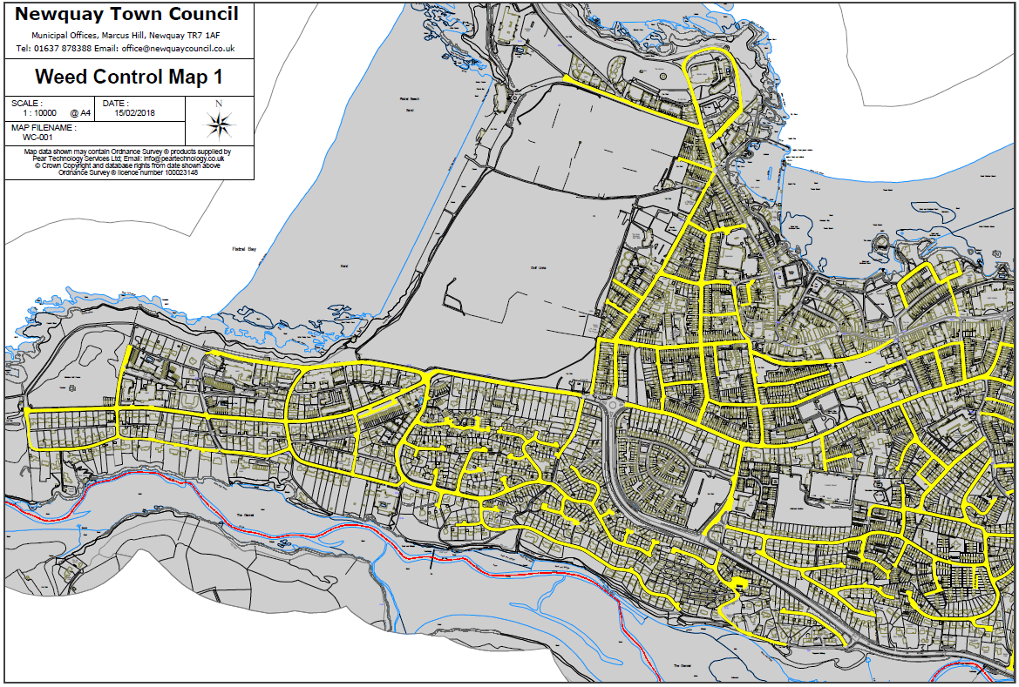

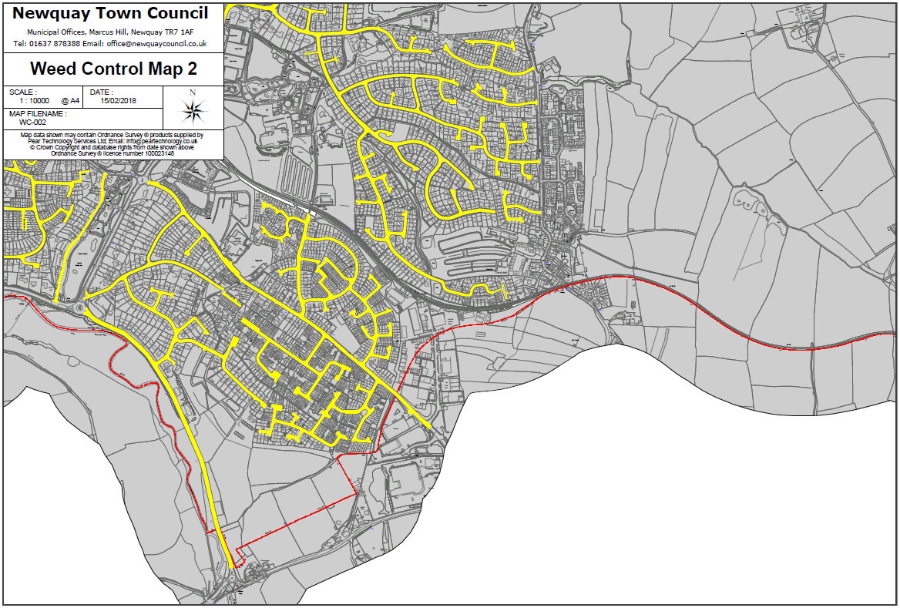

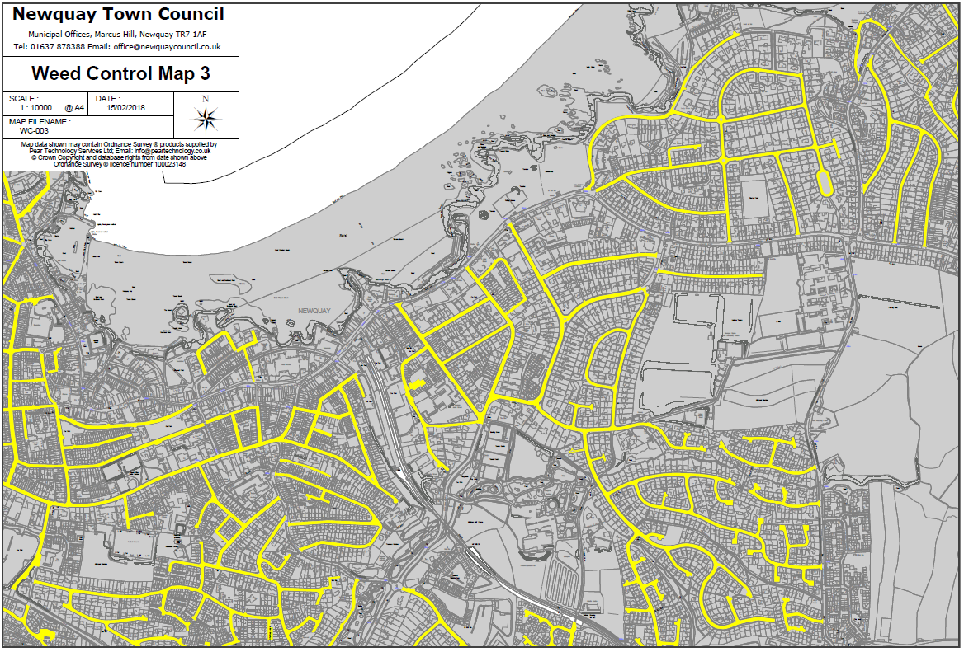

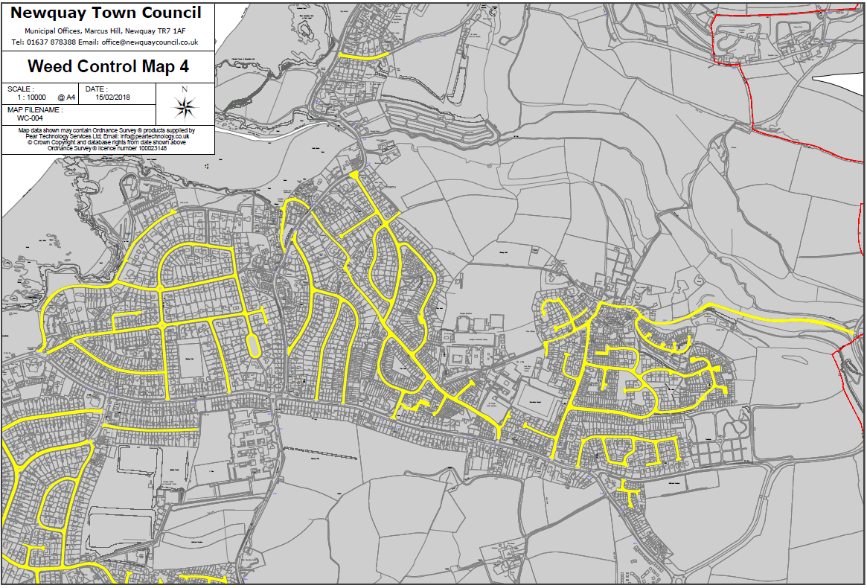

Section 6 The Pricing Document

All prices shall be stated in pounds sterling and exclusive of VAT.

|  |  |  |
| --- | --- | --- |
| **Weeding of Category A Highways** | **Estimate of length of highway which can be weeded (in km)** | **Cost £** |
| **Day Rate** |  | **£** |
| **Half Day Rate** |  | **£** |
| **Weeding of Category B Highways** | **Estimate of length of highway which can be weeded (in km)** |  |
| **Day Rate** |  | **£** |
| **Half Day Rate** |  | **££** |
| **Weeding of Category C Highways** | **Estimate of length of highway which can be weeded (in km)** |  |
| **Day Rate** |  | **£** |
| **Half Day Rate** |  | **££** |
| **Weeding of Unclassified Highways** | **Estimate of length of highway which can be weeded (in km)** |  |
| **Day Rate** |  | **£** |
| **Half Day Rate** |  | **££** |

Section 7 The Quality Assessment

|  |
| --- |
| 1. **Understanding of the Council’s Brief *(10%)***   Please demonstrate your understanding of the Council’s brief outlining proposals on how the project will be managed and delivered. |
|  |
| **2. Experience of the team *(10%)***  Provide details of the team who will be used to deliver the services described in the specification and how their knowledge and experience gained on other projects referenced in section 4 of the questionnaire will be utilised to deliver this contract. |
|  |
| **3. Evidence of Supplier’s ability to respond quickly should problems arise during the display period *(5%)***  Please give information and evidence of the response times expected if any issues should occur during the spraying periods. Please include details of emergency (same day) response processes and non-emergency (next working day) response processes. |
|  |
| **4. Health and Safety and Risk Management processes *(10%)***  Include details of Health and Safety considerations and risk management processes.  Include in your response:   * your methodologies for testing and using all required equipment * Example risk assessment |
|  |
| **5. Project Delivery and Programme *(10%)***  Please demonstrate how you are able to ensure the works are completed on time.  Please include in your response a programme with key milestones. |
|  |
| **6. Promotion and Protection of the Environment *(15%)***  Please demonstrate how the methods you are using are safe in the natural environment. Include in your response:   * With your chosen control method, what impact does it have on the Environment (if any). * Have you explored using alternatives to your chosen method? If not, why and outline your reasoning. |
|  |

PART C - SCHEDULES

Schedule 1 - Form of Quotation and Declarations

**Request for Quotation Which Does Not Include a Formal Deed of Agreement**

Having examined the Request for Quotation and its accompanying documents (which I/we shall keep) and being satisfied as to my/our abilities and experience in all respects to satisfy the requirements of the Contract.

Offer to provide or supply upon the terms and conditions of the contract contained in Appendix 1 in its present form the Services for the prices on the quoted Pricing Document as indicated below for the contract period :-

|  |  |
| --- | --- |
| Pricing Document attached | YES / NO |

and/or during the contract period at the price ascertained under the terms and conditions of contract.

I/We understand and agree that your written letter of acceptance of our Quote shall constitute the making of a binding contract between us.

I/We understand that the information provided in this quotation document and any supporting information provided by us will be relied upon and taken to be true and accurate. If it is subsequently determined that any information supplied was inaccurate, I/we understand and accept that Council reserves the right to exclude our offer to supply (if still under evaluation) or if the Contract has been awarded and the information inaccurately supplied had a significant bearing on the award, that Council shall be at liberty to terminate the Contract.

I/We understand that you are not bound to accept the lowest or any Quote you may receive.

Signed……………………………………………………………………………..

Date ……………………………………………………………………………….

in the capacity of ……………………………………………………………….

duly authorised to sign for and on behalf of

(in BLOCK CAPITALS) ………………………………………………………….

Telephone No. ……………………………………………………………………

Postal Address ……………………………………………………………………

Schedule 2 - Commercially Sensitive Information

The Authority may be obliged to disclose information in or relating to this Quotation following a request for information under the Freedom of Information Act (FOIA) or Environmental Information Regulations (EIR). Please outline in the table below items which you consider are confidential and genuinely commercially sensitive and which should not be disclosed in respect of your Quotation.

I declare that I wish the following information to be designated as Commercially Sensitive.

|  |
| --- |
|  |

The reason(s) it is considered that this information should be exempt under Freedom of Information Act FOIA) or Environmental Information Regulations (EIR) is:

|  |
| --- |
|  |