Supporting information to aid the development of tender documents by potential contractors

Introduction
This document comprises a synopsis of the 2024 Geosyntec report entitled ‘Lines of Evidence to Assess the Effectiveness of PFAS Remediation Technologies’. The purpose of this synopsis is to provide a level of consistency across the board for potential contractors wishing to bid for this current project.
Appendix 1 shows the table of contents of the Geosyntec report and the outline below gives a little more detail of both the literature review aspect (Sections 1-4) but more importantly the Lines of Evidence Approach (Sections 5-6) that we are proposing to develop as part of this project. If you wish to submit a bid for this project and require a full copy of the report, please contact Kirsty Darby (Senior Advisor, Groundwater) on kirsty.darby@environment-agency.gov.uk

Sections 1-4: Introduction and Literature Review
These sections provide a short introduction putting the project into context in terms of land contamination and Environmental Permitting, followed by a literature review of PFAS remediation technologies. The review splits the technologies both by the media they are treating (liquids or solids) and by whether they are field demonstrated or more in-development technologies. We are aware that remediation technologies, particularly for PFAS and emerging contaminants is a fast moving industry and whilst there may be some changes required to this section, the principles of the Lines of Evidence Approach will remain the same.
Section 4 focuses on treatment trains and their use and benefit for PFAS remediation.

Section 5 & 6: Lines of Evidence and Evaluation Framework
These sections describe in detail the Lines of Evidence that we are using internally when looking at remediation options appraisals or remediation strategies for PFAS contaminated sites.
The first aim of this current project is to take this approach, socialise it internally within the EA and upskill our staff so they are confident in using the approach.
The second aim of this current project is to socialise the approach externally with industry and embed the approach as business and usual when developing PFAS remediation options appraisals and remedial schemes.
Section 5 describes Lines of Evidence that have been developed to assist the Environment Agency with evaluating proposed PFAS remediation technologies and approaches. The Lines of Evidence were developed within the context of general and site-specific goals and objectives, consistent with the state of practice for PFAS treatment technologies, and cognisant of current data gaps and technology limitations. The Lines of Evidence described in this section can be referred to by EA regulators for more details during a site-specific and technology specific evaluation utilizing the PFAS remediation technology evaluation framework that is described in Section 6.
Each Line of Evidence is used to initiate a thorough thought process by the user, whether that is a site consultant, remediation contractor or regulator.

Lines of Evidence to consider:
- Protection of Human Health and the Environment - these Lines of Evidence allow the reviewer to understand under what conditions the technology or treatment train will be applied and whether the approach addresses the contaminated site in its entirety.
  - The technology or treatment train can effectively treat the PFAS of concern to acceptable concentrations.
  - The technology or treatment train does not have an adverse impact on the environment.
  - Construction, operation, and maintenance of the technology or treatment train does not pose an unacceptable risk to human health.
  - The technology or treatment train effectively remediates the PFAS of concern and comprises a complete approach (i.e., proposed technology(s) are complementary and additional technologies are not needed).
  - If disposal of PFAS-impacted media is required, an appropriate disposal site protective of human health and the environment is accessible.

- Feasibility and Cost Effectiveness - by considering these Lines of Evidence, evaluators can understand if the technology or treatment train is feasible to implement at a site, how the approach fits into a broader remedial strategy, and whether evaluations of cost effectiveness are comprehensive.
  - The estimated timeframe to achieve remedial objectives with the chosen technology or treatment train is acceptable.
  - Site access limitations for implementing the technology or treatment train are understood and manageable.
  - The technology or treatment train is effective given the spatial location and extent of the PFAS-impacted material.
  - Long-term studies evaluating this technology or treatment train with similar site conditions have been performed.
  - Supply limitations of materials, equipment, and skilled labour have been considered and are acceptable.
  - Discharge permits, waste disposal, utility requirements and other site resources are understood for the technology or treatment train.
  - The site is adequately characterised to implement the technology or treatment train effectively.
  - The technology or treatment train performance and cost has been evaluated based on site-specific treatability studies or similar site conditions.
  - Technology or treatment train capital, operation, and maintenance costs are well understood.
  - The technology or treatment train cost includes the cost of pre-treatment, posttreatment, or other technologies needed to meet remedial objectives (i.e., costs are comprehensive).
  - Post-remediation monitoring requirements are understood for the technology or treatment train.

- Public and Regulator Acceptance - these Lines of Evidence consider how the implementation and use of the technology or treatment train will influence public, regulator, and other stakeholder preferences.
  - The technology or treatment train has been previously and successfully employed at a site(s) within the regulatory framework.
  - The consultant or vendor has previously and successfully employed the technology or treatment train at a PFAS site(s).
  - Public preferences regarding technology or treatment train selection and implementation are addressed (e.g., preference for a destructive technology, concerns over air emissions).
  - Access and operation restrictions (e.g., business, residential, transportation) during technology or treatment train implementation or operation are acceptable to stakeholders.
  - Future site restrictions that may result from technology or treatment train employment are understood and are acceptable to stakeholders.
  - Permitting requirements for the technology or treatment train are understood.

- Sustainability - These LOE frame out sustainability aspects for consideration during selection and implementation.
  - The technology or treatment train meets SuRF-UK’s sustainability framework for site-specific implementation.
  - Energy requirements from the technology or treatment train’s construction, operation, and maintenance are understood.
  - Greenhouse gas emissions from the technology or treatment train’s construction, operation, and maintenance are understood.
  - Passive or renewable energy sources can be used to power the technology or treatment train. Lines of Evidence PFAS Remediation 26 28 February 2024
  - Technology or treatment train chemical requirements (e.g., solvents) are understood.
  - Waste generated from the technology or treatment train is acceptable (e.g., quantity, hazardous nature, disposal options).
  - The technology or treatment train does not adversely impact the natural state of the site (e.g., nutrient depletion, geochemical changes, erosion potential).
  - Technology or treatment train vulnerabilities associated with anticipated climate change impacts are understood.

- Co-Contaminants, Mechanisms and By-Products - These LOE will allow the evaluator to identify if there are concerns related to by-product formation or inability to remediate target classes of PFAS.
  - The technology or treatment train can effectively treat PFAS in the presence of site co-contaminants, if present, including NAPL.
  - The technology or treatment train can effectively treat precursors for the PFAS of concern.
  - The technology or treatment train does not volatilise PFAS of concern or captures and effectively treats volatilised PFAS of concern.
  - The technology or treatment train does not produce hydrofluoric acid or effectively manages hydrofluoric acid.
  - The technology or treatment train treatment kinetics and mechanisms are understood.
  - A PFAS mass balance has been demonstrated for the technology or treatment train in a matrix similar to the site matrix.
  - If PFAS are transformed, PFAS are converted to fluoride or other inert terminal products. Lines of Evidence PFAS Remediation 27 28 February 2024
  - The longevity and stability of technology or treatment train removal mechanisms are well understood.
  - Non-PFAS by-products, including volatile organic products, have been identified, quantified, and are acceptable for the site.

- Ex-Situ Liquids Treatment Technologies - An evaluator can use these Lines of Evidence to assess whether the proposed ex situ remediation technology design is appropriate for the site and identify data gaps or questions pertaining to the technology’s ability to remediate PFAS can be identified using these Lines of Evidence.
  - The technology is effective for the required liquids flow rate.
  - The technology prevents transport of PFAS within the liquid media and to/from other media.
  - The footprint of the treatment technology can be accommodated by the site. Lines of Evidence PFAS Remediation 28 28 February 2024
  - The technology is effective for PFAS given the liquid water quality, including organic content, inorganic constituents, pH, turbidity, and co-contaminants.
  - The technology is effective given seasonal changes in conditions (e.g., groundwater levels, groundwater flow directions).
  - The approach effectively contains or otherwise mitigates the source of PFAS to the liquids (e.g., saturated soils, infiltration through vadose zone).
  - The technology does not require pre-treatment (e.g., particle filtration, organics removal) or pre-treatment has already been incorporated into the proposed approach.
  - The technology does not require post-treatment (e.g. neutralization) or post-treatment has already been incorporated into the proposed approach.
  - Discharge options (e.g., reinjection, surface water discharge, wastewater treatment plant discharge) have been evaluated and the proposed option is feasible. If waste material leaves the site, risk and potential liabilities associated with waste handling and placement are understood

- Ex-Situ Solids Treatment Technologies - A reviewer for an ex-situ solids treatment technology for PFAS will need to consider whether the technology will work effectively for the given matrix composition and site conditions. Additional considerations relate to the treatment technology’s effectiveness in immobilizing or destroying PFAS without unintended PFAS transformations or volatile emissions.
  - Excavation-related risks such as dust generation and materials handling have been satisfactorily addressed.
  - The technology is effective for the volume of solids requiring treatment.
  - The technology is effective for PFAS treatment given the organic matter content, grain size distribution, moisture content, porosity, or other characteristics of the soil or sediment.
  - The solid material does not require pre-treatment (e.g., dewatering, amendments) or pre-treatment has already been incorporated into the proposed approach.
  - The solid material does not require post-treatment or post-treatment has already been incorporated into the proposed approach.
  - The footprint of the treatment technology can be accommodated by the site. Lines of Evidence PFAS Remediation 29 28 February 2024
  - Reuse or disposal options for the treated solids are understood. If solid media leaves the site, risk and potential liabilities associated with solids handling and placement are understood.

- In-Situ Liquids Technologies - After evaluating each of the preceding LOE, the evaluator will have an understanding of the suitability of the in-situ technology for site conditions, and if PFAS in liquids can be effectively remediated.
  - The technology is effective for PFAS given the liquid water quality, including organic content, and co-contaminants.
  - The technology is effective given the transmissivity/permeability of the aquifer material.
  - If the technology involves adding/mixing media, there are not long-term degradation concerns or these have been addressed through long-term monitoring and contingency plans.
  - The technology prevents transport of PFAS within the liquid media and to/from other environmental media.
  - The technology is effective at ambient temperatures or heating requirements and controls are understood and practical.
  - The technology is effective given seasonal changes in conditions (e.g., groundwater levels, groundwater flow directions).
  - The technology effectively mitigates the source of PFAS to the liquids (e.g., upgradient groundwater, vadose zone soil)

- In-Situ Solids Technologies - In situ technologies need to be well understood for the conditions of the site that they are being implemented. Solids with a different porosity and co-contaminants will influence if physical/ chemical treatment methods, biological treatment methods, or high temperature methods are effective at remediating PFAS efficiently.
  - The technology is effective for PFAS treatment given the organic matter content, moisture content, and porosity of the soil or sediment.
  - If the technology involves adding/mixing media into soils, there are not long-term degradation concerns or these have been addressed through long-term monitoring and contingency plans.
  - Dust generation is not expected or will be addressed via dust control measures and dust monitoring.
  - The technology is effective at ambient temperatures or heating requirements and controls are understood and practical. The technology is effective given seasonal changes in conditions (e.g., groundwater levels).
  - The technology prevents PFAS transport from the soil or sediment to surface water, groundwater, or other media

Section 6 describes the evaluation framework specifically:
Part 1 of the framework outlines its summary and purpose and includes a conceptual diagram of the framework (Figure 1). As shown in the figure, the framework has two LOE categories: General Lines of Evidence and Technology-Specific Lines of Evidence. The General LOE category is comprised of 5 subcategories that are applicable to any treatment technology or treatment train. The Technology-Specific LOE category is comprised of 4 subcategories that are specific to the implementation of the technology, in situ or ex situ, and the media it is targeting, solids or liquids. For a standalone PFAS treatment technology, an evaluator will go through each of the General LOE subcategories and choose only one Technology-Specific LOE subcategory that corresponds to the proposed technology. For a treatment train, an evaluator will go through each of the General LOE subcategories for the treatment train system in its entirety and go through the Technology-Specific LOE subcategory that corresponds to each proposed individual PFAS treatment technology within the treatment train.

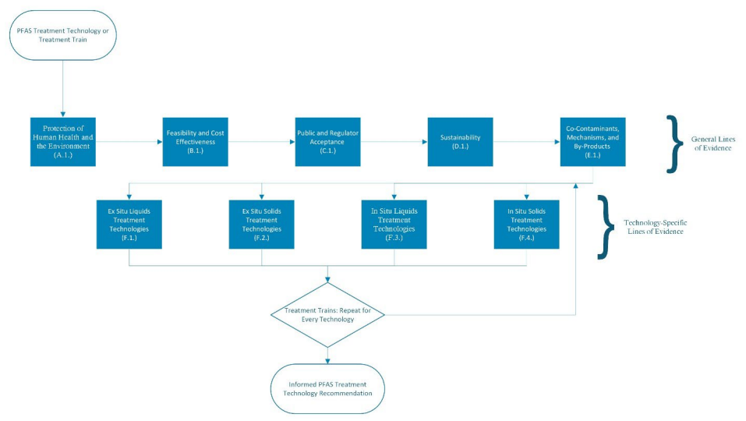
PFAS Remediation Technology Evaluation Framework – Conceptual Diagram

Part 2 of the framework includes checklists containing LOE and good practices. Each section of the checklist can be noted as “Applicable” or “Non-Applicable,” but not all LOE in an applicable category may be applicable to the specific technology being evaluated. There is a “SiteSpecific Notes & Clarifications” box at the top of each section for general notes and clarifications pertaining to a section in its entirety. Each LOE in a section has four possible responses: high feasibility/known, intermediate feasibility/some information, low feasibility not known, or not applicable. There is a “Notes” box for each LOE and good practice to provide specific notes and clarifications. Note application sections can be collapsed for ease of framework navigation (see Section 4 of the framework).

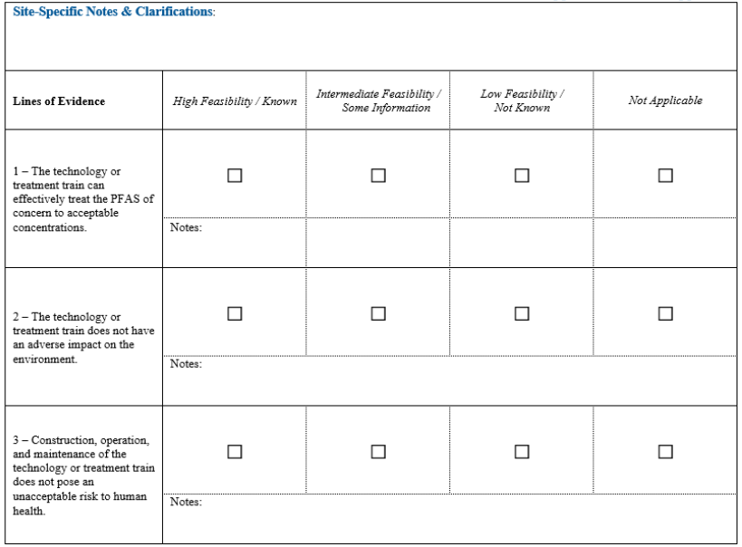
PFAS Remediation Technology Evaluation Framework - Checklist

Appendix 1 – Table of contents of the Lines of Evidence Report (Geosyntec, 2024)
Table of Contents
- Introduction
  - Land Contamination Context
  - Environmental Permitting Context

- Field Demonstrated PFAS Remediation Technologies
  - Field Demonstrated Liquids Treatment Technologies
    - Granular Activated Carbon
    - Ion Exchange Resin
    - Reverse Osmosis
    - Membrane Filtration
    - Colloidal Activated Carbon
    - Foam Fractionation
  - Field-Demonstrated Solids Treatment Technologies
    - Incineration
    - Excavation and Disposal
    - Sorption and Stabilisation
    - Soil Washing

- In-Development PFAS Remediation Technologies
  - In-Development Liquids Treatment Technologies
    - Sorption Technologies
    - Precipitation/Coagulation/Focculation
    - Chemical Oxidation and Reduction
    - Hydrothermal Alkaline Treatment
    - Biodegradation
  - In-Development Solids Treatment Technologies
    - Smouldering Combustion
    - Ball Milling

- Treatment Trains for PFAS Remediation
  - Treatment Train Benefits and Utility
  - Treatment Train Case Studies
    - Foam Fractionation and Ion Exchange
    - Granular Activated Carbon and Ion Exchange
    - Ion Exchange and Plasma
    - SAFF®, Polymer adsorbents, Ion Exchange, HALT and SCWO
    - PFAST®, HALT, SCWO and UV/SGM

- Lines of Evidence to Assess the Effectiveness of PFAS Remediation Technologies
  - Approach
  - Lines of Evidence
    - Protection of Human Health and the Environment
    - Feasibility and Cost Effectiveness
    - Public and Regulator Acceptance
    - Sustainability
    - Co-Contaminants, Mechanisms and By-Products
    - Ex-Situ Liquids Treatment Technologies
    - Ex-Situ Solids Treatment Technologies
    - In-Situ Liquids Technologies
    - In-Situ Solids Technologies
- PFAS Remediation Technology Evaluation Framework
  - Summary and Purpose of Framework
  - Description of the Framework
  - Expected Outcomes of the Framework
- Conclusions
- References

