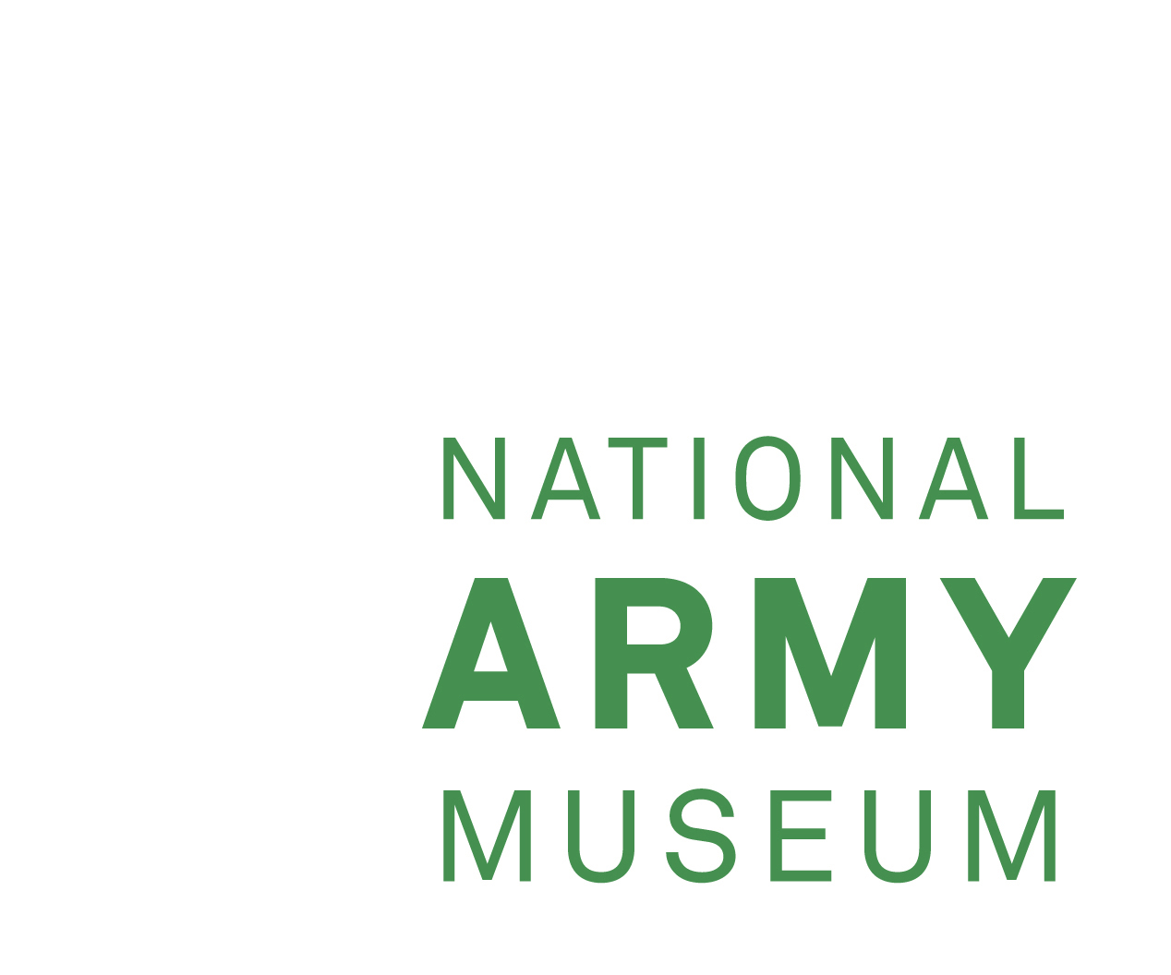

Invitation to Tender for Recruitment Services

Background
Transformed through a £23.75 million investment at its site in Chelsea, the National Army Museum’s (NAM’s) mission is to provide a museum experience that meets the widest range of public need and connects the British public with its Army.
Through five new galleries the public can explore what it’s like to be a soldier, why we fought in conflicts – past and present, and explore British society’s relationship with its army.
The Museum holds world-class collections relating to the British Army over the last 400 years and is supported by a well-developed Collections facility at Stevenage as well as online/digital resources.

The Museum is a Royal Charter Body and a Registered Charity (No 237902). It is
Also an Executive NDPB (Non-Departmental Public Body), with the Ministry of
Defence as its Government Sponsor Department, through which it receives annual
grant-in-aid. There is an annual operating budget in the region of £7.1 million of
which £6 million is Grant in Aid. The Museum’s governing body is the Council of the
National Army Museum, whose non-executive Members carry out the functions of
Charity Trustees.

Requirements
The National Army Museum is seeking to appoint a suitably qualified and experienced recruitment consultant to facilitate the appointment of a new Museum Director General.

The Director General is responsible to the Museum Council for the operation of the Museum and on matters of policy, and to the Permanent Under-Secretary of State at the MOD in respect of financial regularity and propriety of grant in aid expenditure; (the Director General is the Museum Accounting Officer and is answerable to Parliament for the proper stewardship of public funds).

The Director General is responsible for all persons working at the Museum on a permanent or term contract basis, including employees, volunteers and contractors; all of the Museum’s premises, assets and moveable property - including the collections.

Job Description and Person Specification
Background information, Job Description and Person Specification available.

Timetable
The successful candidate will ideally be in post by November 2017.

Tender Response Format
The tender should include the methods that will be used to source candidates, timescales, and full costs for services provided.

Please forward your tender by email or post by 12pm (Noon) on Tuesday 27 June 2017, which should be sent to:

Marked In Confidence:

Recruitment Tender for the attention of Mr J Foster

Email: jfoster@nam.ac.uk
Address: National Army Museum
Royal Hospital Road
Chelsea
London
SW3 4HT

Information received after the mentioned date and time will not be used in the selection process.

Contact
To discuss our requirements in more detail, please contact Teresa Scott, Assistant Director (Human Resources) on 020 7881 2444 or email tscott@nam.ac.uk

