
Katie Goble
Navy Commercial
MP1.1
Navy Command Headquarters
Leach Building
Whale Island
Portsmouth
PO2 8BY

Telephone: 03001575849
Email: katie.goble100@mod.gov.uk

08 December 2020

Dear Sir / Madam

Invitation to Tender Reference 701314413

1. You are invited to tender for the Provision of High Pressure (HP) & Low Pressure (LP) air refurbishment in competition in accordance with the attached documentation.

2. The requirement is set out in the Statement of Requirements.

3. Funding has been approved. The total budget is £41,667.67 (excluding VAT).

4. You may raise questions about the tender and the requirement by contacting the Commercial Officer. The deadline for asking questions is 17 December 2020. Please note that any questions raised, and the answers provided, may be shared with other interested suppliers.

5. Your tender must be submitted no later than 10:00 on 05 January 2021, by email to the Commercial Officer shown above. You should allow sufficient time for submission as late tenders will not be accepted.

6. The anticipated date for the contract award decision is 21 January 2020. Please note that this is an indicative date and may change.

- There will be a Tenderers Conference and Site Visit on 16 December 2020. Any requests to attend should be confirmed by 14 December 2020.

- The Tender submission checklist confirms what is required and what should be included with your tender email.

Yours faithfully

Katie Goble
Commercial Manager

TENDERERS CONFERENCE

A Tenderers Conference will take place on Wednesday 16 December 2020.
The event will commence at HMS Collingwood in the afternoon of Wednesday 16 December. This will include a tour of the relevant parts of the Collingwood site with an opportunity to raise questions.
Due to COVID-19 measures, each tenderer will be restricted to one attendee only, with a limit on the total numbers of attendees.
Tenderers are not mandated to attend the event and answers to any questions raised will be provided to all Tenderers following the event.
Requests to attend the event can be made by emailing the Tenderers Conference Attendees Form to the Commercial Officer by 17:00 Monday 14 December 2020.
Times and further information will be provided prior to the event once all attendees are confirmed.
The Authority will not be able to provide accommodation for this event.

Tenderers Conference Attendees Form
Tenderer Name
Tenderer Contact Name
Tenderer Contact Number
Attendee Full Name
Attendee Date of Birth
Attendee Vehicle Registration, Model & Colour

TENDER SUBMISSION CHECKLIST

Tenderer Name

Tenderer is a Small or Medium Enterprise  (Tick relevant box) | YES | NO

Tick to confirm | Element
Written proposal included detailing how you intend to deliver the requirement
(if proposal contains any prices, a separate copy with prices removed is also included)

 | Annex A – Tender Offer completed and signed
 | Purchase Order completed and signed
 | Statement Relating to Good Standing completed and signed
 | Schedule of Requirements detailing prices completed
 | DEFFORM 68 – Hazardous Articles completed
 | All Terms & Conditions accepted unconditionally and no requests to amend or add will be made after tender submission
 | Payment in arrears though the CP&F/Exostar online payment system accepted
 | All requirements can be delivered/provided within the required timescales
 | Any security or accreditation requirements can be met by contract commencement date
 | Bank and/or Parent Company Guarantee can be provided, if requested
 | Supplier Assurance Questionnaire has been submitted online and copy of response included in tender. A Cyber Implementation Plan has also been completed if you do not meet the Cyber Risk level

INVITATION TO TENDER

Ministry of Defence

Invitation to Tender (ITT)

Less Complex Requirements

(Competitive)

To: | ITT Reference No: 701314413  ITT Issue Date: 08 December 2020  Due for return by (Due Date): 05 January 2021
From: Navy Commercial

Address: MP1.1, NCHQ, Leach Building, Whale Island, Portsmouth, PO2 8BY
Commercial Officer: Katie Goble

Telephone: 03001575849
Email:katie.goble100@mod.gov.uk

This ITT consists of:

- Invitation to Tender – Less Complex Requirements Competitive.
- Annex A - Offer.
- Annex B - Tender Evaluation Criteria.
- Special Notices and Instructions to Tenderers.
- Purchase Order, including the Schedule of Requirements.
- Statement of Requirements.
- MOD Terms and Conditions for Less Complex Requirements.
- DEFFORM 68 (see Clause 9 of Terms and Conditions).
- Statement Relating to Good Standing.
- Cyber Risk Assessment.

The Tenderer must return:

- Completed Annex A to this ITT.
- Completed Purchase Order.
- Any other documentation requested in the Tender submission checklist.

Notices To Tenderers
- You are invited to tender, in accordance with the following Conditions, for the supply of Deliverables detailed in the accompanying ITT Material. The issue of an ITT is not a commitment by the Secretary of State for Defence - ‘the Authority’ - to place an order as a result of the tendering exercise or at a later stage. Any expenditure, work or effort undertaken prior to an offer of contract and acceptance thereof, is a matter solely for the commercial judgement of your company. The Authority reserves the right to:
  - undertake an iterative tendering process following receipt of the tender;
  - waive or change the requirements of this ITT from time to time without prior (or any) notice being given by the Authority;
  - seek clarification or documents in respect of a Tenderer's submission;
  - disqualify any Tenderer that does not submit a compliant tender in accordance with the instructions in this ITT;
  - disqualify any Tenderer that is guilty of serious misrepresentation in relation to its tender, expression of interest, the PQQ or the tender process;
  - withdraw this ITT at any time, or to re-invite tenders on the same or any alternative basis;
  - choose not to award any Contract as a result of the current procurement process; and / or
  - make whatever changes it sees fit to the timetable, structure or content of the procurement process, depending on approvals processes or for any other reason.

Publicity Announcement
- Tenderers are advised that the MOD may wish to publicise the award of the Contract for the requirement described in the Schedule of Requirements in the attached Purchase Order.
- Any Tenderer who wishes to make a similar announcement, either coincident with or subsequent to the MOD's announcement, should contact the Authority’s Representative (Commercial Officer) named in the Purchase Order. The content of any announcement a successful Tenderer may wish to make must be cleared in writing and in advance by the MOD Authority’s Representative (Commercial Officer) named in the Purchase Order who shall liaise with the MOD Security branch responsible for clearance of publicity material for open publication.
- If the notice inviting tenders was advertised in Contracts Finder, the MOD will publish the following information on the Contract awarded unless the MOD decides that there are specific and valid reasons for not doing so:
- Contractor’s Name;
- Nature of the Deliverables to be supplied;
- Award criteria;
- Rationale for Contract award;
- Total price of the Contract awarded.
- Under no circumstances should a successful Tenderer(s) confirm to any third party the fact of their acceptance of an offer of Contract prior to informing the MOD of their acceptance, and / or ahead of the MOD's announcement of the award of Contract.

Codes of Practice
- The attention of Tenderers is drawn to the agreements that have been reached by the MOD / Industry Commercial Policy Group (CPG) on Codes of Practice. The Codes of Practice are intended to demonstrate a commitment by the MOD and its suppliers to the establishment of better working relationships in the supply chain, based upon openness and trust. The opportunity also exists for Tenderers to advertise any subcontracts valued at over £10,000 in the Defence Contracts Online and further details can be obtained directly from:

BiP Solutions Ltd
Web address: ‘www.contracts.mod.uk’
Tel No: 0141 270 7329

Submission of Tender
- Tenderers must:
- Sign and date Part A (but not Part C) (“Effective date”) of the Offer and Acceptance box on both copies of the Purchase Order, scan and return them both as PDFs, as part of their Tender. The Terms and Conditions are to be kept by the Tenderer for their records.
- Complete the Consignor Box with the name and address of the Consignor where the MOD stipulates that the Deliverables will be transported by the MOD (as defined in the Purchase Order under the Transport Instructions box);
- Complete the Schedule to the Purchase Order by populating the Delivery Date column (if stated to do so), the Firm Price (£) Ex VAT sub columns (Per Item and Total inc. packing), finally completing the Total Firm Price at the bottom of the Schedule.
- Sign, scan and return the Tender form, at Annex A to this Invitation to Tender – Less Complex Requirements – Competitive Procurement, as a PDF, as part of their Tender.
- Provide any further information requested in this Invitation to Tender.
- Your Tender must be submitted electronically to the email address stated in the covering letter no later than the date and time stated above. The Authority reserve the right to reject any Tender received after the stated date and time. Hard copy, paper or delivered digital Tenders (e.g. DVD) are no longer required and will not be accepted by the Authority. You must provide one priced copy of your Tender and one unpriced copy. You should ensure that there are no prices present in your unpriced copy.
- You must ensure that your completed SC1A ITT Comp Annex A is signed, scanned and included with your tender, with the SC1A Purchase Order and Schedule of Requirements as a PDF. Your Tender must be compatible with MSWord and other MSOffice applications.
- Not used.
- The email return address is security accredited to OFFICIAL-SENSITIVE. Material that is protectively marked above this classification must not be submitted.
- If you intend to submit any ITAR or Export Controlled information as part of your Tender, you must notify the Commercial Officer before you submit your Tender.
- If you have any difficulty submitting your tender or if you have any questions with regards to the tendering exercise itself, please contact the MOD Commercial Officer named above.
- Any request for an extension of the period for tendering must be received at least four (4) Business Days before the tender return date. Any extension will be at the sole discretion of the Authority and if granted will be granted to all Tenderers. Correspondence connected with your tender which requires attention before the tender return date, or communications stating that no tender will be submitted, should be sent in a separate envelope bearing no external reference to the ITT Reference No. or return date, addressed to the Authority’s Representative (Commercial) as stated above. This procedure is designed to preserve equity between Tenderers by ensuring that no premature disclosure of tender details can take place.
- No useful purpose is served by enquiring about the result of this ITT. Tenderers will be notified of the Authority’s decision as early as possible.

Formation of Contract
- Once the evaluation process has been completed, the Tenderers will be notified of the outcome of the competition and the name of the successful Tenderer. The Authority’s Representative (Commercial) stipulated on the Purchase Order will accept the successful tender by signing and dating Part B of the Offer and Acceptance box of the Purchase Order and dating Part C to signify the Effective Date i.e. the date of the Contract. The Effective Date shall be no earlier than the date of acceptance of the tender and shall allow a reasonable time for the acceptance to be communicated to the Contractor. One copy of the completed Purchase Order will then be returned to the Contractor to be attached to their copy of the Terms and Conditions.

Instruction to Tenderers

- Small and Medium-sized Enterprises The Authority is committed to supporting the Government’s small and medium-sized enterprise (SME) initiative; its ambitious target is that every £1 in every £3 that the Government spends should be with small businesses by 2020. Our goal is that 25% of MOD spending should be spent with SMEs by 2020; this applies to the money which the MOD spends directly with SMEs and through the supply chain. The Authority uses the European Commission definition of an SME.
A key aspect of the Government’s SME Policy is ensuring that its suppliers throughout the supply chain are paid promptly. All suppliers to the Authority and their sub-contractors are encouraged to make their own commitment and register with the Prompt Payment Code.
Suppliers are also encouraged to work with the Authority to support the Authority’s SME initiative. Information on the Authority’s purchasing arrangements, our commercial policies and our SME policy can be found at Gov.UK.

- Price In order to facilitate the comparison of tenders, the prices quoted for the Deliverables and Packaging must reflect the terms of the Purchase Order and be set out in strict accordance with the requirements of the Schedule to Purchase Order.

- Orders for Parts of the Tender The Authority reserves the right, unless the Tenderer expressly states that parts of the tender may not be accepted separately in their tender, to order some or all of the Deliverables stated in the Schedule to the Purchase Order.

- Alternative Conditions The Tenderer shall comply with the notices and instructions set out in this ITT and submit a tender compliant with the MOD Terms and Conditions for Less Complex Requirements. Any offer made subject to additional or alternative contractual conditions will not be considered and will be rejected on the grounds of those conditions alone.

- Tender Evaluation The tender evaluation shall be carried out in accordance with the Evaluation Criteria stated in the ITT tender documentation. The Authority can only evaluate those things stated in your tender.

- Alteration to Purchase Order Any alteration to the Purchase Order suggested by the Tenderer e.g. an alternative Delivery offer, should be effected by striking through the original entry and inserting the alternative adjacent to it. The Tenderer’s attention is, however, drawn to paragraphs 3 to 5 above.

- Completion of Tender

a. In the event of a Deliverable appearing more than once in the attached Schedule of Requirements, whether separately or as part of an assembly, the Tenderer is requested to quote on the basis of the total quantity for that Deliverable.

b. The Tenderer should ensure that their tender is clear and in a form which will allow the Authority to take copies for evaluation purposes.

- Tenders for Selected Deliverables Tenders need not necessarily be for all the Deliverables listed in the Schedule to the Purchase Order. The words “No Tender” should be inserted in the price column against items for which no offer is made.

- Bid costs You will bear all costs associated with preparing and submitting your Tender. If the Tender process is terminated or amended by the Authority, the Authority will not reimburse you.

- ITT Material

  - ITT Material means information (including for example, drawings, handbooks, manuals, instructions, specifications and notes of pre-tender clarification meetings, in whatever form or medium, patterns and samples) issued to you by the Authority or on its behalf, or to which you have been given access, for the purposes of responding to this ITT. ITT Material remains the property of the Authority or other owners and is released solely for the purpose of tendering. The Tenderer shall notify the Authority’s Representative (Commercial Officer) without delay if any additional ITT Material is required for the purpose of tendering. The Tenderer shall be responsible for the safe custody and due return of ITT Material, and shall be responsible for all loss or damage sustained while in their care, and until re-delivered to the Authority.

  - Return of ITT Material In the event that a recipient of ITT Material decides not to participate in the submission of a tender, the ITT Material shall be returned to its place of issue without delay. If a tender is submitted to the Authority, the ITT Material may be retained by the Tenderer until the result of the competition is known. In the event that the Tenderer's bid is unsuccessful the ITT Material shall be returned to its place of issue without delay at the prospective Tenderers cost.

  - Intellectual Property Rights in ITT Material The Intellectual Property Rights in ITT Material may belong to the Authority or a third party. The ITT Material may only be used for the purpose of responding to this ITT and shall not be copied, or disclosed to anyone other than employees of the Tenderer involved in the preparation of the tender, without the prior written approval of the Authority. If the Tenderer discloses the ITT Material other than to employees involved in the tender preparation, or uses the ITT Material other than for the purpose of tendering, the Authority, or the third party owner, may suffer damage for which compensation may be sought from the Tenderer.

  - Confidentiality Agreements Some or all of the ITT Material issued in connection with this ITT may already be the subject of Confidentiality Agreements. The provisions of such agreements are in addition to, and not in substitution for, any obligations arising from receipt of or access to ITT Material under the terms of this ITT, and the provisions of sub-paragraphs 10.a - c above.

- Samples

a. Where it is indicated in Annex B that samples may be required for evaluation, the Tenderer must be prepared to submit them without charge. Samples should be clearly
labelled with the following particulars:

- The Tenderer's name and address.

- The ITT Reference Number and tender return date.

- Description and Item Number as shown in the Schedule to the Purchase Order.

b. The Authority shall retain all samples for twelve (12) months. After this period the Authority shall destroy the samples unless you specifically state you require their return. The sample of any subsequent contracts shall be kept indefinitely.

- Notification of Inventions etc.

  - The Tenderer acknowledges that their prices shall include the use of any intellectual property rights which they own or control to the extent that their use is required for the performance of any resultant Contract. The Tenderer also acknowledges that their prices include subsequent use by the Authority of anything delivered under the Contract.

  - In their tender the Tenderer shall notify the Authority of:
- any invention or design the subject of patent or registered design rights (or application therefore) of which the Tenderer is aware , and;
- any other restriction (including any export requirement or restriction) as to disclosure or use or obligation to make payments in respect of intellectual property (including technical information) to which the Tenderer is subject, and;
- any allegation of infringement of intellectual property rights made against the Tenderer;
which pertains to or appears to be relevant to the performance of any resultant Contract or to subsequent use by the Authority of anything required to be done or delivered under any resultant Contract.

  - The Tenderer shall, at the request of the Authority, give the Authority particulars of every restriction and obligation referred to in sub-paragraph 12.b.(2). above.

  - If the information required under this Paragraph 12 has been provided previously, the Tenderer may satisfy these requirements by giving details of the previous notification.

- The Montreal Protocol As a signatory to the Montreal Protocol on Substances that deplete the Ozone Layer, Her Majesty's Government is committed to the reduction of the production and consumption of those substances controlled under the Protocol. The Tenderer must therefore state whether their response will involve the use of any or all of the substances outlined in Regulation (EC) No 2037/2000 of the European Parliament and of the Council of 29 June 2000 on substances that deplete the ozone layer. A full version of the regulations including the comprehensive list of controlled substances can be found at:

http://ozone.unep.org/new_site/en/montreal_protocol.php

The Tenderer must also provide full details of that use, including where this relates to packaging) or submit a “NIL RETURN”.

- Hazardous Deliverables and Substances It is a condition of this ITT that where the ITT calls for, or the Tenderer proposes, the use of Hazardous Deliverables or substances, the Tenderer shall provide with his tender a completed Safety Data Sheet in accordance with Clause 9 of the Terms and Conditions. Failure to comply fully with this condition may result in the tender being deemed non-compliant thus rendering it ineligible for further consideration by the Authority.

- Elimination Of Asbestos It is a condition of this ITT that the Deliverables shall not incorporate asbestos of any kind. The Tenderer will confirm this by signing and returning the tender form at Annex A to this ITT as part of their tender.

- Transparency, Freedom of Information and Environmental Information Regulations

  - Tenderers should be aware that, if they are to be awarded the Contract, the content of the Contract may be published by the MOD to the general public in line with government policy set out in the Prime Minister’s letter of May 2010 (https://www.gov.uk/government/policies/improving-the-transparency-and-accountability-of-government-and-its-services).

  - Before publishing the Contract, the MOD will redact any information which would be exempt from disclosure if it was the subject of a request for information under the Freedom of Information Act 2000 (“the FOIA”) or the Environmental Information Regulations 2002 (“the EIR”).

  - The FOIA and the EIR provide a more general statutory right of access to information held by or on behalf of public authorities, including information provided by third parties such as suppliers. This right of access is subject to a number of exemptions, including confidential information and commercially sensitive information. Further details of MOD policy on FOIA and EIR can be found on the Acquisition Operating Framework (https://www.aof.mod.uk/aofcontent/tactical/toolkit/index.htm click on "Commercial Toolkit" then "MOD Commercial Management" then "Freedom of Information").

  - In order to assist the MOD in applying the exemptions in the FOIA and the EIR, Tenderers should complete the appropriate Tenderer’s Commercially Sensitive Information box in the Purchase Order, explaining which parts of their tender they consider to be sensitive or confidential. Tenderers are also requested to include in the box the details of a named individual who may be contacted with regard to this information.

  - Tenderers should note that, while their views will be taken into consideration, the ultimate decision whether to publish or disclose information provided to the MOD lies with the MOD. Tenderers are advised to give as much detail as possible on the Form. It is highly unlikely that a contract will be exempt from disclosure in its entirety. Should the MOD decide to publish or disclose information against the wishes of a Tenderer, the Tenderer will be given prior notification.

- Consultation with Credit Reference Agencies The Authority may consult credit reference agencies to assess the creditworthiness of a Tenderer. Information on creditworthiness may be used by the MOD to support and influence decisions to enter into business with a Tenderer.

- Conflicts of Interest

a. MOD policy states that it is sometimes in the MOD’s wider business interests to
allow suppliers to operate on both the client and supply side. Conflicts of Interest (Col) can occur outside of direct commercial relationships between the MOD and its suppliers and therefore all personnel involved in acquisition (both Authority and Tenderer) should be familiar with the Conflicts of Interest Commercial Policy Statement (CPS).

b. Accordingly, Tenderers shall notify immediately the Authority of any current or potential Col relating to the requirement and shall give particulars of every instance.

c. Where the Authority permits the Tenderer or any entity within the Tenderer’s potential supply chain or any entity providing advisory services to the Tenderer or its potential supply chain to work on both the client and supply side, the Contractor shall, as a legally binding agreement or Condition of Contract, be required to:

(1) Adopt a formally agreed, legally binding, Compliance Regime (CR) between the Authority and the Contractor. This shall include but not be limited to:

(a) Manner of operation and management;

(b) Roles and responsibilities;

(c) Standards for integrity and fair dealing;

(d) Levels of access to and protection of competitors sensitive information and Government Furnished Information;

(e) Confidentiality / Non-Disclosure Agreements (NDA’s)(e.g. DEFFORM 702);

(f) The Authority rights of audit;

(g) Physical and Managerial separation.

(2) Identify potential or actual Conflicts of Interest;

(3) Investigate breaches.

- Canvassing Any Tenderer who directly or indirectly seeks to persuade any officer, member, employee, or agent of the MOD concerning this procurement except by responding to this ITT or who directly or indirectly obtains or attempts to obtain information from any such officer, member, employee or agent of the MOD concerning any other Tenderer, tender or proposed tender concerning this procurement before the end of the selection process will be disqualified from consideration for this procurement.

- Collusive Behaviour The Tenderer’s attention is drawn to the requirements of the Competition Act 1998, Part 1. Any Tenderer found to have been part of a ‘Concerted Practice’ or ‘Agreement’, the purpose of which was to prevent, restrict or distort competition, shall be disqualified from consideration from this procurement. Disqualification will be without prejudice to any civil remedy available to the Authority or criminal liability which the conduct of the Tenderer may attract.

- Bribery Any Tenderer who offers to pay or give or does pay or give any sum or sums of money, inducement or valuable consideration directly or indirectly to any party for doing or having done or causing or having caused to be done, any act or omission concerning this tender shall be disqualified. Disqualification will be without prejudice to any civil remedy available to the Authority or criminal liability which the conduct of the Tenderer may attract.

22. Authority Remedies for Breach of Contract Tenderers should be aware of the contractual remedies set out at clause 17 of the Terms and Conditions of the Contract which may apply in the event of a breach of contract by the Contractor. Damages for breach of contract are not limited under the Contract. However Tenderers should also note under Clause 17 that in exercising its rights and remedies under the Contract the Authority must act in a reasonable and proportionate manner having regard to the nature and consequences of the breach of contract. If Tenderers are unsure about the potential liability under the Contract, they should seek advice as appropriate.
23. Confidential Information. All Central Government Departments and their Executive Agencies and Non Departmental Public Bodies are subject to control and reporting within Government, in particular, they report to the Cabinet Office and HM Treasury for all expenditure. Further, the Cabinet Office has a cross-governmental role delivering overall Government policy on public procurement, including ensuring value for money and related aspects of good procurement practice.
For these purposes, the Authority may share within Government any of the Contractor’s documentation / Information (including any that the Contractor considers to be confidential and / or commercially sensitive such as specific bid information) submitted by the Contractor to the Authority during this Procurement. The Information will not be disclosed outside Government. Contractors taking part in this competition must identify any sensitive material in the DEFFORM 539A and consent to these terms as part of the competition process.
24. Cyber Essentials Accreditation For all new requirements advertised from 1st January 2016 which entail the transfer of MOD identifiable information from customer to supplier or the generation of information by a supplier specifically in support of the MOD contract, MOD will require suppliers to have a Cyber Essentials certificate by the contract start date at the latest, and for it to be renewed annually. This requirement must be flowed down the supply chain.
In this context ‘information’ means any information in any written or other tangible form disclosed to one party by or on behalf of the other party under or in connection with the Contract, including information provided in the tender or negotiations which preceded the award of the Contract.
Please notify the Authority as soon as you become aware of any issues with Supply Chain ability to comply with Cyber Essentials.

THE TENDERER MUST SIGN AND RETURN ONE COPY OF SC1A ITT Comp (Annex A)
WITH THEIR TENDER

ANNEX A –
TENDER OFFER

Annex A
SC1A ITT Ref No 701314413

Ministry of Defence

TENDER

To the Secretary of State for Defence (hereinafter called "the Authority")
The undersigned Tenderer having read the Invitation to Tender – Less Complex Requirements – Competitive Procurement and accompanying Conditions of Contract, offers to supply the Deliverables (to the extent which the Authority may determine in ordering the Deliverables ) at the price or prices and at the time or times stated and in accordance with any drawings and / or specifications stated in the Purchase Order and subject the above mentioned MOD Terms and Conditions.

The following additional information is provided:

Notification of Inventions
Please state below details invention or design, other restriction and any allegation of infringement specified in Paragraph 12.b and 12.d (continue on a separate sheet if necessary).

The Montreal Protocol
Please state below details of the use of substances specified in Paragraph 13, or state “NIL RETURN” (continue on a separate sheet if necessary).
Asbestos
By signing this Offer, the Contractor confirms that the Deliverables do not incorporate asbestos as specified in Paragraph 15

Premises where Contract will be performed (if applicable)
The Deliverables, or any part of them supplied under this Contract resulting from this tender will be manufactured and or bought in from premises detailed below:

Value of Tender (excluding VAT)
Total cost of Deliverables, including packaging, required computed at the Tenderer's quoted price £

Total value of tender (to be repeated below in WORDS) £

(WORDS: )

Value Added Tax
If registered for Value Added Tax purposes, please insert

a. Registration No

b. Total amount of Value Added Tax payable on this tender (at current rate(s)) £

Transparency
Should the Tenderer be awarded a Contract resulting from this tender, it understands that the Authority may publish the content of the Contract to the general public. The Commercially Sensitive Information which forms part of the Purchase Order is completed to assist the Authority in applying the appropriate exemptions in the FOIA and the EIR.

- We certify that the offer made in connection with the above tender is intended to be genuinely competitive. No aspect of the price has been fixed or adjusted by any arrangement with any third party. , Arrangement in this context includes any transaction or agreement, private or open, or collusion, formal or informal, and whether or not legally binding. In particular:
  - the offered price has not been divulged to any third party person,
  - no arrangement has been made with any third party that they should refrain from tendering,
  - no arrangement with any third party has been made to the effect that we will refrain from bidding on a future occasion,
  - no discussion with any third party has taken place concerning the details of either’s proposed price, and
  - no arrangement has been made with any third party otherwise to limit genuine competition.
- We understand that any instances of illegal cartels, market sharing arrangements or other anti-competitive practices, suspected by the Ministry of Defence will be referred to the Competition and Markets Authority for investigation and may be subject to action under the Competition Act 1998 and the Enterprise Act 2002.
- We understand that any misrepresentations may also be the subject of criminal investigation or used as the basis for civil action.
- We agree that the Authority may share the Contractor’s information / documentation (submitted to the Authority during this procurement) more widely within Government for the purpose of ensuring effective cross-Government procurement processes, including value for money and related purposes. We certify that we have identified any sensitive material in DEFFORM 539A.

Dated this day of Year
Signature: In the capacity of
(State official position e.g. Director, Manager, Secretary etc.)
Name: (in BLOCK CAPITALS)  duly authorised to sign this tender for and on behalf of:  (Tenderer's Name) | Postal Address:  Telephone No:  Telex No:  Fax No:  Email:

ANNEX B –
TENDER EVALUATION CRITERIA

Section D – Tender Evaluation Criteria

- This section details how your Tender will be evaluated.

- The Tender evaluation will assess the Most Economically Advantageous Tender (MEAT) to The Authority based on the following calculation:

Evaluation Score = Total Price
Technical Score

- Any Tender which is considered non-compliant for any Commercial, Financial and Technical element or criteria will be excluded from the competition and not receive an Evaluation Score.

- Evaluation Scores will be rounded to two decimal places. The Tenderer with the lowest Evaluation Score will be considered to be the Winning Tenderer and awarded any resulting contract.

- In the event that multiple Tenderers achieve the exact same lowest Evaluation Score, then the Tenderer with the lowest Total Price will be considered to be the Winning Tenderer. In the event that multiple Tenderers achieve the exact same lowest Evaluation Score and have the exact same lowest Total Price, then The Authority reserves the right to request those, and only those, Tenderers to submit final and best Total Prices, with the lowest final and best Total Price considered to be the Winning Tenderer.

- Tenders will be evaluated based on the contents of the Tender only. Technical Evaluation will be undertaken independently from Commercial and Financial Evaluations. Technical evaluators will have no knowledge of associated prices.

- Should any exclusions, assumptions, dependencies or caveats apply to your Tender or any of the goods and/or services that you would provide when delivering the requirements, these should be clearly indicated in the relevant areas of the Tender.

Commercial Evaluation

- The Commercial Evaluation will assess if:

- the Tender was received by the due date and time.
- Tender Offer Annex A was submitted.
- the Schedule of Requirements, indicating the breakdown of prices, was submitted.
- all Terms & Conditions have been accepted.
- the Statement of Good Standing was submitted.
- all other requested DEFFORMs were submitted.
- the Tenderer can meet the required delivery dates.
- the Supplier Assurance Questionnaire (and Cyber Implementation Plan, if required) was submitted.

- A Tender may be considered non-compliant if:

- any of the items detailed in D8 are not provided.

- The Authority reserves the right to undertake a financial health check of Tenderers as part of the Commercial Evaluation. Any Tenderer receiving below 10 on a general health check may be considered non-compliant.

- In the event that a Parent Company or Bank guarantee is requested and is not provided, The Authority retains the right to consider the Tenderer non-compliant.

Financial Evaluation

- The Financial Evaluation will assess the Total Price the Tenderer has offered to deliver all the requirements set out in the Statement of Requirements.

- The Total Price should be entered on the Schedule of Requirements and confirmed on DEFFORM 47 Annex A. This shall be the total maximum cost for the provision of all requirements (goods and/or services) set out in the Statement of Requirement for the full maximum duration of the requirement, including any optional services and periods.

- Tenderers are notified that when the contract is in place, payments for goods and/or services will be made after the goods and/or services have been fully delivered. For example, payment for purchase of an item will be made after it has been delivered and installed or payment for annual maintenance of a piece of equipment will be made at the end of the contract year during which the maintenance was undertaken.

- A Tender will be considered non-compliant if:

- the Total Price is greater than the total available funding of £41,667.67; or
- the Tender does not indicate a Total Price; or
- the Tender has not provided prices for the all items in the Schedule of Requirements.

Technical Evaluation

- The Technical Evaluation will assess how much confidence the Tender gives The Authority, that the Tenderer can meet and deliver the requirements set out in the Statement of Requirements.

- The Technical Evaluation will allocate points to a set of evaluation criteria. These criteria will also be weighted, with the points allocated to each individual criteria being multiplied by the associated weight to give a score for that individual criteria. The points, weightings and scores available for each criteria are indicated in the Technical Criteria Table. Guidance on how Tenders will be scored is in the Scoring Criteria Table.

- The scores awarded for each individual criteria will be added together to give the Technical Score.

- Technical evaluators are considered to be Subject Matter Experts (SME) on the Statement of Requirements. If an individual criteria is evaluated by more than the one SME, then an overall moderated points figure will be agreed between the evaluators for that criteria. This moderated points figure will be used for the purposes of the evaluation.

- A Tender will be considered non-compliant if:

- the Tender receives points which are below the threshold set for any individual criteria; or
- the Tender receives a Total Score below 60

- Technical Criteria Table
Figure | Criteria | Points Available | Minimum Threshold | Points Awarded | Weight | Score Available | Score Awarded
1 | To what extent does the tender satisfy the criteria in the Statement of Requirement | 0, 30, 70 or 100 | 30 |  | 40.00% | 40.00
2 | To what extent does the tender indicate they can meet the delivery date | 0, 30, 70 or 100 | 30 |  | 15.00% | 15.00
3 | To what extent does the tender indicate the required health and safety measures are in place | 0, 30, 70 or 100 | 30 |  | 25.00% | 25.00
4 | To what extent does the tender indicate personnel hold the level of certifications required and these can be provided by the winning tenderer | 0, 30, 70 or 100 | 30 |  | 20.00% | 20.00
 | Technical Score |  |  |  |  | 100

- Scoring Criteria Table

Pass | Fail
In the Authority’s opinion the tender response (where relevant to the criteria): | In the Authority’s opinion the tender response (where relevant to the criteria):
clearly details how the requirement will be met in full and sufficient evidence has been provided where required. | does not clearly detail how the requirement will be met in full and sufficient evidence has not been provided where required.
clearly shows that any required volumes, timescales, standards and support will be met. | Does not clearly show that any required volumes, timescales, standards and support will be met.

100 – High Confidence  In the Authority’s opinion the tender response (where relevant to the criteria): | 70 – Good Confidence  In the Authority’s opinion the tender response (where relevant to the criteria): | 30 – Moderate Confidence  In the Authority’s opinion the tender response (where relevant to the criteria): | 0 – Low Confidence  In the Authority’s opinion the tender response (where relevant to the criteria):
addresses and demonstrates a thorough understanding of all elements of the requirement. | addresses and demonstrates an understanding of all elements of the requirement. | addresses and demonstrates an understanding of most of the elements of the requirement | does not address or demonstrate an understanding of most of or all of the requirement
provides a comprehensive, unambiguous and thorough explanation of how all of the requirement will be delivered. | provides sufficient detail and explanation of how all of the requirement will be delivered. | is weak in some areas and does not fully detail or explain how some elements of the requirement will be delivered. | does not demonstrate the ability to deliver some or all of the requirement.
details a thorough explanation of how the full volume of the requirement and all required timescales will be met. | shows sufficient ability to meet the full volume of the requirement and all required timescales. | indicates that most of the requirement will be met but may be lacking detail about volumes or timescales. | does not show that the volume of the requirement and the timescales will be met.
provides comprehensive details showing how all the requirements will be managed with sufficient resource allocated and support provided for the full duration. | provides sufficient information to show how all the requirements will be managed with adequate resource allocated and support provided for the full duration. | provides some details of how the requirements will be managed but leaves concerns about the resource and support provided.  . | does not provide details of how most or all of the requirements will be managed or that the required resource and support will be provided.
comprehensively details how the requirements will be assured and how all quality or standards expected will be met in full | sufficiently details how the requirements will be assured and how the quality or standards expected will be met in full | provides some details of how the requirements will be assured but leaves doubt about the quality or standards | does not demonstrate that the required standards or quality will be met.
has comprehensively considered risks to delivery of the requirement and thoroughly explained how they will be eliminated or mitigated | has considered risks to delivery of the requirement and adequately indicated how they will be eliminated or mitigated | has considered risks to some of the requirement but leaves concerns that there are risks that have not been considered or may not be mitigated | has identified and addressed few or no risks to delivery.

- Evaluation Example Table

The following table provides an example of how Tenders may be evaluated/scored and is for illustrative purposes only. The number of questions and potential points/scores do not necessarily reflect the exact Technical Scores and Scoring Criteria for this particular requirement or how Tenders for this requirement will be evaluated. This example is based on a procurement with 2 pass/fail criteria, 5 scored criteria each with a minimum threshold of 30 and funding of £250,000.
Figure | Weight |  | Tender 1 Points | Tender 1 Score |  | Tender 2 Points | Tender 2 Score |  | Tender 3 Points | Tender 3 Score |  | Tender 4 Points | Tender 4 Score
A | N/A |  | Pass | Pass |  | Pass | Pass |  | Pass | Pass |  | Pass | Pass
B | N/A |  | Pass | Pass |  | Fail | Fail |  | Pass | Pass |  | Pass | Pass
1 | 30.00% |  | 100 | 30.00 |  | 100 | 30.00 |  | 100 | 30.00 |  | 70 | 21.00
2 | 25.00% |  | 70 | 17.50 |  | 100 | 25.00 |  | 30 | 7.50 |  | 100 | 25.00
3 | 18.00% |  | 100 | 18.00 |  | 30 | 5.40 |  | 100 | 18.00 |  | 70 | 12.60
4 | 15.00% |  | 100 | 15.00 |  | 0 | 0.00 |  | 100 | 15.00 |  | 100 | 15.00
5 | 12.00% |  | 100 | 12.00 |  | 100 | 12.00 |  | 100 | 12.00 |  | 100 | 12.00
Technical Score |  |  |  | 92.50 |  |  | 72.40 |  |  | 82.50 |  |  | 81.10
Technical Compliance |  |  |  | Compliant |  |  | Non-Compliant |  |  | Compliant |  |  | Compliant
Total Price |  |  |  | 240,000 |  |  | 215,000 |  |  | 275,000 |  |  | 210,000
Financial Compliance |  |  |  | Compliant |  |  | Compliant |  |  | Non-Compliant |  |  | Compliant
Commercial Compliance |  |  |  | Compliant |  |  | Compliant |  |  | Compliant |  |  | Compliant
Evaluation Score |  |  |  | 2594.59 |  |  | 0.00 |  |  | 0.00 |  |  | 2589.40

In this example, Tender 2 was non-compliant as it did not meet the minimum threshold for Technical Criteria B and 4. Tender 3 was as non-compliant as the Total Price exceeded the funding available. Tender 4 is the Winning Tenderer, as it had the lowest Evaluation Score and was compliant for all Commercial, Financial and Technical criteria.

SPECIAL NOTES AND INSTRUCTIONS TO TENDERERS

Invitation to Tender

Special Notices and Instructions to Tenderers

1. The contents of this Invitation to Tender must not be disclosed to un-authorised persons and must be used only for the purposes of tendering.

2. In addition to the Notices and Instructions specified elsewhere in the Invitation to Tender (ITT) the following shall also apply:

Off payroll working rules (IR35) do not apply to this engagement.

A Cyber Risk Assessment has been raised for this requirement under Assessment number RAR-C38UC7MV. The associated Cyber Risk Profile is ‘very low’’.

All potential suppliers who submit a Tender must also complete a Supplier Assurance Questionnaire against this Cyber Risk Assessment. A Supplier Assurance Questionnaire can be completed online at https://supplier-cyber-protection.service.gov.uk/help/scp/completesaq. A copy of the completed Questionnaire should be submitted with your tender.

Suppliers can register to view the Assessment and submit their Questionnaire at https://supplier-cyber-protection.service.gov.uk/organisation/register

Further guidance on the Cyber Risk process can be found in the Cyber Security Model Industry Buyer and Supplier Guide at https://assets.publishing.service.gov.uk/government/uploads/system/uploads/attachment_data/file/718566/20180203_Cyber_Industry_Buyer_and_Supplier_Guide_v2_1.pdf

Please note that if your Supplier Assurance Questionnaire score does not meet the level set in the Cyber Risk Assessment, this does not prevent you from submitting a Tender. In these circumstances, you should complete and submit a Cyber Implementation Plan which will demonstrate what actions you would be able to take to meet that level. if you are subsequently awarded the contract, the actions in the Cyber Implementation Plan would then need to be undertaken to ensure that you meet the necessary cyber requirements once the contract has commenced.

Cyber Implementation Plan Template

MOD contract number: | 701314413
CSM Risk Acceptance Reference: | RAR-C38UC7MV
CSM Cyber Risk Profile: | very low
Name of Supplier:
Current level of Supplier compliance:
Reasons unable to achieve full compliance:
Measures planned to achieve compliance / mitigate the risk with dates:
Anticipated date of compliance / mitigations in place:

PURCHASE ORDER



PURCHASE ORDER

Contract No: 701314413

Contract Name: Provision of High Pressure (HP) & Low Pressure (LP) air refurbishment

Dated: 08 December 2020

Supply the Deliverables described in the Schedule to this Purchase Order, subject to the attached MOD Terms and Conditions for Less Complex Requirements (up to £122,979).

Contractor | Quality Assurance Requirements (Clause 8)

Name:

Registered Address:

Consignor (if different from Contractor’s registered address) | Transport Instructions (Clause 10)
Name:  Address: | Select method of transport of Deliverables  To be Delivered by the Contractor  To be Collected by the Authority  Each consignment of the Deliverables shall be accompanied by a Delivery Note

Progress Meetings (Clause 13) | Progress Reports (Clause 13)
The Contractor shall be required to attend the following meetings:  To be arranged if and when required unless already detailed in Statement of Requirements. | The Contractor is required to submit the following Reports:  To be arranged if and when required unless already detailed in Statement of Requirements.

Payment (Clause 14)

Payment is to be enabled by CP&F.

Forms and Documentation | Supply of Hazardous Deliverables (Clause 9)
Forms can be obtained from the following websites:  https://www.aof.mod.uk/aofcontent/tactical/toolkit  (Registration is required).  https://www.gov.uk/government/organisations/ministry-of-defence/about/procurement#invoice-processing  https://www.dstan.mod.uk/  (Registration is required).  The MOD Forms and Documentation referred to in the Conditions are available free of charge from:  Ministry of Defence, Forms and Pubs Commodity Management  PO Box 2, Building C16, C Site  Lower Arncott  Bicester, OX25 1LP  (Tel. 01869 256197 Fax: 01869 256824)  Applications via email:  DESLCSLS-OpsFormsandPubs@mod.uk  If you require this document in a different format (i.e. in a larger font) please contact the Authority’s Representative (Commercial Officer), detailed below. | A completed DEFFORM 68 and, if applicable, Safety Data Sheet(s) are to be provided by email with attachment(s) in Adobe PDF or MS WORD format to:  a. The Commercial Officer detailed in the Purchase Order, and  b. DSA-DLSR-MovTpt-DGHSIS@mod.uk  by the following date:  or if only hardcopy is available to the addresses below:  Hazardous Stores Information System (HSIS)  Defence Safety Authority (DSA)  Movement Transport Safety Regulator (MTSR)  Hazel Building Level 1, #H019  MOD Abbey Wood (North)  Bristol BS34 8QW

DEFFORM 111
(Edn 12/17)
Appendix - Addresses and Other Information
 | - Commercial Officer:  Name: Katie Goble  Address: MP1.1, NCHQ, Leach Building, Whale Island, Portsmouth, PO2 8BY  Email: katie.goble100@mod.gov.uk  03001575849 |  | 8. Public Accounting Authority:  1. Returns under DEFCON 694 (or SC equivalent) should be sent to DBS Finance ADMT – Assets In Industry 1, Level 4 Piccadilly Gate, Store Street, Manchester, M1 2WD  44 (0) 161 233 5397  2. For all other enquiries contact DES Fin FA-AMET Policy, Level 4 Piccadilly Gate, Store Street, Manchester, M1 2WD   44 (0) 161 233 5394
 | - Project Manager, Equipment Support Manager or PT Leader (from whom technical information is available):  Name:  Address:  Email   |  | 9. Consignment Instructions:  The items are to be consigned as follows:  As detailed in Schedule of Requirements
 | - Packaging Design Authority:  Organisation and point of contact:  (where no address is shown please contact the Project Team in Box 2)   |  | 10. Transport. The appropriate Ministry of Defence Transport Offices are:  A. DSCOM, DE&S, DSCOM, MoD Abbey Wood, Cedar 3c, Mail Point 3351, BRISTOL BS34 8JH  Air Freight Centre  IMPORTS 030 679 81113 / 81114 Fax 0117 913 8943  EXPORTS 030 679 81113 / 81114 Fax 0117 913 8943  Surface Freight Centre  IMPORTS 030 679 81129 / 81133 / 81138 Fax 0117 913 8946  EXPORTS 030 679 81129 / 81133 / 81138 Fax 0117 913 8946  B. JSCS  JSCS Helpdesk  01869 256052 (option 2, then option 3); JSCS Fax No 01869 256837 www.freightcollection.com
- (a) Supply/Support Management Branch or Order Manager
Branch/Name:

As per section 2

(b) U.I.N.
 | - Drawings/Specifications are available from: |  | 11. The Invoice Paying Authority:  Ministry of Defence 0151-242-2000  DBS Finance  Walker House, Exchange Flags Fax: 0151-242-2809  Liverpool, L2 3YL Website is: https://www.gov.uk/government/organisations/ministry-of-defence/about/procurement#invoice-processing
 | - Intentionally Left Blank
 | - Quality Assurance Representative:  Commercial staff are reminded that all Quality Assurance requirements should be listed under the General Contract Conditions.  AQAPS and DEF STANs are available from UK Defence Standardization, for access to the documents and details of the helpdesk visit http://dstan.uwh.diif.r.mil.uk/ [intranet] or https://www.dstan.mod.uk/ [extranet, registration needed] |  | 12. Forms and Documentation are available through *:  Ministry of Defence, Forms and Pubs Commodity Management  PO Box 2, Building C16, C Site  Lower Arncott  Bicester, OX25 1LP (Tel. 01869 256197 Fax: 01869 256824)  Applications via fax or email: Leidos-FormsPublications@teamleidos.mod.uk
* NOTE
1. Many DEFCONs and DEFFORMs can be obtained from the MOD Internet Site: https://www.aof.mod.uk/aofcontent/tactical/toolkit/index.htm

2. If the required forms or documentation are not available on the MOD Intranet site requests should be submitted through the Commercial Officer named in Section 1.

Contractor’s Commercially Sensitive Information (Clause 5). Not to be Published

Description of Contractor’s Commercially Sensitive Information:

Cross reference to location of sensitive information:

Explanation of Sensitivity:

Details of potential harm resulting from disclosure:

Period of Confidence (if Applicable):

Contact Details for Transparency / Freedom of Information matters:

Name:

Position:

Address:

Telephone Number:

E-Mail Address:

Offer and Acceptance
A) The Purchase Order constitutes an offer by the Contractor to supply the Deliverables. This is open for acceptance by the Authority for 90 days from the date of signature. By signing the Purchase Order the Contractor agrees to be bound by the attached Terms and Conditions for Less Complex Requirements (up to £122,979)  Name (Block Capitals):  Position:  For and on behalf of the Contractor:  Authorised Signatory ……………………………..  Date: | B) Acceptance  Name (Block Capitals):  Position:  For and on behalf of the Authority:  Authorised Signatory …………………………….  Date:

C) Effective Date of Contract:

SCHEDULE OF REQUIREMENTS

Schedule of Requirements

Deliverables
Item Number | MOD Stock Reference No. | Part No. (where applicable) | Specification | Consignee Address Code | Packaging Requirements inc. PPQ and DofQ | Delivery Date  (estimated dates to be confirmed on contract award) | Total Qty | Firm Price (£) Ex VAT
 |  |  |  |  |  |  |  | Per Item | Total  (including packaging, delivery and any applicable import charges)
1 |  |  | Provision of HP and LP Air Refurbishment Services as outlined in the Statement of Requirement | XY | 00 | January 2021-  March 2021 | 1
 |  |  |  |  |  |  |  | Total Firm Price
Item Number | Consignee Address (XY code only)
All | HMS Collingwood

Item Number | Payment Schedule
1 | Payment to be made following delivery and installation

STATEMENTS OF REQUIREMENTS

Statement of Requirements

TP1268 – High Pressure (HP) & Low Pressure (LP) air refurbishment

- A requirement has been identified to refurbish the HP & LP air system in Marlborough Building (667).

- The current HP and LP air installations within Marlborough Building are legacy installations with components over 30 years old. The pipework transferring the HP air from the Defence Infrastructure Organisation (DIO) plant room to the classrooms is degrading and regularly requires repair on the many seals within the system. The fragility within the air system pipework is impacting on both career and equipment maintenance courses, causing delays and cancellations.

- The installation is not to commence until the Authority to Proceed is obtained from the Training Equipment Project Management Team (TEPMT) Project Manager (PM).

- The outline of this requirement is detailed in table 1 and should be read against table 2 and annexes. All works are to comply with JSP375 part 2 vol3 chapter 4 where applicable.

Requirement | Description | Annex
1 | Refurbish the 3 x training boards in room K5C. | A
2 | Refurbish the HP air bottle control board in room K5C lab 1. | B
3 | Install HP air bottle into room K5C lab 2. | C
4 | Replace all pipework from valve FV2 to room K5C and room H4. | D
5 | Remove HP air system in room H8. | E
6 | Install double block & bleed valve isolations in rooms K1, K5C and H4. | F
7 | Set-to-work, commission and present the HP air system. | N/A

Table 1 – outline of requirements

- Quote must include a scheme of works which must detail installation time frames. The principle requirements must be met as detailed in table 1 below.

Req. No | Requirement | Priority | Remarks
1 | Refurbish the 3 x training boards in room K5C.
1.1 | Refurbish HP air training boards in K5C lab 1 and lab 2 (3 boards in total) to serviceable condition. | M | Utilise Hale Hamilton supplied component service kits. Admiralty pipework to be replaced with modern COTS (e.g. Swagelok) industrial fittings.
1.2 | Ensure training boards provide following outputs:  - 500 psi (automatically reduced)  - 100 psi (manually reduced) | M
2 | Refurbish the HP air control board in room K5C lab 1.
2.1 | Refurbish HP air control boards in K5C lab 1 to serviceable condition. | M | Utilise Hale Hamilton supplied component service kits. Admiralty pipework to be replaced with modern COTS (e.g. Swagelok) industrial fittings.
3 | Install HP air bottle into room K5C lab 2.
3.1 | Remove HP air bottle and bracket from room H8 and install in room K5C lab 2 | M
3.2 | Refurbish HP air storage bottle drain valve board in lab 2 to serviceable condition and. | M | Utilise Hale Hamilton supplied component service kits. Admiralty pipework to be replaced with modern COTS (e.g. Swagelok) industrial fittings.
3.3 | Connect HP air bottle into HP air system and drain valve. | M | COTS industrial fittings (e.g. Swagelok) to be used.
3.4 | Recertify HP air storage cylinder. | M
3.5 | Ensure drain valve provides 3000psi output. | M
4 | Replace all pipework from valve FV2 to room K5C and room H4.
4.1 | Replace all pipework from valve FV2 to input valve of training boards 1,2 & 3 in room K5C lab 1 and lab 2 and room H4. | M | COTS industrial fittings (e.g. Swagelok) to be used.
4.2 | Replace all pipework and components from valve FV2 to flexible hose connection (from Typhoon compressor). | M | COTS industrial fittings and components (e.g. Swagelok) to be used.
5 | Remove HP air equipment in room H8.
5.1 | Remove all HP air components, backboards and pipework from room H8 and connecting pipework to room H4. | M | HP air bottle and bracket to be relocated to room H5C lab 2 (see requirement 3). HP air components to be returned to the Authority. Connecting pipework to be disposed of appropriately.
6 | Install double block & bleed valve isolations in rooms K1, K5C and H4.
6.1 | Supply & install double block & bleed valve isolation suitable for local tag-out process. | M | Double block & bleed isolation positions:  - Install in place of FV2 room K1  - Install at input to HP air control board in room K5C Lab 1.  - Install at input to MTLS air panel in room H4
7 | Set-to-work, commission and present the HP air system.
7.1 | System to be commissioned and presented to MCTA for an engineering check prior to acceptance. | M | Written Scheme of Examination to be amended to reflect changes made to the system.

Table 2 – principle requirements

- Priority definitions are detailed in table 3 below.

Priority | Definition
M | Mandatory requirements represent legal obligations and must be met.

Table 3 – priority definitions

- Additional requirements:

  - Any person or body performing work of any type on RN compressed air or gas systems or equipment’s must have the necessary practical knowledge and resources to perform the task. Resources deemed necessary include all relevant technical information (design codes, design details/tolerances, corrosion allowances, test procedures), special tools, calibration and test equipment.

  - All work shall be carried out in accordance with current Regulations & standards appertaining to the type of work undertaken.

  - The contractor shall supply all tools and lifting equipment (with current certification) and any other equipment as necessary to complete this task.

  - The whole of the work covered by this specification shall be undertaken without MoD assistance unless otherwise stated.

  - All materials required to carry out the task shall be supplied by the contractor unless otherwise stated.

  - Contractors are to be available at installation inspections that are conducted by external authorities, (eg SCIDA, MCTA).

  - Contractors are to be able to work unescorted within the establishment either through having the appropriate security clearance (e.g. Security Check (SC) or Baseline Personnel Security Standard (BPSS)) or providing their own escorts that have the appropriate security clearance, unless otherwise stated.
  - Prior to commencement of any work by contractors on site they must conduct a site induction brief (4 Cs) with the Training Equipment Installation Coordinator (TEIC). The safety brief is site generic and the brief is valid for a period of up to 12 months. The contractor must carry the 4Cs card issued by TEIC at all times when working on site and be able to produce the card upon request. A site (building) specific brief must be obtained from the building manager or training unit prior to work commencing.

  - TEPMT TEIC and contractors shall consult the onsite asbestos register to identify any possible issues with the proposed work schedule and on asbestos materials in the vicinity of the work to be undertaken.

Health and safety

- Prior to starting work, the contractor will be required to forward the following:

- Risk Assessment that includes:

    - The tasks should be identified.

    - All hazards should be identified, including COVID-19.

    - Hazards should be eliminated where possible.

    - Persons at risk should be identified.

    - All risks should be evaluated.

    - Controls should be developed for these risks.

    - The Assessment should be recorded.

    - Controls should be implemented.

    - The Assessment should be reviewed and monitored as necessary.

- Proposed Safe System of Work / Method Statement that should include:

- Details of work to be done.

- Method of doing this work.

- Location of the worksite.

- Project timing and phasing.

- Details of Personnel, their skills, training and competence.

- Details of equipment to be used including Maintenance procedures and records.

- Additional precautions due to COVID-19 requirements

- Copy of the company’s Health and Safety Policy.

- History of the Company’s safety performance.

- Certification and Tests of Plant and Equipment being employed.

- COSHH assessments for any hazardous materials being brought and used on site.

- The company is responsible for ensuring that all employees are compliant with the H&S requirements detailed in their Risk Assessment and Method Statement, e.g. use of PPE.

- Waste management certification as required.

- The company shall provide evidence at contract award that they have current 3rd party liability insurance with a minimum value of £5M.

- Recently there have been reports concerning the lack of PPE worn by contractors in HMS Collingwood. Contractors are reminded that the wearing of all PPE is mandatory for the specific task as detailed in accordance with the risk assessment. In particular:

- Hard hats are to be worn when necessary and where there is a danger of knocks and falling items.

- High Visibility jackets must be worn when working outside of buildings and inside as necessary.

- Safety shoes/boots are always to be worn when working on site. Plimsolls are never acceptable.

- Risk Assessment and Method statement are always to be on hand for the task in progress.

- All workers are to be in date for the 4C’s Induction with TEIC before commencing any work.

- ‘Lone man’ working’ is not allowed within TEPMT controlled projects.

- Contractors must ‘sign in/out’ of the building before and on completion of the working period.

- Contractors not abiding with the ethos of the induction training and H&S regulation will be escorted off site. Repeated transgressions may result in breach of contract.

Working hours

- The contractor will normally be required to contain work within the routine working hours of the Establishment i.e. 0800 – 1600 Monday to Thurs, 0800 – 15.30 Fri. Work outside of routine working hours must be agreed and authorised with the TEPMT Senior Project Manager (SPM) a minimum of 24hrs in advance.

Worksite

- The worksite is always to be kept clean and tidy. All waste to be removed and disposed of in accordance with current legislation and the site cleaned before handover to TEPMT

Miscellaneous information

- Establishment: HMS COLLINGWOOD

- Training Project: TP1268 – High Pressure (HP) & Low Pressure (LP) air refurbishment

Annexes:

A. Requirement 1 – Refurbish the 3 x training boards in room K5C
B. Requirement 2 – Refurbish the HP air bottle control board in room K5C lab 1
C. Requirement 3 – Install HP air bottle into room K5C lab 2
D. Requirement 4 – Replace all pipework from valve FV2 to room K5C and room H4
E. Requirement 5 – Remove HP air system in room H8
F. Requirement 6 – Install double block & bleed valve isolations in rooms K1, K5C and H4

Annex A to

File reference 20201203-PST01060-TP 1268 - HP LP air refurbishment-SOR - V6
02 December 2020
Requirement 1 – Refurbish the training boards in room K5C lab 1 (1 x training board) and lab 2 (2 x training boards).

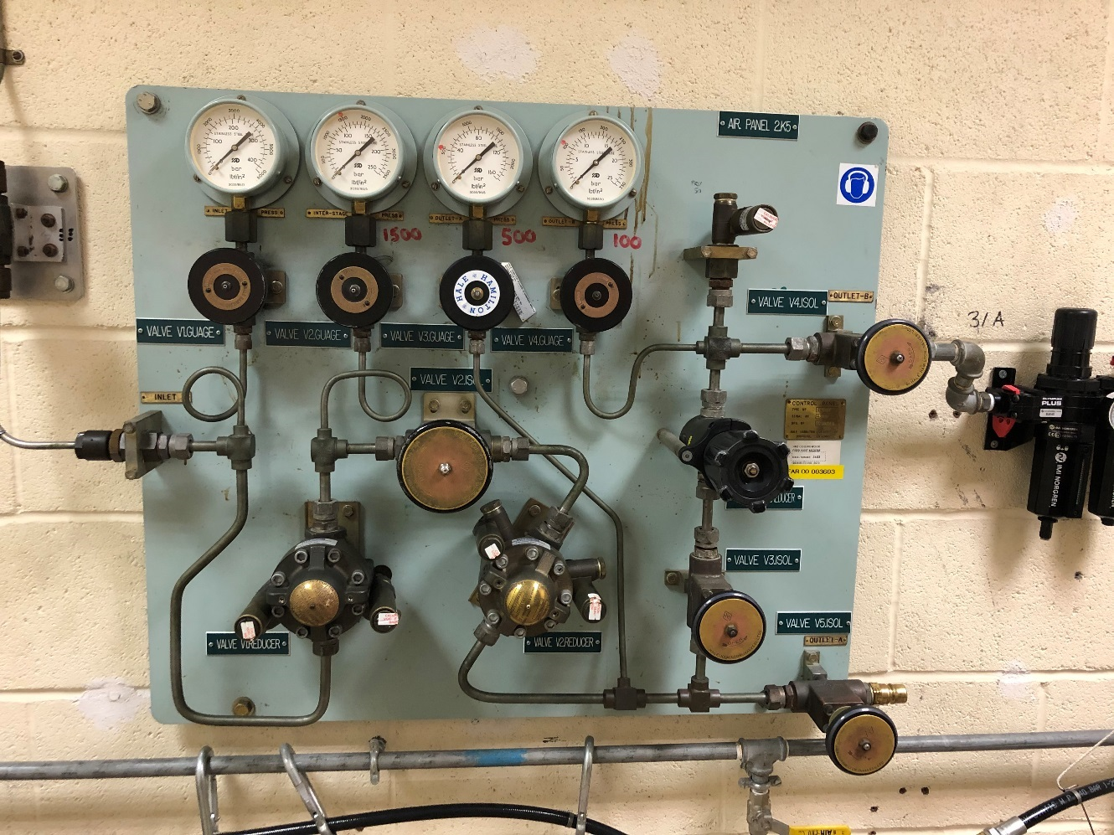
1500psi
100psi (manually adjusted)
Manual reducer*
500psi
Automatic reducer*
Automatic reducer*
3000psi HP air supply from K1 compressor

Annex B to

File reference 20201203-PST01060-TP 1268 - HP LP air refurbishment-SOR - V6
02 December 2020
Requirement 2 – Refurbish the HP air bottle control board in room K5C lab 1

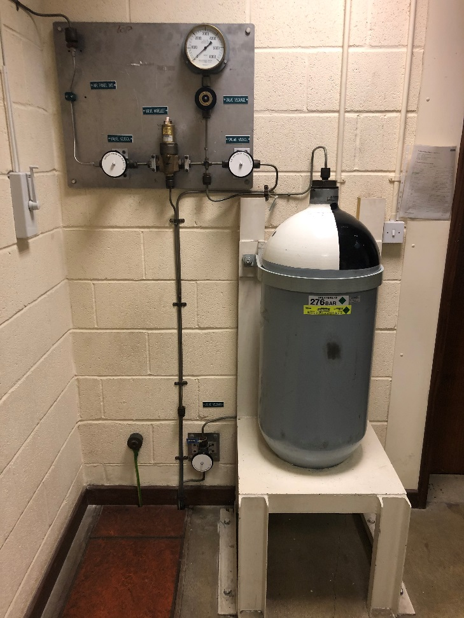  Existing HP air bottle / associated control panel / drain valve – room K5C lab 1 | 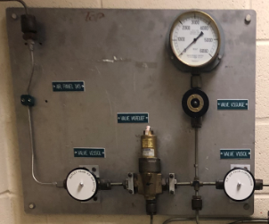  HP air bottle control panel



HP air bottle drain valve

Annex C to

File reference 20201203-PST01060-TP 1268 - HP LP air refurbishment-SOR - V6
02 December 2020
Requirement 3 – Install HP air bottle into room K5C lab 2
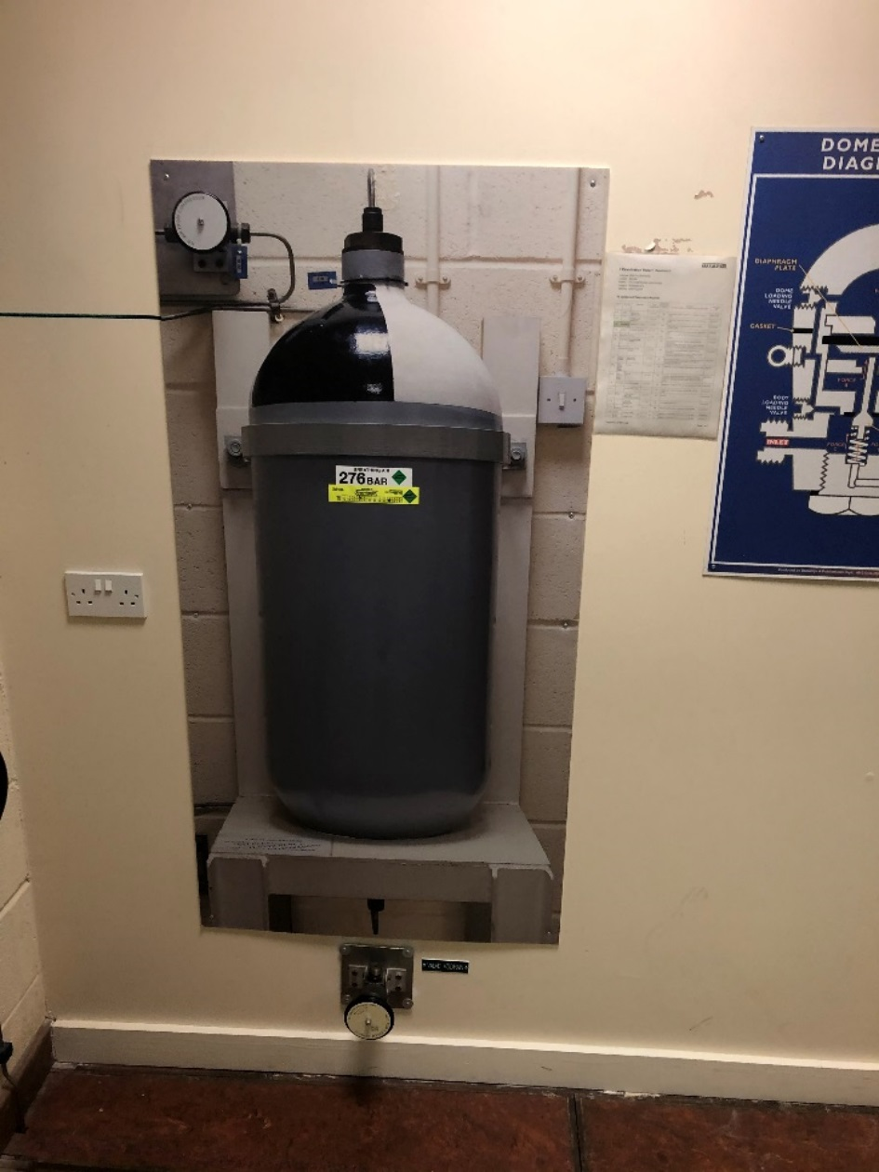  Existing “mock-up” HP air bottle – room K5C lab 2 | 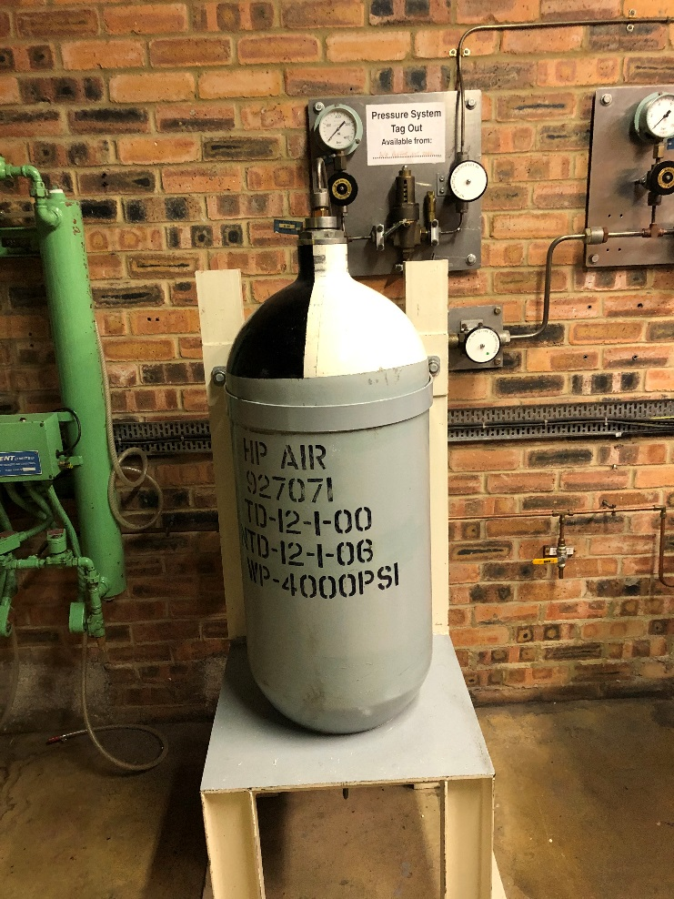  Existing HP air bottle – room H8

Annex D to

File reference 20201203-PST01060-TP 1268 - HP LP air refurbishment-SOR - V6
02 December 2020
Requirement 4 – Replace all pipework from valve FV2 to room K5C and room H4

Pipework to be replaced

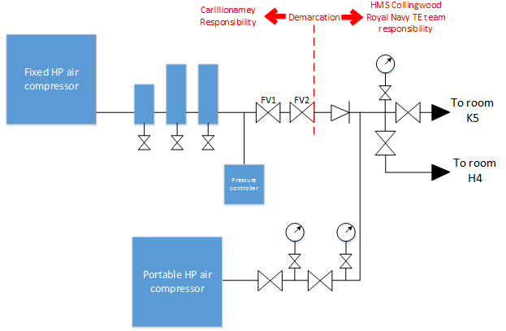
Pipework & components to be replaced
Flexible hose
Pipework to be replaced

Annex E to

File reference 20201203-PST01060-TP 1268 - HP LP air refurbishment-SOR - V6
02 December 2020
Requirement 5 – Remove HP air equipment in room H8

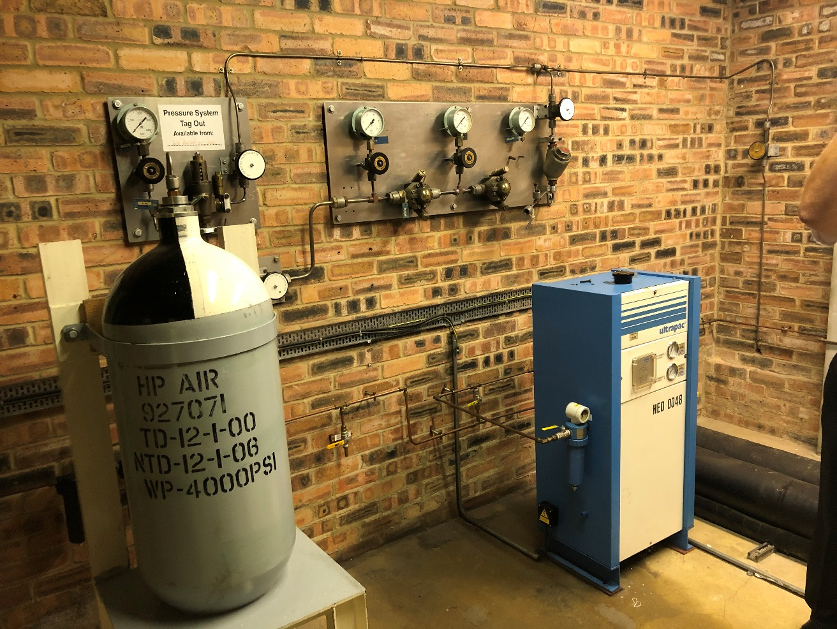
Will be relocated to H5C lab 2 (including bracket)
HP air equipment & pipework to be removed (shaded area)
HP air system – room K8

Annex F to

File reference 20201203-PST01060-TP 1268 - HP LP air refurbishment-SOR - V6
02 December 2020
Requirement 6 – Install double block & bleed valve isolations in rooms K1, K5C and H4
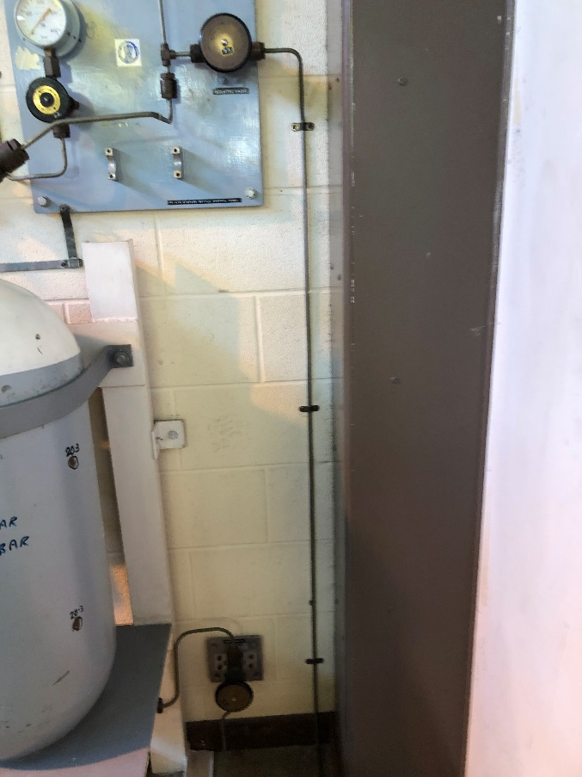  Location of double block & bleed valve isolation – room H4 | 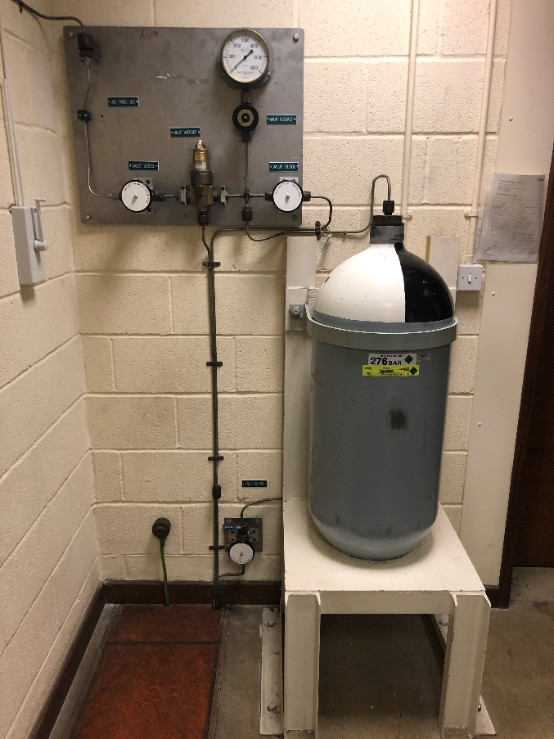  Location of double block & bleed valve isolation – room K5C lab 1
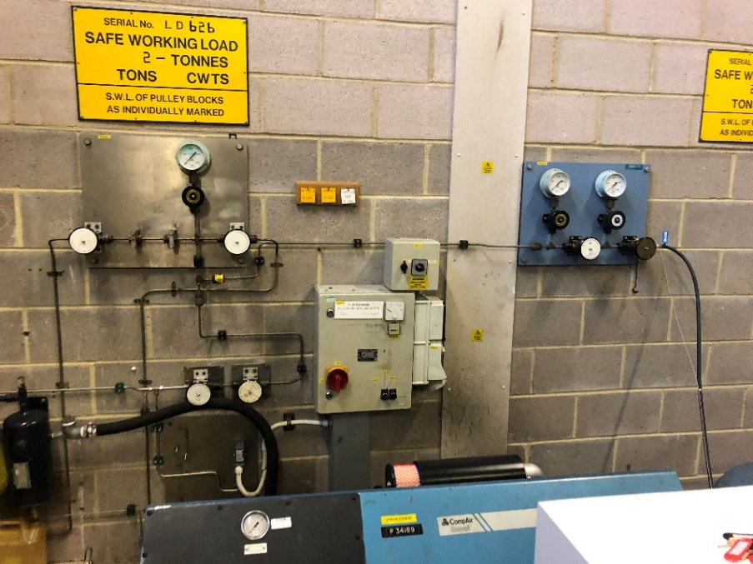

Location of double block & bleed valve isolation – room K1

TERMS AND CONDITIONS

SC1A
(Edn 08/20)

MOD Terms and Conditions for Less
Complex Requirements
(up to £122,979)

1 Definitions - In the Contract:
The Authority means the Secretary of State for Defence of the United Kingdom of Great Britain and Northern Ireland, (referred to in this document as "the Authority"), acting as part of the Crown; Business Day means 09:00 to 17:00 Monday to Friday, excluding public and statutory holidays;
Contract means the agreement concluded between the Authority and the Contractor, including all terms and conditions, associated purchase order, specifications, plans, drawings, schedules and other documentation, expressly made part of the agreement in accordance with Clause 2.c;
Contractor means the person, firm or company specified as such in the purchase order. Where the Contractor is an individual or a partnership, the expression shall include the personal representatives of the individual or of the partners, as the case may be;

Contractor Commercially Sensitive Information means the information listed as such in the purchase order, which is information notified by the Contractor to the Authority, which is acknowledged by the Authority as being commercially sensitive; Contractor Deliverables means the goods and / or services including packaging (and supplied in accordance with any QA requirements if specified) which the Contractor is required to provide under the Contract in accordance with the schedule to the purchase order;
Effective Date of Contract means the date stated on the purchase order or, if there is no such date stated, the date upon which both Parties have signed the purchase order;
Firm Price means a price excluding Value Added Tax (VAT) which is not subject to variation;
Hazardous Contractor Deliverable means a Contractor Deliverable or a component of a Contractor Deliverable that is itself a hazardous material or substance or that may in the course of its use, maintenance, disposal, or in the event of an accident, release one or more hazardous materials or substances and each material or substance that may be so released;
Legislation means in relation to the United Kingdom any Act of Parliament, any subordinate legislation within the meaning of section 21 of the Interpretation Act 1978, any exercise of Royal Prerogative or any enforceable community right within the meaning of Section 2 of the European Communities Act 1972. Notices means all notices, orders, or other forms of communication required to be given in writing under or in connection with the Contract;
Parties means the Contractor and the Authority, and Party shall be construed accordingly;
Transparency Information means the content of this Contract in its entirety, including from time to time agreed changes to the Contract, and details of any payments made by the Authority to the Contractor under the Contract.
2 General
a. The Contractor shall comply with all applicable Legislation, whether specifically referenced in this Contract or not.
b. Any variation to the Contract shall have no effect unless expressly agreed in writing and signed by both Parties.
c. If there is any inconsistency between these terms and conditions and the purchase order or the documents expressly referred to therein, the conflict shall be resolved according to the following descending order of priority:
- the terms and conditions;
- the purchase order; and
- the documents expressly referred to in the purchase order.
d. Neither Party shall be entitled to assign the Contract (or any part thereof) without the prior written consent of the other Party.
e. Failure or delay by either Party in enforcing or partially enforcing any provision of the Contract shall not be construed as a waiver of its rights or remedies. No waiver in respect of any right or remedy shall operate as a waiver in respect of any other right or remedy.

- The Parties to the Contract do not intend that any term of the Contract shall be enforceable by virtue of the Contracts (Rights of Third Parties) Act 1999 by any person that is not a Party to it.
- The Contract and any non-contractual obligations arising out of or in connection with it shall be governed by and construed in accordance with English Law, and subject to Clause 15 and without prejudice to the dispute resolution procedure set out therein, the Parties submit to the exclusive jurisdiction of the English courts. Other jurisdictions may apply solely for the purpose of giving effect to this Clause 2.g and for enforcement of any judgement, order or award given under English jurisdiction.
3 Application of Conditions
- The purchase order, these terms and conditions and the specification govern the Contract to the entire exclusion of all other terms and conditions. No other terms or conditions are implied.
- The Contract constitutes the entire agreement and understanding and supersedes any previous agreement between the Parties relating to the subject matter of the Contract.
4 Disclosure of Information
Disclosure of information under the Contract shall be managed in
accordance with DEFCON 531 (SC1).
5 Transparency
- Subject to Clause 5.b, but notwithstanding Clause 4, the Contractor understands that the Authority may publish the Transparency Information to the general public. The Contractor shall assist and cooperate with the Authority to enable the Authority to publish the Transparency Information.
- Before publishing the Transparency Information to the general public in accordance with Clause 5.a, the Authority shall redact any information that would be exempt from disclosure if it was the subject of a request for information under the Freedom of Information Act 2000 or the Environmental Information Regulations 2004, including the Contractor Commercially Sensitive Information.
- The Authority may consult with the Contractor before redacting any information from the Transparency Information in accordance with Clause 5.b. The Contractor acknowledges and accepts that its representations on redactions during consultation may not be determinative and that the decision whether to redact information is a matter in which the Authority shall exercise its own discretion, subject always to the provisions of the Freedom of Information Act 2000 or the Environmental Information Regulations 2004.
- For the avoidance of doubt, nothing in this Clause 5 shall affect the Contractor’s rights at law.
6 Notices
a. A Notice served under the Contract shall be:
- in writing in the English language;
- authenticated by signature or such other method as may be agreed between the Parties;
- sent for the attention of the other Party’s
representative, and to the address set out in the purchase order;
- marked with the number of the Contract; and
- delivered by hand, prepaid post (or airmail), facsimile transmission or, if agreed in the purchase order, by electronic mail.
b. Notices shall be deemed to have been received:
- if delivered by hand, on the day of delivery if it is the receipient’s Business Day and otherwise on the first Business of the recipient immediately following the day of delivery;

- if sent by prepaid post, on the fourth Business Day (or the tenth Business Day in the case of airmail) after the day of posting;
- if sent by facsimile or electronic means:
(a) if transmitted between 09:00 and 17:00 hours on a Business Day (recipient’s time) on completion of receipt by the sender of verification of the transmission from the receiving instrument; or

(b) if transmitted at any other time, at 09:00 on the first Business Day (recipient’s time) following the completion of receipt by the sender of verification of transmission from the receiving instrument.
7 Intellectual Property
- The Contractor shall as its sole liability keep the Authority fully indemnified against an infringement or alleged infringement of any intellectual property rights or a claim for Crown use of a UK patent or registered design caused by the use, manufacture or supply of the Contractor Deliverables.
- The Authority shall promptly notify the Contractor of any infringement claim made against it relating to any Contractor Deliverable and, subject to any statutory obligation requiring the Authority to respond, shall permit the Contractor to have the right, at its sole discretion to assume, defend, settle or otherwise dispose of such claim. The Authority shall give the Contractor such assistance as it may reasonably require to dispose of the claim and will not make any statement which might be prejudicial to the settlement or defence of the claim
8 Supply of Contractor Deliverables and Quality Assurance
a. This Contract comes into effect on the Effective Date of Contract.
b. The Contractor shall supply the Contractor Deliverables to the Authority at the Firm Price stated in the Schedule to the purchase order.
c. The Contractor shall ensure that the Contractor Deliverables:
- correspond with the specification;
- are of satisfactory quality (within the meaning of the Sale of Goods Act 1979, as amended) except that fitness for purpose shall be limited to the goods being fit for the particular purpose held out expressly by or made known expressly to the Contractor and in this respect the Authority relies on the Contractor’s skill and judgement; and
- comply with any applicable Quality Assurance Requirements specified in the purchase order.
d. The Contractor shall apply for and obtain any licences required to import any material required for the performance of the Contract in the UK. The Authority shall provide to the Contractor reasonable assistance with regard to any relevant defence or security matter arising in the application for any such licence.
9 Supply of Data for Hazardous Contractor Deliverables
a. The Contractor shall establish if the Contractor Deliverables are, or contain, Dangerous Goods as defined in the Regulations set out in this Clause 9. Any that do shall be packaged for UK or worldwide shipment by all modes of transport in accordance with the following unless otherwise specified in the Schedule to the purchase order:
- the Technical Instructions for the Safe Transport of Dangerous Goods by Air (ICAO), IATA Dangerous Goods Regulations;
- the International Maritime Dangerous Goods (IMDG) Code;
- the Regulations Concerning the International Carriage of Dangerous Goods by Rail (RID); and
- the European Agreement Concerning the International Carriage of Dangerous Goods by Road (ADR).
b. Certification markings, incorporating the UN logo, the package code and other prescribed information indicating that the package corresponds to the successfully designed type shall be marked on the packaging in accordance with the relevant regulation.
c. As soon as possible and in any event within the period specified in the purchase order (or if no such period is specified no later than one month prior to the delivery date), the Contractor shall provide to the Authority’s representatives in the manner and format prescribed in the purchase order:
- confirmation as to whether or not to the best of its knowledge any of the Contractor Deliverables are Hazardous Contractor Deliverables; and
- for each Hazardous Contractor Deliverable, a Safety Data Sheet containing the data set out at Clause 9.d, which shall be updated by the Contractor during the period of the Contract if it becomes aware of any new relevant data.
d. Safety Data Sheets if required under Clause 9.c shall be provided in accordance with the REACH Regulations (EC) No 1907/2006 and any additional information required by the Health and Safety at Work etc. Act 1974 and shall contain:
- information required by the Classification, Labelling and Packaging (CLP) Regulation 1272/2008 or any replacement thereof; and
- where the Hazardous Contractor Deliverable is, contains or embodies a radioactive substance as defined in the Ionising Radiation Regulations SI 1999/3232, details of the activity, substance and form (including any isotope); and
- where the Hazardous Contractor Deliverable has magnetic properties, details of the magnetic flux density at a defined distance, for the condition in which it is packed.
e. The Contractor shall retain its own copies of the Safety Data Sheets provided to the Authority in accordance with Clause 9.d for 4 years after the end of the Contract and shall make them available to the Authority’s representatives on request.
f. Nothing in this Clause 9 reduces or limits any statutory or legal obligation of the Authority or the Contractor.
g. Where delivery is made to the Defence Fulfilment Centre (DFC) and / or other Team Leidos location / building, the Contractor must comply with the Logistic Commodities and Services Transformation (LCST) Supplier Manual.

10 Delivery / Collection
- The purchase order shall specify whether the Contractor Deliverables are to be delivered to the consignee by the Contractor or collected from the consignor by the Authority.
- Title and risk in the Contractor Deliverables shall pass from the Contractor to the Authority on delivery or on collection in accordance with Clause 10.a.
- The Authority shall be deemed to have accepted the Contractor Deliverables within a reasonable time after title and risk has passed to the Authority unless it has rejected the Contractor Deliverables within the same period.
11. Marking of Contractor Deliverables
- Each Contractor Deliverable shall be marked in accordance with the requirements specified in the purchase order or if no such requirement is specified, the Contractor shall mark each Contractor Deliverable clearly and indelibly in accordance with the requirements of the relevant DEF-STAN 05-132 as specified in the contract or specification. In the absence of such requirements, the Contractor Deliverables shall be marked with the MOD stock reference, NATO Stock Number (NSN) or alternative reference number shown in the Contract.
- Any marking method used shall not have a detrimental effect on the strength, serviceability or corrosion resistance of the Contractor Deliverables.
- The marking shall include any serial numbers allocated to the Contractor Deliverable.
- Where because of its size or nature it is not possible to mark a Contractor Deliverable with the required particulars, the required information should be included on the package or carton in which the Contractor Deliverable is packed, in accordance with condition 12 (Packaging and Labelling (excluding Contractor Deliverables containing Ammunition or Explosives)).

12 Packaging and Labelling of Contractor Deliverables (Excluding Contractor Deliverables Containing Ammunition or Explosives)
The Contractor shall pack or have packed the Contractor Deliverables in accordance with any requirements specified in the purchase order and Def Stan 81-041 (Part 1 and Part 6).
13 Progress Monitoring, Meetings and Reports
The Contractor shall attend progress meetings and deliver reports at the frequency or times (if any) specified in the purchase order and shall ensure that its Contractor’s representatives are suitably qualified to attend such meetings. Any additional meetings reasonably required shall be at no cost to the Authority.
14 Payment
- Payment for Contractor Deliverables will be made by electronic transfer and prior to submitting any claims for payment under clause 14b the Contractor will be required to register their details (Supplier on-boarding) on the Contracting, Purchasing and Finance (CP&F) electronic procurement tool.
- Where the Contractor submits an invoice to the Authority in accordance with clause 14a, the Authority will consider and verify that invoice in a timely fashion.
- The Authority shall pay the Contractor any sums due under such an invoice no later than a period of 30 days from the date on which the Authority has determined that the invoice is valid and undisputed.
- Where the Authority fails to comply with clause 14b and there is undue delay in considering and verifying the invoice, the invoice shall be regarded as valid and undisputed for the purpose of clause 14c after a reasonable time has passed.
- The approval for payment of a valid and undisputed invoice by the Authority shall not be construed as acceptance by the Authority of the performance of the Contractor’s obligations nor as a waiver of its rights and remedies under this Contract.
- Without prejudice to any other right or remedy, the Authority reserves the right to set off any amount owing at any time from the Contractor to the Authority against any amount payable by the Authority to the Contractor under the Contract or under any other contract with the Authority, or with any other Government Department.
15 Dispute Resolution
- The Parties will attempt in good faith to resolve any dispute or claim arising out of or relating to the Contract through negotiations between the respective representatives of the Parties having authority to settle the matter, which attempts may include the use of any alternative dispute resolution procedure on which the Parties may agree.
- In the event that the dispute or claim is not resolved pursuant to Clause 15.a the dispute shall be referred to arbitration and shall be governed by the Arbitration Act 1996. For the purposes of the arbitration, the arbitrator shall have the power to make provisional awards pursuant to Section 39 of the Arbitration Act 1996.
- For the avoidance of doubt it is agreed between the Parties that the arbitration process and anything said, done or produced in or in relation to the arbitration process (including any awards) shall be confidential as between the Parties, except as may be lawfully required in judicial proceedings relating to the arbitration or otherwise. No report relating to anything said, done or produced in or in relation to the arbitration process may be made beyond the tribunal, the Parties, their legal representatives and any person necessary to the conduct of the proceedings, without the concurrence of all the Parties to the arbitration.

16 Termination for Corrupt Gifts
The Authority may terminate the Contract with immediate effect, without compensation, by giving written notice to the Contractor at any time after any of the following events:
a. where the Authority becomes aware that the Contractor, its employees, agents or any sub-contractor (or anyone acting on its behalf or any of its or their employees):
- has offered, promised or given to any Crown servant any gift or financial or other advantage of any kind as an inducement or reward;
- commits or has committed any prohibited act or any offence under the Bribery Act 2010 with or without the knowledge or authority of the Contractor in relation to this Contract or any other contract with the Crown;
- has entered into this or any other contract with the Crown in connection with which commission has been paid or has been agreed to be paid by it or on its behalf, or to its knowledge, unless before the contract is made particulars of any such commission and of the terms and conditions of any such agreement for the payment thereof have been disclosed in writing to the Authority.
b. In exercising its rights or remedies to terminate the Contract under Clause 16.a. the Authority shall:
- act in a reasonable and proportionate manner having regard to such matters as the gravity of, and the identity of the person committing the prohibited act;
- give due consideration, where appropriate, to action other than termination of the Contract, including (without being limited to):
- requiring the Contractor to procure the termination of a subcontract where the prohibited act is that of a Subcontractor or anyone acting on its or their behalf;
- requiring the Contractor to procure the dismissal of an employee (whether its own or that of a Subcontractor or anyone acting on its behalf) where the prohibited act is that of such employee.
c. Where the Contract has been terminated under Clause
16.a.the Authority shall be entitled to purchase substitute Contractor Deliverables from elsewhere and recover from the Contractor any costs and expenses incurred by the Authority in obtaining the Contractor Deliverables in substitution from another supplier.
17 Material Breach
In addition to any other rights and remedies, the Authority shall have the right to terminate the Contract (in whole or in part) with immediate effect by giving written notice to the Contractor where the Contractor is in material breach of its obligations under the Contract. Where the Authority has terminated the Contract under Clause 17 the Authority shall have the right to claim such damages as may have been sustained as a result of the Contractor’s material breach of the Contract.
18 Insolvency
The Authority shall have the right to terminate the contract if the Contractor is declared bankrupt or goes into liquidation or administration. This is without prejudice to any other rights or remedies under this Contract.
19 Limitation of Contractor’s Liability
- Subject to Clause 19.b the Contractor's liability to the Authority in connection with this Contract shall be limited to £5m (five million pounds).
- Nothing in this Contract shall operate to limit or exclude the Contractor's liability:
(1) for:
- any liquidated damages (to the extent expressly provided for under this Contract);
- any amount(s) which the Authority is entitled to claim, retain or withhold in relation to the Contractor’s failure to perform or under-perform its obligations under this Contract, including service credits or other deductions (to the extent expressly provided for under this Contract);
- any interest payable in relation to the late payment of any sum due and payable by the Contractor to the Authority under this Contract;
- any amount payable by the Contractor to the Authority in relation to TUPE or pensions to the extent expressly provided for under this Contract;

- under Condition 7 of the Contract (Intellectual Property), and DEFCONs 91 or 638 (SC1) where specified in the contract;
- for death or personal injury caused by the Contractor’s negligence or the negligence of any of its personnel, agents, consultants or sub-contractors;
- for fraud, fraudulent misrepresentation, wilful misconduct or negligence;
- in relation to the termination of this Contract on the basis of abandonment by the Contractor;
- for breach of the terms implied by Section 2 of the Supply of Goods and Services Act 1982; or
- for any other liability which cannot be limited or excluded under general (including statute and common) law.
c. The rights of the Authority under this Contract are in addition to, and not exclusive of, any rights or remedies provided by general (including statute and common) law.

20 The Project Specific DEFCONs and DEFCON SC Variants that apply to this Contract are:

DEFCON 5J (Edn 11/16) - Unique Identifiers
DEFCON 14 (Edn 09/20) - Inventions And Designs Crown Rights And Ownership Of Patents And Registered Designs
DEFCON 16 (Edn 10/04) - Repair And Maintenance Information
DEFCON 21 (Edn 10/04) - Retention Of Records
DEFCON 76 SC1 (Edn 12/16) - Contractor's Personnel at Government Establishments
DEFCON 82 SC1 (Edn 06/17) – Special Procedures for Initial Spares
DEFCON 90 (Edn 11/06) - Copyright
DEFCON 129J SC1 (Edn 06/17)– The Use of the Electronic Business Delivery Form
DEFCON 502 SC1 (Edn 11/16)- Specifications Changes
DEFCON 503 SC1 (Edn 12/16) – Formal Amendments to Contract
DEFCON 532A SC1 (Edn 08/20) - Protection of Personal Data
(Where Personal Data is not being processed on behalf of the Authority)
DEFCON 534 (Edn 06/17) – Subcontracting and Prompt Payment
DEFCON 538 (Edn 06/02) - Severability
DEFCON 566 (Edn 10/20) - Change of Control of Contractor
DEFCON 609 (Edn 08/18) or SC1 (Edn 08/18) - Contractor's Records
DEFCON 620 SC1 (Edn 12/16)– Contract Change Control Procedure
DEFCON 656A (Edn 08/16) - Termination for Convenience Under £5m
DEFCON 658 SC1 (Edn.11/17) - Cyber
Further to DEFCON 658 the Cyber Risk Level of the Contract is
Very Low, as defined in Def Stan 05-138

21 The special conditions that apply to this Contract are:
AUTHORISATION BY THE CROWN FOR USE OF THIRD PARTY INTELLECTUAL PROPERTY RIGHTS
Notwithstanding any other provisions of the Contract and for the avoidance of doubt, award of the Contract by the Authority and placement of any contract task under it does not constitute an authorisation by the Crown under Sections 55 and 56 of the Patents Act 1977 or Section 12 of the Registered Designs Act 1949. The Contractor acknowledges that any such authorisation by the Authority under its statutory powers must be expressly provided in writing, with reference to the acts authorised and the specific intellectual property involved.

22 The processes that apply to this Contract are:
The Contractor shall notify the Authority as soon as they become aware of any circumstance which will impact on their ability to deliver any of the requirements or meet any of the stated timescales.

DEFFORM 68 –
HAZARDOUS ARTICLES

Hazardous Articles, Deliverables, Materials or

Substances Statement by the Contractor

Contract Number:

Contract Title:

Contractor:

Date of Contract:

* To the best of our knowledge there are no hazardous Articles, Deliverables, materials or substances to be supplied.

* To the best of our knowledge the hazards associated with Articles, Deliverables, materials or substances to be supplied under the Contract are identified in the Safety Data Sheets (Qty: ) attached in accordance with either:

DEFCON 68 ; or

Condition 9 of Standardised Contract 1A/B Conditions ;

Contractor’s Signature:

Name:

Job Title:

Date:

* check box () as appropriate

To be completed by the Authority

DMC:

NATO Stock Number:

Contact Name:

Contact Address:

Contact Phone Number:

Contact Email Address:
Copy to be forwarded to:
Hazardous Stores Information System (HSIS)
Department of Safety & Environment, Quality and Technology (D S & EQT)
Spruce 2C, #1260
MOD Abbey Wood (South)
Bristol, BS34 8JH

Email: DESTECH-QSEPEnv-HSISMulti@mod.gov.uk

STATEMENT RELATING TO
GOOD STANDING

Dear Sir or Madam,
- Thank you for your interest in the Provision of High Pressure (HP) & Low Pressure (LP) air refurbishment
- You will be aware that the MOD expects its suppliers to maintain high standards of integrity and professionalism in their business dealings and adhere to the laws of the countries where they operate.
- The MOD reserves the right to exclude a supplier from the procurement who has been convicted of any of the offences or misconduct listed in the Statement Relating to Good Standing.
- The MOD therefore requires all potential suppliers to complete the Statement Relating to Good Standing. This requires a signature on behalf of the company to confirm that none of the matters referred to in the Statement (being different grounds for discretionary exclusion) apply to the supplier.
- If any of the matters referred to in the Statement apply to a potential supplier, they must provide additional information on the circumstances, including any remedial action to prevent its recurrence. This additional information, excluding any supporting documentation, shall not exceed five (5) A4 pages in total.
- You are required to report any final convictions or settlements for bid rigging, fraud, bribery, corruption or other dishonest irregularity in connection with procurement and if so, any measures that you have taken to prevent such behaviour happening again. Any evidence of such anti-competitive behaviour in relation to this procurement procedure could result in your disqualification from the procedure.
- The Statement Relating to Good Standing should be signed on behalf of the legal entity seeking to contract for this requirement at Director Level or equivalent. Please return the signed Statement Relating to Good Standing and any additional information to the Authority with your tender submission.
- May I once again thank you for the interest you have shown in this requirement.

Yours faithfully

Katie Goble

The Statement Relating To Good Standing
Contract Title: Provision of High Pressure (HP) & Low Pressure (LP) air refurbishment
Contract Number: 701314413
      - We confirm, to the best of our knowledge and belief, that [insert potential supplier] including its directors or any other person who has powers of representation, decision or control or is a member of the administrative, management or supervisory body of [insert potential supplier] has not been convicted of any of the following offences within the past 5 years:
- conspiracy within the meaning of section 1 or 1A of the Criminal Law Act 1977 or article 9 or 9A of the Criminal Attempts and Conspiracy (Northern Ireland) Order 1983 where that conspiracy relates to participation in a criminal organisation as defined in Article 2 of Council Framework Decision 2008/841/JHA;
- corruption within the meaning of section 1(2) of the Public Bodies Corrupt Practices Act 1889 or section 1 of the Prevention of Corruption Act 1906;
- common law offence of bribery;
- bribery within the meaning of section 1,2 or 6 of the Bribery Act 2010; or section 113 of the Representation of the People Act 1983;
- any of the following offences, where the offence relates to fraud affecting the European Communities financial interests as defined by Article 1 of the Convention on the protection of the financial interests of the European Communities:
- the common law offence of cheating the Revenue;
- the common law offence of conspiracy to defraud;
- fraud or theft within the meaning of the Theft Act 1968, the Theft Act (Northern Ireland) 1969, the Theft Act 1978 or the Theft (Northern Ireland) Order 1978;
- fraudulent trading within the meaning of section 458 of the Companies Act 1985, Article 451 of the Companies (Northern Ireland) Order 1986 or section 933 of the Companies Act 2006;
- fraudulent evasion within the meaning of section 170 of the Customs and Excise Management Act 1979 or section 72 of the Value Added Tax Act 1994;
- an offence in connection with taxation in the European Union within the meaning of section 71 of the Criminal Justice Act 1993;
- destroying, defacing or concealing of documents or procuring the extension of a valuable security within the meaning of section 20 of the Theft Act 1968 or section 19 of the Theft Act (Northern Ireland) 1969;
- fraud within the meaning of section 2,3 or 4 of the Fraud Act 2006; or
- the possession of articles for use in frauds within the meaning of section 6 of the Fraud Act 2006, or making, adapting, supplying or offering to supply articles for use in frauds within the meaning of section 7 of that Act;
- any offence listed:
- in section 41 of the Counter Terrorism Act 2008; or
- in Schedule 2 to that Act where the court has determined that there is a terrorist connection;
- any offence under sections 44 to 46 of the Serious Crime Act 2007 which relates to an offence covered by (f) above;
- money laundering within the meaning of section 340(11) and 415 of the Proceeds of Crime Act 2002;
- an offence in connection with the proceeds of criminal conduct within the meaning of section 93A, 93B, or 93C of the Criminal Justice Act 1988 or article 45, 46 or 47 of the Proceeds of Crime (Northern Ireland) Order 1996;
- an offence under section 4 of the Asylum and Immigration (Treatment of Claimants etc) Act 2004;
- an offence under section 59A of the Sexual Offences Act 2003;
- an offence under section 71 of the Coroners and Justice Act 2009;
- an offence in connection with the proceeds of drug trafficking within the meaning of section 49, 50 or 51 of the Drug Trafficking Act 1994; or
- an offence under section 2 or 4 of the Modern Slavery Act 2015;
- any other offence within the meaning of Article 57(1) of Public Contracts Directive –
- as defined by the law of any jurisdiction outside England and Wales and Northern Ireland: or
- created in the law of England and Wales or Northern Ireland after the day on which these Regulations were made;
- any breach of its obligations relating to the payment of taxes or social security contributions where the breach has been established by a judicial or administrative decision having final and binding effect in accordance with the legal provisions of the country in which it is established or with those of any jurisdictions of the United Kingdom
      - [Insert potential supplier] further confirms to the best of our knowledge and belief that within the last 3 years it:
- has fulfilled its obligations relating to the payment of taxes and social security contributions of the country in which it is established or with those of any jurisdictions of the United Kingdom;
- is not bankrupt or is not the subject of insolvency or winding-up proceedings, where its assets are being administered by a liquidator or by the court, where it is in an agreement with creditors, where its business activities are suspended or it is in any analogous situation arising from a similar procedure under the laws and regulations of any State;
- has not committed an act of grave professional misconduct, which renders its integrity questionable;
- has not entered into agreements with other suppliers aimed to at distorting competition;
- is not subject to a conflict of interest within the meaning of regulation 24;
- has not been involved in the preparation of this procurement procedure which would result in distortion of competition which could not be remedied by other, less intrusive, measures other than exclusion from this procedure;
- has not had a contract terminated, damages or other comparable sanctions taken as a result of significant or persistent deficiencies in the performance of a substantive requirement under a prior public contract, a prior contract, or a prior concession contract as defined by the Concession Contracts Regulations 2016;
- is not guilty of serious misrepresentation in providing any information required by this statement;
- has not unduly influenced the decision-making process of the Authority or obtained confidential information that may confer upon it undue advantages in the procurement procedure;
- in relation to procedures for the award of a public services contract, is licensed in the relevant State in which he is established or is a member of an organisation in that relevant State where the law of that relevant State prohibits the provision of the services to be provided under the contract by a person who is not so licensed or who is not such a member;
- has fulfilled its obligations in the fields of environmental, social and labour law established by EU law, national law, collective agreements or by the international environmental, social and labour law provisions listed in the Public Contracts Directive as amended from time to time (as listed in PPN 8/16 Annex C).

I confirm that to the best of my knowledge my declaration is correct. I understand that the contracting authority will use the information in the selection process to assess my organisation’s suitability to be invited to participate further in this procurement, and I am signing on behalf of my organisation. I understand that the Authority may reject my submission if there is a failure to provide a declaration or if I provide false or misleading information.
Organisation’s name
Signed
(By Director of the Organisation or equivalent)
Name
Position
Date

Commercial Off The Shelf

