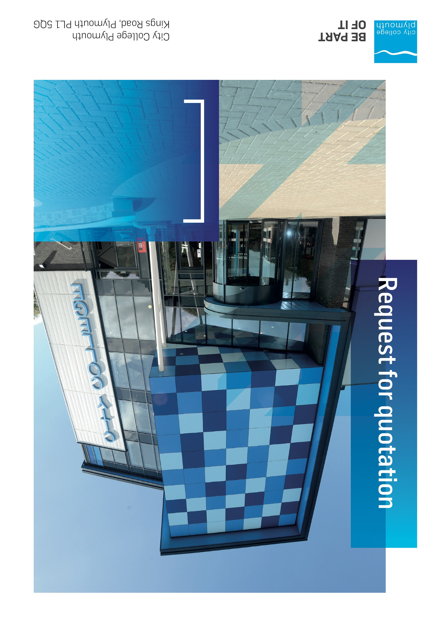



# Business Overview & Background

City College Plymouth has a learning environment and organisational culture that impacts positively on the health, wellbeing and sustainability of our community and enables all of our students and staff to achieve their full potential.

City College Plymouth is one of the largest providers of innovative, technical and professional, education in the South West with a national reputation for promoting enterprise, employability and science, technology, engineering and mathematics (STEM). The College plays a central role in the educational, cultural and economic life of the region and works with strategic partners to facilitate growth, raise aspirations and foster wealth creation.

The College was awarded the Teaching Excellence Framework (TEF) Gold award for its university-level provision and its most recent Ofsted inspection confirmed that the College continues to be ‘Good’ with many outstanding features. The College was rated first in the South West and second nationally for student satisfaction in the latest FE Choices student satisfaction survey.

City College Plymouth is also one of the first Institutes of technology in the UK Working in collaboration with education providers and employers across the South West to improve the training in science, technology, engineering and maths in order to address skills gaps within these industries and support regional growth.

City College supports the region’s employers with their award-winning Apprenticeship provision, as well as providing a range of courses and bespoke training programmes which enable employees to upskill or retrain to better support their business’ requirements.

The College operates on two main sites within the city, serving 12,500 students and employing over 650 staff. The College operates year round, with opening times from 0800-2100 on some days.

## Our GUIDING PRINCIPLE

City College Plymouth has a learning environment and organisational culture that impacts positively on the health, wellbeing and sustainability of our community and enables all of our students and staff to achieve their full potential.

## Our Vision

To be the learning destination of choice.

## Our CORE VALUES

Respect, ownership, integrity for all.

## Our CULTURE

Nurturing a passion for teaching and learning.

Enriching our community through knowledge, experience and skills.

Enabling every student to be the best that they can be.

## The Way Forward - our Priorities

• Staff - our most important investment

• Students - our purpose

• Community - making a difference

• Achievement - reputation for success

• Wellbeing - infusing health into every day

# Requirement

Following a change in our main waste contractor and the reconfiguration of the main external bins City College Plymouth is looking to purchase various internal and external bins to compliment this.

Please can you provide a quote for the following?

* 46 x 95 L Arena Style recycling bin or equivalent with signage (white)
* 46 x 95 L Arena Style recycling bin or equivalent with signage (Green)
* 6x 55L mini bin (Green)
* 1 x 55L mini bin (White)
* 24 x 55l mini bin (brown)
* 24 x 5l Kitchen Caddies (brown)
* 15 x External Topsy style bin or equivalent (Green)

Please provide images of the bins as part of your return and input pricing within appendix A.

Please also clearly state the current lead time and any delivery costs.

# Submission Deadlines

All submissions for responding to this Mini Quote must be submitted via email as stated below, no later than 21st February 2023

Any submissions received after this date will not be considered.

# Submission Questions and Clarifications

You may contact the following person if you have any questions or require clarification on any topics covered in this Mini Quotation:

**Adam Baker**

Procurement Officer

Phone: 01752 305313

[Tenders@cityplym.ac.uk](mailto:Tenders@cityplym.ac.uk)

# pricing

Your pricing should be submitted using Appendix A.

Prices should be firm and valid for the contract period and not be subject to increase or escalation of any kind.

The data provided in Appendix A **should not** be considered a commitment to purchase, services will only be ordered on award of contract.

# Terms and Conditions

The College’s normal business terms are 1-2 months from the date of invoice. Payment will become due subject to the above upon the College’s full acceptance of the goods/services. This Request for Quotation and any resulting purchase order will be subject to the College’s General Terms and Conditions of Purchase of Goods/Services – see Appendix B.

# Validity

Bidder’s offers should be open and valid for acceptance for a period of no less than ninety [90] days from the date of submission.