Request for Quotation

SC230016 – River Trent Sampling & Water Quality Analysis

November 2023

Request for Quotation
SC230016 – River Trent Sampling & Water Quality Analysis

You are invited to submit a quotation for the requirement described in the specification, Section 2.
Please confirm by email, receipt of these documents and whether you intend to submit a quote or not.
Your response should be returned to the following email address by:
Email: martin.spurr@environment-agency.gov.uk
Date: 08/12/2023
Time: 12:00PM
Ensure you include the name of the quotation and ‘Final Submission’ in the subject field to make it clear that it is your response.
Contact Details and Timetable
Martin Spurr will be your contact for any questions linked to the content of the quote or the process. Please submit any clarification questions via email and note that, unless commercially sensitive, both the question and the response will be circulated to all tenderers.
Action | Date
Date of issue of RFQ | 21/11/2023
Deadline for clarifications questions | 01/12/2023 at 12:00 GMT
Deadline for receipt of Quotation | 08/12/2023 at 12:00 GMT
Intended date of Contract Award | 22/12/2023
Intended Contract Start Date | 29/01/2024
Intended Delivery Date / Contract Duration | 15/03/2024

Section 1: General Information
Glossary
Unless the context otherwise requires, the following words and expressions used within this Request for Quotation shall have the following meanings (to be interpreted in the singular or plural as the context requires):
“Authority” | means ‘Environment Agency’ who is the Contracting Authority.
“Contract” | means the contract to be entered into by the Authority and the successful supplier.
“Response” | means the information submitted by a supplier in response to the RFQ.
“RFQ” | means this Request for Quotation and all related documents published by the Authority and made available to suppliers.

Conditions applying to the RFQ
You should examine your Response and related documents ensuring it is complete and in accordance with the stated instructions prior to submission.
Your Response must contain sufficient information to enable the Authority to evaluate it fairly and effectively. You should ensure that you have prepared your Response fully and accurately and that prices quoted are arithmetically correct for the units stated.
By submitting a Response, you, the supplier, are deemed to accept the terms and conditions provided in the RFQ. Confirmation of this is required in Annex 2.
Failure to comply with the instructions set out in the RFQ may result in the supplier’s exclusion from this quotation process.
Acceptance of Quotations
By issuing this RFQ the Authority does not bind itself to accept any quotation and reserves the right not to award a contract to any supplier who submits a quotation.
Costs
The Authority will not reimburse you for any costs and expenses which you incur preparing and submitting your quotation, even if the Authority amends or terminates the procurement process.
Self-Declaration and Mandatory Requirements
The RFQ includes a self-declaration response (Annex 1) which covers basic information about the supplier, as well as any grounds for exclusion. If you do not comply with them, your quotation will not be evaluated.
Any mandatory requirements will be set out in Section 2, Specification of Requirements and, if you do not comply with them, your quotation will not be evaluated.
Clarifications
Any request for clarification regarding the RFQ and supporting documentation must be submitted via email no later than the deadline for clarifications set out in the Timetable. The Authority shall be under no obligation to respond to queries raised after the clarification deadline.
The Authority will respond to all reasonable clarifications as soon as possible but cannot guarantee a minimum response time. The Authority will publish all clarifications and its responses to all suppliers via email unless deemed commercially sensitive.
If a supplier believes that a request for clarification is commercially sensitive, it should clearly state this when submitting the clarification request. However, if the Authority considers either that:
- the clarification and response are not commercially sensitive; and
- all suppliers may benefit from its disclosure,

then the Authority will notify the supplier (via email), and the supplier will have an opportunity to withdraw the request for clarification by sending a further message requesting the withdrawal of the clarification request. If not withdrawn by the supplier within 2 working days of the Authority’s notification, the Authority may publish the clarification request and its response to all suppliers and the Authority shall not be liable to the supplier for any consequences of such publication.
The Authority reserves the right to seek clarification of any aspect of a quotation and/or provide additional information during the evaluation phase to carry out a fair evaluation. Where the Authority seeks clarification on any aspect of the quotation, the supplier must respond within the timeframe requested by the Authority.
Amendments
The Authority may amend the RFQ at any time prior to the deadline for receipt. If it amends the RFQ the Authority will notify you via email.
Suppliers may modify their quotation prior to the deadline for Responses. No Responses may be modified after the deadline for Responses.
Suppliers may withdraw their quotations at any time by submitting a notice via the email to the named contact.
Conditions of Contract
The Authority’s standard ‘Conditions of Contract – Research & Development’ provided as part of the RFQ will be included in any contract awarded as a result of this quotation process. The Authority will not accept any changes to these terms and conditions proposed by a supplier.
Suppliers should note that the quotation provided by the successful bidder will form part of the Contract.
Prices
Prices must be submitted in £ sterling, exclusive of VAT.
Disclosure
All Central Government Departments, their Executive Agencies and Non Departmental Public Bodies are subject to control and reporting within Government. In particular, they report to the Cabinet Office and HM Treasury for all expenditure. Further the Cabinet Office has a cross-Government role delivering overall Government policy on public procurement, including ensuring value for money and related aspects of good procurement practice. For these purposes, the Authority may disclose within Government any details contained in your quotation. The information will not be disclosed outside Government during the procurement.
In addition, the Authority is subject to the Freedom of Information Act 2000 and the Environmental Information Regulations 2004, which provide a public right of access to information held by public bodies. In accordance with these two statutes, the Authority may be required to disclose information contained in your quotation to any person who submits a request for information pursuant to those statutes.
Further to the Government’s transparency agenda, all UK Government organisations must advertise on Contract Finder in accordance with the following publication thresholds:
- Central Contracting Authority’s: £12,000
- Sub Central Contracting Authority’s and NHS Trusts: £30,000
For the purpose of this RFQ the Authority is classified as a 'Sub Central Contracting Authority' with a publication threshold of '£30,000' inclusive of VAT.
If this opportunity is advertised via Contracts Finder, we are obliged to publish details of the awarded contract including who has won the contract, the contract value, and indicate whether the winning supplier is a small and medium-sized enterprise (“SMEs”) or voluntary organisation or charity. A copy of the contract must also be published with confidential information redacted.
By submitting a Response, you consent to these terms as part of the procurement.
Disclaimers
Whilst the information in this RFQ and any supporting information referred to herein or provided to you by the Authority have been prepared in good faith the Authority does not warrant that this information is comprehensive or that it has been independently verified.
The Authority does not:
- make any representation or warranty (express or implied) as to the accuracy, reasonableness or completeness of the RFQ;
- accept any liability for the information contained in the RFQ or for the fairness, accuracy or completeness of that information; or
- accept any liability for any loss or damage (other than in respect of fraudulent misrepresentation or any other liability which cannot lawfully be excluded) arising as a result of reliance on such information or any subsequent communication.
Any supplier considering entering into contractual relationships with the Authority following receipt of the RFQ should make its own investigations and independent assessment of the Authority and its requirements for the goods and/or services and should seek its own professional financial and legal advice.
Protection of Personal Data
In order to comply with the General Data Protection Regulations 2018 the supplier must agree to the following:
- You must only process any personal data in strict accordance with instructions from the Authority.
- You must ensure that all the personal data that we disclose to you or you collect on our behalf under this agreement are kept confidential.
- You must take reasonable steps to ensure the reliability of employees who have access to personal data.
- Only employees who may be required to assist in meeting the obligations under this agreement may have access to the personal data.
- Any disclosure of personal data must be made in confidence and extend only so far as that which is specifically necessary for the purposes of this agreement.
- You must ensure that there are appropriate security measures in place to safeguard against any unauthorised access or unlawful processing or accidental loss, destruction or damage or disclosure of the personal data.
- On termination of this agreement, for whatever reason, the personal data must be returned to us promptly and safely, together with all copies in your possession or control.
General Data Protection Regulations 2018
For the purposes of the Regulations the Authority is the data processor.
The personal information that we have asked you provide on individuals (data subjects) that will be working for you on this contract will be used in compiling the tender list and in assessing your offer. If you are unsuccessful the information will be held and destroyed within two years of the award of contracts. If you are awarded a contract it will be retained for the duration of the contract and destroyed within seven years of the contract’s expiry.
We may monitor the performance of the individuals during the execution of the contract, and the results of our monitoring, together with the information that you have provided, will be used in determining what work is allocated under the contract, and in any renewal of the contract or in the award of future contracts of a similar nature. The information will not be disclosed to anyone outside the Authority without the consent of the data subject, unless the Authority is required by law to make such disclosures.
Equality, Diversity & Inclusion (EDI)
The Client is striving to create a diverse and inclusive working environment where every individual has equality of opportunity to progress and to apply their unique insights to making the UK a great place for living. The Service Provider is expected to respect this commitment in all dealings with 'Environment Agency of Horizon House, Deanery Road, Bristol, BS1 5AH' staff and service users.
Suppliers are expected to;
- support Defra group to achieve its Public Sector Equality Duty as defined by the Equality Act 2010, and to support delivery of Defra group’s Equality & Diversity Strategy.
- meet the standards set out in the Government’s Supplier Code of Conduct
- work with Defra group to ensure equality, diversity and inclusion impacts are addressed (positive and negative) in the goods, services and works we procure, barriers are removed and opportunities realised.
Sustainable Procurement
Addressing global sustainability impacts and realising additional community benefits within commercial activity is core to Defra group’s approach, working with its supply chain is key to achieving sustainable outcomes. In addition to supporting Defra group to meet its outcomes we look to understand and reduce negative sustainability impacts associated with our commercial activity and realise benefits.
The Client encourages its suppliers to share these values, work to address negative impacts and realise opportunities, measure performance and success.
Suppliers are expected to have an understanding of the Sustainable Development Goals, the interconnections between them and the relevance to the Goods, Services and works procured on the Client’s behalf
Conflicts of Interest
The concept of a conflict of interest includes but is not limited to any situation where an Involved Person or Relevant Body has directly or indirectly, a financial, economic or other personal interest which might be perceived to compromise their impartiality and independence in the context of the procurement procedure and/or affect the integrity of the contract award.
We expect suppliers to mitigate appropriately against any real or perceived conflict of interest through their work with government. A supplier with a position of influence gained through a contract should not use that position to unfairly disadvantage any other supplier or reduce the potential for future competition
Where the supplier is aware of any circumstances giving rise to a conflict of interest or has any indication that a conflict of interest exists or may arise you should inform the Authority of this as soon as possible (whether before or after they have submitted a quotation). Tenderers should remain alert to the possibility of conflicts of interest arising at all stages of the procurement and should update the Authority if any new circumstances or information arises, or there are any changes to information already provided to the Authority. Failure to do so, and/or to properly manage any conflicts of interest may result in a quotation being rejected.
Provided that it has been carried out in an open, fair and transparent manner, routine pre-market engagement carried out by the Authority should not represent a conflict of interest for the supplier.

Section 2: The Invitation
Specification of Requirements

Background to Requirement
The Environment Agency is undertaking a research project to understand the fate of Antimicrobial Resistance (AMR) in the environment after being discharged into a river.

In order to investigate the distribution of AMR in the environment we will carry out surveillance monitoring for various AMR measures in surface waters.
The project will commence with an initial 2 week study (comprised of 6 sampling days carried out in 3 consecutive day slots) in line with the specification below.

Specific Objectives/Deliverables

Sampling
- Sampling will be grab samples of surface waters.

Locations
There is 18 sampling points defined along a 2.6km stretch of the river Trent and adjoining tributaries and the Final Effluent drain of the Severn Trent Stoke Bardolph STW. Further information about the sampling sites is given in section 1.5 Appendix.

Site  ID | Waterbody | Access | Co-ordinates (Lat, Lon) | What3Words
1 | River Trent | Footpath | 52.96836629,  -1.033602163 | comedy.organisms.mass
2 | River Trent | Footpath | 52.97002866,  -1.035175239 | worm.estimate.tastes
3 | River Trent | Footpath | 52.97107825,  -1.036447327 | stag.reflector.famous
4 | Ouse Dyke | Road | 52.96764520,  -1.037269714 | sleepers.trumpet.piglets
5 | Ouse Dyke | Road | 52.97106636,  -1.036921116 | research.optimists.bids
6 | River Trent | Road | 52.97218253,  -1.037002719 | graver.licks.private
7 | Stream with  Cottages STP FE | Road | 52.97294854,  -1.037539609 | constants.cookery.dividing
8 | River Trent | Road | 52.97318820,  -1.037218978 | glorious.geek.alerting
9 | Drain with STW  FE + SS CSO | Road | 52.97334801,  -1.037598942 | sharpness.trunk.lobby
10 | River Trent | Road | 52.97358583,  -1.037250187 | waltzed.poster.different
11 | River Trent | Road | 52.97377653,  -1.037261952 | quietest.skins.gourmet
12 | River Trent | Road | 52.97407387,  -1.037276660 | glitter.describes.snooping
13 | River Trent | Road | 52.97471766,  -1.037385436 | bunkers.acid.excusing
14 | River Trent | Road | 52.97630624, -1.037676626 | anchovies.poetic.reds
15 | River Trent | Road | 52.97946425, -1.038307721 | befitting.factoring.snooping
16 | River Trent | Footpath | 52.98295636, -1.038444002 | poetry.solid.companies
17 | River Trent | Footpath | 52.98602103, -1.034071736 | tweaked.blanks.obstruct
18 | River Trent | Footpath | 52.98613123, -1.026075503 | marriage.parkland.raking

Sampling frequency and number
- Sampling will be in done in two consecutive weeks in February/March 2024.
  - Provisional dates for sampling:
    - 19 Feb 2024, 20 Feb 2024, 21 Feb 2024
    - 26 Feb 2024, 27 Feb 2024, 28 Feb 2024
- Sampling will take place on 3 consecutive days in each week (the Monday, Tuesday and Wednesday) (6 sampling days total).
- From the 6 sampling days of 18 sites each day it yields 18 sample collections per day and 108 sample collections total.

Sampling volumes
- At each site, several sample bottles are to be filled for various AMR analyses – see below table.
- In total 8 litres will be collected from each site.
- Each day 18 collections of 8 litres will be collected (144 litres per day, 864 litres total).
Bottle | Type | Volume to collect | Purpose | Destination
A | Plastic | 1 litre | Water quality analysis | Contractor
B | Sterile, plastic | 2 litres | Bacterial phenotypes | EA Starcross
C | Sterile, plastic | 2 litres | Fungal phenotypes | UK Lab TBC
D | Sterile, plastic | 3 litres | DNA analyses | EA Starcross

Sampling logistics
- Samples should be taken at a recorded time each day starting with site 1 (the most upstream site) and sampled in order down to site 18 (the most downstream site).
- Samples will be stored in appropriate containers for microbiological, molecular & chemical analysis.
- Samples labelled with a unique barcode identifying location, date and sampler ID.
- At each sampling site the following will be recorded; exact time (HH:MM), date and exact GPS coordinates (where different than the planned site).
- Samples will be taken by competent staff trained in environmental sampling.
- Once taken grab samples will be refrigerated.
- Samples will be transported for analysis in refrigerated transport.
- Samples will arrive for analysis within 24 hours (i.e., to arrive by morning of next day).

River and Tributary Hydrometry [OPTIONAL DELIVERABLE]
- This deliverable is optional. If possible we are interested in quotes in which any of the below are included.

Scope
Whilst it is not possible or feasible to carry out a full hydrometric survey across the river cross section at each of the 18 sites, we are interested in point measurements taken at the sampling sites. Particularly at the tributary sites (sites 4, 5, 7 and 9) for which there is no upstream or downstream data available.
Prior to commencing the analysis the contractor will develop/provide documented protocols and instrumentation details.

Hydrometry analyses
 | Analysis | Details
1 | Water velocity in m/s | - Measured by portable acoustic point velocity instrument (e.g. Sontek Flowtracker, Nivustick) or ADCP float (e.g. Sontek M9 or StreamPro)  - Ideally measured close to the grab sampling point in the main river.  - For the tributary sites (sites 4, 5, 7 and 9) take multiple measurements at the centre and intervals across the stream (where access from bridge allows) to give a fuller picture of the waterbody velocity.
2 | Water flow in m³/s | - Ideally measured close to the grab sampling point in the river.  - Measured with a portable flow meter.
3 | Water level in m | - To be measured for the four tributary sites (sites 4, 5, 7 and 9) taken from bridges. Only measure at main river sites if access allows.  - Measured with ranging pole or depth gauge or similar.

Hydrometry reporting
- Hydrometry data will be reported within 5 days of sampling date.
- Reports will be in format prescribed by the Environment Agency.

Water Quality Analysis

Analysis
- Analysis will be completed within 48 hours of receiving the sample.
- Prior to commencing the analysis the contractor will develop/provide documented standards and protocols.
- No work may be sub contracted to another party unless with the express permission of the Environment Agency.

Analyses required
- The water quality analyses detailed in the below table is required for each sample (taken either in-field or in-lab subsequently).
 | Analysis | Details
1 | In-field | - Water temperature
2 | Chemical analysis | - pH  - Turbidity  In addition, the following water quality and nutrients should be measured, e.g. by spectrophotometric assays:  - Chemical oxygen demand (COD)  - Total Nitrogen  - Ammonium-nitrogen (NH4-N)  - Nitrite  - Nitrate  - Orthophosphate

Analysis reporting
- Analysis data will be reported within 5 days of sampling date.
- Reports will be in a format prescribed by the Environment Agency.

Timescales/Deadlines

Task No. | Deliverable | Responsible party | Format / Compatibility Requirements | Date of completion, end:
0 | Attend kick off meeting | Contractor & EA | Virtual meeting | By 31st January 2024
1 | Sampling | Contractor with guidance by EA (for sample sites) | Sampling points sampled in accordance with sampling days plan | By 6th March 2024
2 [OPTIONAL] | Hydrometry measurements | Contractor with guidance by EA (for sample sites) | Measurements taken at same time as sampling. | By 6th March 2024
3 | Distribution of samples to (i) UK lab for AMR analyses and (ii) EA Starcross (Devon) lab for DNA analyses. | Contractor with support/ guidance by EA | Samples for each lab will be sent onwards in order to arrive within 24 hours of first samples taken (i.e. to arrive by morning of next day). | By 6th March 2024
4 | Sample preparation & chemical analysis | Contractor | Samples will be prepared & analysis within 48 hours of sampling. | By 8th March 2024
5 | Report (sample collection, hydrometry and chemical analysis) | Contractor with format supplied by EA team. | Results will be reported to EA on a weekly basis. | By 15th March 2024

Skills of Personnel Required
- Expertise in taking environmental (surface water) samples
- Technical expertise – in hydrometry (including in-field measurement of river velocity/flow/level)
- Technical expertise – in chemical analysis (including sample preparation of environmental samples)
- Health & Safety qualified staff
- Ability to work collaboratively and share knowledge
- Ability for problem solving
- Excellent communication skills (written and verbal)

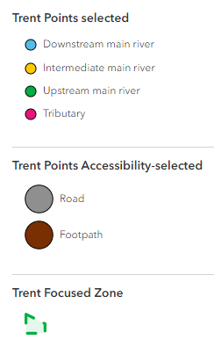
Appendix: Sampling Sites Detail
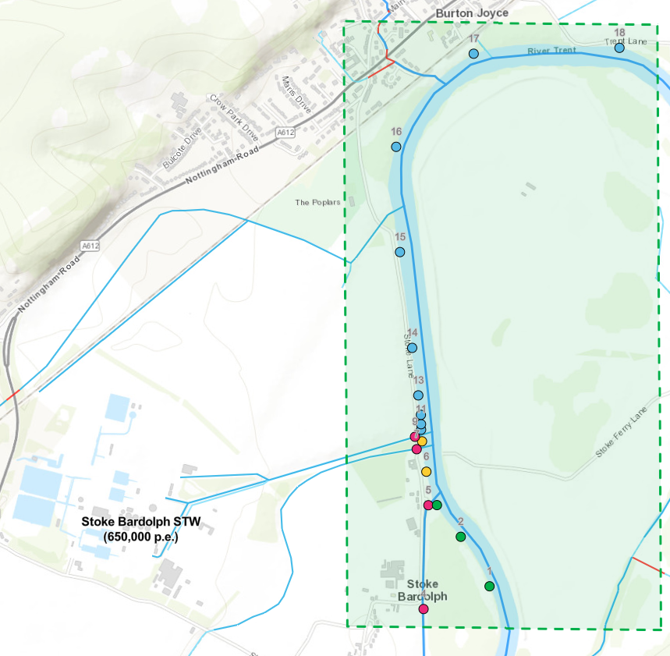
Figure 1: Map of proposed sampling study with 18 sampling points (14 main river and 4 tributary). Points are coloured by accessibility (outside ring) and river location classifier (inner circle).

Appendix Table 1: Maps, photographs and notes about each sample site location.
Site ID | Map | Aerial/Oblique photo | StreetView photo | Comment
 | Upstream main river
1 | 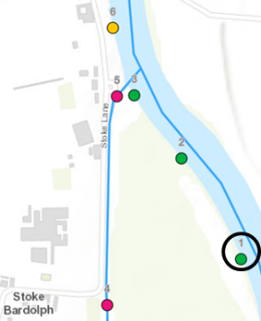 | 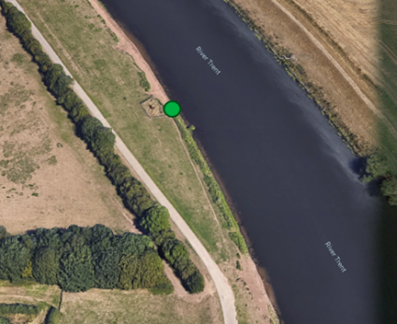 | 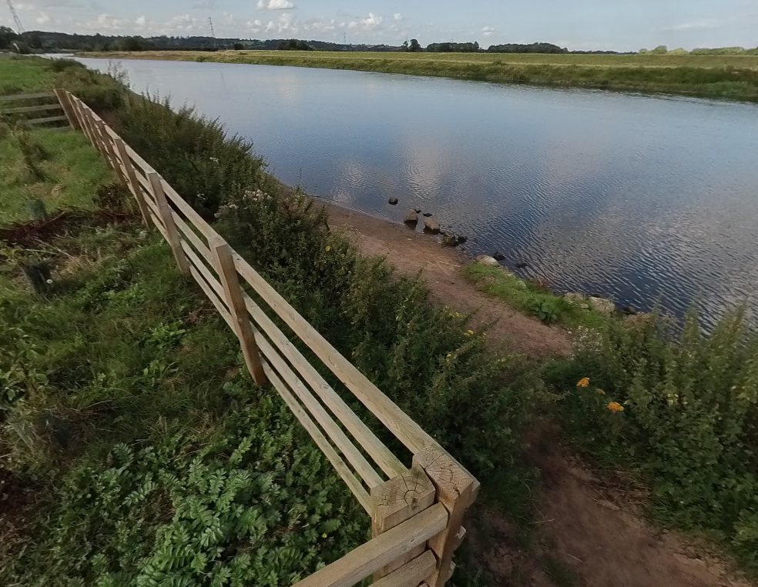 | River Trent upstream main river
2 | 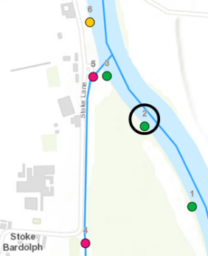 | 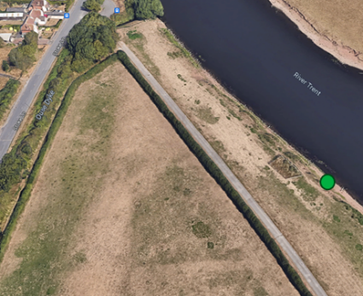 | 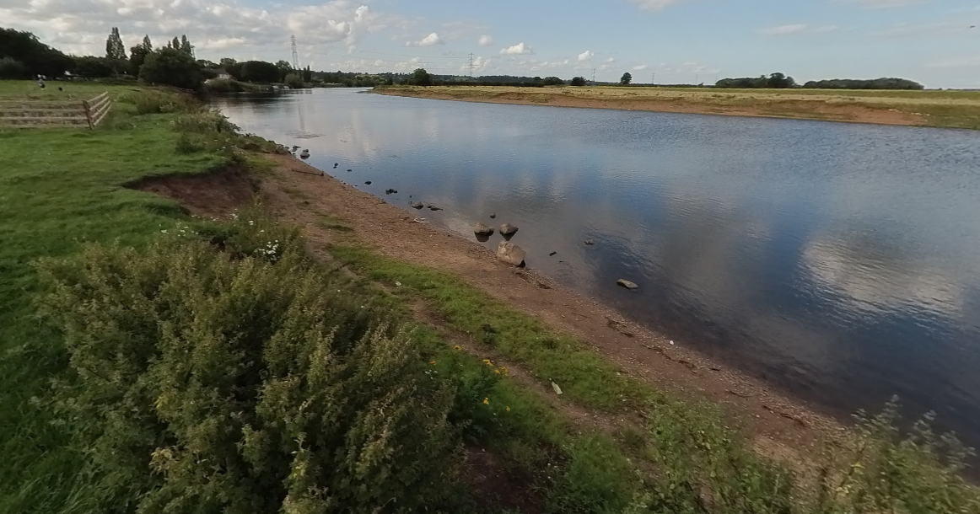 | River Trent upstream main river
3 | 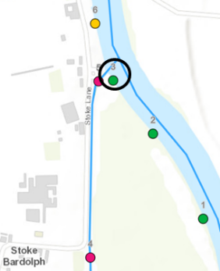 | 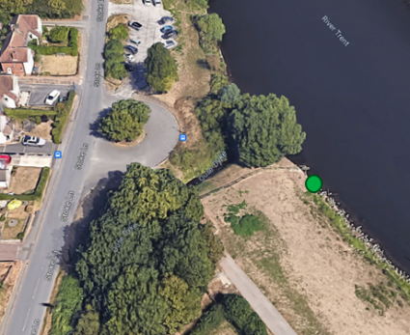 | 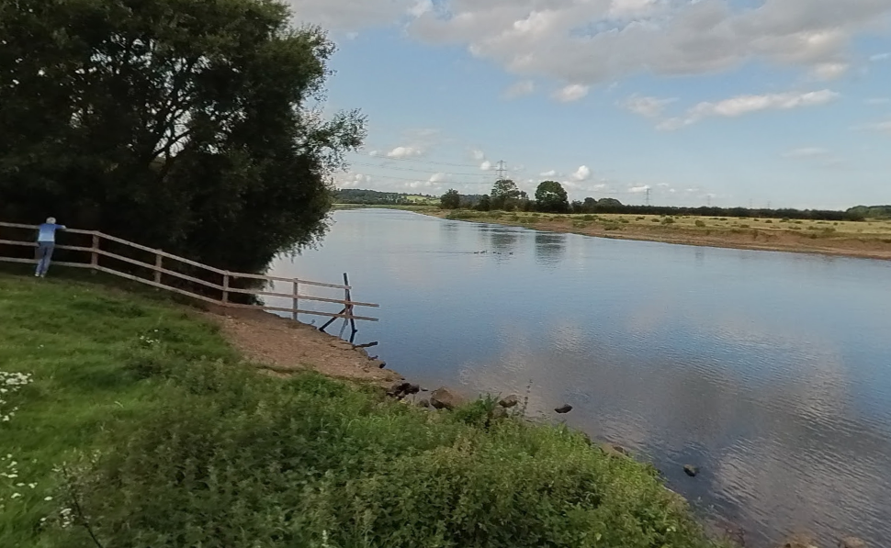 | River Trent upstream main river
4 | 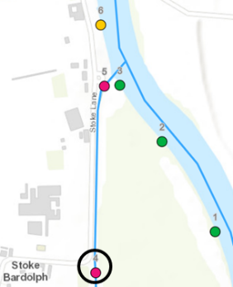 | 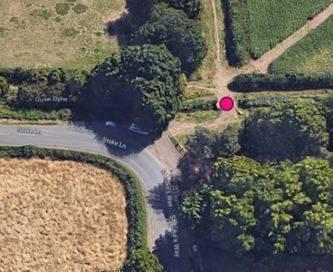 | 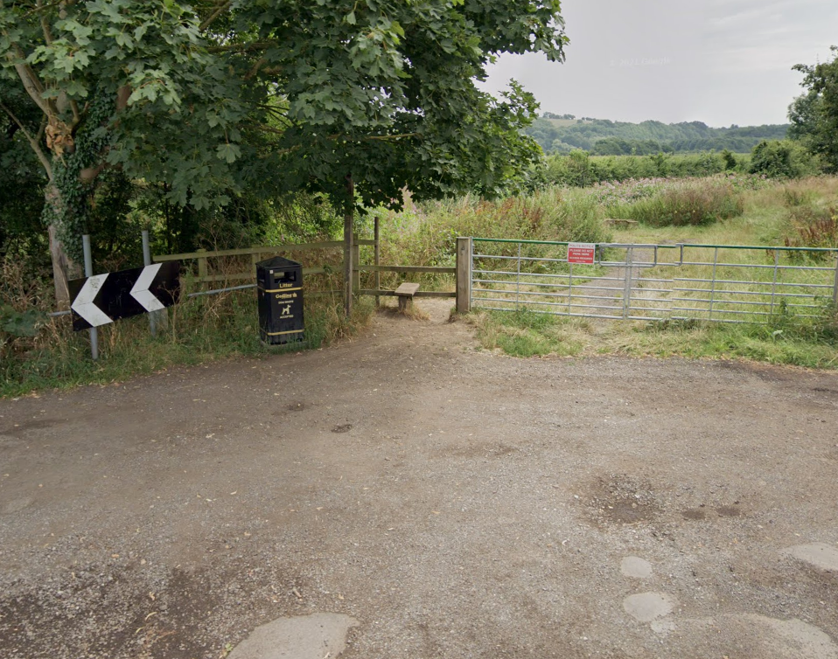 | Ouse Dyke (tributary)  Access over stile from footbridge
5 | 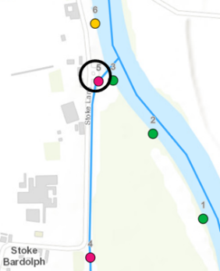 | 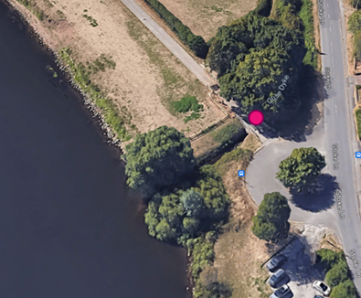 | 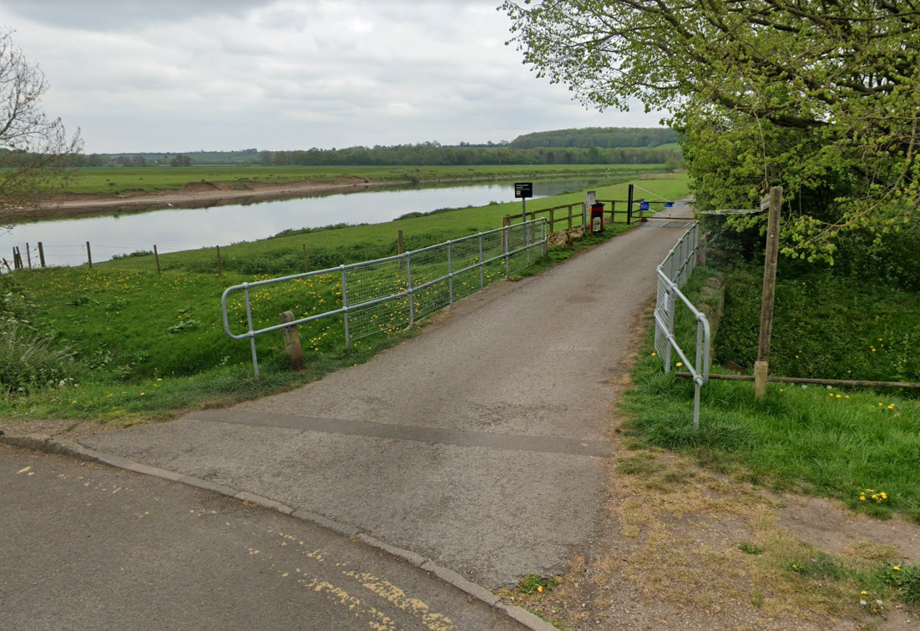 | Ouse Dyke (tributary)  [Ideally sample from non-river side of road]
6 | 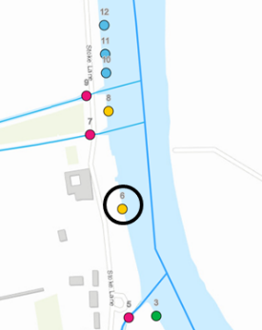 | 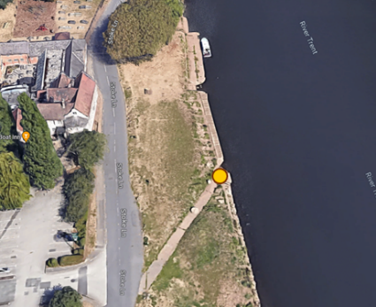 | 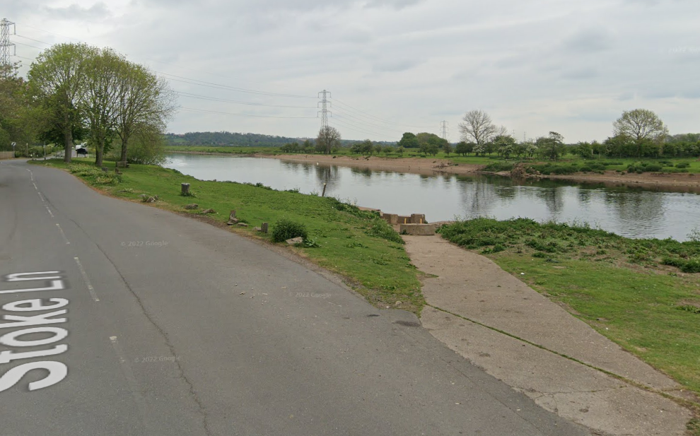 | River Trent  intermediate main river
7 | 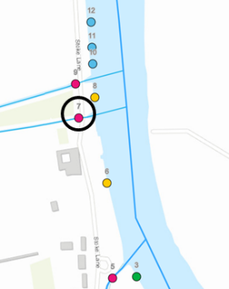 | 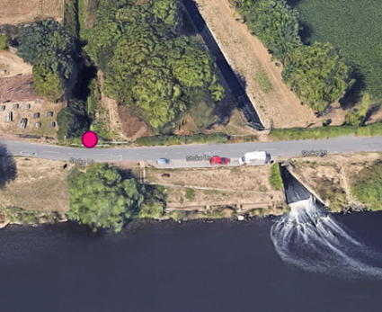 | 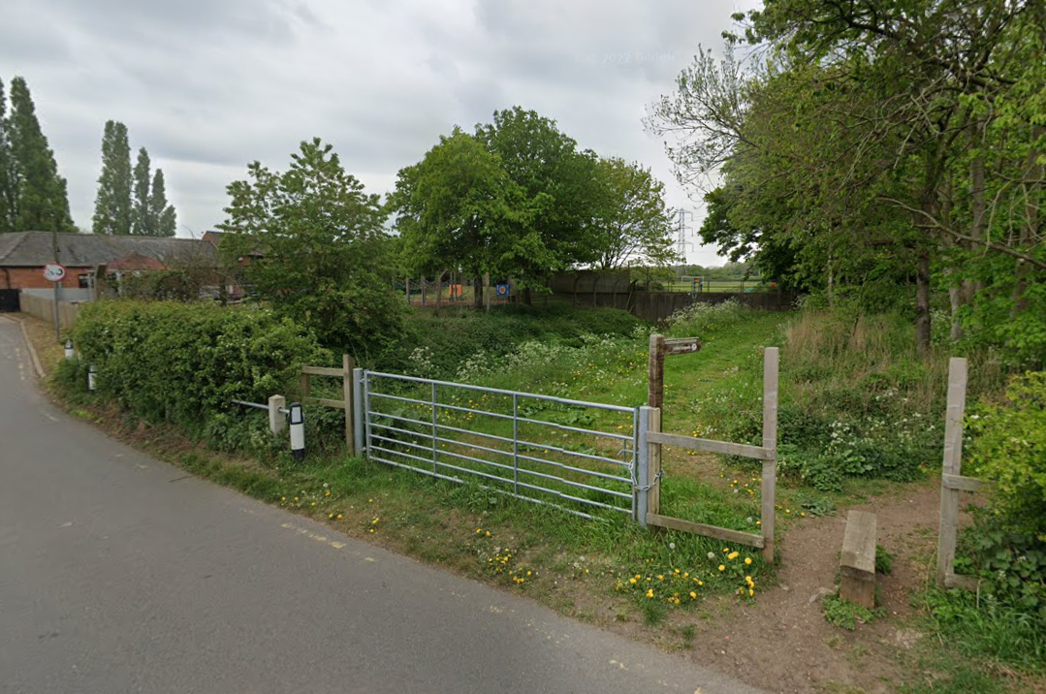 | Drain with Cottages STP FE  Via stile to tributary  Ideally sample from non-river side of road
8 | 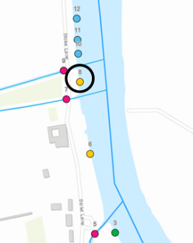 | 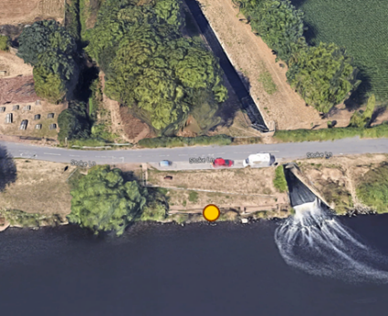 | 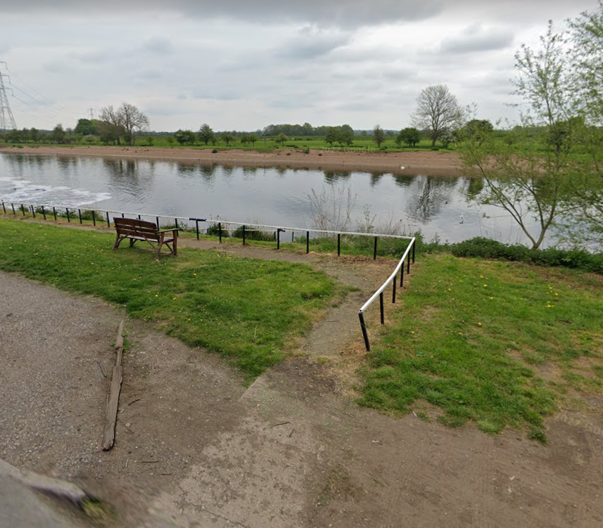 | River Trent (intermediate main river)  Ideally not in water disturbed by discharge
9 | 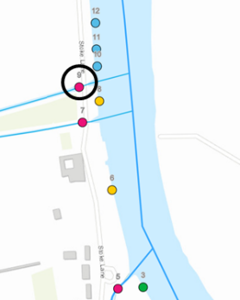 | 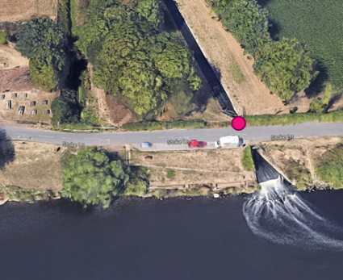 | 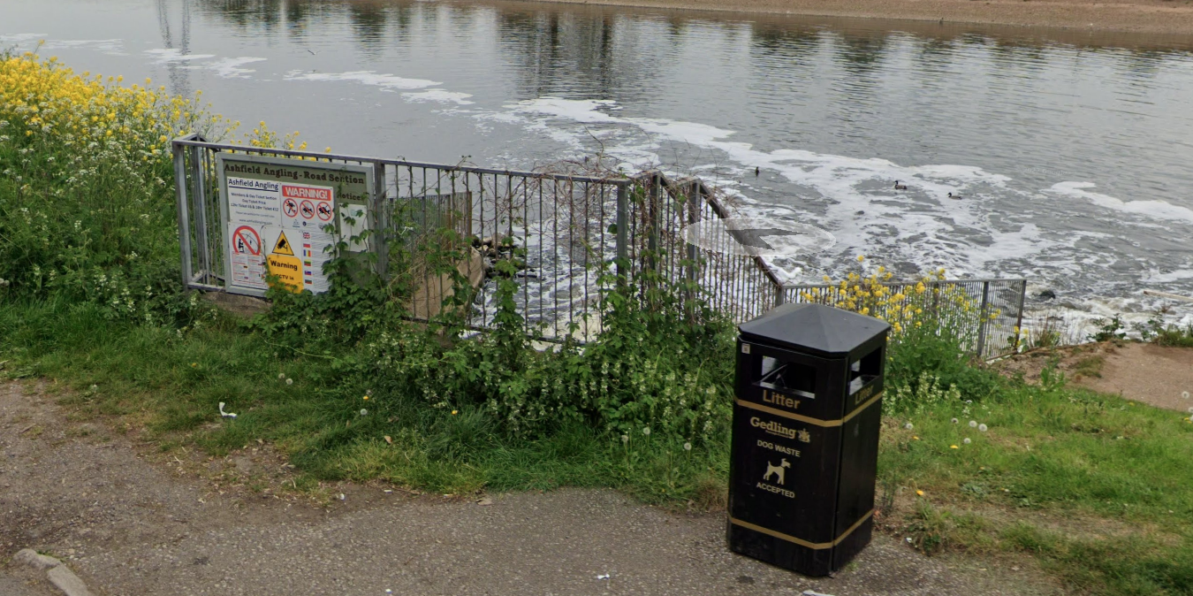 | Drain with STW FE + SS CSO
10 | 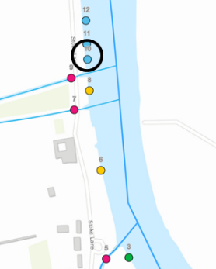 | 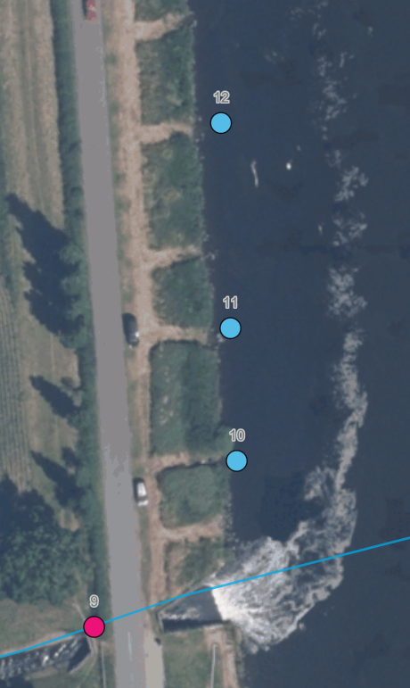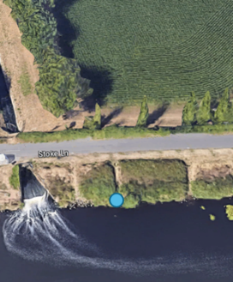 | 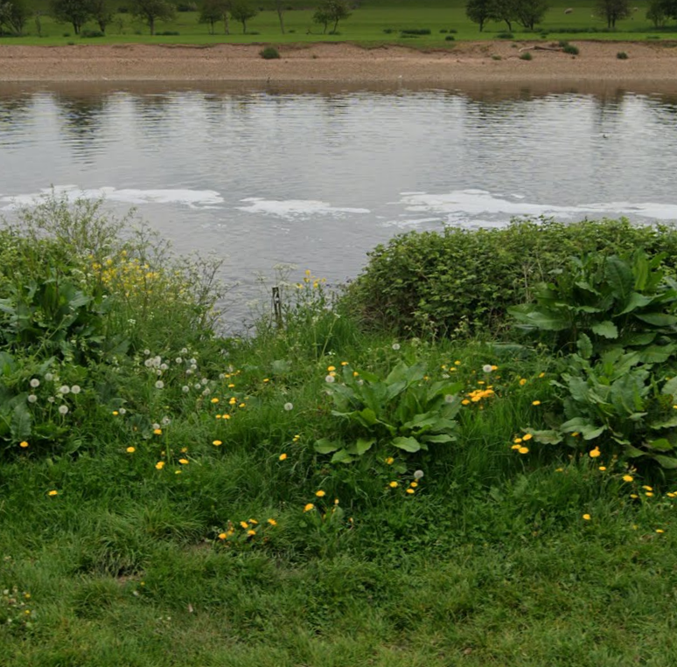 | River Trent downstream main river  2nd access point from discharge  Post #41
11 | 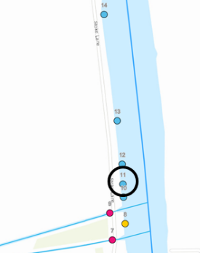 | 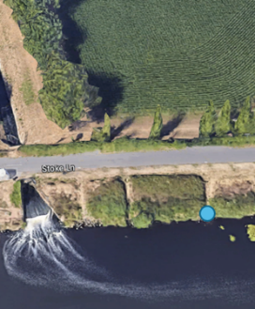 | 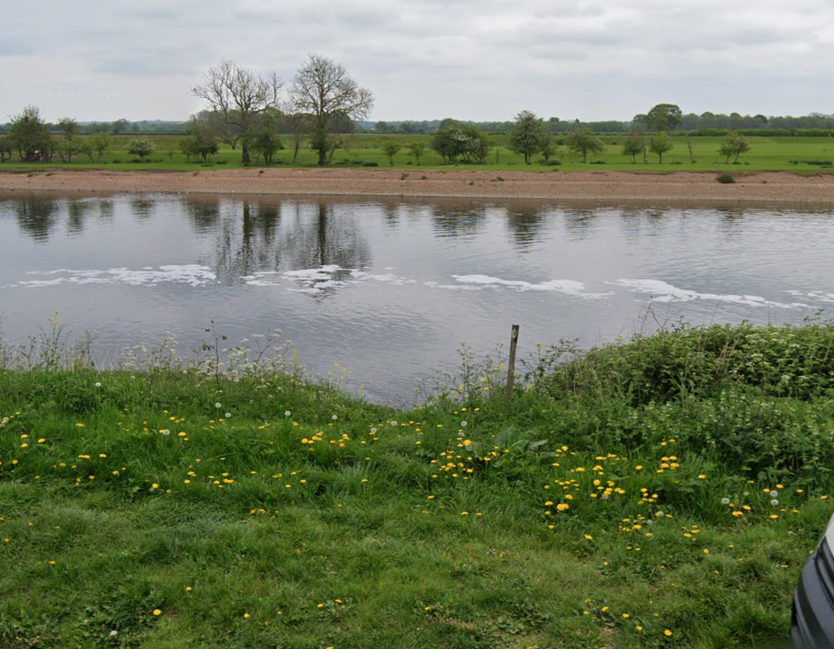 | River Trent downstream main river  3rd access point from discharge  Post #40
12 | 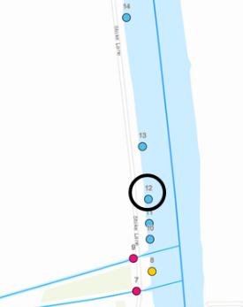 | 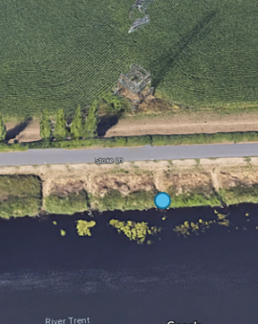 | 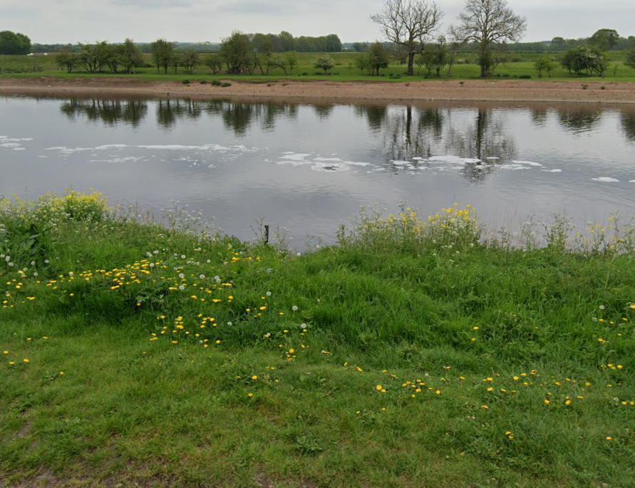 | River Trent downstream main river  5th access point from discharge  Post #38
13 | 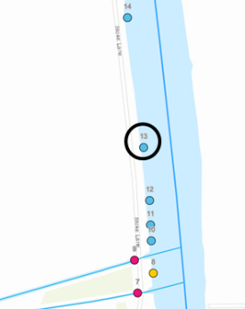 | 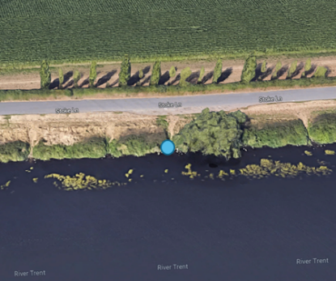 | 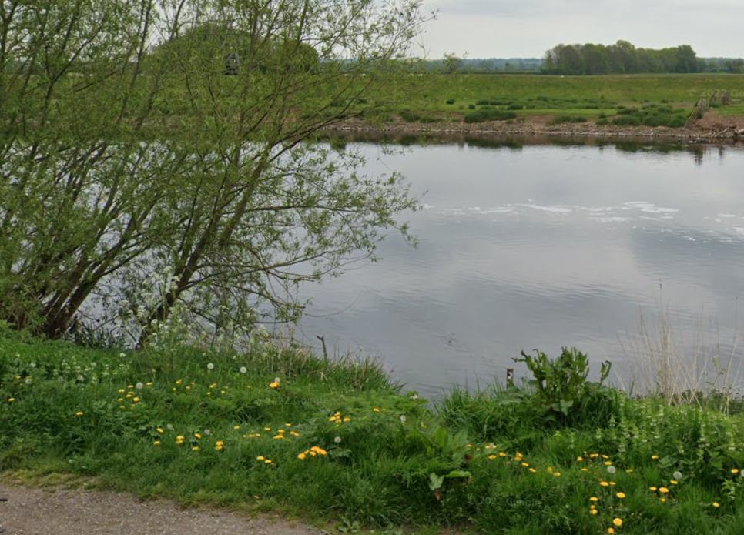 | River Trent downstream main river  RHS of 1st tree from discharge  Post #34
14 | 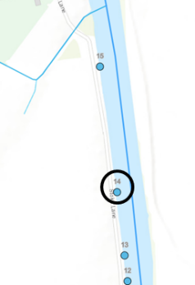 | 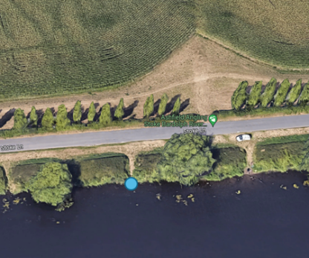 | 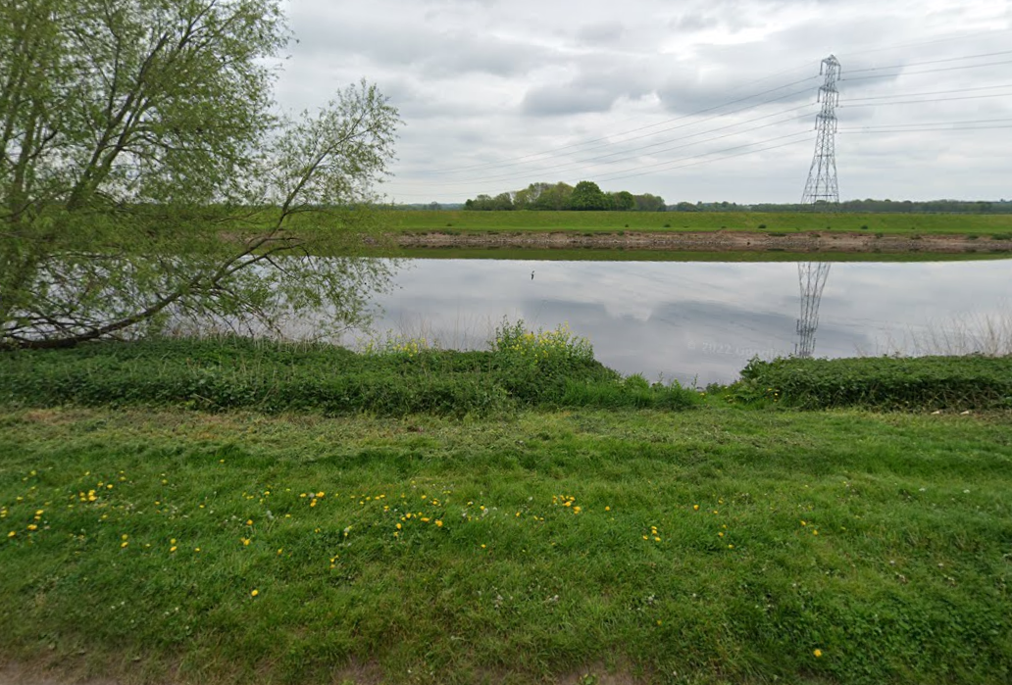 | River Trent downstream main river  Post #24
15 | 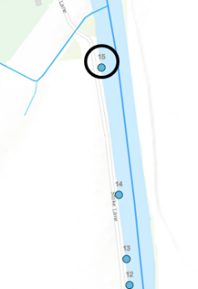 | 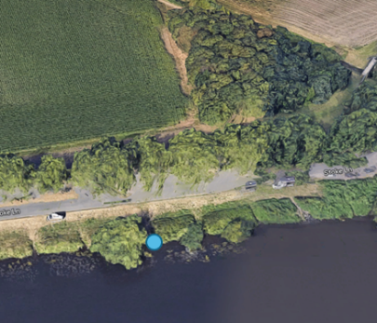 | 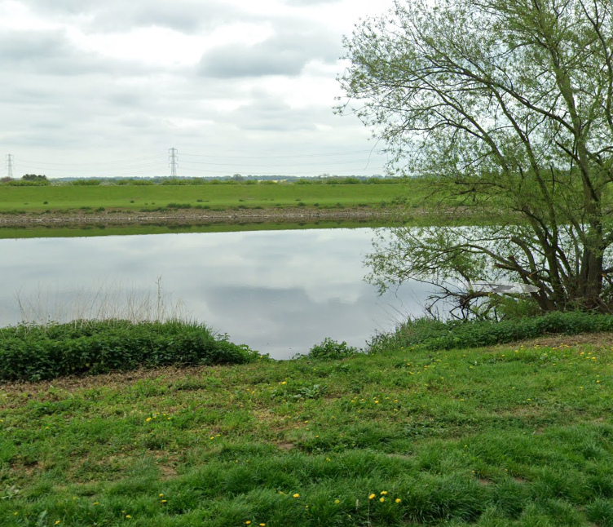 | River Trent downstream main river  Post #6
16 | 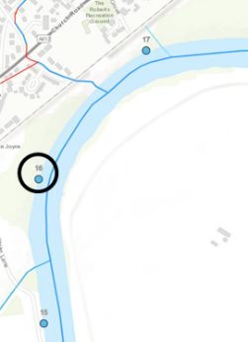 | 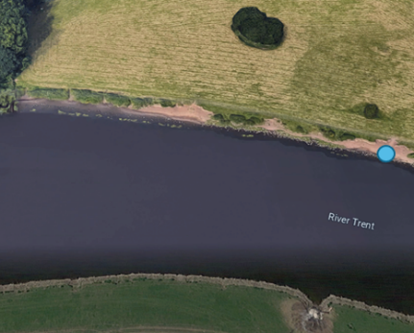 | 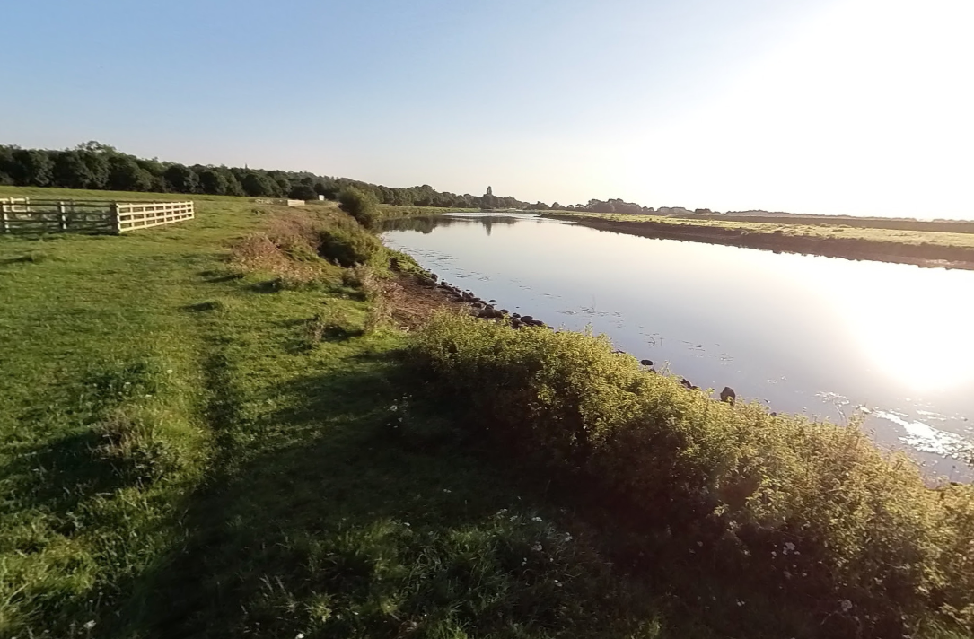 | River Trent downstream main river  Access from footpath
17 | 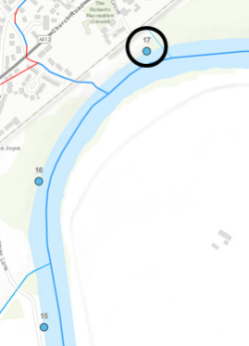 | 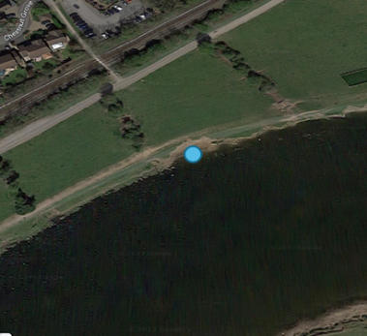 | 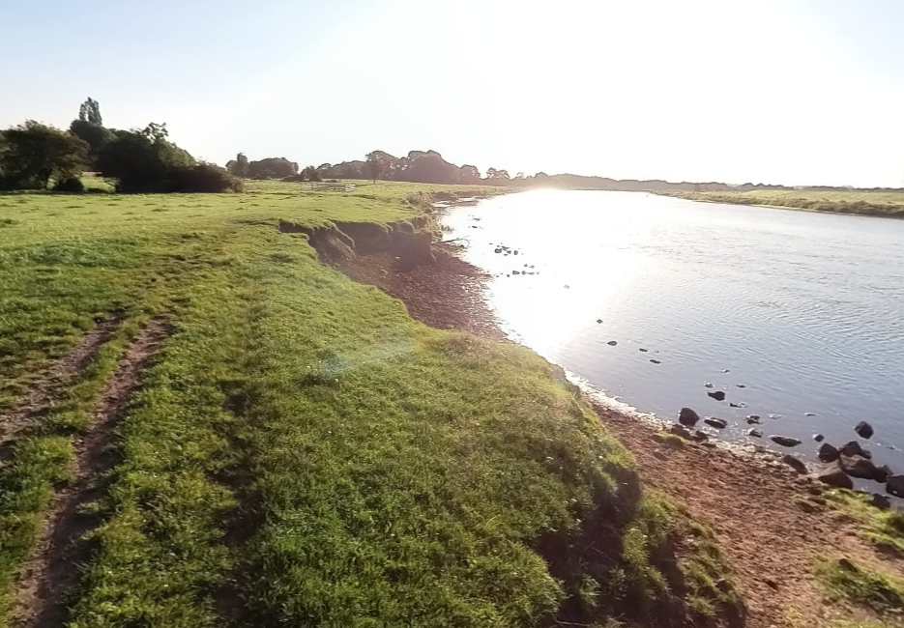 | River Trent downstream main river  Access from footpath
18 | 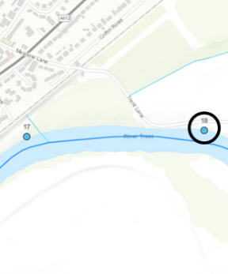 | 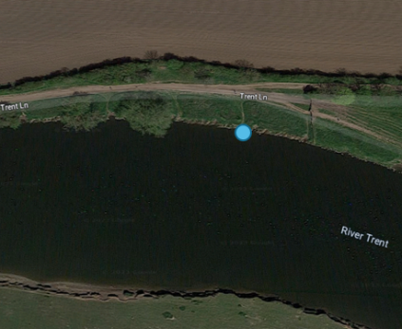 | 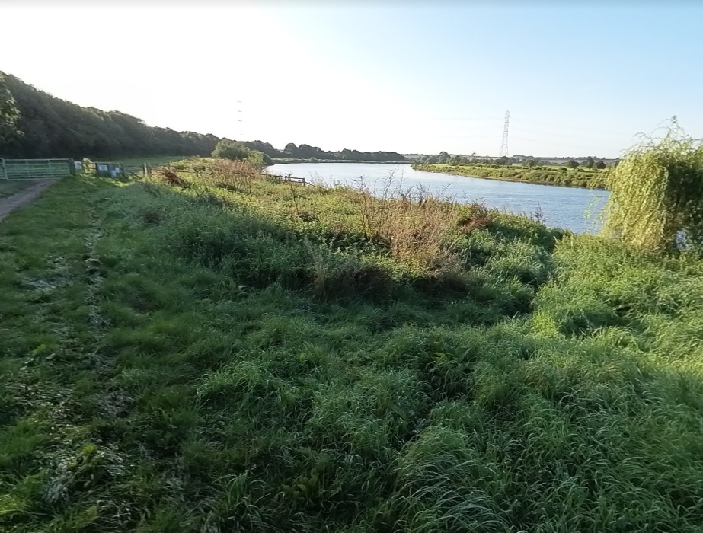 | River Trent downstream main river  Access from footpath

Payment
The Authority will raise purchase orders to cover the cost of the services and will issue to the awarded supplier following contract award.
The Authority’s preference is for all invoices to be sent electronically, quoting a valid Purchase Order number. Please send us an invoice after all the work has been completed.
It is anticipated that this contract will be awarded for a period of 7 weeks to end no later than 15/03/2024. Prices will remain fixed for the duration of the contract award period. We may at our sole discretion extend this contract to include related or further work. Any extension shall be agreed in writing in advance of any work commencing and may be subject to further competition.

Evaluation Methodology
We will award this contract in line with the most economically advantageous tender (MEAT) as set out in the following award criteria:
Technical – 60%
Commercial – 40%

Evaluation criteria
Evaluation weightings are 60% technical and 40% commercial, the winning tenderer will be the highest scoring combined score.

Award Criteria | Weighting (%) | Evaluation Topic & Weighting | Sub-Criteria | Weighted Question
Technical | 60% | Service / Product Proposal | Methodology (50%) | 2 Questions  Q1.1 Please describe the project methodology/approach that will be used to deliver the project  (25% of technical score available)  Q1.2 Which instruments and analyses will be considered?  (25% of technical score available)
 |  |  | Key personnel (20%) | 1 Question  Q2 Please describe the relevant skills and experience of the personnel directly involved with the project (Max. 2-3 person’s CV details can be included).  (20% of technical score available)
 |  |  | Quality Assurance measures (20%) | 2 Questions  Q3.1 Please detail previous experience of undertaking similar projects  (10% of technical score available)  Q3.2 Please provide an overview of how you will project manage this programme – e.g., the quality of services for your service area?  (10% of technical score available)
 |  |  | Management of sustainability and social value (5%) | 1 Question  Q4 What are your policies, management, and procedures to meet standard requirements? (5% of technical score available)
 |  |  | Health & Safety (5%) | 1 Question  Q5 Please provide a health and safety statement for the work you will be providing. (5% of technical score available)
Commercial | 40% | Whole life cost of the proposed Contract | Commercial Model | 1 Question  Q6 Does contractor have clear understanding related to the price, payment terms, and other financial aspects of the agreement?  (100% of commercial score available)

Technical (60%)
Technical evaluations will be based on responses to specific questions covering key criteria which are outlined below. Scores for questions will be based on the following:
Description | Score | Definition
Very good | 100 | Addresses all the Authority’s requirements with all the relevant supporting information set out in the RFQ. There are no weaknesses and therefore the tender response gives the Authority complete confidence that all the requirements will be met to a high standard.
Good | 70 | Addresses all the Authority’s requirements with all the relevant supporting information set out in the RFQ. The response contains minor weaknesses and therefore the tender response gives the Authority confidence that all the requirements will be met to a good standard.
Moderate | 50 | Addresses most of the requirements with most of the relevant supporting information set out in the RFQ. The response contains moderate weaknesses and therefore the tender response gives the Authority confidence that most of the requirements will be met to a suitable standard.
Weak | 20 | Substantially addresses the requirements but not all and provides supporting information that is of limited or no relevance or a methodology containing significant weaknesses and therefore raises concerns for the Authority that the requirements may not all be met.
Unacceptable | 0 | No response or provides a response that gives the Authority no confidence that the requirement will be met.

Technical evaluation is assessed using the evaluation topics and sub-criteria stated in the Evaluation Criteria section above.
Separate submissions for each technical question should be provided and will be evaluated in isolation. Tenderers should provide answers that meet the criteria of each technical question.

Methodology (50%) | Detailed Evaluation Criteria
Q1.1 Please describe the project methodology/approach that will be used to deliver the project. | Your response should:  1) Demonstrate a clear understanding of the nature of the requirements.  2) Be a clear, practical, achievable, and cost-effective methodology to deliver these requirements.  3) Have information in sufficient detail to allow a full appraisal of the suitability of the approach to deliver for the project.  25% of technical score available
Q1.2 Which instruments and analyses will be considered? | 25% of technical score available

Key personnel (20%) | Detailed Evaluation Criteria
Q2.1 Please describe the relevant skills and experience of the personnel directly involved with the project. | 20% of technical score available

Quality Assurance measures (20%) | Detailed Evaluation Criteria
Q3.1 Please detail previous experience of undertaking similar projects. | 10% of technical score available
Q3.2 Please provide an overview of how you will project manage this programme – e.g. the quality of services for your service area? | 10% of technical score available

Management of sustainability and social value (5%) | Detailed Evaluation Criteria
Q4.1 What are your policies, management, and procedures to meet standard requirements? | 5% of technical score available

Management, Health, and Safety (5%) | Detailed Evaluation Criteria
Q5.1 Please provide a health and safety statement for the work you will be providing. | 5% of technical score available

Commercial (40%)
The Contract is to be awarded as fixed price which will be paid according to the completion of the deliverables stated in the Specification of Requirements.
Suppliers are required to submit a total cost to provide the deliverables stated in the Specification of Requirements. In addition to this the Commercial Response template must be completed to provide a breakdown of the whole life costs against each deliverable used in the delivery of this requirement.
Calculation Method
The method for calculating the weighted scores is as follows:
- Commercial
Score = (Lowest Quotation Price / Supplier’s Quotation Price ) x [40%] (Maximum available marks)
- Technical
Score = (Bidder’s Total Technical Score / Highest Technical Score) x [60%] (Maximum available marks)
The total score (weighted) (TWS) is then calculated by adding the total weighted commercial score (WC) to the total weighted technical score (WT): WC + WT = TWS.

Information to be returned
Please note, the following information requested must be provided. Incomplete tender submissions may be discounted.
Please complete and return the following information:
- separate response submission for each technical question (in accordance with the response instructions)
- completed Mandatory Requirements (Annex 1)
- completed Acceptance of Terms and Conditions (Annex 2)
Award
Once the evaluation of the Response(s) is complete all suppliers will be notified of the outcome via email.
The successful supplier will be issued the contract via a Purchase Order.

Annex 1 Mandatory Requirements
Part 1 Potential Supplier Information
Please answer the following self-declaration questions in full and include this Annex in your quotation response.
Part 1.1 Potential Supplier Information:
Question no. | Question | Response
1.1(a) | Full name of the potential supplier submitting the information
1.1(b) | Registered office address (if applicable)
1.1(c) | Company registration number (if applicable)
1.1(d) | Charity registration number (if applicable)
1.1(e) | Head office DUNS number (if applicable)
1.1(f) | Registered VAT number
1.1(g) | Are you a Small, Medium or Micro Enterprise (SME)? | (Yes / No)
Note: See EU definition of SME https://ec.europa.eu/growth/smes/business-friendly-environment/sme-definition_en
Part 1.2 Contact details and declaration
By submitting a quotation to this RFQ I declare that to the best of my knowledge the answers submitted and information contained in this document are correct and accurate.
I declare that, upon request and without delay you will provide the certificates or documentary evidence referred to in this document.
I understand that the information will be used in the selection process to assess my organisation’s suitability to be invited to participate further in this procurement.
I understand that the authority may reject this submission in its entirety if there is a failure to answer all the relevant questions fully, or if false/misleading information or content is provided in any section.
I am aware of the consequences of serious misrepresentation.

Question no. | Question | Response
1.2(a) | Contact name
1.2(b) | Name of organisation
1.2(c) | Role in organisation
1.2(d) | Phone number
1.2(e) | E-mail address
1.2(f) | Postal address
1.2(g) | Signature (electronic is acceptable)
1.2(h) | Date

Part 2 Exclusion Grounds
Part 2.1 Grounds for mandatory exclusion
Question no. | Question | Response
2.1(a) | Please indicate if, within the past five years you, your organisation or any other person who has powers of representation, decision or control in the organisation been convicted anywhere in the world of any of the offences within the summary below.
 | Participation in a criminal organisation. | (Yes / No)  If yes please provide details at 2.1 (b)
 | Corruption. | ((Yes / No)  If yes please provide details at 2.1 (b)
 | Fraud. | (Yes / No)  If yes please provide details at 2.1 (b)
 | Terrorist offences or offences linked to terrorist activities | (Yes / No)  If yes please provide details at 2.1 (b)
 | Money laundering or terrorist financing | (Yes / No)  If yes please provide details at 2.1 (b)
 | Child labour and other forms of trafficking in human beings | (Yes / No)  If yes please provide details at 2.1 (b)
2.1(b) | If you have answered yes to question 2.1(a), please provide further details.  Date of conviction, specify which of the grounds listed the conviction was for, and the reasons for conviction.  Identity of who has been convicted  If the relevant documentation is available electronically please provide the web address, issuing authority, precise reference of the documents.
2.1 (c) | If you have answered Yes to any of the points above have measures been taken to demonstrate the reliability of the organisation despite the existence of a relevant ground for exclusion? (i.e. Self-Cleaning) | (Yes / No)
2.1(d) | Has it been established, for your organisation by a judicial or administrative decision having final and binding effect in accordance with the legal provisions of any part of the United Kingdom or the legal provisions of the country in which the organisation is established (if outside the UK), that the organisation is in breach of obligations related to the payment of tax or social security contributions? | (Yes / No)
2.1(e) | If you have answered yes to question 2.3(a), please provide further details. Please also confirm you have paid or have entered into a binding arrangement with a view to paying, the outstanding sum including where applicable any accrued interest and/or fines.

Part 2.2 Grounds for discretionary exclusion
Question no. | Question | Response
2.2(a) | The detailed grounds for discretionary exclusion of an organisation are set out on this webpage, which should be referred to before completing these questions.  Please indicate if, within the past three years, anywhere in the world any of the following situations have applied to you, your organisation or any other person who has powers of representation, decision or control in the organisation
2.2(b) | Breach of environmental obligations? | (Yes / No)  If yes please provide details at 2.2 (f)
2.2(c) | Breach of social obligations? | (Yes / No)  If yes please provide details at 2.2 (f)
2.2(d) | Breach of labour law obligations? | (Yes / No)  If yes please provide details at 2.2 (f)
2.2(e) | Shown significant or persistent deficiencies in the performance of a substantive requirement under a prior public contract, a prior contract with a contracting entity, or a prior concession contract, which led to early termination of that prior contract, damages or other comparable sanctions? | (Yes / No)  If yes please provide details at 2.2 (f)
2.2 (f) | If you have answered Yes to any of the above, explain what measures been taken to demonstrate the reliability of the organisation despite the existence of a relevant ground for exclusion? (Self Cleaning)

Annex 2 Acceptance of Terms and Conditions
I/We accept in full the terms and conditions appended to this Request for Quote document.
Company ____________________________________________________
Signature ____________________________________________________
Print Name ____________________________________________________
Position ____________________________________________________
Date ____________________________________________________

