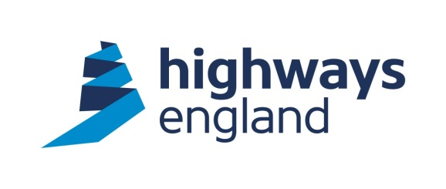  Our ref: CNB3/72A  Your ref:  AMCO Rail  Amalgamated Construction Ltd  Head Office  Whalley Rd  Barugh Green  Barnsley  South Yorkshire  S75 1HT  For the attention of: Redacted | Highways England  Procurement  Lateral  8 City Walk  Leeds  LS11 9AT  Direct Line: Redacted  Tuesday 15th May 2018  http://highwaysengland.co.uk
CLOSED BRANCH LINES major WORKS – CNB3/72A, MILLERSDALE VIADUCT, WATERPROOFING AND REFURBISHMENT.

Dear Sir,

I refer to your recent tender exercise for the above contract, carried out by Highways England - Historical Railways Estate Team. I am pleased to advise you that you are appointed as Principal Contractor to carry out these works. This letter may be considered as formal notice of the award of contract in the sum of £619,471.95 as per your Tender submission received on 23rd February 2018.

You should note that we will not pay for any works unless it has been specifically authorised in writing within the terms of the agreement.

Jacobs will be the CDM Principal Designer and the Engineer under the Contract and henceforth all instructions in connection with the project will be issued by them. The construction phase Health and Safety Plan supplied with your revised Tender is under review and no work is to commence on site until this has been prepared to the satisfaction of the CDM Principal Designer and a written notice from Highways England Historical Railways Estate team has been received.

Invoices should be sent to FS Payments at Highways Agency, The Cube, 199 Wharfside Street Birmingham B1 1RN, quoting the Blanket Purchase Agreement number, Release number and Receipt number. These details will be provided by the Historical Railways Estate team as works are certified.

I trust the above is acceptable. The agreed Start Date is 18th June 2018. The Completion Date is 26th October 2018. Should you wish to discuss the matter further please contact Redacted the Project Manager for Historical Railways Estate on Redacted.

Please acknowledge receipt of this letter by return.

I wish you well in undertaking the works.

Yours sincerely

Redacted

Redacted
Redacted
Email: Redacted

