

**Review of identified Commercial off the Shelf (COTS) tools for the re-development of FeAST**

# VFront

This is an intuitive graphic interface (set of configurable forms), essentially a front end which sits on top of a mysql or postresSQL database. It’sdesigned for non-expert basic users to allow them to work safely on the data in the database.

It does allow for different access privileges (but this essentially means hiding certain fields or tables). It does have export data modules, statistics and report management based on xml protocols.

Essentially, it’s for those who require an easy to install and configure database front-end. This will not facilitate the complex logic that is needed outside of the database relationships between data or allow multiple organisations to interact with it – i.e., it’s an internal tool and not suitable for web hosted service.

# TIBCO Spotfire

This is a licensed platform for exploring and visualizing data using customised analytics, for finding trends, outliers in data etc. It is not designed for a web-based public facing application as the pricing model is pay per named user.

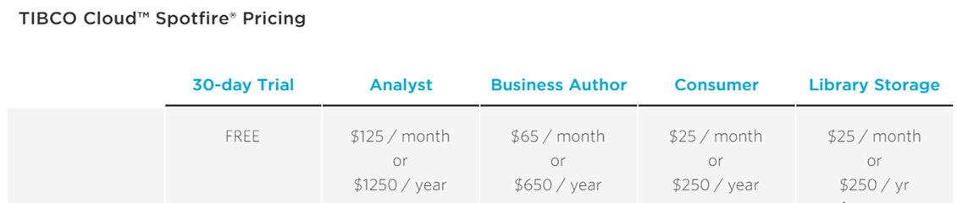

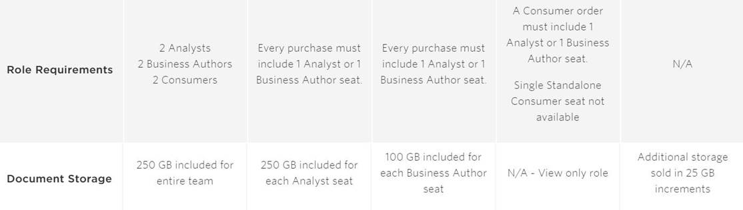<https://account.cloud.tibco.com/signup/spotfire>

<https://www.tibco.com/products/tibco-spotfire/editions-pricing>

# CASPIO

This is designed for creating online database applications in the cloud for managing data, digitising workflows and automating processes – more suited for external use.

The logic needed would be complex to implement but likely to be possible. Unsure whether it could offer all requirements as these are not fully documented. Main issue is the ongoing monthly costs of $400 per month to use.

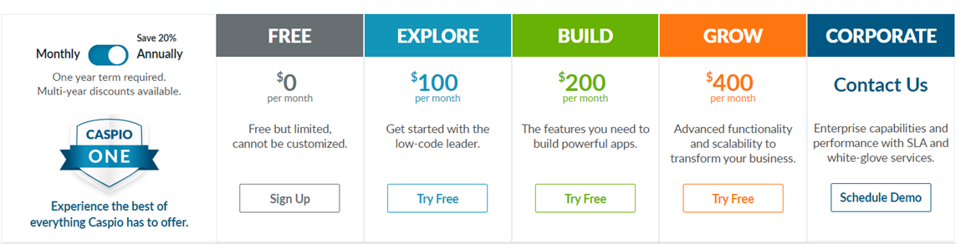

<https://www.caspio.com/>

# Other Options

There are potentially other off the shelf packages (that would need configuration) that could deliver as well as something simpler like a purpose-built python based app (but the latter would be a custom build).

A complete user requirements exercise is required next.

Work will need to:

* Find out who the users are.
* Assess the existing feedback/collated data and material on existing system and suggestions.
* Run a user gathering workshop/set of tailored interviews.
* Prioritise the user stories into phased development.
* Assess these sets against suitable COTS / custom builds including python.?
* Provide costed and pro / cons options with ongoing costs included.